**USER GUIDE**

**LINUX_DEBIAN_CREATE_DELETE_MODIFY_SAMBASHARE**

**Version 1.0**



**Document Release Note**

|  |  |  |  |
| --- | --- | --- | --- |
| **Document Name** | USER_GUIDE_LINUX_DEBIAN_SAMBASHARE | | |
| **Version** | 1.0 | **Date** | 15/01/2021 |
| **Authors** | Amol Chaudhari  Manoj Kumar  Parth Dhabalia | | |
| **Reviewers** | Shweta Singh  Rachamadugu Aparna | | |
| **Modified By** |  | **Modified Date** |  |

**Run Samba_Share.py file in terminal with super user privileges.**

#### Upon successful execution Samba Share GUI will appear as show below :

#### 

1. **Create Samba Share :**

To create a samba share click on create button.

Share creation window should appear.

Now fill the share name to be create.

Click on the browse button to select the folder to be shared.

A file explorer instance will follow as shown below:

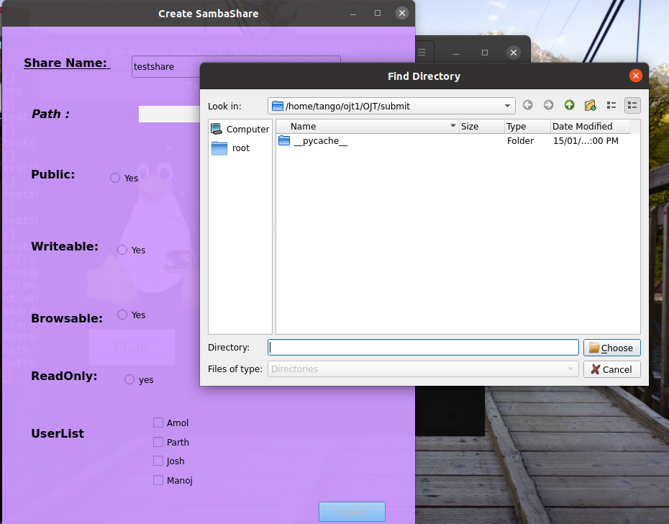

Navigate to the folder, select it and press choose.

Now set all the other parameters for samba share.

Following which the submit button will be enabled and the create samba share query will be submitted upon pressing the button.

You will see one of the following two popups :

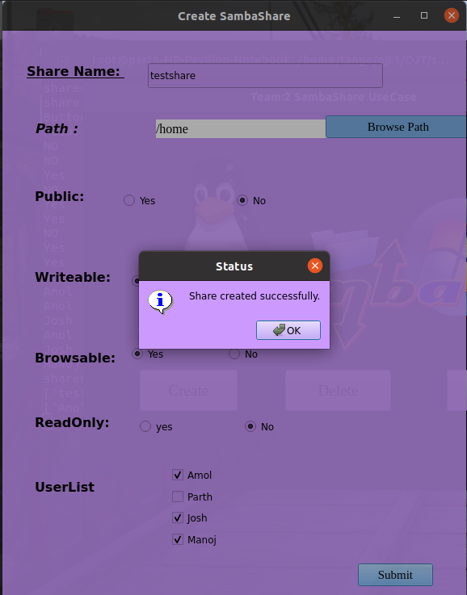

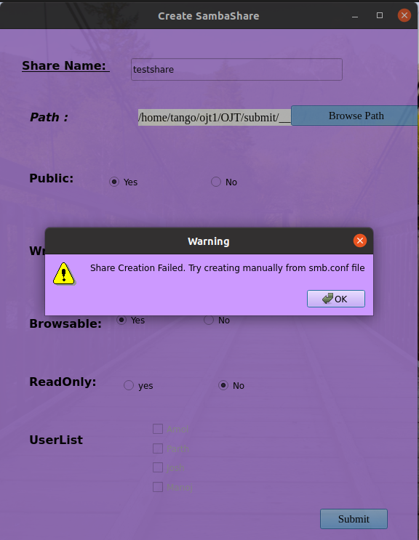

The latter is occurred when the samba share configuration file “smb.conf” is missing. It can either be resolved by reinstalling samba server or replacing the smb.conf file in /etc/samba directory.

2.) **Delete Samba Share**

Upon pressing the delete button you will the see delete window as shown below:

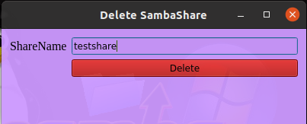

Enter the Samba Share name and press the delete button.

One of the two popus will be shown:

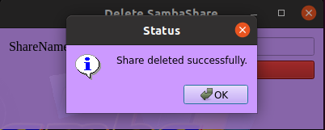

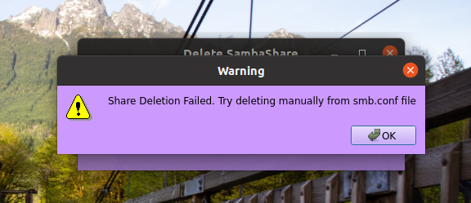

The latter is occurred when the samba share configuration file “smb.conf” is missing. It can either be resolved by reinstalling samba server or replacing the smb.conf file in /etc/samba directory.

**3.) Modify Samba Share**

Upon clicking the Modify button, modify form will open. Enter the name of the samba share. If it exists the existing parameters will be autofilled in the below labels. Otherwise ShareName does not exist label will appear as shown below:

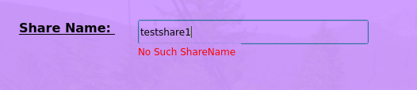

Once the sharename is entered all the parameters will be filled in. The user can modify the parameters there itself and hit submit to submit the changes made to the parameters of the share.

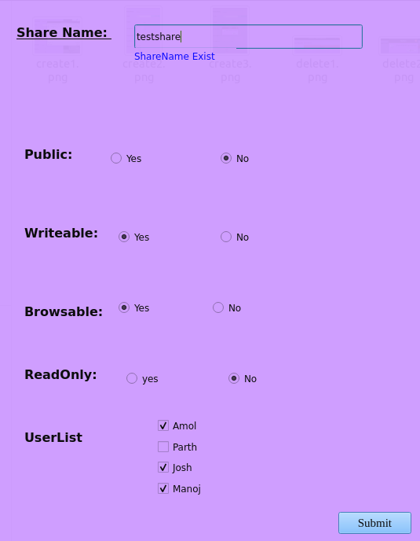

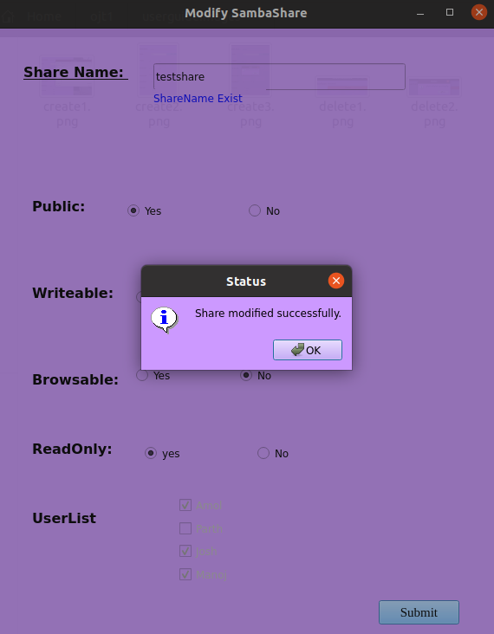

Now if user encounters error while entering the name of sambashare as shown below then the samba share configuration file “smb.conf” is missing. It can either be resolved by reinstalling samba server or replacing the smb.conf file in /etc/samba directory.