# **Documentation**

**Instructions to run the project locally.**

(Assuming the compressed zip folder is extracted)

**Prerequisites:**

Ensure that you have the following installed on your system.

* Visual Studio Code
* Node and npm package manager
* MongoDB Compass

**Create a MongoDB Database:**

Open the MongoDB Compass and start the server locally.

Create a new database with the name of your choice (e.g. mydb).

**Steps to Run Backend Server:**

* Open the VS Code in the project directory and open a new terminal.
* Go to Server directory using the command line by this command “**cd server**”.
* Now run this command “**npm install**”.
* Now find the “**.env**” file and give the **PORT** of your choice. Change the **MONGO_URL** to the URL of your database.
  + (Note: For some node.js users the following URL may give errors

**mongodb://localhost:27017/{your_database_name}**

To troubleshoot this, replace “localhost” by “127.0.0.1”.

**mongodb://127.0.0.1:27017/{your_database_name}**)

* When all the installation is done and env is setup, run this command “**npm start**”.
* A new collection will be created in the MongoDB database with name “**users”.**
* Add data to “**users”** collection in MongoDB.
  + Open the database you created and open the “**users”** collection.
  + A following page may appear.
  + 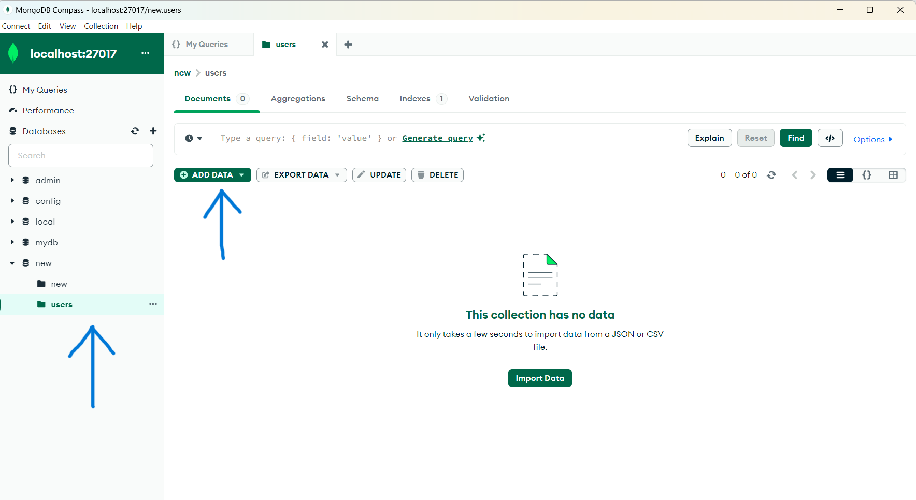
  + After this click on the “**ADD DATA**” button and select the option “**Import JSON or CSV file**” and find the directory where the compressed folder is extracted and select the file with filename “**data.json**”.
  + Reload the MongoDB and you’re up. The database is ready to use.
  + Reload the backend server.
* Your Backend sever is up and running.

**Steps to Run Frontend Server:**

* Change the API URL
* Open the ‘App.jsx’ file and locate the line where the Axios request is made to fetch data.

**(http://localhost:7000/getContacts?page=${page}&limit=${limit})**

* Replace (**http://localhost:7000/getContacts**) with the appropriate URL where your backend server is running.
* Now open another terminal in the project directory and type “**cd client**” to go to the react app using command line.
* Now run this command to install all dependencies and modules “**npm install**”.
* After installation run this command to host you react app on your local machine “**npm run dev**”.

**Your Project for Infinite Scrolling is up and running!**