

# Basic Information

**Name : AMOL RAMESH DEVKATE**

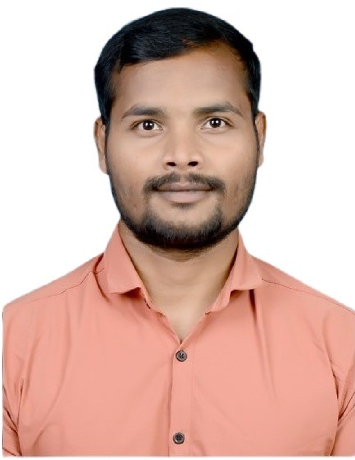

**Course : PG - DAC**, March22

**Address :** Skyline Heights, Plot No 28, Sector 5A, Karanjade, Panvel, Navi Mumbai, Maharashtra.

**Mobile No**  **:** 8104784380

**Email**   **:** amoldevkate4011@gmail.com

# Profile

# I am an enthusiastic, generous, courage person who has skills and have a patience to learn more skills. To work in a challenging environment demanding all my skills and efforts to explore and adapt myself in different fields and it can be utilized towards the growth, development and success of an organization.

# Academic Details

|  |  |  |  |  |  |  |
| --- | --- | --- | --- | --- | --- | --- |
| **Level** | **Stream** | **Institute** | **Board/University** | **Passing Year** | **Degree %** | **Division** |
| BE | Electrical | Priyadarshini College of Engineering Nagpur | Rashtrasant Tukadoji Maharaj Nagpur University , Nagpur , Maharashtra | 2019 | 60.2 % | I |
| XII | Computer Science | New English Junior College,  Wardha, Maharashtra | Maharashtra State Board Of Secondary and Higher Secondary Education Pune | 2014 | 62.46 % | I |
| X | General | Sushil Himmatsingka Vidhylaya, Wardha, Maharashtr a | Maharashtra State Board of Secondary and Higher Secondary Education Pune | 2012 | 78.18 % | I |

**Academic Projects**

## Title : Flyby (Airline Management System)

**Platform :** Spring boot , React JS **Duration :** 1 Month

**Description :** Flyby is an intuitive website using which one can make reservations, its minimalistic and user friendly graphic interface will help to interact with the system and meet their requirements in just a few clicks.

# Technology Skill : Java ,MySQL, Servlet , Jdbc, Hibernate ,Spring Boot ,React, GitHub.

**Extra-Curricular :** 1. Awarded for holding 1st position in line follower robo event

under “Antaragni-technorion ’’ Annual Social Gathering held at G.H.Raisoni College of Engineering, Nagpur.

2. Winner in “Over The Top” event organised by Electrical Engineering Department, PCE Nagpur.

# Personal Information

**Date of Birth :** 16/06/1996 **Gender :** Male

**Nationality :** Indian **Languages Known :** English, Hindi , Marathi

# I hereby declare that the information given above is true to the best of my Information knowledge belief.

## Date : Signature : Amol Devkate