BANK MARKETING ANALYTICS
Amol Kawade – Capstone Project

1. Business Problem and Objectives
Banks use direct marketing campaigns to encourage customers to subscribe to term deposits. Contacting every customer equally can be inefficient, so understanding which customer and campaign characteristics are associated with subscription can help improve targeting. This project explores bank marketing data, identifies patterns in subscription outcomes, and compares supervised learning models to predict whether a customer will subscribe.

2. Dataset and Methodology
The dataset contains 11,162 customer records and 17 original columns covering demographics, account characteristics, loans, contact methods, and campaign history. A total of 5,289 customers subscribed and 5,873 did not, giving an overall subscription rate of 47.38%. The initial inspection reported no missing values. Data preparation included duplicate checks, categorical-value cleanup, descriptive statistics, and IQR-based outlier investigation. Potential outliers were examined rather than automatically deleted.
Exploratory analysis used target-distribution, numerical-distribution, category subscription-rate, and correlation visualizations. For predictive modeling, the data was split into 80% training and 20% testing with stratification. Numerical features were imputed and standardized, and categorical features were imputed and one-hot encoded within a preprocessing pipeline. Logistic Regression and Random Forest were compared. The call-duration variable was excluded from the main prediction model because it is only known after a call, making it unavailable for pre-call targeting.

3. Key Exploratory Findings
Factor | Observed result | Interpretation
Previous campaign outcome | 91.32% subscription rate after a previous success (978/1,071) | Strong association; prior success may help prioritize follow-up.
Job category | Students: 74.72%; retired: 66.32%; blue-collar: 36.42% | Rates vary by occupation; consider both rate and segment size.
Education | Tertiary: 54.11%; primary: 39.40% | Subscription rates differ across education categories.
Housing loan | No: 57.03%; yes: 36.64% | Customers without housing loans had a higher observed rate.
Personal loan | No: 49.53%; yes: 33.15% | Customers without personal loans had a higher observed rate.
Contact method | Cellular: 54.33%; unknown: 22.59% | Recorded contact method is associated with different outcomes.
Campaign frequency | 1 contact: 53.38%; 5 contacts: 36.77%; 8 contacts: 25.00% | Rates generally trend downward as contact frequency rises, though some small groups fluctuate.
These are descriptive associations, not evidence that any single factor causes a customer to subscribe. Rates for categories with small customer counts should be interpreted
cautiously.

4. Supervised Model Results
Both models were evaluated on the held-out test set of 2,233 observations (1,175 non-subscribers and 1,058 subscribers). Random Forest performed better than Logistic Regression on the reported metrics.
Metric | Logistic Regression | Random Forest | Better result
Accuracy | 0.69 | 0.74 | Random Forest
Precision — subscription | 0.71 | 0.77 | Random Forest
Recall — subscription | 0.59 | 0.64 | Random Forest
F1-score — subscription | 0.65 | 0.70 | Random Forest
Recall — no subscription | 0.78 | 0.82 | Random Forest
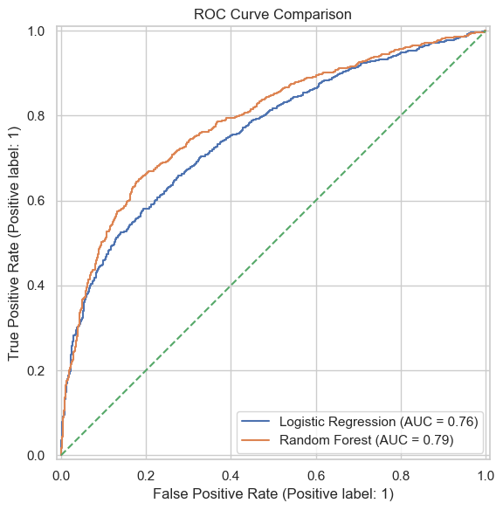
Fig 2. ROC Curve Comparison
Random Forest achieved 74% accuracy and a 0.70 F1-score for the subscription class, compared with 69% accuracy and a 0.65 F1-score for Logistic Regression. Its subscription precision of 0.77 means that 77% of customers predicted to subscribe were actual subscribers at the model's chosen threshold. Its recall of 0.64 means it identified 64% of actual subscribers. This remains a trade-off: some potential subscribers are missed, while some contacted customers may not subscribe. ROC-AUC values were not included in the supplied results, so no conclusion about ROC-AUC is made here.

5. Recommendations
- Use Random Forest as the leading candidate for further validation because it outperformed Logistic Regression on the reported test metrics.
- Use predicted probabilities to rank customers for campaign prioritization, then choose a decision threshold based on the cost of contacting customers and the value of a successful subscription.
- Review previous campaign outcomes as a useful targeting signal. The 91.32% rate after a prior campaign success is notable, but the bank should verify how much this signal generalizes to future campaigns.
- Investigate contact fatigue. Since subscription rates generally fall with higher contact counts, test contact limits or timing strategies rather than assuming repeated calls improve conversion.
- Design controlled campaign experiments to test whether changes in contact strategy actually improve conversion, rather than relying only on observational differences.

6. Limitations and Conclusion
The analysis is based on historical observational data, so associations should not be interpreted as causal effects. Some categories, especially those with many unknown values or low customer counts, may produce less stable estimates. Accuracy alone is insufficient for selecting a marketing model; precision, recall, F1-score, ROC-AUC, and campaign economics should all be considered. The supplied results do not include numerical cluster profiles, so no specific unsupervised customer-segment conclusions are reported.
In conclusion, the dataset shows meaningful variation in subscription rates across previous campaign outcomes, occupation, loan status, contact method, and campaign frequency. Random Forest is the stronger of the two tested classifiers based on the reported metrics. A practical next step is to validate its probability rankings and run controlled targeting experiments to determine whether model-assisted outreach can improve campaign efficiency.

