Create default pod

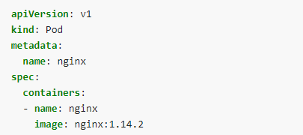

**Assignment: Create and list pod in test namespace. Use same nginx image**

Create multiple container pod

apiVersion: v1

kind: Pod

metadata:

name: multi-pod

namespace: amit

spec:

containers:

- name: nginx-container

image: nginx

- name: ubuntu-container

image: ubuntu

kubectl create -f multi-pod.yaml

kubectl get pods -n amit

kubectl describe pod multi-pod -n amit

kubectl logs multi-pod -n amit