docker search nginx

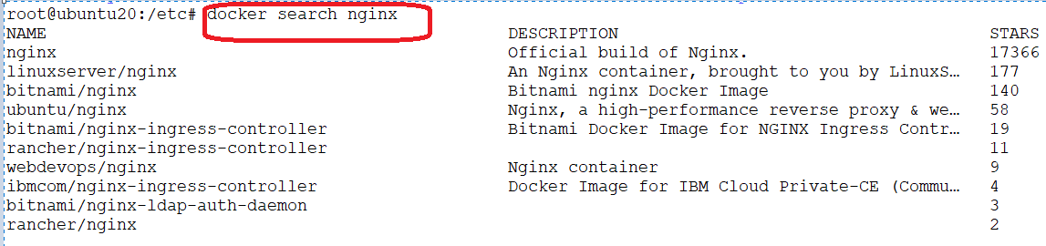

docker pull nginx

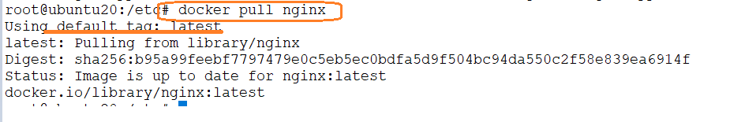

docker pull --all-tags mysql

docker images

docker run <image name>: will run the container

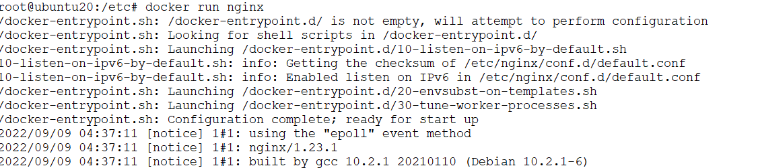

Press Ctrl+C to exit

docker run -it nginx /bin/bash

docker run -d nginx

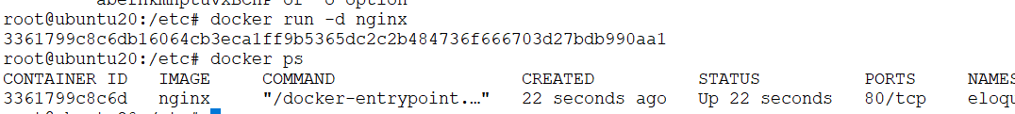

docker ps



docker stop <container id/ container name>

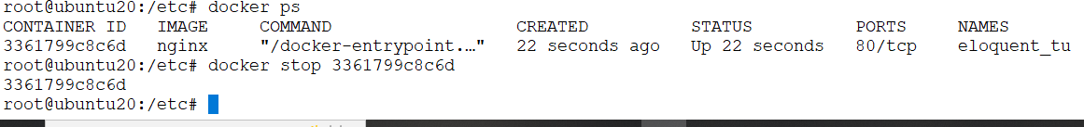

docker rename <old name> <new name>

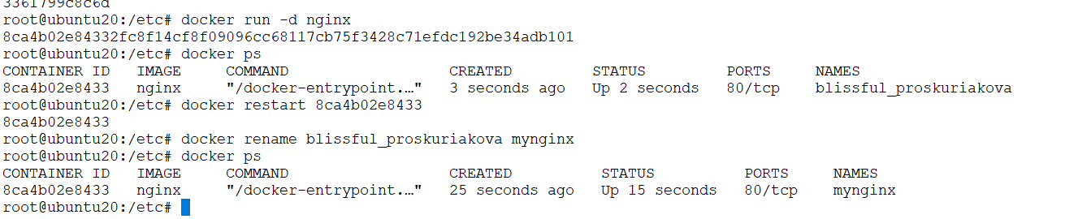docker restart <container id>

docker exec -it mynginx bash

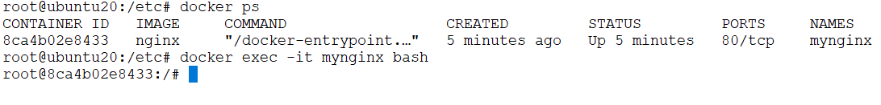

docker logs <container id/container name>

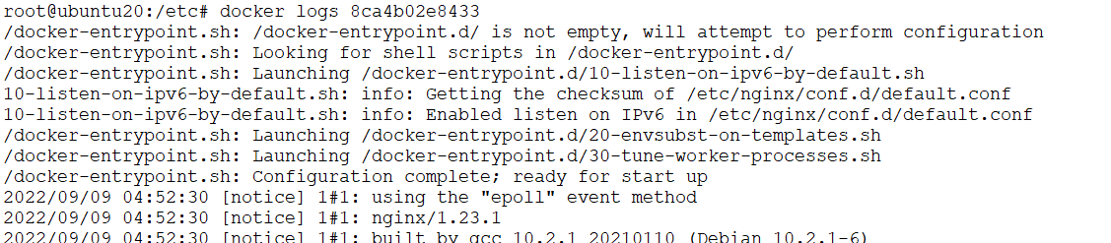

docker rm <container id/ container name>

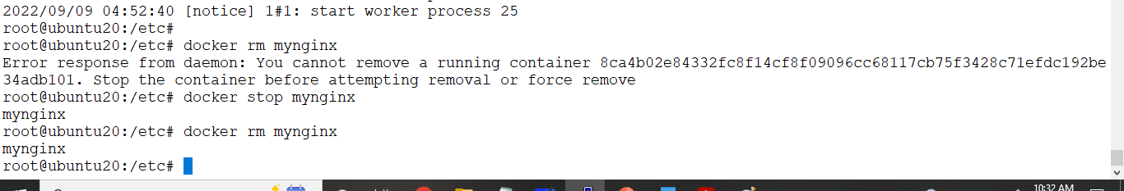

Sign-up for docker hub

<https://hub.docker.com/signup>

