Lab3:

* Create a dockerfile using vi editor

*FROM debian:stable*

*LABEL authors="amit"*

*RUN apt-get update && apt-get install -y --force-yes apache2*

*EXPOSE 80*

* Save the dockerfile
* docker built -t mydeb .

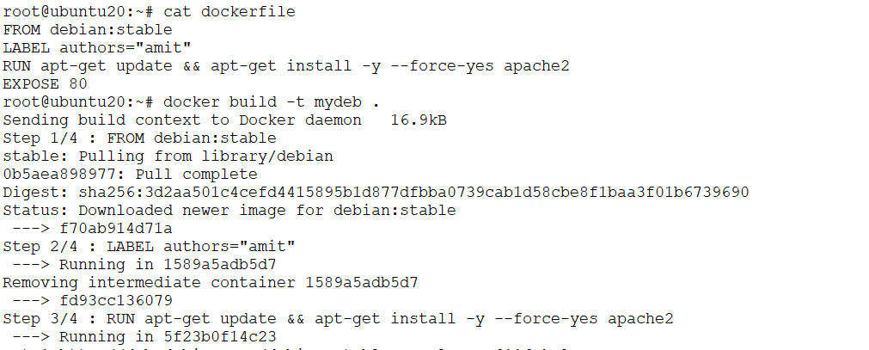

*docker images*

*docker inspect <image id>*

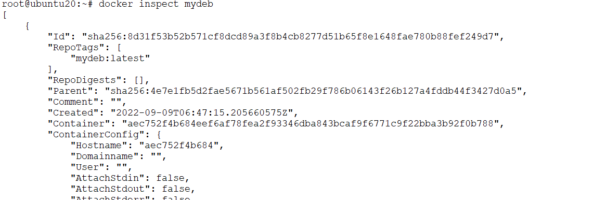

CMD, RUN and ENTRYPOINT

To start, let's create a script, log-event.sh. It simply adds one line to a file and then prints it:

#!/bin/sh

echo `date` $@ >> log.txt;

cat log.txt;

*mkdir test*

*cd test*

*vi date.sh*

#copy and paste the above bash script

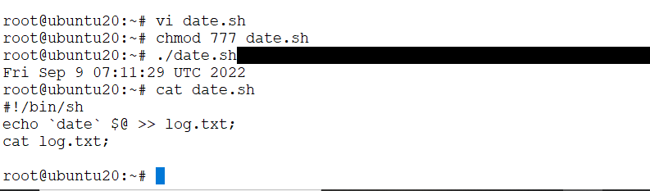

Lets add the run command in dockerfile

*FROM alpine*

*ADD date.sh /*

*RUN ["/date.sh", "image created"]*

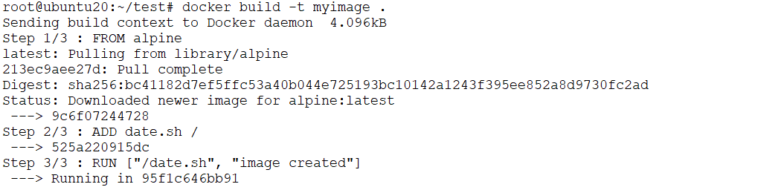

*docker run myimage cat log.txt*

Check the time

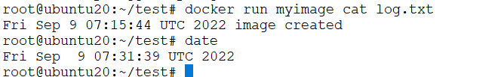

If we run the container several times, we'll see that the date in our log file doesn't change. This makes sense because the **run step executes at image build time**, not at the container runtime.

Modify the docker file and RUN command now

*FROM alpine*

*ADD date.sh /*

*RUN ["/date.sh", "image created"]*

*CMD ["/date.sh", "container started"]*

*docker build -t myimage1 .*

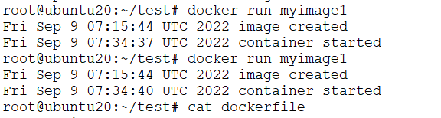

If we run this multiple times, we'll see that the image created entry stays the same. But the container started entry updates with every run. This shows how cmd indeed executes every time the container starts.

If we run the older command

*docker run myimage1 cat log.txt*



This time the cmd specified in the Dockerfile is ignored. That's because we have specified arguments to the docker run command.

Lets add two commands:

root@ubuntu20:~/test# vi dockerfile

*FROM alpine*

*ADD date.sh /*

*RUN ["/date.sh", "image created"]*

*CMD ["/date.sh", "container started"]*

*CMD ["/date.sh", "container running"]*

docker build myimage2 .



That's because **only the last cmd is invoked if more than one is specified.**

**ENTRYPOINT**

*FROM alpine*

*ADD date.sh /*

*RUN ["/date.sh", "image created"]*

*ENTRYPOINT ["/date.sh"]*

docker build -t myimage3 .

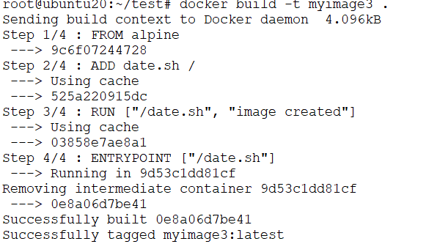

*docker run myimage3 welcome to container*

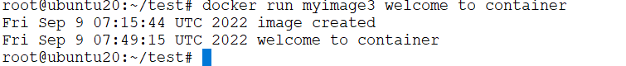

Assignment: Try CMD and ENTRYPOINT together and let me know the observation

Tag and push

*docker login*

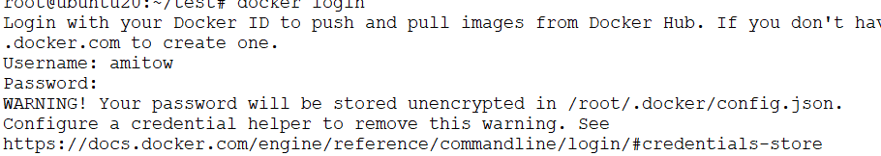

*docker image tag myimage amitow/myimage*

*docker image push amitow/myimage*