**STEPS**

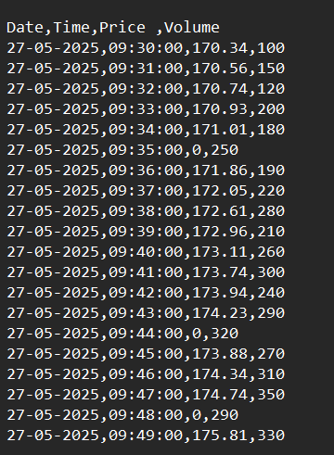**Step 1:**

Raw Input(S3):

Ticker data (date,time,price,volume)

Named as Ticker data (CSV format)

**Step 2 :**

Open AWS console and Create S3 Bucket named as “glueprojects3”

Create 2 folders - # RawInput (for input file i.e, Ticker data) # Output (for Clean and enriched time series data after transformations ) 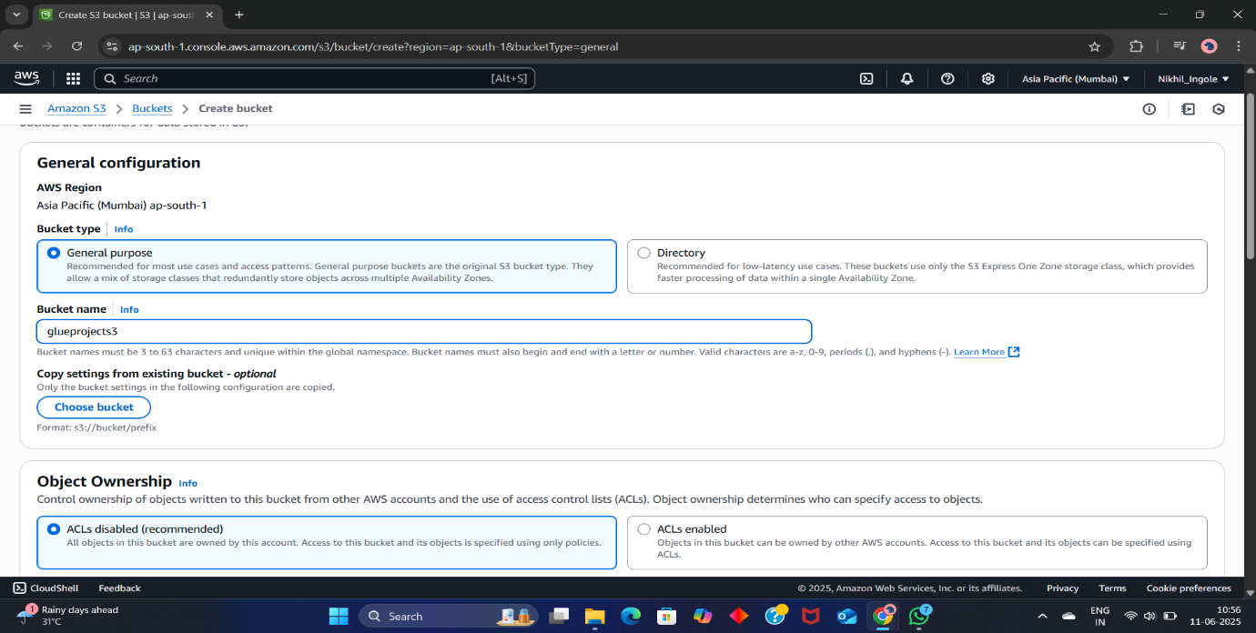

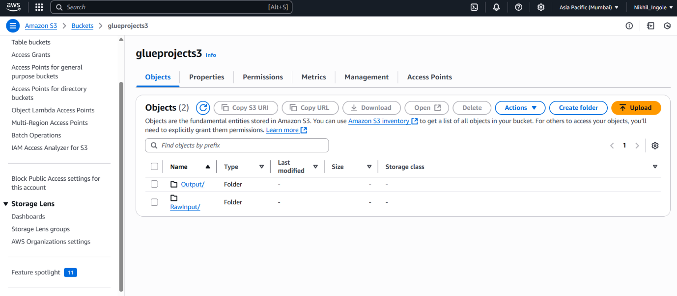

**Step 3:**

Identity and Access Management (IAM) Role:

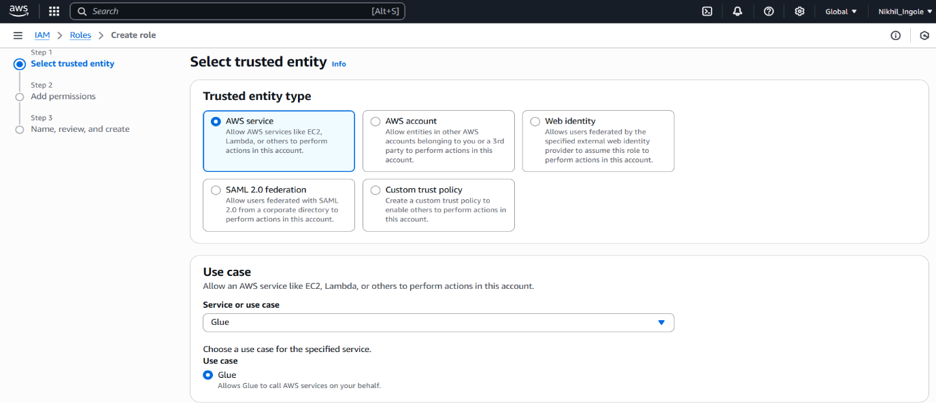

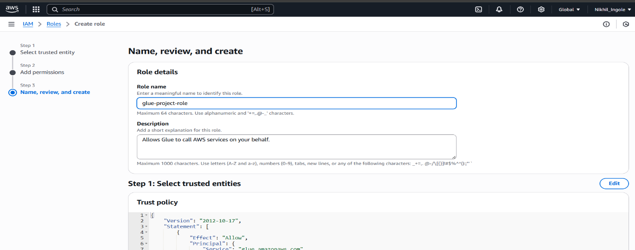

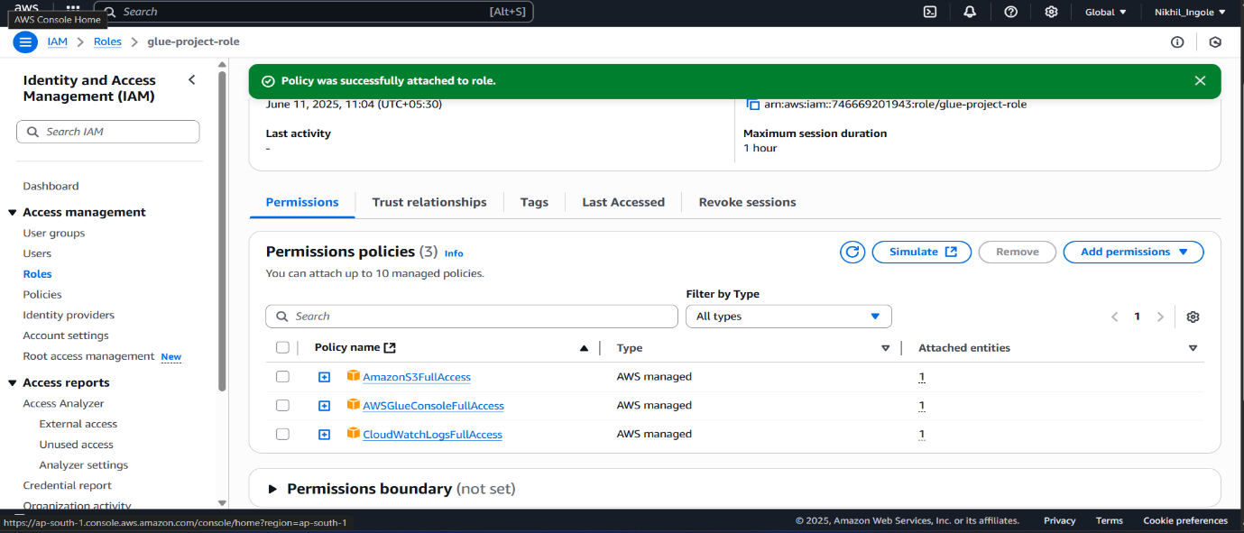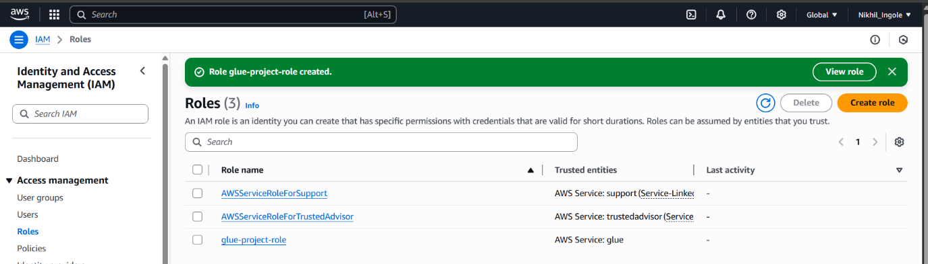

**Step 4:**

Search for “AWS Glue” Service

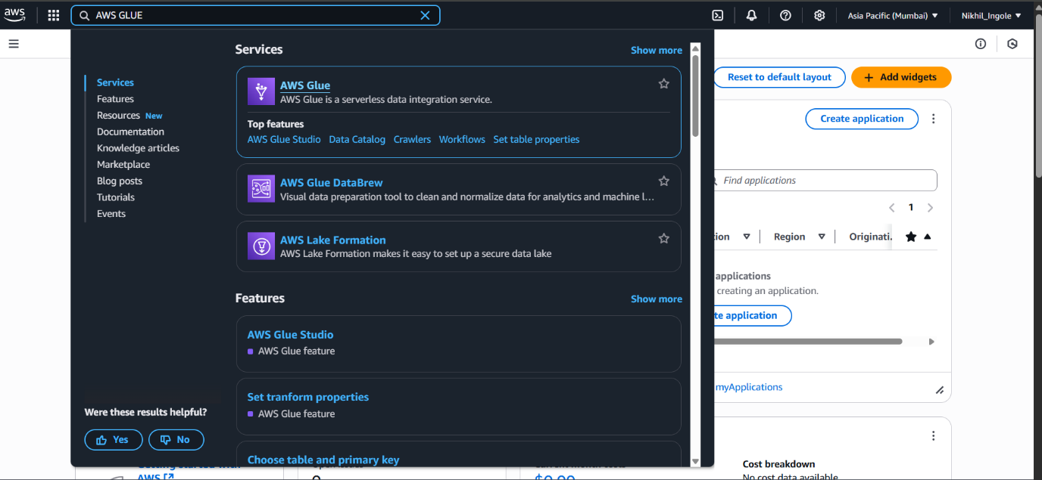

**Step 5:**

Create Database in Glue Catalog named as “project_db”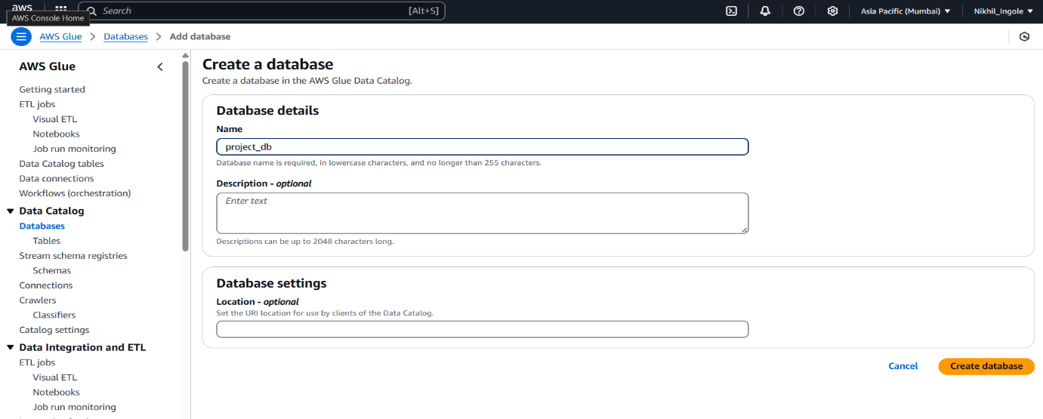

**Step 6:**

Create table under this Database by running Crawler

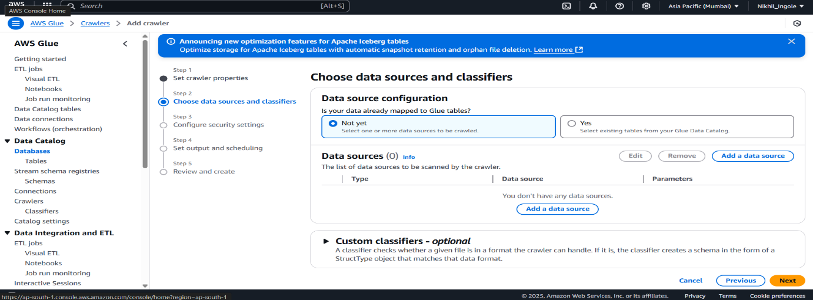

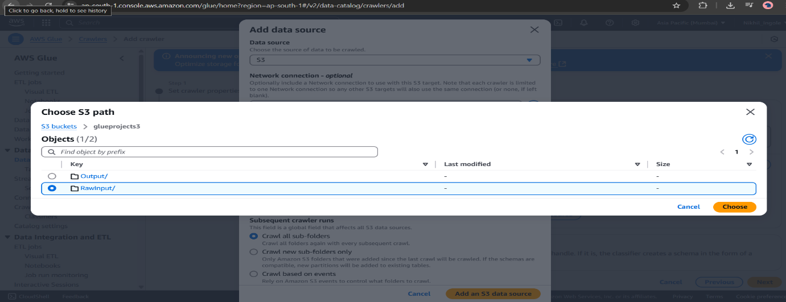

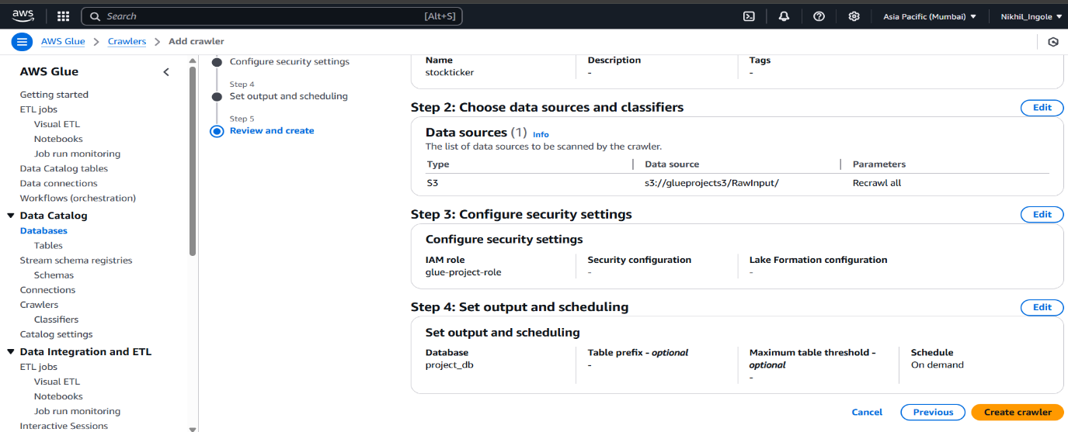

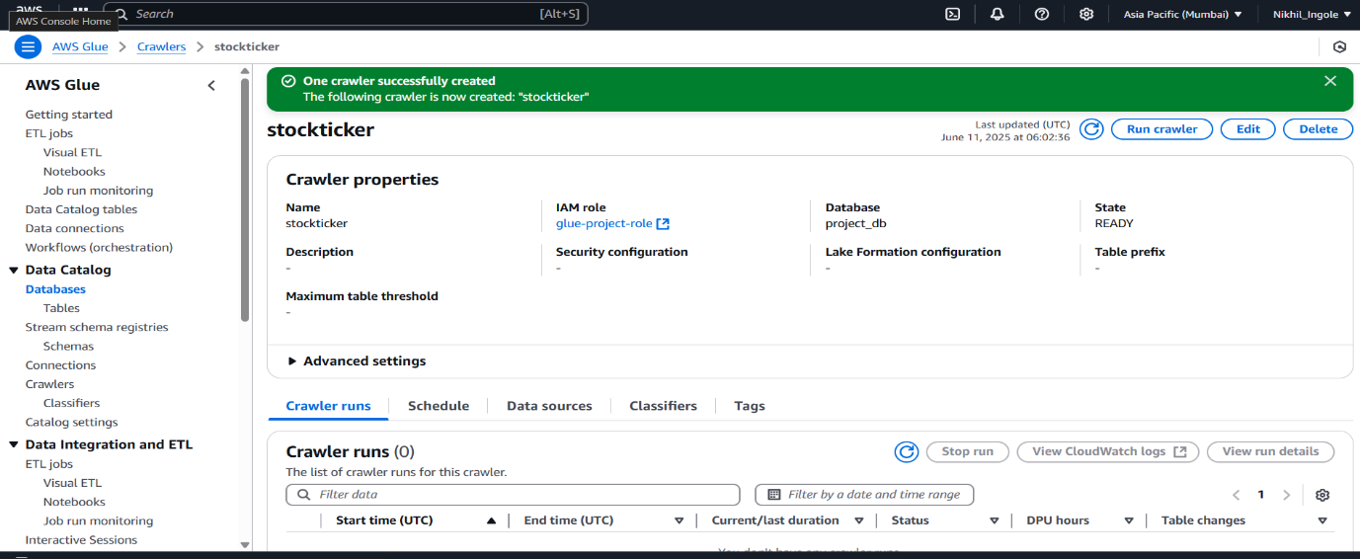

**Step 7:**

Check whether the Table has created or not

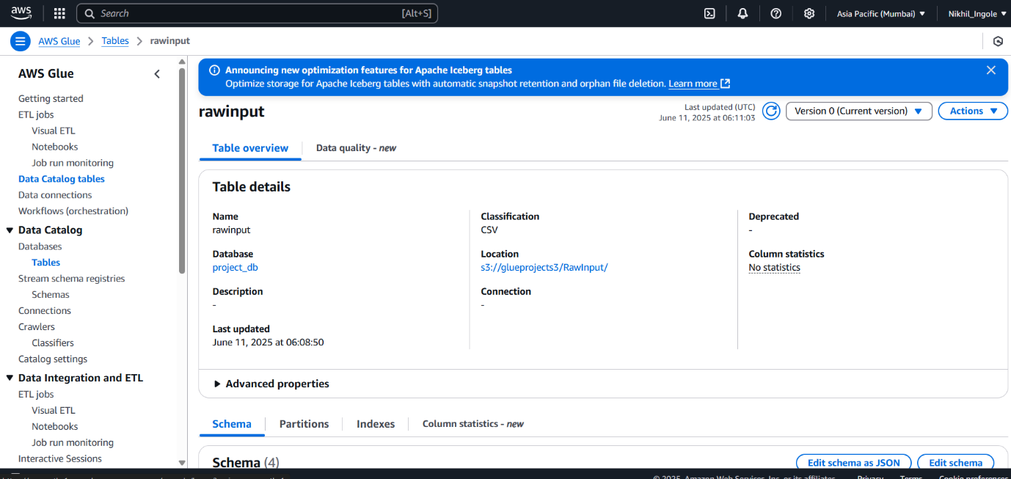

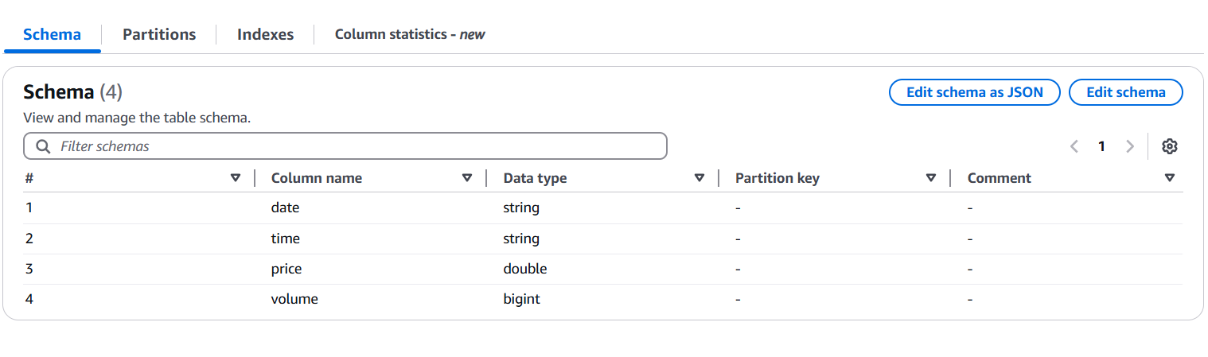

**Step 8:**

Create ETL Jobs

#Source : S3 Bucket (glueprojects3--RawInput)

#Transforms : i) Remove anomalies (e.g., zero price)

ii) Calculate moving averages

#Target : S3 Bucket(glueprojects3—Output)

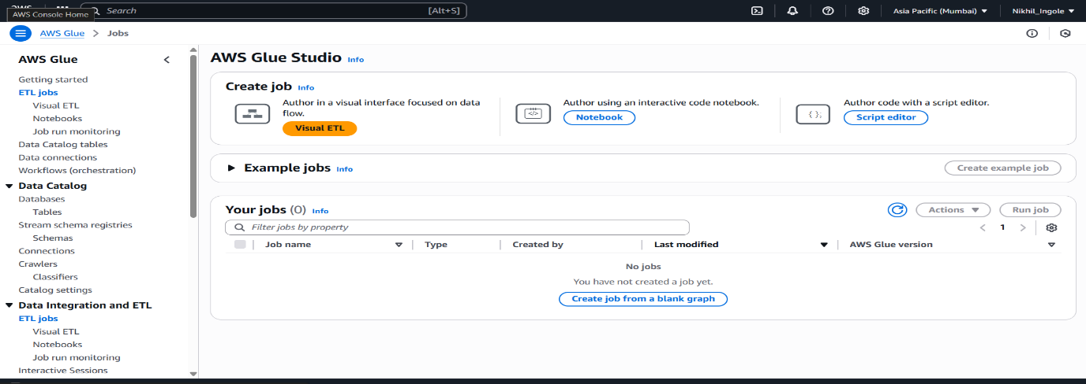

Data Source – Amazon S3

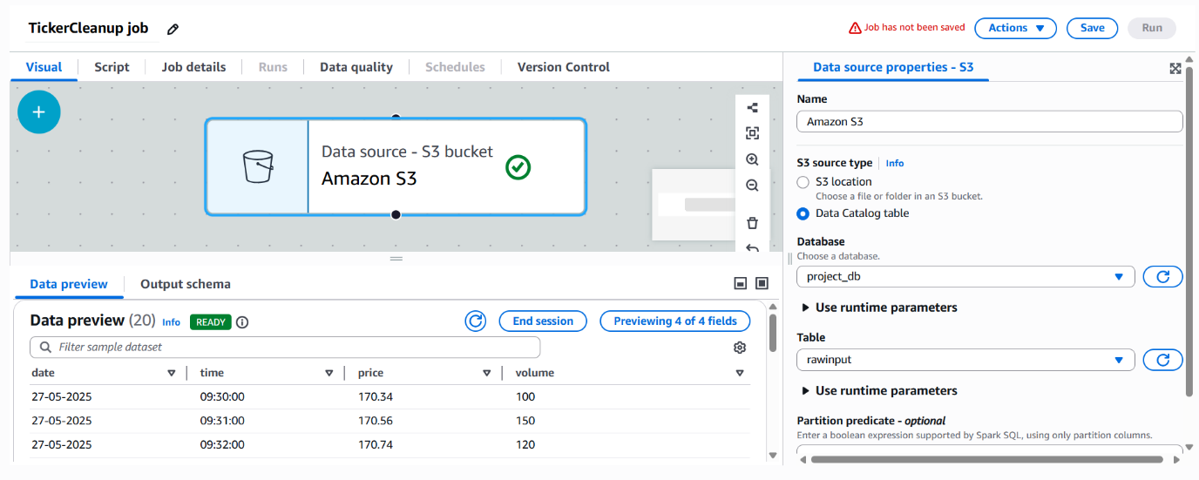

#Transforms : i)Remove Anamolies by using Filter Condition(price>0)

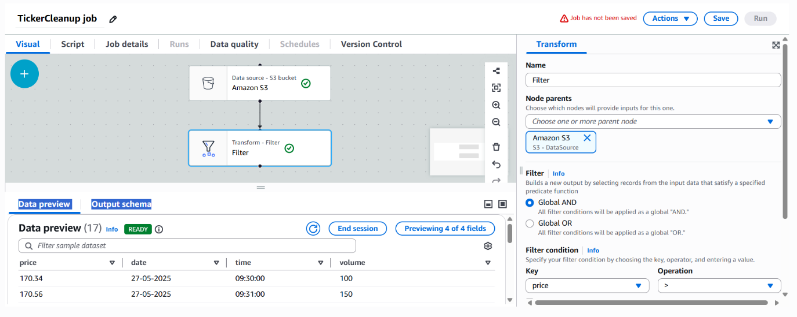

#Transforms : ii)Calculate Moving Averages

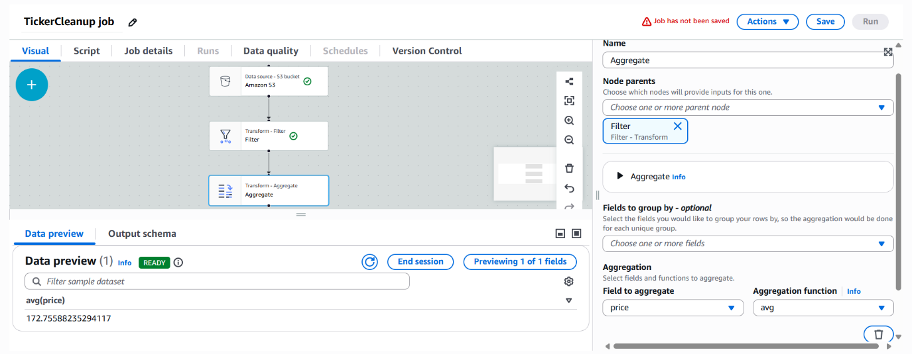

#Target :S3 Bucket(glueprojects3—Output)

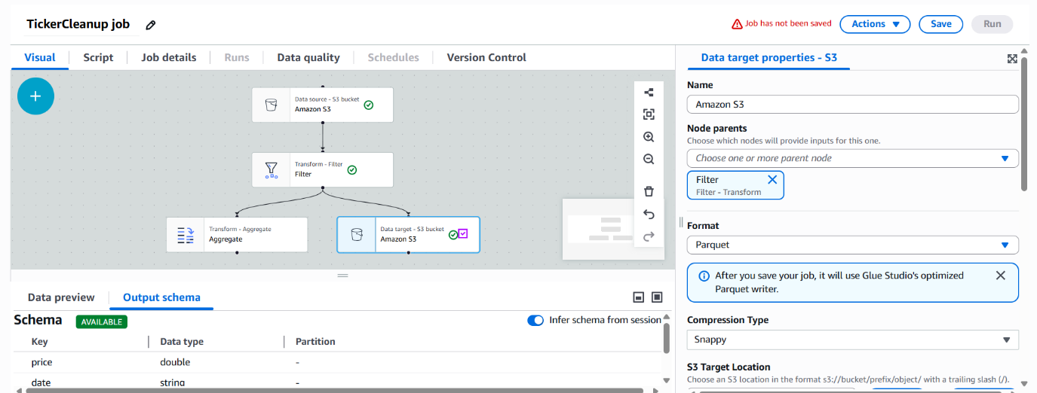

ETL job Script :

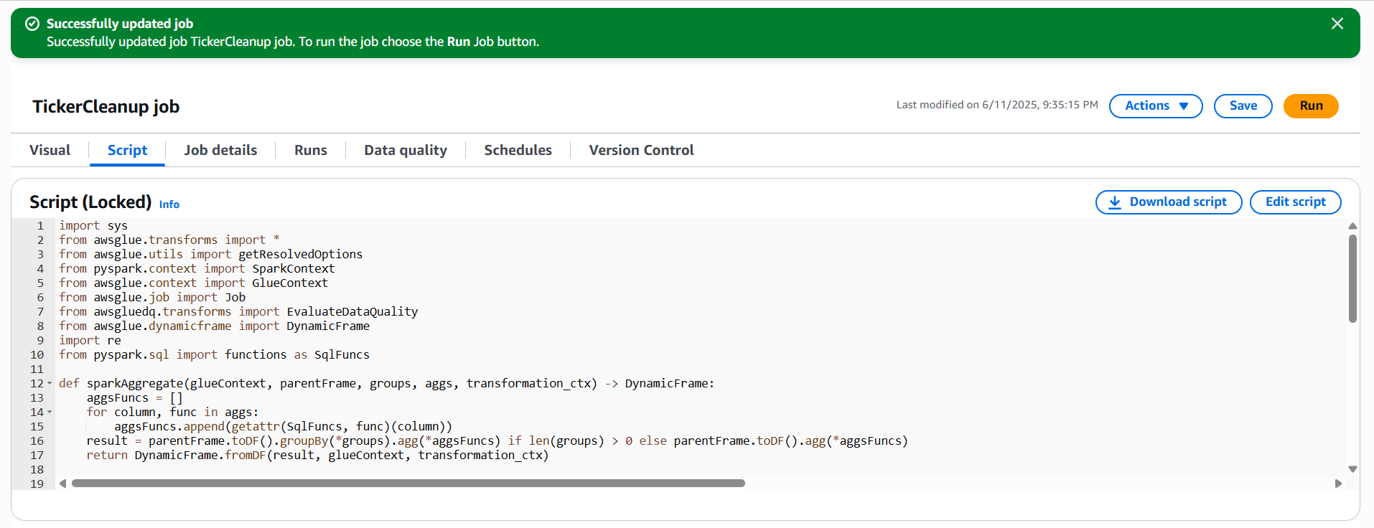

**Step 9:**

Save Job and Run

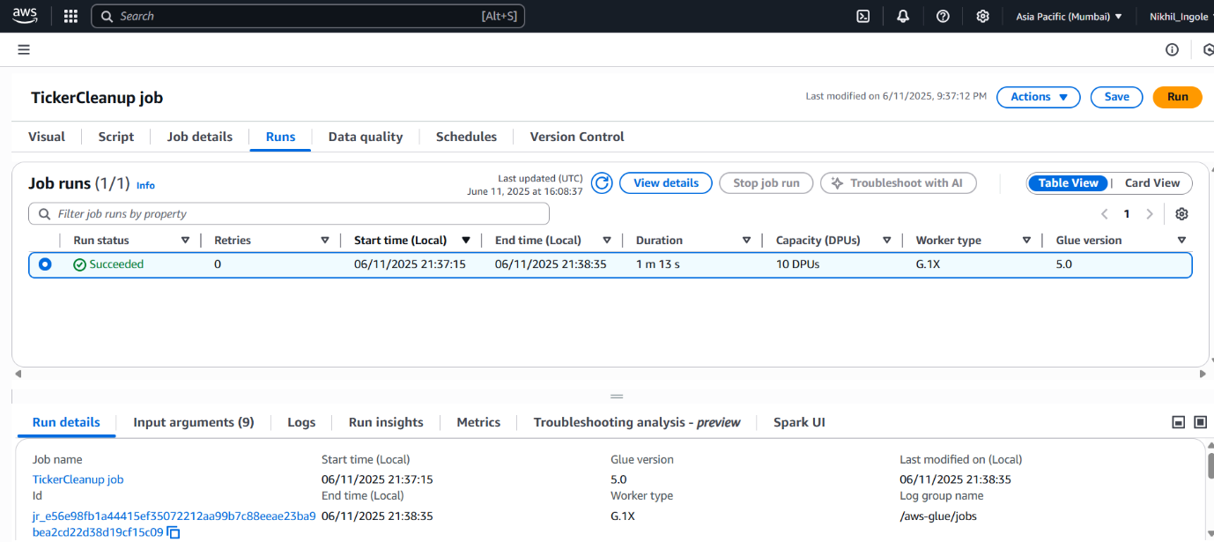

Run status : “Succeeded”

Extraction,Transformation and Loading has succeded

Outuput(S3): Clean and enriched time series data

