**Dockerizing Jenkins pipeline**

This document is an explanation of the project Dockerizing Jenkins pipeline. It creates a Docker image using Dockerfile and publishes it to Docker hub using Jenkins pipeline. The code can be found on the github.

**STEP 1):** Setup the VS code and the Github repository

* Open the VS code
* Create a Directory “Simplilearn-Project” in the terminal and change the directory.
* Run Create a repository “Docker-Pipeline “ in the github.com
* Create a file name “README.md” add details of the project in the file.
* Execute the steps to do initial commit, this will add the project in the GitHub master branch.
* git remote add origin <https://github.com/AmolVarwade/docker-pipeline> git add  .
* git commit –m “ First Commit”
* git push –u origin master

**Step 2):** Set up a Jenkin Server and a Docker-machine.

* Download and install Jenkins from guide <https://pkg.jenkins.io/debian-stable/>
* This will run the Jenkin server at localhost:8080 port and it can be accessed in the browser using <http://localhost:8080/>
* Select “Install Selected packages” and wait for installation to finish.
* Create a new user after installation is finished.
* Install a Docker on the same machine where Jenkin is installed using <https://docs.docker.com/engine/install/ubuntu/> the link.

**Step 3):** Setup Jenkinsfile in the repository

* Create Jenkinsfile in the project root directory.
* Add below content in the file.

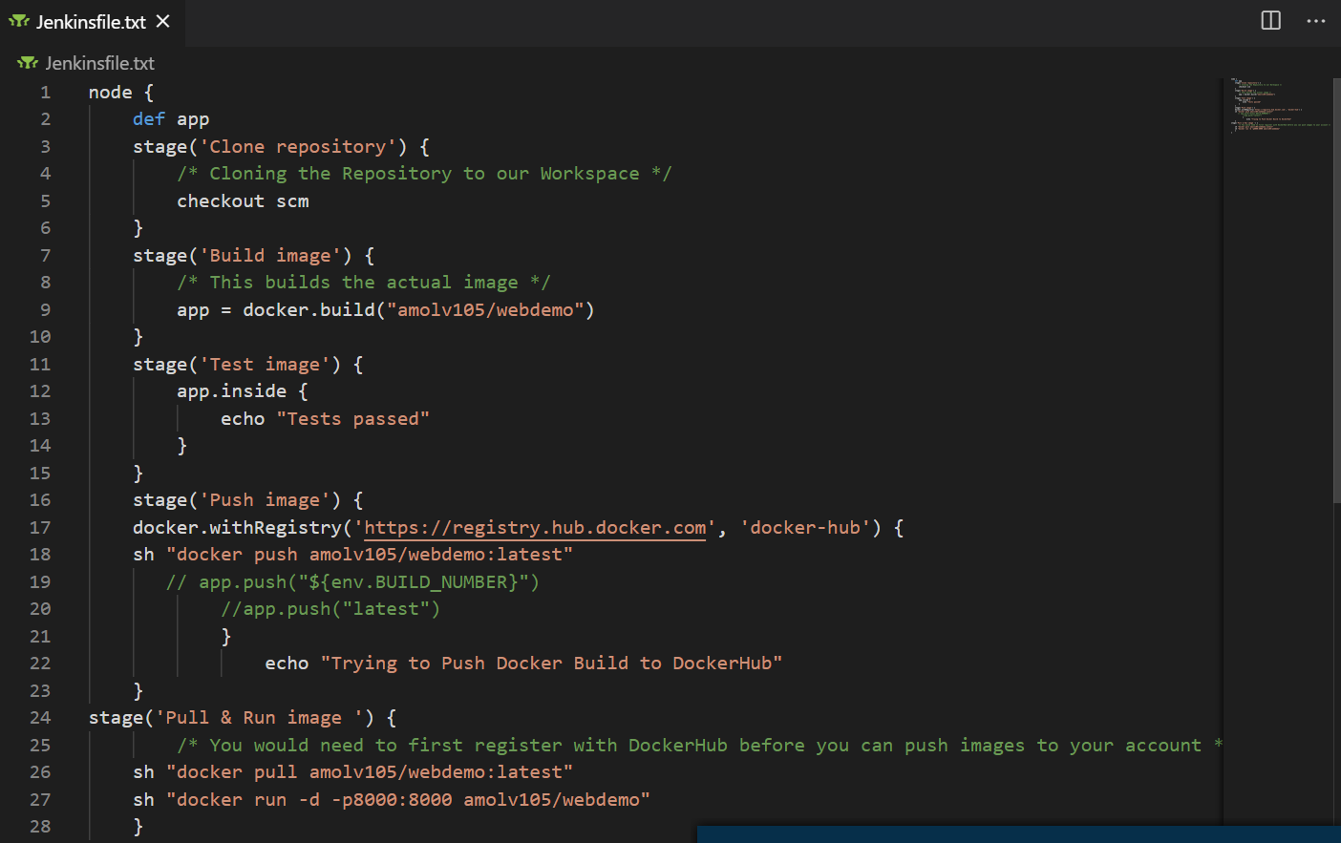

The script has five stages in the Jenkins.

1. Clone repository
2. Build Image
3. Test Image
4. Deploying the image in the dockerhub repository
5. Executing Image from Jenkins

**Step 4):** Check the Output of application

* Login to docker container using below command
* docker exec -t <Container ID> /bin/bash
* curl <http://127.0.0.1:8000/>
* You should see Hello NodeApp !!