1. What Are the Different Types of Machine Learning?

There are three types of machine learning:

Supervised Learning

In supervised machine learning, a model makes predictions or decisions based on past or labeled data. Labeled data refers to sets of data that are given tags or labels, and thus made more meaningful.

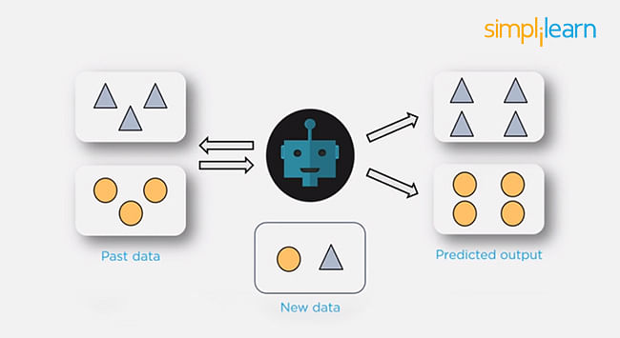

Unsupervised Learning

In unsupervised learning, we don't have labeled data. A model can identify patterns, anomalies, and relationships in the input data.

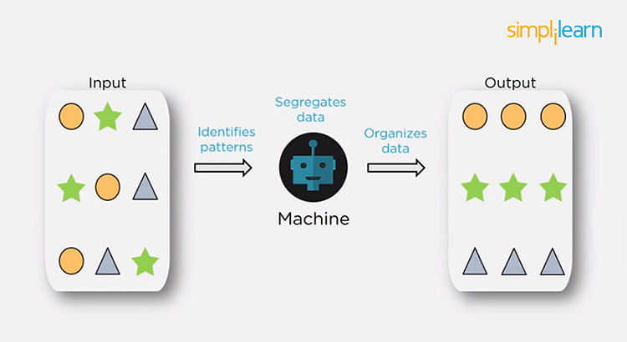

Reinforcement Learning

Using [reinforcement learning](https://www.simplilearn.com/tutorials/machine-learning-tutorial/reinforcement-learning), the model can learn based on the rewards it received for its previous action.

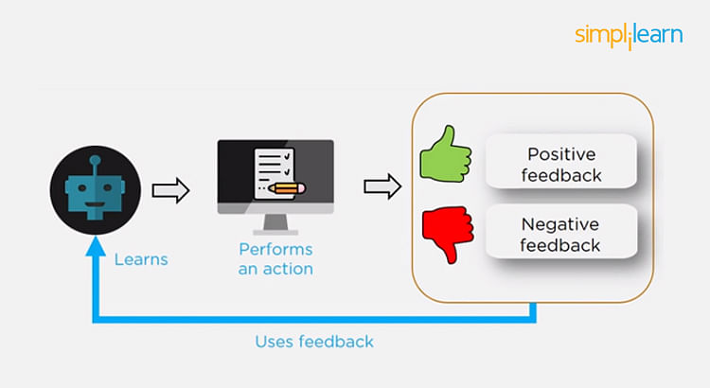

Consider an environment where an agent is working. The agent is given a target to achieve. Every time the agent takes some action toward the target, it is given positive feedback. And, if the action taken is going away from the goal, the agent is given negative feedback.

Also Read: [Supervised and Unsupervised Learning in Machine Learning](https://www.simplilearn.com/tutorials/machine-learning-tutorial/supervised-and-unsupervised-learning)

2. What is Overfitting, and How Can You Avoid It?

The Overfitting is a situation that occurs when a model learns the training set too well, taking up random fluctuations in the training data as concepts. These impact the model’s ability to generalize and don’t apply to new data.

When a model is given the training data, it shows 100 percent accuracy—technically a slight loss. But, when we use the test data, there may be an error and low efficiency. This condition is known as overfitting.

There are multiple ways of avoiding overfitting, such as:

* Regularization. It involves a cost term for the features involved with the objective function
* Making a simple model. With lesser variables and parameters, the variance can be reduced
* Cross-validation methods like k-folds can also be used
* If some model parameters are likely to cause overfitting, techniques for regularization like LASSO can be used that penalize these parameters

Also Read: [Overfitting and Underfitting in Machine Learning](https://www.simplilearn.com/tutorials/machine-learning-tutorial/overfitting-and-underfitting)

Future-Proof Your AI/ML Career: Top Dos and Don'ts

Free Webinar | 5 Dec, Tuesday | 7 PM IST[REGISTER NOW](https://www.simplilearn.com/future-proof-your-ai-ml-career-webinar?utm_source=webinarpromo&utm_medium=FRS-banner&utm_campaign=Sept)



3. What is ‘training Set’ and ‘test Set’ in a Machine Learning Model? How Much Data Will You Allocate for Your Training, Validation, and Test Sets?

| **Population** | **Sample** |
| --- | --- |
| The population includes all members of a specified group. | A sample is a subset of the population. |
| Collecting data from an entire population can be time-consuming, expensive, and sometimes impractical or impossible. | Samples offer a more feasible approach to studying populations, allowing researchers to draw conclusions based on smaller, manageable datasets |
| Includes all residents in the city. | Consists of 1000 households, a subset of the entire population. |

