**Introduction to Bootstrap:**

Bootstrap:

* Bootstrap is a free front-end framework for faster and easier web development
* Bootstrap includes HTML and CSS based design templates for typography, forms, buttons, and tables, navigation, modals, image carousels and many other, as well as optional JavaScript plug-in.
* Bootstrap also gives you the ability to easily create responsive designs.
* **What is Responsive Web Design?**  
    
  Responsive web design is about creating web sites which automatically adjust themselves to look good on all devices, from small phones to large desktops.

**1) Bootstrap Grid System:**

1) Bootstrap's grid system allows up to 12 columns across the page.

2) If you do not want to use all 12 columns individually, you can group the columns together to create wider columns:

|  |  |  |  |  |  |  |  |  |  |  |  |
| --- | --- | --- | --- | --- | --- | --- | --- | --- | --- | --- | --- |
| span 1 | span 1 | span 1 | span 1 | span 1 | span 1 | span 1 | span 1 | span 1 | span 1 | span 1 | span 1 |
| span 4 | | | | span 4 | | | | span 4 | | | |
| span 4 | | | | span 8 | | | | | | | |
| span 6 | | | | | | span 6 | | | | | |
| span 12 | | | | | | | | | | | |

Bootstrap's grid system is responsive, and the columns will re-arrange automatically depending on the screen size.

Grid Classes:

The Bootstrap grid system has four classes:

* xs (for phones - screens less than 768px wide)
* sm (for tablets - screens equal to or greater than 768px wide)
* md (for small laptops - screens equal to or greater than 992px wide)
* lg (for laptops and desktops - screens equal to or greater than 1200px wide)

The following is a basic structure of a Bootstrap grid:

<div class="row">  
  <div class="col-*-*"></div>  
  <div class="col-*-*"></div>  
</div>  
<div class="row">  
  <div class="col-*-*"></div>  
  <div class="col-*-*"></div>  
  <div class="col-*-*"></div>  
</div>  
<div class="row">  
  ...  
</div>

## 4) Three Equal Columns

## <div class="row">   <div class="col-sm-4">.col-sm-4</div>   <div class="col-sm-4">.col-sm-4</div>   <div class="col-sm-4">.col-sm-4</div> </div>

## 5) Two Unequal Columns

## <div class="row">   <div class="col-sm-4">.col-sm-4</div>   <div class="col-sm-8">.col-sm-8</div> </div>

# 2) Bootstrap Tables:

1) A basic Bootstrap table has a light padding and only horizontal dividers.

The .table class adds basic styling to a table:

### Example

| **Firstname** | **Lastname** | **Email** |
| --- | --- | --- |
| John | Doe | john@example.com |
| Mary | Moe | [mary@example.com](mailto:mary@example.com) |

## 2) Striped Rows:

The .table-striped class adds zebra-stripes to a table:

### Example

| **Firstname** | **Lastname** | **Email** |
| --- | --- | --- |
| John | Doe | john@example.com |
| Mary | Moe | mary@example.com |
| July | Dooley | july@example.com |

## 3) Bordered Table:

The .table-bordered class adds borders on all sides of the table and cells:

### Example

| **Firstname** | **Lastname** | **Email** |
| --- | --- | --- |
| John | Doe | john@example.com |
| Mary | Moe | mary@example.com |
| July | Dooley | july@example.com |
|  |  |  |

## 5) Hover Rows

The .table-hover class adds a hover effect (grey background color) on table rows:

### Example

| **Firstname** | **Lastname** | **Email** |
| --- | --- | --- |
| John | Doe | john@example.com |
| Mary | Moe | mary@example.com |
| July | Dooley | july@example.com |

## 5) Condensed Table:

The .table-condensed class makes a table more compact by cutting cell padding in half:

### Example

| **Firstname** | **Lastname** | **Email** |
| --- | --- | --- |
| John | Doe | john@example.com |
| Mary | Moe | mary@example.com |
| July | Dooley | july@example.com |

**3) Images:**

## 1) Rounded Corners:

The .img-rounded class adds rounded corners to an image (IE8 does not support rounded corners):

### Example

<img src="cinqueterre.jpg" class="img-rounded" >

## 2) Rounded Corners:

The .img-rounded class adds rounded corners to an image (IE8 does not support rounded corners):

### Example

<img src="cinqueterre.jpg" class="img-rounded">

## 3) Thumbnail :

The .img-thumbnail class shapes the image to a thumbnail:

### Example

<img src="cinqueterre.jpg" class="img-thumbnail" alt="Cinque Terre">

**4) Buttons:**

Button Style

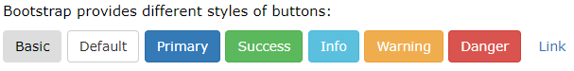

To achieve the button styles above, Bootstrap has the following classes:

* .btn
* .btn-default
* .btn-primary
* .btn-success
* .btn-info
* .btn-warning
* .btn-danger
* .btn-link

**Syntax:**

<button type="button" class="btn">Basic</button>  
<button type="button" class="btn btn-default">Default</button>

## 5) Glyph icons:

1)Bootstrap provides 260 glyphicons from the [Glyphicons](http://glyphicons.com/) Halflings set.

Glyphicons can be used in text, buttons, toolbars, navigation, forms, etc.

Here are some examples of glyphicons:

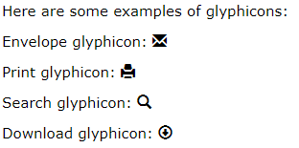

* **Glyphicon Syntax:**

A glyphicon is inserted with the following syntax:

<span class="glyphicon glyphicon-*name*"></span>

1) <p>Envelope icon: <span class="glyphicon glyphicon-envelope"></span></p>

<p>Envelope icon as a link:  
  <a href="#"><span class="glyphicon glyphicon-envelope"></span></a>  
</p>

2) <p>Search icon: <span class="glyphicon glyphicon-search"></span></p>

<p>Search icon on a button:  
   <button type="button" class="btn btn-default">  
     <span class="glyphicon glyphicon-search"></span> Search  
   </button>  
 </p>

3) <p>Print icon: <span class="glyphicon glyphicon-print"></span></p>   
 <p>Print icon on a styled link button:  
   <a href="#" class="btn btn-success btn-lg">  
     <span class="glyphicon glyphicon-print"></span> Print   
   </a>  
 </p>

## 6) Badges

Badges are numerical indicators of how many items are associated with a link:

[News **5**](javascript:void(0);)  
[Comments **10**](javascript:void(0);)  
[Updates **2**](javascript:void(0);)

The numbers (5, 10, and 2) are the badges.

Use the .badge class within <span> elements to create badges:

### Example

<a href="#">News <span class="badge">5</span></a><br>  
<a href="#">Comments <span class="badge">10</span></a><br>  
<a href="#">Updates <span class="badge">2</span></a>

Badges can also be used inside other elements, such as buttons:

Primary **7**

The following example shows how to add badges to buttons:

### Example

<button type="button" class="btn btn-primary">Primary <span class="badge">7</span></button>

# 7) Bootstrap Pagination:

## 1) Basic Pagination

If you have a web site with lots of pages, you may wish to add some sort of pagination to each page.

A basic pagination in Bootstrap looks like this:

C:\Users\Seema\Desktop\pagination.png

### Example

<ul class="pagination">  
  <li><a href="#">1</a></li>  
  <li><a href="#">2</a></li>  
  <li><a href="#">3</a></li>  
  <li><a href="#">4</a></li>  
  <li><a href="#">5</a></li>  
</ul>

## 2) Active State:

The active state shows what is the current page:

C:\Users\Seema\Desktop\st.png

Add class .active to let the user know which page he/she is on:

### Example

<ul class="pagination">  
  <li><a href="#">1</a></li>  
  <li class="active"><a href="#">2</a></li>  
  <li><a href="#">3</a></li>  
  <li><a href="#">4</a></li>  
  <li><a href="#">5</a></li>  
</ul>

## 3) Disabled State

A disabled link cannot be clicked:

Add class .disabled if a link for some reason is disabled:

### Example

<ul class="pagination">  
  <li><a href="#">1</a></li>  
  <li><a href="#">2</a></li>  
  <li><a href="#">3</a></li>  
  <li class="disabled"><a href="#">4</a></li>  
  <li><a href="#">5</a></li>  
</ul>

**8) Pager**:

## What is Pager?

Pager is also a form of pagination (as described in the previous chapter).

Pager provides previous and next buttons (links).

To create previous/next buttons, add the .pager class to an <ul> element:

<ul class="pager">  
  <li><a href="#">Previous</a></li>  
  <li><a href="#">Next</a></li>  
</ul>

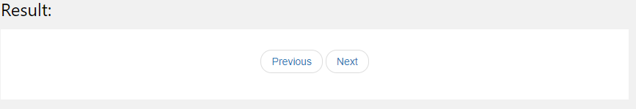

**9) Panel:**

1) A panel in bootstrap is a bordered box with some padding around its content:

A Basic Panel

Panels are created with the .panel class, and content inside the panel has a .panel-body class:

### Example

<div class="panel panel-default">  
  <div class="panel-body">A Basic Panel</div>  
</div>

## 2) Panel Heading:

Panel Heading

Panel Content

The .panel-heading class adds a heading to the panel:

### Example

<div class="panel panel-default">  
  <div class="panel-heading">Panel Heading</div>  
  <div class="panel-body">Panel Content</div>  
</div>

## 6) Panel Footer:

Panel Content

Panel Footer

The .panel-footer class adds a footer to the panel:

### Example

<div class="panel panel-default">  
  <div class="panel-body">Panel Content</div>  
  <div class="panel-footer">Panel Footer</div>  
</div>

# 10) Bootstrap Dropdown:

A dropdown menu is a toggleable menu that allows the user to choose one value from a predefined list:

Dropdown Example

### Example

<div class="dropdown">  
  <button class="btn btn-primary dropdown-toggle" type="button" data-toggle="dropdown">Dropdown Example  
  <span class="caret"></span></button>  
  <ul class="dropdown-menu">  
    <li><a href="#">HTML</a></li>  
    <li><a href="#">CSS</a></li>  
    <li><a href="#">JavaScript</a></li>  
  </ul>  
</div>

### Example Explained

The .dropdown class indicates a dropdown menu.

To open the dropdown menu, use a button or a link with a class of .dropdown-toggle and the data-toggle="dropdown" attribute.

The .caret class creates a caret arrow icon (), which indicates that the button is a dropdown.

Add the .dropdown-menu class to a <ul> element to actually build the dropdown menu.

**11) Tabs/Menus:**

1) Most web pages have some kind of a menu.

In HTML, a menu is often defined in an unordered list <ul> (and styled afterwards), like this:

<ul class="list-inline">

<li><a href="#">Home</a></li>

<li><a href="#">Menu 1</a></li>

<li><a href="#">Menu 2</a></li>

<li><a href="#">Menu 3</a></li>

</ul>

## 2) Tabs:

Tabs are created with <ul class="nav nav-tabs">:

**Tip:** Also mark the current page with <li class="active">.

The following example creates navigation tabs:

### Example

<ul class="nav nav-tabs">  
  <li class="active"><a href="#">Home</a></li>  
  <li><a href="#">Menu 1</a></li>  
  <li><a href="#">Menu 2</a></li>  
  <li><a href="#">Menu 3</a></li>  
</ul>

### *) Tabs with Dropdown Menu:

<ul class="nav nav-tabs">  
  <li class="active"><a href="#">Home</a></li>  
  <li class="dropdown">  
    <a class="dropdown-toggle" data-toggle="dropdown" href="#">Menu 1  
    <span class="caret"></span></a>  
    <ul class="dropdown-menu">  
      <li><a href="#">Submenu 1-1</a></li>  
      <li><a href="#">Submenu 1-2</a></li>  
      <li><a href="#">Submenu 1-3</a></li>   
    </ul>  
  </li>  
  <li><a href="#">Menu 2</a></li>  
  <li><a href="#">Menu 3</a></li>  
</ul>

**12) Bootstrap Navigation Bar:**

A navigation bar is a navigation header that is placed at the top of the page:

With Bootstrap, a navigation bar can extend or collapse, depending on the screen size.

A standard navigation bar is created with <nav class="navbar navbar-default">.

The following example shows how to add a navigation bar to the top of the page:

### Example

<nav class="navbar navbar-default">  
  <div class="container-fluid">  
    <div class="navbar-header">  
      <a class="navbar-brand" href="#">WebSiteName</a>  
    </div>  
    <ul class="nav navbar-nav">  
      <li class="active"><a href="#">Home</a></li>  
      <li><a href="#">Page 1</a></li>  
      <li><a href="#">Page 2</a></li>  
      <li><a href="#">Page 3</a></li>  
    </ul>  
  </div>  
</nav>

**13) Forms:**

## 1) Bootstrap's Default Settings:

Form controls automatically receive some global styling with Bootstrap:

All textual <input>, <textarea>, and <select> elements with class .form-control have a width of 100%.

**Types of Forms:**

* Vertical form (this is default)
* Horizontal form
* Inline form

Standard rules for all three form layouts:

* Wrap labels and form controls in <div class="form-group"> (needed for optimum spacing)
* Add class .form-control to all textual <input>, <textarea>, and <select> elements.

**1) Vertical Form:**

<form>  
  <div class="form-group">  
    <label>Email address:</label>  
    <input type="text" class="form-control" id="email">  
  </div>  
  <div class="form-group">  
    <label>Password:</label>  
    <input type="text" class="form-control" id="pwd">  
  </div>  
  <div class="checkbox">  
    <label><input type="checkbox"> Remember me</label>  
  </div>  
  <button type="submit" class="btn btn-default">Submit</button>  
</form>

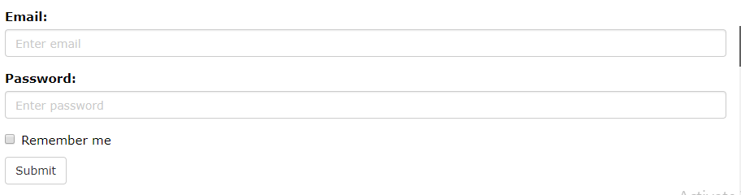

**2) Inline Form:**

In an inline form, all of the elements are inline, left-aligned, and the labels are alongside.

Additional rule for an inline form:

* Add class .form-inline to the <form> element

The following example creates an inline form with two input fields, one checkbox, and one submit button:

<form class="form-inline">  
  <div class="form-group">  
    <label>Email address:</label>  
    <input type="text" class="form-control" id="email">  
  </div>  
  <div class="form-group">  
    <label>Password:</label>  
    <input type="text" class="form-control" id="pwd">  
  </div>  
  <div class="checkbox">  
    <label><input type="checkbox"> Remember me</label>  
  </div>  
  <button type="submit" class="btn btn-default">Submit</button>  
</form>

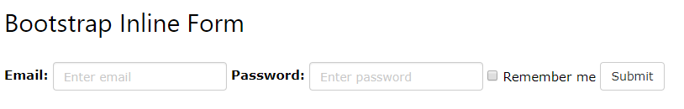

**3) Horizontal Form:**

A horizontal form means that the labels are aligned next to the input field (horizontal) on large and medium screens. On small screens (767px and below), it will transform to a vertical form (labels are placed on top of each input).

Additional rules for a horizontal form:

* Add class .form-horizontal to the <form> element

<form class="form-horizontal">  
  <div class="form-group">  
    <label>Email:</label>  
      <input type="text" class="form-control" id="email" placeholder="Enter email">  
    </div>  
  <div class="form-group">  
    <label>Password:</label>  
      <input type="text" class="form-control" id="pwd" placeholder="Enter password">  
    </div>  
  <div class="form-group">   
      <div class="checkbox">  
        <label><input type="checkbox"> Remember me</label>  
      </div>  
    </div>  
  <div class="form-group">   
   <button type="submit" class="btn btn-default">Submit</button>  
  </div>  
</form>

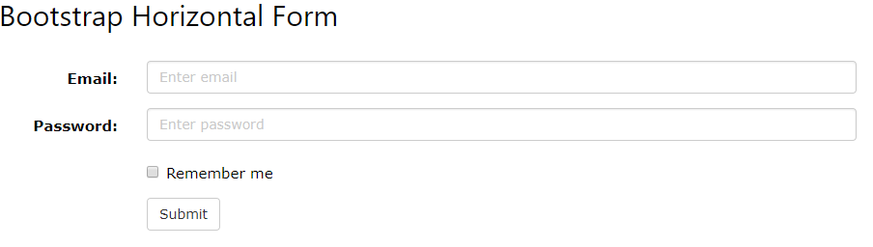

**14) The Carousel Plug-in:**

The Carousel plug-in is a component for cycling through elements, like a carousel (slideshow).

<div id="myCarousel" class="carousel slide" data-ride="carousel">  
  <!-- Indicators -->  
  <ol class="carousel-indicators">  
    <li data-target="#myCarousel" data-slide-to="0" class="active"></li>  
    <li data-target="#myCarousel" data-slide-to="1"></li>  
    <li data-target="#myCarousel" data-slide-to="2"></li>  
  </ol>  
  
  <!-- Wrapper for slides -->  
  <div class="carousel-inner">  
    <div class="item active">  
      <img src="la.jpg">  
    </div>  
  
    <div class="item">  
      <img src="chicago.jpg">  
    </div>  
  
    <div class="item">  
      <img src="ny.jpg”>  
    </div>  
  </div>  
  
  <!-- Left and right controls -->  
  <a class="left carousel-control" href="#myCarousel" data-slide="prev">  
    <span class="glyphicon glyphicon-chevron-left"></span>  
    <span class="sr-only">Previous</span>  
  </a>  
  <a class="right carousel-control" href="#myCarousel" data-slide="next">  
    <span class="glyphicon glyphicon-chevron-right"></span>  
    <span class="sr-only">Next</span>  
  </a>  
</div>

## 15) The Modal Plugin:

The Modal plugin is a dialog box/popup window that is displayed on top of the current page:

<button type="button" class="btn btn-info btn-lg" data-toggle="modal" data-target="#myModal">Open Modal</button>  
  
<!-- Modal -->  
<div id="myModal" class="modal fade" role="dialog">  
  <div class="modal-dialog">  
  
    <!-- Modal content-->  
    <div class="modal-content">  
      <div class="modal-header">  
        <button type="button" class="close" data-dismiss="modal">&times;</button>  
        <h4 class="modal-title">Modal Header</h4>  
      </div>  
      <div class="modal-body">  
        <p>Some text in the modal.</p>  
      </div>  
      <div class="modal-footer">  
        <button type="button" class="btn btn-default" data-dismiss="modal">Close</button>  
      </div>  
    </div>  
  
  </div>  
</div>

## 14) The Tooltip Plug-in:

The Tooltip plug-in is small pop-up box that appears when the user moves the mouse pointer over an element:

## How To Create a Tooltip:

To create a tooltip, add the data-toggle="tooltip" attribute to an element.

Use the title attribute to specify the text that should be displayed inside the tooltip:

<a href="#" data-toggle="tooltip" title="Hooray!">Hover over me</a>

**Note:** Tooltips must be initialized with jQuery: select the specified element and call the tooltip() method.

The following code will enable all tooltips in the document:

### Example

<script>  
$(document).ready(function(){  
  $('[data-toggle="tooltip"]').tooltip();   
});  
</script>

# 15) Bootstrap Popover Plug-in:

The Popover plug-in is similar to tooltips; it is a pop-up box that appears when the user clicks on an element. The difference is that the popover can contain much more content.

How To Create a Popover:

To create a popover, add the data-toggle="popover" attribute to an element.

Use the title attribute to specify the header text of the popover, and use the data-content attribute to specify the text that should be displayed inside the popover's body:

<a href="#" data-toggle="popover" title="Popover Header" data-content="Some content inside the popover">Toggle popover</a>

Jquery-Code:

<script>  
$(document).ready(function(){  
  $('[data-toggle="popover"]').popover();   
});  
</script>