**Topics: Normal distribution, Functions of Random Variables**

1. The time required for servicing transmissions is normally distributed with *μ* = 45 minutes and *σ* = 8 minutes. The service manager plans to have work begin on the transmission of a customer’s car 10 minutes after the car is dropped off and the customer is told that the car will be ready within 1 hour from drop-off. What is the probability that the service manager cannot meet his commitment?
2. 0.3875
3. **0.2676**
4. 0.5
5. 0.6987

Ans: Time taken to service a car is 50 minutes.

P (X > 50) = 1 – P (X ≤ 50).

Z = (X - 45)/8.0

Thus, the question can be answered by using the normal table to find

P (X ≤ 50) = P (Z ≤ (50 - 45)/8.0) = P (Z ≤ 0.625) =73.4%

Probability that the service manager will not meet his demand will be = 100-73.4 = 26.6%

or 0.2676

1. The current age (in years) of 400 clerical employees at an insurance claims processing center is normally distributed with mean *μ* = 38 and Standard deviation *σ* =6. For each statement below, please specify True/False. If false, briefly explain why.
2. More employees at the processing center are older than 44 than between 38 and 44.

Ans: **False** If more employees are older than 44, this will shift the*μ*  towards 44 with

Considering sd. Which is not possible as μis given 38 with sd 6.

1. A training program for employees under the age of 30 at the center would be expected to attract about 36 employees.

Ans:

TRUE

Z=(X-µ)/ *σ*

P(X≤30) = p(Z≤(30-38)/6) = p(Z≤-1.33)= 0.0918 (using z table)

Expected count = 0.0918*400 = 36.72

1. If *X1* ~ *N*(μ, σ2) and *X*2 ~ *N*(μ, σ2) are *iid* normal random variables, then what is the difference between 2 *X*1 and *X*1 + *X*2? Discuss both their distributions and parameters.

Ans: As both are independent normal random variables, X1 + X2 are exactly normal with

associate parameters. and 2X1 will just larger scale version of X1, so as X1 normally

distributed 2X1 aslo normally distributed.

1. Let X ~ N(100, 202). Find two values, *a* and *b*, symmetric about the mean, such that the probability of the random variable taking a value between them is 0.99.
2. 90.5, 105.9
3. 80.2, 119.8
4. 22, 78
5. 48.5, 151.5
6. 90.1, 109.9

Ans: Since we need to find out the values of a and b, which are symmetric about the mean, such

that the probability of random variable taking a value between them is 0.99.

The Probability of getting value between a and b should be 0.99.

So the Probability of going wrong, or the Probability outside the a and b area **is 0.01**

(i.e 1- 0.99).

The Probability towards left from a **= - 0.005 (**i.e. 0.01/2).

The Probability towards right from b **= + 0.005** (i.e. 0.01/2).

So since we have the probabilities of a and b, we need to calculate X, the random variable

at a and b which has got these probabilities.

By finding the Standard Normal Variable Z (Z Value), we can calculate the X values.

Z = (X- μ) / σ

For Probability 0.005 the Z Value **is -2.57 (from Z Table).**

Z * σ + μ = X

Z (-0.005) * 20+100 = -(-2.57) *20+100 **= 151.4**

Z (+0.005) * 20+100 = (-2.57) *20+100 **= 48.6**

So, option D is correct.

1. Consider a company that has two different divisions. The annual profits from the two divisions are independent and have distributions Profit1 ~ N(5, 32) and Profit2 ~ N(7, 42) respectively. Both the profits are in $ Million. Answer the following questions about the total profit of the company in Rupees. Assume that $1 = Rs. 45
2. Specify a Rupee range (centered on the mean) such that it contains 95% probability for the annual profit of the company.

Ans:

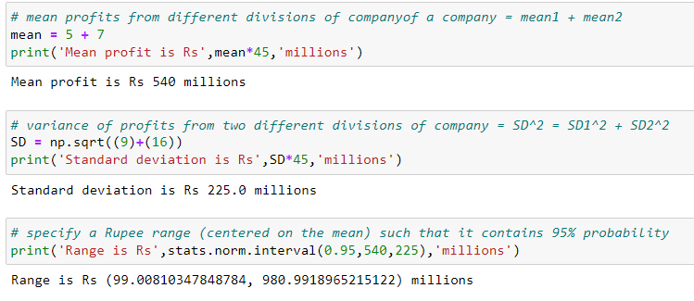

1. Specify the 5th percentile of profit (in Rupees) for the company

Ans:

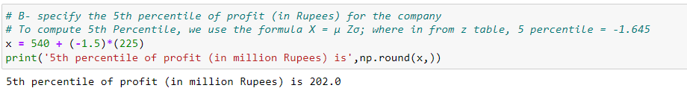

1. Which of the two divisions has a larger probability of making a loss in a given year?

Ans:

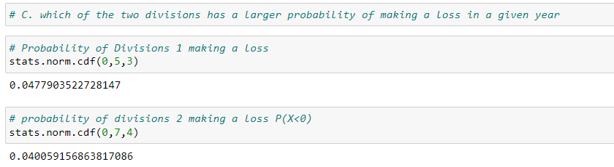

Division 1 has has a larger probability of making a loss in a given year.