MIT Thesis

Word Template Instructions

Overview
MIT Libraries’ made the official Microsoft Word Thesis template as an alternative to the Overleaf MIT Thesis template and in alignment with the MIT Thesis Specification, but it is the responsibility of each student to ensure their final thesis meets the requirements laid out in the MIT Thesis Specifications as well as any department specific requirements.
The template includes the following sections. Optional sections are labeled. All other sections are required by Institute Policy. You can delete the optional sections that you do not want in your thesis.
- Title page
- Thesis Committee (optional)
- Abstract
- Acknowledgements (optional)
- Table of Contents
- List of Figures (only optional if you have no figures)
- List of Tables (only optional if you have no tables)
- Chapters
- Appendices (optional)
- Bibliography/References/Works Cited

**You can easily copy and paste to add additional sections like Degrees or Departments, Thesis Supervisors, Chapters, etc
Table of Contents
Overview 1
Fillable form 3
Table of Contents 3
Create new headings in Table of Contents 3
Accessibility 5
Outline / Structural tagging 5
Alt Text 6
Tables 6
Accessibility Check 6
Export to PDF/A 6
Correct Accessibility After Conversion to PDF/A 8
Re-saving your PDF as a PDF/A 12

Fillable form
The template functions as a fillable form where you can click on text within brackets to type of paste parts of your thesis. For instance, if you click on the following bracketed text
[Thesis title as submitted to registrar]
You can enter the title of your thesis. Once your text is entered, the brackets will be gone, and the filled text will look like ordinary text. See the below example:
Building a Community Center for Cambridge

Table of Contents
Before submitting, double check the page numbers listed in the Table of Contents accurately reflect the pagination of your thesis.

Create new headings in Table of Contents
Thesis sections included in the template are already linked to the Table of Contents.
To add additional chapters or sections:
- Type out your chapter title, then highlight that title.
- In the toolbar at the top of the page, navigate to the “Home” tab and the “Styles” section within it.
- With that new chapter title still highlighted, click on “Heading 1” in “Styles”. This will encode your Chapter title as a navigation point equal to the other chapters.
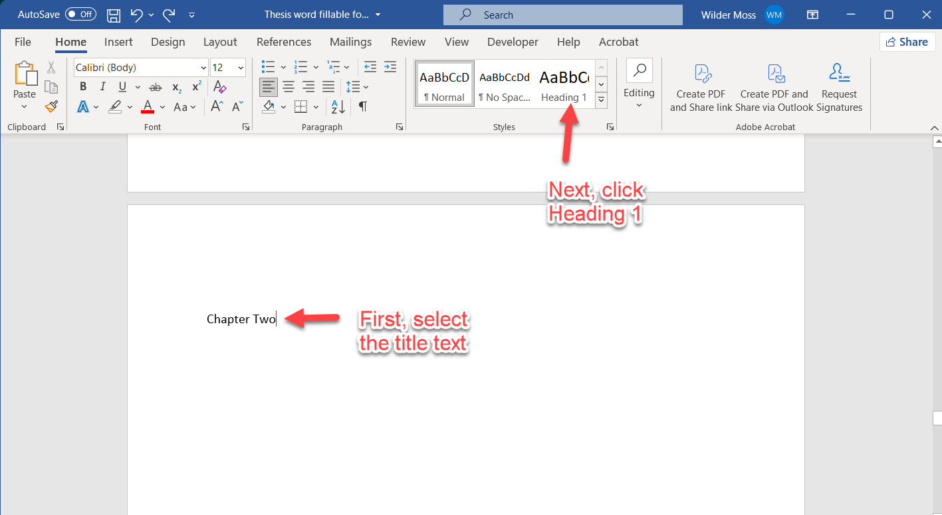
Figure 1: Illustrative screenshot showing where to click for "Heading 1". Note: Your chapter title should be highlighted. The text is not highlighted in this screenshot only because it is not possible to highlight while taking a screenshot.
Your Table of Contents will not automatically update to show new Chapters or sections. To force an update, click on the Table of Contents and select “Update Table” in the top left corner of the table. Select “Update entire table”, and click “OK”. This will add any text that has been encoded with the style “Heading 1”.
If you would like sub-chapters to appear in the Table of Contents, you can utilize style “Heading 2” for sub-chapters and change the settings of the Table of Contents to show both headings.
- Go to the “References” tab in the Toolbar at the top of the page, and click “Table of Contents”.
- In the pop-up next to “Show levels”, you can increase the levels to 2 or more depending on your needs. You can also adjust the look of the Table of Contents by clicking on “Modify”.
- Click “OK” to save and then close the pop-up.
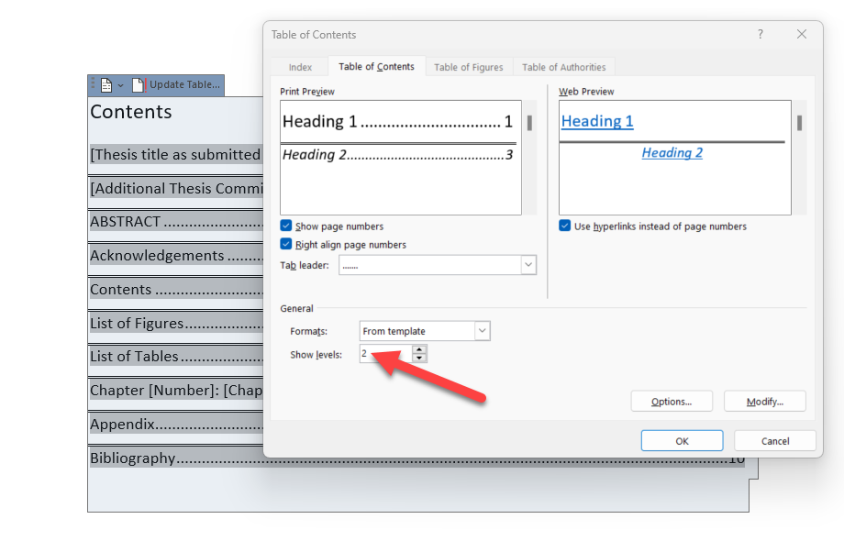

Accessibility

Outline / Structural tagging
An extra accessibility feature is a document outline. By formatting the outline of your document, you can tag each section of your thesis so that assistive technology can differentiate the function or importance of different sections of text.
A properly formatted outline also helps you to see which styles are encoded for different parts of your thesis.
To see the outline for your document, go to the top toolbar in Word, and click on “View”. Then click “Outline”. What you will see is similar to how a screen reader device views your document. To simplify your view, you can check the box for “Show First Line Only” in the top toolbar. This will temporarily limit your view of each section to just the first line.
The outline works by “nesting” sections of your thesis according to “Level”. Heading 1 correlates to Level 1, Heading 2 is Level 2, and onward ending with the “Normal” style being “Body” level. Generally speaking, you would want your Chapter titles to be Level 1, sub-chapters titles to be Level 2, and the main text of a chapter to be Body level. With this set up, a reader can easily listen to the outlined Chapters and sub-chapters to know which section they want to navigate to.
The Thesis Template has a relatively tidy outline besides the blank lines / carriage returns. Ideally, a document should not have blank lines for spacing. Instead, utilize the space before and after paragraphs. For the Thesis Template title page, blank lines were used to show proper spacing on a title page, without making it overly difficult for students to adjust the spacing for their content.

Alt Text
To add or edit alt text for an image:
- Right click the image and select “Edit Alt Text” from the drop down
- In the right side panel, add your alt text. Word has a helpful guide to indicate what types of information or details you should include in alt text. You can alternatively click “Generate a description for me”, but be sure to edit and correct the description that Word generates.

Tables
To add a table in Word, look at the top toolbar in Word, and click on the “Insert” tab. Now click on the “Table” option.
- You can create a new table within Word by clicking “Insert table”. A pop-up will appear that lets you choose your number of columns and rows, etc
- You can insert a table from Excel by clicking “Excel Spreadsheet”. Word will automatically add a table to the Word Doc and also open an Excel sheet that is tied to that Word table. Whatever you type or paste into the new Excel sheet will appear in the Word table. You may need to click on the Word table for the data to appear.
To make your tables accessible:
- Right click your table and select “Table Properties” from the drop down.
- In the pop-up, click on the “Alt Text” tab, and enter a unique Title for your table. If you have multiple tables with the same name, you can add sequential numbers. Example: Library Data 1
- Click “OK” to save, and then close the pop-up.

Accessibility Check
To check the accessibility of your Word doc:
- Look to the top toolbar in Word, and click on the “Review” tab
- Click on “Check Accessibility”. A report will appear on the right side of the document.

Export to PDF/A
Once you have finished your thesis, you can export to PDF/A
- In the top left, click “File” and then “Export”
- In the “Export” tab, click on “Create Adobe PDF”
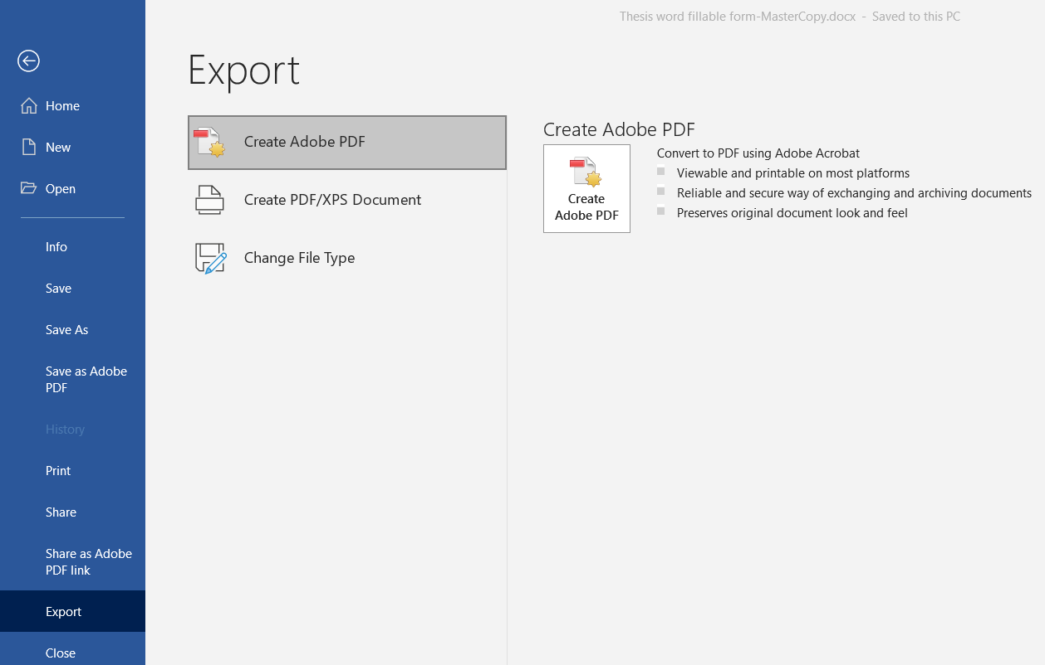
- In the pop-up, click “Options”
- Customize the options by checking only the following options:
  - Convert document information
  - Create PDF/A-1a:2005 compliant file
  - Create Bookmarks
    - Convert Word Headings to Bookmarks
    - Convert Word Styles to Bookmarks
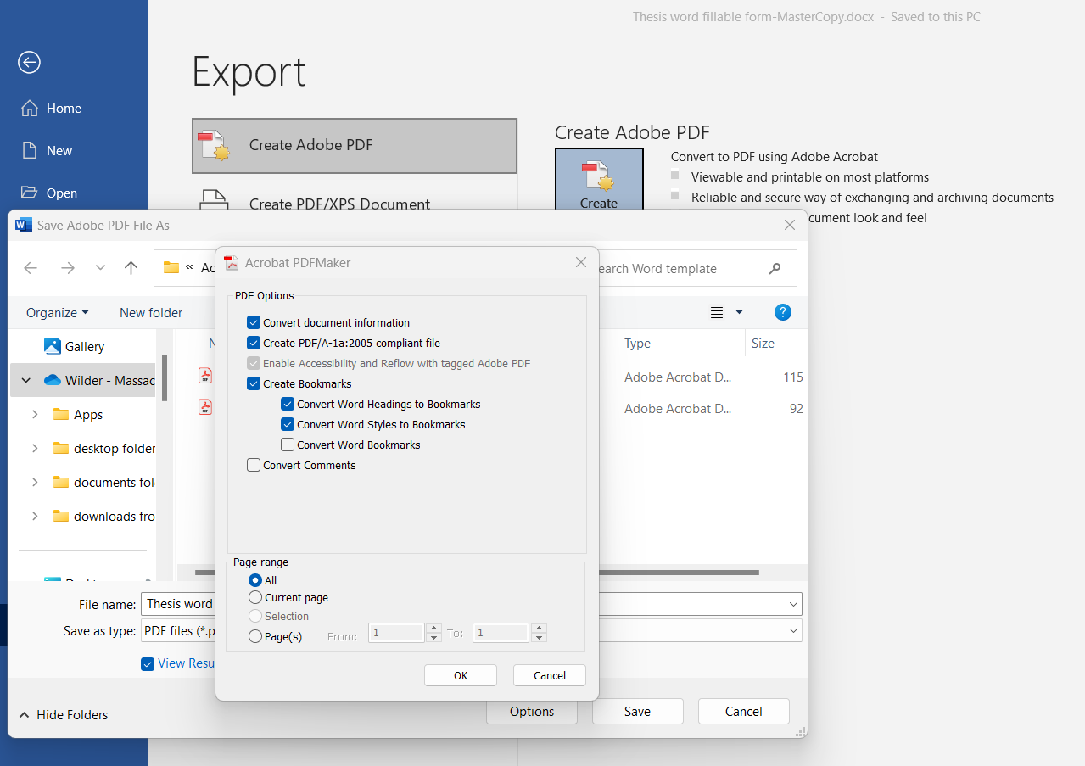

Correct Accessibility After Conversion to PDF/A
To check accessibility of your PDF,
If you follow the above instructions on Accessibility, you should only see failures for the “Title” and “Tab Order”. To correct these errors, you will need to enable editing of the document.
To fix the Title:
- In the top left corner, click on "Menu", and in the dropdown, click "Document properties".
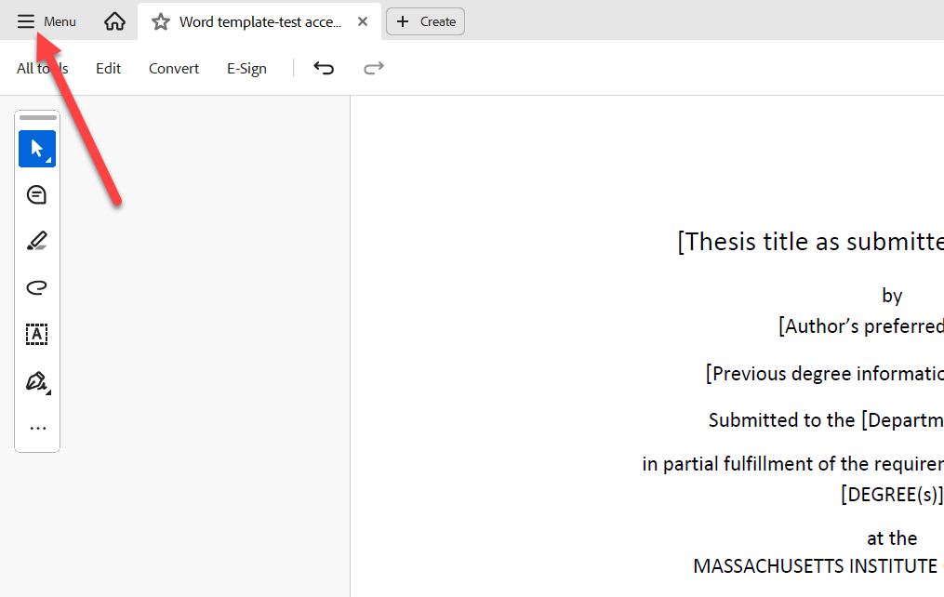
- In the pop-up window, edit the "Title field" to the actual thesis title and then click "OK" to save.
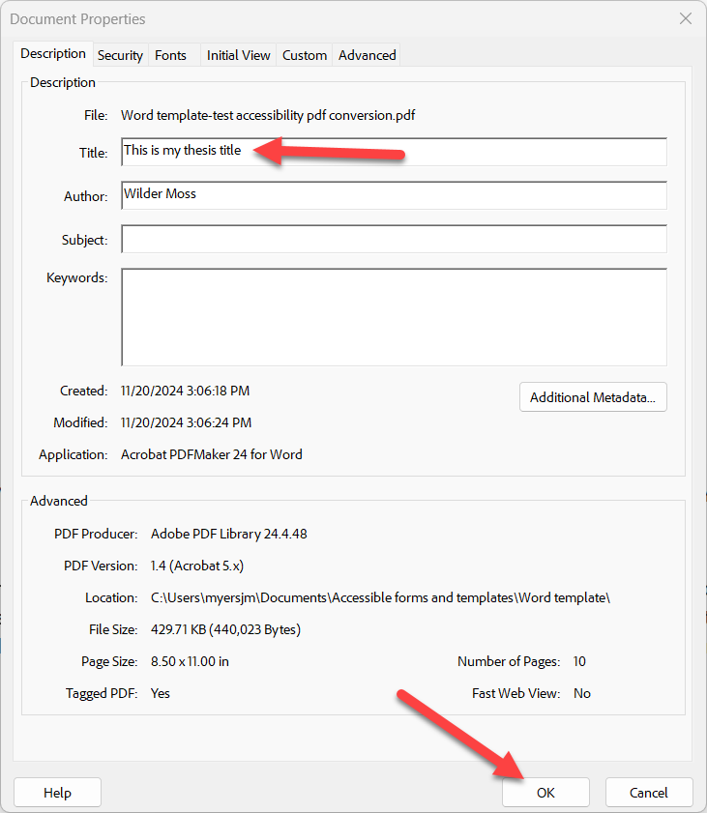
To fix the Tab Order:
- On the left side, click into the Pages panel
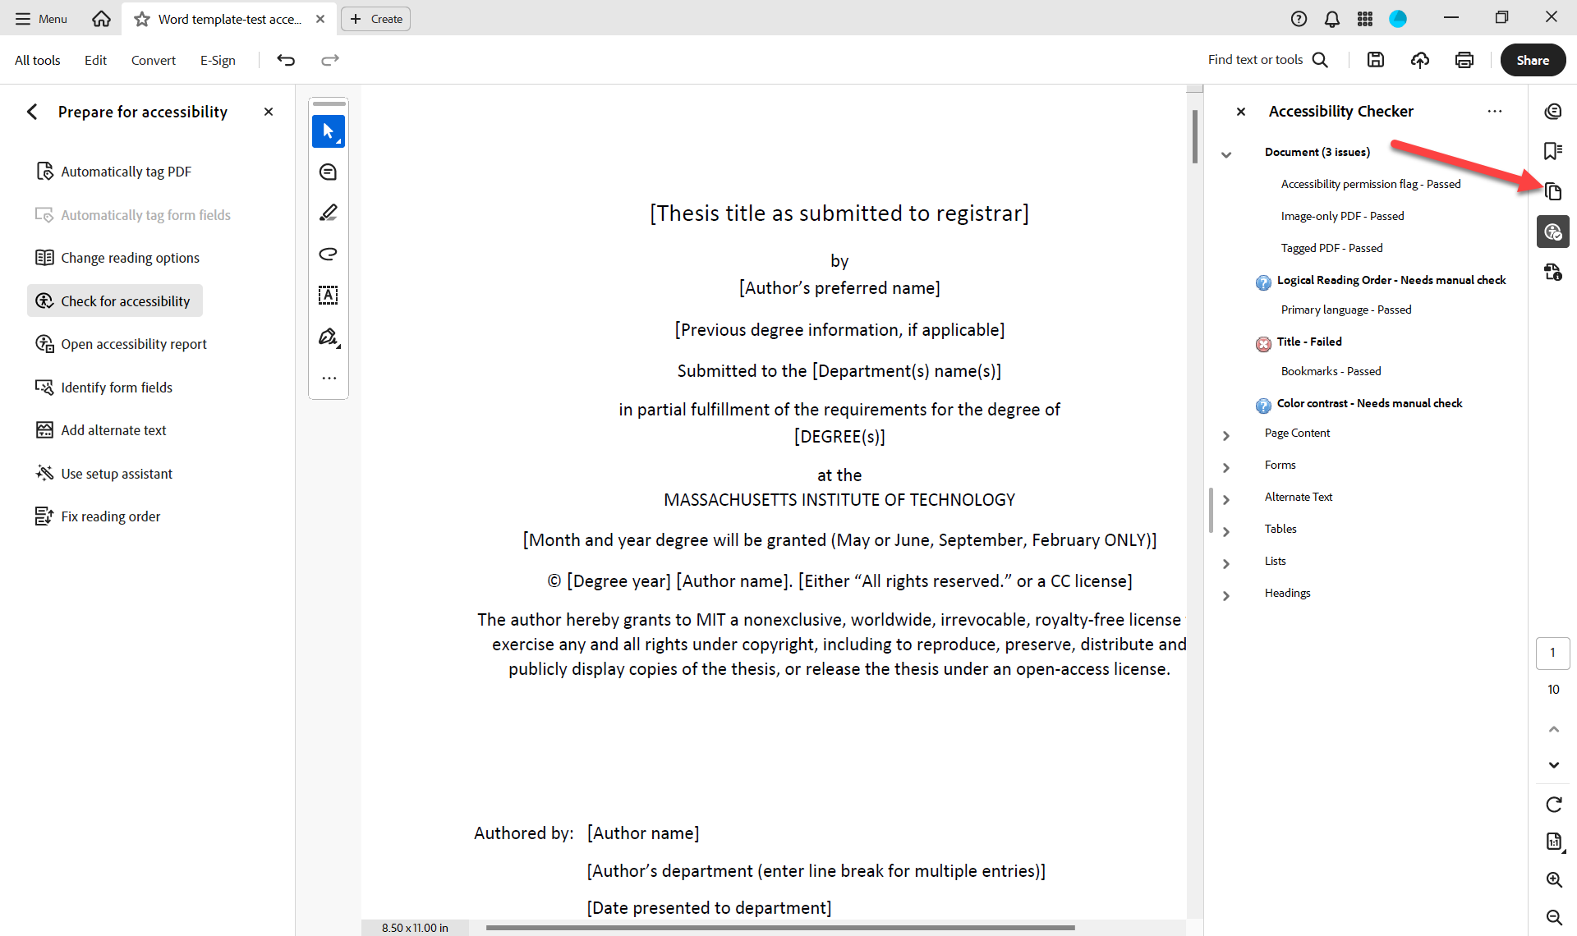
- Click on any page, and then use the CTRL + A keystroke to select all pages
- While all pages are still selected, right click and select “Page Properties” from the dropdown list
- In the Page Properties dialog box, select Tab Order and then choose Use Document Structure.
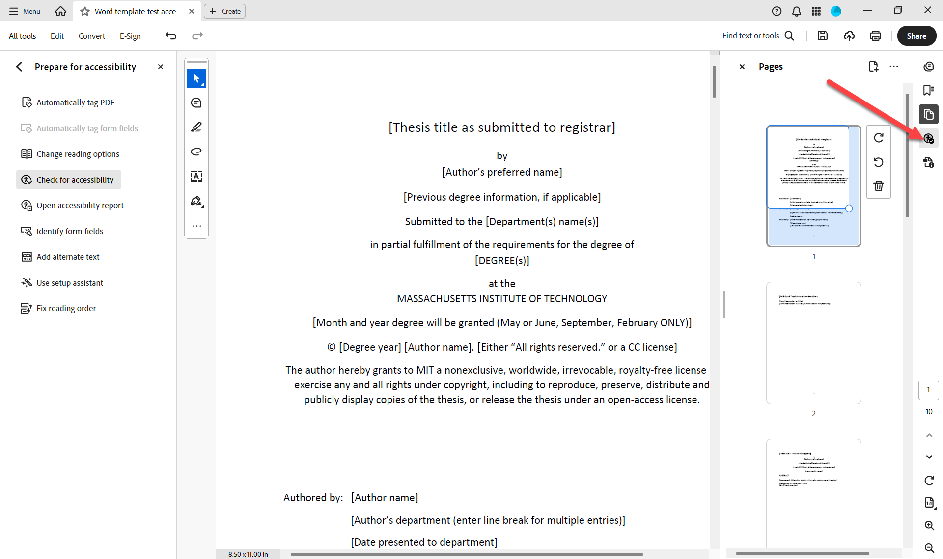
- Click 'OK'
- Return to the Accessibility Report panel, and click the 3 dots at the top of the panel
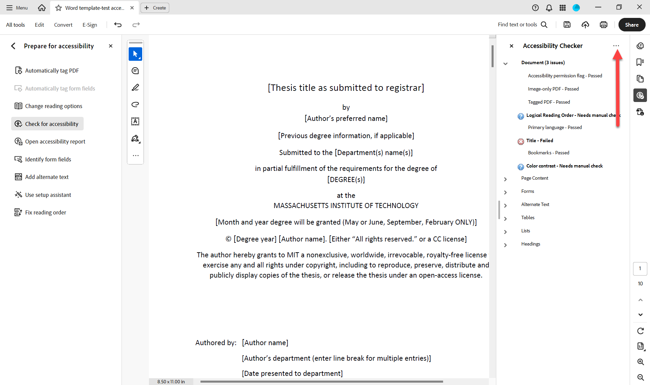
- From the dropdown, select “Check Again”
- Document should now pass the Accessibility Check. If you run into issues, try going back through the above accessibility instructions. Reach out to mit-theses@mit.edu with any further questions.

Re-saving your PDF as a PDF/A

- In the top left corner, click on Menu
- Select “Save as Other” from the drop down list
- Select “Archival PDF (PDF/A)”
- In the pop-up, click on “Settings”
- Within this settings pop-up, select “Save as PDF/A-1b”. You can set a specific image resolution at the bottom of the page, or go with the default.
- Click OK
