Self Learning 2
Name: Aman Raibole
Course :PGCP AC
Batch: B1
PRN :260240120022
Form No: 251101142
Module : c++
Date : 7/3/2026

1. Write a C++ program to calculate Simple and Compound interest.

#include<iostream>
#include<cmath>
using namespace std;

double calculateSimpleInterest(double principal, double rate, int time) {
return (principal * rate * time) / 100;
}

double calculateCompoundInterest(double principal, double rate, int time) {
return principal * pow((1 + rate / 100), time) - principal;
}

int main() {
double principal, rate;
int time;

cout << "Enter principal amount: ";
cin >> principal;
cout << "Enter annual interest rate (in %): ";
cin >> rate;
cout << "Enter time (in years): ";
cin >> time;

double simpleInterest = calculateSimpleInterest(principal, rate, time);
double compoundInterest = calculateCompoundInterest(principal, rate, time);

cout << "Simple Interest: " << simpleInterest << endl;
cout << "Compound Interest: " << compoundInterest << endl;

return 0;
}

Output:

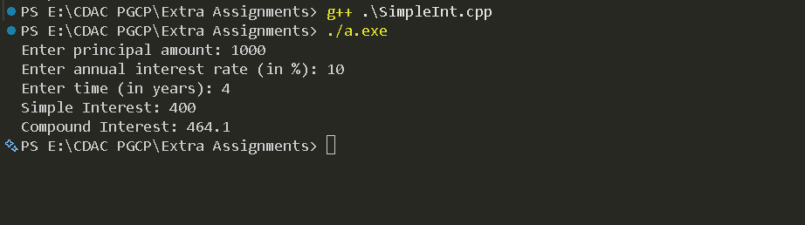

2. Write a C++ Program to transpose one matrix and display both the matrices with proper prompt.

#include<iostream>
using namespace std;

class Matrix {
private:
int **mat;
int row;
int col;

public:
Matrix(){
this->row =1;
this->col=1;
mat = new int*[1];
mat[0] = new int(0);
}

Matrix(const int row,int col){
this->row = row;
this->col = col;
mat = new int*[row];
for (int i = 0; i < row; i++)
{
mat[i] = new int[col]();
}
}

void Accept(){
for(int i = 0 ; i< row ;i++){
for (int j = 0; j < col; j++)
{
cout<<"Enter element at pos"<<i+1<<','<<j+1<<" : ";
cin>>mat[i][j];
}
}

}

void setElement(int i, int j, int num){
mat[i][j] = num;
}

void setCol(int col){
this->col =col;
}

void setRow(int Row){
this->row =row;
}

void transpose(){
Matrix temp(this->col,this->row);
for(int i = 0 ; i< row;i++){
for (int j = 0; j < col; j++)
{
temp.setElement(j,i,mat[i][j]);
}
}

temp.display();

}

void display(){
for(int i = 0 ; i< row ;i++){
for (int j = 0; j < col; j++)
{
cout<<mat[i][j]<<" ";
}
cout<<endl;
}
cout<<endl;
}

};

int main(){

int row,col;

cout<<"Enter number of rows: "<<endl;
cin>>row;
cout<<"Enter number of columns : "<<endl;
cin>>col;

Matrix m1(row,col);

m1.Accept();
cout<<"Original matrix : "<<endl;
m1.display();
cout<<"Transpose of the matrix : "<<endl;
m1.transpose();

}

Output:
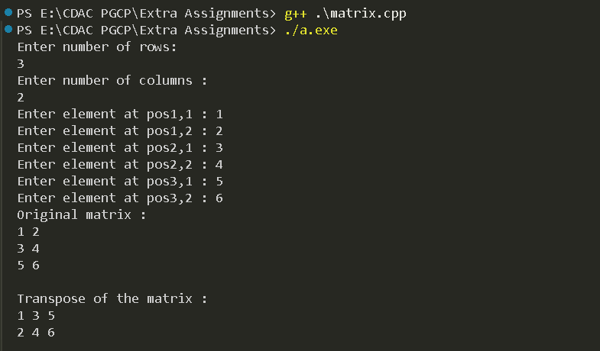

3. Write a C++ program to process students' marks with the help of classes.
The class has private variables for name, mark 1, mark 2, mark 3.
It has two member functions - getdata() - to get input and result() -
to print the results. All subjects mark must be >= 50 for pass otherwise fail. I
mplement this program for n number of students.

#include<iostream>
using namespace std;

/*3. Write a C++ program to process students' marks with the help of classes.
The class has private variables for name, mark 1, mark 2, mark 3.
It has two member functions - getdata() - to get input and result() -
to print the results. All subjects mark must be >= 50 for pass otherwise fail. I
mplement this program for n number of students.*/

class Student {
private:
string name;
int mark1;
int mark2;
int mark3;

public:
void getdata() {
cout << "Enter student's name: ";
cin >> name;
cout << "Enter mark 1: ";
cin >> mark1;
cout << "Enter mark 2: ";
cin >> mark2;
cout << "Enter mark 3: ";
cin >> mark3;
}

void result() {
if (mark1 >= 50 && mark2 >= 50 && mark3 >= 50) {
cout << name << " has passed." << endl;
} else {
cout << name << " has failed." << endl;
}
}
};

int main() {
int n;
cout << "Enter number of students: ";
cin >> n;

Student* students = new Student[n];

for (int i = 0; i < n; i++) {
students[i].getdata();
}

for (int i = 0; i < n; i++) {
students[i].result();
}

delete[] students;
return 0;
}

Output:
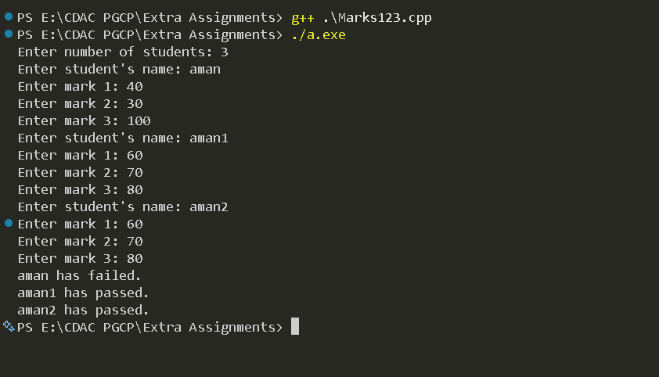

4. Write a C++ program that allows the user to input 5 grades, i.e. marks between 0-100. The program must calculate the average mark, and state the number of marks less than 65.

#include <iostream>

int main() {
int grade;
float average;
int loop;
int sum;
int valid_entry;
int failures;

sum = 0;
failures = 0;

for (loop = 0; loop < 5; loop = loop + 1) {
valid_entry = 0;
while (valid_entry == 0) {
std::cout << "Enter mark (0-100): ";
std::cin >> grade;
if (grade >= 0 && grade <= 100) {
valid_entry = 1;
} else {
std::cout << "Invalid input. Please enter a mark between 0 and 100." << std::endl;
}
}
if (grade < 65) {
failures++;
}
sum = sum + grade;
}
average = static_cast<float>(sum) / 5;
std::cout << "Average mark: " << average << std::endl;
std::cout << "Number of failures: " << failures << std::endl;
return 0;
}

Output:

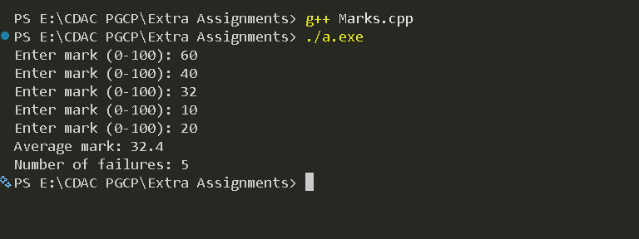

5. Write a menu driven C++ program to add, subtract and multiply given two matrices defined in class. Modify your program using operator overloading method.

#include <iostream>

using namespace std;

const int MAX_SIZE = 10;

class Matrix {
private:
int mat[MAX_SIZE][MAX_SIZE];
int rows, cols;

public:
Matrix() : rows(0), cols(0) {}

void getInput() {
cout << "Enter number of rows and columns: ";
cin >> rows >> cols;
cout << "Enter matrix elements:\n";
for (int i = 0; i < rows; ++i) {
for (int j = 0; j < cols; ++j) {
cin >> mat[i][j];
}
}
}

void display() const {
for (int i = 0; i < rows; ++i) {
for (int j = 0; j < cols; ++j) {
cout << mat[i][j] << " ";
}
cout << endl;
}
}

Matrix operator+(const Matrix& other) const {
if (rows != other.rows || cols != other.cols) {
cout << "Error: Dimensions must be the same for addition\n";
return Matrix();
}
Matrix result;
result.rows = rows;
result.cols = cols;
for (int i = 0; i < rows; ++i) {
for (int j = 0; j < cols; ++j) {
result.mat[i][j] = mat[i][j] + other.mat[i][j];
}
}
return result;
}

Matrix operator-(const Matrix& other) const {
if (rows != other.rows || cols != other.cols) {
cout << "Error: Dimensions must be the same for subtraction\n";
return Matrix();
}
Matrix result;
result.rows = rows;
result.cols = cols;
for (int i = 0; i < rows; ++i) {
for (int j = 0; j < cols; ++j) {
result.mat[i][j] = mat[i][j] - other.mat[i][j];
}
}
return result;
}

Matrix operator*(const Matrix& other) const {
if (cols != other.rows) {
cout << "Error: Columns of first matrix must equal rows of second for multiplication\n";
return Matrix();
}
Matrix result;
result.rows = rows;
result.cols = other.cols;
for (int i = 0; i < rows; ++i) {
for (int j = 0; j < other.cols; ++j) {
result.mat[i][j] = 0;
for (int k = 0; k < cols; ++k) {
result.mat[i][j] += mat[i][k] * other.mat[k][j];
}
}
}
return result;
}
}; // End of Matrix class

int main() {
Matrix m1, m2, m3;
cout << "Enter details for Matrix 1:\n";
m1.getInput();
cout << "Enter details for Matrix 2:\n";
m2.getInput();

int choice;
do {
cout << "\nMenu:\n";
cout << "1. Add matrices\n";
cout << "2. Subtract matrices\n";
cout << "3. Multiply matrices\n";
cout << "4. Exit\n";
cout << "Enter your choice: ";
cin >> choice;

switch (choice) {
case 1:
m3 = m1 + m2;
cout << "Result of Addition:\n";
m3.display();
break;
case 2:
m3 = m1 - m2;
cout << "Result of Subtraction:\n";
m3.display();
break;
case 3:
m3 = m1 * m2;
cout << "Result of Multiplication:\n";
m3.display();
break;
case 4:
cout << "Exiting program.\n";
break;
default:
cout << "Invalid choice.\n";
}
} while (choice != 4);

return 0;
}

Output:

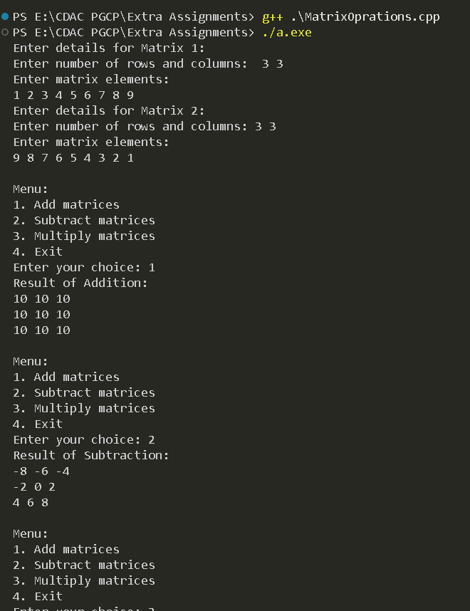

6. Create a Donor class which contains the members as
name, age, blood group, and address. Include a method to display
the donor's information. Write a C++ program to create an object
of the Donor class and display the donor's information.

#include<iostream>
using namespace std;

/*6. Create a Donor class which contains the members as
name, age, blood group, and address. Include a method to display
the donor's information. Write a C++ program to create an object
of the Donor class and display the donor's information.*/

class Donor {
private:
string name;
int age;
string bloodGroup;
string address;

public:
Donor(){
this->name = "";
this->age = 0;
this->bloodGroup = "";
this->address = "";
}

Donor(const string name,const int age,const string bloodGroup,const string address){
this->name = name;
this->age = age;
this->bloodGroup = bloodGroup;
this->address = address;
}

void setName(string name){
this->name = name;
}

void setAge(int age){
this->age = age;
}

void setBloodGroup(string bloodGroup){
this->bloodGroup = bloodGroup;
}

void setAddress(string address){
this->address = address;
}

void displayInfo(){
cout << "Name: " << name << endl;
cout << "Age: " << age << endl;
cout << "Blood Group: " << bloodGroup << endl;
cout << "Address: " << address << endl;
}
};

int main()
{
string name, bloodGroup, address;
int age;

cout << "Enter donor's name: ";
getline(cin, name);
cout << "Enter donor's age: ";
cin >> age;
cin.ignore(); // To ignore the newline character after age input
cout << "Enter donor's blood group: ";
getline(cin, bloodGroup);
cout << "Enter donor's address: ";
getline(cin, address);

Donor donor(name, age, bloodGroup, address);
cout << "\nDonor Information:" << endl;
donor.displayInfo();

return 0;
}

Output:

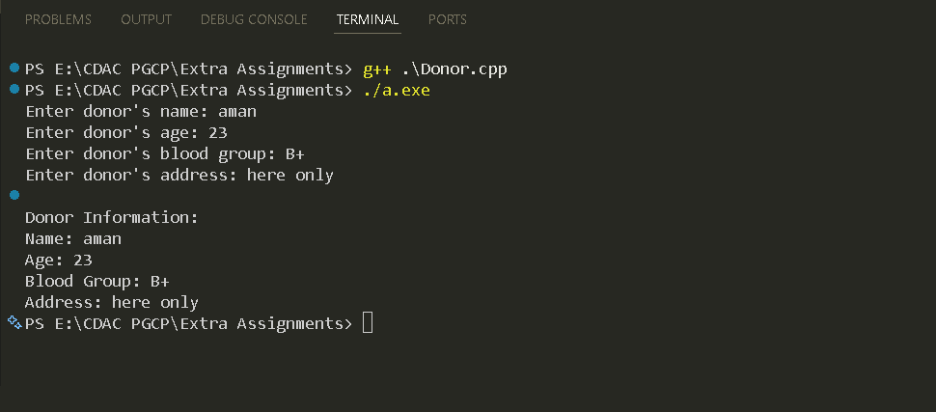
7. Create an Electricity Charges class which contains the members as units consumed and a method to calculate the electricity bill based on the following criteria:
- For the first 100 units: Rs. 1.20 per unit
- For the next 100 units: Rs. 2.00 per unit
- For units above 200: Rs. 3.00 per unit
Write a C++ program that accepts the units consumed from the keyboard and displays the total electricity bill.

#include<iostream>
using namespace std;
/*7. An electricity board charges the following rates to domestic users:
For the first 100 units -. 5.5P per unit
For next 200 units -. 7.25P per unit
Beyond 300 units - *. 8.75P per unit
All users are charged a minimum of ₹. 60.
If the total amount is more than. 750 then an additional surcharge of 10% is added on the higher slab units.
Write a C++ program to read the names of users and number of units consumed and print out the charges with names.*/

class ElectricityCharges {
private:
string name;
int units;

public:
ElectricityCharges(){
this->name = "";
this->units = 0;
}

ElectricityCharges(const string name,const double units){
this->name = name;
this->units = units;
}

void setName(string name){
this->name = name;
}

void setUnits(double units){
this->units = units;
}

double calculateCharges(){
double charges = 0.0;

if (units <= 100) {
charges = units * 5.5 / 100;
} else if (units <= 300) {
charges = (100 * 5.5 / 100) + ((units - 100) * 7.25 / 100);
} else {
charges = (100 * 5.5 / 100) + (200 * 7.25 / 100) + ((units - 300) * 8.75 / 100);
}

if (charges < 60) {
charges = 60; // Minimum charge
} else if (charges > 750) {
charges += charges * 0.10; // Add surcharge
}

return charges;
}
};

int main()
{
string name;
double units;

cout << "Enter user's name: ";
cin >> name;
cout << "Enter number of units consumed: ";
cin >> units;

ElectricityCharges user(name, units);
double totalCharges = user.calculateCharges();

cout << "User: " << name << endl;
cout << "Units Consumed: " << units << endl;
cout << "Total Charges: Rs." << totalCharges << endl;

return 0;
}

Output:

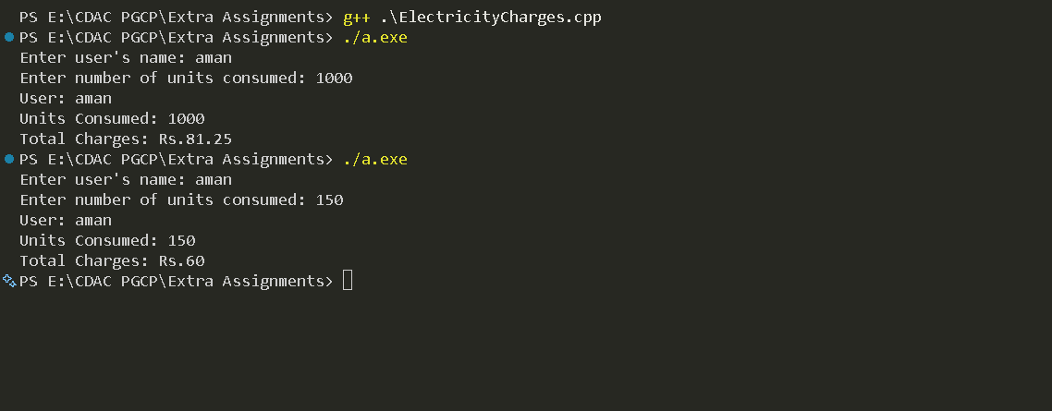

8. Implement the calculator through a C++ program (use switch). The program should ask the user to input two operands and an operator. Your program should print the result of performing the required operation on the input operands as the following output:
Enter operand 1:5
Enter operand 2: 10
Enter operation: /
The result of 5/10 is 0.5

#include<iostream>
using namespace std;

class Calculator {
private:
double num1;
double num2;
char operation;

public:
Calculator(){
this->num1 =0;
this->num2=0;
this->operation='+';
}

Calculator(const double num1,const double num2,const char operation){
this->num1 = num1;
this->num2 = num2;
this->operation = operation;
}

void setNum1(double num1){
this->num1 = num1;
}

void setNum2(double num2){
this->num2 = num2;
}

void setOperation(char operation){
this->operation = operation;
}

double calculate(){
switch (operation)
{
case '+':
return num1 + num2;
case '-':
return num1 - num2;
case '*':
return num1 * num2;
case '/':
if (num2 != 0) {
return num1 / num2;
} else {
cout << "Error: Division by zero!" << endl;
return 0; // Return 0 or handle as needed
}
default:
cout << "Invalid operation!" << endl;
return 0; // Return 0 or handle as needed
}
}
};

int main()
{
double num1, num2;
char operation;

cout << "Enter the first number: ";
cin >> num1;
cout << "Enter the second number: ";
cin >> num2;
cout << "Enter the operation (+, -, *, /): ";
cin >> operation;

Calculator calc(num1, num2, operation);
double result = calc.calculate();
cout << "Result: " << result << endl;

return 0;
}

Output:
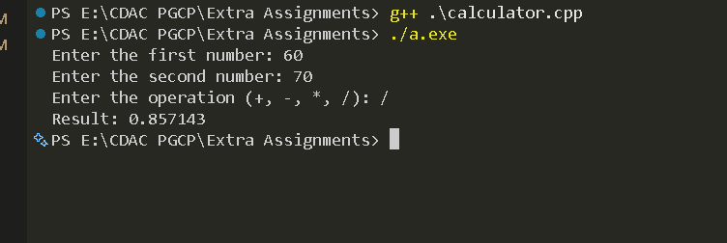

9. Create Time Class which contains the members as hour, minute and second. Write a C++ program that accepts member data for one Time class object from the keyboard. Then, ask the user to perform one of the following functions to that Time object:
AddHours
AddMinutes
AddSeconds
And finally display the newly modified Time information.

#include<iostream>
using namespace std;
/*9. Create Time Class which contains the members as hour, minute and second. Write a C++ program that accepts member data for one Time class object from the keyboard. Then, ask the user to perform one of the following functions to that Time object:
AddHours
AddMinutes
AddSeconds
And finally display the newly modified Time information.*/

class Time {
private:
int hour;
int minute;
int second;

public:
Time(){
this->hour =0;
this->minute=0;
this->second=0;
}

Time(const int hour,const int minute,const int second){
this->hour = hour;
this->minute = minute;
this->second = second;
}

void setHour(int hour){
this->hour = hour;
}

void setMinute(int minute){
this->minute = minute;
}

void setSecond(int second){
this->second = second;
}

void addHours(int h){
this->hour += h;

}

void addMinutes(int m){
this->minute += m;
if (this->minute >= 60) {
addHours(this->minute / 60); // Add extra hours
this->minute %= 60;
}
}

void addSeconds(int s){
this->second += s;
if (this->second >= 60) {
addMinutes(this->second / 60); // Add extra minutes
this->second %= 60;
}
}

void displayTime(){
cout << "Time: " << hour << "h " << minute << "m " << second << "s" << endl;
}
};

int main()
{
int hour, minute, second;
cout << "Enter time (hour minute second): ";
cin >> hour >> minute >> second;

Time t(hour, minute, second);

int choice;
cout << "Choose an option to modify time:" << endl;
cout << "1. Add Hours" << endl;
cout << "2. Add Minutes" << endl;
cout << "3. Add Seconds" << endl;
cout << "Enter your choice: ";
cin >> choice;

switch (choice) {
case 1:
int h;
cout << "Enter hours to add: ";
cin >> h;
t.addHours(h);
break;
case 2:
int m;
cout << "Enter minutes to add: ";
cin >> m;
t.addMinutes(m);
break;
case 3:
int s;
cout << "Enter seconds to add: ";
cin >> s;
t.addSeconds(s);
break;
default:
cout << "Invalid choice!" << endl;
return 1;
}

t.displayTime();

return 0;
}

Output:

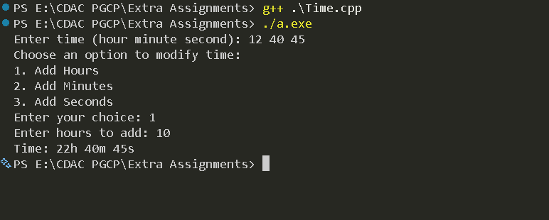

10. Write a menu driven program to perform the following options using separate functions. Accept a number and then, do the following operations on this number:
1. Prime number or not
2. Odd or Even
3. Positive or Negative
4. Exit

#include<iostream>
using namespace std;
/*10. Write a menu driven program to perform the following options using separate functions. Accept a number and then, do the following operations on this number:
1. Prime number or not
2. Odd or Even
3. Positive or Negative
4. Exit*/

bool isPrime(int num) {
if (num <= 1) return false;
for (int i = 2; i <= num / 2; i++) {
if (num % i == 0) return false;
}
return true;
}

int main() {
int choice;
int number;

do {
cout << "Menu:" << endl;
cout << "1. Check if prime" << endl;
cout << "2. Check if odd or even" << endl;
cout << "3. Check if positive or negative" << endl;
cout << "4. Exit" << endl;
cout << "Enter your choice: ";
cin >> choice;

if (choice == 4) {
cout << "Exiting..." << endl;
break;
}

cout << "Enter a number: ";
cin >> number;

switch (choice) {
case 1:
if (isPrime(number)) {
cout << number << " is a prime number." << endl;
} else {
cout << number << " is not a prime number." << endl;
}
break;
case 2:
if (number % 2 == 0) {
cout << number << " is even." << endl;
} else {
cout << number << " is odd." << endl;
}
break;
case 3:
if (number > 0) {
cout << number << " is positive." << endl;
} else if (number < 0) {
cout << number << " is negative." << endl;
} else {
cout << number << " is zero." << endl;
}
break;
default:
cout << "Invalid choice. Please try again." << endl;
}
} while (true);

return 0;
}

Output:

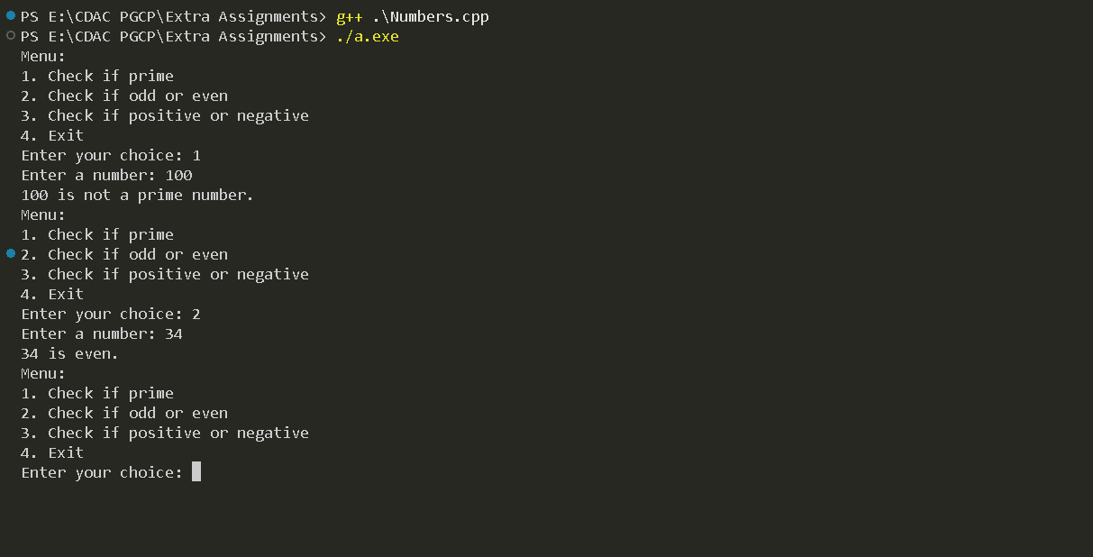

11. Write a C++ program to reverse a given string.

#include<iostream>
using namespace std;

/*11. Write a C++ program to reverse a given string.*/

int main()
{
string str;
cout << "Enter a string: ";
getline(cin, str);

string reversedStr = "";
for (int i = str.length() - 1; i >= 0; i--)
{
reversedStr += str[i];
}

cout << "Reversed string: " << reversedStr << endl;

return 0;
}

Output:

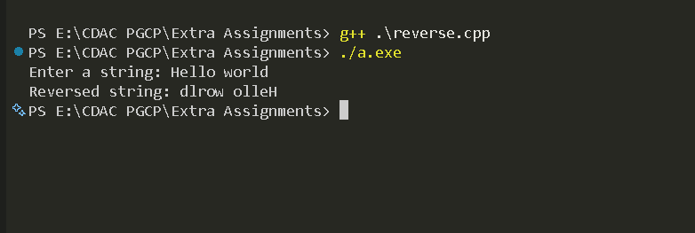

12.Write a C++ Program to Compare Two given Strings and display the result.
#include<iostream>
using namespace std;

/*12.Write a C++ Program to Compare Two given Strings and display the result.*/
int main()
{
string str1, str2;
cout << "Enter the first string: ";
cin >> str1;
cout << "Enter the second string: ";
cin >> str2;

if (str1 == str2)
{
cout << "The strings are equal." << endl;
}
else
{
cout << "The strings are not equal." << endl;
}

return 0;
}

Output:
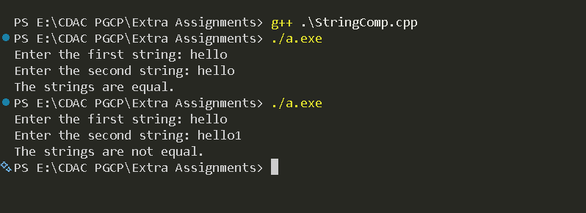

13. Write a program in C++ to determine how many of the characters are vowels and how many are consonants in a given line of text. Also terminate the string when the input character encountered is other than the alphabets (a-z or A-Z) and Blank spaces.
Hint:
a. When the input string is 'C plus plus FOR BEGINNERS, TEST YOUR C plus plus PROGRAMMING STRENGTHS'. Program will consider the string 'C plus plus FOR BEGINNERS' only because ',' is encountered.
b. When the input string is 'C++ LEARINING IS NOT A PROBLEM'. Program will consider the character 'C' only because the '+' is encountered.

#include<iostream>
using namespace std;

/*5. Write a program in C++ to determine how many of the characters are vowels and how many are consonants in a given line of text. Also terminate the string when the input character encountered is other than the alphabets (a-z or A-Z) and Blank spaces.
Hint:
a. When the input string is 'C plus plus FOR BEGINNERS, TEST YOUR C plus plus PROGRAMMING STRENGTHS'. Program will consider the string 'C plus plus FOR BEGINNERS' only because ',' is encountered.
b. When the input string is 'C++ LEARINING IS NOT A PROBLEM'. Program will consider the character 'C' only because the '+' is encountered.*/

int main()
{
char str[100];
int vowelCount = 0, consonantCount = 0;

cout << "Enter a line of text: ";
cin.getline(str, 100);

for (int i = 0; str[i] != '\0'; i++)
{
char ch = str[i];

if ((ch >= 'a' && ch <= 'z') || (ch >= 'A' && ch <= 'Z'))
{
ch = tolower(ch); // Convert to lowercase for uniformity

if (ch == 'a' || ch == 'e' || ch == 'i' || ch == 'o' || ch == 'u')
{
vowelCount++;
}
else
{
consonantCount++;
}
}
else if (ch != ' ')
{
break; // Terminate on encountering non-alphabetic character
}
}
cout << "Number of vowels: " << vowelCount << endl;
cout << "Number of consonants: " << consonantCount << endl;

return 0;
}

Output:

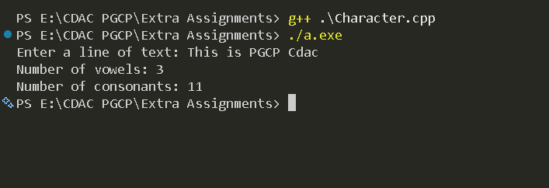

14.Create a C++ class for a stock item abstract data type.
It should have the attributes of stock levels (an integer)
and unit price (a float). Define the methods to return the
values of these two attributes and to set them using parameters.
Add two more methods to allow stock receipt and issues updating the
stocklevel as appropriate. Write a menu driven C++ program to solve the problem.

#include<iostream>
using namespace std;

/*14.Create a C++ class for a stock item abstract data type.
It should have the attributes of stock levels (an integer)
and unit price (a float). Define the methods to return the
values of these two attributes and to set them using parameters.
Add two more methods to allow stock receipt and issues updating the
stocklevel as appropriate. Write a menu driven C++ program to solve the problem.*/
class Stock {
private:
int stockLevel;
float unitPrice;

public:
Stock(){
this->stockLevel = 0;
this->unitPrice = 0.0;
}

Stock(const int stockLevel,const float unitPrice){
this->stockLevel = stockLevel;
this->unitPrice = unitPrice;
}

void setStockLevel(int stockLevel){
this->stockLevel = stockLevel;
}

void setUnitPrice(float unitPrice){
this->unitPrice = unitPrice;
}

int getStockLevel(){
return stockLevel;
}

float getUnitPrice(){
return unitPrice;
}

void receiveStock(int quantity){
stockLevel += quantity;
}

void issueStock(int quantity){
if(quantity > stockLevel){
cout << "Not enough stock to issue." << endl;
} else {
stockLevel -= quantity;
}
}
};

int main()
{
Stock item;
int choice, quantity;
float price;

do {
cout << "Menu:" << endl;
cout << "1. Set Stock Level" << endl;
cout << "2. Set Unit Price" << endl;
cout << "3. Receive Stock" << endl;
cout << "4. Issue Stock" << endl;
cout << "5. Display Stock Information" << endl;
cout << "6. Exit" << endl;
cout << "Enter your choice: ";
cin >> choice;

switch(choice) {
case 1:
cout << "Enter stock level: ";
cin >> quantity;
item.setStockLevel(quantity);
break;
case 2:
cout << "Enter unit price: ";
cin >> price;
item.setUnitPrice(price);
break;
case 3:
cout << "Enter quantity to receive: ";
cin >> quantity;
item.receiveStock(quantity);
break;
case 4:
cout << "Enter quantity to issue: ";
cin >> quantity;
item.issueStock(quantity);
break;
case 5:
cout << "Stock Level: " << item.getStockLevel() << endl;
cout << "Unit Price: $" << item.getUnitPrice() << endl;
break;
case 6:
cout << "Exiting..." << endl;
break;
default:
cout << "Invalid choice. Please try again." << endl;
}
} while(choice != 6);

return 0;
}

Output:

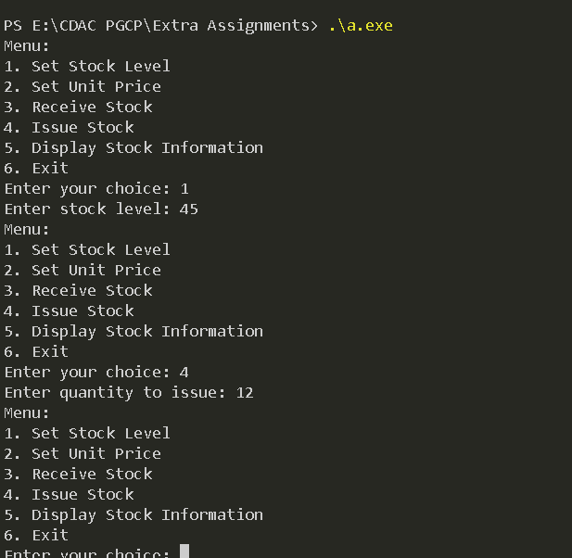

15. Raising a number n to power p is the same as multiplying by itself t times. Write a function called power() that makes a double value for n and an int value for p and returns the result as double value. Use default argument of 2 for p, so that if this argument is omitted, the number will be squared. Write a main() function that gets values from the user to test this function.

#include<iostream>
using namespace std;

double power(double n, int p=2){
if (p == 0)
{
return 1;
}
else
{
return n * power(n, p - 1);
}
}

int main()
{
double n;
int p;

cout << "Enter the number: ";
cin >> n;
cout << "Enter the power: ";
cin >> p;

double result = power(n, p);
cout << n << " raised to the power of " << p << " is: " << result << endl;

return 0;
}

Output:
