**CPIT- 455: Software engineering (II)**

Dependable Systems Assignment

Online Exam Platform

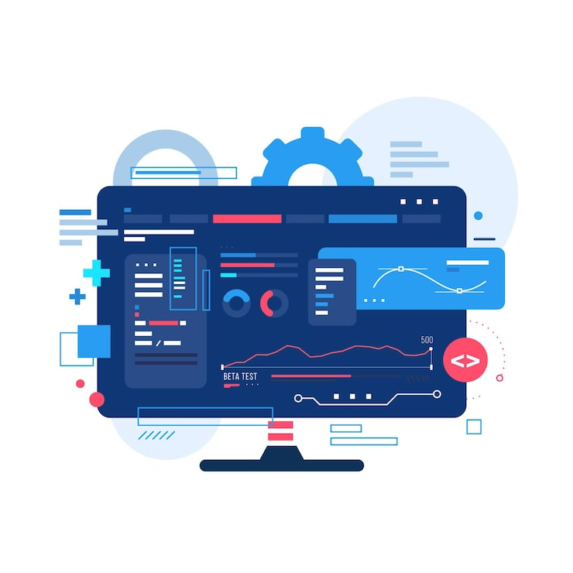

**Prepared to:  
Dr.** Adeeb Noor

**Prepared by:  
Abdulrahman Monaquel**

**1. Concept**

**Introduction**

An online exam platform is very important for schools and certification Providers. Exams are short and high stakes, so any system issue directly affects trust and fairness. Students must log in on time, submit without problems, and know their data is safe. To achieve this, the platform must meet five main dependability requirements: Availability, Reliability, Safety, Security, and Resilience.

**1. Availability**

Requirement: The system must always be up during exams with very little downtime.  
Justification: Exams have fixed times. If the system goes down, students lose time and schedules are disrupted.  
Example: In a 2-hour exam, even 10 minutes of downtime can harm thousands of students. Availability also makes sure answers are submitted and recorded on time.

**2. Reliability**

Requirement: The platform must deliver questions correctly and store answers without errors or loss.  
Justification: Issues like timers not working, lost sessions, or missing answers break the integrity of the exam.  
Example: If a student finishes questions but the system fails to save them, the results cannot be trusted. Reliability means the system always behaves the same way for everyone.

**3. Safety**

Requirement: The platform must protect student work, results, and the exam process.  
Justification: Safety avoids lost answers, scoring errors, or other failures that could affect grades.  
Example: If a server crashes, the system must recover answers and keep results consistent. Safety includes safeguards and preventive measures.

**4. Security**

Requirement: Exam content, student data, and proctoring recordings must be safe from unauthorized access.  
Justification: Data leaks or tampering destroy the credibility of exams and the institution.  
Example: Question banks, answers, and logs must be encrypted and only accessible by authorized staff. Security also covers safe data transmission and defense against attacks.

**5. Resilience**

Requirement: The system must keep running or recover quickly if parts fail.  
Justification: Even if one part fails, exams should continue without disruption.  
Example: If the main data center goes down, traffic must switch to a backup with minimal impact. Resilience uses redundancy, failover, and local caching so students can keep working.

**2. Implementation**

Designing a dependable online exam platform requires balancing ease of use with strong technical safeguards. The system must support thousands of students logging in at the same time, protect against errors or failures, and ensure that no exam data is lost or manipulated. In this design, the focus is on redundancy, diversity, and security features that directly support the CIMT dependability dimensions: **availability, reliability, safety, integrity, and timeliness**.

**System Overview**

The system is divided into four main components, each playing a role in ensuring dependability:

1. **Student Interface** – Students access exams through a web browser or a mobile application. Both interfaces are designed to work under different conditions, including low bandwidth. To handle poor connections, the system saves answers locally every 30 seconds, then uploads them when the internet is restored. This prevents lost progress and supports **reliability**.
2. **Exam Server** – The core application runs on multiple servers that share traffic through a load balancer. Since the services are stateless, any server can process a request without depending on another. This makes it possible to add more servers during peak exam times, ensuring **availability** and **timeliness**.
3. **Database System** – All student data, exam questions, and results are stored in a secure database. A backup database is continuously synchronized, ready to take over if the main one fails. This protects both **integrity** and **availability**.
4. **Admin Panel** – Instructors and administrators use a separate portal to schedule exams, upload questions, and review results. Access is restricted with multi-factor authentication, reducing risks of unauthorized actions and supporting **safety**.

**Redundancy Design**

Redundancy is used to prevent single points of failure:

1. **Multiple Servers** – At least three servers run the exam application. If one server goes down, the others continue to handle traffic, and students are not affected. This provides **fault tolerance** and improves **availability**.
2. **Database Backup** – A hot-standby database mirrors the primary in real time. If the primary fails, the backup automatically becomes active with almost no downtime. This ensures **reliability** of exam data.
3. **Answer Auto-Save** – Student answers are saved both locally and on the server. Even if a student’s internet connection drops for a few minutes, the local cache ensures no answers are lost. This protects **safety** and **timeliness**.
4. **Content Delivery Network (CDN)** – Exam questions and resources are distributed across a CDN. Students connect to the nearest server node, reducing delays and ensuring smooth delivery even during heavy usage.

**Diversity Design**

Diversity protects the platform from depending on a single solution:

1. **Cloud + Local Backup** – Primary hosting is in the cloud, but a local backup server at the university data center can run exams if the cloud provider experiences downtime. This ensures **service continuity**.
2. **Multiple Internet Providers** – Data centers are connected through at least two ISPs. If one provider goes offline, traffic is automatically routed through the second. This keeps exams **available** without interruption.
3. **Browser and Device Diversity –** The platform supports multiple web browsers and mobile devices. If a compatibility issue arises with one browser or device, students can continue the exam using an alternative supported option. This reduces single points of failure related to software or hardware.
4. **Data Storage Diversity** – Exam submissions and logs are stored in two types of storage: a relational database and a separate immutable log. This way, even if one storage method is compromised, the other provides evidence of exam activity.

**Security and Dependability Features**

Several safeguards are included to support confidentiality, fairness, and accountability:

1. **Role-Based Access Control (RBAC):** Students, teachers, and administrators each have different permissions. For example, teachers can upload questions but cannot change results after submission, protecting **integrity**.
2. **Encryption:** All data in transit is protected with TLS, and stored data is encrypted. This ensures that even if data is intercepted, it cannot be misused, supporting **safety**.
3. **Audit Logs:** Every event, such as student login or exam submission, is logged securely. These logs cannot be altered and serve as proof in case of disputes, strengthening **reliability**.
4. **Failure Handling:** If part of the system fails, exams continue without interruption. For instance, if a proctoring module crashes, exams are not stopped; instead, monitoring continues with alternative methods. This ensures **availability**.

**3. Measurement**

Availability is calculated as:

**Availability = MTBF / (MTBF + MTTR)**

We Assume:

MTBF = 5000 hours

MTTR = 0.5 hours

A= 5000 /5000+0.5

**3.2 Service Level Agreements (SLAs)**

**Availability:** ≥ 99.99% during exam windows

**Downtime: Yearly** 52m 36s **| Monthly** 4m 23s

**Response Time:** < 2 seconds for page load

**Recovery Time:** < 1 hour for any critical failure

These SLAs ensure that the system meets the dependability expectations for students and faculty.

**4. Trend**

Future Evolution:

In the next five years, the online exam platform can evolve to further improve dependability, security, and user experience:

1. **AI-Based Proctoring:**  
   AI tools can monitor exams in real time to detect suspicious behavior, reducing reliance on human proctors while maintaining **integrity**.
2. **Blockchain Records:**  
   Immutable records of submissions and results can strengthen data **integrity** and transparency, preventing tampering and disputes.
3. **Personalized Accessibility Features**The platform could adapt exams to student's needs Like visually impaired students getting screen reader support or extended time automatically. This ensures fairness while making the system more inclusive.
4. **Enhanced Security:**  
   Biometric authentication and anomaly detection can further protect against unauthorized access, maintaining **safety** and **reliability**.