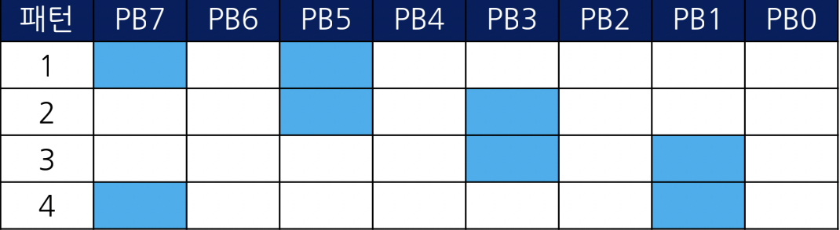

패턴 1) 1010 0000 >> 0xA0

패턴 2) 0010 1000 >> 0x28

패턴 3) 0000 1010 >> 0x0A

패턴 4) 1000 0010 >> 0x82

#define F_CPU 16000000L

#include <avr/io.h>

#include <util/delay.h>

int main(void)

{

DDRB = 0xFF;

while (1)

{

PORTB = 0xA0;

_delay_ms(2000);

PORTB = 0x28;

_delay_ms(2000);

PORTB = 0x0A;

_delay_ms(2000);

PORTB = 0x82;

_delay_ms(2000);

}

}