**KENYATTA UNIVERSITY TEACHING, REFERRAL & RESEARCH HOSPITAL**

**OFFICE OF THE DIRECTOR TRAINING & RESEARCH**

**P.O Box 7674- 00100 Nairobi**

**Tel:** 0794589824 **Website:** www.kutrrh.go.ke **Email:** director-training@kutrrh.go.ke

**OUR REF : KUTRRH/TISN/ADM/ ONC/Application_No_/Admission_No**

**Dear : First_Name Other_Names Surname Kenya.**

**REF : ADMISSION TO THE HIGHER DIPLOMA IN programName COURSE Intake_Code CLASS**

Following your application to pursue a **Higher Diploma** in **faculty**  **programName (Settlement_Type) letterHead3** *Provisional_Admision_Reason.*in the Kenyatta University Teaching, Referral and Research Hospital’s Training Institute of Specialized Nursing (KUTRRH TISN), I am pleased to inform you that you are among the successful applicants for nomination into the program for the 2024/2025 academic year, **Intake_Code.**

The reporting date for registration and orientation will be **EndDateText** at the KUTRRH TISN (TRI complex).

The duration of the course will be one year. If you are not able to take up the offer of admission immediately, please inform the office of the Head of Institute through **CompanyEmail** . Please note that this offer of admission will be valid for one year and you can defer your studies for a further one year after which you will be required to re-apply for consideration. The course will be offered in two blocks and any student dropping out will be required to reapply.

Kindly confirm acceptance of offer by sending an email to the training institute by **CompanyEmail.**

Enclosed find the fee structure and an additional list of requirements for your training.

**FEE STRUCTURE AND ADDITIONAL INFORMATION**

|  |  |
| --- | --- |
|  |  |
| **Details** | **FINAL** |
| Tuition | 220,750.00 |
| **One-Time Payments** |  |
| Maintenance Fund | 5,000.00 |
| Learning accessories | 10,000.00 |
| Library/Internet | 10,000.00 |
| Graduation fee | 7,000.00 |
| School ID | 500.00 |
| Activity Fee | 5,000.00 |
| Practicum supervision | 15,000.00 |
| **Total Fees** | **273,250.00** |

International students shall pay a total of **Kes.327,900**

All foreign students shall be required to pay a temporary Licensing fee to NCK before commencement of the Course.

|  |  |  |
| --- | --- | --- |
| **NCK CHARGES** | |  |
| **ITEM** | **AMOUNT (KES.)** | **WHEN PAYMENT IS NEEDED** |
| Indexing fee | Provided by NCK | Upon admission |
| NCK Examinations | Provided by NCK | In the 2nd Year |
| Registration and  Licensure | Provided by NCK | After completion of the Program |

Please note that all NCK charges are payable **directly to NCK** by the student.

All students are required to undertake an AHA Course on BLS/ACLS (depending on course requirements) within the course, this training is not included in the student Fee.

**Additional requirements**

Upon registration, you will be required to have the following items:

**UNIFORM**

**For Perioperative Program**

* 2 pairs of green scrubs
* 1 pair of uniform (royal blue bottom and white top as illustrated below)

**For Critical care, Oncology and Nephrology programs**

* 1 pair of royal blue Infinity scrubs.
* 2 pairs of uniform (royal blue bottom and white top as illustrated below) Pictures for illustration

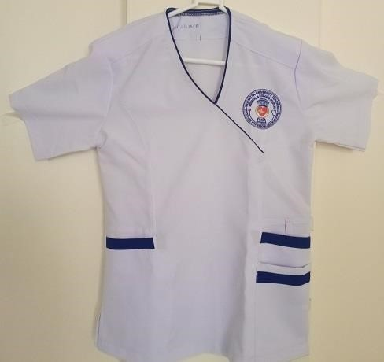

Female uniform

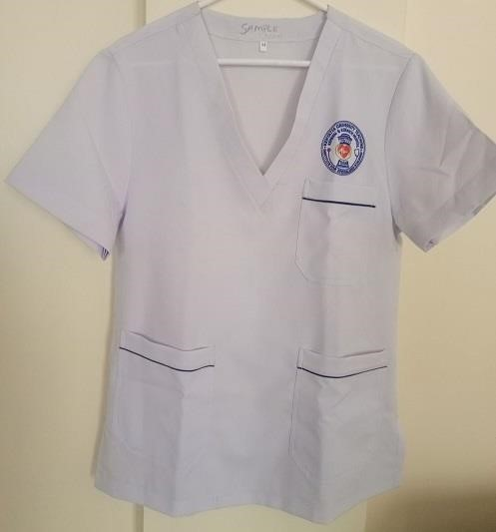

Male uniform

* A stethoscope
* A pen torch.
* General stationery.
* A nurses’ watch.
* A valid NCK License.
* Certified Copies of Academic and Professional Certificates.
* A laptop.
* Valid medical insurance card.
* A pair of white Crocs shoes.

**Note**

* Fees is payable in full or in three instalments as below:
  + 1st installment of Kshs. 100,000 in semester 1
  + 2nd installment of Kshs. 100,000 in semester 2 and
  + 3rd installment of Kshs. 73,250 in semester 3

All fees shall be paid through the following bank account:

**Kenyatta University Training, Referral and Research Hospital Bank:**

**KCB Bank**

**Branch: TRM Branch**

**AC. No. 1258637243**

Provide evidence of your payments during registration.

For more enquiries contact us through traininginstitute@kutrrh.go.ke or call the Administrator or Head of Institute through **0715 124236**

Yours sincerely

Dr. Caroline Ngugi

Director, Training & Research

Kenyatta University Teaching, Referral & Research Hospital