Dustyne Brown – Hands On MS Assessment – 4/25/12

Step #11-Statistics

What is your project cost? $59,140.00

When will your project finish? 7/23/12

What is its current duration in days? 51.44days

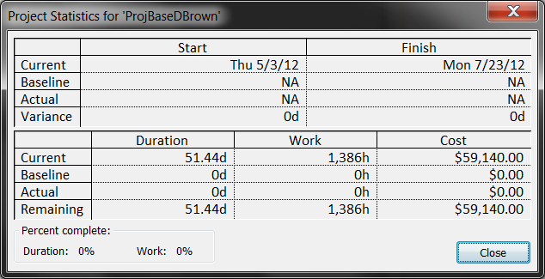

Step#12-Gnatt

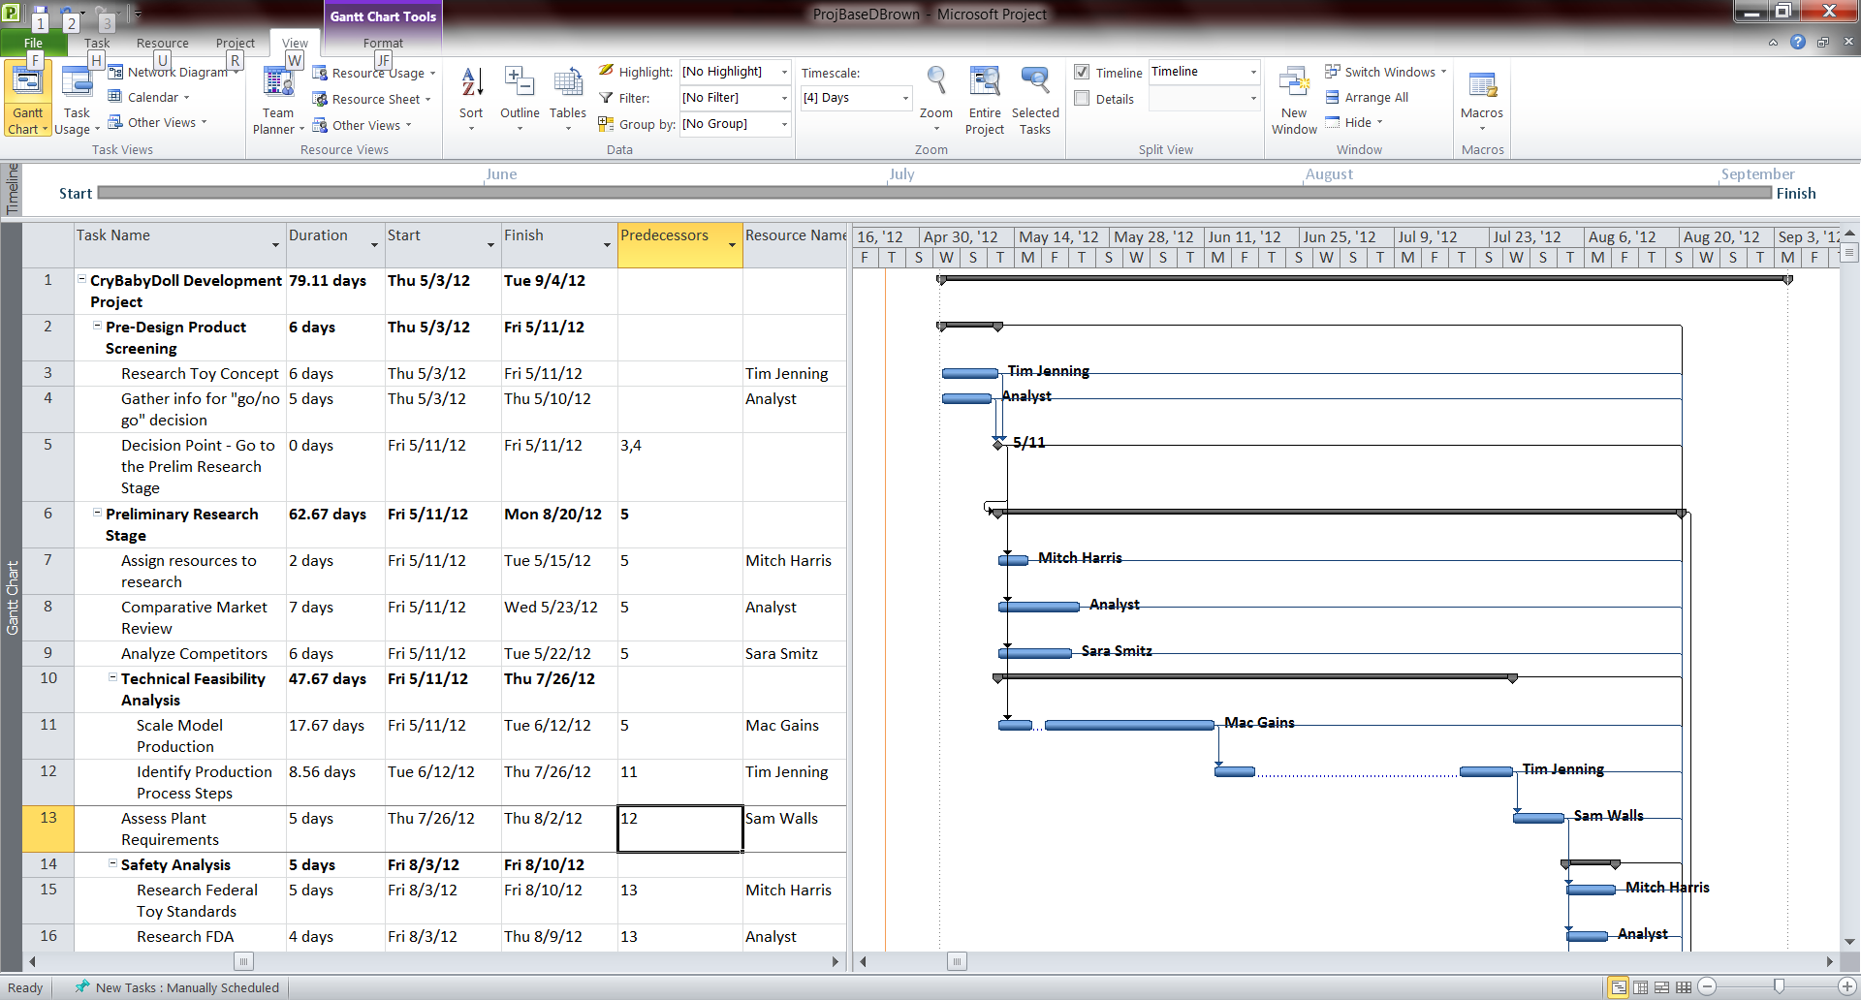

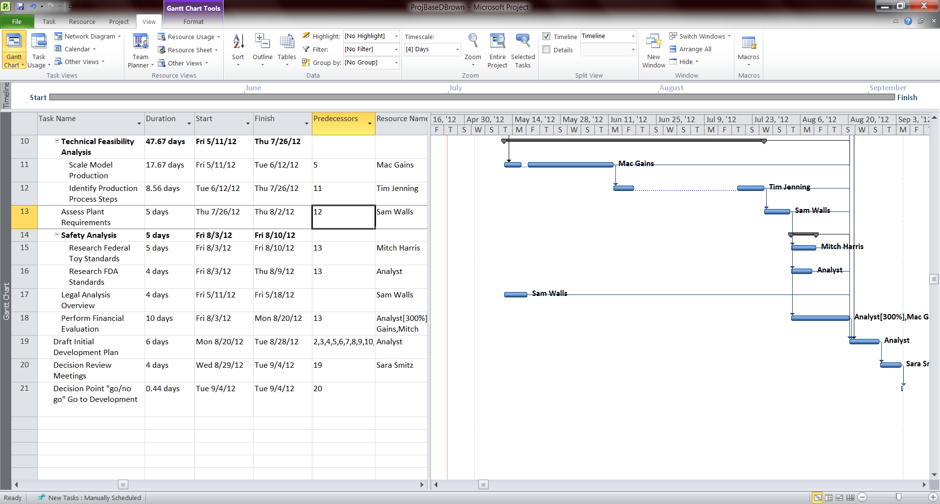

Step#13- Resources

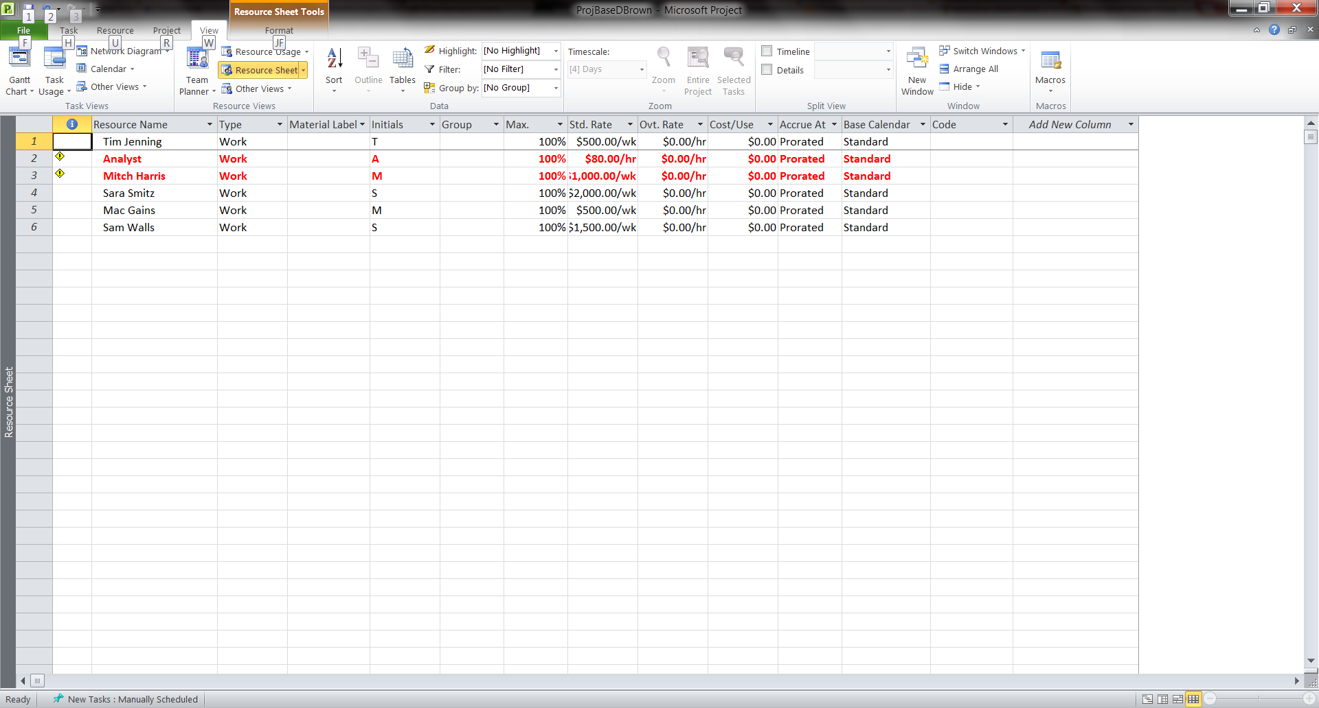

Step#14 – Reports

A:Report Overview – “Top Level Tasks”

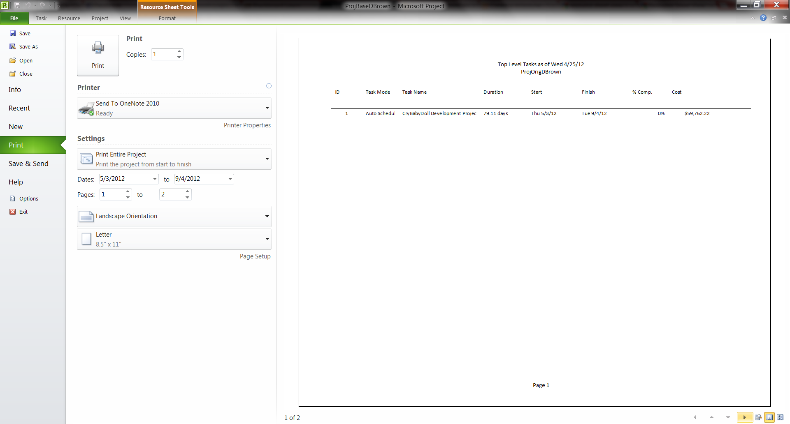

B: Report Overview – Milestones

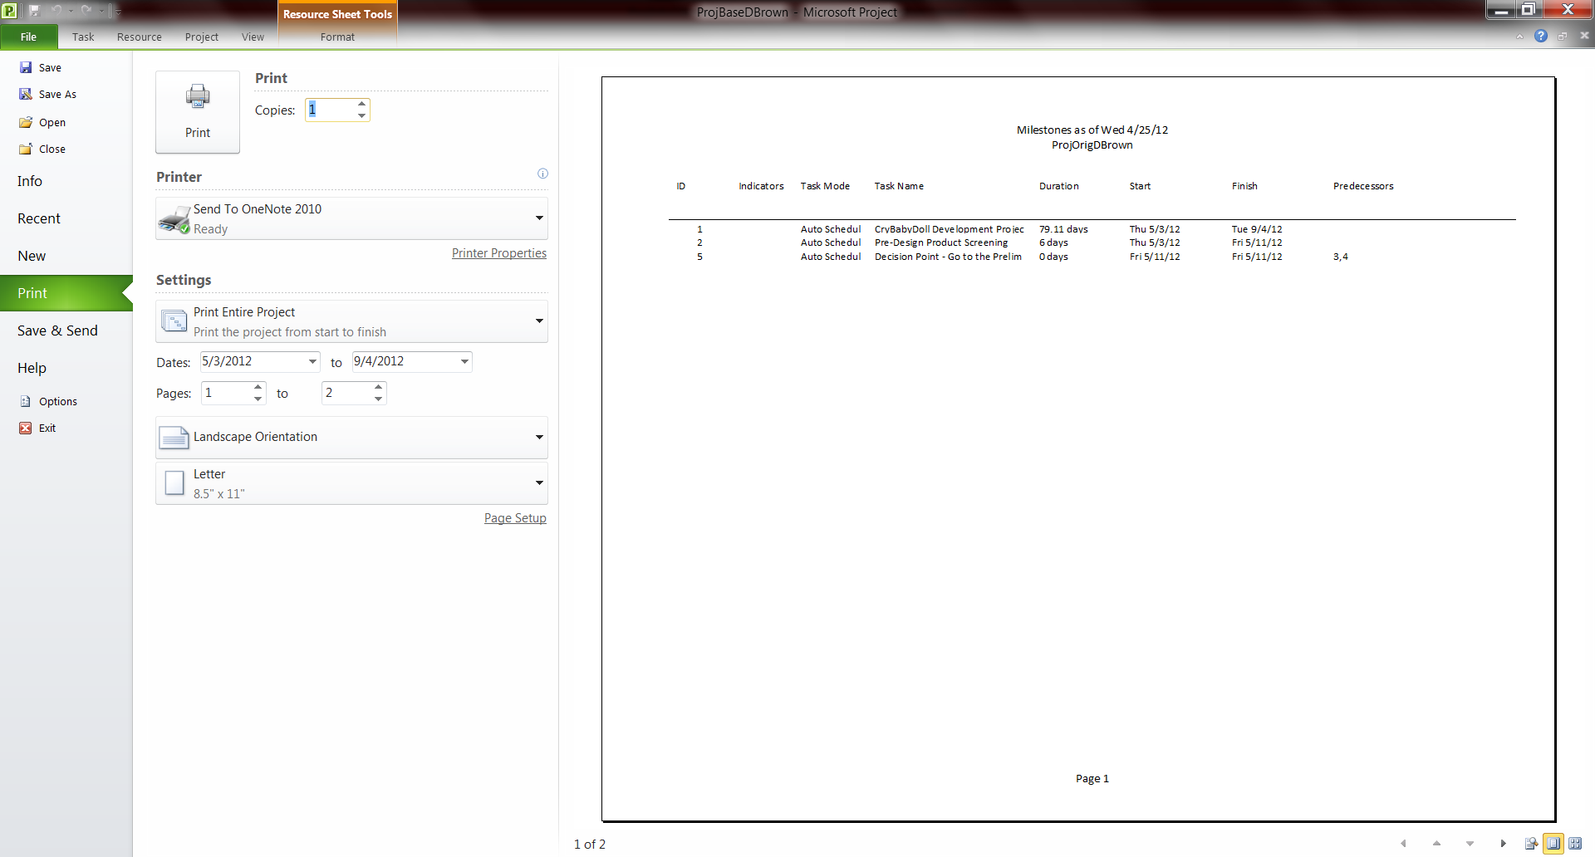

C: Report Assignments – “Who does what?”

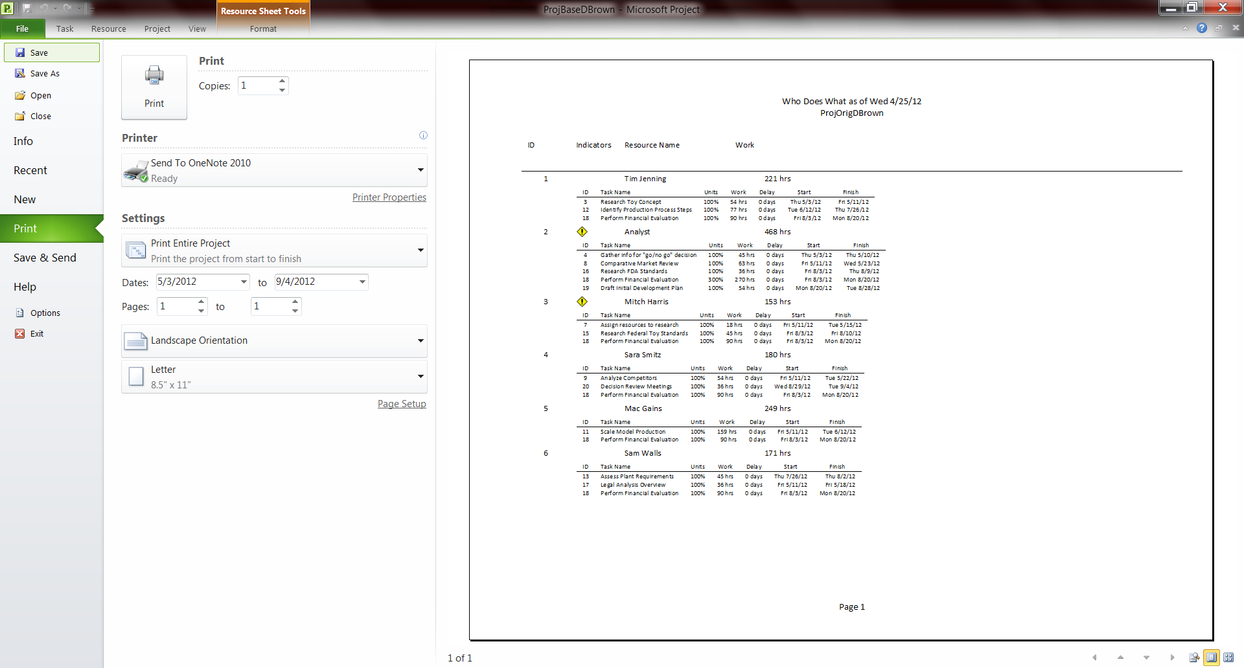

D: Report Overview – “Working Days”

