Dustyne Brown

Database Modeling

#2 – First Normal Form

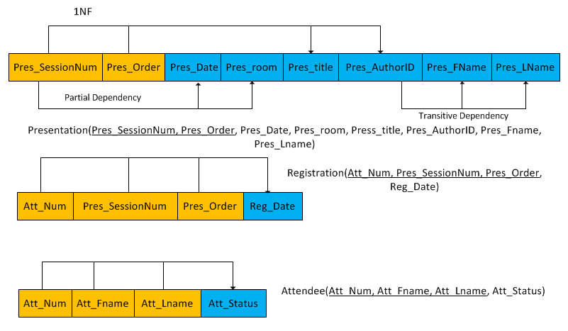

#6 Components

|  |  |  |  |
| --- | --- | --- | --- |
| Entity | What does a record (row) in this table represent? | When would we add a row to this table? | When (If ever) would we delete a row from this table?) |
| Place | The Presentation’s location and time | If we were hosting presentations in different states | If every clock in the world stopped working |
| Presentation | Tells us the Presentation’s number, title and Author (So general information about the presentation) | If there were multiple Authors to a presentation | If the company hosting these presentations were to use the presentation’s order to determine its Number |
| Author | Lists the Author’s name in relation to their number | If we wanted their middle initial | If the company decided to only list last names |
| Registration | Registration dates of the presentation | If we wished to collect more information about the Presentation (Example, admission fees if they charge) | If company decided to not track the order of the presentations  and simply know the order based off the presentation’s date |
| Attendee | The names and status of the attendees at each presentation | If we wished to gather more information about the attendee | IF we desired to only track last or first names, a row could be deleted |