Route /

Delete movie with id 573a1390f29313caabcd4eaf.

Movie 573a1390f29313caabcd4eaf deleted:

Get movie with id 573a1391f29313caabcd6f98

Update existing movie:

Trying to update deleted movie:

Get movies with query

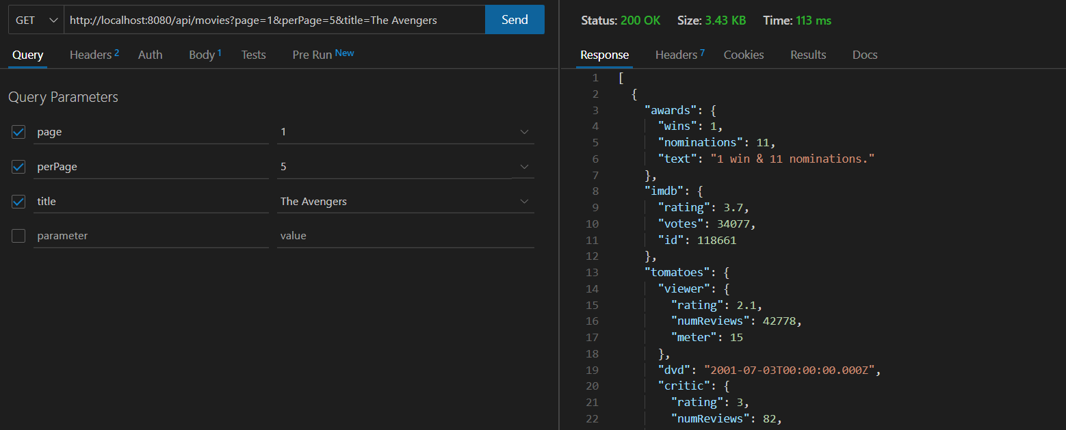

Wrong route:

