МІНІСТЕРСТВО ОСВІТИ І НАУКИ, МОЛОДІ ТА СПОРТУ УКРАЇНИ
Національний аерокосмічний університет ім. М.Є. Жуковського
“Харківський авіаційний інститут”

Кафедра комп’ютерних систем, мереж і кібербезпеки

Лабораторна робота № 7

з дисципліни “Технології програмування”

РОЗРОБЛЕННЯ JAVA-ЗАСТОСУНКІВ З ВИКОРИСТАННЯМ ОБ’ЄКТНО-
ОРІЄНТОВАНОГО ПІДХОДУ.

ХАІ.503.525і1.22о. 125, ПЗ

Виконав студент гр. 525і1 Проценко Д.І.
(№ групи) (П.І.Б.)

(підпис, дата)

Перевірив ст. викладач каф.503
(науковий ступінь, вчене звання, посада)

Здоровець Ю. В.

(підпис, дата) (П.І.Б.)

Харків 2022

Тема роботи: Розроблення Java-застосунків з використанням об’єктно орієнтованого підходу.

Мета роботи:
1. Відпрацювати навички об'єктно-орієнтованого аналізу і розробки архітектури програмних систем.

2. Навчитися розробляти програми на мові Java з використанням об'єктно орієнтованого підходу.

Завдання 1.

Частина 1. Умови завдання
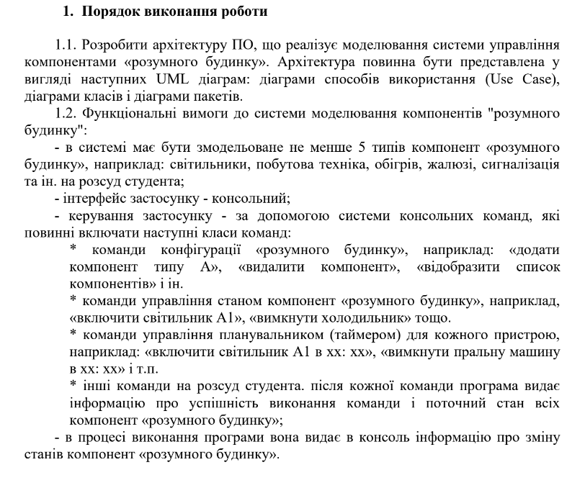
Рис. 1 Умови завдання
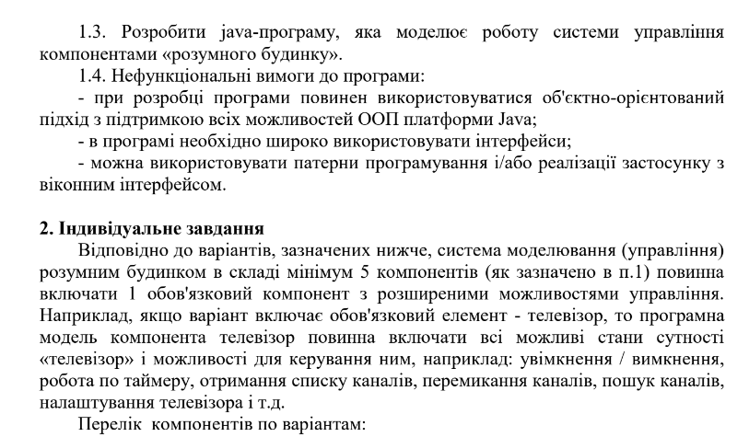
Рис. 2 Персональне завдання

Частина 2. Текст програми
import javax.management.InvalidAttributeValueException;
import java.io.*;
import java.security.InvalidKeyException;
import java.util.*;
import java.util.stream.Collectors;
public class Main {
public static void main(String[] args) throws IOException, InvalidKeyException {
//make a list of starter pack house objects
List<House> objects = new ArrayList<>();
Scanner s = new Scanner(System.in);
int changeable = 0;
int changeable2 = 0;
CreateStarterPack(objects);
Menu1(objects);
}
private static void Menu1(List<House> objects) throws IOException, InvalidKeyException {
Scanner s = new Scanner(System.in);
int changeable = 0;
int changeable2 = 0;
System.out.println("\nNext move:\n1.Add new object\n2.Delete object\n" +
"3.Change condition of object\n4.Working at user time\nelse.EXIT");
changeable = s.nextInt();
try {
switch (changeable) {
case 1:
CreateNewObject(objects);
break;
case 2:
System.out.print("Which one :");
changeable2 = s.nextInt();
if (changeable2 >= objects.size())
throw new IllegalArgumentException("Illegal argument of list: " + changeable2);
objects.remove(changeable2-1);
break;
case 3:
System.out.print("Which one :");
changeable2 = s.nextInt();
if (changeable2 > objects.size())
throw new IllegalArgumentException("Illegal argument of list: " + changeable2);
ChangeObject(objects,changeable2 - 1);
break;
case 4:
Time time1 = new Time(0,0);
System.out.println("Time(int int): ");
time1.setHours(s.nextInt());
if (time1.getHours() > 23)
throw new InvalidAttributeValueException("Wrong hours value - " + time1.getHours());
time1.setMinutes(s.nextInt());
if (time1.getMinutes() > 59)
throw new InvalidAttributeValueException("Wrong minutes value - " + time1.getMinutes());
List<House> Filtered_Objects = objects.stream()
.filter(house -> house.isWithinWorkingHours(time1))
.collect(Collectors.toList());
System.out.println();
int i = 1;
for (House object : Filtered_Objects) {
System.out.println(i++ + ": " + object);
}
Filtered_Objects.clear();
Menu1(objects);
default:
System.exit(0);
}
} catch (IOException e) {
throw new RuntimeException(e);
} catch (InvalidKeyException e) {
throw new RuntimeException(e);
} catch (IllegalArgumentException e) {
System.err.println("Error:" + e.getMessage());
} catch (InvalidAttributeValueException e) {
throw new RuntimeException(e);
}
int i = 1;
System.out.println();
for (House object : objects) {
System.out.println(i++ + ": " + object);
}
Menu1(objects);
}
private static void ChangeObject(List<House> objects, int num) throws IOException {
House object = objects.get(num);
int changeable;
Scanner s = new Scanner(System.in);
Time time1 = new Time(0, 0);
/*
System.out.println("\nWhat type:\n1.Fridge\n2.Blinds\n3.Lamp\n4.Conditioner\n5.Shower_cabin");
changeable = s.nextInt();
House house = null;
boolean active;
int Temperature;
boolean Shower;
Time time1 = new Time(0,0);
Time time2 = new Time(0,0);
switch (changeable)
{
case 1:
System.out.println("Change: 1.Temperature\n2.Change condition\n3.Time On\n4.Time Off\nelse.Get back");
changeable = s.nextInt();
switch (changeable){
case 1:
System.out.print("Temperature: ");
}
}
*/
try {
if (object instanceof Fridge) {
System.out.println("\nChange: \n1.Change condition\n2.Time On\n3.Time Off\n4.Temperature\nelse.Get back");
changeable = s.nextInt();
switch (changeable) {
case 1:
if (object.isActive())
object.ElementOff();
else
object.ElementOn();
System.out.println("***CHANGE COMPLETE***");
break;
case 2:
System.out.println("Time(int int): ");
time1.setHours(s.nextInt());
if (time1.getHours() > 23)
throw new InvalidAttributeValueException("Wrong hors value - " + time1.getHours());
time1.setMinutes(s.nextInt());
if (time1.getMinutes() > 59)
throw new InvalidAttributeValueException("Wrong minutes value - " + time1.getMinutes());
object.onTime(time1);
break;
case 3:
System.out.println("Time(int int): ");
time1.setHours(s.nextInt());
if (time1.getHours() > 23)
throw new InvalidAttributeValueException("Wrong hors value - " + time1.getHours());
time1.setMinutes(s.nextInt());
if (time1.getMinutes() > 59)
throw new InvalidAttributeValueException("Wrong minutes value - " + time1.getMinutes());
object.offTime(time1);
break;
case 4:
System.out.print("Temperature: ");
((Fridge) object).setTemperature(s.nextInt());
System.out.println("***CHANGE COMPLETE***");
break;
default:
//Menu1(objects);
break;
}
} else if (object instanceof Blinds) {
System.out.println("\nChange: \n1.Change condition\n2.Time On\n3.Time Off\nelse.Get back");
changeable = s.nextInt();
switch (changeable) {
case 1:
if (object.isActive())
object.ElementOff();
else
object.ElementOn();
System.out.println("***CHANGE COMPLETE***");
break;
case 2:
System.out.println("Time(int int): ");
time1.setHours(s.nextInt());
if (time1.getHours() > 23)
throw new InvalidAttributeValueException("Wrong hours value - " + time1.getHours());
time1.setMinutes(s.nextInt());
if (time1.getMinutes() > 59)
throw new InvalidAttributeValueException("Wrong minutes value - " + time1.getMinutes());
object.onTime(time1);
break;
case 3:
System.out.println("Time(int int): ");
time1.setHours(s.nextInt());
if (time1.getHours() > 23)
throw new InvalidAttributeValueException("Wrong hours value - " + time1.getHours());
time1.setMinutes(s.nextInt());
if (time1.getMinutes() > 59)
throw new InvalidAttributeValueException("Wrong minutes value - " + time1.getMinutes());
object.offTime(time1);
break;
default:
//Menu1(objects);
break;
}
} else if (object instanceof Lamp) {
System.out.println("\nChange: \n1.Change condition\n2.Time On\n3.Time Off\nelse.Get back");
changeable = s.nextInt();
switch (changeable) {
case 1:
if (object.isActive())
object.ElementOff();
else
object.ElementOn();
System.out.println("***CHANGE COMPLETE***");
break;
case 2:
System.out.println("Time(int int): ");
time1.setHours(s.nextInt());
if (time1.getHours() > 23)
throw new InvalidAttributeValueException("Wrong hours value - " + time1.getHours());
time1.setMinutes(s.nextInt());
if (time1.getMinutes() > 59)
throw new InvalidAttributeValueException("Wrong minutes value - " + time1.getMinutes());
object.onTime(time1);
break;
case 3:
System.out.println("Time(int int): ");
time1.setHours(s.nextInt());
if (time1.getHours() > 23)
throw new InvalidAttributeValueException("Wrong hours value - " + time1.getHours());
time1.setMinutes(s.nextInt());
if (time1.getMinutes() > 59)
throw new InvalidAttributeValueException("Wrong minutes value - " + time1.getMinutes());
object.offTime(time1);
break;
default:
//Menu1(objects);
break;
}
} else if (object instanceof Conditioner) {
System.out.println("\nChange: \n1.Change condition\n2.Time On\n3.Time Off\n4.Temperature\nelse.Get back");
changeable = s.nextInt();
switch (changeable) {
case 1:
if (object.isActive())
object.ElementOff();
else
object.ElementOn();
System.out.println("***CHANGE COMPLETE***");
break;
case 2:
System.out.println("Time(int int): ");
time1.setHours(s.nextInt());
if (time1.getHours() > 23)
throw new InvalidAttributeValueException("Wrong hours value - " + time1.getHours());
time1.setMinutes(s.nextInt());
if (time1.getMinutes() > 59)
throw new InvalidAttributeValueException("Wrong minutes value - " + time1.getMinutes());
object.onTime(time1);
break;
case 3:
System.out.println("Time(int int): ");
time1.setHours(s.nextInt());
if (time1.getHours() > 23)
throw new InvalidAttributeValueException("Wrong hours value - " + time1.getHours());
time1.setMinutes(s.nextInt());
if (time1.getMinutes() > 59)
throw new InvalidAttributeValueException("Wrong minutes value - " + time1.getMinutes());
object.offTime(time1);
break;
case 4:
System.out.print("Temperature: ");
((Fridge) object).setTemperature(s.nextInt());
System.out.println("***CHANGE COMPLETE***");
break;
default:
//Menu1(objects);
break;
}
} else if (object instanceof Shower_cabin){
System.out.println("\nChange: \n1.Change condition\n2.Time On\n3.Time Off\n" +
"4.Temperature\n5.Change Hydro Massage\nelse.Get back");
changeable = s.nextInt();
switch (changeable) {
case 1:
if (object.isActive())
object.ElementOff();
else
object.ElementOn();
System.out.println("***CHANGE COMPLETE***");
break;
case 2:
System.out.println("Time(int int): ");
time1.setHours(s.nextInt());
if (time1.getHours() > 23)
throw new InvalidAttributeValueException("Wrong hours value - " + time1.getHours());
time1.setMinutes(s.nextInt());
if (time1.getMinutes() > 59)
throw new InvalidAttributeValueException("Wrong minutes value - " + time1.getMinutes());
object.onTime(time1);
break;
case 3:
System.out.println("Time(int int): ");
time1.setHours(s.nextInt());
if (time1.getHours() > 23)
throw new InvalidAttributeValueException("Wrong hours value - " + time1.getHours());
time1.setMinutes(s.nextInt());
if (time1.getMinutes() > 59)
throw new InvalidAttributeValueException("Wrong minutes value - " + time1.getMinutes());
object.offTime(time1);
break;
case 4:
System.out.print("Temperature: ");
((Shower_cabin) object).setTemperature(s.nextInt());
System.out.println("***CHANGE COMPLETE***");
break;
case 5:
if(((Shower_cabin) object).isHydroMassage())
((Shower_cabin) object).OffHydroMassage();
else
((Shower_cabin) object).OnHydroMassage();
break;
default:
//Menu1(objects);
break;
}
}
} catch(InvalidAttributeValueException e){
System.err.println("Wrong value of time: " + e.getMessage());
throw new RuntimeException(e);
}
}
private static void CreateNewObject(List<House> objects) throws IOException, InvalidKeyException {
int changeable;
Scanner s = new Scanner(System.in);
System.out.println("\nWhat type:\n1.Fridge\n2.Blinds\n3.Lamp\n4.Conditioner\n5.Shower_cabin");
changeable = s.nextInt();
House house = null;
boolean active;
int Temperature;
boolean Shower;
Time time1 = new Time(0, 0);
Time time2 = new Time(0, 0);
System.out.print("Is active(true/false): ");
active = s.nextBoolean();
System.out.print("Time on(int int): ");
time1.setHours(s.nextInt());
time1.setMinutes(s.nextInt());
System.out.print("Time off(int int): ");
time2.setHours(s.nextInt());
time2.setMinutes(s.nextInt());
try {
switch (changeable) {
case 1:
System.out.print("Temperature(int): ");
Temperature = s.nextInt();
house = new Fridge(active, time1, time2, Temperature);
break;
case 2:
house = new Blinds(active, time1, time2);
break;
case 3:
house = new Lamp(active, time1, time2);
break;
case 4:
System.out.print("Temperature(int): ");
Temperature = s.nextInt();
house = new Conditioner(active, time1, time2, Temperature);
break;
case 5:
System.out.print("Temperature(int): ");
Temperature = s.nextInt();
System.out.print("Hydro Massage(true/false): ");
Shower = s.nextBoolean();
house = new Shower_cabin(active, time1, time2, Temperature, Shower);
break;
default:
throw new InvalidKeyException("Invalid key:" + changeable);
}
objects.add(house);
} catch (InvalidKeyException e) {
System.err.println("Error:" + e.getMessage());
}
}
private static void CreateStarterPack(List <House> objects)throws IOException{
Time onTime2 = new Time(9, 0);
Time offTime2 = new Time(18, 0);
Blinds blinds1 = new Blinds(false, onTime2, offTime2);
objects.add(blinds1);
Time onTime3 = new Time(5, 0);
Time offTime3 = new Time(8, 0);
Lamp lamp1 = new Lamp(false, onTime3, offTime3);
objects.add(lamp1);
Time onTime1 = new Time(9, 0);
Time offTime1 = new Time(22, 0);
Fridge fridge1 = new Fridge(true, onTime1, offTime1, 15);
objects.add(fridge1);
Time onTime4 = new Time(15,30);
Time offTime4 = new Time(19,30);
Conditioner conditioner1 = new Conditioner(true, onTime4, offTime4, 18);
objects.add(conditioner1);
Time onTime5 = new Time(19,00);
Time offTime5 = new Time(20,30);
Shower_cabin shower_cabin1 = new Shower_cabin(true,onTime5, offTime5,65,true);
objects.add(shower_cabin1);
int i = 1;
System.out.println("\n\t\tSTARTER PACK");
for (House object : objects) {
System.out.println(i++ + ": " + object);
}
}
}
class Time {
private int hours;
private int minutes;
public Time(int hours, int minutes)
{
this.minutes = minutes;
this.hours = hours;
}
public void setHours(int hours) {
this.hours = hours;
}
public void setMinutes(int minutes) {
this.minutes = minutes;
}
public int getHours() {
return hours;
}
public int getMinutes() {
return minutes;
}
public String getTime() {
return hours + ":" + minutes;
}
}
public interface Controller{
public void onTime(Time onTime);
public void offTime(Time offTime);
public void ElementOn();
public void ElementOff();
}
class House implements Controller {
private boolean IsWork;
protected Time OnTime;
protected Time OffTime;
public House(boolean isWork, Time onTime, Time offTime) {
IsWork = isWork;
OnTime = onTime;
OffTime = offTime;
}
@Override
public void onTime(Time onTime) {
this.OnTime = onTime;
}
@Override
public void offTime(Time offTime) {
this.OffTime = offTime;
}
@Override
public void ElementOn() {
IsWork = true;
}
@Override
public void ElementOff() {
IsWork = false;
}
public boolean isActive() {
return IsWork;
}
public boolean isWithinWorkingHours(Time inputTime) {
if(this.isActive() && inputTime.getHours() > OffTime.getHours()){
return true;
} else if (inputTime.getHours() > OnTime.getHours() && inputTime.getHours() < OffTime.getHours()) {
return true;
} else if (inputTime.getHours() == OnTime.getHours() && inputTime.getMinutes() >= OnTime.getMinutes()) {
return true;
} else if (inputTime.getHours() == OffTime.getHours() && inputTime.getMinutes() < OffTime.getMinutes()) {
return true;
}
return false;
}
}
class Blinds extends House{
public Blinds(boolean isWork, Time onTime, Time offTime) {
super(isWork, onTime, offTime);
}
@Override
public String toString() {
return "Blinds {"+
"Condition=" + (isActive() == true? "working":"no working") +
", OnTime=" + OnTime.getTime() +
", OffTime=" + OffTime.getTime() +
"}";
}
}

class Conditioner extends House{
private int Temperature;
public Conditioner(boolean isWork, Time onTime, Time offTime, int temperature) {
super(isWork, onTime, offTime);
Temperature = temperature;
}
@Override
public String toString() {
return "Conditioner {" +
(isActive() == true? "Condition=" + (isActive() == true? "working":"no working") +
", OnTime=" + OnTime.getTime() +
", OffTime=" + OffTime.getTime() +
", Temperature=" + Temperature:
"Condition=" + (isActive() == true? "working":"no working") +
", OnTime=" + OnTime.getTime() +
", OffTime=" + OffTime.getTime()) +
'}';
}
}

class Fridge extends House{
private int Temperature;
public Fridge(boolean isWork, Time onTime, Time offTime, int temperature) {
super(isWork, onTime, offTime);
Temperature = temperature;
}
public void setTemperature(int temperature) {
Temperature = temperature;
}
@Override
public String toString() {
return "Fridge {" +
(isActive() == true? "Condition=" + (isActive() == true? "working":"no working") +
", OnTime=" + OnTime.getTime() +
", OffTime=" + OffTime.getTime() +
", Temperature=" + Temperature :
"Condition=" + (isActive() == true? "working":"no working") +
", OnTime=" + OnTime.getTime() +
", OffTime=" + OffTime.getTime()
) +
'}';
}
}

class Lamp extends House{
public Lamp(boolean isWork, Time onTime, Time offTime) {
super(isWork, onTime, offTime);
}
@Override
public String toString() {
return "Lamp {" +
"Condition=" + (isActive() == true? "working":"no working") +
", OnTime=" + OnTime.getTime() +
", OffTime=" + OffTime.getTime() +
"}";
}
}

class Shower_cabin extends House{
private int Temperature;
private boolean HydroMassage;
public Shower_cabin(boolean isWork, Time onTime, Time offTime, int temperature, boolean hydroMassage) {
super(isWork, onTime, offTime);
Temperature = temperature;
HydroMassage = hydroMassage;
}
public int getTemperature() {
return Temperature;
}
public void setTemperature(int temperature) {
Temperature = temperature;
}
public boolean isHydroMassage() {
return HydroMassage;
}
public void OnHydroMassage() {
HydroMassage = true;
}
public void OffHydroMassage() {
HydroMassage = false;
}
@Override
public String toString() {
return "Shower_cabin{" +
(isActive() == true? "Condition=" + (isActive() == true? "working":"no working") +
", OnTime=" + OnTime.getTime() +
", OffTime=" + OffTime.getTime() +
", Temperature=" + Temperature +
", HydroMassage=" + HydroMassage:
"Condition=" + (isActive() == true? "working":"no working") +
", OnTime=" + OnTime.getTime() +
", OffTime=" + OffTime.getTime()
) +
'}';
}
}

Частина 3. Діаграма структури класів

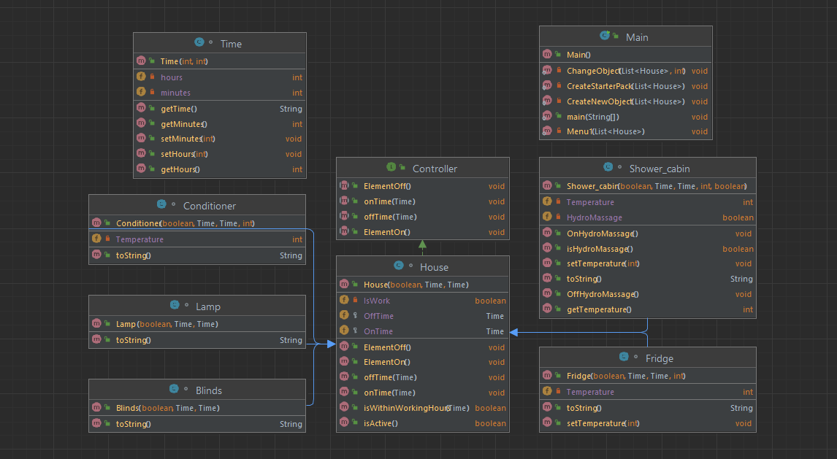
Рис. 3 Діаграма классів

Частина 4. Скріншоти виконання завдання

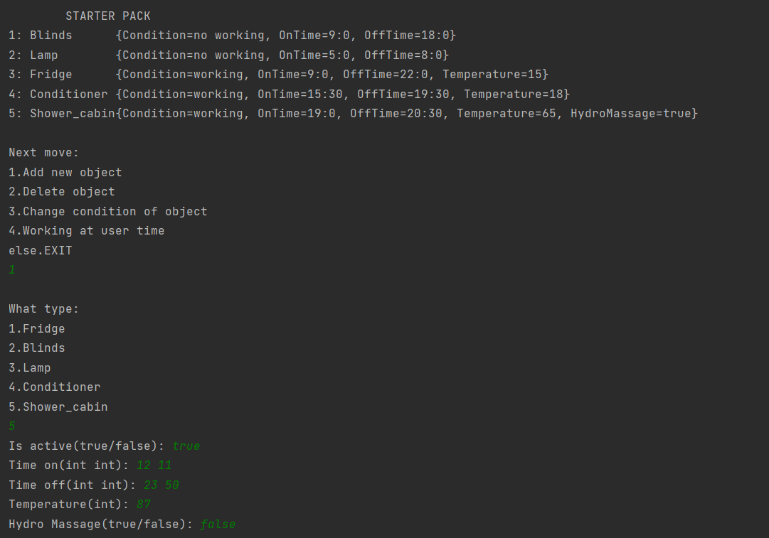
Рис. 4 Скріншот виконання завдання (1 частина)

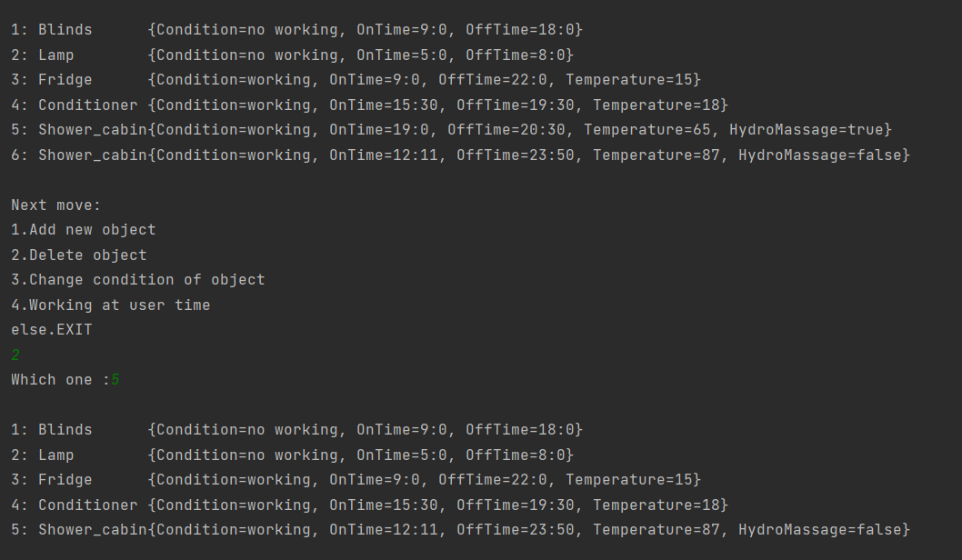
Рис. 5 Скріншот виконання завдання (2 частина)

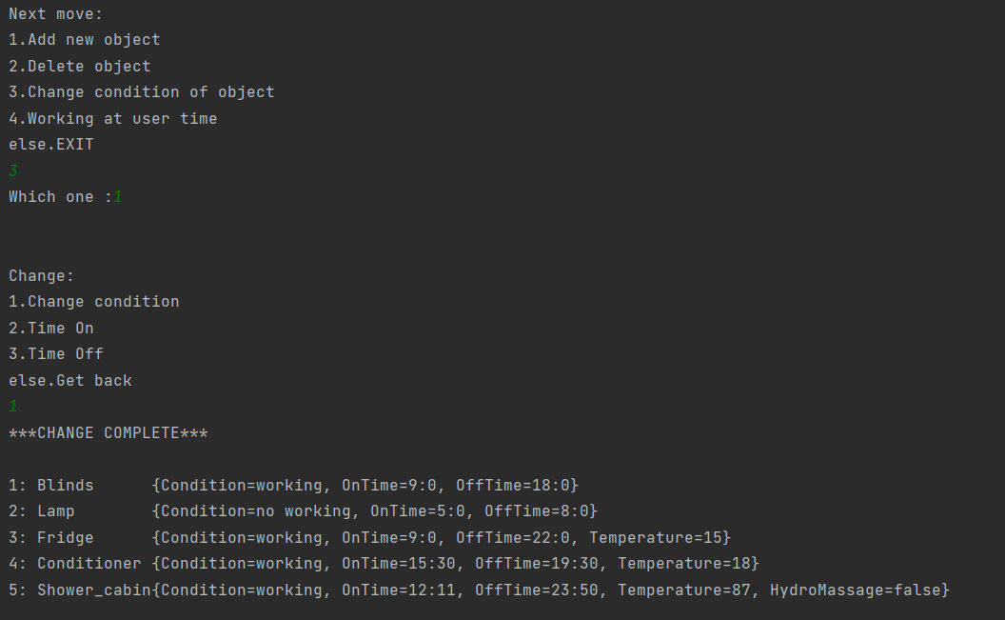
Рис. 6 Скріншот виконання завдання (3 частина)

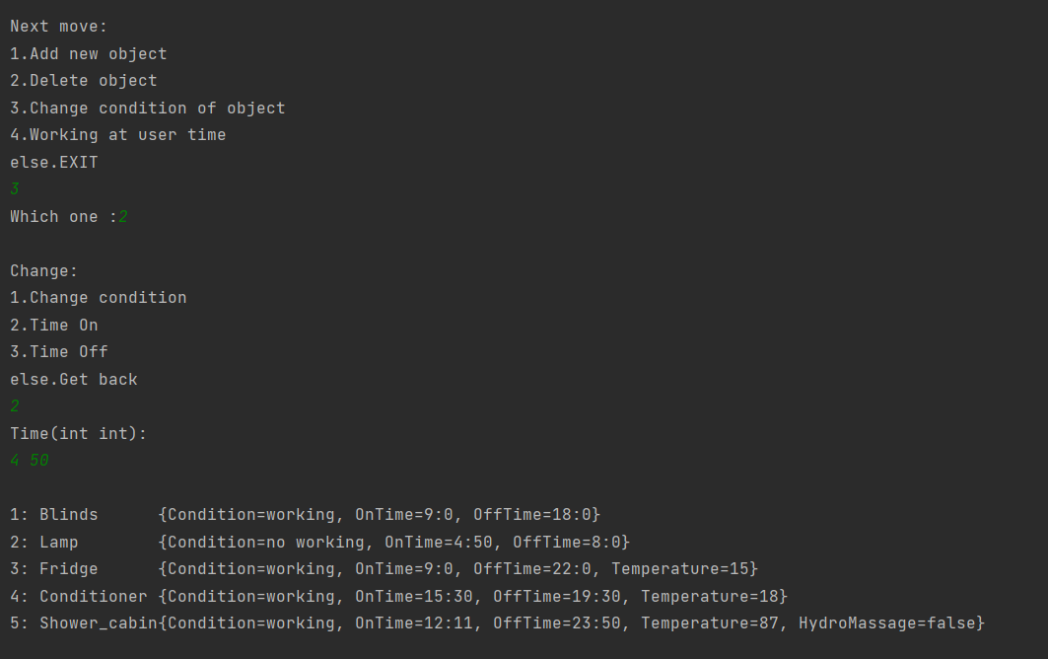
Рис. 7 Скріншот виконання завдання (4 частина)

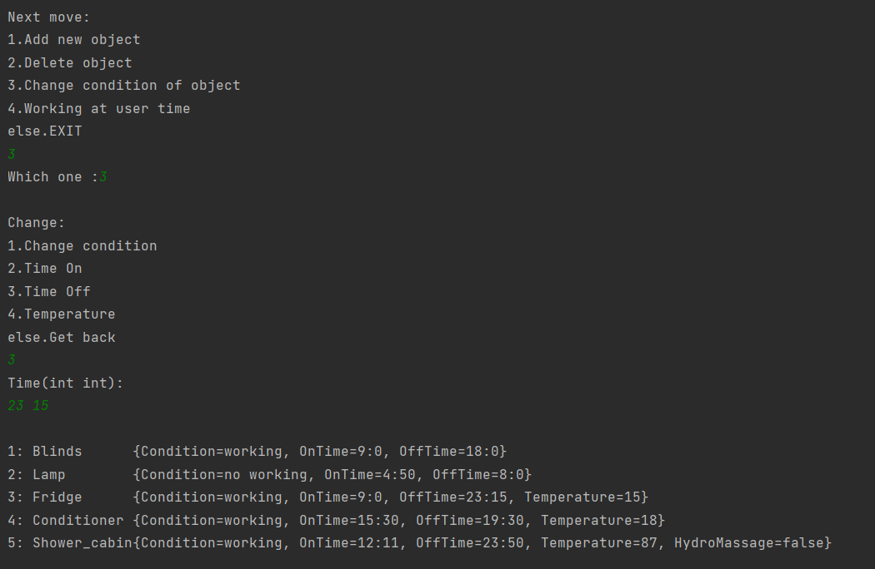
Рис. 8 Скріншот виконання завдання (5 частина)

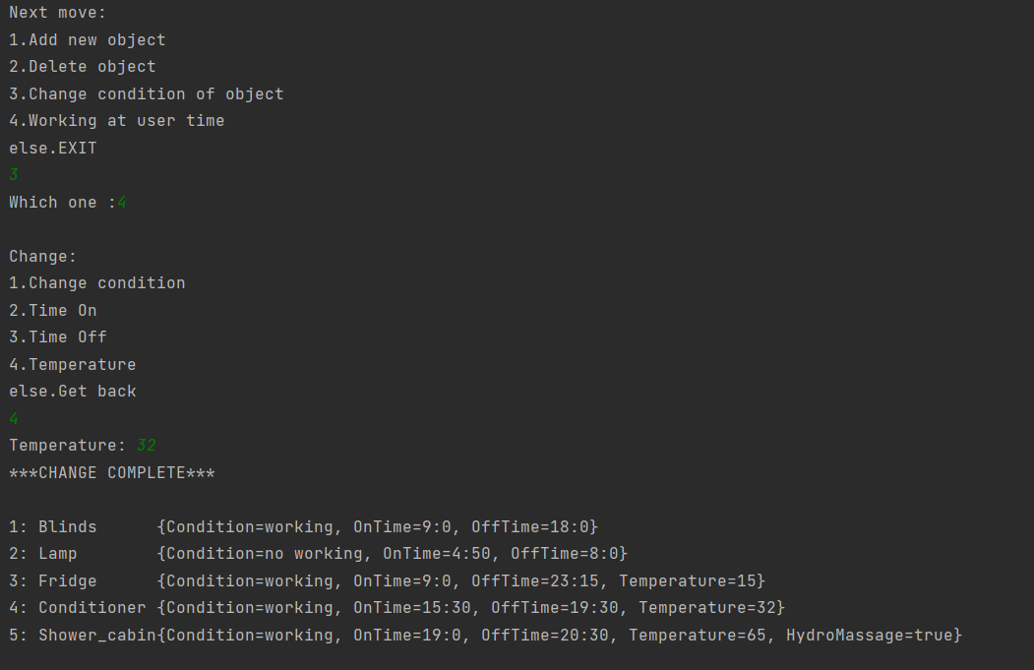
Рис. 9 Скріншот виконання завдання (6 частина)

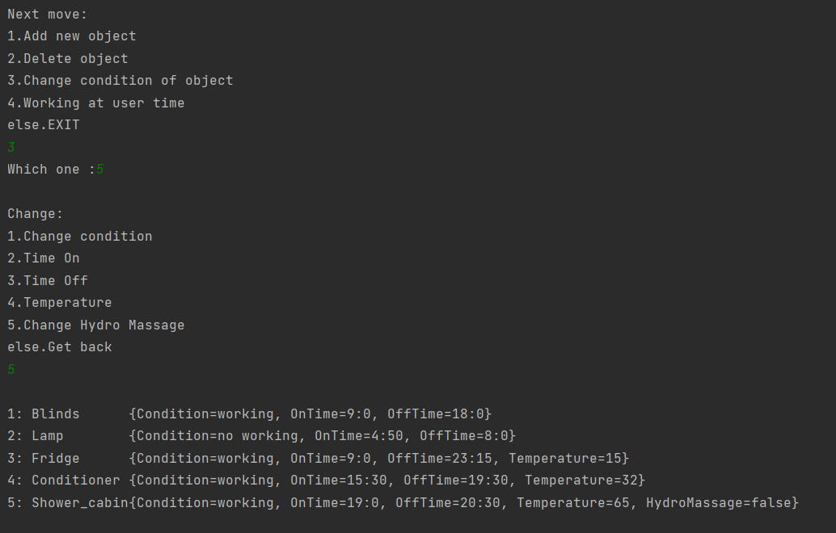
Рис. 10 Скріншот виконання завдання (7 частина)

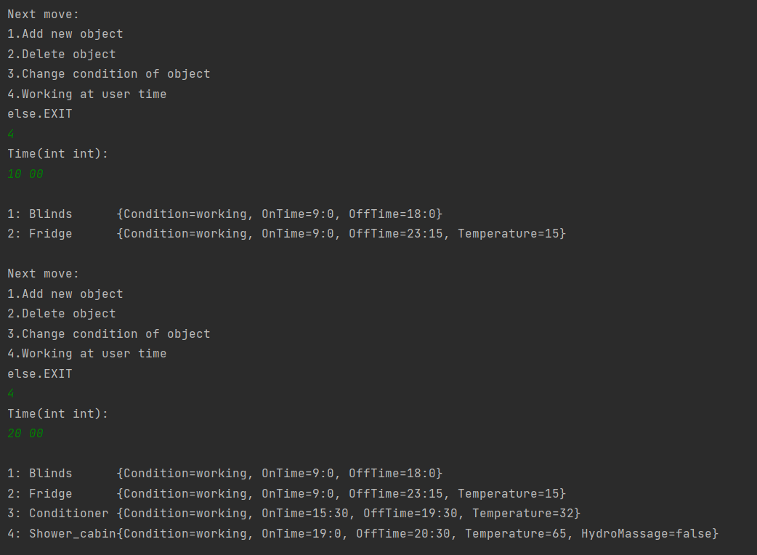
Рис.11 Скріншот виконання завдання (8 частина)

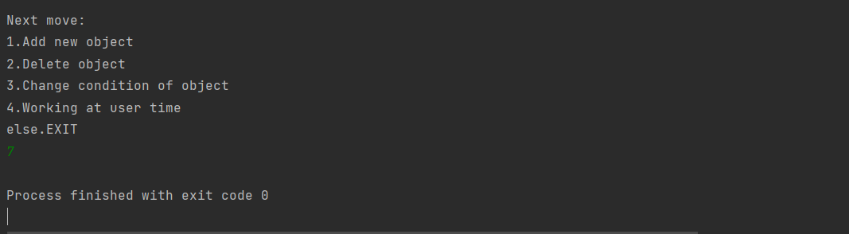
Рис. 12 Скріншот виконання завдання (9 частина)

Завдання 2. (перероблене 5.1)

Частина 1. Умови завдання
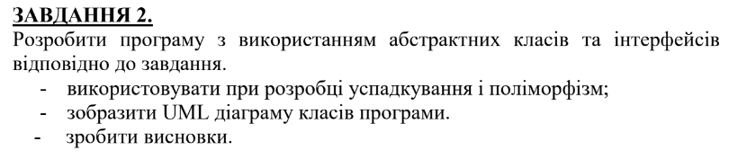
Рис. 13 Умови завдання

Рис. 14 Персональне завдання

Частина 2. Текст програми

/* Film.java */
public interface Film {
public String getName();
public void setName(String name);
public int getBudjet();
public void setBudjet(int budjet);
public void setLanguage(String language);
public String getLanguage();
}

/* UkrainianFilm.java */
abstract class UkrainianFilm implements Film{
protected String language;
protected String Name;
protected int Budjet;
@Override
public String getName() {
return this.Name;
}
@Override
public void setName(String name) {
this.Name = name;
}
@Override
public int getBudjet() {
return this.Budjet;
}
@Override
public void setBudjet(int budjet) {
this.Budjet = budjet;
}
@Override
public void setLanguage(String language) {
this.language = language;
}
@Override
public String getLanguage() {
return this.language;
}
}

/* Comedy.java */

class Comedy extends UkrainianFilm
{
private boolean IsFunny;
public boolean getisFunny() {
return IsFunny;
}
public void setFunny(boolean funny) {
IsFunny = funny;
}
}

Частина 3. Діаграма структури класів

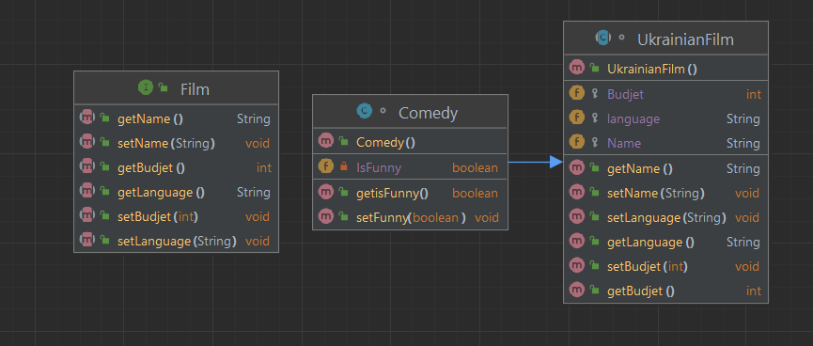

Рис. 15 Діаграма классів

Частина 4. Скріншоти виконання завдання

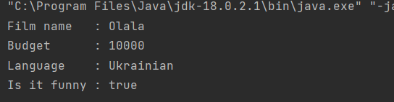
Рис. 16 Скріншот виконання завдання (1 частина)

Висновки
1. Відпрацював навички об'єктно-орієнтованого аналізу і розробки архітектури програмних систем.

2. Навчився розробляти програми на мові Java з використанням об'єктно орієнтованого підходу.

Використані джерела
- Лекції з “Технології програмування”в

