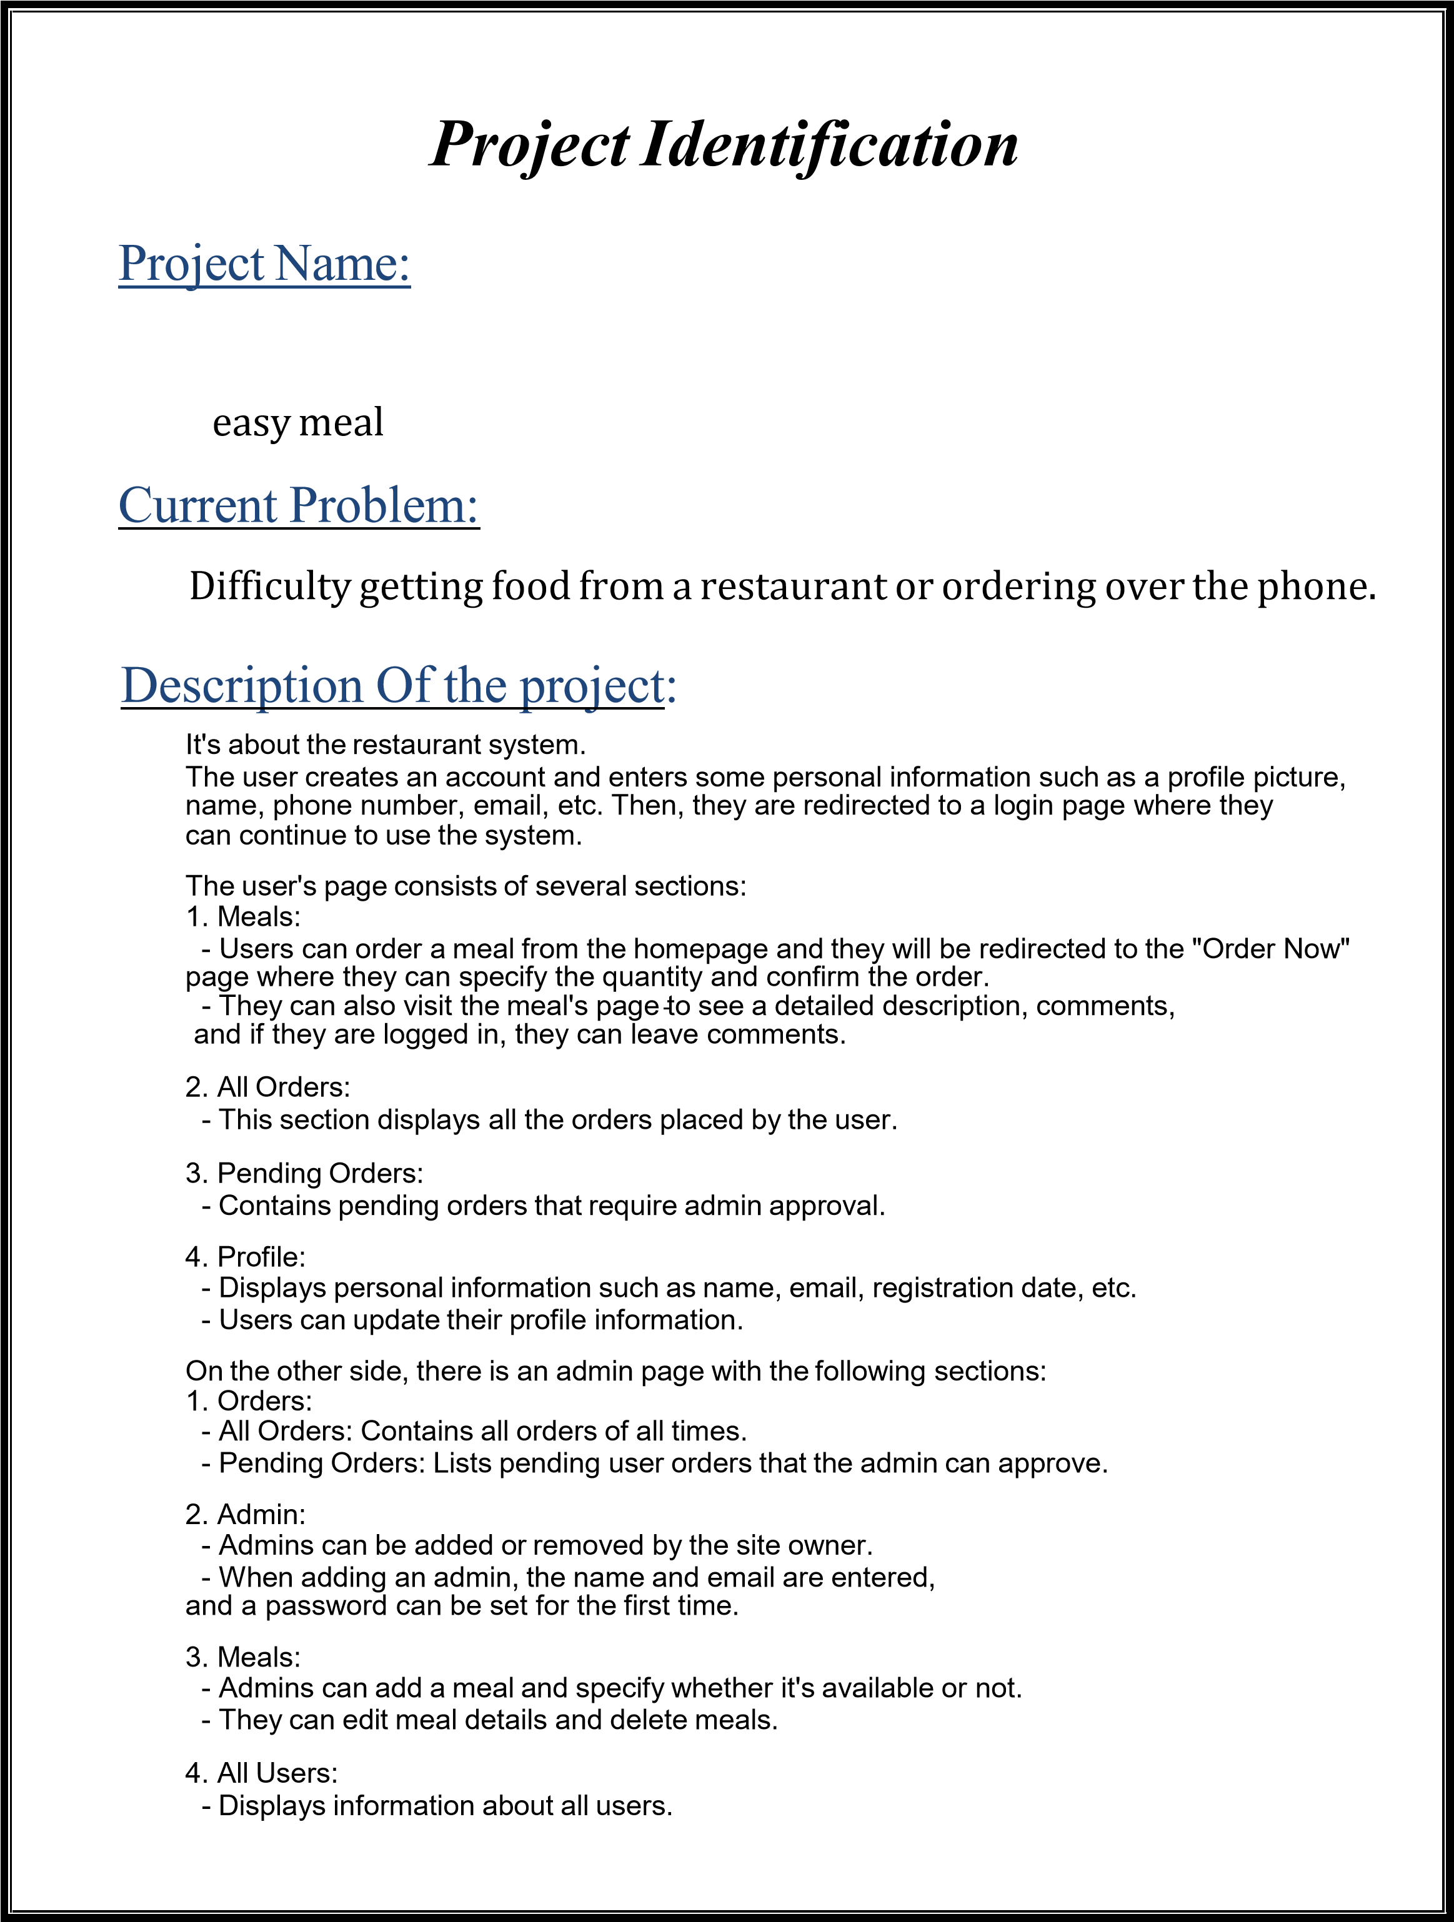
System Request
⇒ (EASY MEAL)
Project Sponsor: | Eng. Ahmed Al-Baz
Business Need: | - Make ordering meals easier and faster  - Ease of choosing your meal and seeing reviews.  - Increase profits.  - Improve Customers services.
Business  Requirements: | - It needs stable internet in the restaurant.  - The customer is aware enough to order foodfrom the Internet.  - High quality pictures of meals.  - Employees to manage this system.
Business Value: | - Increase profit by at least 8% every year.  - Decrease salary of waiters and employees by at least 12% every year.
Special Issues or Constraints: | - Using system wrong.  - Canceled many orders.  - Top level security by team to work with data.
System Request

Feasibility Analysis
Technical Feasibility
- System team should be updated used technology ( front end devolper , back end devolper)
- it user dealing with hard ware in profitional way.
3.data base soft ware .
4.hosting to web site.
Economic Feasibility
- This system cost will be nearly 5000$ to be spent on the used hardware and software and training staff with out salary of devolpers.

- Annual profit will be 10,000$ 15000$.
- I need 5 developers to work on this system and the salary of each one will be 1500 $.
Organizational Feasibility
- This application is familiar and easy to use for any user.
- Senior managers will have full access to this system to add new meals or drinks, on the other hand, other employees have less access (deleting orders or confirm oders).
Project Methodology
Parallel Development.

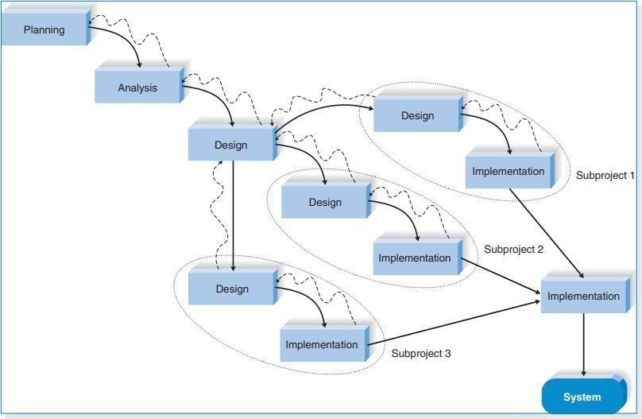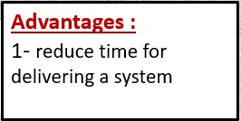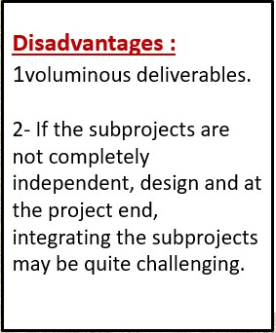

Time Estimation
 | Planning | Analysis | Design | Implementation
Standard percentages | 15% | 20% | 35% | 30%
Estimated time based on planning time | 1.5 month | 2 months | 3.5 months | 3 months
Name of Task | Project Identification
Start Date | 2023-10-01
End Date | 2023-10-10
The person assigned to the task | Amr Tarek
Priority | High
Resources Needed | Microsoft Word
Estimated Time | 9 Days
Actual Time | 4 Day
Name of Task | System Request
Start Date | 2023-10-01
End Date | 2023-10-15
The person assigned to the task | Mohamed osama
Priority | High
Resources Needed | Microsoft Word
Estimated Time | 14 Day
Actual Time | 14 Day
Name of Task | Feasibility Analysis
Start Date | 2023-10-10
End Date | 2023-10-15
The person assigned to the task | Zeyad Hany
Priority | High
Resources Needed | Microsoft Word
Estimated Time | 5 Days
Actual Time | 5 Days
Tasks Identification

Name of Task | Project Methodology
Start Date | 2023-10-15
End Date | 2023-11-01
The person assigned to the task | Amr Tarek
Priority | High
Resources Needed | Microsoft Word
Estimated Time | 17 Day
Actual Time | 9 Day

Name of Task | Time estimation
Start Date | 2023-10-15
End Date | 2023-11-01
The person assigned to the task | Mohammed Hatim
Priority | High
Resources Needed | Microsoft word
Estimated Time | 17 Day
Actual Time | 9 Day

Name of Task | Tasks Identification
Start Date | 2023-11-1
End Date | 2023-11-10
The person assigned to the task | Abdulrahman Mohammed
Priority | High
Resources Needed | Microsoft word
Estimated Time | 9 Day
Actual Time | 5 Day
Name of Task | Pert Chart
Start Date | 2023-11-10
End Date | 2023-11-20
The person assigned to the task | Abdulrahman Ashraf
Priority | High
Resources Needed | Microsoft Word
Estimated Time | 10 Days
Actual Time | 9 Day

Name of Task | Gantt chart
Start Date | 2023-11-20
End Date | 2023-11-30
The person assigned to the task | Mohammed Alaa
Priority | High
Resources Needed | Microsoft Word Microsoft Excel
Estimated Time | 10 Days
Actual Time | 10 Day

Name of Task | Interview
Start Date | 2023-11-20
End Date | 2023-11-30
The person assigned to the task | Zeyad Hany  Amr Tarek  Ahmed wally  Abdulrahman Ashraf  Mohamed Osama
Priority | High
Resources Needed | Microsoft Word
Estimated Time | 10 Days
Actual Time | 10 Day

Name of Task | Questionnaire
Start Date | 2023-11-20
End Date | 2023-11-30
The person assigned to the task | Mohammed Hatim
Priority | High
Resources Needed | Google Forms
Estimated Time | 10 Days
Actual Time | 10 Day

Name of Task | Context diagram
Start Date | 2023-12-1
End Date | 2023-12-15
The person assigned to the task | Abdulrahman Mohammed
Priority | High
Resources Needed | app.creately
Estimated Time | 15 Days
Actual Time | 15 Day

Name of Task | Level-0 _ DFD
Start Date | 2023-12-15
End Date | 2023-12-25
The person assigned to the task | Abdulrahman Mohammed
Priority | High
Resources Needed | app.creately
Estimated Time | 10 Days
Actual Time | 10 Day

Task ID | Task Name | Assigned  to | Estimated |  |  | Actual |  |  | Dependenc  y | Status
 |  |  | Duratio n  (Days) | Start Date | Finish Date | Start Date | Finish Date | Duration  Variance
A | Project Identification | Amr Tarek | 9 | 2024-  10-01 | 2024-  10-10 | 2024-  10-01 | 2024- 10-5 | 4 | - | Closed
B | System Request | Mohamed osama | 14 | 2024-  10-01 | 2024-  10-15 | 2024- 10-01 | 2024-  10-15 | 14 | - | Closed
C | Feasibility  Study | Zeyad Hany | 5 | 2024-  10-10 | 2024-  10-15 | 2024-  10-6 | 2024-  10-11 | 5 | A | Closed
D | Project Methodology | Amr Tarek | 17 | 2024-  10-15 | 2024-  11-01 | 2024-  10-11 | 2024-  10-20 | 9 | C | Closed
E | Time  estimation | Mohammed  Hatim | 17 | 2024-  10-15 | 2024-  11-01 | 2024-  10-11 | 2024-  10-20 | 9 | C | Closed
F | Task | Abdulrahman  Mohammed | 9 | 2024- | 2024- | 2024- | 2024- | 5 | E | Closed
 | Identification |  |  | 11-01 | 11-10 | 10-20 | 10-25
G | Work Plan | Mohammed alaa | 9 | 2024-  11-1 | 2024-  11-10 | 2024- 10-20 | 2024-  10-25 | 5 | E | Closed
H | Pert Chart | ahmed  wally | 10 | 2024- 11-10 | 2024-  11-20 | 2024-  11-11 | 2024-  11-20 | 9 | F, G | Closed
I | Gantt Chart | ahmed wally | 10 | 2024-11- 20 | 2024-11- 30 | 2024-11- 20 | 2024-1130 | 10 | G, H | Closed
J | Questionnaire | Amr tarek | 10 | 2024-11- 20 | 2024-11- 30 | 2024-11- 20 | 2024-1120 | 10 | -
k | Interview | Mohammed hatim  Amr tarek  Ahmed wally  Mohammed Alaa,  Mohamed  Osama | 10 | 2024-11-  20 | 2024-11-  30 | 2024-11-  20 | 2024-11-  20 | 10 | - | Closed
L | Context diagram | Ahmed wally | 15 | 2024-121 | 2024-1215 | 2024-121 | 2024-1215 | 15 | K | Closed
M | Level-0 _  DFD | abdulrahman  Ashraf | 20 | 2024-1215 | 2024-1225 | 2024-1215 | 2024-1225 | 10 | K,L | Closed
O | Data dictionary | Zeyad Hany  Amr tarek  Abdulrahman  mohammed | 5 | 2024-1225 | 2024-1230 | 2024-1225 | 2024-1230 | 5 | M | Closed
P | Process specification | Abdulrahman Mohammed  ,  Zeyad Hany | 5 | 2024-1225 | 2024-1230 | 2024-1225 | 2024-1230 | 5 | M | Closed
Work Plan

ASSS

Activity |  | Description | Predecessors | Duration in Days
 | A | Project Identification | - | 4
 | B | System Request | - | 14
 | C | Feasibility Study | A | 5
 | D | Project Methodology | C | 17
 | E | Time Estimation | C | 17
 | F | Task Identification | E | 9
 | G | Work Plan | E | 9
 | H | Pert chart | F,G | 10
 | I | Gantt chart | G,H | 10
 | J | Questionnaire | - | 10
 | K | Interview | - | 10
 | L | Context diagram | K | 15
 | M | Level-0-DFD | K,L | 10
 | N | Data dictionary | M | 5

Pert Chart
O
Process specification
M
5
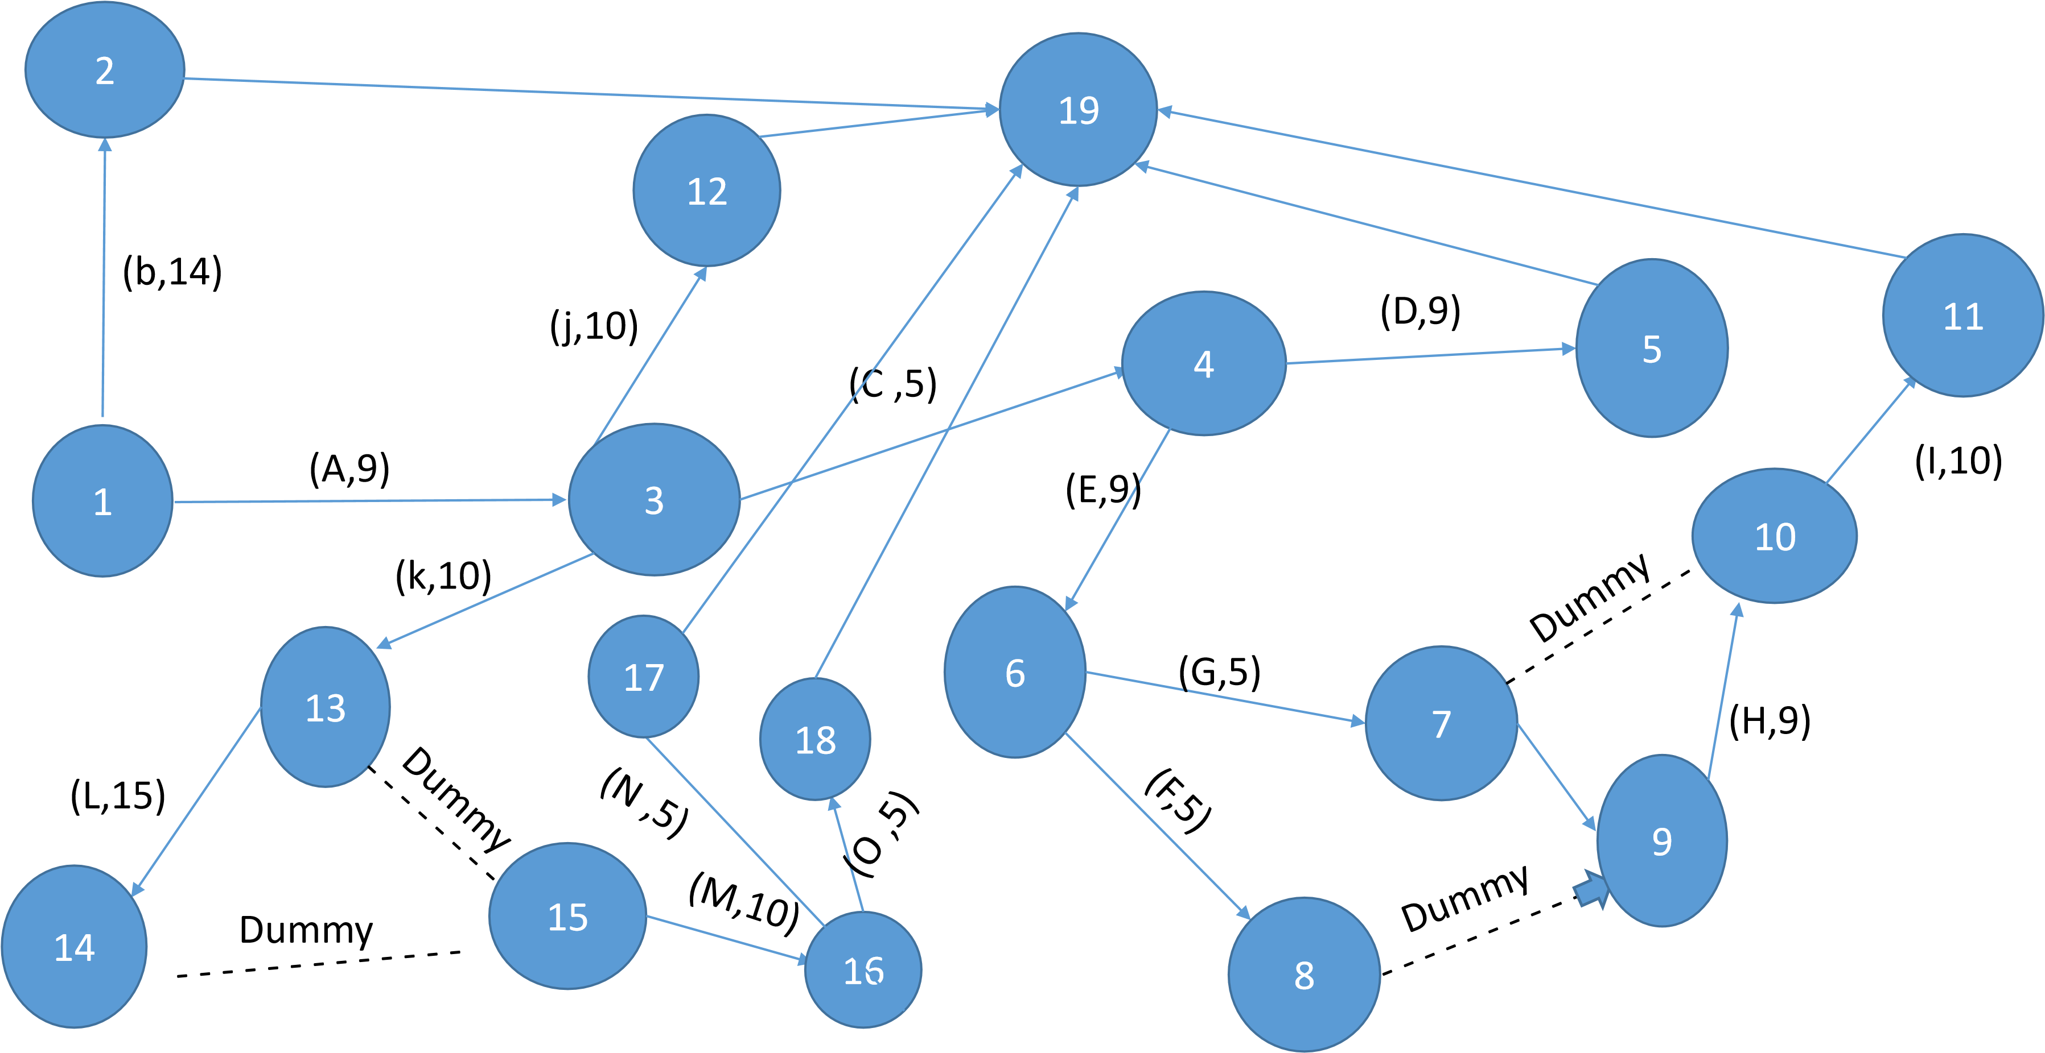

 |  | 4 |  | 9 | 14 |  |  | 26 |  |  | 35 |  |  | 45 |  |  | 55 |  |  | 70 |  |  | 80 |  |  | 85
Project
Identification
System Request
Feasibility Study
Project
Methodology
Time
Estimation
Task
Identification
Work Plan
Pert chart
Gantt chart
Questionnaire
Interview
Context diagram
Level-0-DFD
Data dictionary
Process specification

O M L K H G E C A



Analysis

(
Project

Proposal)

Interview
• How're you?
- Fine thanks.
What do you think about using the Internet in business?
-Useful, as it saves a lot of time and effort and increases profits.
- Do you think that your business needs Internet services? And why?
-Yes, because it will make it easier for customers to deal with us and reduce the cost.
- Who has permission to manage the application?
-it team.
- How was the process managed in the past and who can provide me with more information?
-It was managed by the call center, Call center manager.
- How will the system be marketed?
-It will be announced that a new feature will be added to the restaurant, and there is a marketing team that knows more than me.
- Does the delivery team have the ability to handle the pressure resulting from marketing?
-Yes.
- What is the expected increase in orders through the system?
%35-
- Do you think the application will succeed?
- Yes, I think so.

• Do you want to add anything to the application?
- No.
• Nice to meet you.
- Nice to meet you too.

Interview Report
Person Interviewed: general manager
Interviewer: Amr Tarek
Purpose of Interview:
1. How will the system be managed?
2 How will the system benefit the restaurant?
- How will the system be marketed?
- What are the expectations from the system?
Summary of Interview:
- Views the internet as valuable for saving time, effort, and boosting profits, Believes internet services are necessary to enhance customer interactions and reduce costs.
- IT team has the authority to manage the application , Previously overseen by the call center, with the call center manager holding relevant information.
- Marketing plan involves announcing a new restaurant feature , Defers to the specialized marketing team for detailed strategies.
- Predicts a 35% increase in orders through the system.
Open Items:
- Zeyad Hany will present a report on Team
It
- Mohammed Alaa will conduct a personal interview with the delivery team
- Ahmed Wally will meet the call center team
- Mohamed Osama will present a report on the marketing team

Interview

1. How're you?
- Fine thanks

2. Can you provide an overview of the restaurant project and its unique selling points?
- The project is a restaurant that offers [type of cuisine] and stands out with unique selling points such as [special decor or service

2. Who is the target audience for the restaurant, and what strategies are in place to attract and retain customers?
- The target audience for the restaurant is [specify age group or psychographic interests], and we rely on strategies like [advertising, promotional offers, loyalty programs, and partnerships] to attract and retain customers.

3. How do you plan to create awareness and generate footfall for the restaurant?
- The marketing manager can explain the marketing channels such as social media marketing, local advertising, public relations, influencer partnerships, or community engagement.

4. What market research was conducted to identify the demand and competition in the area?
- The marketing manager can discuss the market research methods used to identify the target market, evaluate the competition, and assess the demand for the restaurant's offerings.

5. How do you plan to leverage digital marketing and online platforms to reach a wider audience?
- We employ digital marketing strategies and online platforms to reach a broader audience, such as website development, search engine optimization (SEO), online advertising campaigns, and online food delivery partnerships.

6. How do you plan to measure the success of marketing campaigns and initiatives?
- The marketing manager can explain the key performance indicators (KPIs) used to measure the effectiveness of marketing efforts, such as customer acquisition metrics, sales revenue, customer feedback, or social media engagement.
- How do you plan to adapt and evolve the marketing strategy based on customer feedback and changing market trends?
- The marketing manager can elaborate on the processes in place to collect and analyze customer feedback, monitor market trends, and make adjustments to the marketing strategy accordingly.

- Do you think the application will succeed?
- Yes, I think so.

• Do you want to add anything to the application?
- No.

9. Nice to meet you.
- Nice to meet you too.
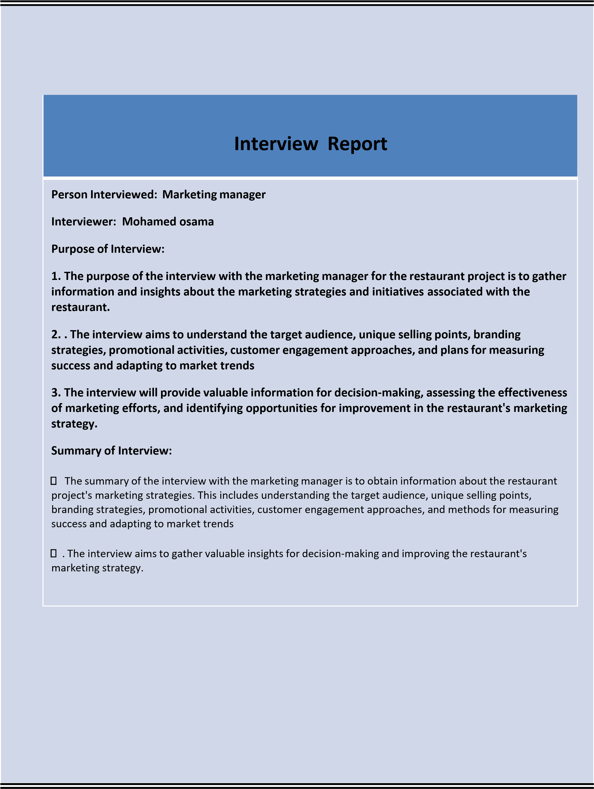

Interview with IT
Engineer

(include questions and answers)

Question: How would you design the architecture of a Restaurant Online System to ensure scalability and responsiveness?
Answer: "I would opt for microservices architecture to enhance scalability. Frontend development could be handled with modern frameworks like React, and for the backend, a combination of Node.js or Django. Using a reliable database like PostgreSQL would be ideal for data storage."

Question: What security measures would you implement to protect user data and ensure secure transactions?
Answer: "I would prioritize HTTPS to encrypt data in transit. Implementing secure authentication methods such as OAuth and ensuring data encryption at rest. Regularly updating API keys, conducting security audits, and employing token-based authentication would be essential."

Question: How would you design the database to efficiently manage restaurant menus, orders, and customer information?
Answer: "I'd design a relational database with tables for menus, orders, and customers. Normalization and indexing would be crucial for optimal performance. Additionally, incorporating NoSQL databases for specific needs like menu items with varying attributes."

Question: How would you approach integrating the Restaurant Online System with external services such as payment gateways or third-party delivery platforms?
Answer: "I would design robust APIs to facilitate seamless integration. OAuth for secure authentication, HTTPS for encrypted data transfer, and regular updates to API keys to maintain security during external integrations."

Question: What strategies would you employ to ensure the Restaurant Online System can handle increased traffic during peak hours?
Answer: "Implementing load balancing, horizontal scaling, and caching mechanisms would be key to handling increased traffic. Continuous monitoring using tools like Prometheus helps identify performance bottlenecks for timely optimizations."

Question: How would you ensure a positive and user-friendly experience for both customers and restaurant staff?
Answer: "Creating an intuitive and responsive user interface, prioritizing clear navigation and calls-to-action. Adhering to web accessibility standards (WCAG) for inclusivity and considering user feedback for continuous improvement."

Question: Once the Restaurant Online System is live, how would you approach system maintenance, updates, and addressing potential disruptions?
Answer: "Establishing a version control system, implementing continuous
integration/delivery, and scheduling regular maintenance windows. Automated testing, user support channels, and a well-defined incident response plan would be crucial for addressing disruptions promptly."

Interview Report
Person Interviewed: IT Engineer
Interviewer: Abdulrahman Mohammed
Purpose of Interview:
- Assess IT Engineer’s experience in developing online systems, particularly in the restaurant industry.
- Evaluate IT Engineer’s knowledge of system architecture and security measures.
- Understand IT Engineer’s approach to database design and integration with external services.
Summary of Interview:
  - He emphasizes microservices architecture for scalability, with React for the frontend and
Node.js/Django for the backend.
  - His database design involves normalization and indexing for optimal performance, with considerations for NoSQL databases.
  - John prioritizes security through HTTPS, OAuth, and regular API key updates.
Open Items:
•

Analysis(communication service)
Q1 : Hallo ,How are you?
A : good thank you.

Q2:What do you want in your system?
A: first I need new developed devices , strong internet network and Employees with experience .

Q3:What kind of experience do you want to be in your employees? A: That he/she work before in any Restaurant or has any experience by using new devices and can treat with any problem

Q4:what kind of devices do you want in your system?
A: Like phones and computers and strong internet network.
Q5:what kind problems that can face your employees?
A: when the customer need to decline the order or replaced it .

Q6:what type of problems that can face you while working?
A:when many customer rang on the same time and he will find the service is not available now.

Q7:How we will solve this problem?
A: By have more devices and phones .

Q8:There any thing you want to add?
A: No thank you .

Interview Report

- Person interviewed : communication manager

- Interviewer: Ahmed wally
- Purpose of interview:
- What do you want in your system?

- What kind of experience do you want to be in your employees?

- what kind of devices do you want in your system?

5-what type of problems that can face you while working?
6-How we will solve this problem?
Summary of interview:
The devices we need in the system ,the experience that we need it to be in our employees and how to solve the problems that will face us while working .
Open items:

Interview
1-How are you ?
-Fine it`s a nice day 2-Present you self .
I am x
Iam x years old
I live in x
- what is your opinion about this online serve?
It is a nice step to support popularity of the restaurant and have it`s customer truth,

- What made you apply for this job as a delivery employee?
I fined it suitable for me and have a good profit
- Do you have previous experience in the field of order delivery? If so, please explain.
Sure I have worked as deliver man for one year before, and I worked at many popular restaurant before.
- How do you manage your time between delivering orders quickly and ensuring good service?
The most important to cover this issue is to identify the shortest road And the suitable speed + save the best statue of the order.
- How do you deal with customers in the event of a problem such as a delayed delivery or an incorrect order?
I apologize to him and try to keep his trust in the service, and I assure him that his correct request will arrive as soon as possible

- Can you handle orders that are located within your area of expertise?
For sure iam familiar with technology and have the ability to handle this issue using goggle maps
- let say your day target is 10 orders. can you achieve them?
For sure , I have enough experience to deal with target and achieve it effetely
- why do you think you have an advantage to have this job?
I have the enough experience
And iam fit to achieve a all works
- Do you have any ideas or suggestions to improve your company's order delivery process?
May be make it available online payment.

- is there anything else that you would like to add?
No thanks
Interview report
Person interviewed: xxxxxxxxxxxx
Interviewer: Mohammed Hatim

Purpose of interview:
1-check his ability to take this position .
2-can he handle with issues.
3- The interview aims to gather valuable insights for decision-making and improving the restaurant's delivery serves.

Summary of interview
- "He provided excellent responses to the questions posed and maintained his composure." 
- He suggest a nice idea to improve the serves using online patment 
 

Interview

(include questions and answers)

interviewer: Hello, thank you for joining us today. We're constantly striving to improve our services, and customer feedback is crucial to our success. What are your thoughts on the development of our restaurant's system and online services?

User: Hi there, thank you for having me. I've noticed that your restaurant has implemented some changes in recent months, particularly in terms of online ordering and delivery services. I have to say, the improvements have been quite noticeable.

interviewer: I'm glad to hear that. We've invested a lot of time and resources into upgrading our systems to provide a more seamless experience for our customers. Can you elaborate on some of the specific changes that have caught your attention?

User: Certainly. I've found the online ordering process to be much more user-friendly compared to before. The website is more intuitive, and I appreciate the option to customize my orders and schedule deliveries. The overall process seems to be more efficient and convenient.

interviewer: That's great to hear. We've been working closely with our tech team to optimize the online ordering platform, so it's reassuring to hear positive feedback. Have you encountered any issues or challenges while using our online services?

User: Overall, the experience has been smooth, but there have been a few minor hiccups. For instance, I encountered a delay in receiving my order once, but your customer service team was responsive and handled the situation well. It's clear that you're making an effort to address any issues promptly.

interviewer: Thank you for sharing that feedback. We strive for consistency in our service, so any
delays are certainly areas where we aim to improve. Moving forward, we'll continue to monitor and enhance our delivery operations to minimize any potential disruptions.

User: It's also worth mentioning that the integration of online payment options has been convenient. I appreciate the variety of payment methods available, and it's clear that the restaurant is adapting to modern consumer preferences.

interviewer: Absolutely. We recognized the importance of offering diverse payment options to accommodate our customers. Security and convenience are top priorities, so we will continue to assess and integrate new payment technologies as they emerge.

User: With the increasing demand for online food delivery, I'm curious about the restaurant's strategy for maintaining the quality of the dining experience, especially when it comes to food freshness and presentation during delivery.

interviewer: That's a valid concern. We've placed a strong emphasis on packaging and delivery logistics
to ensure that our food reaches our customers in optimal condition. Our team has been diligent in

selecting suitable packaging materials to preserve the quality and presentation o
f our dishes.
Freshness and presentation are key factors, and we are dedicated to upholding those standards, even
for delivery orders.

User: I'm pleased to hear that the restaurant is prioritizing those aspects. It's evident that you're
making comprehensi
ve efforts to adapt to the evolving landscape of food service.

interviewer

Indeed, the restaurant industry has undergone significant changes, and we're committed
to staying ahead of the curve. We value feedback from our customers, and your insights are valua
ble
in guiding our ongoing improvements. Is there anything else you'd like to share about your experience
with our restaurant's system and online services?

User: Overall, I've been impressed with the developments, and I commend the restaurant for its
dedi
cation to enhancing the customer experience. The combination of efficient online services and
quality food has made for a positive dining experience. I look forward to seeing how the restaurant
continues to innovate and refine its offerings.

interviewer

Thank you for your kind words. We take pride in providing a positive dining experience,
whether it's in our restaurant or through our online services. Your feedback encourages us to maintain
our momentum in delivering exceptional service. We'll ce
rtainly continue to build on these
improvements and strive for excellence in all aspects of our operations.

User: It's been a pleasure sharing my thoughts with you, and I appreciate the opportunity to
contribute to the ongoing progress of the restaurant.
I'll certainly look forward to engaging with your
services again in the future.

interviewer
Thank you for your time and valuable feedback. We're grateful for your support, and
:
we're dedicated to creating memorable experiences for our customers.
.

Interview Report
Person Interviewed: user

Interviewer: abdulrahman ashraf

Purpose of Interview:

The purpose of the interview was to gather customer feedback regarding the development of the restaurant's system and online services. The manager expressed the restaurant's ongoing commitment to enhancing its services and highlighted the significance of customer input in this process. The user acknowledged the noticeable improvements in online ordering and delivery services and provided specific feedback on the enhanced user-friendliness of the online ordering process, the intuitive website, and the ability to customize orders and schedule deliveries. However

Summary of Interview:

The manager expressed the critical role of customer feedback in their ongoing efforts for improvement. I have noticed that the restaurant has made notable improvements, especially in online ordering and delivery services. The manager was pleased to hear your positive comments and emphasized the significant investment of time and resources in upgrading their systems to enhance the customer experience. You have highlighted the userfriendly nature of the online ordering process, the intuitive website, the option to customize orders and schedule deliveries as specific changes that caught your attention

Questionnaire
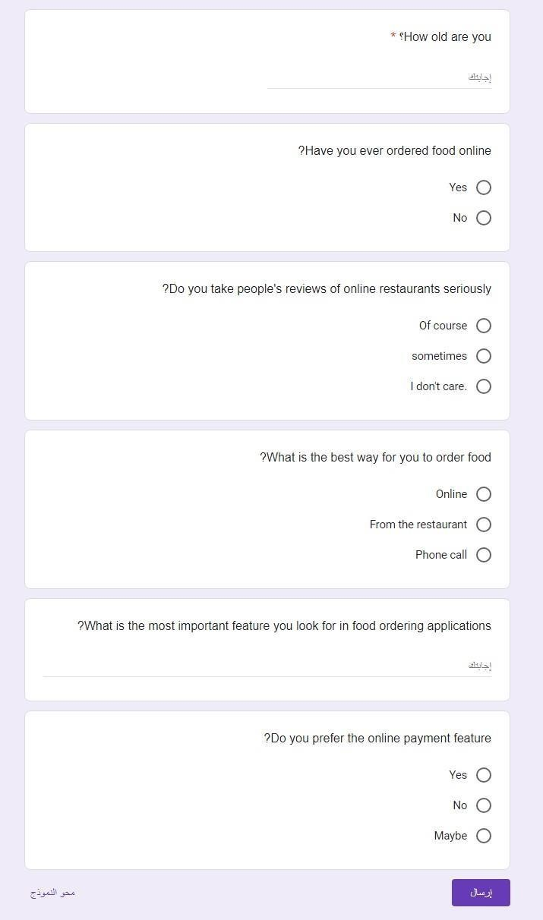

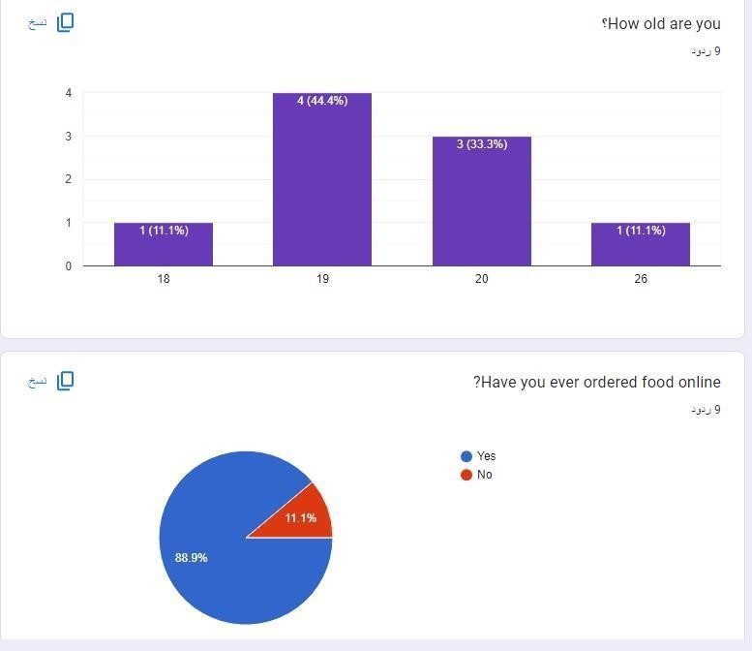

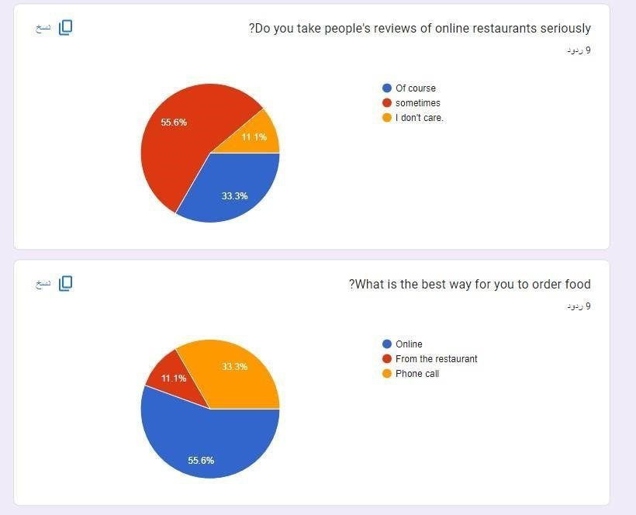

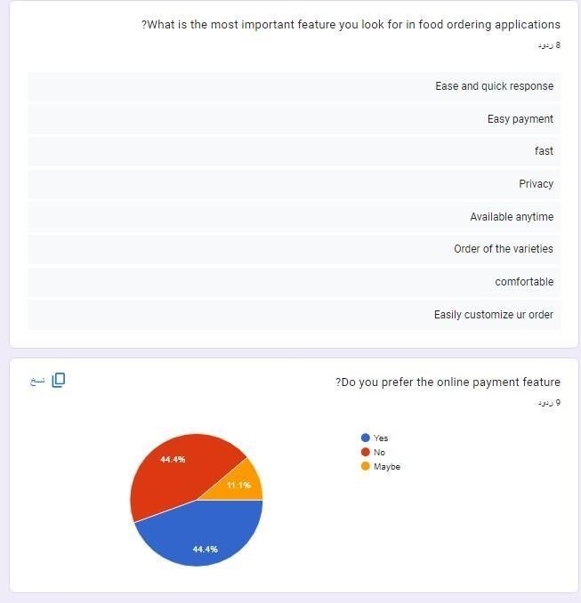

Questionnaire 2

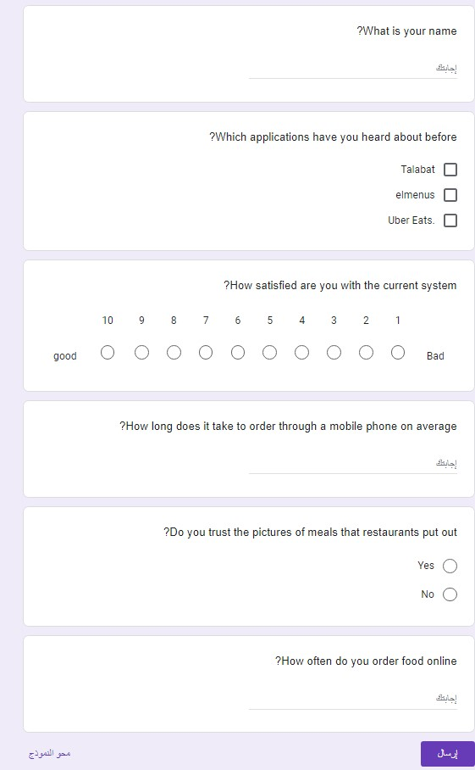
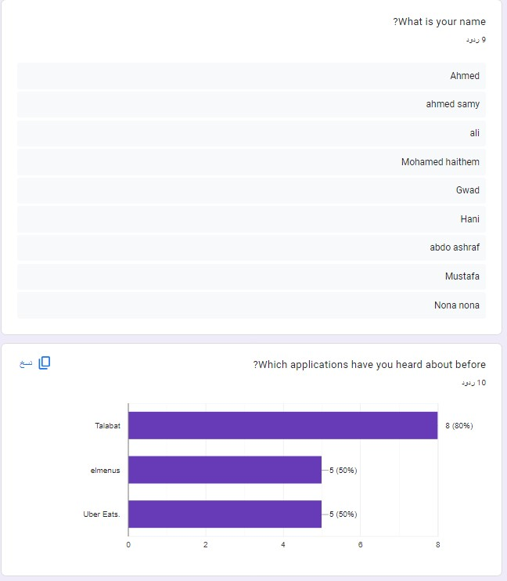

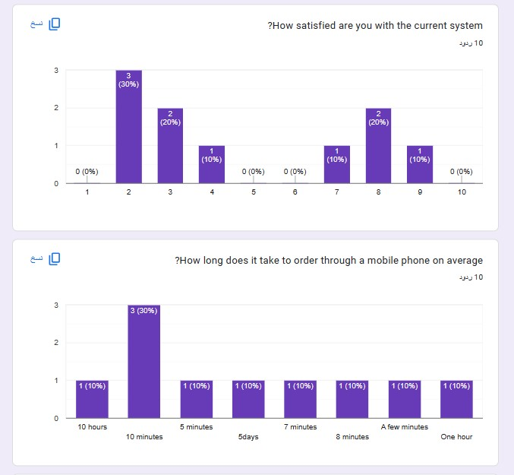

Questionnaire 3
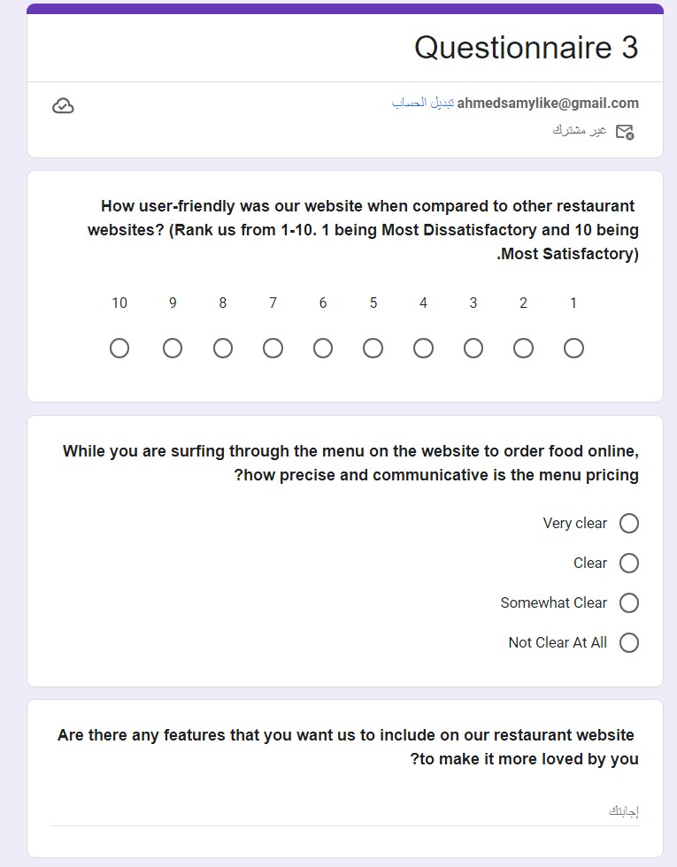
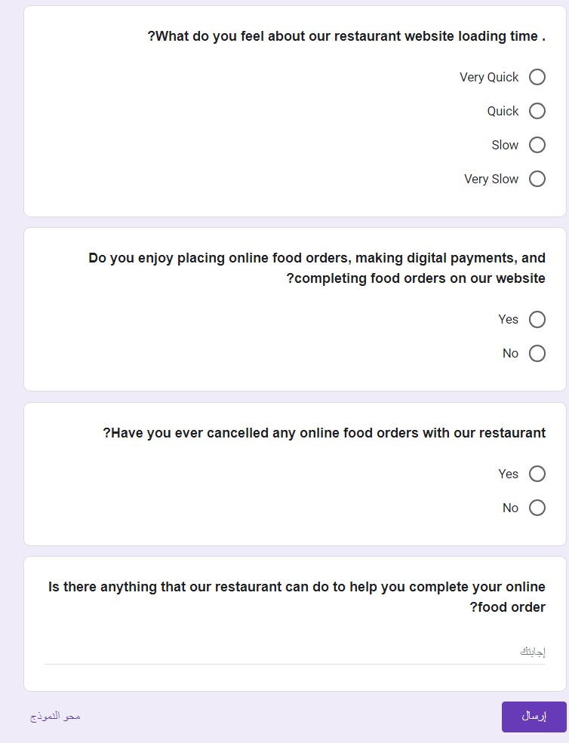
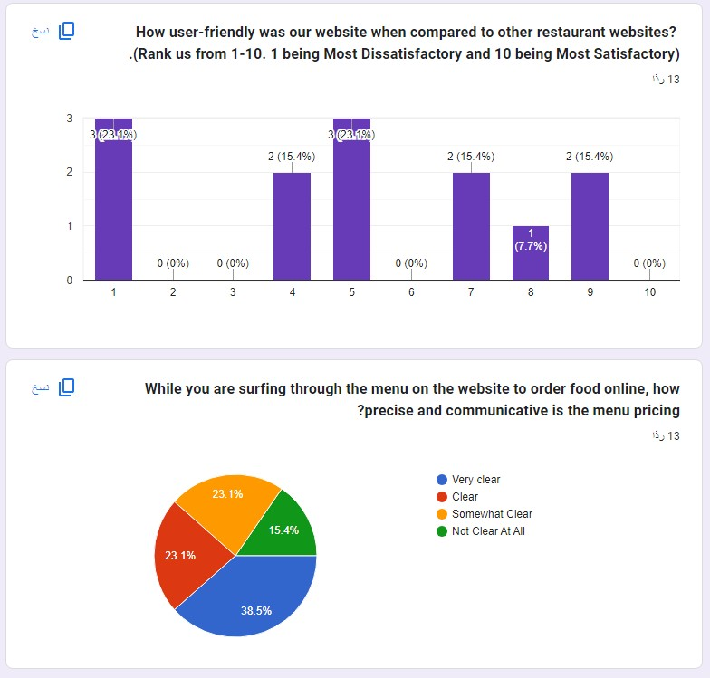
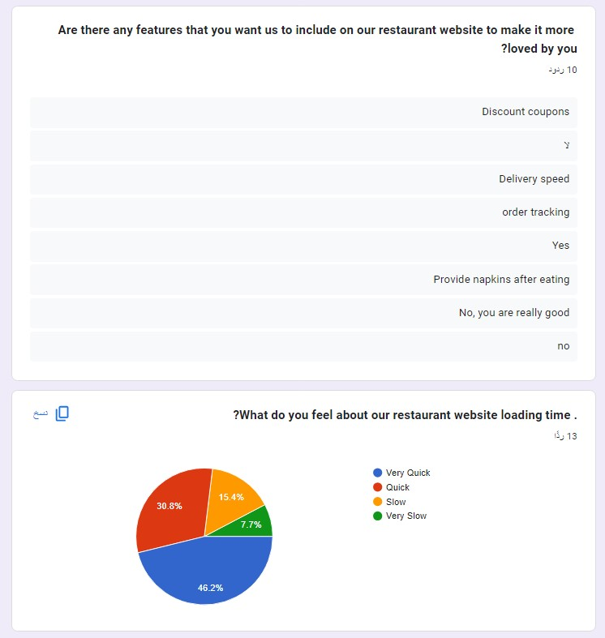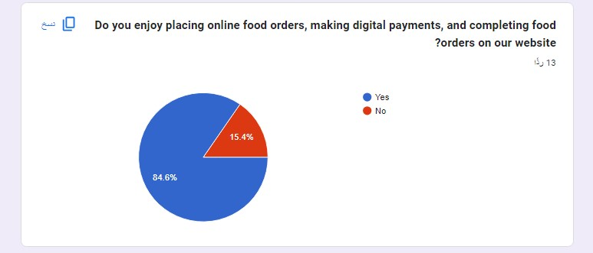
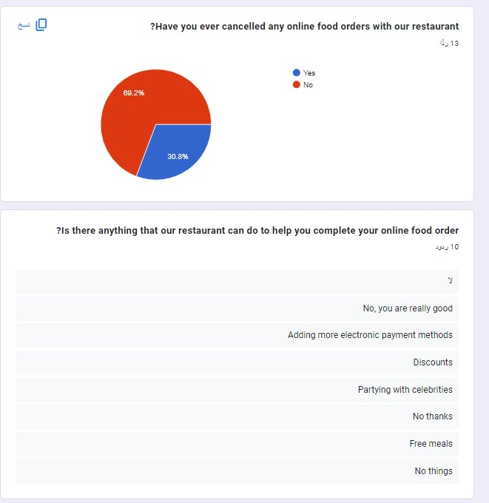
Context diagram
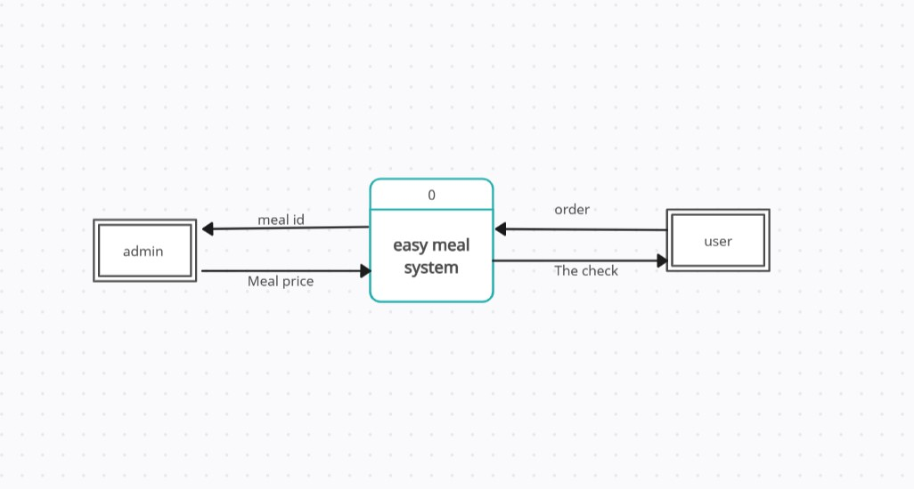

Data Flow Diagram – Level 0
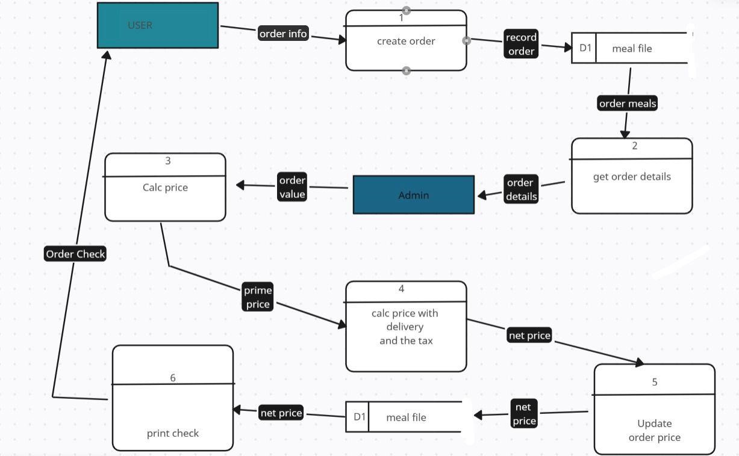

Data dictionary

DFD: data flow
(1) description forms for data flow
ID:1
Name(label) : order info
Description: contain order info
Source: External Entity : user | Distington: process create order
Type of data flow: external
Data structure: order info Structure | Volume/time:3/day

ID:2
Name(label) : record order
Description: contain order info
Source: operation : cerate order | Distington: data store meals file
Type of data flow: file
Data structure: record order Structure | Volume/time:2/day

ID:3
Name(label) : ordered meal
Description: contain order info
Source: data store (meals file) | Distington: operation identify Order details
Type of data flow: file
Data structure: ordered meal Structure | Volume/time:2/day

ID:4
Name(label) : order details
Description: contain order details
Source: operation (get order details) | Distington: Entity (Admin)
Type of data flow: screen
Data structure: order details Structure | Volume/time:2/day

ID:5
Name(label) : order value
Description: contain order value
Source: operator (get meal details) | Distington: operation calc prime price to the order
Type of data flow: form
Data structure: prime price of order Structure | Volume/time:2/day

ID:6
Name(label) : prime price
Description: contain prime price
Source: operation(calc prime order) | Distington:  Operator (set price with delivery)
Type of data flow: interval
Data structure: prime data structure | Volume/time:2/day

ID:7
Name(label) : net price
Description: contain total price
Source: Operator (set price with delivery) | Distington: operato (update order price)
Type of data flow: interval
Data structure: net price Structure | Volume/time:2/day

ID:8
Name(label) : record net price
Description: contain total price
Source: Operator (set price with delivery) | Distington: data store (meails file)
Type of data flow: file
Data structure: net price Structure | Volume/time:2/day

ID:9
Name(label) : net price
Description: contain total price
Source: data store (meails file) | Distington: operator (print chek)
Type of data flow: report
Data structure: net price Structure | Volume/time:2/day

ID:10
Name(label) : order chek
Description: final result send to the user
Source: operator (print chek) | Distington: entity (user)
Type of data flow: report screen
Data structure: order chek Structure | Volume/time:2/day

ID | 1
Name | Food name
Alias | Food name
Description | Full Food name
Length | 50
Input Format | X (50)
Output Format | X (50)
Default Value | None
Continuous / Discrete | Discrete
Type | String
Base / Derived | Base
Upper Limit | -
Lower Limit | -
Comments | -

ID | 2
Name | Customer Card
Alias | card
Description | Customer card
Length | 20
Input Format | g (20)
Output Format | g (40)
Default Value | None
Continuous / Discrete | Discrete
Type | integer
Base / Derived | Base
Upper Limit | 100
Lower Limit | 0
Comments | -

ID | 3
Name | customer name
Alias | customer name
Description | Full customer name
Length | 50
Input Format | X (50)
Output Format | X (50)
Default Value | Your name
Continuous / Discrete | Discrete
Type | String
Base / Derived | Base
Upper Limit | -
Lower Limit | -
Comments | -

ID | 4
Name | Food price
Alias | cost
Description | Price of food
Length | 20
Input Format | g (20)
Output Format | g (40)
Default Value | None
Continuous / Discrete | Discrete
Type | integer
Base / Derived | Base
Upper Limit | 100
Lower Limit | 0
Comments | -

ID | 5
Name | manager name
Alias | manager name
Description | Full manager name
Length | 50
Input Format | X (50)
Output Format | X (50)
Default Value | Your name
Continuous / Discrete | Discrete
Type | String
Base / Derived | Base
Upper Limit | -
Lower Limit | -
Comments | -

ID | 6
Name | Empoyee name
Alias | Employee name
Description | Full Employee name
Length | 50
Input Format | X (50)
Output Format | X (50)
Default Value | Your name
Continuous / Discrete | Discrete
Type | String
Base / Derived | Base
Upper Limit | -
Lower Limit | -
Comments | -

ID | 7
Name | Resturant name
Alias | Resturant name
Description | Full Resturant name
Length | 50
Input Format | X (50)
Output Format | X (50)
Default Value | none
Continuous / Discrete | Discrete
Type | String
Base / Derived | Base
Upper Limit | -
Lower Limit | -
Comments | -

DFD: Data Store
ID | D1
Name |  | Menu Item file:
Alias |  | Menu Item
Description | Fresh and healthy
File Type | Microsoft Excel
File Format | xlsx
Record Size | 200GB
Maximum Records | 200 sort
Average Records | 100 sort
Growth per Year | 12%
Data Set
Data Structure | Uploading data
Primary Key | ItemID
Secondary Key | CategoryID
Comments

DFD: Data Store
ID | D2
Name |  | OrderItem file :
Alias | Order
Description | Orderi tem
File Type | Microsoft Excel
File Format | xlsx
Record Size | 200GB
Maximum Records | 200000 order
Average Records | 100000 order
Growth per Year | 8%
Data Set
Data Structure | Uploading data
Primary Key | OrderItemID
Secondary Key | OrderID
Comments

DFD: Data Store
ID | D3
Name |  | Customer file :
Alias | Customer
Description | O
File Type | Microsoft Excel
File Format | xlsx
Record Size | 200GB
Maximum Records | 50000 order
Average Records | 25000 order
Growth per Year | 30%
Data Set
Data Structure | Uploading data
Primary Key | customerID
Secondary Key | Email
Comments



Process Specification Form

Number:1
Name: Create order
Description: In this process we ask order
I
n
p
u
t

D
a
t
a

F
l
o
w
:

T
h
e

m
e
a
l

w
e

w
a
n
t

.

Output Data Flow: Give him the meal info

Type of Process
Online Batch Manual
Process Logic:
Structured English Decision Table Decision Tree
Unresolved Issues:0
If this order his first one
Give him some suggestion meal
Else
Just give him his meal
✓

Note: apply process specification for all project processes



Process Specification Form

Number:
2

Name

:
Get meal
Description: give us meal info
Input Data Flow: the meal you want

Output Data Flow: Give him the meal info

Type of Process
Online Batch Manual
Process Logic:
Structured English Decision Table Decision Tree
✓

Note: apply process specification for all project processes

Breakfast meal give him orange juice

meal

dinner meal

give him tea.



Process Specification Form
Number:3
Name: Calculate the price meal
Description: In this step the price is calculated
Input Data Flow: Meal you want
Output Data Flow: the price of this meal.

Type of Process
Online Batch Manual
Process Logic:
Structured English Decision Table Decision Tree

Buy 1000$or more | T | T | F | F
Subscribe in our services | T | F | T | F
ACTION
Give him a coupon 25% discount | X | X
Give him  5%discount | X |  | X


Process Specification

Process Specification Form

Number:4
Name: price of the meal after delivery
Description: adding delivery price in meal price
Input Data Flow: price of the meal and delivery
Output Data Flow: print adding price

Type of Process
Online Batch Manual
Process Logic:
Structured English Decision Table Decision Tree
If he subscribe in our services
Deliver his order for free
Else
Add the deliver price in order price

✓

Note: apply process specification for all project processes


Process Specification

Process Specification Form

Number:6
Name: print the check
Description: we print the check
Input Data Flow: the order info
Output Data Flow: print it
Type of Process
Online Batch Manual
Process Logic:
Structured English Decision Table Decision Tree
If he will pay online give him check as PDF
Else if he will pay after delivery
Give him check hand by hand

✓

Note: apply process specification for all project processes

