**README**

In this assignment, I have attempted the Alternative2 method where Alice and Bob will take turn to generate and verify blocks.

1. To run the program, start by running sub.py which will initiate the pubnub connection for alice or bob to send the newly generated block with a valid <Nonce>.
2. Open another terminal to run the main program (blockchain.py) for alice and bob to start generating blocks and publishing with the pubnub connection.

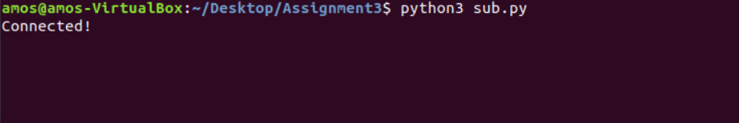**sub.py running**

**Expected outcome**

After running blockchain.py, the program will prompt for user to press enter to simulate Alice to start mining the first block (block1.json)

**Running blockchain.py**



When user hit <Enter> Alice will start mining block1. This will take some time. Program will prompt user “please wait…”.

“block1 generated!” after it is successfully generated. At the same time, Alice will broadcast the currently generated block through the pubnub channel. Also, block1.json will be generated within the same folder.

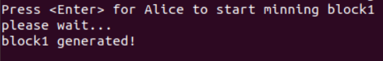



**Sub.py (Alice broadcast through the channel of the respective block)**

At this point, it will be pending Bob to verify block1’s hash with the previous block hash (block0.json), similarly, program will prompt for user to hit <Enter>. Once user hit enter, the Hash hex digest for previous and current block will be printed and if matches, “Verified” will be printed. If it does not match, the program will end.

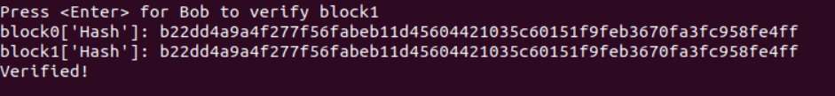

Next, it will be Bob’s turn to generate the next block (block2.json). Just like previously, user will need to hit enter for Bob to start generating.

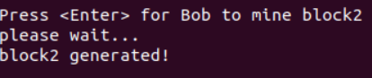



**Sub.py (Bob broadcast through the channel of the respective block)**

Now it will be Alice’s turn to verify Bob’s block. Once verified, alice will be ready to start mining the next block. Likewise, If it does not match, the program will end.

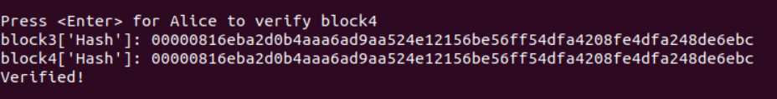

This goes on until block11 is generated and verified. Alice will mine 1st,3rd,5th,7th,9th and 11th block whereas Bob will generate 2nd,4th,6th,8th and 10th block as shown in following snips below:

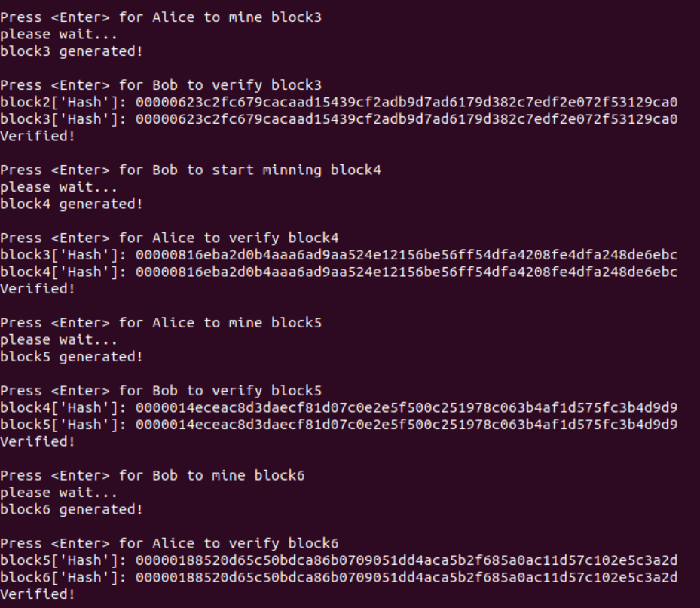

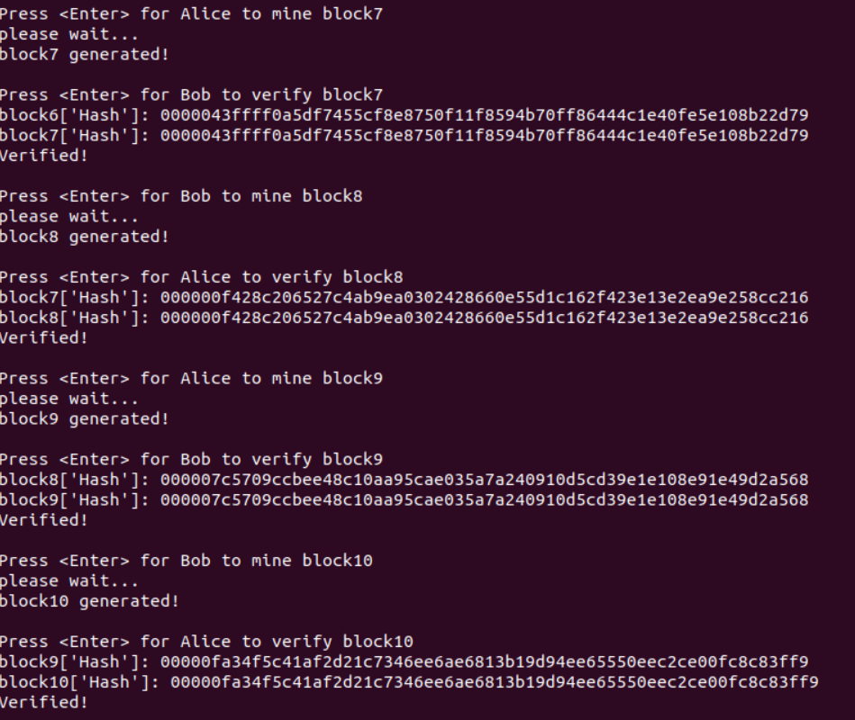

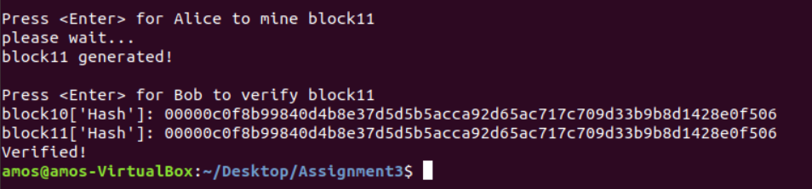

Following snip will be sub.py. All broadcasts done by Alice and Bob in the Blockchain Proof Of Work simulation

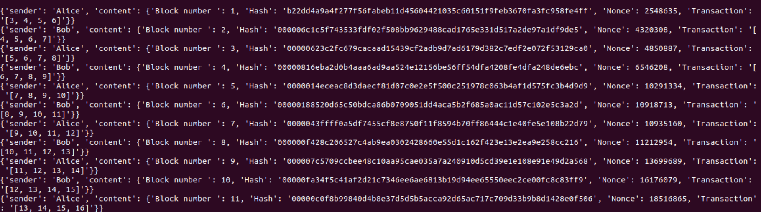

Block1.json – block11.json will be generated in the same folder.