Matthias Fast, Amos Dinh, Jannik Völker 4750990, 5504890, 5370226

**1 Requirements Specification**

**Groupname**  
IceCreamEmpire

**Introduction**

The system is designed for the company IceCreamEmpire. The company wants to plan and track the daily tours to sell ice cream. It has to assign vehicles and vendors to a tour through a neighborhood.

It also wants to provide some information about the ice cream, where it is stored and what the sales numbers are. The system consists of the following entities, attributes and relationships.

**Tour**

Each tour has a start-datetime and an end-datetime, as well as an unique ID. It is an one-time event and not a recurring event. Each tour is individually planned.

There is can be one of each of the following assigned to a tour: ice cream vendor, vehicle, neighborhood.

**Ice cream vendor**

An ice cream vendor has a forename, a last name, a salary and a unique ID.   
Vendors can sell ice cream on different tours.

**Neighborhood**

A neighborhood has a unique ID. It has a name, a distance to the headquarter and an area covered (square km). A neighborhood can be served ice cream on multiple tours

**Vehicle**

Each Vehicle is identified by its unique ID. It has a vehicle type and storage capacity. One vehicle may be used for many tours. It may store different ice cream flavors with specific amounts.

**Flavor**

Each ice cream flavor is saved with its name and a unique ID. Each flavor has a base price per scoop.

**Content**

Each flavor can have a unique content (if the information is known)consisting of amount of calories and the basis (e.g. milk, water, hazelnut milk) from which the attribute if the flavor is vegan can be derived. The content can be identified by corresponding flavor ID.

**Order**

If someone orders ice cream on a tour, an order linked to that tour is created. An order is identified by an unique ID and has a datetime and payment type.

**Order detail**

Each order consists of multiple order details. The order details can be differentiated by the corresponding flavor ID and order ID. A detail includes the amount of an ordered flavor. A vendor has the option to give a discount on the ordered flavor (of the order detail) e.g. for a child that has its birthday on that day. The discount is provided in percent and based on the base price of the flavor.

**Warehouse**

There are multiple warehouses. Each warehouse has an address and a capacity. It is identified by a unique ID.

Each warehouse may store multiple flavors. Individual flavors may be stored in multiple warehouses. The amount of each stored flavor per warehouse is also saved in the system.

**2 ER Diagram**

The figure below represents the Entity-Relationship Diagram, which is a blueprint for the IceCreamEmpire database.

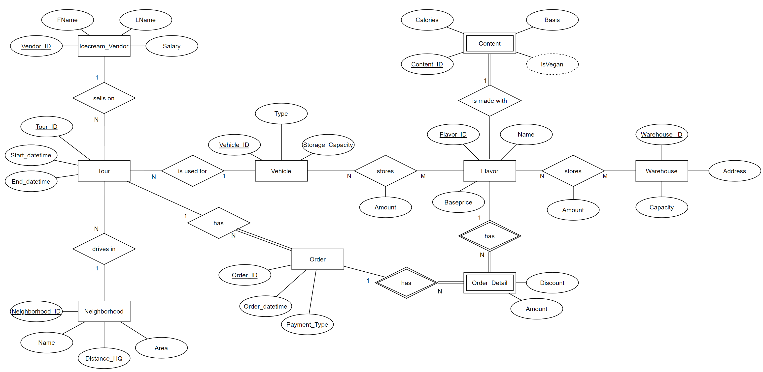

**3 Normalization**

Requirement: 3NF

A relation is in 3NF, if it satisfies 2NF (and in turn 1NF) and no non-prime attributes are transitively dependent on any candidate key.

All relations satisfy 1NF since there are no multivalued attributes nor nested relations.

All relations satisfy 2NF since there are no non-prime attributes which are only partially dependent on any candidate key.

All relations are in 3NF.

For example, violation of 2NF is avoided in “OrderDetails“ by not specifying the “Price“ (“BasePrice“) in the “OrderDetails“, which would be functionally dependent on the partial key “flavor_id”.

There is no violation of 3NF in relation “Warehouses”.

“Capacity” is not transitively dependent on the “warehouse_id” because “address” itself is a candidate key, therefore there is no problem.

Contents

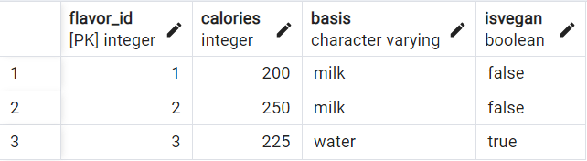

Flavors

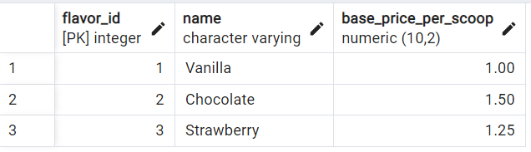

IceCreamVendors

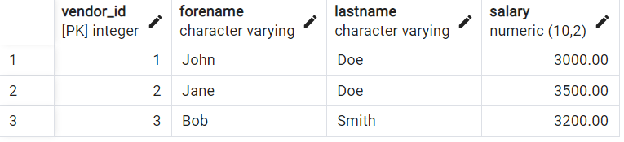

Neighborhoods

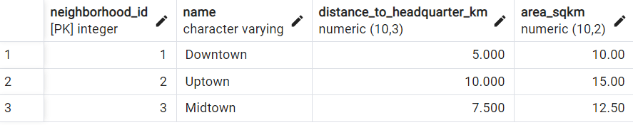

Orderdetails

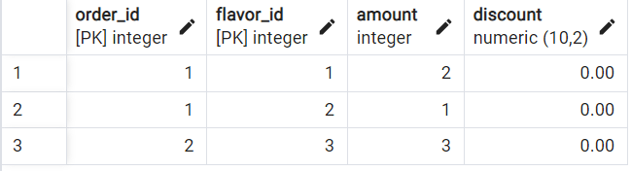

Orders

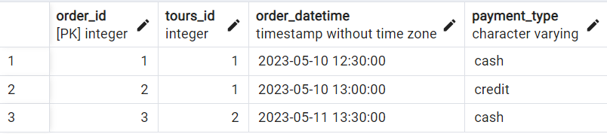

Tours

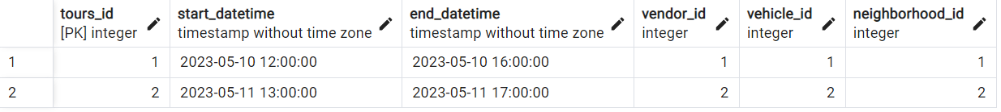

Vehicles

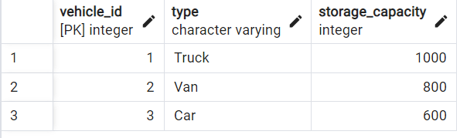

VehiclesStoreFlavours

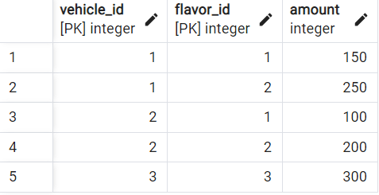

Warehouses

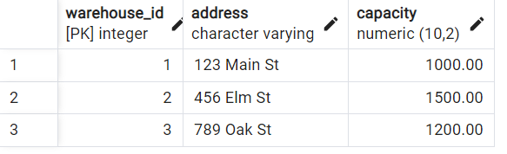

WarehoursesStoreFlavours

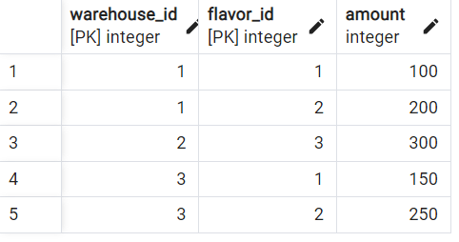

**4 Application**

The system is designed for the company IceCreamEmpire. The company wants to plan and track the daily tours to sell ice cream. It has to assign vehicles and vendors to a tour through a neighborhood.

It also wants to provide some information about the ice cream, where it is stored and what the sales numbers are. The system consists of the following entities, attributes and relationships.