Matthias Fast, Amos Dinh, Jannik Völker 4750990, 5504890, 5370226

03.06.2023

**Documentation**

**Groupname**  
IceCreamEmpire

**1 Requirements Specification**

**Introduction**

The system is designed for the company IceCreamEmpire. The company wants to plan and track the daily tours to sell ice cream. It has to assign vehicles and vendors to a tour through a neighborhood.

It also wants to provide some information about the ice cream, where it is stored and what the sales numbers are. The system consists of the following entities, attributes and relationships.

**Tour**

Each tour has a start-datetime and an end-datetime, as well as an unique ID. It is an one-time event and not a recurring event. Each tour is individually planned.

There is can be one of each of the following assigned to a tour: ice cream vendor, vehicle, neighborhood.

**Ice cream vendor**

An ice cream vendor has a forename, a last name, a salary and a unique ID.   
Vendors can sell ice cream on different tours.

**Neighborhood**

A neighborhood has a unique ID. It has a name, a distance to the headquarter and an area covered (square km). A neighborhood can be served ice cream on multiple tours

**Vehicle**

Each Vehicle is identified by its unique ID. It has a vehicle type and storage capacity. One vehicle may be used for many tours. It may store different ice cream flavors with specific amounts.

**Flavor**

Each ice cream flavor is saved with its name and a unique ID. Each flavor has a base price per scoop.

**Content**

Each flavor can have a unique content (if the information is known)consisting of amount of calories and the basis (e.g. milk, water, hazelnut milk) from which the attribute if the flavor is vegan can be derived. The content can be identified by corresponding flavor ID.

**Order**

If someone orders ice cream on a tour, an order linked to that tour is created. An order is identified by an unique ID and has a datetime and payment type.

**Order detail**

Each order consists of multiple order details. The order details can be differentiated by the corresponding flavor ID and order ID. A detail includes the amount of an ordered flavor. A vendor has the option to give a discount on the ordered flavor (of the order detail) e.g. for a child that has its birthday on that day. The discount is provided in percent and based on the base price of the flavor.

**Warehouse**

There are multiple warehouses. Each warehouse has an address (street number, street, city, zipcode) and a capacity. It is identified by a unique ID.

Each warehouse may store multiple flavors. Individual flavors may be stored in multiple warehouses. The amount of each stored flavor per warehouse is also saved in the system.

**2 ER Diagram**

The figure below represents the Entity-Relationship Diagram, which is a blueprint for the IceCreamEmpire database.

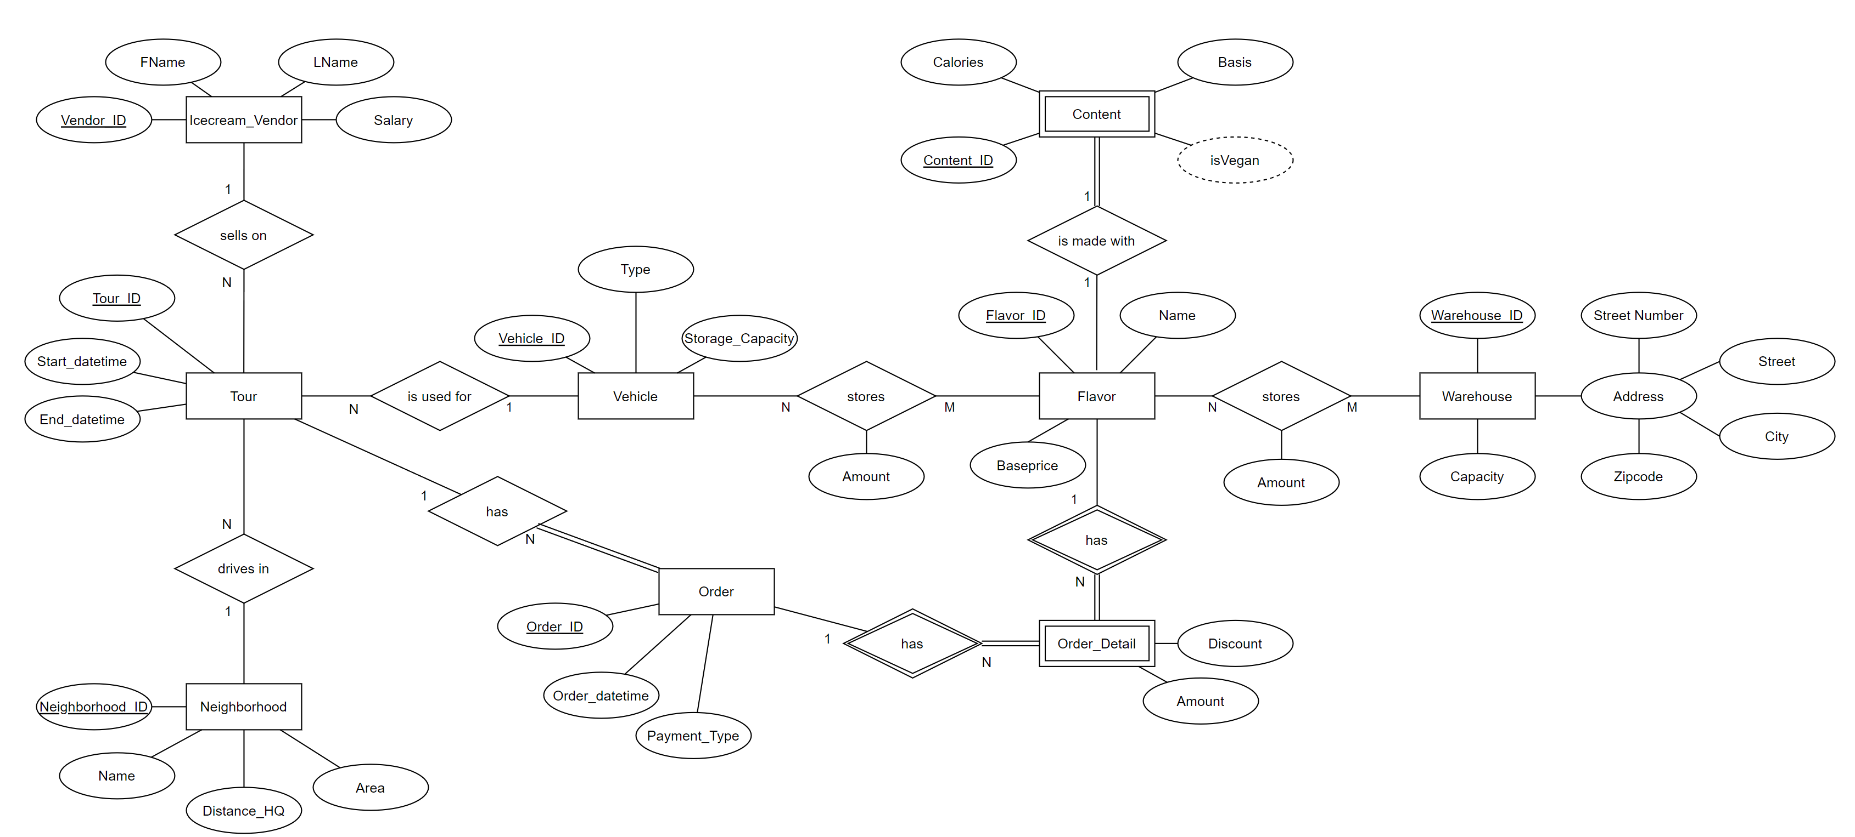

**3.1 Normalization**

Requirement: 3NF

A relation is in 3NF, if it satisfies 2NF (and in turn 1NF) and no non-prime attributes are transitively dependent on any candidate key.

All relations satisfy 1NF since there are no multivalued attributes nor nested relations.

All relations satisfy 2NF since there are no non-prime attributes which are only partially dependent on any candidate key.

All relations are in 3NF.

For example, violation of 2NF is avoided in “OrderDetails“ by not specifying the “Price“ (“BasePrice“) in the “OrderDetails“, which would be functionally dependent on the partial key “flavor_id”.

There is no violation of 3NF in relation “Warehouses”.

“Capacity” is not transitively dependent on the “warehouse_id” because “address” itself is a candidate key, therefore there is no problem.

Contents

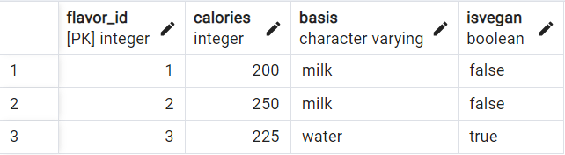

Flavors

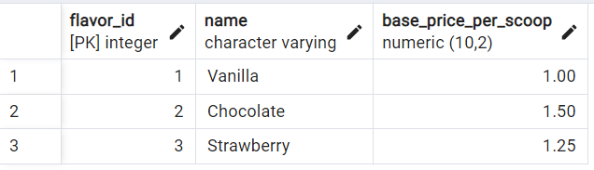

IceCreamVendors

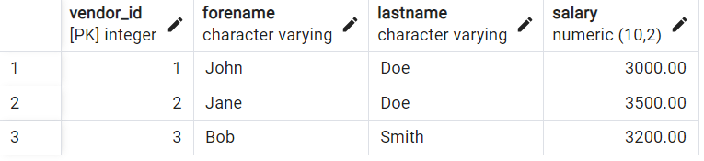

Neighborhoods

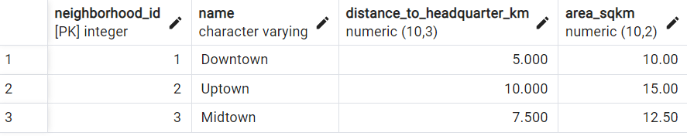

Orderdetails

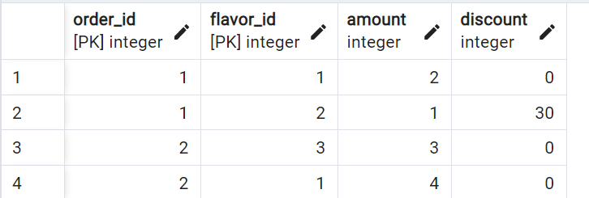

Orders

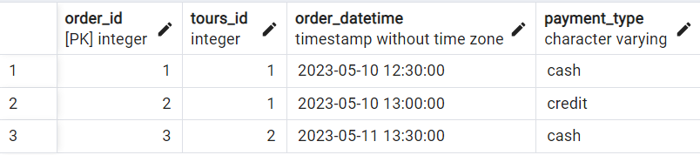

Tours

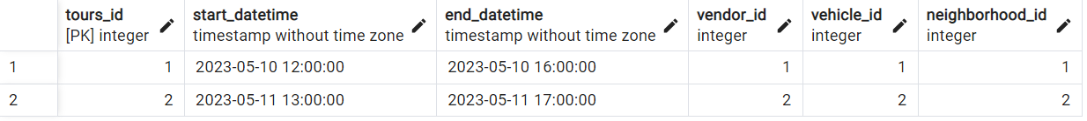

Vehicles

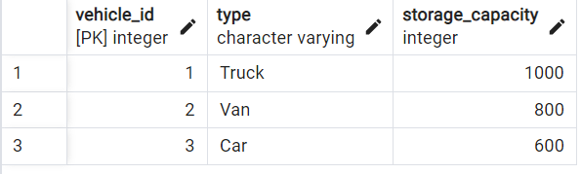

VehiclesStoreFlavours

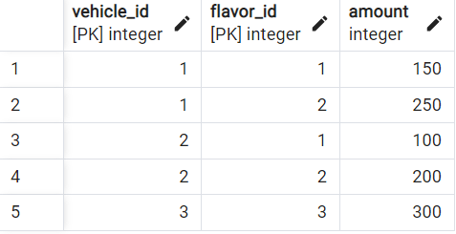

Warehouses

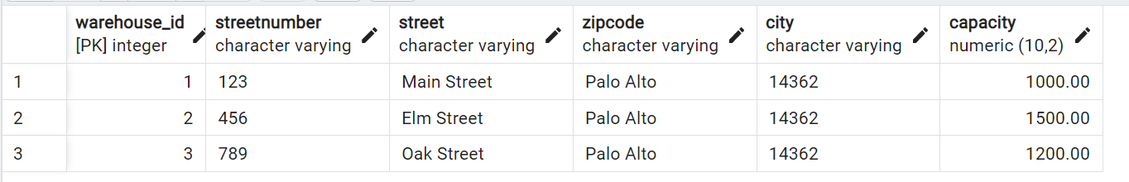

WarehoursesStoreFlavours

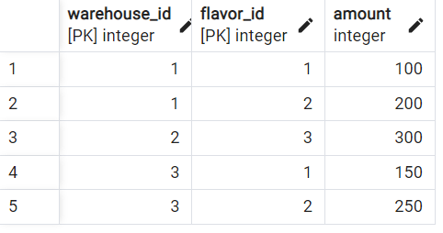

**3.2 DDL and insert Statements, Views**

DDL Statements for creation, the data insert statements as well as the defined views, the procedure and secondary indices may be found in the *src/db/init.sql* file.

The queries and their description may be found in the *src/db/queries.sql* file.

**4 Application**

The system is designed for the company IceCreamEmpire. The company wants to plan and track the daily tours to sell ice cream. It has to assign vehicles and vendors to a tour through a neighborhood.

It also wants to provide some information about the ice cream, where it is stored and what the sales numbers are. The system consists of the following entities, attributes and relationships.

The application uses docker to make it portable. For the database postgresql is used. The application layer uses SQLAlchemy to to access the database. sqlalchemy.ext.automap.automap_base is used in some instances to map the postgresql relations to python.

Project zip file:

doc/ — the documentation and ER diagram

src/db/ — the DDL & Insert SQL files

src/frontend/ — he fronted

src/frontend/app/app.py — the main programm

src/frontend/app/crudorder.py — Order and Orderdetail CRUD

src/frontend/app/crudtour.py — Tour CRUD

src/frontend/app/classes/queries.py — SQLAlchemy connection

The frontend uses the python package streamlit. On every user input the whole code defined in the frontend is rerun (stateless). Data which should outlast this refresh can be stored in a session state.

From the frontend, the relation extension can be viewed.

In the dashboard, total sales per vendor (refreshed on button click, using the materialized view from 3.), revenue per flavor, Vendor salaries, and the current sock per flavor can be viewed. CRUD operations are available for Tours, Orders and respective Orderdetails. More information is provided in the video.

**5 Starting the application**

To start the application, run from inside the zip-folder:

docker-compose up

The frontend can then be accessed from:

localhost