1. 用來寄信的 gmail 需要調降安全性，才能給我們的伺服器來連線使用

<https://myaccount.google.com/lesssecureapps?pli=1>

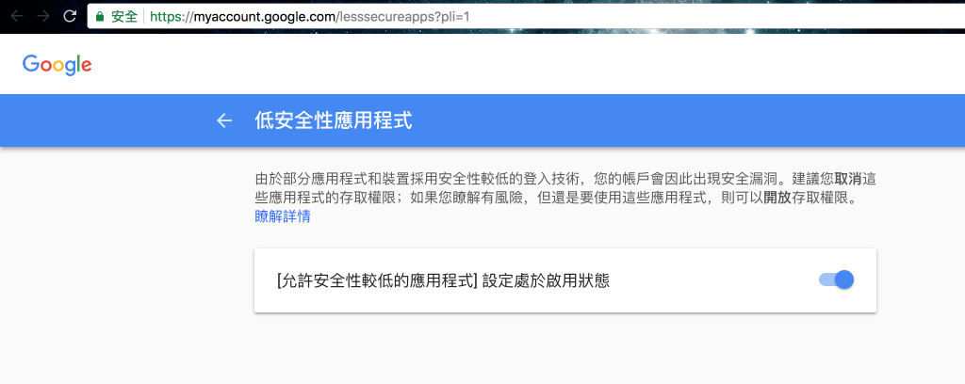

1. In Terminal, cd to project folder -> Install composer
2. composer require phpmailer/phpmailer
3. Sample php

<?php

// Import PHPMailer classes into the global namespace

// These must be at the top of your script, not inside a function

use PHPMailer\PHPMailer\PHPMailer;

use PHPMailer\PHPMailer\SMTP;

use PHPMailer\PHPMailer\Exception;

// Load Composer's autoloader

require 'vendor/autoload.php';

// Instantiation and passing `true` enables exceptions

$mail = new PHPMailer(true);

try {

//Server settings

$mail->SMTPDebug = SMTP::DEBUG_SERVER; // Enable verbose debug output

$mail->isSMTP(); // Send using SMTP

$mail->Host = 'smtp1.example.com'; // Set the SMTP server to send through

$mail->SMTPAuth = true; // Enable SMTP authentication

$mail->Username = 'user@example.com'; // SMTP username

$mail->Password = 'secret'; // SMTP password

$mail->SMTPSecure = PHPMailer::ENCRYPTION_STARTTLS; // Enable TLS encryption; `PHPMailer::ENCRYPTION_SMTPS` encouraged

$mail->Port = 587; // TCP port to connect to, use 465 for `PHPMailer::ENCRYPTION_SMTPS` above

//Recipients

$mail->setFrom('from@example.com', 'Mailer');

$mail->addAddress('joe@example.net', 'Joe User'); // Add a recipient

$mail->addAddress('ellen@example.com'); // Name is optional

$mail->addReplyTo('info@example.com', 'Information');

$mail->addCC('cc@example.com');

$mail->addBCC('bcc@example.com');

// Attachments

$mail->addAttachment('/var/tmp/file.tar.gz'); // Add attachments

$mail->addAttachment('/tmp/image.jpg', 'new.jpg'); // Optional name

// Content

$mail->isHTML(true); // Set email format to HTML

$mail->Subject = 'Here is the subject';

$mail->Body = 'This is the HTML message body <b>in bold!</b>';

$mail->AltBody = 'This is the body in plain text for non-HTML mail clients';

$mail->send();

echo 'Message has been sent';

} catch (Exception $e) {

echo "Message could not be sent. Mailer Error: {$mail->ErrorInfo}";

}