DockerFile to GHCR Through Jenkins

Overview:

The Textile-barcode application is to be pushed to ghcr for the EC2 instance to be created to pull it.
The whole project is separated into three different services namely:-

          - Backend
          - Frontend
          - Database

For each of the services corresponding images are created using DockerFile. The dockerfiles are build into images compatible for ghcr and then pushed to gchr. This process is not done manually, rather it is automated using Jenkins.

Step 1: Git & GitHub

The first step our project is setting up our source file and pushing it to our local repo and then to our remote repo in github.

- The git is initialized and the source files are staged and commited.
- Now the source files are in local repo. Thus before we push to our remote repo. We have to config this local repo to point to the remote repo in github.
- We add the remote and then successfully push it to the remote repo.

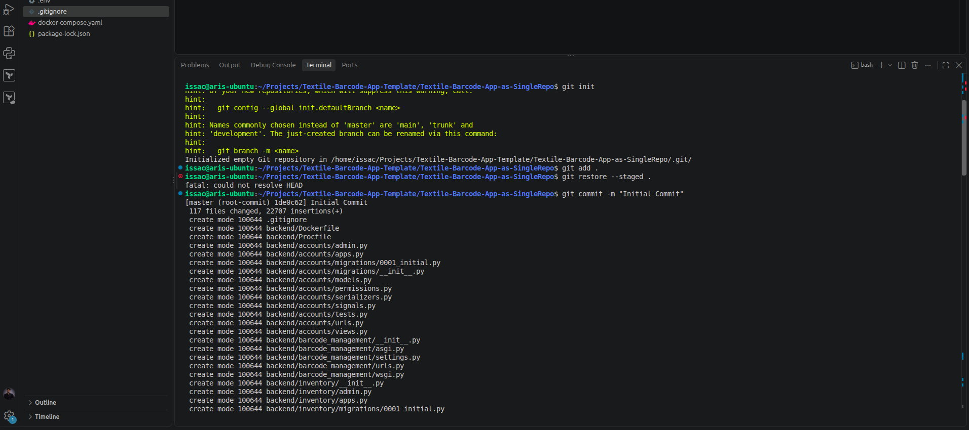
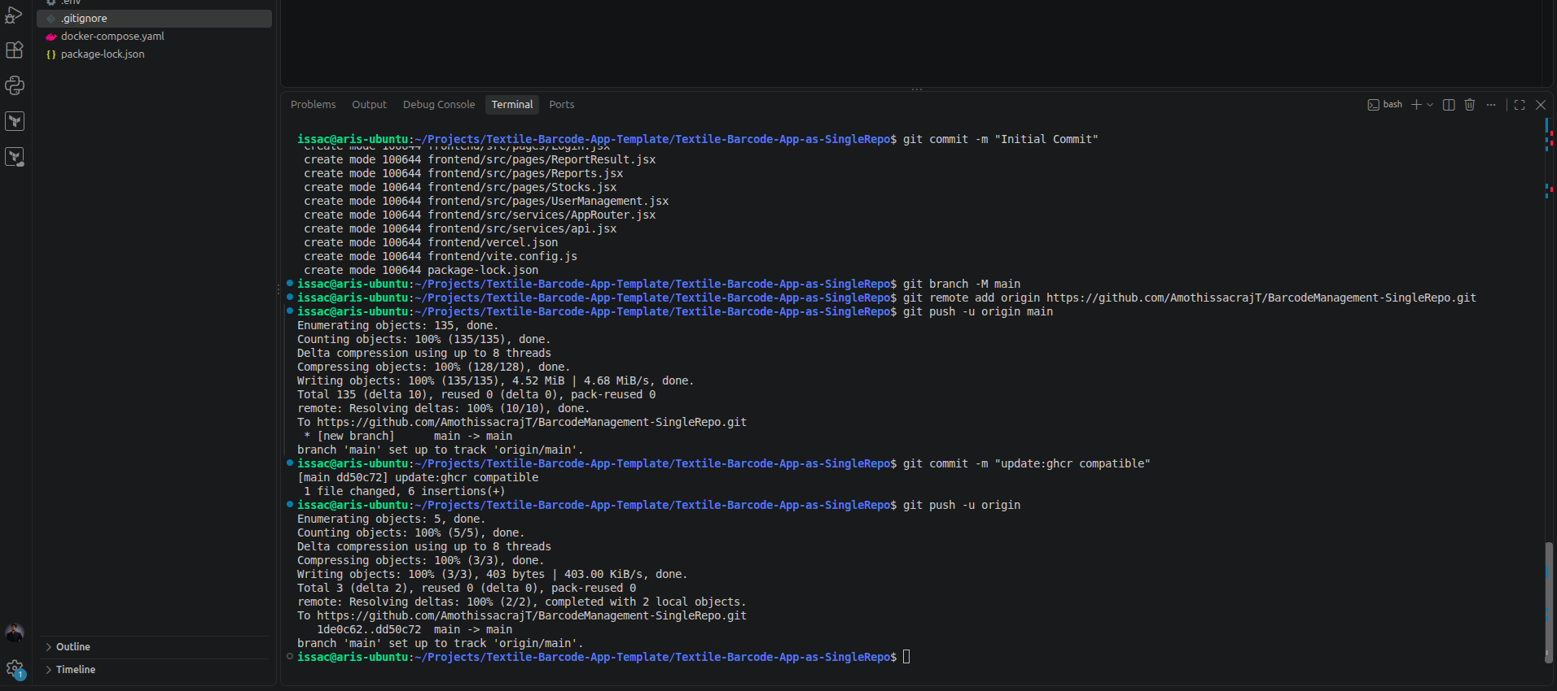

Remote Repo:

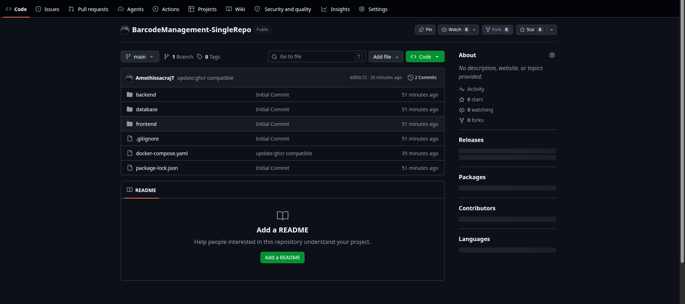
As there are multiple dockerfile we could write a compose file to automate building all the dockerfile. But at first the compose was written to automate the build of these images and automate the running a container for these images. But now docker compose build can be used to automate the building of these images without need for individual commands.

Step 2: Jenkins

In jenkins we create a new freestyle job to auntomate the building of these images and then also pushing it to ghcr.

Function of jenkins:

- To build the image from dockerfile with compose
- To push these images to ghcr

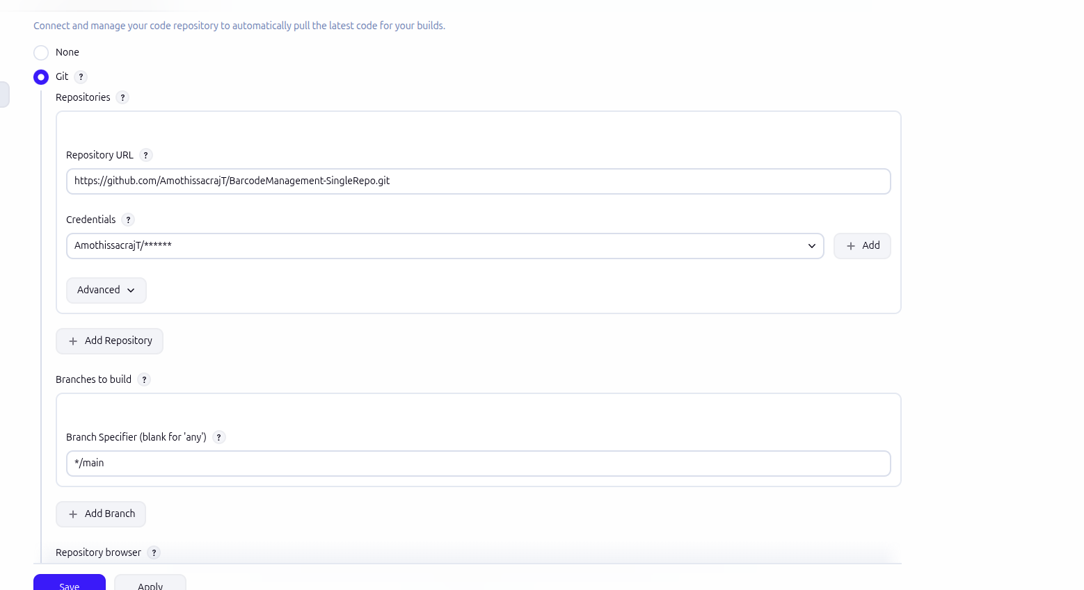

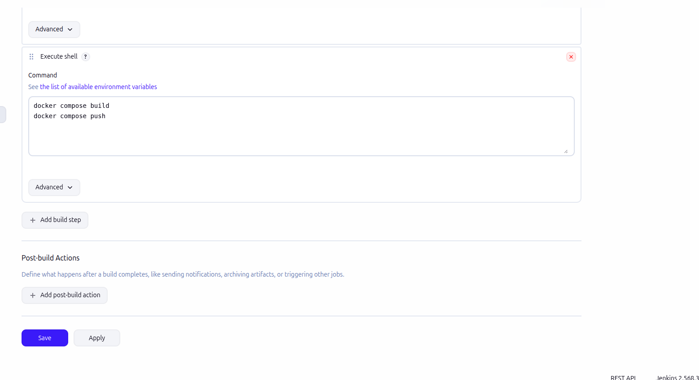

Now that the jenkins job has been written, we will try build now for this job. WE FACE AN ERROR

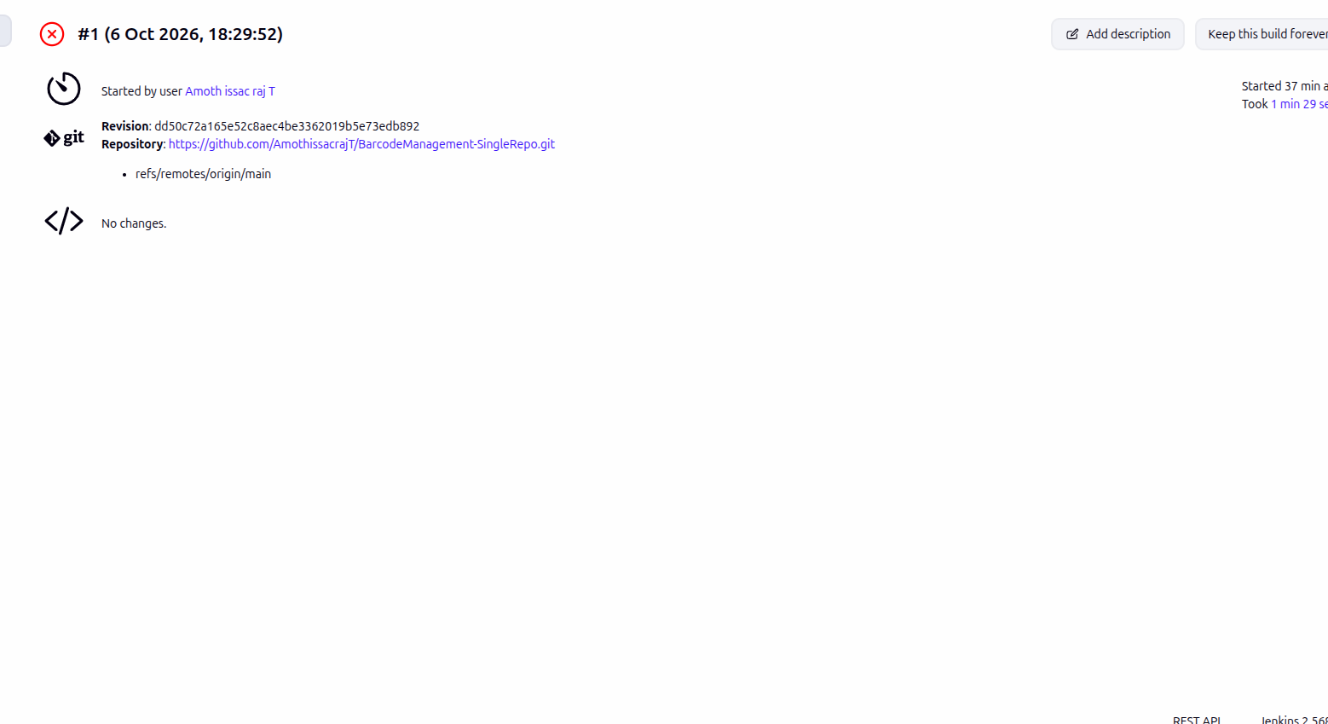

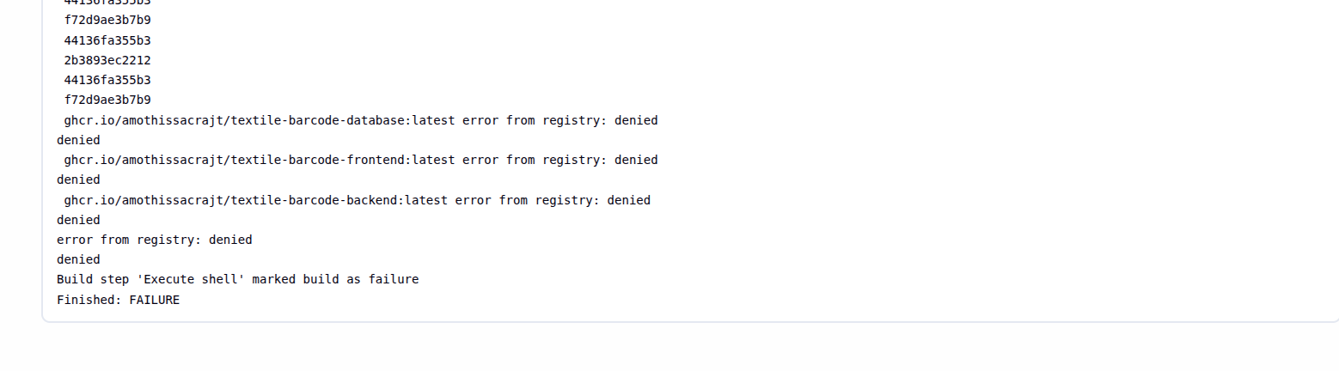

Jenkins was able to build the image but was not able to push it to ghcr. This is because the jenkinks is not able to access my ghcr repo, the permission is denied.

Step 3: Credentials

Thus now jenkins should have my Personal Access Token (PAT). why should jenkins have it? , it is for jenkins to login to ghcr.

docker login ghcr.io -u <username> <PAT token>

this is the command to login to ghcr. For that to happen we will use global credentials in jenkins to manage credentials.

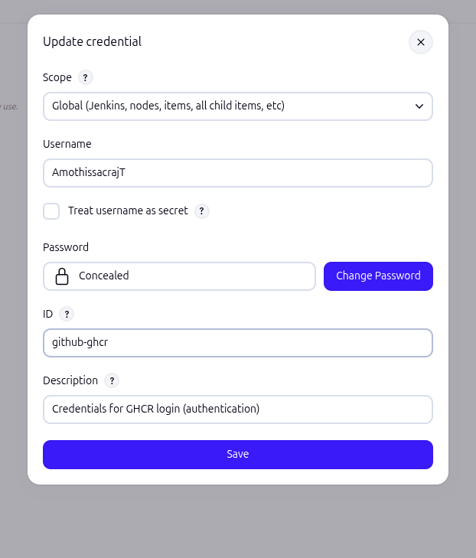
By this jenkins handles these credentials. Now we could use this username & password credentails to login.

First we have to enable Use secret text(s) or file(s) under Environment topic.

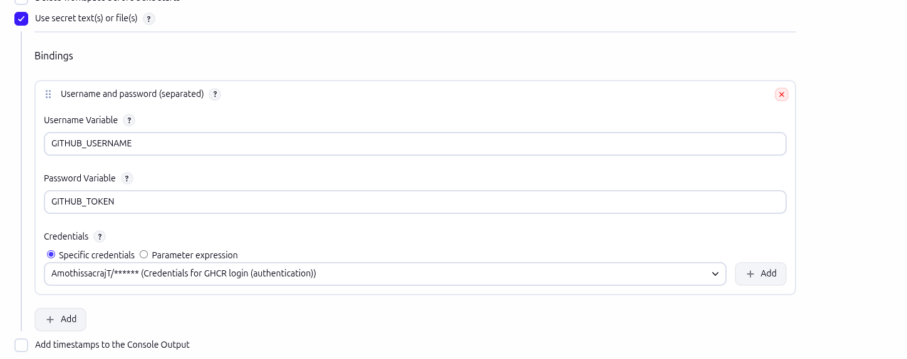
we will declare global variable for username and password. Then use it to login before push.

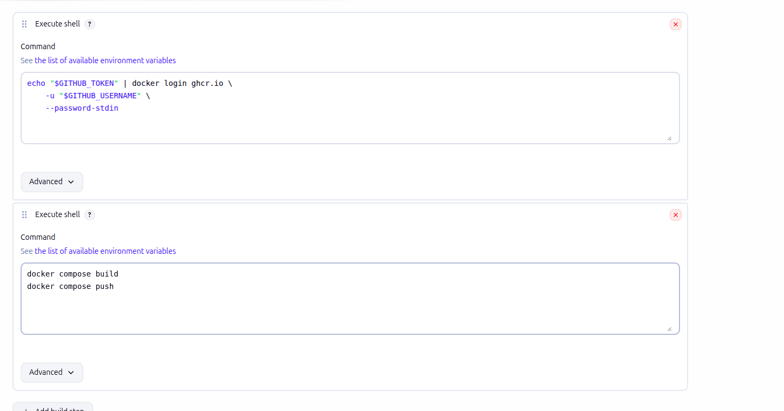
echo "$GITHUB_TOKEN" | docker login ghcr.io
-u "$GITHUB_USERNAME"
--password-stdin

this command is used to pipe the token to the login command and avoid explicitly putting the $GITHUB_TOKEN into the command which can cause the leak of secret token by checking logs.
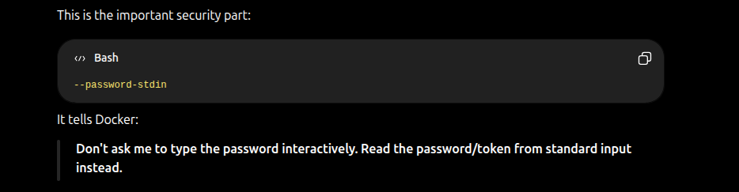
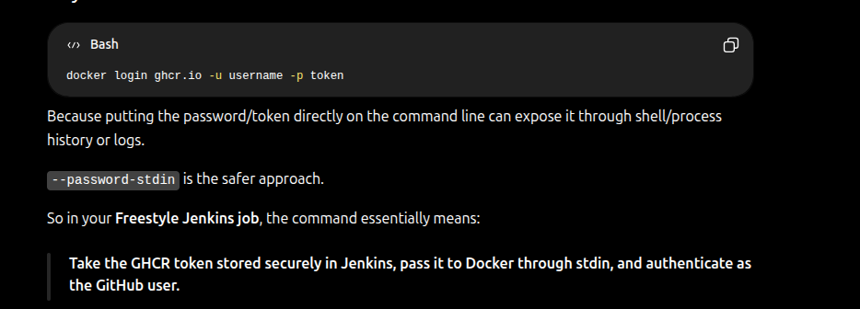
Reference from GPT
Now build the job.

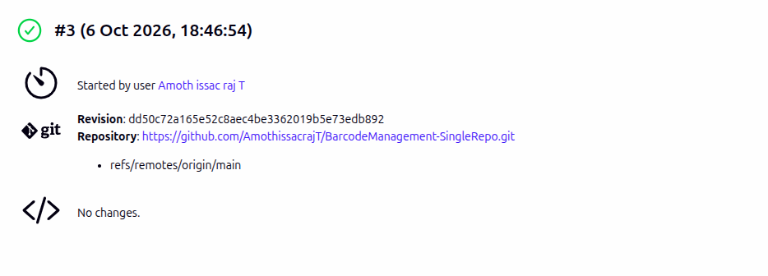

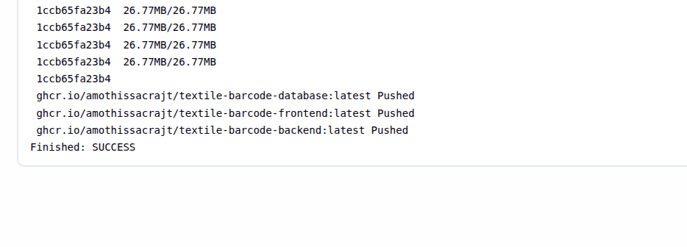
Now that it is pushed to the ghcr we will cross check it.

