1) Create a database called "contact" :

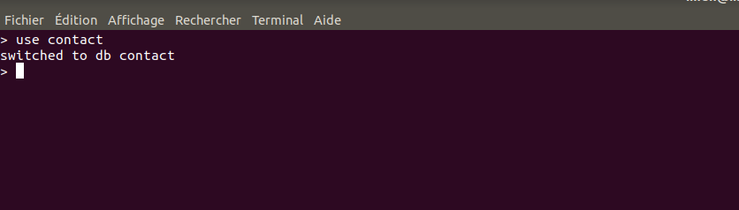
2) * Create a collection called "contactlist"
* Insert these documents in "contactlist"

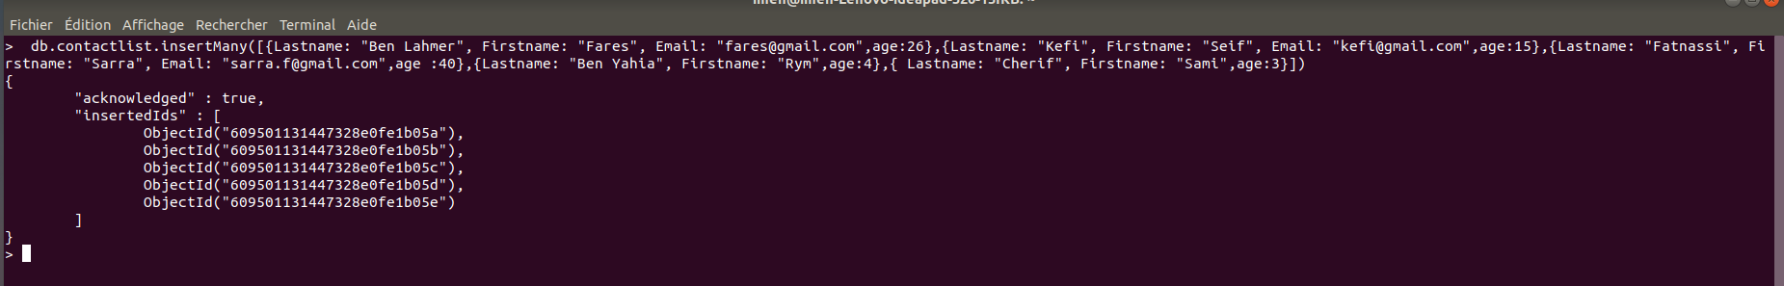
3) Display all of the contacts list :

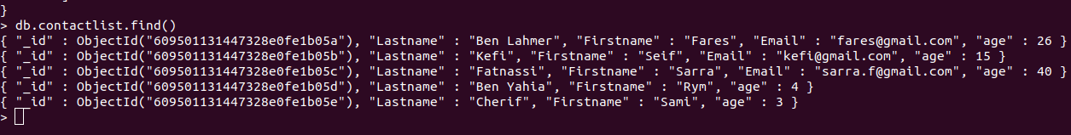

4) Display all the information about only one person using his ID :

5)Display all the contacts with an age >18
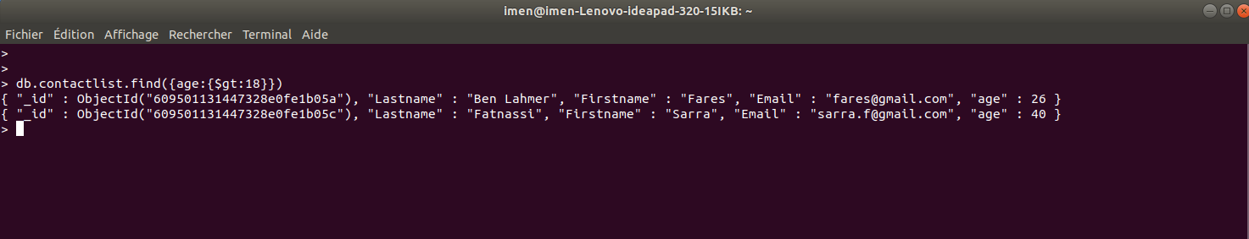
6) Display all the contacts with an age>18 and name containing "ah" :

7) Change the contact's first name from"Kefi Seif" to "Kefi Anis"

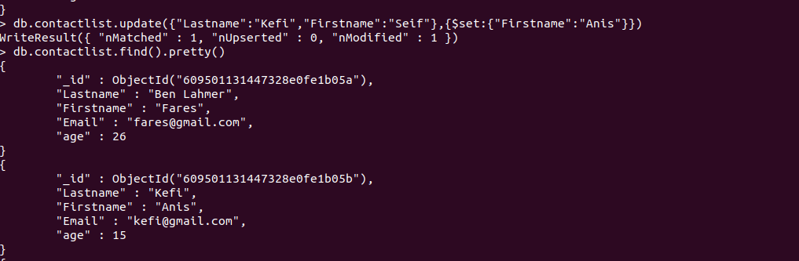
8) Delete the contacts that are aged under <5

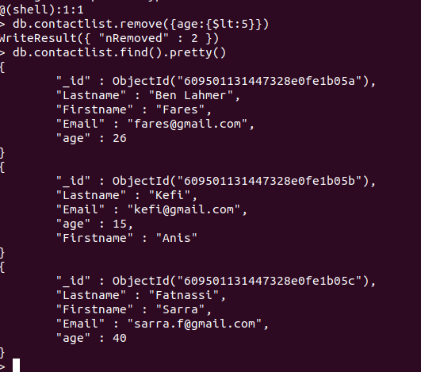
9) Display all of the contacts list :

