DDL Checkpoint

1)

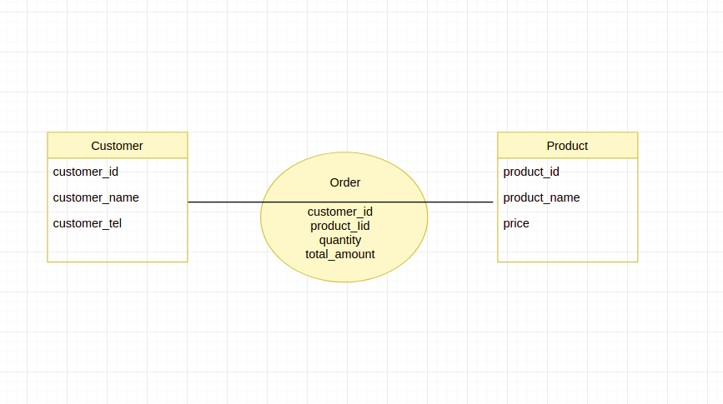
2) ALTER TABLE Product ADD categorie VARCHAR(20)

3) ALTER TABLE Order ADD CONSTRAINT orderDate DATE DEFAULT sysdate

