Deliverable 1 – Design Document
Project 3: Distributed Job Queue and Worker Management (SDN + TCP sockets) · Computer Networks, PES University
Repository: https://github.com/Amp1611/jackfruit-distributed-job-queue
Member | Name | SRN | Brief contribution
Member 1 | Aadhya | PES1UG25CS004 | Application protocol and scheduler (app/protocol.py, app/scheduler.py)
Member 2 | Amartya Maiya P | PES1UG25CS050 | Worker, client and Mininet topology (app/worker.py, app/client.py, topology/topology.py)
Member 3 | A Kavin Sharvesh | PES1UG25CS003 | Ryu SDN controller (controller/controller.py)
Problem statement
Build a distributed job queue in which clients submit jobs over TCP to a central scheduler. The scheduler queues the jobs, dispatches them to a pool of workers, monitors worker health and returns the results. The network is emulated in Mininet and managed by an SDN controller (Ryu, OpenFlow 1.3) that identifies and prioritises job-queue traffic and can change forwarding paths at run time.
1. Problem understanding and architecture
The design keeps the application and the network separate and connects them through a small interface. Clients (h1) submit jobs to the scheduler (h2), which dispatches them round-robin to workers (h3, h4) over TCP port 5000. Three OpenFlow 1.3 switches connect the hosts, with two paths between s1 and s3 (direct, or via s2). The Ryu controller programs the switches, gives job traffic its own rules and reads the scheduler's state.
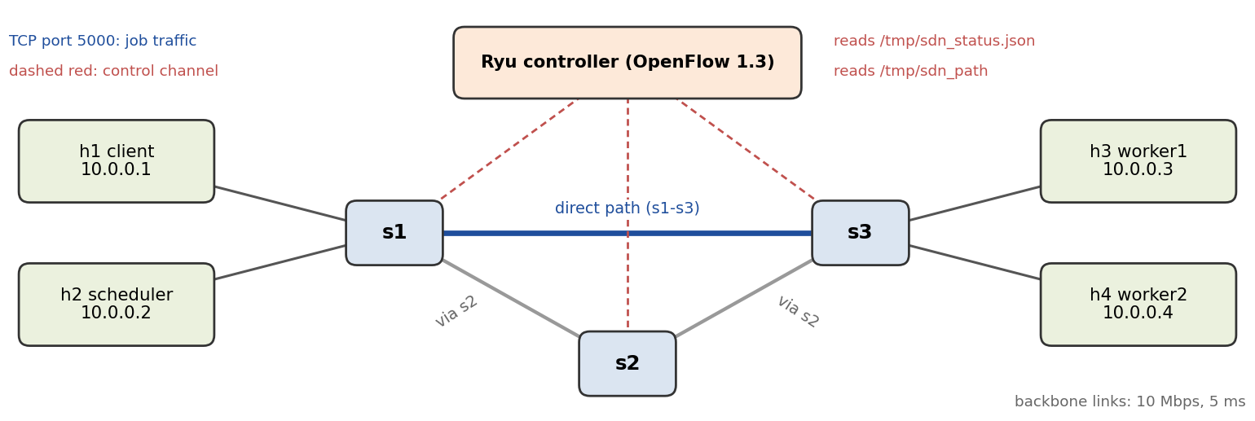
2. TCP socket implementation
- Protocol: newline-delimited text over TCP port 5000 (docs/protocol.md). Worker messages: REGISTER, HEARTBEAT, DONE/FAIL. Client messages: SUBMIT, answered by ACK, then RESULT/FAILED. The scheduler sends JOB to workers.
- Scheduler (h2): one thread per connection. A connection whose first line is REGISTER is a worker, any other is a client. SUBMIT gets an ACK <job_id> and is queued. A dispatcher thread sends JOB to the next worker in round-robin order and forwards the result to the client.
- Fault handling: workers send a heartbeat every 2 s. A worker silent for 8 s is removed and its unfinished jobs are put back in the queue.
- Worker (h3, h4): registers, sends heartbeats with its active job count and runs each job in its own thread (job types REVERSE, SUM, SLEEP, PRIME, with input limits). It reconnects automatically every 2 s if the scheduler is unavailable.
- Client: sends --count jobs over --parallel connections and prints each result with latency (average, min, max). An unknown job type returns an error and a bad payload returns FAILED; the scheduler keeps running.
3. Mininet and SDN implementation
- Topology (topology.py): hosts h1–h4 and OVS switches s1–s3 using OpenFlow 1.3 in secure fail mode, with fixed MACs and port numbers the controller relies on. Backbone links are 10 Mbps with 5 ms delay. The script starts the scheduler and workers on h2–h4 and runs a connectivity check.
- Controller (controller.py, Ryu 4.34): installs forwarding rules when each switch connects. It answers ARP requests itself (ARP proxy) so broadcasts do not loop around the s1–s2–s3 cycle. Traffic on TCP port 5000 matches priority-100 rules (tcp_dst=5000, tcp_src=5000), so job traffic is identified and counted separately. Flow statistics are logged every 5 s as [job traffic] lines per switch.
4. Socket–SDN integration
- Scheduler to controller: every 2 s the scheduler writes queue length, job counts and per-worker state to /tmp/sdn_status.json (temporary file plus atomic rename). The controller reads it and logs it as [app status] next to the traffic counters.
- Controller to network: /tmp/sdn_path holds direct or via_s2. When it changes, the controller logs PATH CHANGE and installs new rules that move job traffic over s2.
- Design choice: files work because the Mininet hosts and the controller share the VM's filesystem, which is simple and easy to inspect. The path change is triggered by hand for now; for D2 we plan a proper control channel and automatic changes driven by worker failure and load.
5. Initial testing
Every test below was run on all three team VMs with the same results.
Test | How | Result
Connectivity, workers registered | pingall; h2 cat /tmp/sdn_status.json | 0% dropped; both workers listed
Single job | REVERSE with "hello world" | dlrow olleh
Round-robin | 6 SUM jobs | 6 correct results; 3 jobs in each worker log
Concurrency | 5 parallel connections × 3 SLEEP jobs | 15/15 jobs succeeded
Error handling | Unknown type FOO; SUM with payload abc | Error message; FAILED, scheduler keeps running
SDN sees job traffic | ovs-ofctl dump-flows s1; controller log | priority-100 tcp_dst=5000 rules; [job traffic] lines
Dynamic path change | echo via_s2 > /tmp/sdn_path, then run jobs | PATH CHANGE logged; job traffic seen on s2
Packet capture | Wireshark on s1-eth4 and lo | Job traffic on tcp.port == 5000; OpenFlow Flow Mod messages
Worker-failure recovery is implemented but not yet tested; we plan to cover it in D2.
6. How to build and run (Ubuntu VM)
Prerequisites: Mininet, Open vSwitch, and a Python 3.9 venv with Ryu (exact commands under *Prerequisites* in README.md).
git clone https://github.com/Amp1611/jackfruit-distributed-job-queue.git && cd jackfruit-distributed-job-queue
# Terminal 1 - controller (start first)
source venv/bin/activate && ryu-manager controller/controller.py
# Terminal 2 - network and app, without the venv; wait for "Ready" and the mininet> prompt
sudo python3 topology/topology.py
mininet> h1 python3 app/client.py --type REVERSE --payload "hello world" # prints dlrow olleh
# Terminal 3 - checks
sudo ovs-ofctl -O OpenFlow13 dump-flows s1 # then: echo via_s2 > /tmp/sdn_path
# If a run is interrupted: sudo mn -c. The full test list is in README.md.

