# 

# **ID2209 – Distributed Artificial Intelligence and Intelligent Agents**

# **Assignment 1 – GAMA and Agents**

Group 12

Noémie Nicaise

Harshdeepsinh Parmar

09/11/2020

The objective of Assignment 1 is to get familiar with GAMA Platform and to learn, implement and infer agent-based simulations. The theme of the assignments is Festival, where each assignment will have different topics to implement. The first assignment will focus on GAMA and Agents, where we will create a basic festival area which consists of guests, an information centre and stores for food and drink. We will also learn about the movements and behaviour of agents in GAMA.

**How to Get Started**

Once you’ve installed GAMA platform, you can create a new project, Festival to implement the tasks.

We’ve created three models to implement the logic:

* Festival_basic.gaml
* Festival_memory.gaml
* Festival_security.gaml

To run the simulation, we press the “Run” button to run the main file and infer the outcomes.

There are many parameters you can observe and alter in the simulation window, such as, speed, pause, play etc. You can also see the messages in the output window.

General Overview:

Agents

Basically, a system consists of intelligent entities which are called agents which together form a cluster to interact by coexistence and co-operation. Here, in this assignment, we create three different types of Agents, namely, Guest, Store and an Information Centre. Each agent will have different attributes and functions.

Guest: Simulating the virtue of a human at a festival, Guest possesses the qualities of a human as feeling hungry, thirsty, getting food and drink and moving.

Store: Simulating the virtue of a store, which can sell food and drink. In this simulation, there are two attributes of a shop, either it sells food or drink whenever a guest asks for it.

Information Centre: Simulating the virtue of the Information Desk at a festival which has most of the information about it in general.

These agents in simulation are bound to cooperate and exchange information.

Implementation: Approaching the problem

According to the assignment objectives, we’ve approached it on three different levels by creating three different models and the final model serves as a main file for assignment 1.

Model 1: Festival_basic.gaml

Serves as a base to develop the idea of festivals by introducing agents. Using functions such as Reflex and Skill, we demonstrate the behavior of agents.

The basic model where agents exist and have attributes is created by using “species” for each agent. Each species will have “Reflex” to act on certain kinds of behaviour. Such as:

* *Reflex beCrazy: when a guest wanders around the fest.*
* *Reflex thirstyOrHungry: let the guest know that they are hungry or thirsty*
* *Reflex moveToTarget: Guest goes to a specified target*
* *Reflex askInfoCentre: Guest goes to Information centre to fetch information*
* *Reflex drinkOrEat: Guest fulfills his hunger or thirst.*

Output:

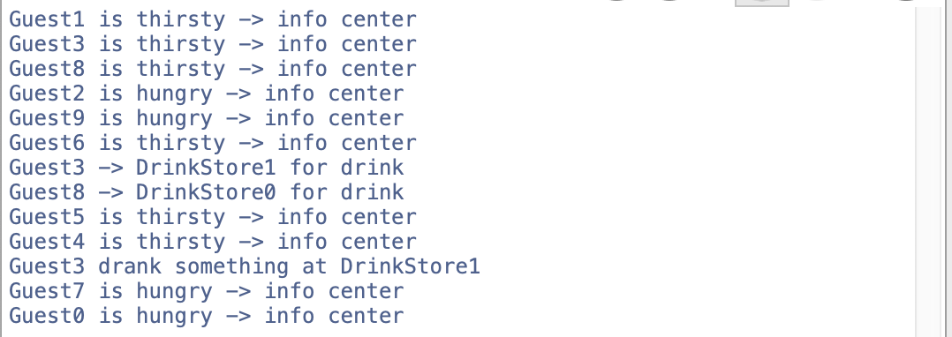

Model 2: Challenge 1: Festival_memeory.gaml:

This model implements the so-called function of “small brain” to remember the positions. Thereby, eliminating the need to visit the Information centre everytime. They can either directly use their memory to go to a shop or, as they want to discover new shops, they can go to the Information centre or ask the nearby guests on the way. This is implemented using the “ask” function.

* *Reflex askGuest: introduces the logic where one nearby guest asks another guest for a store and goes to that store.*
* *It also computes the comparison of total distance travelled saved by exchanging knowledge using the function “gain”.*

Output:

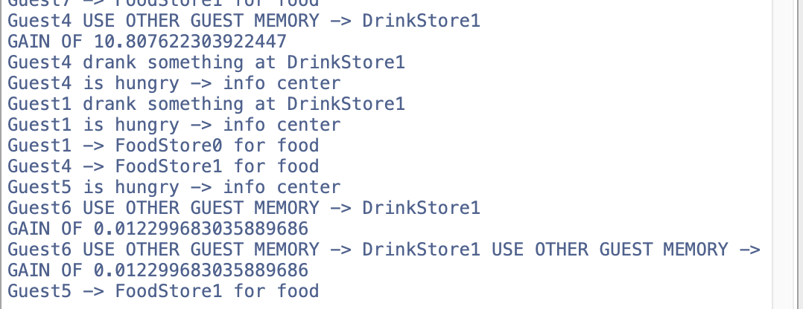

Model 3: Challenge 2: Festival_security.gaml

This model introduces a new agent called “FestSecurity”, which simulates the virtue of security guards in the festival. The information centre holds the information about the location of the security guard. Two reflexes of Fest Security:

* *Reflex findBadGuest: To find the bad behaving guest*
* *Reflex badGuestCaught: To bust and evacuate the bad behaving guest by using “die” function*

Output:

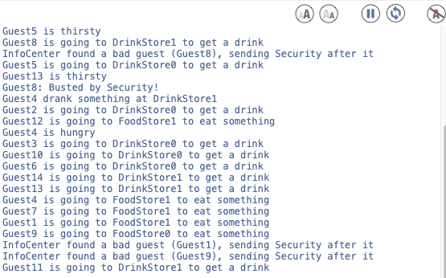

Results and Conclusion

The results achieved by implementing the logic to complete the objectives of the assignment gave us significant knowledge to start with on how to simulate multi-agents systems and perform tasks to interact between different agents. Working on the theme “Festival” gave us insights on the movement and behaviour of agents.

Overall, we conclude that we were able to get familiar with the GAMA platform and its syntax and were able to achieve the desired output which will serve as a base for future assignments and projects.