Title Page Product Documentation

Preface
We have made an addin of Subversion for VS.NET, named Ankh. The development of Ankh, was conducted as a final year project at HiO in cooperation with CollabNet. The system contains an addin/GUI layer written in the coding language C#, and a .NET wrapper layer divided in a lower level layer covering the SVN's client API coded in Managed C++ and a more object-oriented part coded in C#. The code is documented in detail in the Code Comment Web Report available on our internet site and on the enclosed CD.
This report is written for the computer personnel responsible for marketing, maintenance, updating, support and modifications to the system. The purpose of this document is to give a description of how t he system is constructed, how to install and configure the addin and what type of testing the system have been exposed to.
It is an advantage to have knowledge about revision control systems and VS.NET to get a better understanding of this document.

Table of contents

Title Page Product Documentation 1
Preface 2
Table of contents 3
1 Introduction 5
1.1 Why use Ankh ? 5
1.2 How the program works 5
1.3 Menus and navigation 5
2 The Ankh project overview 6
2.1 Development tools 6
2.1.1 VS.NET 6
2.1.2 VS.NET addin architecture 7
2.1.3 Code Comment Web Report 7
2.1.4 NUnit 7
2.1.5 NAnt 7
2.1.6 C# 8
2.1.7 Managed C++ 8
2.1.8 xml / xsl documentation for web 8
2.1.9 EA 8
2.2 System architecture 8
2.3 Conceptual model 9
2.4 Use case diagrams 10
2.5 Coding structure 11
2.5.1 Naming guidelines 11
2.5.1.1 General 11
2.5.1.2 Classes 12
2.5.1.3 Interfaces 12
2.5.1.4 Methods 12
2.5.1.5 Properties 12
2.5.1.6 Attributes 12
2.5.1.7 Method parameters 12
2.5.1.8 Fields 12
2.5.2 Formatting 12
2.5.3 Comments 13
2.5.3.1 General 13
2.5.3.2 xml documentation comments 14
2.5.4 Namespaces 14
2.5.4.1 Ankh 14
2.5.4.2 Ankh.Commands 14
2.5.4.3 Ankh.UI 15
2.5.4.4 AnkhSetUp 15
2.5.4.5 NSvn 15
2.5.4.6 NSvn.Common 15
2.5.4.7 NSvn.Core 15
2.5.4.8 NSvn.Core.Tests 15
2.5.4.9 NSvn.Core.Tests.MCpp 15
2.5.4.10 Solution Items 15
2.6 Testing 15
2.6.1 Unit testing with NUnit 15
2.6.2 Functional testing 16
2.6.3 Testing of GUI 16
2.7 Future developments 16
3 Installation and configuration 16
4 Conclusion 16
5 Appendix 16
5.1 Dictionary 16
5.2 Use case schemes 23
5.3 Class diagrams 49
5.3.1 Class diagram of Ankh 49
5.3.2 Class diagram of Ankh.UI 50
5.3.3 Class diagram of Ankh.Commands 51
5.3.4 Class diagram of NSvn 52
5.3.5 Class diagram of NSvn.Common 52
5.3.6 Class diagram of NSvn.Core 53
5.3.7 Class diagram of NSvn.Core.Client 54
5.3.8 Class diagram of NSvn.Core.Tests 54
5.3.9 Class diagram of NSvn.Core.Tests.MCpp 54

Introduction

Why use Ankh ?
Description of Ankh

How the program works
What the program can do for you.

Menus and navigation
A combination of :
- multisquared windows (Windows where a special event in one window effects the output in another window.)
- multiwindow (Each window could be moved independently.)
- Multidocuments (One main window manage many dialog boxes. )
were used because our goal was to implement Subversion into VS.NET as smoothly as possible.

The menu choices are as functional and obvious as possible. For example the command "svn cp" are named "copy" in the menu context. There might be some programmers that already are familiar with SVN. The wording used in Ankh therefore don’t deviate considerably from the SVN standard. We have deliberately avoided new notions.

To be able to distinguish between SVN and VS.NET's own menu choices, dialog boxes, Solution Explorer, Output pane etc. without deviating too much from VS.NET's GUI design an icon was used. As the Subversion group tend to use Egyptic words we decided to follow their trend. The name Ankh was selected because it is Egyptic and could be visualised as a simple icon.

Our navigation model is described in the figure bellow. If the programmer right click on a file, directory or project a menu will pop up. If input parameters for the option selected is required, a dialog box will be displayed. The result of the action initiated in the dialog box will be displayed in a Svn pane in the Output window. If the option selected is Edit properties new properties will be added to the Properties window. There are also a new pane containing a file tree view of the repository.

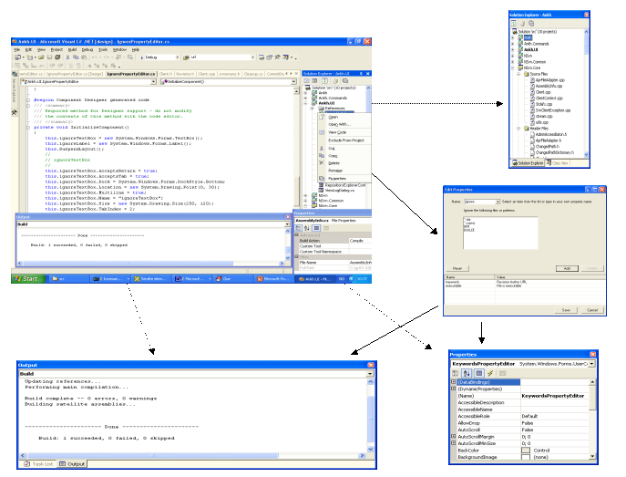

The Ankh project overview

Development tools
VS.NET provide a tool that generate a web report displaying information about the definitions in your code in a series of .htm pages. This feature allow you to browse the code structure within files in your current project or solution, such as classes, objects, members and interfaces. The comments are written in the C# source code by use of xml-tags combined with a special comment syntax. Ex ///<summary> This is a summary</summary>.

VS.NET
Visual Studio .NET is a set of development tools for building ASP Web applications, XML Web services, desktop applications, and mobile applications. Visual Basic .NET, Visual C++ .NET, and Visual C# .NET all use the same integrated development environment (IDE), which allows them to share tools and facilitates in the creation of mixed-language solutions. In addition, these languages leverage the functionality of the .NET Framework, which provides access to key technologies that simplify the development of ASP Web applications and XML Web services.

VS.NET addin architecture
In VS.NET it is possible to make addins. This makes it possible for us programmers to add whatever preferred tool into VS.NET. We have made a COM addin.
A COM addin is a dynamic-link library (DLL) that contains not only your custom code, but also special registry entries. These registry entries are used by Microsoft Office applications to determine the COM addin's behaviour at run time.

Code Comment Web Report
VS.NET provide a tool that generate a web report displaying information about the definitions in your code in a series of .html pages. This feature allow you to browse the code structure within files in your current project or solution, such as classes, objects, members and interfaces. The comments are written in the C# source code by use of xml-tags combined with a special comment syntax.
Ex ///<summary> This is a summary</summary>.

NUnit
NUnit is a unit-testing framework for all .Net languages. Initially ported from JUnit which is a unit-testing for Java. The current version, 2.0 is the second major release of this NUnit based unit testing tool for Microsoft .NET. It is written in C# and has been completely redesigned to take advantage of many .NET language features, for example custom attributes and other reflection related capabilities. NUnit brings xUnit to all .NET languages.

NAnt
NAnt is a free .NET build tool. Instead of writing shell commands, the configuration files are XML-based, calling out a target tree where various tasks get executed. Each task is run by an object that implements a particular Task interface. Example of a test performed is listed bellow. The test verify the implementation of the method Add in the lower wrapper layer.

[Test]
public void TestBasic()
{
string testFile = this.CreateTextFile( "testfile.txt" );

ClientContext ctx = new ClientContext( new NotifyCallback() );
Client.Add( testFile, false, ctx );

Assertion.Assert( "No notification callbacks received",
this.Notifications.Length > 0 );

Assertion.AssertEquals( "svn st does not report the file as added",
'A', this.GetSvnStatus( testFile ) );

}

C#
Microsoft C# (pronounced C sharp) is a new programming language designed for building a wide range of enterprise applications that run on the .NET Framework. C# code is compiled as managed code, which means it benefits from the services of the common language runtime. These services include language interoperability, garbage collection, enhanced security, and improved versioning support.

Managed C++
Managed Extensions for C++ are enhancements made to the C++ language. Managed Extensions simplify the task of migrating existing C++ applications to the new .NET Framework. Attributes, like C++ keywords, are used in source files and interpreted by the compiler. Attributes are designed to provide a quick and efficient method to simplify COM programming with Visual C++.

EA

System architecture
The system is divided into 2 main layers, a GUI/addin layer and a .NET wrapper layer. The addin/GUI layer contain coding of the addin and graphical user interface in the C# language. This layer is called Ankh. The wrapper is divided into a lower level .NET wrapper layer for the SVN's client API coded in Managed C++ and a more object-oriented high level coded in C#. The .NET wrapper is called NSvn.
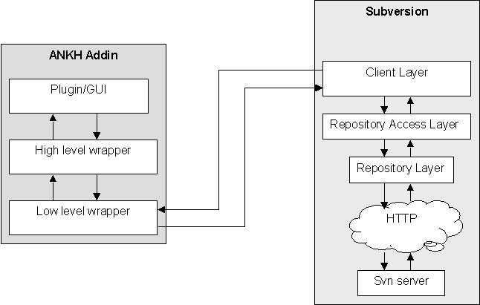

Conceptual model
The system was analysed from the developers point of view. Two actors were identified, the potential user of the system and the repository.

One example of the collection of the conceptual model diagrams is listed bellow. A collection of all the use case diagrams are enclosed in appendix XXX.

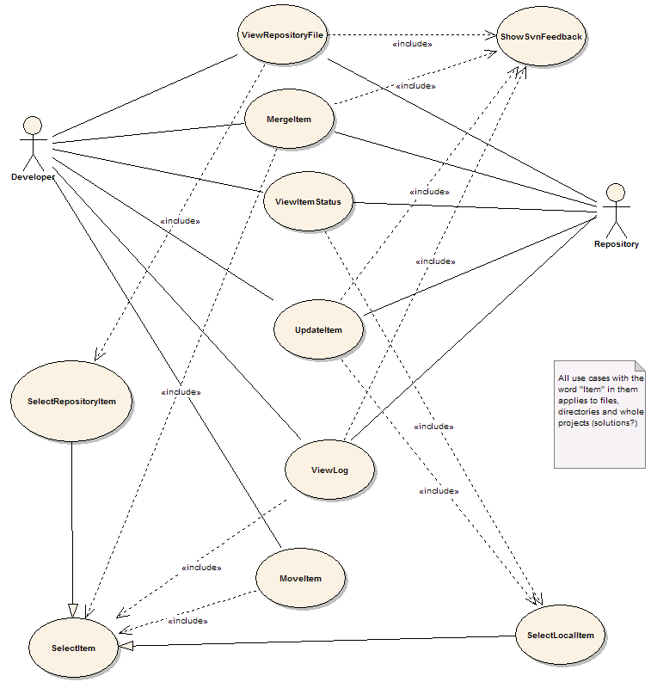

Use case diagrams
Each object identified in the conceptual model was analysed as a use case. One example of the Add use case is listed bellow. A collection of all the use cases are enclosed in appendix XXX.

Use case | Add item
Actors | 1 Developer
Preconditions
1 The item is not currently in the workspace
2 The item is in a directory that is currently in the workspace
Scenario
1 The user invokes the VS.NET command File.AddNewItem or File.AddExistingItem
2 The item is added to the working copy
3 <Include 'ShowSvnFeedback'>
Postconditions
1 The item is in the workspace

Coding structure

Naming guidelines
Ankh follow the Microsoft .NET class library naming guidelines. A summary of these guidelines are listed below:

General
- Hungarian notation, eg lpszFooBar are not used
- Underscores are not used

Classes
- Class names use Pascal case, like:
public class FooBar{...}

Interfaces
- Interface names use Pascal Case
- The name of an interface starts with the letter I

Methods
- Methods are named using Pascal Case

Properties
- Properties are named using Pascal Case
- It was permitted to name a property the same as the underlying type:
- public Color Color
- {
- get{ return this.color; }
- }

Attributes
- Attributes are named with Attribute suffix added, as in FooBarAttribute.
- Attributes suffix are not used when applying an attribute(in C# this suffix is optional):
- //yes
- [FooBar]
- public void Foo()
- {...}

- //no
- [FooBarAttribute]
- public void Foo()
- {...}

Method parameters
- Parameters are named in camelCase

Fields
- Private fields are named using camel case

Formatting
- Tab characters are not used for indentation.
- Each nested block are indented 4 spaces relative to the enclosing block
- The 'normal' indentation style are used:
- //yes
- public void FooBar()
- {
- //...
- }

- //no
- public void FooBar(){
- //...
- }

- //no
- public void FooBar()
- {
- //...
- }

- //no
- public void FooBar()
- {
- //...
- }

- All use of member fields are prefixed with.:
- public class Foo
- {
- //...

- public void Bar()
- {
- this.baz = 42; //yes
- baz = 13; //no
- }

- private int baz;
- }
- Members of a class are ordered according to their protection level, in the following order from the top:
  - public member methods
  - public properties
  - public fields(should be avoided as a general rule)
  - protected member methods
  - protected properties
  - protected fields(should be avoided)
  - private member methods
  - private properties
  - private fields

Comments

General
Comments generally add information that is not obviouse from reading the code alone. Atrocities such as the following is avoided:

// increase counter by 1
counter++;
We have tried to choose variable and method names as self-explainable as possible to eliminate a lot of comments. Method names are verbs and variable names are substantives. In general. End-of-line comments are avoided unless absolutely necessary. The only exception was while making a method/function call that took a large number of arguments. In that case it was accepted to put each argument on a separate line and add a comment describing the parameter at the end of the line.

xml documentation comments
All classes and methods that are part of a public API have an extensive documentation comment. These comments are used to generate documentation about parameters, return value ,potential exceptions that are thrown by the method and a verbose summary
For entities that are not a part of a public API(protected/private methods, classes for internal use etc...) the comments are less stringent or formal. The main objective of the comments have been to provide enough information so that others can discern what a method does and what it's parameters are for.

Namespaces
The code contains more than 100 files. To better be able to locate each individual file the code is divided into different namespaces. Each unique namespace contain a logical collection of files closely connected to its functions. The following sections describe the purpose of each namespace.

Ankh
Ankh is the name of our addin. The name Ankh was selected because it is Egyptic and could be visualised as a simple icon that easily could be used in the marketing of Ankh. It was important to select an icon that could not be confused with another well known software/tool. To be able to distinguish between SVN and VS.NET's own menu choices, dialog boxes, Solution Explorer, Output pane etc. without deviating too much from VS.NET's GUI design an icon was needed. As the Subversion group tend to use Egyptic words we decided to follow this trend. The purpose of the namespace Ankh is to represent the GUI/addin layer. The coding language in Ankh is C#. The namespace Ankh has two children named Commands and UI.

Ankh.Commands
The purpose of the C ommands namespace is to serve as a "connection" between the graphical user interface and the NSvn wrapper. The Commands namespace has a filename collection representing all implemented functions from SVN. The majority of the filenames were derived from the Use Case Bubble diagrams enclosed and relations between these files are shown in class diagrams also enclosed.

Ankh.UI
The purpose of the UI namespace is to gather all files connected to the graphical user interface. The files are mainly represented by dialog-boxes and user controls.

AnkhSetUp
Purpose

NSvn
NSvn is the name of our VS.NET wrapper. The choise of the name selected was based on the short name of Subversion, SVN, combined with the letter N symbolising .NET. NSvn includes all files related to the .NET wrapper . The namespace NSvn has 2 children named Common and Core.

NSvn.Common
Purpose

NSvn.Core
Purpose

NSvn.Core.Tests
Purpose

NSvn.Core.Tests.MCpp
Purpose

Solution Items
Purpose

Testing

Unit testing with NUnit
Purpose

Functional testing
Feedback from alpha release.

Testing of GUI
Feedback from GUI paper-prototype test.

Future developments
Implementation of svnadmin.

Installation and configuration
Required OS, RAM, platform etc. Installation. Assumptions (svnadmin not implemented)

Conclusion

Appendix

Dictionary
alpha testing - The term alpha test means the first phase of testing in a software development process. The first phase includes unit testing, component testing, and system testing.
API - Application Program Interface
beta release - Software under testing of the intended audience.
beta testing - Beta test is the second phase of software testing in which the intended audience tries the product out.
CVS - A free open source revision control system, the successor of Subversion.
GUI - Graphical User Interface
IDE - Integrated Development Environment
IIS - Internet Information Server
NAnt - A free .NET build tool.
NUnit - Tool for unit testing.
.NET Framework -
repository – A repository is much like an ordinary file server, except that it remembers every change ever made to your files.
revision control system -
SVN – Short version of Subversion, which is a free open source revision control system.
SWIG - Simplified Wrapper and Interface Generator
UI - User Interface
UML - Unified Modelling Language
VS .NET - Visual Studio .NET. A programming platform that includes editors for programming in C#, C++, Managed C++ and Visual Basic
wc - Working Copy. Collection of files and directories under revision control.
Working Copy - Collection of files and directories under revision control.

Use case diagrams
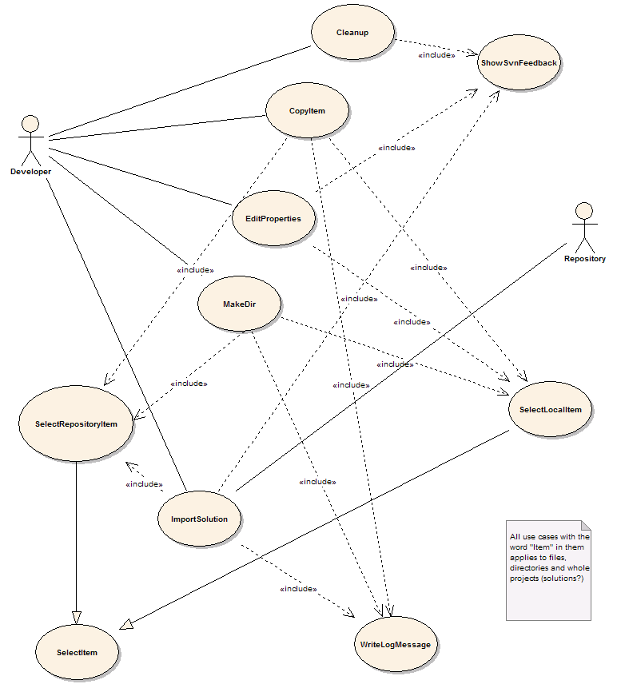
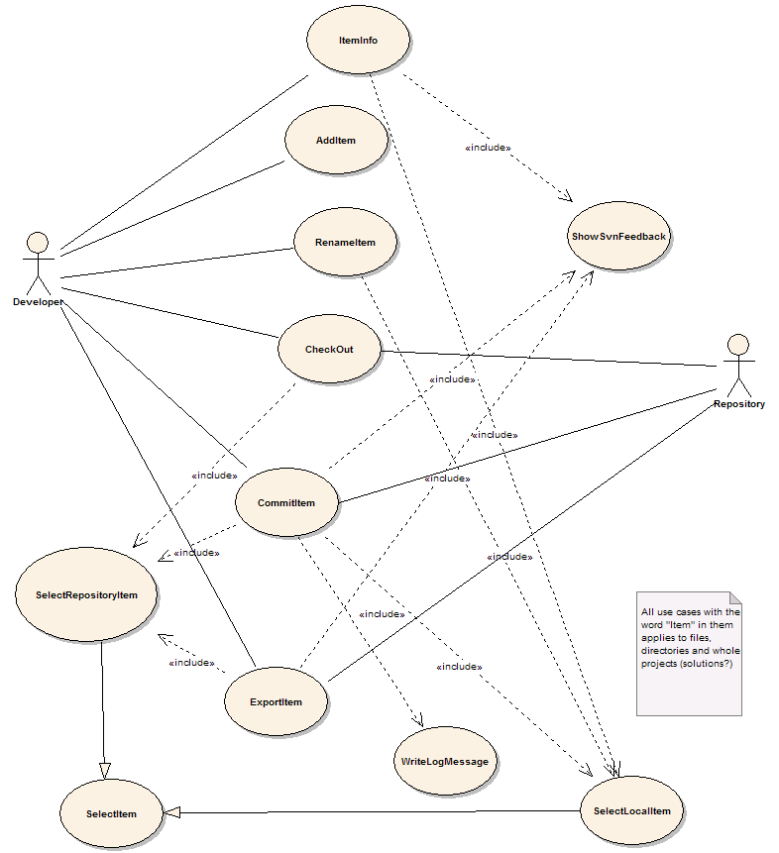
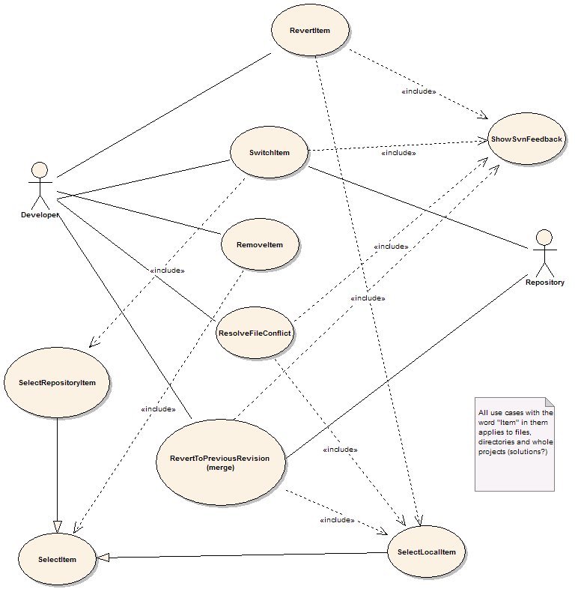
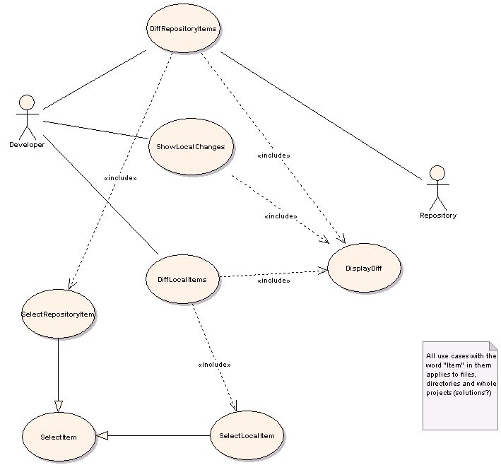

Use case schemes

Use case | Add item
Actors | 1 Developer
Preconditions
1 The item is not currently in the workspace
2 The item is in a directory that is currently in the workspace
Scenario
1 The user invokes the VS.NET command File.AddNewItem or File.AddExistingItem
2 The item is added to the working copy
3 <Include 'ShowSvnFeedback'>
Postconditions
1 The item is in the workspace

Use case | Cleanup
Actors | 1 Developer
Preconditions
1 The working copy is locked
2 An SVN operation has failed due to the locked wc
Scenario
1 Developer is asked whether a cleanup is desired
2 Cleanup is run on the working copy area
3 <Include 'ShowSvnFeedback'>
Postconditions
1 The working copy is in an unlocked state
2 OR: Cleanup failed

Use case | Commit item
Actors | 1 Developer  2 Repository
Preconditions
1 The item has local changes
2 The item is in the working copy
Scenario
1 <Include 'SelectLocalItem'>
2 The user selects Commit item from a menu
3 <Include 'WriteLogMessage'>
4 Commit the item to the repository
5 <Include 'ShowSvnFeedback'>
Postconditions
1 The item is committed
2 OR: The commit is rejected because of other committed changes

Use case | Copy Item
Actors | 1 Developer  2 Repository
Preconditions
1 Item doesn't exist at destination path
2 Item is under revision control
Scenario
1 <Include 'SelectItem'>
2 Developer selects "Copy" from menu
3 <Include 'SelectItem'>
4 <Include 'WriteLogMessage'>
5 Developer invokes "Paste"
6 svn copies item
Postconditions
1 Item is copied to new destination

Use case | Diff Local Item
Actors | 1 Developer  2 Repository
Preconditions
1 The item is under revision control
Scenario
1 <Include 'SelectLocalItem'>
2 Developer selects "Diff" from menu
3 Developer selects revisions
4 svn performs a diff
5 <Include 'DisplayDiff'>
Postconditions
1 The diff is displayed

Use case | Diff Repository Item
Actors | 1 Developer  2 Repository
Preconditions
1 The item exists in the repository
Scenario
1 <Include 'SelectRepositoryItem'>
2 Developer selects "Diff" from menu
3 Developer selects revisions
4 If developer wants to compare two different paths select another repository
5 svn performs a diff
6 <Include 'DisplayDiff'>
Postconditions
1 The diff is displayed

Use case | Edit Properties
Actors | 1 Developer
Preconditions
1 The item is under revision control
Scenario
1 <Include 'SelectItem'>
2 User selects "edit properties" on an item
3 Dialogbox pops up and the developer can edit the property list
4 Developer close the dialog box
5 The properties are applied onto the item
6 <Include 'ShowSvnFeedback'>
Postconditions
1 Properties are set on the item

Use case | Export Item
Actors | 1 Developer  2 Repository
Preconditions
1 The item exists in the repository
Scenario
1 <Include 'SelectRepositoryItem'>
2 Developer selects "Export"
3 Developer selects local folder to export to
4 SVN exports the item
5 <Include 'ShowSvnFeedback'>
Postconditions
1 The item is exported to a local directory

Use case | Import Solution
Actors | 1 Developer  2 Repository
Preconditions
1 The solution is not currently an SVN working copy
Scenario
1 Developer selects a VS.NET solution
2 Developer selects "Import solution"
3 <Include 'SelectRepositoryItem'>
4 <Include 'WriteLogMessage'>
5 SVN imports all source files contained in the solution
6 Close solution
7 Inform developer that backup copies will be made, and where
8 Make backup copies of solution directories
9 Delete solution directories
10 Check out solution from repository to original location
11 Reopen solution
Postconditions
1 Solution is under version control

Use case | Item info
Actors | 1 Developer
Preconditions
1 The item is under revision control
Scenario
1 <Include 'SelectLocalItem'>
2 Retrieve info from svn
3 Display info in VS:NET property pane
Postconditions

Use case | Make directory
Actors | 1 Developer
Preconditions
1 The parent path exists
2 The parent path is under version control
Scenario
1 <Include 'SelectItem'>
2 Developer selects "Make directory"
3 Developer enters new directory name
4 <Include 'WriteLogMessage'>
5 SVN creates new directory
6 <Include 'ShowSvnFeedback'>
Postconditions
1 New directory is created

Use case | Make patch
Actors | 1 Developer
Preconditions
1 Project is under revision control
Scenario
1 <Include 'SelectLocalItem'>
2 Developer invokes the MakePatch command
3 Run SVN diff on the item
4 Present developer with the diff
5 Allow user to copy diff to clipboard
6 OR: create new mail message with diff as attachment
Postconditions
1 A patch is created

Use case | Merge Item
Actors | 1 Developer  2 Repository
Preconditions
1 Paths exist and are in version control
Scenario
1 <Include 'SelectItem'>
2 Developer selects "Merge"
3 <Include 'SelectItem'>
4 Developer confirms operation
5 SVN performs the merge
6 <Include 'ShowSvnFeedback'>
Postconditions
1 The working copy contains the merged differences

Use case | Move Ite
Actors | 1 Developer  2 Repository
Preconditions
1 Item doesn't exist at destination path
2 Item is under revision control
Scenario
1 <Include 'SelectItem'>
2 Developer choose "Cut" from menu
3 <Include 'SelectItem'>
4 Developer selects "Paste" from menu
5 <Include 'WriteLogMessage'>
6 svn moves item
Postconditions
1 Item is moved to new destination

Use case | Remove Item
Actors | 1 Developer  2 Repository
Preconditions
1 The item is under revision control
Scenario
1 <Include 'SelectItem'>
2 Developer choose "Remove" from menu
3 Developer is asked to confirme the delete
4 svn removes the item
Postconditions
1 The item is removed

Use case | Rename Item
Actors | 1 Developer
Preconditions
1 The item is under version control
Scenario
1 <Include 'SelectLocalItem'>
2 Developer invokes the VS.NET Rename command on the item
3 SVN renames the item
Postconditions
1 The item has a new name

Use case | Resolve File Conflict
Actors | 1 Developer
Preconditions
1 The files must be under revision control
2 A conflict must have occured
Scenario
1 <Include 'SelectLocalItem'>
2 Developer selects which of the revisions he wants to retain
3 svn delets the remaining files
4 Status is updated
Postconditions
1 Conflict is resolved

Use case | Revert Item
Actors | 1 Developer
Preconditions
1 The item has local changes
2 The item is under revision control
Scenario
1 <Include 'SelectLocalItem'>
2 Developer selects "Revert" from menu
3 Ask developer to confirm the revert
4 svn reverts item to "pristine" state
Postconditions
1 The item is reverted

Use case | Select Item
Actors | 1 Developer  2 Repository
Preconditions
1 The item exists
2 The item is under version control
Scenario
1 Developer selects item from a tree view
2 OPTIONAL: Developer selects revision
Postconditions
1 The item is selected

Use case | Select Local Item
Actors | 1 Developer
Preconditions
1 Item under revision control
Scenario
1 The developer clicks on an item in Solution Explorer
Postconditions
1 The item is selected

Use case | Select Repository Item
Actors | 1 Developer  2 Repository
Preconditions
1 Item under revision control
Scenario
1 The developer specifies an URL to the repository
2 Developer provides login credentials if required
3 SVN connects to repository and requests a list of files
4 The repository files are displayed in a tree-view
5 Developer selects an item from the tree-view
Postconditions
1 The item is selected

Use case | Show Local Changes
Actors | 1 Developer
Preconditions
1 The item is under revision control
Scenario
1 <Include 'SelectLocalItem'>
2 Developer choose "Show Local Changes" from menu
3 svn performs a diff
4 <Include 'DisplayDiff'>
Postconditions
1 The diff is displayed

Use case | Show SVN feedback
Actors
Preconditions
1 The user has initiated an operation that needs to provide feedback
Scenario
1 A new Output window is created in VS.NET
2 The window receives focus
3 Output messages are written to the window
Postconditions
1 The developer is enlightened

Use case | Switch Item
Actors | 1 Developer  2 Repository
Preconditions
1 Working copy item exists
2 Repository path exists
Scenario
1 <Include 'SelectLocalItem'>
2 Developer selects "Switch"
3 <Include 'SelectRepositoryItem'>
4 Developer confirms the operation
5 SVN switches to the specified path
Postconditions
1 The working copy is updated to the specified path

Use case | Update Item
Actors | 1 Developer  2 Repository
Preconditions
1 The item is under revision control
Scenario
1 <Include 'SelectLocalItem'>
2 Developer selects "Update" from the menu
3 Optional: selects revision to be updated to
4 svn updates
5 <Include 'ShowSvnFeedback'>
Postconditions
1 The item is updated

Use case | View Item Status
Actors | 1 Developer
Preconditions
1 The item is under revision control
Scenario
1 An icon is displayed in the Solution Explorer next to the item signifying its status
Postconditions
1 Developer is enlightened

Use case | View Log
Actors | 1 Developer  2 Repository
Preconditions
1 The item must be under revision control
Scenario
1 <Include 'SelectItem'>
2 Developer selects "Log" from menu
3 Optional: Developer choose revision range
4 svn fetches log from repository
5 Display log
Postconditions
1 Log messages are displayed

Use case | View Repository File
Actors | 1 Repository  2 Developer
Preconditions
1 The file exists in the repository
Scenario
1 <Include 'SelectRepositoryItem'>
2 Developer selects "View"
3 SVN retrieves file contents from repository
4 If file is text: Show in VS.NET editor window
5 else: Invoke associated application
Postconditions
1 The selected file is displayed

Use case | Write Log Message
Actors | 1 Developer
Preconditions
1 An operation requiring log message has been invoked
Scenario
1 Developer selects whether he wants to see diff
2 Developer writes log message
3 Developer clicks "ok"
Postconditions

Class diagrams

Class diagram of Ankh
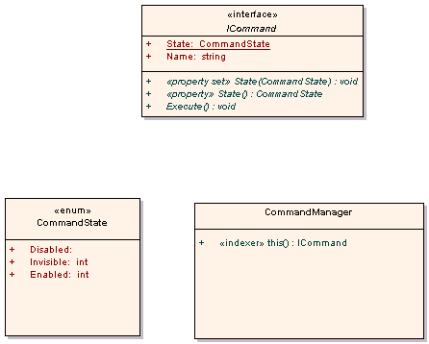

Class diagram of Ankh.UI
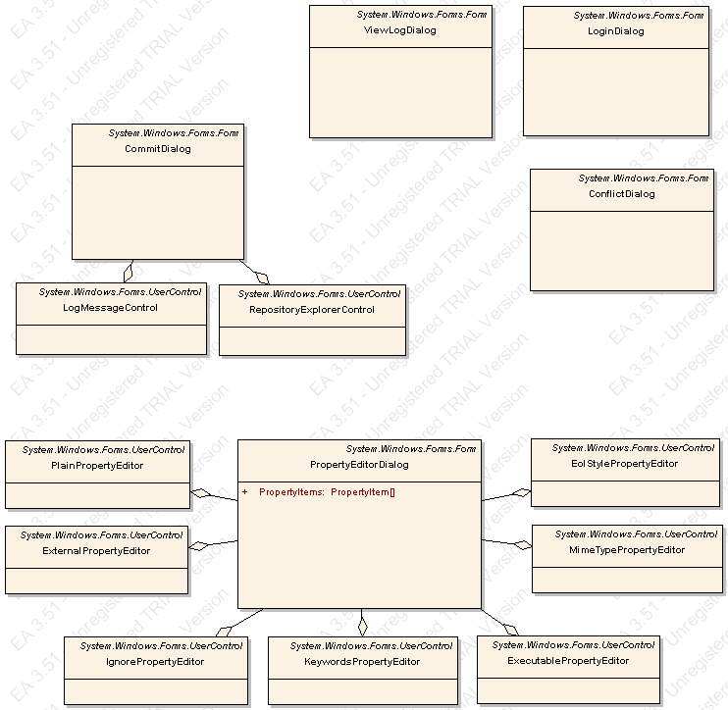

Class diagram of Ankh.Commands
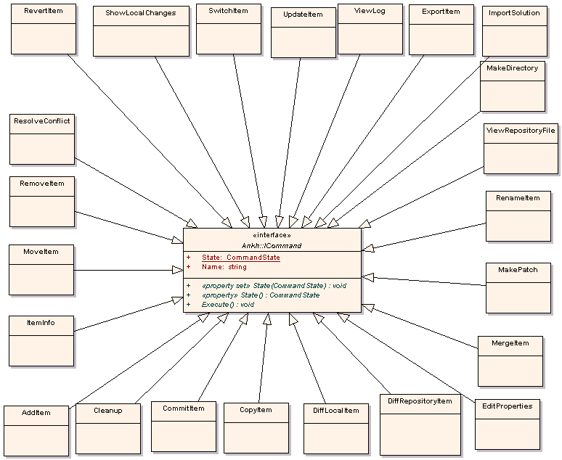

Class diagram of NSvn
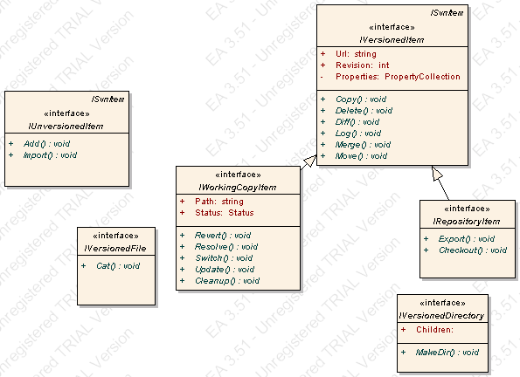

Class diagram of NSvn.Common
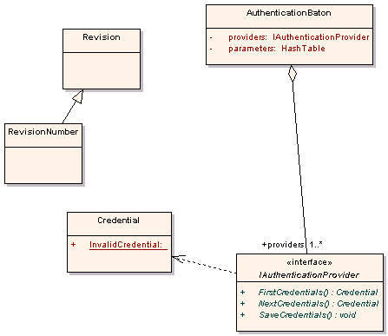

Class diagram of NSvn.Core
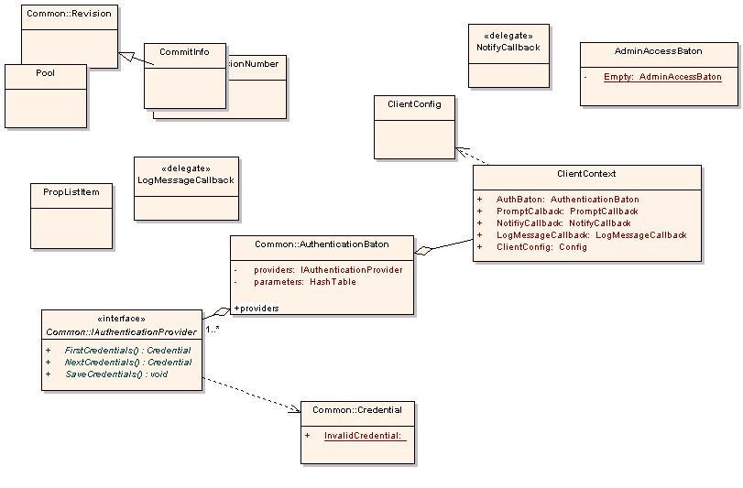

Class diagram of NSvn.Core.Client
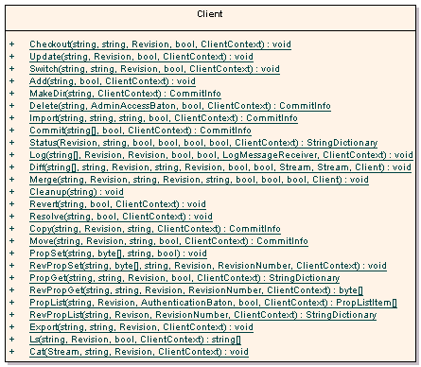

Class diagram of NSvn.Core.Tests

Class diagram of NSvn.Core.Tests.MCpp
  

 
http://msdn.microsoft.com/library/default.asp?url=/library/en-us/cpgenref/html/cpconnamingguidelines.asp
 
 
 
 
 
 
 
 
 
 
 
 
 
 

