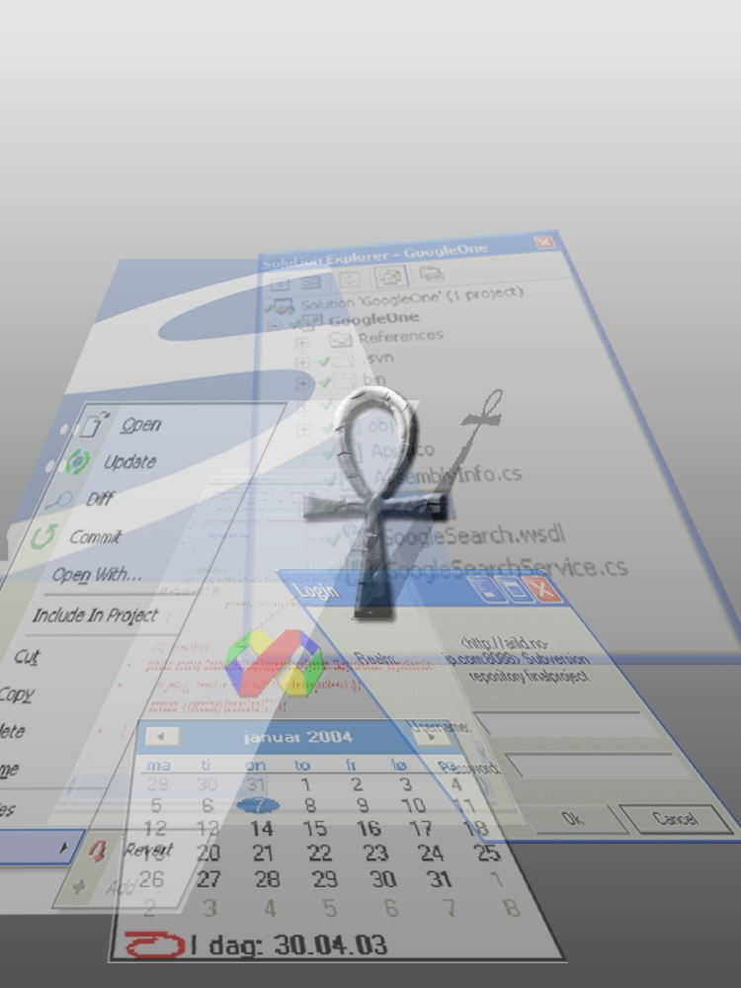

Preface
This report describes the testing of Ankh. Ankh is a Visual Studio .NET addin for the Subversion revision control system. An addin is a software component that makes it possible to addfunctionality into an already existing product. The development of Ankh was conducted as a final year project at HiO in cooperation with CollabNet.
This report is intended for computer personnel responsible for maintenance, updating, support and modifications of the system. The purpose of this document is to give a description of how the system is tested.
It is advantageous to have knowledge of revision control systems and VS.NET to best understand this document. A dictionary containing the terminology used is enclosed in the appendix. Screenshots of Ankh are enclosed in the appendix. This part is included to make it possible to read this report independently from the process and product documentation.

Table of contents

Preface 2
Table of contents 3
1 Testing Goals 4
2 Continuous NUnit testing through development 4
3 Independent NAnt build 6
4 Paper prototype testing 7
5 Functional testing 7
5.1 Testing of status icons in Solution Explorer 10
5.2 Testing of add in Solution Explorer 12
5.3 Testing of update in Solution Explorer 17
5.4 Testing of commit in Solution Explorer 20
5.5 Testing of diff in Solution Explorer 24
5.6 Testing of delete/remove in Solution Explorer 25
5.7 Testing of revert in Solution Explorer 26
5.8 Testing of Commit dialog 30
5.9 Testing of Login dialog 32
5.10 Testing of feedback in AnkhSVN output pane 32
5.11 Testing of Ankh integration in Solution Explore 34
5.12 Testing of the Repository Explorer 34
5.13 Error handling 36
6 Conclusion 37
7 Appendix 38
7.1 Dictionary 38
7.2 Ankh screenshots 40
7.2.1 AnkhSVN output pane 40
7.2.2 Commit dialog 41
7.2.3 Date picker 41
7.2.4 Diff in code view 42
7.2.5 Item menu 43
7.2.6 Login dialog 43
7.2.7 Repository Explorer 44
7.2.8 Revert dialog 44
7.2.9 Solution Explorer 45
7.2.10 Ankh warning 45

Testing Goals

A major goal in this project was to create an aggressive automated test suite that would insure that Ankh was thoroughly tested for weaknesses at every stage of development. We started out writing unit tests for small discrete portions of the program and then in later stages we combined parts of the program gradually, finally testing the discrete parts as well as the integration of all components in the end.

With the help of the automated testing product Nunit , and the continuous builds generated using the automated building tool Nant we had an important safeguard against regression flaws - build and execution errors became quickly apparent to all members of the team Functional integrity was also tested by the development team which used Ankh while developing Ankh. We also made both binary and source releases of Ankh available at http://ankhsvn.tigris.org, and we have received ots of valuable feedback from users in this way. Early paper prototype testing of the GUI confirmed that our navigational model was logical and intuitive. The final set of all tests created is described in this report.

Continuous NUnit testing through development
NUnit is a free open source unit-testing framework for all .NET languages. NUnit was originally ported from JUnit which is a unit-testing tool for Java. We used version 2.0 during the testing of Ankh. NUnit is coded in C# . An example of a unit-test is shown below. The test verifies the implementation of the Add method in the lower wrapper layer of Ankh. The Add method adds an unversioned file to revision control. An unversioned file is a file that is not under revision control. Revision control is described in the product and process report.

namespace NSvn.Core.Tests
{
/// <summary>
/// Tests NSvn::Core::Client::Add
/// </summary>
[TestFixture]
public class AddTest : TestBase
{
[SetUp]
public override void SetUp()
{
this.ExtractWorkingCopy();
this.notifications = new ArrayList();
}

/// <summary>
/// Attempts to add a file, checking that the file actually was
/// added
/// </summary>
[Test]
public void TestBasic()
{
string testFile = this.CreateTextFile( "testfile.txt" );

ClientContext ctx = new ClientContext( new NotifyCallback() );
Client.Add( testFile, false, ctx );

Assertion.Assert( "No notification callbacks received",
this.Notifications.Length > 0 );

Assertion.AssertEquals( "svn st does not report the file as added",
'A', this.GetSvnStatus( testFile ) );

}

}

In the Setup() method a working copy is extracted. A working copy is a collection of files and folders under revision control. To be able to add an unversioned file to revision control a working copy is required. An ArrayList is initialised. This list will contain feedback from the Subversion API after Client.Add(..) has added the unversioned file to revision control.

In the TestBasic() method an unversioned file “testfile.txt” is created. The input parameter “false” in Client.Add(...) indicates that Add is performed on only one file, not recursively. Client.Add(..) is run with required input parameters and should add an unversioned file to the extracted working copy. Assertion.Assert(....) checks whether there has been any feedback from Subversion (SVN) after the add was performed. If this.Notifications.Length is less than 1 (no notifications received at all) the test will fail and “No notification callbacks received” will be displayed in the NUnit display. If this.Notifications.Length is more than 0 the test will succeed. Assertion.AssertEquals(...) checks if the status on the file has changed to “A” by invoking the command line client. If the status is not “A” the test will fail and “svn st does not report the file as added” will be displayed by NUnit. If the status is “A” the test will succeed.

Independent NAnt build
Independent NAnt builds of Ankh were done continuously during development to ensure sanity and quality of the addin/wrapper. At regular intervals NAnt checked out a fresh working copy, built the project and all unit tests were run. A build e-mail describing whether the build failed or succeeded was sent to all group members after every build. An example of a build e-mail is shown below.
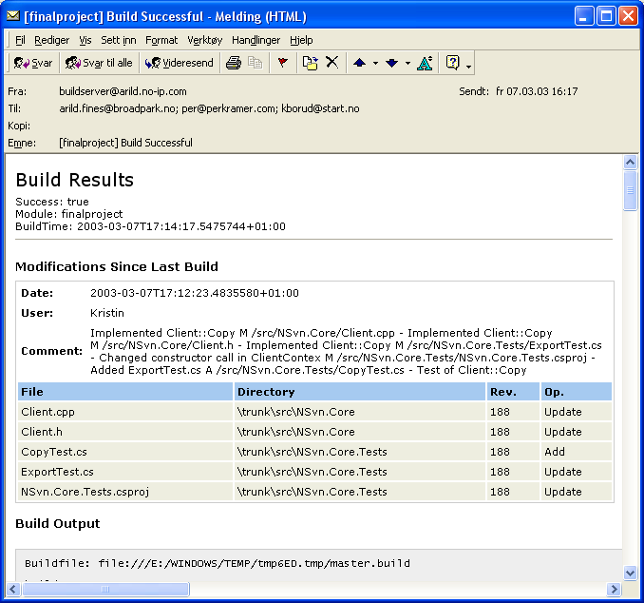

Paper prototype testing
To test the GUI design a paper prototype test was devised to check whether our navigation model, as well as our choice of names for buttons, menus and text fields etc. were logical and intuitive.
The paper prototype test was performed on three test subjects, each with some programming experience. One of the individuals was familiar with revision control systems and VS.NET. Before the tests were performed the participants were given a short introduction to revision control and VS.NET. Three scenarios were selected covering integration of commit, log and edit properties. The overall conclusion from these tests was that for the most part our navigation model was intuitive as well as logical but that it could be improved. Based on the feedback we modified the names of button and text fields in dialog boxes, and the placement of buttons, text fields, combo boxes etc. A need for integrated help was also identified.

Functional testing
During the Alpha testing we published both binary and source versions of Ankh at http://ankhsvn.tigris.org. This allowed users to choose whether to build Ankh from source or install it from a Windows Installer package.
Since we wanted to know when Ankh failed in some way, we embedded an error reporting mechanism into it. When an unhandled exception was thrown by Ankh or NSvn the user was asked whether he wanted to submit an error report. If the user agreed a web browser would open and the user was sent to a web form. The error message would be automatically filled in, including the stack trace and version number. The user could also choose to fill in a separate comment and/or his email address. The Ankh error report page is shown below.

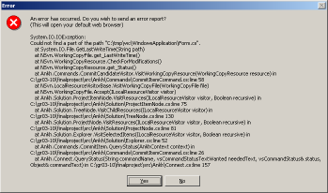
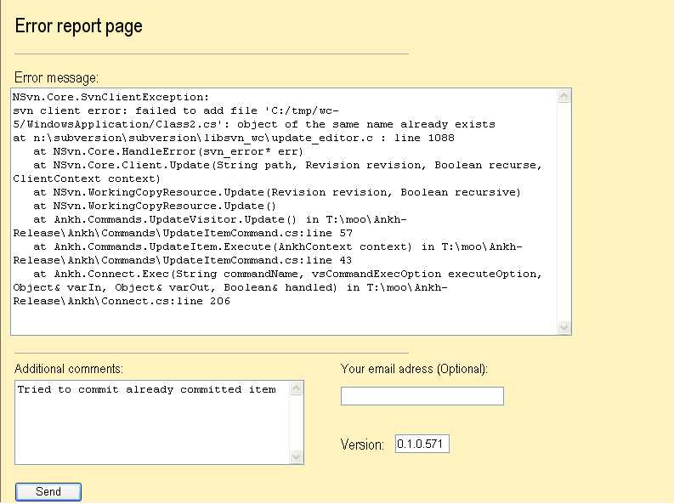

The submitted report is sent to a private mailing list that all the group members are subscribed to. Details from the exception stack trace give useful information about issues that must be resolved. (see issue tracker at http://ankhsvn.tigris.org). The issue tracker documents existing weaknesses and possible future improvements to Ankh. The issue list shows type of feature, priority, status, result and summary of the issues. This database helps us to remember things we plan to implement in later versions and makes it easy to see the status on issues to be solved in near future. The Revert dialog was implemented by user request from this testing phase. Ankh’s revert dialog is enclosed in the environment image collection.

It was not possible to use Ankh until the most basic SVN commands, including add, update, commit and status, were implemented. . As soon as it was usable Ankh was regularly used in the development process, providing a unique opportunity for testing. The picture below shows the Ankh project with a new instance of VS.NET above. The new instance was started from the Ankh project. This made it possible to continuously work with the last update of Ankh and testing it at the same time with real data.

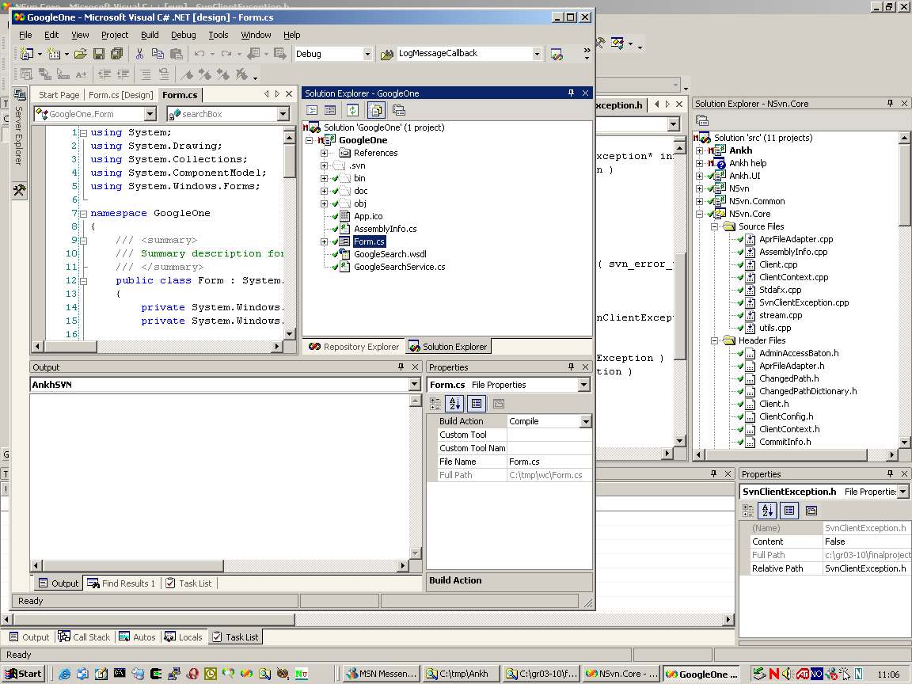

Ankh was tested on the intended audience in Ankh Alpha1-release. AnkhSetup.msi was made available for installation from http://ankhsvn.tigris.org. The installer included a test repository that is optionally extracted to the computers local hard drive during installation.
Ankh supports mainly Visual Basic (VB), Visual C# (VC#) and Visual C++ (VC++) projects. Support for VC++ projects is weaker than VC# and VB projects, this because the VS automation model is different for VC++ projects. Ankh Alpha 0.1 was tested functionally with a number of tests described in the following sub chapters.

Testing of status icons in Solution Explorer
Solution Explorer display files, folders, projects and the solution (item) with updated Ankh status icons. Tests performed to verify Ankh status icons displayed in Solution Explorer are listed in the table below. An image of Solution Explorer is enclosed in the appendix.

Test | Result /Comment | Date
Status icon is shown in Solution Explorer in front of an unversioned file. | Ok if VB files are within versioned projects. | 19.05.2003
Status icon is shown in Solution Explorer in front of an unversioned file. | Ok if VC++ files are within versioned projects. | 19.05.2003
Status icon is shown in Solution Explorer in front of an unversioned file. | Ok if VC# files are within versioned projects. | 19.05.2003
Status icon is shown in Solution Explorer in front of an unversioned directory. | Ok if VB folders are within versioned projects. | 19.05.2003
Status icon is shown in Solution Explorer in front of an unversioned directory. | Not visible for C++ folders. | 19.05.2003
Status icon is shown in Solution Explorer in front of an unversioned directory. | Ok if VC# folders are within versioned projects. | 19.05.2003
Status icon is shown in Solution Explorer in front of an unversioned project. | Icons not visible on VC# projects | 19.05.2003
Status icon is shown in Solution Explorer in front of an unversioned project | Icons not visible on VC++ projects. | 19.05.2003
Status icon is shown in Solution Explorer in front of an unversioned project | Icons not visible on VB projects. | 19.05.2003
Status icon is shown in Solution Explorer in front of a versioned file | Ok | 19.05.2003
Status icon is shown in Solution Explorer in front of a versioned folder | Ok | 19.05.2003
Status icon is shown in Solution Explorer in front of a versioned project | Ok | 19.05.2003

Test | Result /Comment | Date
Status icon is shown in Solution Explorer in front of a versioned solution | Ok | 19.05.2003
Status icon is shown in Solution Explorer in front of a modified, saved, versioned file | Ok the status is shown if the modified file is saved | 19.05.2003
Status icon is shown in Solution Explorer in front of a modified, saved, versioned folder | Ok the status is shown if the modified folder is saved | 19.05.2003
Status icon is shown in Solution Explorer in front of a modified, saved, versioned project | Ok the status is shown if the modified project is saved. | 19.05.2003
Status icon is shown in Solution Explorer in front of a modified, saved, versioned solution | Ok the status is shown if the modified solution is saved. | 19.05.2003
Status icon is shown in Solution Explorer in front of an added, versioned file. | Ok, visible for VB files. | 19.05.2003
Status icon is shown in Solution Explorer in front of an added, versioned file. | Ok, visible for VC# files. | 19.05.2003
Status icon is shown in Solution Explorer in front of an added, versioned file. | Ok, visible for VC++ files. | 19.05.2003
Status icon is shown in Solution Explorer in front of an added, versioned folder | Ok for VB folders. | 19.05.2003
Status icon is shown in Solution Explorer in front of an added, versioned folder | Ok for C# folders. | 19.05.2003
Status icon is shown in Solution Explorer in front of an added, versioned folder. | Icons not visible for C++ folders. | 19.05.2003
Status icon is shown in Solution Explorer in front of an added, versioned project. | Ok for VC++ projects. | 19.05.2003
Status icon is shown in Solution Explorer in front of an added, versioned project. | Ok for VC#, projects. | 19.05.2003
Status icon is shown in Solution Explorer in front of an added, versioned project. | Ok for VB projects. | 19.05.2003
Status icon is shown in Solution Explorer in front of an added, versioned project. | Ok for Help projects. | 19.05.2003

Test | Result /Comment | Date
Status icon is shown in Solution Explorer in front of a conflicted, versioned file. | Ok. | 19.05.2003
Status icon is shown in Solution Explorer in front of a conflicted, versioned project | Ok. | 19.05.2003
Status icon is shown in Solution Explorer in front of a conflicted, versioned solution | Ok. | 19.05.2003
Status icon is shown in Solution Explorer in front of a locked, versioned file | Not visible. | 19.03.2003
Status icon is shown in Solution Explorer in front of a locked, versioned folder | Not visible. | 19.03.2003
Status icon is shown in Solution Explorer in front of a locked, versioned project | Not visible. | 19.03.2003
Status icon is shown in Solution Explorer in front of a locked, versioned project | Not visible. | 19.03.2003

Testing of add in Solution Explorer
Tests performed to verify the Add item menu option in Solution Explorer are listed in the table below. The Add option adds an unversioned file to revision control. An image of the item menu is enclosed in the appendix.

Test | Result /Comment | Date
Add option is enabled in menu if unversioned VB file (status icon ) is selected in Solution Explorer and right clicked. | Ok | 19.05.2003
Add option is enabled in menu if unversioned VC# file (status icon ) is selected in Solution Explorer and right clicked. | Ok | 19.05.2003
Add option is enabled in menu if unversioned VC++ file (status icon ) is selected in Solution Explorer and right clicked. | Ok | 19.05.2003

Test | Result /Comment | Date
Add option is enabled in menu if unversioned Help file (status icon ) is selected in Solution Explorer and right clicked. | Ok | 19.05.2003
Add option is enabled in menu if unversioned VB folder (status icon ) is selected in Solution Explorer and right clicked. | Ok for VB if folders are within a versioned project. | 19.05.2003
Add option is enabled in menu if unversioned VC# folder (status icon ) is selected in Solution Explorer and right clicked. | Ok for VC# if folders are within a versioned project. | 19.05.2003
Add option is enabled in menu if unversioned VC++ folder (status icon ) is selected in Solution Explorer and right clicked. | Not enabled for VC++ folders. | 19.05.2003
Add option is enabled in menu if unversioned VB project (status icon ) is selected in Solution Explorer and right clicked. | Ok | 19.05.2003
Add option is enabled in menu if unversioned VC# project (status icon ) is selected in Solution Explorer and right clicked. | Ok | 19.05.2003
Add option is enabled in menu if unversioned VC++ project (status icon ) is selected in Solution Explorer and right clicked. | Ok | 19.05.2003
Add option is enabled in menu if unversioned Help project (status icon ) is selected in Solution Explorer and right clicked. | Ok | 19.05.2003
Add option is disabled in menu if versioned VC# file (status icon ) is selected in Solution Explorer and right clicked. | Ok | 19.05.2003
Add option is disabled in menu if versioned VC# folder (status icon ) is selected in Solution Explorer and right clicked | Ok | 19.05.2003

Test | Result /Comment | Date
Add option is disabled in menu if versioned VC# project ( status icon ) is selected in Solution Explorer and right clicked | Ok | 19.05.2003
Add option is disabled in menu if versioned VC# solution (status icon ) is selected in Solution Explorer and right clicked | Ok | 19.05.2003
Add option is disabled in menu if modified, versioned VC# file (status icon ) is selected in Solution Explorer and right clicked | Ok | 19.05.2003
Add option is disabled in menu if modified, versioned VC# folder (status icon ) is selected in Solution Explorer and right clicked | Ok | 19.05.2003
Add option is disabled in menu if modified, versioned VC# project (status icon ) is selected in Solution Explorer and right clicked | Ok | 19.05.2003
Add option is disabled in menu if modified, versioned VC# solution (status icon ) is selected in Solution Explorer and right clicked | Ok | 19.05.2003
Add option is disabled in menu if added, versioned VB file (status icon ) is selected in Solution Explorer and right clicked. | Ok | 19.05.2003
Add option is disabled in menu if added, versioned VC# file (status icon ) is selected in Solution Explorer and right clicked. | Ok | 19.05.2003
Add option is disabled in menu if added, versioned VC++ file (status icon ) is selected in Solution Explorer and right clicked. | Ok | 19.05.2003
Add option is disabled in menu if added, versioned VB folder (status icon ) is selected in Solution Explorer and right clicked | Ok | 19.05.2003
Add option is disabled in menu if added, versioned VC# folder (status icon ) is selected in Solution Explorer and right clicked | Ok | 19.05.2003

Test | Result /Comment | Date
Add option is disabled in menu if added, versioned VC++ folder (status icon ) is selected in Solution Explorer and right clicked | Ok | 19.05.2003
Add option is disabled in menu if added, versioned VC# project (status icon ) is selected in Solution Explorer and right clicked | Ok | 19.05.2003
Add option is disabled in menu if added, versioned VC++ project (status icon ) is selected in Solution Explorer and right clicked | Ok | 19.05.2003
Add option is disabled in menu if added, versioned VB project (status icon ) is selected in Solution Explorer and right clicked | Ok | 19.05.2003
Add option is disabled in menu if conflicted, versioned file (status icon ) is selected in Solution Explorer and right clicked. | Ok | 21.05.2003
Add option is disabled in menu if conflicted, versioned folder (status icon ) is selected in Solution Explorer and right clicked | Ok. | 21.05.2003
Add option is disabled in menu if conflicted, versioned project (status icon ) is selected in Solution Explorer and right clicked | Ok. | 21.05.2003
Add option is disabled in menu if locked, unversioned file is selected in Solution Explorer and right clicked | Ok, tested at VB files in locked, unversioned VB project. | 19.05.2003
Add option is disabled in menu if locked, unversioned folder is selected in Solution Explorer and right clicked | Ok, tested at VB folder in locked, unversioned VB project. | 19.05.2003
Add option is enabled in menu if locked, unversioned project is selected in Solution Explorer and right clicked. | Ok, tested at VB project in locked, unversioned VB project. . | 19.05.2003
“Working copy locked” warning if Add option is selected from item menu for a locked, unversioned project | Ok, tested at VB project. | 19.05.2003

Test | Result /Comment | Date
It is possible to add an unversioned VC# file (*.cs) to revision control | Ok | 19.05.2003
It is possible to add an unversioned VC++ file (*.cpp) to revision control | Ok | 19.05.2003
It is possible to add an unversioned VB file (*.vb) to revision control | Ok | 19.05.2003
It is possible to add an unversioned folder to a versioned VC# project | Ok | 19.05.2003
It is possible to add an unversioned folder to a versioned VB project | Ok | 19.05.2003
It is possible to add an unversioned folder to a versioned Help project | Return error message | 19.05.2003
It is possible to add an unversioned folder to a versioned Extensibility project | Ok, for the main part of the Extensibility project, not possible for the Setup part of the project. | 19.05.2003
It is possible to add a VC# project to revision control | Ok | 19.05.2003
It is possible to add a VC++ project to revision control | Ok | 19.05.2003
It is possible to add a VB project to revision control | Ok | 19.05.2003
It is possible to add a Help project to revision control | Ok | 19.05.2003
It is possible to add a Extensibility project to revision control | Main part of VS.NET Add-in and Shared Add-in project added. Setup part of Extensibility project not added. | 19.05.2003
Status icon is changed to in front of VC# file in Solution Explorer after unversioned file is added | Ok | 19.05.2003
Status icon is changed to in front of file in Solution Explorer after unversioned file is added | Ok if Refresh was ran on VB and VC++ files | 19.05.2003
Status icon is changed to in front of folder in Solution Explorer after unversioned folder is added | Ok for C# projects. Ok if Refresh was ran on VB folder. Icon not visible for added C++ Header and Source folders. | 19.05.2003
Status icon is changed to in front of project in Solution Explorer after unversioned VB project is added | Ok | 19.05.2003
Status icon is changed to in front of project in Solution Explorer after unversioned VC# project is added | Ok | 19.05.2003
Status icon is changed to in front of project in Solution Explorer after unversioned VC++ project is added | Ok | 19.05.2003
Test | Result /Comment | Date
Status icon is changed to in front of project in Solution Explorer after unversioned project is added | Ok for Help projects | 19.05.2003
Status icon is changed to in front of project in Solution Explorer after unversioned project is added | Ok for Main part of Extensibility projects (not Setup part) | 19.05.2003
Add works recursively on files in C++ folder | Ok, tested on folders containing C++ Header and Source files. | 19.05.2003
Add works on several VB files | Ok | 20.05.2003
Add works on several VC# files | Ok | 20.05.2003

Testing of update in Solution Explorer
Tests performed to verify the Update item menu option in Solution Explorer are listed in the table below. The Update option updates a versioned file to include last committed changes.

Test | Result /Comment | Date
Update option is disabled in menu if unversioned VB file (status icon ) is selected in Solution Explorer and right clicked | Ok | 20.05.2003
Update option is disabled in menu if unversioned VC# file (status icon ) is selected in Solution Explorer and right clicked | Ok | 20.05.2003
Update option is disabled in menu if unversioned VC++ file (status icon ) is selected in Solution Explorer and right clicked | Ok | 20.05.2003
Update option is disabled in menu if unversioned VB folder (status icon ) is selected in Solution Explorer and right clicked | Ok | 20.05.2003
Update option is disabled in menu if unversioned VC# folder (status icon ) is selected in Solution Explorer and right clicked | Ok | 20.05.2003
Update option is disabled in menu if unversioned VC++ folder (status icon ) is selected in Solution Explorer and right clicked | Update enabled for VC++ folders. | 20.05.2003

Test | Result /Comment | Date
Update option is disabled in menu if unversioned VB project (status icon ) is selected in Solution Explorer and right clicked | Ok | 20.05.2003
Update option is disabled in menu if unversioned VB# project (status icon ) is selected in Solution Explorer and right clicked | Ok | 20.05.2003
Update option is disabled in menu if unversioned VC++ project (status icon ) is selected in Solution Explorer and right clicked | Ok | 20.05.2003
Update option is enabled in menu if versioned file (status icon ) is selected in Solution Explorer and right clicked | Ok. | 20.05.2003
Update option is enabled in menu if versioned folder (status icon ) is selected in Solution Explorer and right clicked | Ok | 20.05.2003
Update option is enabled in menu if versioned project (status icon ) is selected in Solution Explorer and right clicked. | Ok. | 20.05.2003
Update option is enabled in menu if versioned solution (status icon ) is selected in Solution Explorer and right clicked. | Ok. | 20.05.2003
Update option is enabled in menu if modified, versioned file (status icon ) is selected in Solution Explorer and right clicked. | Ok. | 20.05.2003
Update option is enabled in menu if modified, versioned folder (status icon ) is selected in Solution Explorer and right clicked. | Ok. | 20.05.2003
Update option is enabled in menu if modified, versioned project (status icon ) is selected in Solution Explorer and right clicked. | Ok. | 20.05.2003
Update option is enabled in menu if modified, versioned solution (status icon ) is selected in Solution Explorer and right clicked. | Ok. | 20.05.2003

Test | Result /Comment | Date
Update option is enabled in menu if added, versioned VB file (status icon ) is selected in Solution Explorer and right clicked. | Ok | 20.05.2003
Update option is enabled in menu if added, versioned VC# file (status icon ) is selected in Solution Explorer and right clicked. | Ok | 20.05.2003
Update option is enabled in menu if added, versioned VC++ file (status icon ) is selected in Solution Explorer and right clicked. | Ok | 20.05.2003
Update option is enabled in menu if added, versioned VB folder (status icon ) is selected in Solution Explorer and right clicked. | Ok | 20.05.2003
Update option is enabled in menu if added, versioned VC# folder (status icon ) is selected in Solution Explorer and right clicked. | Ok | 20.05.2003
Update option is enabled in menu if added, versioned VC++ folder (status icon ) is selected in Solution Explorer and right clicked. | Ok | 20.05.2003
Update option is enabled in menu if added, versioned VB project (status icon ) is selected in Solution Explorer and right clicked. | Ok | 20.05.2003
Update option is enabled in menu if added, versioned VC# project (status icon ) is selected in Solution Explorer and right clicked. | Ok | 20.05.2003
Update option is enabled in menu if added, versioned VC++ project (status icon ) is selected in Solution Explorer and right clicked. | Ok | 20.05.2003
Ankh Lock Warning in case of locked item | Ok. | 21.05.2003
Status icon is changed in front of file in Solution Explorer after versioned file is updated to modified, corresponding file | Ok | 21.05.2003
Status icon is changed in front of folder in Solution Explorer after versioned folder is updated to modified, corresponding folder | Ok | 21.05.2003

Test | Result /Comment | Date
Status icon is changed in front of project in Solution Explorer after versioned project is updated to modified, corresponding project | Ok | 21.05.2003
Status icon is changed in front of solution in Solution Explorer after versioned solution is updated to modified, corresponding solution | Ok | 21.05.2003
Ankh error handling if no communication to Internet Explorer for update to external repository | Ok | 21.05.2003
Update works recursively on several items (file, folder, project, solution) | Ok | 21.05.2003

Testing of commit in Solution Explorer
Tests performed to verify the Commit item menu option in Solution Explorer are listed in the table below. The Commit option publishes the latest changes by sending the changes to the repository. An image of the commit dialog is enclosed in the appendix.

Test | Result /Comment | Date
Commit option is disabled in menu if unversioned VC++ file (status icon ) is selected in Solution Explorer and right clicked | Ok | 20.05.2003
Commit option is disabled in menu if unversioned VC# file (status icon ) is selected in Solution Explorer and right clicked | Ok | 20.05.2003
Commit option is disabled in menu if unversioned VB file (status icon ) is selected in Solution Explorer and right clicked | Ok | 20.05.2003
Commit option is disabled in menu if unversioned VC# folder (status icon ) is selected in Solution Explorer and right clicked | Ok | 20.05.2003
Commit option is disabled in menu if unversioned VC++ folder (status icon ) is selected in Solution Explorer and right clicked | Ok | 20.05.2003

Test | Result /Comment | Date
Commit option is disabled in menu if unversioned VB folder (status icon ) is selected in Solution Explorer and right clicked | Ok | 20.05.2003
Commit option is disabled in menu if unversioned VC# project (status icon ) is selected in Solution Explorer and right clicked | Ok | 20.05.2003
Commit option is disabled in menu if unversioned VC++ project (status icon ) is selected in Solution Explorer and right clicked | Ok | 20.05.2003
Commit option is disabled in menu if unversioned VB project (status icon ) is selected in Solution Explorer and right clicked | Ok | 20.05.2003
Commit option is disabled in menu if versioned file (status icon ) is selected in Solution Explorer and right clicked | Ok. | 22.05.2003
Commit option is disabled in menu if versioned folder (status icon ) is selected in Solution Explorer and right clicked | Ok. | 22.05.2003
Commit option is disabled in menu if versioned project ( status icon ) is selected in Solution Explorer and right clicked | Ok. | 22.05.2003
Commit option is disabled in menu if versioned solution (status icon ) is selected in Solution Explorer and right clicked | Ok. | 22.05.2003
Commit option is enabled in menu if modified, versioned file (status icon ) is selected in Solution Explorer and right clicked | Ok. | 22.05.2003
Commit option is enabled in menu if modified, versioned folder (status icon ) is selected in Solution Explorer and right clicked | Ok. | 22.05.2003
Commit option is enabled in menu if modified, versioned project (status icon ) is selected in Solution Explorer and right clicked | Ok. | 22.05.2003

Test | Result /Comment | Date
Commit option is enabled in menu if modified, versioned solution (status icon ) is selected in Solution Explorer and right clicked | Ok. | 22.05.2003
Commit option is enabled in menu if added, versioned VB file (status icon ) is selected in Solution Explorer and right clicked | Ok | 19.03.2003
Commit option is enabled in menu if added, versioned VC# file (status icon ) is selected in Solution Explorer and right clicked | Ok | 19.03.2003
Commit option is enabled in menu if added, versioned VC++ file (status icon ) is selected in Solution Explorer and right clicked | Ok | 19.03.2003
Commit option is enabled in menu if added, versioned VC# folder (status icon ) is selected in Solution Explorer and right clicked | Ok | 19.03.2003
Commit option is enabled in menu if added, versioned VC++ folder (status icon ) is selected in Solution Explorer and right clicked | Ok | 19.03.2003
Commit option is enabled in menu if added, versioned VB folder (status icon ) is selected in Solution Explorer and right clicked | Ok | 19.03.2003
Commit option is enabled in menu if added, versioned VB project (status icon ) is selected in Solution Explorer and right clicked | Ok | 19.03.2003
Commit option is enabled in menu if added, versioned VC# project (status icon ) is selected in Solution Explorer and right clicked | Ok | 19.03.2003
Commit option is enabled in menu if added, versioned VC++ project (status icon ) is selected in Solution Explorer and right clicked | Ok | 19.03.2003
Commit option is enabled in menu if conflicted, versioned file (status icon ) is selected in Solution Explorer and right clicked | Ok. | 22.03.2003

Test | Result /Comment | Date
Commit option is enabled in menu if conflicted, versioned folder (status icon ) is selected in Solution Explorer and right clicked | Ok. | 22.03.2003
Commit option is enabled in menu if conflicted, versioned project (status icon ) is selected in Solution Explorer and right clicked | Ok. | 22.03.2003
Commit option is disabled in menu if locked, versioned file is selected in Solution Explorer and right clicked | Ok. | 22.03.2003
Commit option is disabled in menu if locked, versioned folder is selected in Solution Explorer and right clicked | Ok. | 22.03.2003
Commit option is disabled in menu if locked, versioned project is selected in Solution Explorer and right clicked | Ok. | 22.03.2003
Commit dialog box pops up if Commit is selected from item menu | Ok. | 22.03.2003
Status icon is changed to in front of file in Solution Explorer after modified, versioned file is committed | Ok. | 22.03.2003
Status icon is changed to in front of folder in Solution Explorer after modified, versioned folder is committed | Ok. | 22.03.2003
Status icon is changed to in front of project in Solution Explorer after added, versioned project is committed | Ok. | 22.03.2003
Status icon is changed to in front of solution in Solution Explorer after added, versioned solution is committed | Ok. | 22.03.2003
Ankh error handling if no communication to Internet Explorer for commit to external repository | Ok. | 22.03.2003
Commit works recursively on several items (file, folder, project, solution) | Ok. | 22.03.2003

Testing of diff in Solution Explorer
Tests performed to verify the Diff item menu option in Solution Explorer are listed in the table below. The Diff option makes it possible to see removed, added and unchanged text if the file is not binary. An image of the diff displayed in code view is enclosed in the appendix.

Test | Result /Comment | Date
Diff option is enabled in menu if modified, versioned file (status icon ) is selected in Solution Explorer and right clicked | Ok | 25.05.2003
Diff option is enabled in menu if modified, versioned folder (status icon ) is selected in Solution Explorer and right clicked | Ok | 25.05.2003
Diff option is enabled in menu if modified, versioned project (status icon ) is selected in Solution Explorer and right clicked | Ok | 25.05.2003
Diff option is enabled in menu if modified, versioned solution (status icon ) is selected in Solution Explorer and right clicked | Ok | 25.05.2003
Diff option is enabled in menu if added, versioned VB file (status icon ) is selected in Solution Explorer and right clicked | Ok | 19.03.2003
Diff option is enabled in menu if added, versioned VC# file (status icon ) is selected in Solution Explorer and right clicked | Ok | 19.03.2003
Diff option is enabled in menu if added, versioned VC++ file (status icon ) is selected in Solution Explorer and right clicked | Ok | 19.03.2003
Diff option is enabled in menu if added, versioned VB folder (status icon ) is selected in Solution Explorer and right clicked | Ok | 19.03.2003
Diff option is enabled in menu if added, versioned VC# folder (status icon ) is selected in Solution Explorer and right clicked | Ok | 19.03.2003

Test | Result /Comment | Date
Diff option is enabled in menu if added, versioned VC++ folder (status icon ) is selected in Solution Explorer and right clicked | Ok | 19.03.2003
Diff option is enabled in menu if added, versioned VB project (status icon ) is selected in Solution Explorer and right clicked | Ok | 19.03.2003
Diff option is enabled in menu if added, versioned VC# project (status icon ) is selected in Solution Explorer and right clicked | Ok | 19.03.2003
Diff option is enabled in menu if added, versioned VC++ project (status icon ) is selected in Solution Explorer and right clicked | Ok | 19.03.2003
Diff is visible in temporary file in code view if Diff is performed on a file | Ok | 25.05.2003
Diff is visible in temporary file in code view if Diff is performed on a folder | Ok | 25.05.2003
Diff is visible in temporary file in code view if Diff is performed on a project | Ok | 25.05.2003
Diff is visible in temporary file in code view if Diff is performed on a solution | Ok | 25.05.2003
The diff visible in temporary file in code view shows unchanged text in green colour | Ok | 25.05.2003
The diff visible in temporary file in code view shows removed text in red colour | Ok | 25.05.2003
The diff visible in temporary file in code view shows new, added text in blue colour | Ok | 25.05.2003
Diff works recursively on several items (file, folder, project, solution) | Ok | 25.05.2003

Testing of delete/remove in Solution Explorer
Tests performed to verify the Exclude From Project and Delete item menu option in Solution Explorer are listed in the table below. The Delete option permanently deletes versioned items from the working copy. Exclude From Project option removes versioned items from the working copy.

Test | Result /Comment | Date
Versioned file in Solution Explorer is not visible after Delete option is selected from item menu for versioned file | Ok. | 26.05.2003
Test | Result /Comment | Date
Versioned folder in Solution Explorer is not visible after Delete option is selected from item menu for versioned folder | Ok. | 26.05.2003
Versioned project in Solution Explorer is not visible after Remove option is selected from item menu for versioned project | Ok. | 26.05.2003
Delete option on item menu works recursively on several items (file, folder, project, solution) | Ok. | 26.05.2003
Remove option on item menu works recursively on several items (file, folder, project, solution) | Ok. | 26.05.2003

Testing of revert in Solution Explorer
Tests performed to verify the Revert item menu option in Solution Explorer are listed in the table below. The Revert option restores the pristine working copy. An image of the revert dialog is enclosed in the appendix.

Test | Result /Comment |  | Date
Revert option is disabled in menu if unversioned file (status icon ) is selected in Solution Explorer and right clicked | Ok. |  | 26.05.2003
Revert option is disabled in menu if unversioned folder (status icon ) is selected in Solution Explorer and right clicked |  | Ok. |  | 26.05.2003
Revert option is disabled in menu if unversioned project (status icon ) is selected in Solution Explorer and right clicked |  | Ok. |  | 26.05.2003
Revert option is disabled in menu if versioned file (status icon ) is selected in Solution Explorer and right clicked |  | Ok. |  | 26.05.2003
Revert option is disabled in menu if versioned folder (status icon ) is selected in Solution Explorer and right clicked |  | Ok. |  | 26.05.2003
Revert option is disabled in menu if versioned project ( status icon ) is selected in Solution Explorer and right clicked |  | Ok. |  | 26.05.2003

Test |  | Result /Comment |  | Date
Revert option is disabled in menu if versioned solution (status icon ) is selected in Solution Explorer and right clicked |  | Ok. |  | 26.05.2003
Revert option is enabled in menu if modified, versioned file (status icon ) is selected in Solution Explorer and right clicked |  | Ok. |  | 26.05.2003
Revert option is enabled in menu if modified, versioned folder (status icon ) is selected in Solution Explorer and right clicked |  | Ok. |  | 26.05.2003
Revert option is enabled in menu if modified, versioned project (status icon ) is selected in Solution Explorer and right clicked |  | Ok. |  | 26.05.2003
Revert option is enabled in menu if modified, versioned solution (status icon ) is selected in Solution Explorer and right clicked | Ok. |  | 26.05.2003
Revert option is enabled in menu if added, versioned VB file (status icon ) is selected in Solution Explorer and right clicked | Ok |  | 19.03.2003
Revert option is enabled in menu if added, versioned VC# file (status icon ) is selected in Solution Explorer and right clicked | Ok |  | 19.03.2003
Revert option is enabled in menu if added, versioned VC++ file (status icon ) is selected in Solution Explorer and right clicked | Ok |  | 19.03.2003
Revert option is enabled in menu if added, versioned VB folder (status icon ) is selected in Solution Explorer and right clicked | Ok |  | 19.03.2003
Revert option is enabled in menu if added, versioned VC# folder (status icon ) is selected in Solution Explorer and right clicked | Ok |  | 19.03.2003
Revert option is enabled in menu if added, versioned VC++ folder (status icon ) is selected in Solution Explorer and right clicked | Ok |  | 19.03.2003

Test | Result /Comment | Date
Revert option is enabled in menu if added, versioned VB project (status icon ) is selected in Solution Explorer and right clicked | Ok | 19.03.2003
Revert option is enabled in menu if added, versioned VC# project (status icon ) is selected in Solution Explorer and right clicked | Ok | 19.03.2003
Revert option is enabled in menu if added, versioned VC++ project (status icon ) is selected in Solution Explorer and right clicked | Ok | 19.03.2003
Revert option is enabled in menu if deleted, versioned file is selected in Solution Explorer and right clicked | Ok. | 26.05.2003
Revert option is enabled in menu if deleted, versioned folder is selected in Solution Explorer and right clicked | Ok. | 26.05.2003
Revert option is enabled in menu if deleted, versioned project is selected in Solution Explorer and right clicked | Ok. | 26.05.2003
Revert option is enabled in menu if conflicted, versioned file (status icon ) is selected in Solution Explorer and right clicked | Ok. | 26.05.2003
Revert option is enabled in menu if conflicted, versioned folder (status icon ) is selected in Solution Explorer and right clicked | Ok. | 26.05.2003
Revert option is enabled in menu if conflicted, versioned project (status icon ) is selected in Solution Explorer and right clicked | Ok. | 26.05.2003
Revert option is disabled in menu if locked, versioned file is selected in Solution Explorer and right clicked | Ok. | 26.05.2003
Revert option is disabled in menu if locked, versioned folder is selected in Solution Explorer and right clicked | Ok. | 26.05.2003
Revert option is disabled in menu if locked, versioned project is selected in Solution Explorer and right clicked | Ok. | 26.05.2003
Revert dialog box pops up if revert is selected from file menu for VB file | Ok | 19.05.2003
Revert dialog box pops up if revert is selected from file menu for VC# file | Ok | 19.05.2003

Test | Result /Comment | Date
Revert dialog box pops up if revert is selected from file menu for VC++ file | Ok | 19.05.2003
Revert dialog box pops up if revert is selected from folder menu for VB folder | Ok | 19.05.2003
Revert dialog box pops up if revert is selected from folder menu for VC# folder | Ok | 19.05.2003
Revert dialog box pops up if revert is selected from folder menu for VC++ folder | Ok | 19.05.2003
Revert dialog box pops up if revert is selected from project menu for VB project | Ok | 19.05.2003
Revert dialog box pops up if revert is selected from project menu for VC# project | Ok | 19.05.2003
Revert dialog box pops up if revert is selected from project menu for VC++ project | Ok | 19.05.2003
Revert dialog box pops up if revert is selected from solution menu for VB solution | Ok | 19.05.2003
Revert dialog box pops up if revert is selected from solution menu for VC# solution | Ok | 19.05.2003
Revert dialog box pops up if revert is selected from solution menu for VC++ solution | Ok | 19.05.2003
If Ok button in Revert dialog box is clicked the item is reverted | Ok. | 19.05.2003
If Cancel button in Revert dialog box is clicked the item is not reverted | Ok. | 26.05.2003
Status icon is changed to in front of file in Solution Explorer after modified, versioned file is reverted | Ok. | 26.05.2003
Status icon is changed to in front of folder in Solution Explorer after modified, versioned folder is reverted | Ok. | 26.05.2003
Status icon is changed to in front of project in Solution Explorer after modified, versioned project is reverted | Ok. | 26.05.2003
Status icon is changed to in front of solution in Solution Explorer after modified, versioned solution is reverted | Ok. | 26.05.2003
Revert option in item menu works recursively on several items (file, folder, project, solution) | Ok. | 26.05.2003

Testing of Commit dialog
Tests performed to verify the commit dialog are listed in the table below. The commit dialog shows paths for files to be committed and add a log message to the new revision when the Ok button is clicked. It is also possible to see the difference between added, removed and unchanged text by clicking on the Diff button. An image of the commit dialog is enclosed in the appendix.

Test | Result /Comment | Date
Correct path of VC# file to be committed is visible in upper part of commit dialog if file is selected to be committed | Ok | 20.05.2003
Correct path of folder to be committed is visible in upper part of commit dialog if folder is selected to be committed | Ok. | 15.05.2003
Correct path of project to be committed is visible in upper part of commit dialog if project is selected to be committed | Ok. | 15.05.2003
Correct path of solution to be committed is visible in upper part of commit dialog if solution is selected to be committed | Ok. | 15.05.2003
Correct path of items to be committed is visible in upper part of commit dialog if file, folder, project and solution is selected to be committed. (Recursive check) | Ok. | 15.05.2003
It is not possible to delete or print in upper text area (read only) in commit dialog | Ok | 20.05.2003
Default log message starts with the text # All lines starting with a # will be ignored | Ok | 20.05.2003
Check that all lines after the text # All lines starting with a # will be ignored actually is ignored in the log message after commit | Ok | 20.05.2003
Correct path is displayed on VC# file in lower text area if file is selected to be committed | Ok | 19.05.2003

Test | Result /Comment | Date
Correct path is displayed on folder in lower text area if folder is selected to be committed | Ok. | 15.05.2003
Correct path is displayed on project in lower text area if project is selected to be committed | Displayed the path to the file to be committed within the project. Did not display path to project file. Tested C# project | 19.05.2003
Correct path is displayed on solution in lower text area if solution is selected to be committed | Ok. | 15.05.2003
Correct path is displayed on items in lower text area if file, folder, project, solution is selected to be committed. (Recursive check) | Ok. | 19.05.2003
If Show diff button is clicked the difference between added, removed an unchanged text is displayed | Ok | 19.05.2003
If Show diff button is clicked the name of the button is changed to Hide diff | Ok | 19.05.2003
If Hide diff button is clicked the diff-area is removed | Ok | 19.05.2003
If Hide diff button is clicked the name of the button is changed to Show diff | Ok | 19.05.2003
If Ok button is clicked status icons are changed in Solution Explorer and feedback is shown in AnkhSVN output | Ok tested on C# file | 19.05.2003
If Cancel button is clicked status icons are not changed in Solution Explorer and feedback (indicating that nothing has been performed) is shown in AnkhSVN output | Ok | 19.05.2003

Testing of Login dialog
Tests performed to verify the Login dialog are listed below. The Login dialog authenticates the user by username and password. If Save button is clicked in the dialog the dialog will remember the password next time the login dialog pops up. An image of the Login dialog is shown in the appendix.

Test | Result /Comment | Date
Svn error handling if username don’t correspond to password and Ok button is clicked. | Ok. | 15.05.2003
Svn error handling if password is not correct and Ok button is clicked. | Ok. | 15.05.2003
If Ok button is clicked for correct password and username | Ok. | 15.05.2003
Cancel operation if Cancel button is clicked | Ok. | 15.05.2003

Testing of feedback in AnkhSVN output pane
Tests performed to verify the AnkhSVN output pane are listed in the table below. The AnkhSVN output shows feedback from the add, update, commit, revert and cleanup options. An image of the AnkhSVN output pane is enclosed in the appendix.

Test | Result /Comment | Date
If AnkhSVN output is not visible in VS.NET. View → Other Windows → Output display AnkhSVN output | Ok. | 22.05.2003
Feedback from svn is shown in output pane if add is performed on a VB file | Ok | 19.03.2003
Feedback from svn is shown in output pane if add is performed on a VC# file | Ok | 19.03.2003
Feedback from svn is shown in output pane if add is performed on a VC++ file | Ok | 19.03.2003
Feedback from svn is shown in output pane if add is performed on a VB folder | Ok | 19.03.2003
Feedback from svn is shown in output pane if add is performed on a VC# folder | Ok | 19.03.2003
Feedback from svn is shown in output pane if add is performed on a VC++ folder | Ok | 19.03.2003
Feedback from svn is shown in output pane if add is performed on a VB project | Ok | 19.03.2003

Test | Result /Comment | Date
Feedback from svn is shown in output pane if add is performed on a VC# project | Ok | 19.03.2003
Feedback from svn is shown in output pane if add is performed on a VC++ project | Ok | 19.03.2003
Feedback from svn is shown in output pane if update is performed on a file | Ok. | 22.05.2003
Feedback from svn is shown in output pane if update is performed on a folder | Ok. | 22.05.2003
Feedback from svn is shown in output pane if update is performed on a project | Ok. | 22.05.2003
Feedback from svn is shown in output pane if update is performed on a solution | Ok. | 22.05.2003
Feedback from svn is shown in output pane if commit is performed on a file | Ok. | 22.05.2003
Feedback from svn is shown in output pane if commit is performed on a folder | Ok. | 22.05.2003
Feedback from svn is shown in output pane if commit is performed on a project | Ok. | 22.05.2003
Feedback from svn is shown in output pane if commit is performed on a solution | Ok. | 22.05.2003
Feedback from svn is shown in output pane if revert is performed on a VB file | Ok | 19.05.2003
Feedback from svn is shown in output pane if revert is performed on a VC# file | Ok | 19.05.2003
Feedback from svn is shown in output pane if revert is performed on a VC++ file | Ok | 19.05.2003
Feedback from svn is shown in output pane if revert is performed on a VB folder | Ok | 19.05.2003
Feedback from svn is shown in output pane if revert is performed on a VC# folder | Ok | 19.05.2003
Feedback from svn is shown in output pane if revert is performed on a VC++ folder | Ok | 19.05.2003
Feedback from svn is shown in output pane if revert is performed on a VB project | Ok | 19.05.2003

Test | Result /Comment | Date
Feedback from svn is shown in output pane if revert is performed on a VC# project | Ok | 19.05.2003
Feedback from svn is shown in output pane if revert is performed on a VC++ project | Ok | 19.05.2003
Feedback from svn is shown in output pane if revert is performed on a solution | Not ok, reverted VB, VC#, VC++ and Help project, but displayed an error message. | 19.05.2003

Testing of Ankh integration in Solution Explore
Tests performed to verify the successful integration of Ankh into Solution Explorer are listed in the table below.

Test | Result /Comment | Date
All working copy items (complete file tree) are listed in Solution Explorer “show all files” view with status icons | Ok for VC++ projects. | 19.03.2003
All working copy items (complete file tree) are listed in Solution Explorer “show all files” view with status icons | Ok for VC# projects. | 19.03.2003
All working copy items (complete file tree) are listed in Solution Explorer “show all files” view with status icons | VB project icon sometimes disappear, but gets back if refresh option is ran | 19.03.2003
Close Solution Explorer if it is open. Open View → Solution Explorer. All working copy items with status icons are displayed in Solution Explorer | Ok | 19.03.2003
Ankh working copy display in Solution Explorer is not negatively affected by VS.NETs “Refresh” option | Ok | 19.03.2003

Testing of the Repository Explorer
Tests performed to verify the Repository Explorer are listed in the table below. The Repository Explorer shows files and folders with icons in a file tree view. An image of Repository Explorer and Date picker are enclosed in the appendix.

Test | Result /Comment | Date
Repository Explorer is visible as default if new instance of VS.NET is opened | Ok. | 19.03.2003

Test | Result /Comment | Date
VS.NET icons indicating the difference between file, folder, project and solution are shown in front of each item if valid url and revision is selected and Go button is clicked | Ok | 19.03.2003
All repository items are displayed with icons in Repos Explorer if Repository Explorer is opened from Main menu. Close Repository Explorer if it is open. Open View → Repos Explorer | Ok | 19.03.2003
Go button is enabled by default, valid revision and url are displayed | Ok | 19.03.2003
Go button is disabled if revision is not defined in revision combo but url is defined | Ok | 19.03.2003
Go button is disabled if revision is defined in revision combo but url is not defined | Not Ok. Go button is enabled if url is not defined. | 19.03.2003
Error dialog pops up if url is not valid and Go button is clicked | Ok | 19.03.2003
Warning dialog pops up if revision number is not valid and Go button is clicked | Ok | 19.03.2003
Date combo is enabled if Date is selected revision | Ok | 19.03.2003
Date combo is disabled if Head is selected revision | Ok | 19.03.2003
Date combo is disabled if revision number is selected | Ok | 19.03.2003
Calendar is displayed if Date combo is clicked and selected revision is Date | Ok | 19.03.2003
File tree view is displayed if valid url and valid revision is selected and Go button is clicked | Ok | 19.03.2003
File tree view is displayed if valid url and valid revision number is printed and Go button is clicked | Ok | 19.03.2003

Error handling
Error handling is separated into two categories to handle SVN errors and Ankh errors. As Subversion is still under development there are still some weaknesses that are captured through SVN error handling.

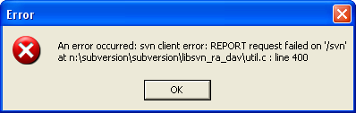

This error message was the result of an exception thrown from SVN. Error messages caused by defects in Ankh are captured via Ankh error handling. We continuously collect information about unhandled exceptions from SVN as well as Ankh as a result of these error mails.

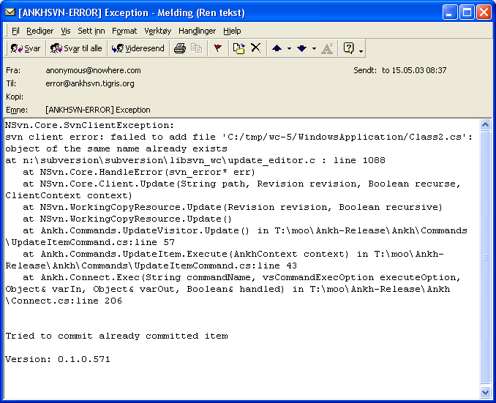

Conclusion
Ankh was unit tested with NUnit and built outside VS.NET with NAnt continuously during the development phase to secure quality and sanity. Ankh was tested functionally by using Ankh while developing Ankh. The intended audience at http://ankhsvn.tigris.org tested ankh. Feedback from these users provided useful information used to decide what was to be improved and ideas for new features. The already mentioned, early paper prototype testing of the GUI confirmed that our navigation model was logical and intuitive and gave us useful ideas of how to improve the GUI. Throughout the development process the testing strategy has paid off by not only providing a measurable indication of reliability but also by making defects apparent so that they could be addressed and resolved efficiently. Error messages are divided in 2 categories Ankh errors and SVN errors that reflect two different tools under development.

Appendix

Dictionary
Addin A software component that extends the functionality of another product.
Alpha release Alpha is the first release to the general public where basic functionality exists and a reasonable amount of stability is present. Some features may still be absent and there are probably major defects still in the code
API Application Program Interface
Base revision Last committed or updated revision
Beta release A beta release is significantly more advanced than the alpha release. While still not completely stable because of lingering bugs, all features planned for the final release should be present and reasonably reliable. This is when the more elusive bugs will be become apparent.
COM Component Object Model (COM), a software architecture that allows the components made by different software vendors to be combined into a variety of applications. COM defines a standard for component interoperability. It is not dependent on any particular programming language, is available on multiple platforms, and is extensible.
Commit Send changes from your working copy to the repository.
Conflicted file If two users modify the same file at the same line a conflict will occur if the file is under revision control. The conflict occurs because the repository simply doesn’t know whether both or only one of the lines should be added.
CVS Concurrent Versions System -A free open source version control system, the predecessor to Subversion.
DLL Dynamic Link Library
Doxygen Doxygen is a documentation system for C++, C, Java, IDL
(Corba, Microsoft, and KDE-DCOP flavours);and to some extent PHP and C#. The documentation is extracted directly from the sources, which makes it much easier to keep the documentation consistent with the source code. It can generate an on-line documentation browser (in HTML) and/or an off-line reference manual from a set of documented source files.
Draco.NET Draco.NET is an automated build system. It monitors your source
repository, automatically rebuilds your project when changes are
detected and e-mails
you the build result along with a list of changes since the last build. Draco.NET version 1.4 supports the NAnt build tool. It now also supports Subversion as we contributed code to their repository.
Folder Directory
GUI Graphical User Interface
Head revision Last revision in repository
Item File, folder, project or solution
IDE Integrated Development Environment
IIS Internet Information Server
IL Intermediate Language, the bytecode to which all languages in the .NET framework compile.
NAnt A free .NET build tool.
NUnit A unit testing framework, based on JUnit and part of the xUnit family. .

Repository The server component of the Subversion version control system; this is where your files get stored.
Repository Explorer
An Ankh tool used to browse a Subversion repository.
Revision control system
In a typical software development environment, many developers will be engaged in work on one code base. Revision control makes it easier for several people to share the same collection of program source code. A revision control system is a centralised system for sharing information where the core is a repository.
Solution Explorer A window in VS.NET used to manage files in a project/solution
SVN Short name for Subversion, which is a free open source revision control system.
SWIG Simplified Wrapper and Interface Generator
UI User Interface
UML Unified Modelling Language
Unversioned file File not under version control
VB Visual Basic .NET
VC++ Visual C++ .NET
VC# Visual C# .NET
Versioned file File under version control
VS .NET Visual Studio .NET. A programming platform that includes environments for developing C#, C++, Managed C++ and Visual Basic programs.
WC Short for Working Copy.
Working Copy Collection of files and directories under revision control.

Ankh screenshots
This appendix shows images of menus, dialog boxes, file tree views, output panes etc. used by Ankh. This part is included to make it possible for the reader to read this report independently from the process and product documentation. The aim of this appendix is to quickly update the reader about the environment the tests are performed in based on minimum knowledge about VS.NET and Ankh on before hand.

AnkhSVN output pane
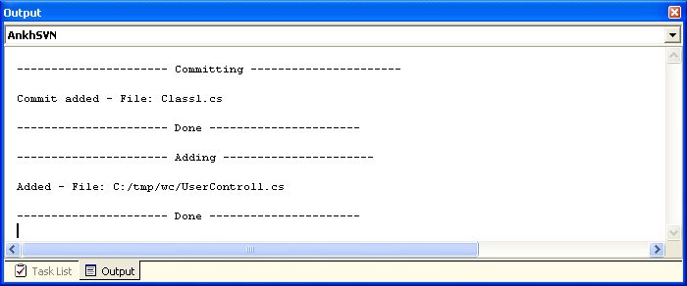

Commit dialog
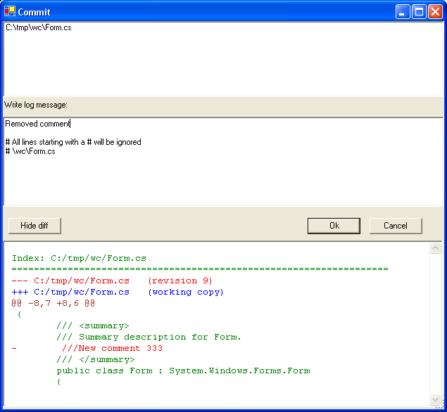

Date picker
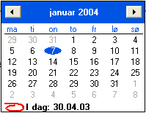

Diff in code view
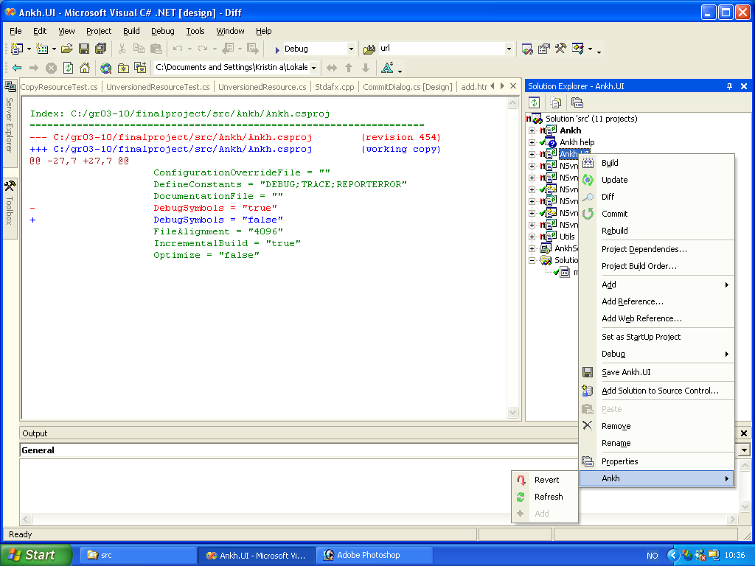

Item menu
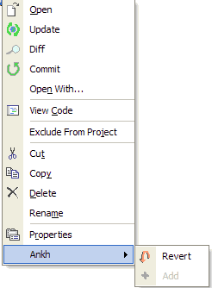

Login dialog

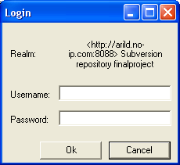

Repository Explorer
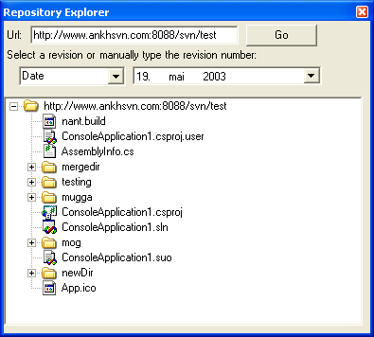

Revert dialog

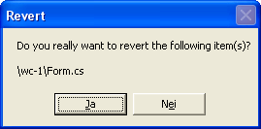

Solution Explorer
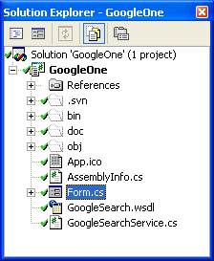

Ankh warning

