Front Page (specified by HIO) Process

Abstract
The development of the Subversion addin for Visual Studio .NET, named Ankh, was conducted as a final year project at HiO in cooperation with CollabNet.
Before Ankh was developed Subversion (SVN) had to be used from the command prompt. This is a very common approach for UNIX developers, but developers on Windows are more accustomed to graphical clients. The dominant developer tool on Windows is currently Microsoft Visual Studio.NET, and integration into this environment would make Subversion a viable alternative to a large number of Windows developers.
First step was to make a .NET wrapper for the Subversion's client API, and thereby use the wrapper to create a Visual Studio .NET addin for SVN. The system was coded in the C# and Managed C++ programming languages.
Improvements due to the development of Ankh:
- Most of the Windows users are not fond of using command prompts. By creating a GUI, SVN is made available for a huge amount of new Windows programmers. Today the audience of SVN are mainly Unix users. We hope to reach a new audience and convert the trend of UNIX user dominance.
- SVN is accessed directly from within the coding environment VS.NET itself.
- Increased productivity since revision control is directly accessible in VS.NET.
- We can offer the Windows users a FREE, open source revision control tool integrated in VS.NET.

Preface
This document describe how the process evolved and reasons for the selected approaches. The audience for this report is CollabNet and HIO. A dictionary containing the terminology used in this report is enclosed in the appendix.
The project group wanted to do a project in the Microsoft's .NET environment. One of the group members had used Subversion for several school and private projects for the last year and had the idea of the project. By developing Ankh we had a vision to provide the useful Subversion tool to a wider audience for no cost in an open source community.

After having defined the project we contacted CollabNet through the Subversion developer mailing list, and they immediately showed interest in being the employer for our project and provided our external supervisor, Karl Fogel.

The report is optimised for a paper-version.

Thanks to
Eva Hadler Vidhovde, HIO supervisor, for useful comments and guidelines for how a final project should be performed and an always optimistic attitude.
Karl Fogel, external supervisor from CollabNet, for giving us the liberty to fully influence the development process and final product of Ankh.
Ann Mari Torvatn for always paying interest to our project and for dedicating so much of her valuable time giving guidance to our documentation and visual presentation.
Thanks to Craig Skibo, Microsoft, for useful advises through the addin mailing list in VS .NET integration issues.
Thanks to all of you who have contributed to the testing of Ankh.

Table of contents
Front Page (specified by HIO) Process 1
Abstract 1
Preface 2
Table of contents 3
1 Introduction 5
1.1 The birth of the project 5
1.2 Revision Control 5
1.3 CollabNet 6
1.4 Subversion 7
1.5 Aim 7
1.6 Why use Ankh ? 7
1.7 What can Ankh do for you ? 8
1.8 How does Ankh work ? 8
1.9 Project specifications 15
2 Development process 16
2.1 Pilot project 16
2.2 Learning phase and tools used 16
2.3 Design phase 17
2.3.1 System design 17
2.3.2 Analysis of the users of our program: 18
2.3.3 Mental model 18
2.3.4 Navigation model and menus 20
2.4 Implementation and coding phase 21
2.4.1 NSvn wrapper layer 21
2.4.2 View Status icons in Solution Explorer 22
2.4.3 Ankh integration of menu options into VS .NET 24
2.4.4 Commit your changes to the repository (commit) 27
2.4.5 Examine changes of item in working copy 29
2.4.6 View file tree of repository in Repos Explorer (Repository Explorer 29
2.4.7 Ankh Help integration 31
2.4.8 General project challenges 33
2.4.9 Possible alternative approach 34
2.5 Testing 34
1.1.1 Unit testing and independent NAnt build 35
1.1.2 Functional testing and error handling 35
1.1.3 Testing of GUI 35
2.6 Deviations from project specifications 36
3 Phases of evolution in the group process 36
3.1.1 Commit mail 37
3.1.2 Build mail 38
3.1.3 Diary and internet sites 39
3.1.4 Issue-tracker 39
3.1.5 Relations to the employer CollabNet 40
3.1.6 Planning and methodology 40
4 Conclusion 40
5 Evaluation of work performed 41
6 References 42
7 Appendix 43
7.1 Dictionary 43
7.2 Development tools 44
7.2.1 VS.NET 44
7.2.2 VS.NET addin architecture 45
7.2.3 Code Comment Web Report 45
7.2.4 NUnit 45
7.2.5 NAnt 45
7.2.6 C# 45
7.2.7 Managed C++ 45
7.2.8 EA 45

Introduction
This chapter describe the background of the project, why Ankh should be used and what Ankh can do for you.

The birth of the project
One of the group members had used Subversion for several school and private projects for the last year and had the idea of the project. By developing Ankh we had a vision to provide the useful Subversion tool to a wider audience for no cost in an open source community.
Ankh is an Egyptic symbol representing both physical and eternal life. This could sound optimistic in the computer world. Based on the feedback we have experienced through the project period we know Ankh will be used. The Ankh project will be sustained. Ankh is a new born addin/wrapper project that will grow stronger and be a robust product in the well established open source community the project group appraise is a part of at http:\\ankhsvn.tigris.org.

Revision Control
In a typical software development environment, many developers will be engaged in work on one code base. Revision control makes it easier for several people to share the same collection of files and directories in a code base. A revision control system is a centralised system for sharing information where the core is a repository.

A repository is much like an ordinary file server, except that it remembers every change ever made to your files. Yellow boxes indicates directories, green boxes indicate files in the figure below. The numbers on the blue arrow indicate version numbers.
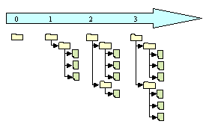
Each individual programmer checks out a working copy. A working copy is a collection of files and directories under revision control. Each file tree in the figure above are examples of a working copy that could be checked out from the repository. During the development work cycle these working copies are updated and synchronised with the repository.

When a commit is performed your changes are sent from your working copy to the repository. A commit makes your changes available for your colleagues. When a commit is performed it is possible to write a log message. A log message usually contain a short resume of changes performed.

Using revision control makes it possible to get an amazing overview of the work performed at any time from anywhere. If one project member has a problem that is difficult to solve another project members could easily get information of what is performed and support the other project member to solve the problem.
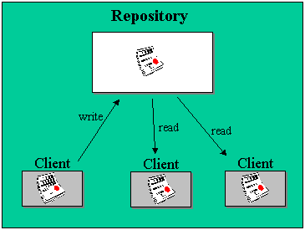

CollabNet
CollabNet is a California-based company that provided the initial founding in 2000 to begin development work on Subversion and currently has several paid developers working on the Subversion project. CollabNet offers a wide range of products and services to improve software quality and accelerate time-to-market during product development. Their main product is SourceCast, which is a Web-based software development platform. Subversion is aimed to be the successor of an existing revision control system called CVS (Concurrent Version System) and CollabNet intends to make it a part of the SourceCast platform.

Subversion
Subversion is a free open source revision control system which makes it easier for several people to work within the same set of files. The files are placed into a central repository. Subversion has a number of options. An attempt to analyse the Ankh integration of these SVN options from the users point of view is done in the mental model in this report. The Ankh integration of these SVN options are analysed from the developers point of view in a conceptual model in the product report. Additional information of Subversion could be obtained from http:\\subversion.tigris.org.
When we started to work with Ankh Subversion (SVN) had to be used from the command prompt. The prompt below shows the status command “svn st” followed by feedback from SVN.
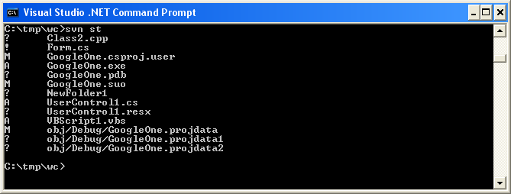

Aim
The aim of this project was to provide an integration for Subversion into the existing coding environment Visual Studio .NET. By making an addin for Visual Studio .NET the revision control system is made available for a huge amount of new users. The .NET wrapper layer is also available as a standalone component so that it easily can be used in other applications in the future.

Why use Ankh ?
Ankh is a free open source tool that integrates the revision control system Subversion into VS.NET. Today there are several revision control systems available as an addin to VS.NET on the marked, but non of them are free.
Subversion is the successor of a widely used revision control system named CVS (Concurrent Versions System). Subversion was initially founded to improve CVS. The initial goal of Subversion was to preserve the same functionality as CVS and fix the most obvious flaws. Ankh is recommended because it is a useful, free tool which offers an improvement of the widely used CVS.

What can Ankh do for you ?
When we started to integrate Ankh into VS.NET we made priority to those options that were most frequently used on a day to day basis. We aimed to get a product that could be used as soon as possible. Priority were therefore made to the integration of the Subversion commands add, update, delete/remove, commit, diff, status, list and revert. Ankh therefore contain the following functionality:
- View status icons in working copy in Solution Explorer (Status icons in Solution Explorer)
- Add files, directories, project and solutions (item) to the working copy (Add)
- Update working copy item to include changes from last revision (Update)
- Examine changes of item in working copy (Diff)
- Revert changes in item in working copy (Revert)
- Delete/remove item from working copy (Delete)
- Commit changes to the repository (Commit)
- Show file tree view of repository in Repos Explorer (Repository Explorer)
- Authenticate the user if the repository used is restricted

XXX All menu options and dialog boxes automatically display tooltip after some seconds. Ankh Help Integration gives useful information about how to use Ankh.

How does Ankh work ?
This subchapter describe the different options available in Ankh with screenshots of dialog boxes, menus, output panes and explorer panes. A simple example of how Ankh could be used is described in the product report. The example in the product report include the most frequently used Ankh options in a day to day basis. A complete description of how to use Ankh is given in the user manual. If you are not familiar with the VS.NET environment it could be useful to look at the navigation model in the subchapter
“2.3.4XXX Navigation model and menus” in this report to get a better understanding of this subchapter.

Status icons in Solution Explorer
Show status of working copy files, folders, projects and solutions (item) in Solution Explorer. Ankh show status on locally modified items (no repository access).

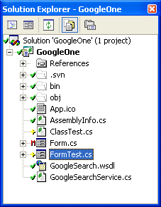

The meaning of the different status icons are listed below:
: unversioned item : Item not under revision control
: versioned item : Item under revision control
: modified, versioned item
: added, versioned item
: deleted, versioned item XXX To be removed - never used in Ankh Alpha ?
: conflicted, versioned item : If two users modify the same file at the same line a conflict will occur if the file is under revision control. The conflict occurs because the repository simply don’t know whether both or only one of the lines should be added. In some coding cases these new lines could mean the same and it would be logic to choose one of them.
: locked, versioned item : A locked item is an item that is not accessible. During for example a commit an item is not accessible for additional changes – it is locked. XXX To be removed -never used i Ankh Alpha ?

If an item is conflicted - the conflict has to be solved. If an item is locked a cleanup is required. Ankh gives the following warning in case of a lock.

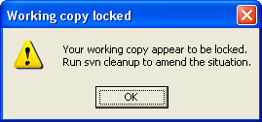

Ankh update status icons in Solution Explorer automatically after the status has changed on item(s). During the development phase a Refresh option on folders, projects and solutions are offered in the Ankh item menu. The Refresh option update the status icons in Solution Explorer on the selected folder, individual project or the solution recursively.

Add
Add items to your working copy and schedule them for addition to the repository. These items will be added to the repository in your next commit. If you add something and change your mind before committing, you can unschedule the addition using revert. Add works on different solutions, projects, folders and files. Add could be performed on several items and works recursively on folders, individual projects and the solution. The Add option is available from the item menu which is displayed if an item is selected in Solution Explorer and right clicked.

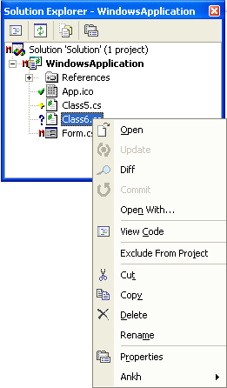

The Add option is confirmed in AnkhSVN output pane after add is performed.
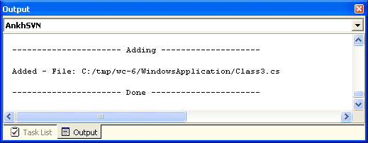

Update
Update brings changes from the repository into your working copy. It brings your working copy up-to-date with the head revision (last revision in repository). If there has been changes to the same file - text or code is twisted. Update could be performed on several items and works recursively on folders, individual projects and the solution. The Update option is available from the item menu which is displayed if an item is selected in Solution Explorer and right clicked. The Update option is confirmed in AnkhSVN output pane after update is performed.
.
Diff
Display the changes of item(s). The client compares base revision (last updated or committed revision) and working copy. Diff on an item is displayed in code view in a temporary file.

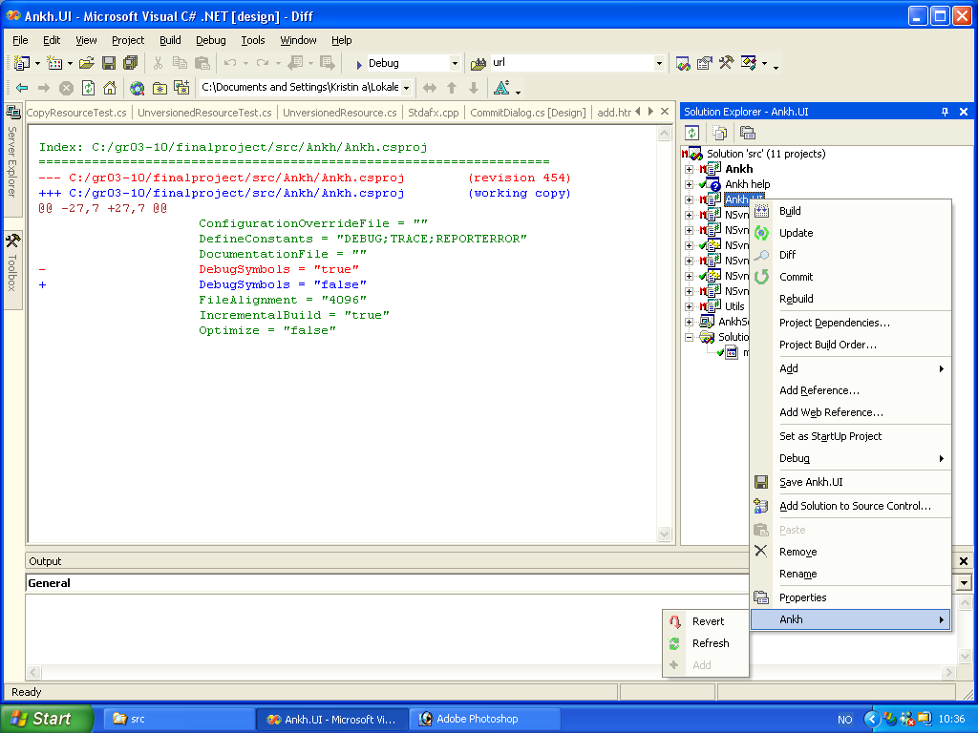

Red colour indicate text removed (danger), green text indicate unchanged text and blue indicate new text added. Diff could be performed on several items and works recursively on folders, individual projects and the solution. The Diff option is available from the item menu which is displayed if an item is selected in Solution Explorer and right clicked.

Revert
Restore pristine working copy. Pristine working copy is the last updated working copy or working copy from last local commit. Undo all local changes. Revert could be performed on several items and works recursively on folders, individual projects and the solution. The Revert option is available from the item menu which is displayed if an item is selected in Solution Explorer and right clicked. The Revert option is confirmed in AnkhSVN output pane after revert is performed.

Delete/Remove
Remove or delete items in working copy from revision control. Delete could be performed on several items and works recursively on folders, individual projects and the solution. The Delete and Exclude From Project option is available from the item menu which is displayed if an item is selected in Solution Explorer and right clicked.The Delete option is confirmed in AnkhSVN output pane after delete is performed.

Commit
Send changes from your working copy to the repository. A commit operation can publish changes to any number of items. In your working copy, you can change files, contents, create, delete and then commit the complete set of changes as a unit. It is possible to examine changes of item (Diff) in working copy from within the commit dialog. Commit works recursively on folders, individual projects and the solution. The Commit option is available from the item menu which is displayed if an item is selected in Solution Explorer and right clicked. If Commit is selected from the item menu the Commit dialog will be displayed.

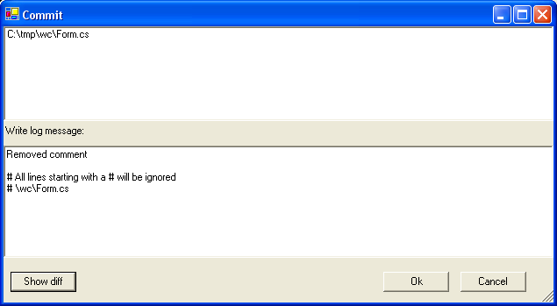

The upper text area display the items to be committed. This area is write protected which makes it impossible for the user to edit. In the lower text area it is possible to write a log message. All lines starting with # will be ignored in the log message sent to the repository. If Ok-button is clicked the log message and the committed items are sent to the repository. If Cancel-button is clicked the commit is cancelled. If Show diff-button is clicked it is possible to examine the changes of the selected item(s) in working copy.

If the repository require authentication for the commit the Login dialog will be displayed.

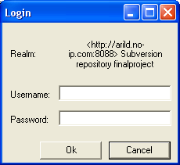

Ok-button is enabled if the password and username is printed. The Commit option is confirmed in AnkhSVN output pane after the commit is performed.

Repository Explorer
The Repository Explorer display a file tree view of repository with file-type icons corresponding to those used by VS .NET for a valid url and revision.

The Repository Explorer is available from Tools → Repos Explorer from main menu in VS.NET.

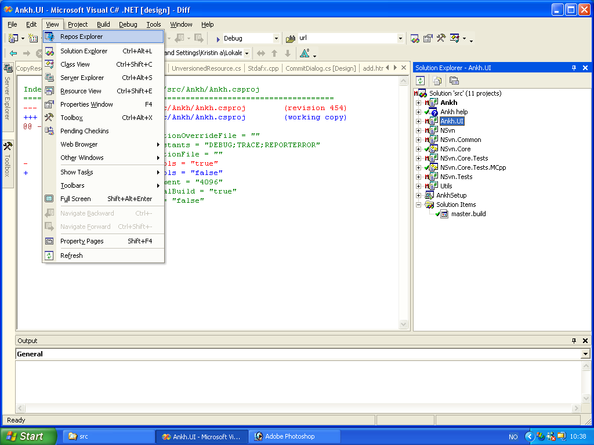

The repository Explorer could display any revision defined as head, date or number. Head revision means last revision in the repository. If date revision is selected the data-combobox is enabled and a calendar is available. If not valid url or revision is printed an error message is shown. Below is the Repository Explorer with date revision selected. The calendar is available.
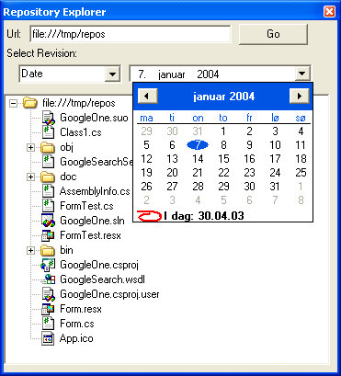

In general menu options, buttons etc. that are not available in Ankh for the spesific item are enabled. Tooltip are supported for all menu options and dialog boxes. XXX Didn’t work in Alpha. XXX Help Integration gives useful information about how to use Ankh.

A more detailed description of challenges in the coding phase are listed in the subchapter Implementation and coding phase.

Project specifications
To ensure the sanity and quality of the system at any given moment, and to catch regression bugs continuous unit tests using the NUnit testing framework were conducted.
We have provided NAnt build scripts that enable NSvn to be built without requiring the user to have Visual Studio.NET installed. The .NET wrapper layer is therefore available as a standalone unit for use in other applications.
The .NET wrapper layer covers the SVN client's API based on last version of SVN.
Common programming guidelines were composed to get an overall consistent look of the code.
Subversion was used for revision control both for the source code and documentation. All documentation was written in English.

Development process
This chapter covers the development process in the Ankh project. We passed through phases of learning, design, implementation/coding, and testing.

Pilot project

In this phase we wrote progress report, project proposal, contacted CollabNet, coded the diary, made the work plan and work schedule.

Learning phase and tools used
A description of the tools used is given in appendix 6.2 and the dictionary.

During our project we continuously used Subversion for revision control. Revision control systems are not a part of any lectures at HIO so we had to learn how to use Subversion and understand parts of the Subversion code (Client API coded in C) to be able to make the Ankh NSvn wrapper layer. To get a better understanding of the Client API in Subversion we frequently used the doxygen part of the Subversion documentation which is a web based “code comment report”. Subversion was under development and to be able to follow the development process we subscribed to the Subversion mailing list.

To get familiar with the VS.NET environment we explored features and ran macros and samples available through the help utility. During the development phase we frequently used the help utility integrated in VS.NET.

The code was mainly written in C# except from a thin Managed C++ code layer in the NSvn wrapper. To get familiar with the C# coding language we started to look at tutorials in C# and ran samples advised by the VS.NET help utility.

To gather information about VS.NET addins we searched at internet, tested some available free addins, read articles about the VS.NET addin architecture and used the help utility in VS.NET.

To get an overview of NUnit and NAnt we looked at tutorials.

Enterprise Architect were used to develop use case diagrams and schemes as one of the group members were familiar to this tool and easily could transfer his knowledge to the rest of the group.

The diary was programmed in python as one of the group members were familiar with the programming language and we were not sure whether a Tomcat server would be available for two alternative diaries made last year in Distributed Information Systems. Most of the diary at our internet site was coded during Christmas holiday last year, but the site was maintained and adjusted through the project period.

All of the tools and programming languages used were new for two of the group members and we believe that this project could not have been accomplished if not the third group members had knowledge of the majority of these tools.

Design phase
In this phase we agreed on system design, analysed the potential users of our program, tried to figure out what Ankh could be able to do for the user in a mental model and discussed the navigation model and menus to be used.
A conceptual model of Ankh from the developers point of view was made where we analysed each menu-option in Subversion and how it could be implemented in VS.NET. These use case diagrams and schemes are enclosed in the product documentation.
Common programming guidelines were composed before we started the coding to get an overall consistent look of the code. These guidelines are enclosed in appendix 6.3.

System design
The system is divided into two main layers, a GUI/addin layer and a .NET wrapper layer. The addin/GUI layer contains code of the addin and graphical user interface in the C# language. This layer is called Ankh. The wrapper is divided into a lower level part for the SVN's client API coded in Managed C++ and a more object-oriented high level part coded in C#. The .NET wrapper is called NSvn.
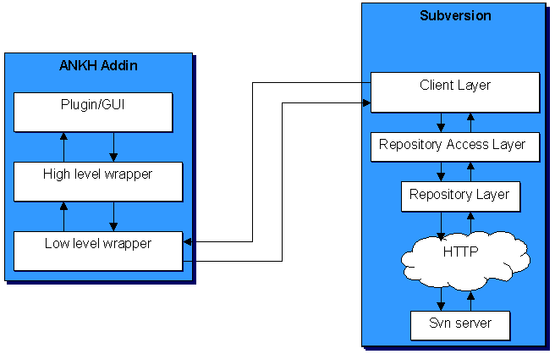

Analysis of the users of our program:
The users of Ankh probably:
- have programming experience
- use or have knowledge about VS.NET
- have knowledge about revision control systems
- are fastidious to design and user-friendliness
- are usually men
- are often within the age of 20-45
- are probably member of a project group
- choose to use our addin because a revision control system is a useful tool in development of a potential software product
- might have knowledge of the revision control system Subversion or CVS (the successor to Subversion)
Ankh is made for a programming environment. We concluded that ordinary people without programming experience would not represent Ankh users. A high level of functionality from fastidious users would therefore be required for the GUI.

Mental model
A mental model from the users point of view was made to describe the functionality of the wrapper and what Ankh could do for the user if we were able to implement all commands from Subversion. Two actors were identified. The programmer that wants to use revision control and the repository that could be compared to a server (with some additional features). Relations between the objects and the actors are shown with lines. The action objects Import or CheckOut must be performed before any of the other action objects can be performed (i.e. the solution in VS.NET has to be under revision control). An item means a file, folder, project or solution.

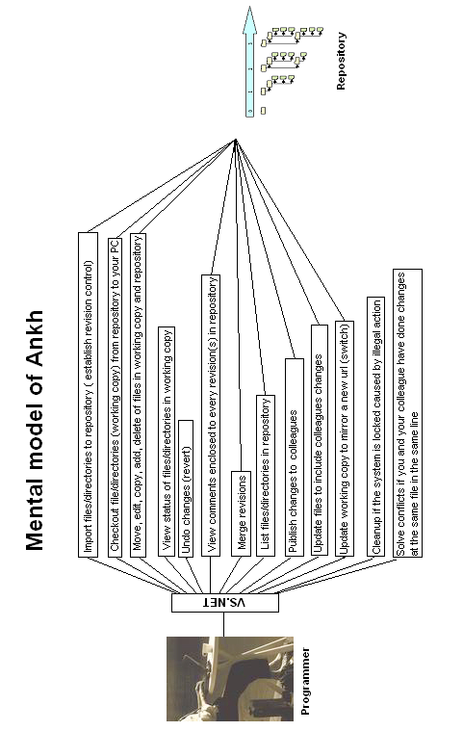

Navigation model and menus
Our goal was to implement Subversion into VS.NET as smoothly as possible. The VS.NET GUI was rather complex with lots of windows, menus and icons. Ankh was supposed to be a supplementary tool to VS.NET. Making fancy design in fresh colours would probably act distracting on the programmer who is supposed to concentrate on the coding. We therefore decided to use as much as possible of the already existing GUI. Add a new pane to the ouput view, implement icons into Solution Explorer, add new Explorer pane and add new menu options to the already existing menus connected to a file, directory, project or solution.

The following window types were used:
- Multi squared windows (Windows where a special event in one window effects the output in another window.)
- Multi window (Each window could be moved independently.)
- Multi documents (One main window manage many dialog boxes. )
To be able to distinguish between SVN and VS.NET's own menu options, dialog boxes, Output pane etc. without deviating too much from VS.NET's GUI design Ankh icons were used.
The name Ankh, which is the name of our addin, was selected because it is Egyptic and could be visualised as a simple icon that easily could be used in the marketing of Ankh. It was important to select an icon that could not be confused with another well known software/tool and had a neutral meaning. As the Subversion group tend to use Egyptic words we decided to follow their trend.
The menu choices are as functional and obvious as possible. For example the command "svn ci" are named "commit" in the menu context. There might be some programmers that already are familiar with SVN. The wording used in Ankh therefore don’t deviate considerably from the SVN standard. We have deliberately avoided new notions. “Publish” could have been a more understandable notion for “commit”, but as we decided to also take into account users already familiar with SVN we have avoided new notions.

Our navigation model is described in the figure below. If the programmer right click on a file, folder, project or solution (item) a menu will pop up. If input parameters for the option selected is required, a dialog box will be displayed. The result of the action initiated in the dialog box or from the item menu will be displayed in a AnkhSVN pane in the Output view. If the option selected is Edit properties we planned that new properties would be added to the Properties vindow. There are also a new pane containing a file tree view of the repository.

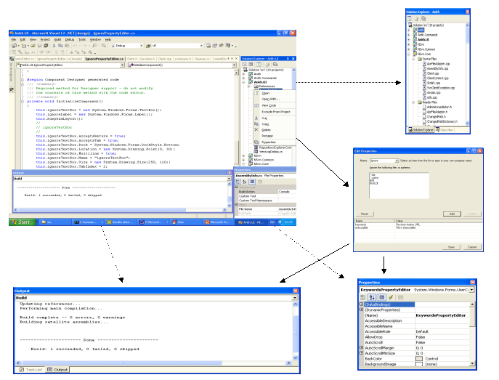

Implementation and coding phase
Before we started the coding we had agreed on common programming guidelines to get an overall consistent look of the code. The programming guidelines are described in detail in the product documentation.
XXX NB This chapter is not complete yet. Should be ignored at the moment

NSvn wrapper layer
NSvn is the name of our VS.NET wrapper. The choice of the name selected was based on the short name of Subversion, SVN, combined with the letter N symbolising .NET. The wrapper contain a complete translation of the Subversion Client API coded in C. The wrapper is divided in 2 levels. A lower level part coded in Managed C++ and a more object-oriented higher level part coded in C#. NSvn contain the functionality of all “svn” commands described in the SVN Client API (“svnadmin” commands are not included). Unit-tests to verify the translation were performed for all “svn” commands. The NSvn wrapper was built outside VS.NET by the NAnt tool. The .NET wrapper layer is available as a standalone component so that it easily can be used in other applications in the future.

It was not possible to start the VS.NET integration before the wrapper was completed.

View Status icons in Solution Explorer
This subsection describe the integration of the SVN command status into VS.NET’s Solution Explorer to give an indication of the GUI improvements and challenges of the integration.

The picture below shows an example of how SVN works today in a command prompt.

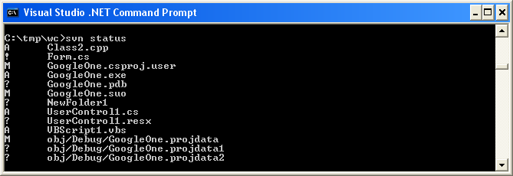

The “svn status” command prints the status of files and directories in a working copy. A working copy is a collection of files and directories under revision control. The letter or symbol in front of each file indicate the status of each file or directory.

The Subversion command “svn status” was integrated into VS.NET in Solution Explorer. Solution Explorer display files, directories, projects and solutions (item) with updated Ankh status icons in front of each item. The status icons visible in the Solution Explorer makes it easier to see which files that have changed status while working.
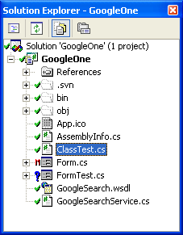
By using icons we hope to help the user to reduce his cognitive strain in a longer term .
The meaning of the different status icons are listed below:
: unversioned item : Item not under revision control
: versioned item : Item under revision control
: modified, versioned item
: added, versioned item
: deleted, versioned item XXX To be removed ?
: conflicted, versioned item : If two users modify the same file at the same line a conflict will occur if the file is under revision control. The conflict occurs because the repository simply don’t know whether both or only one of the lines should be added. In some coding cases these new lines could mean the same and it would be logic to choose one of them.
: locked, versioned item : A locked item is an item that is not accessible. During for example a commit an item is not accessible for additional changes – it is locked. XXX To be removed ?

The red colour of the icons are used to signalise danger or attract attention. If an item is modified it could mean that some text are scheduled to be removed in a potential commit. Deleted items are scheduled for delete in a potential commit. Data that are modified or deleted therefore represent a danger because data could be “removed” from working copy. If an item is conflicted or locked a warning message will be displayed. The following warning will be displayed in case of a lock.

It is important to solve a potential conflict and cleanup locked items. Red colour is therefore used to attract attention to locked and conflicted items.

The green colour on the versioned item icon () signalise that everything is ok. If a commit succeed the icon will be displayed in front of the committed item. The yellow colour on the added, versioned item icon () signalise that the item is ready (scheduled) for commit. Blue colour on the unversioned item icon () signalise a new category of items which is not versioned.
Ankh update status icons automatically after the status has changed. When we first integrated the status icons into VS.NET we refreshed the status icons on all items in the whole file tree view if the status on one item was changed. This was very time consuming and we therefore modified Ankh to refresh the status on the particular item(s) if the status had been changed. A recursive refresh option of the status icons is available in the item menu for the solution, individual projects and folders.
XXX

Ankh integration of menu options into VS .NET
This subsection describe the Ankh integration of the SVN command add, update, remove/delete and revert into VS.NET’s Solution Explorers item menu to give an indication of the GUI improvements and challenges of the integration. Below is the item menu for the file.
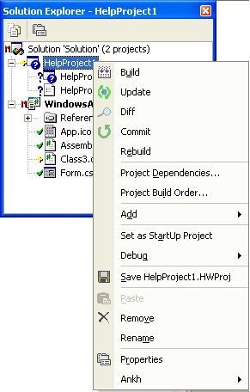

In VS.NET item menus are implemented not only for files and directories, but also for projects and solutions. Hooking up to these menus required integration of update, add, remove, delete, revert not only for files and directories but whole projects and solutions. VS.NET is a coding environment for several coding languages. Solution and Projects in Visual Basic, Visual C#, Visual C++, Setup and Deployment Projects and Other projects are different. It was required to identify and analyse which files and directories these different projects and solutions included to be able to perform Ankh menu options recursively (on all files and directories within a project or solution). Support for C++ projects are weaker than support for VB and C# projects. Below is some of the different project types listed in the Add New Project Dialog which is a part of VS.NET.

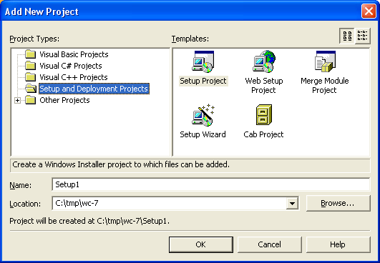

When VS.NET Delete an item, Exclude an item From a Project or Remove an item from a solution in a working copy – Ankh must catch the event and exclude or delete the item automatically from the working copy. The event fired by VS.NET was different for C++ items compared to items in the other coding languages this made the coding more complicated than assumed on beforehand.

Ankh icons are meant to help the user to remember the menu options and thereby reduce the users cognitive load. It is easier to remember a picture than to remember a technical term. The Ankh Add option could be confused with the VS.NET Add option. To avoid this the Ankh Add option has an icon in front of the menu option and is placed in the Ankh submenu.

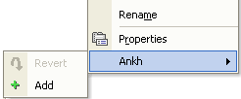

A magnifying glass was used in front of the Diff option to help the user remember that the Diff option display details about what is removed and added text since last local commit or update. Revert could be associated with “undo” as it revert changes performed in the working copy and brings the working copy back to pristine state. An icon that looks like the undo icon is therefore used in the item menu in front of the revert option.

The Revert dialog below was integrated on users request after the source code release at http://ankhsvn.tigris.org. Details from this release are given in the test report.

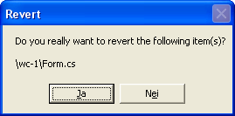

XXX
AnkhSVN output pane
Notification callback
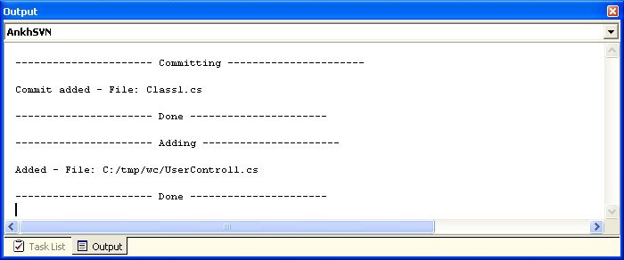

Commit your changes to the repository (commit)
This subsection describe the integration of the SVN command commit into VS.NET’s Solution Explorer to give an indication of the GUI improvements and challenges of the integration.

Image of the Commit dialog is shown below.

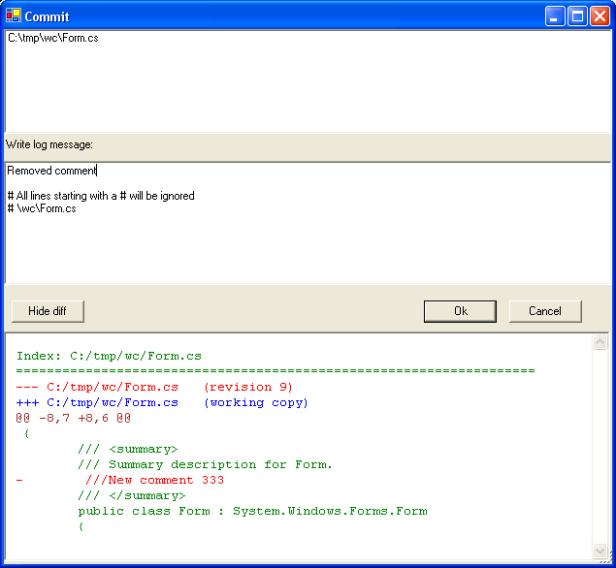

XXX
Login dialog

XXX Client context

Examine changes of item in working copy

XXX

View file tree of repository in Repos Explorer (Repository Explorer
This subsection describe the integration of the SVN command list into VS.NET’s Repository Explorer to give an indication of the GUI improvements and challenges of the integration.

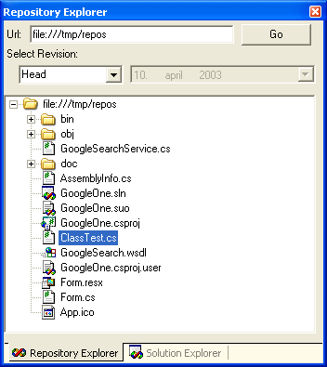
XXX UIHierarcy ?

Date picker to reduce possibility of wrong user input.
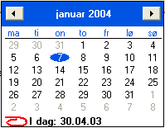

Reuse of user controls
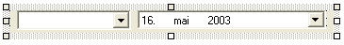

Ankh Help integration

In respect of the potential new user group we made priority to start the development of an advanced Ankh Help integration into VS.NET. The Ankh Help was meant to be a user guide integrated in VS.NET available from the main menu. The Ankh Help integration cover information of basic operations and how to use Ankh. Some keywords are included in the Index view. The Index view works as a simple search where the search words are listed in the Index view.
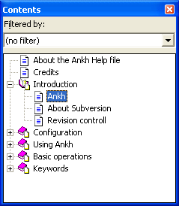
If “Ankh” is selected in the list of Contents the content of “Ankh” is visible in the ? view.
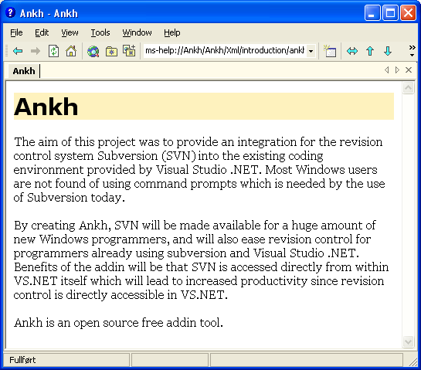
If the keyword “about” is selected in the Index view.
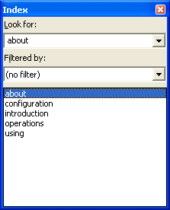
Results of the selected keyword is visible in the Index Results view:
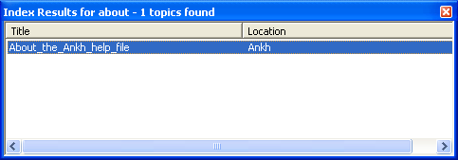
“About this help file” is visible in the ? view.
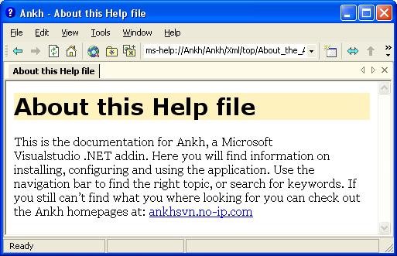
Collection level files to hierarchically integrate the Ankh Help Collection into VS .NET’s Help Collection were made. A method to customise the Help Registration merge module was used for deployment. Deployment and plugin of Ankh Help Integration into VS.NET Help Integration were not completed due to an error message using Orca-validation on the File_ParentHxT parameter in the HelpPlugin table in MSHelp2_RegTables__RTL_---_---.msm we could not solve. The parameter recommended by VS .NET Help Integration that gave the error message was FL_vscc_hxt_ENU____.3643236F_FC70_11D3_A536_0090278A1BB8. An alternative approach to deploy the project was to use H2Reg, but as this tool cost money which is not preferable for an open source we decided not to use it.

General project challenges
New versions of Subversion were released about every third week as Subversion was under development. We therefore had to adjust our addin during the development phase to new versions a number of times. Within every update we had to check out the source code of Subversion, build the project and distribute the .dll files to the Apache server and adjust new changes in Subversion to our addin. This was a time consuming process. We started with SVN version 0.16 and ended with version 0.22.2.

During the project progress Subversion unexpected changed their Client API to include a more flexible authentication. This introduced a new client context structure, that included client specific call backs and batons which served as a cache for configuration options and other various data. This made a delay in the project.

In middle March Microsoft announced a potential serious bug in VS.NET that only affects C++ developers. The bug could occur while creating Managed C++ Class Libraries that usually contain a mixture of native code and intermediate language (IL).
The build product of a “Managed C++ application” is an assembly of IL with an .exe extension. As we are using mixed DLLs this bug could affect our addin. A possible suggestion of a “workaround” solution for this bug was to set the build output in the Managed C++ Class Library project to have an IL-only file. As we had limited time available and did not experience a big impact of this bug we have not implemented the “workaround”.
The most difficult part of the C# coding in the Ankh project was the integration into VS.NET because this area was poorly documented and few relevant examples were available. The examples available were mainly macros coded in Visual Basic. To gather information in this phase we used news channels, mailing lists, books and searched at Internet. As the Ankh project is open source we hope to transfer our knowledge of the VS .NET integration coded in C# to others. The Ankh project represent a complete example of how to hook up to menus, make explorer panes, output panes and how to make dialog boxes and user controls coded in C#.
XXXHow was technical problems solved ? What was the solution ? Was it difficult to find a solution ? How good was the solution ?

Possible alternative approach
We primarily intended to write most of the system in the C# programming language, but discovered that writing the .NET wrapper layer in Managed C++(C++ extensions for the .NET environment) was a better choice since Managed C++ offered a better integration with C-based APIs such as that of Subversion. Another alternative was to use a tool called SWIG (Simplified Wrapper and Interface Generator) - a tool that generates wrappers for C and C++-based APIs automatically. The C# module had recently been added to SWIG and was still in a state of development. We research these alternatives and seaked advice from people with knowledge in the area on the Subversions mailing list. We generally received support from the mailing list to our choice.

Testing
Ankh was unit-tested with NUnit and built outside VS.NET with NAnt continuously during the development phase. Ankh was tested functionally by using Ankh while developing Ankh. Ankh was tested by the intended audience at http://ankhsvn.tigris.org. Feedback from these tests gave useful information of what to be improved and ideas for future development. An early paper prototype testing of the GUI confirmed that our navigation model was logic and intuitive and gave us useful ideas of how to improve the GUI. In the end Ankh was tested functionally with a number of tests described in the test report to give an indication of the robustness of Ankh. Error messages are divided in 2 categories Ankh errors and SVN errors that reflect two different tools under development.

Unit testing and independent NAnt build
Unit-testing of Ankh was performed continuously during the project period to ensure sanity and quality of the addin/wrapper. Every time a commit of Ankh was performed the project was built by NAnt and all unit-tests were ran.

Functional testing and error handling
During the Alpha testing phase the source code was published in the well established open source community at http://ankhsvn.tigris.org. The term alpha test means the first phase of testing in a software development process. The first phase includes unit testing, component testing, and system testing. To gather as much information as possible from this phase exception mails were sent to all group members. These mails contained valuable information about exceptions thrown from Ankh. When an exception was thrown from Ankh it was captured and the user was asked whether he wanted to send the exception and add a comment by mail. Details from the exception mails gave useful information of issues to be solved (see issue tracker at http://ankhsvn.tigris.org). The issue tracker lists preliminary weaknesses and possible future improvements of Ankh. The Revert dialog was implemented by users request from this testing phase.

After having implemented the most basic functions add, update, commit and status it was possible to use Ankh. Ankh was therefore tested functionally by using Ankh while developing Ankh. A new instance of VS.NET was started from the Ankh project. This made it possible to continuously work with the last update of Ankh and testing it at the same time with real data. Ankh was thereby tested by using an iterative methodology in a natural environment with real data.

Ankh was tested on the intended audience in Ankh Alpha version 1.0. Ankh was made available for installation from http://ankhsvn.tigris.org. Ankh Alpha version 1.0 require the SVN Client version 0.22.2. The installer optionally included a test repository that was extracted to the computers local hard drive during installation. The persons who downloaded Ankh were encouraged to use this repository to test Ankh. Ankh Alpha version 1.0 was tested functionally with a number of tests described in the test report.

Error handling is divided in 2 categories Ankh errors and SVN errors that reflect two different tools under development.

Testing of GUI
Testing of GUI was performed to ensure optimal functionality of the GUI. A paper prototype test was performed to check whether our navigation model was logic and intuitive. We also tested whether our choice of button-names, names in menus and names on text fields etc. were logic. The test was performed on 3 test persons with programming experience. One of the persons was familiar with revision control systems and VS.NET. Before the tests were performed the test persons were given a short introduction to revision control and VS.NET. 3 scenarios were selected covering VS.NET integration of the “svn commands” commit, log and properties. The overall conclusion from these tests were that our navigation model was intuitive and logic. Useful feedback from the tests made us modify button names and text fields in dialog boxes, and reorganise the placing of buttons, text fields, comboboxes etc.. A need of Help Integration was also identified.

Deviations from project specifications
Process and product documentation was written in Word in stead of xml due to strict time-schedule and unforeseen challenges. We started to write the documentation in xml. Xml/xsl-documentation is suited for small documents, but among other things have no option for spell check. To get table of content, page numbering that should take into account different images sizes, headers/footers etc. complicated xsl-code would have been required. As the HIO did not require both an optimised paper and web-version of the documentation we made priority to the quality of the content in stead.

Phases of evolution in the group process
This section describe how we worked through the different phases of the project.

In the beginning of the project the group members worked together shorter or longer periods almost every day until all group members were masters of all new software and tools to be used during the project period. In this period we worked mainly together the all 3 of us at the school computer and remote on one “home PC”.

We started to work separately when all group members had successfully installed required software and tools on their home computers. We continued to meet at school also after we started to work independently at our home computers. In periods when we worked separately we communicated via MSN, mail and mobile.

We aimed that all group members were given the possibility to participate on as many as possible of the different parts of the project. If all should participate on all parts of the project there would probably been 3 versions of the project which was not the intention and the project would not have been delivered within the time frame scheduled. We aimed that all group members should be given the possibility to contribute and understand all the different parts of the project. All group members have coded in Managed C++, all have made NUnit tests, all have coded C# in the GUI layer and the wrapper layer. All have been involved in the part of the integration into VS.NET. All have used EA to generate use case diagrams and class diagrams. All group members have also contributed to the documentation written in Word and XML. All documentation will be proof-read by the other group members.

During the project period we have discussed what to do and individually proposed what to work with. We have not had any group leader that has dedicated work, but taken the initiative for different tasks ourselves.

We did early decide that Arild was the contact person towards CollabNet, Per was the contact person towards the computer department at HIO, and Kristin had the responsibility to present weekly progress to Eva with contribution from the rest of the group if needed in weekly meetings.

When we had about 30 % of the project period left we decided to go for the “good foot” as expressed by a Norwegian football player called Nils Arne Eggen. Arild represented an amazing knowledge base, had an enormous working capacity and was the code guru in the group. Per had an amazing ability to acquire new knowledge, showed an impressive creativity in technical discussions and has a marvellous ability to feel comfortable in whatever working conditions. Kristin enjoyed the marketing part of the Ankh project. Per and Arild therefore worked together on the VS.NET integration of “svn commands” while Kristin worked with the documentation and the Ankh Help Integration into VS.NET.

To be able to at any time get the last update of the project we reviewed information from commit mails, build mails, the diary and had code reviews in addition to SVN revision control. Commit mails, build mails and the diary are described in the sections below.

Commit mail
Every time a project member did a commit, made his changes available for the rest of the group, a mail was sent to all group members. The mail contained a log message written to the specific revision and a “svn diff” that contained information about which files and directories that had been modified, added or deleted and which sentences that had been added or removed in each file (not binary files).
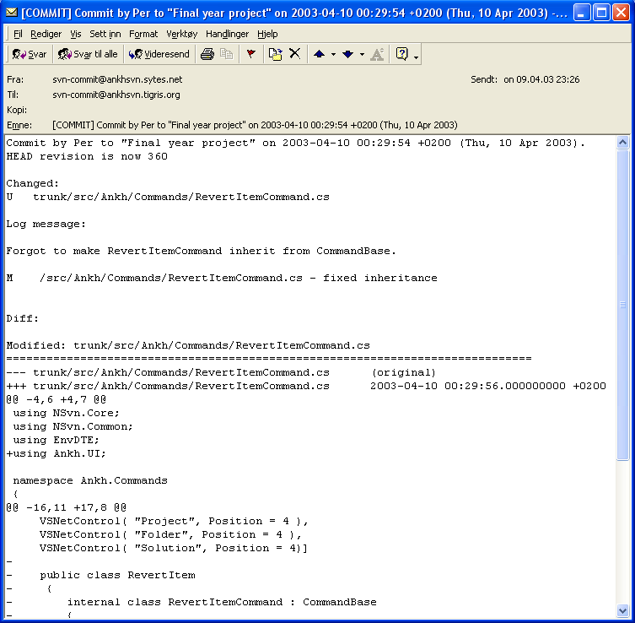
Using revision control and receiving commit mails made it possible to get an amazing overview of the work performed at any time. If one group member had a problem that was difficult to solve another group member could easily get information of what was performed and support the other group member to solve the problem.

Build mail
Every time a project member published her changes to the rest of the group, an independent NAnt build outside VS.NET was performed. In this build all unit-tests were ran to ensure the sanity and quality of the system at any given moment. A mail was sent to each group member with information about whether the build was a success or not.
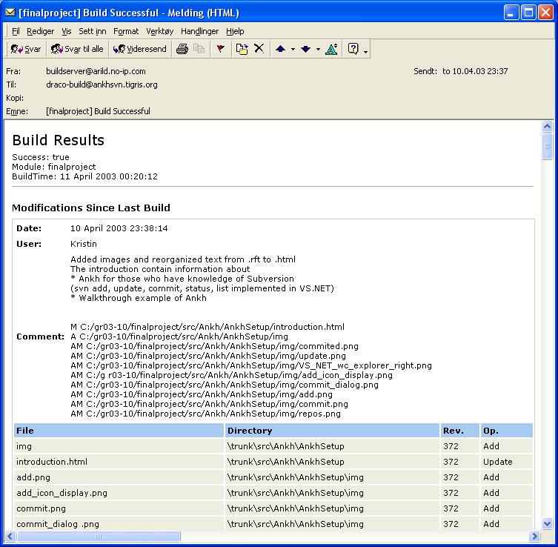

Diary and internet sites
The Internet site was adjusted to give focus on Ankh as a product not as a final year project at HIO. The diary had both a public and a private part. In the last part of the project period Ankh became a part of the Open Source Community at http:\\ankhsvn.tigris.org. In the tigris.org Open Source Community an issue tracker was available for ankhsvn. We started to use this tool close to the Alpha release.

Issue-tracker
The issue tracker lists preliminary weaknesses and possible future improvements of Ankh. The issue list shows type of feature, priority, status, result and summary of the issues. This list helped us to remember things we planned to implement in later versions and gave us the status on issues to be solved in near future.

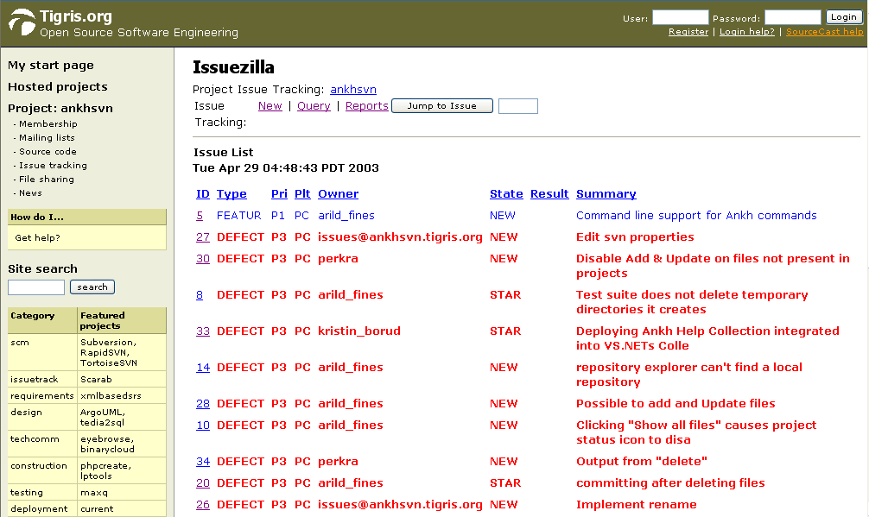

Relations to the employer CollabNet
XXX How the relations to CollabNet evolved through the process

Planning and methodology
In the beginning of the project period we used the waterfall method. Results from one phase were used in next phase of the development. It was not possible to start VS.NET integration before the wrapper was completed. During the VS.NET integration phase we used an iterative methodology. During development we used Ankh while developing Ankh. Ankh was thereby tested in a natural environment with real data.
We experienced that it was difficult to make realistic planes and follow a time schedule, but after all we are very satisfied with the work performed taken into account the challenges we have gone through.

XXX Waterfall method or prototyping ? Traditional systemising or X-ray sequence ? Feedback from CollabNet and potential users ?

Conclusion
Improvements due to the development of Ankh:
- By creating a GUI, SVN is made available for a huge amount of new Windows programmers. Today the audience of the SVN are mainly Unix users. We hope to convert this trend.
- SVN is accessed directly from within VS.NET itself.
- Increased productivity since revision control is directly accessible in VS.NET.
- We can offer the Windows users a FREE open source revision control tool integrated in VS.NET
- VS .NET integration coded in C# is poorly documented. The Ankh project represent a complete example of how to hook up to menus, make explorer panes, output panes and how to make dialog boxes and user controls coded in C#. Since Ankh is open source code we hope to transfer our knowledge to others.
The .NET wrapper layer is available as a standalone component so that it easily can be used in other applications in the future. The wrapper covers a complete translation of the Subversions Client API coded in C to Managed C++ and C# code.

Evaluation of work performed
The Ankh project was developed using advanced C# code. We have explored a new area of VS .NET that was poorly documented, and hope that our knowledge about VS.NET integration could be transferred to others through the open source community at http:\\ankhsvn.tigris.org.

The number of challenges in the Ankh project have been high. Through the project period we have worked with tools under development that still suffer from some children diseases. A possible serious bug was discovered in VS.NET and Subversion were still under development. Ankh were adjusted and built against the SVN source code for a number of SVN versions.

Due to strict project specifications there were not much space left for creativity. Even though examples of creativity is shown by:
- using Ankh while developing Ankh
- reuse of usercontrols to avoid duplication of codelines in the Ankh GUI. In the Ankh.UI namespace usercontrols are reused within other usercontrols
- Ankh icons in item menu were implemented to hopefully reduce the users cognitive strain in on a long term base

In respect of the potential new user group we made priority to develop an advanced Ankh Help Integration.

Ankh is available for anybody, anywhere through the open source community at tigris.org. The Ankh project will sustain in the open source community at http:\\ankhsvn.tigris.org.

Revision control were used to optimise the working conditions and process. Commit mails, build mails, error mails and the the issue tracker made it easier to support and encourage eachother through the process period.

During the process period we have learnt how to use Enterprise Architect, Subversion and Visual Studio .NET. We have coded in C# and Managed C++, learnt how to write unit-tests in NUnit, written xml documentation, learnt how to make an addin to VS .NET and we have got a better understanding of the SVN Client API. We have learnt how an Open Source Community works and have been a part of the well established Open Source Community at tigris.org through the Ankh project.

Ankh was unit-tested with NUnit and built outside VS.NET with NAnt continuously during the development phase. Ankh was tested functionally by using Ankh while developing Ankh. Ankh was tested by the intended audience at http://ankhsvn.tigris.org. An early paper prototype testing of the GUI was also performed to check whether our navigation model was logic and intuitive. In the end Ankh was tested functionally with a number of tests described in the test report.

The technical challenges the group has been exposed to has mainly been solved internally within the group or using mailing lists and news groups. We have aimed to avoid Ankh work load in technical issues on ours supervisors.

All group members have coded in Managed C++, all have made NUnit tests, all have coded C# in the GUI layer and the wrapper layer. All have been involved in the part of the integration into VS.NET. All have used EA to generate use case diagrams and class diagrams. All group members have also contributed to the documentation written in Word and XML. All documentation have been proof-read by the other group members.

Thanks to Arild who had the splendid idea of the project, represented an amazing knowledge base in the Ankh project, had an enormous working capacity and was the code guru in the group.

Thanks to Per who had an amazing ability to acquire new knowledge, showed an impressive creativity in technical discussions and has a marvellous ability to feel comfortable in whatever working conditions.

Thanks to Kristin who enjoyed the marketing part of the Ankh project.

XXX What we did, what we learnt, evaluation of work performed. What does the employer mean about the product ? Will it be available download from Subversion internet site ? Could the wrapper be used in another context ? What could have been done different ?

References
- “NUnit” http://nunit.org/
- “VS.NET help” integrated in VS.NET
- “NAnt”
- ”Ant” http://ant.apache.org/manual/
- "Creating Office Managed COM Add-Ins with Visual Studio .NET” by Paul Cornell, Microsoft Corporation, June 6, 2002
- ”EA” at http://www.sparxsystems.com.au/
- “The Mixed DLL Loading Problem Using Visual C++ .NET”, March 16, 2003 http://www.codeguru.com/dll/kmg15.html
- “15 SWIG and C#” http://www.swig.org/Doc1.3/CSharp.html
- “Subversion: The Definitive Guide”, Draft: Revision 5113, 26 February, 2003, by Ben Collins-Sussman, Brian W. Fitzpatrick, C. Michael Pilato, http://subversion.tigris.org
- “Inside Microsoft Visual Studio .NET” by Brian Johnson, Craigh Skibo, Marc Young

Appendix

Dictionary
alpha testing - The term alpha test means the first phase of testing in a software development process. The first phase includes unit testing, component testing, and system testing.
API - Application Program Interface
beta release - Software under testing of the intended audience.
beta testing - Beta test is the second phase of software testing in which the intended audience tries the product out.
COM - Component Object Model (COM), a software architecture that allows the components made by different software vendors to be combined into a variety of applications. COM defines a standard for component interoperability It is not dependent on any particular programming language, is available on multiple platforms, and is extensible.
COM add-in - Is a dynamic-link library (DLL) that contains not only your custom code, but also special registry entries. These registry entries are used by Microsoft Office applications to determine the COM addin's behaviour at run time.
commit - Send changes from your working copy to the repository. Publish your
changes to your colleagues.
container – directory, project, solution
conflicted file – If two users modify the same file at the same line a coflict will occur if the file is under revision control. The conflict occurs because the repository simply don’t know whether both or only one of the lines should be added. In some coding cases these new lines could mean the same and it would be logic to choose one of the lines
CVS – Concurrent Version System. A free open source revision control system, the successor of Subversion.
GUI - Graphical User Interface
IDE - Integrated Development Environment
IIS - Internet Information Server
IL - Intermediate Language
Item – file, directory, project, solution
Item menu –
NAnt - A free .NET build tool.
NUnit - Tool for unit testing.
.NET Framework –
pristine working copy - is the last updated working copy or working copy from last local commit.
recursively – Means to do something on all subitems. If I want to add all files and directories of a specific project in VS.NET to the working copy – I will have to add all files and all directories connected to the specific project to. Files and directories are defined as subitems.
repository – A repository is much like an ordinary file server, except that it remembers every change ever made to your files.
Repository Explorer – File tree view of the repository content.
revision control system – In a typical software development environment, many developers will be engaged in work on one code base. Revision control makes it easier for several people to share the same collection of program source code. A revision control system is a centralised system for sharing information where the core is a repository.
Solution Explorer –
SVN – Short version of Subversion, which is a free open source revision control system.
SWIG - Simplified Wrapper and Interface Generator
UI - User Interface
UML - Unified Modelling Language
unversioned file – File not under revision control
VB –Visual Basic .NET
VC++ - Visual C++ .NET
VC# - Visual C# .NET
versioned file – File under revision control
VS .NET - Visual Studio .NET. A programming platform that includes editors for programming in C#, C++, Managed C++ and Visual Basic
wc - Working Copy. Collection of files and directories under revision control.
Working Copy - Collection of files and directories under revision control.

Development tools

VS.NET
Visual Studio .NET is a set of development tools for building ASP Web applications, XML Web services, desktop applications, and mobile applications. Visual Basic .NET, Visual C++ .NET, and Visual C# .NET all use the same integrated development environment (IDE), which allows them to share tools and facilitates in the creation of mixed-language solutions. In addition, these languages leverage the functionality of the .NET Framework, which provides access to key technologies that simplify the development of ASP Web applications and XML Web services.

VS.NET addin architecture
In VS.NET it is possible to make addins. This makes it possible for us programmers to add whatever preferred tool into VS.NET. We have made a COM addin.
A COM addin is a dynamic-link library (DLL) that contains not only your custom code, but also special registry entries. These registry entries are used by Microsoft Office applications to determine the COM addin's behaviour at run time.

Code Comment Web Report
VS.NET provide a tool that generate a web report displaying information about the definitions in your code in a series of .html pages. This feature allow you to browse the code structure within files in your current project or solution, such as classes, objects, members and interfaces. The comments are written in the C# source code by use of xml-tags combined with a special comment syntax.

NUnit
Nunit is a free open source unit-testing framework for all .Net languages. Initially ported from JUnit which is a unit-testing tool for Java. Version 2.0, the second major release of Nunit, was used in the testing of Ankh. NUnit brings xUnit to all .NET languages. The Nunit tests are visualised by a testing tree view where the various tests get executed gradually.

NAnt
NAnt is a free .NET build tool. Instead of writing shell commands, the configuration files are XML-based, calling out a target tree where various tasks get executed. Each task is run by an object that implements a particular Task interface.

C#
Microsoft C# (pronounced C sharp) is a new programming language designed for building a wide range of enterprise applications that run on the .NET Framework. C# code is compiled as managed code, which means it benefits from the services of the common language runtime. These services include language interoperability, garbage collection, enhanced security, and improved versioning support.

Managed C++
Managed Extensions for C++ are enhancements made to the C++ language. Managed Extensions simplify the task of migrating existing C++ applications to the new .NET Framework. Attributes, like C++ keywords, are used in source files and interpreted by the compiler. Attributes are designed to provide a quick and efficient method to simplify COM programming with Visual C++.

EA
Enterprise Architect is a project oriented UML modelling tool for the Windows platform. This tool was used to generate the use case diagrams and class diagrams.

 

