Ankh Test Report

Preface
This report contains the testing of Ankh. Ankh is an addin of the revision control system Subversion for VS.NET. The development of Ankh was conducted as a final year project at HiO in cooperation with CollabNet.
This report is written for the computer personnel responsible for maintenance, updating, support and modifications to the system. The purpose of this document is to give a description of how t he system is tested.
It is an advantage to have knowledge about revision control systems and VS.NET to get a better understanding of this document. A dictionary containing terminology used is enclosed in the appendix. An Ankh image environment collection is also enclosed in the appendix. This part is included to make it possible for the reader to read this report independently from the process and product documentation. The aim of this appendix was to quickly update the reader about the environment the tests are performed in based on minimum knowledge about VS.NET and Ankh on before hand.

Table of contents

Preface 2
Table of contents 3
1 Aim of the testing 3
2 Continuous NUnit testing through development 4
3 Independent NAnt build 5
4 Paper prototype testing 6
5 Functional testing 7
5.1 Testing of status icons in Solution Explorer 9
5.2 Testing of add in Solution Explorer 11
5.3 Testing of update in Solution Explorer 15
5.4 Testing of commit in Solution Explorer 17
5.5 Testing of diff in Solution Explorer 19
5.6 Testing of delete/remove in Solution Explorer 22
5.7 Testing of revert in Solution Explorer 23
5.8 Testing of Commit dialog 26
5.9 Testing of Login dialog 27
5.10 Testing of feedback in AnkhSVN output pane 27
5.11 Testing of Ankh integration in Solution Explore 28
5.12 Testing of the Repository Explorer 29
5.13 Error handling 30
6 Conclusion 31
7 Appendix 32
7.1 Dictionary 32
7.2 Ankh environment image collection 33
7.2.1 AnkhSVN output pane 33
7.2.2 Commit dialog 34
7.2.3 Date picker 34
7.2.4 Diff in code view 35
7.2.5 Item menu 36
7.2.6 Login dialog 36
7.2.7 Repository Explorer 37
7.2.8 Revert dialog 37
7.2.9 Solution Explorer 38
7.2.10 Ankh warning 38

Purpose of the testing
The aim of the testing was to identify and capture possible weaknesses in Ankh and thereby make Ankh as robust as possible. Ankh was tested bottom-up and top down. We started to write unit-tests of small parts of the program. In a later stage we combined bit-by-bit parts of the program, and tested the whole program in the end.

Ankh was unit-tested with NUnit and built outside VS.NET with NAnt continuously during the development phase to secure quality and sanity. Ankh was tested functionally by using Ankh while developing Ankh. The intended audience at http://ankhsvn.tigris.org tested Ankh. An early paper prototype testing of the GUI was also performed to check whether our navigation model was logic and intuitive. In the end Ankh was tested functionally with a number of tests described in this report.

Continuous NUnit testing through development
NUnit is a free open source unit-testing framework for all .NET languages. Initially ported from JUnit which is an unit-testing tool for Java. Version 2.0 was used in the testing of Ankh. NUnit is coded in C# . Code example of a unit-test performed is listed below. The test verify the implementation of the Add method in the lower wrapper layer of Ankh. The Add method is supposed to add an unversioned file to revision control.

namespace NSvn.Core.Tests
{
/// <summary>
/// Tests NSvn::Core::Client::Add
/// </summary>
[TestFixture]
public class AddTest : TestBase
{
[SetUp]
public override void SetUp()
{
this.ExtractWorkingCopy();
this.notifications = new ArrayList();
}

/// <summary>
/// Attempts to add a file, checking that the file actually was
/// added
/// </summary>
[Test]
public void TestBasic()
{
string testFile = this.CreateTextFile( "testfile.txt" );

ClientContext ctx = new ClientContext( new NotifyCallback() );
Client.Add( testFile, false, ctx );

Assertion.Assert( "No notification callbacks received",
this.Notifications.Length > 0 );

Assertion.AssertEquals( "svn st does not report the file as added",
'A', this.GetSvnStatus( testFile ) );

}

}
XXX Could some of you make this more clear ?

In the Setup() method a working copy is extracted. A working copy is a collection of files and folders under revision control. To be able to add an unversioned file to revision control a working copy is required. An arraylist is initialised. This list will contain feedback after Client.Add(..) has added the unversioned file to revision control.

In the TestBasic() method an unversioned file “testfile.txt” is created. The input parameter “false” in Client.Add(...) indicates that Add is performed on only one file, not recursively. Client.Add(..) is ran with required input parameters and should add an unversioned file to the extracted working copy. Assertion.Assert(....) checks whether there has been any feedback from Subversion (SVN) after the add was performed. If this.Notifications.Length is less than 1 the test will fail and “No notification callbacks received” will be displayed in the NUnit editor. Assertion.AssertEquals(...) checks if the status on the file has changed to “A”. If the status is not “A” the test will fail and “svn st does not report the file as added” will be displayed in the NUnit editor.

Independent NAnt build
Independent NAnt build of Ankh was performed continuously during the project period to ensure sanity and quality of the addin/wrapper. Every time a commit was performed NAnt checked out a fresh working copy, built the project and all unit-tests were run. A build mail concluding whether the build failed or succeeded was sent to all group members frequently during development. Example of a build mail is shown below.
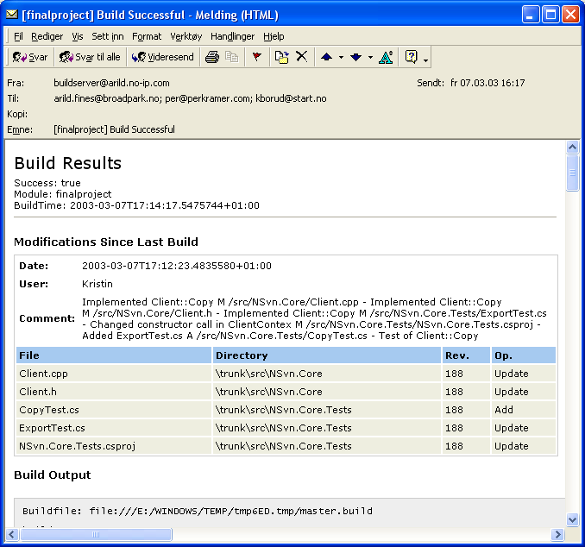

Paper prototype testing
Testing of GUI was performed to ensure optimal functionality of the GUI. A paper prototype test was performed to check whether our navigation model was logic and intuitive; whether our choice of button-names, names in menus and names on text fields etc. were logic. The test was performed on three test persons with programming experience. One of the persons was familiar with revision control systems and VS.NET. Before the tests were performed the test persons were given a short introduction to revision control and VS.NET. Three scenarios were selected covering integration of commit, log and edit properties. The overall conclusion from these tests were that our navigation model was intuitive and logic. Useful feedback from the tests made us modify button names and text fields in dialog boxes, and reorganise the placing of buttons, text fields, combo boxes etc. A need of Help Integration was also identified.

Functional testing
During the Alpha testing phase the source code was published at http://ankhsvn.tigris.org. The term alpha test means the first phase of testing in a software development process. The first phase includes unit testing, component testing, and system testing. When an unhandled exception was thrown the user was asked whether he wanted to submit an error report. If the user clicked yes a web browser opened where the error message already was filled in. It is optional to add a comment and your email address. The Ankh error report page is shown below.

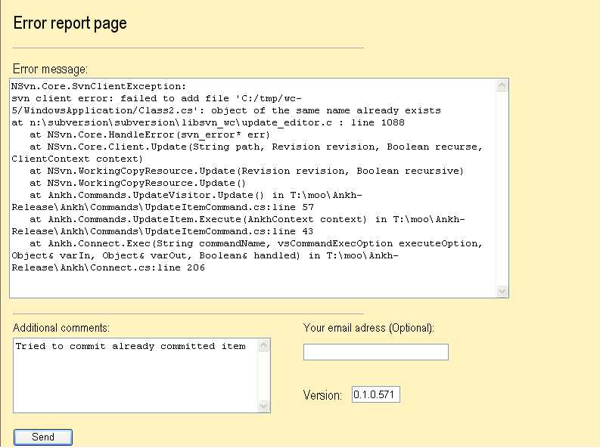

To gather as much information as possible from this phase exception mails were sent to all group members. These mails contained valuable information about unhandled exceptions thrown from Ankh. Details from the exception mails gave useful information of issues to be solved (see issue tracker at http://ankhsvn.tigris.org). The issue tracker lists preliminary weaknesses and possible future improvements of Ankh. The issue list shows type of feature, priority, status, result and summary of the issues. This list helped us to remember things we planned to implement in later versions and gave us the status on issues to be solved in near future. The Revert dialog was implemented by users request from this testing phase. Ankhs
revert dialog is enclosed in the environment image collection.

After having implemented the most basic functions add, update, commit and status it was possible to use Ankh. Ankh was therefore tested functionally by using Ankh while developing Ankh. The picture below shows the Ankh project with a new instance of VS.NET above. The new instance was started from the Ankh project. This made it possible to continuously work with the last update of Ankh and testing it at the same time with real data. Ankh was thereby tested by using an iterative methodology in a natural environment with real data.

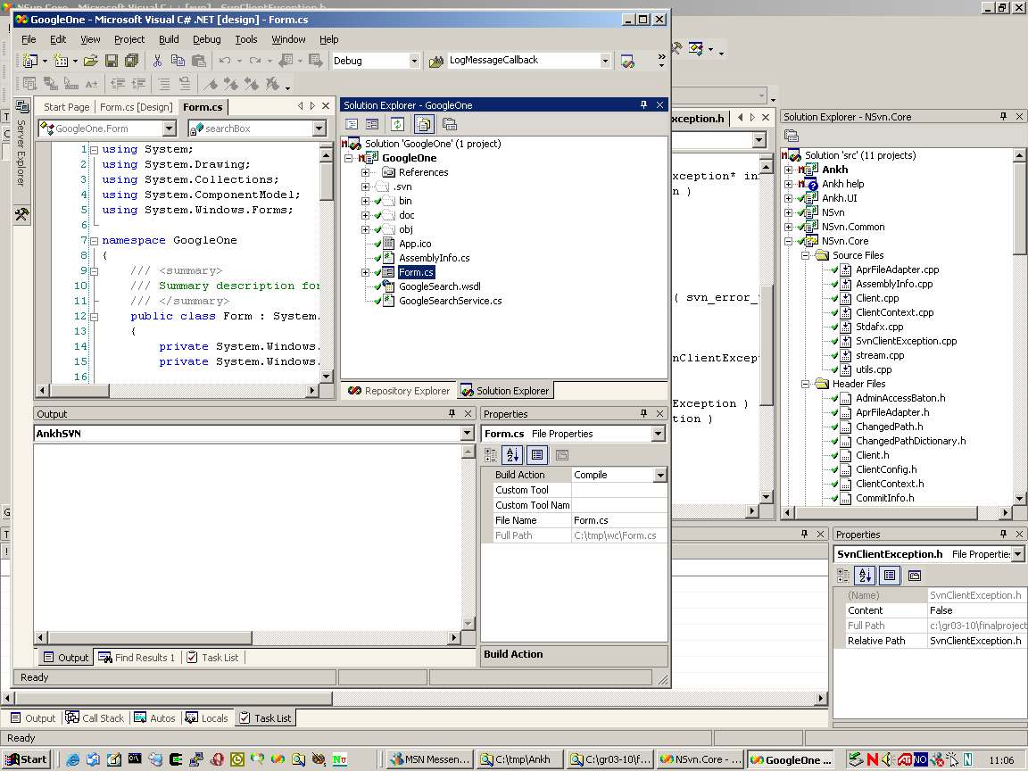

Ankh was tested on the intended audience in Ankh Alpha1-release. AnkhSetup.msi was made available for installation from http://ankhsvn.tigris.org. Ankh Alpha1-release still requires some of the SVN Client version 0.22.2 commands. The installer included a test repository that is optionally extracted to the computers local hard drive during installation. The persons who download Ankh are encouraged to use this repository to test Ankh.

Ankh supports mainly Visual Basic (VB), Visual C# (VC#) and Visual C++ (VC++) projects. Support for VC++ projects is weaker than VC# and VB projects, this because VS automation process is different in VC#. Ankh Alpha version 1.0 was tested functionally with a number of tests described in the following sub chapters.

Testing of status icons in Solution Explorer
Solution Explorer display files, folders, projects and the solution (item) with updated Ankh status icons. Tests performed to verify Ankh status icons displayed in Solution Explorer are listed in the table below. An image of Solution Explorer is enclosed in the appendix.

Test | Result /Comment | Date
Status icon is shown in Solution Explorer in front of an unversioned file. | Ok if VB files are within versioned projects. | 19.05.2003
Status icon is shown in Solution Explorer in front of an unversioned file. | Ok if VC++ files are within versioned projects. | 19.05.2003
Status icon is shown in Solution Explorer in front of an unversioned file. | Ok if VC# files are within versioned projects. | 19.05.2003
Status icon is shown in Solution Explorer in front of an unversioned directory. | Ok if VB folders are within versioned projects. | 19.05.2003
Status icon is shown in Solution Explorer in front of an unversioned directory. | Not visible for C++ folders. | 19.05.2003
Status icon is shown in Solution Explorer in front of an unversioned directory. | Ok if VC# folders are within versioned projects. | 19.05.2003
Status icon is shown in Solution Explorer in front of an unversioned project. | Icons not visible on VC# projects | 19.05.2003
Status icon is shown in Solution Explorer in front of an unversioned project | Icons not visible on VC++ projects. | 19.05.2003
Status icon is shown in Solution Explorer in front of an unversioned project | Icons not visible on VB projects. | 19.05.2003
Status icon is shown in Solution Explorer in front of a versioned file | Ok | 19.05.2003
Status icon is shown in Solution Explorer in front of a versioned folder | Ok | 19.05.2003
Status icon is shown in Solution Explorer in front of a versioned project | Ok | 19.05.2003
Status icon is shown in Solution Explorer in front of a versioned solution | Ok | 19.05.2003
Status icon is shown in Solution Explorer in front of a modified, saved, versioned file | Ok the status is shown if the modified file is saved | 19.05.2003
Status icon is shown in Solution Explorer in front of a modified, saved, versioned folder | Ok the status is shown if the modified folder is saved | 19.05.2003

Status icon is shown in Solution Explorer in front of a modified, saved, versioned project | Ok the status is shown if the modified project is saved. | 19.05.2003
Status icon is shown in Solution Explorer in front of a modified, saved, versioned solution | Ok the status is shown if the modified solution is saved. | 19.05.2003
Status icon is shown in Solution Explorer in front of an added, versioned file. | Ok, visible for VB files. | 19.05.2003
Status icon is shown in Solution Explorer in front of an added, versioned file. | Ok, visible for VC# files. | 19.05.2003
Status icon is shown in Solution Explorer in front of an added, versioned file. | Ok, visible for VC++ files. | 19.05.2003
Status icon is shown in Solution Explorer in front of an added, versioned folder | Ok for VB folders. | 19.05.2003
Status icon is shown in Solution Explorer in front of an added, versioned folder | Ok for C# folders. | 19.05.2003
Status icon is shown in Solution Explorer in front of an added, versioned folder. | Icons not visible for C++ folders. | 19.05.2003
Status icon is shown in Solution Explorer in front of an added, versioned project. | Ok for VC++ projects. | 19.05.2003
Status icon is shown in Solution Explorer in front of an added, versioned project. | Ok for VC#, projects. | 19.05.2003
Status icon is shown in Solution Explorer in front of an added, versioned project. | Ok for VB projects. | 19.05.2003
Status icon is shown in Solution Explorer in front of an added, versioned project. | Ok for Help projects. | 19.05.2003
Status icon is shown in Solution Explorer in front of a deleted, versioned file. | If file is deleted the file disappear from file tree view in Solution Explorer | 19.05.2003
Status icon is shown in Solution Explorer in front of a deleted, versioned folder. | If folder is deleted the folder disappear from file tree view in Solution Explorer | 19.05.2003
Status icon is shown in Solution Explorer in front of a deleted, versioned project. | If project is deleted the project disappear from file tree view in Solution Explorer. | 19.05.2003
Status icon is shown in Solution Explorer in front of a conflicted, versioned file. | Ok. | 19.05.2003
Status icon is shown in Solution Explorer in front of a conflicted, versioned project | Ok. | 19.05.2003
Status icon is shown in Solution Explorer in front of a conflicted, versioned solution | Ok. | 19.05.2003
Status icon is shown in Solution Explorer in front of a locked, versioned file | Not visible. | 19.03.2003
Status icon is shown in Solution Explorer in front of a locked, versioned folder | Not visible. | 19.03.2003
Status icon is shown in Solution Explorer in front of a locked, versioned project | Not visible. | 19.03.2003
Status icon is shown in Solution Explorer in front of a locked, versioned project | Not visible. | 19.03.2003

Testing of add in Solution Explorer
Tests performed to verify the Add item menu option in Solution Explorer are listed in the table below. The add option adds an unversioned file to revision control. An image of the item menu is enclosed in the appendix.

Test | Result /Comment | Date
Add option is enabled in menu if unversioned file (status icon ) is selected in Solution Explorer and right clicked. | Ok for VB files. | 20.05.2003
Add option is enabled in menu if unversioned file (status icon ) is selected in Solution Explorer and right clicked. | Ok for VC# files. | 20.05.2003
Add option is enabled in menu if unversioned file (status icon ) is selected in Solution Explorer and right clicked. | Ok for VC++ files. | 20.05.2003
Add option is enabled in menu if unversioned file (status icon ) is selected in Solution Explorer and right clicked. | Ok for Help files. | 20.05.2003

Add option is enabled in menu if unversioned folder (status icon ) is selected in Solution Explorer and right clicked. | Ok for VB if folders are within a versioned project. | 20.05.2003
Add option is enabled in menu if unversioned folder (status icon ) is selected in Solution Explorer and right clicked. | Ok for VC# if folders are within a versioned project. | 20.05.2003
Add option is enabled in menu if unversioned folder (status icon ) is selected in Solution Explorer and right clicked. | Ok for VC++ if folders are within a versioned project. Not enabled for VC++ folders. | 20.05.2003
Add option is enabled in menu if unversioned folder (status icon ) is selected in Solution Explorer and right clicked. | Not enabled for VC++ folders. | 20.05.2003
Add option is enabled in menu if unversioned project (status icon ) is selected in Solution Explorer and right clicked. | Ok for VB projects. | 20.05.2003
Add option is enabled in menu if unversioned project (status icon ) is selected in Solution Explorer and right clicked. | Ok for VC# projects. | 20.05.2003
Add option is enabled in menu if unversioned project (status icon ) is selected in Solution Explorer and right clicked. | Ok for VC++ projects. | 20.05.2003
Add option is enabled in menu if unversioned project (status icon ) is selected in Solution Explorer and right clicked. | Ok for Help projects. | 20.05.2003
Add option is disabled in menu if versioned file (status icon ) is selected in Solution Explorer and right clicked. | Ok | 20.05.2003

Add option is disabled in menu if versioned folder (status icon ) is selected in Solution Explorer and right clicked | Ok | 20.05.2003
Add option is disabled in menu if versioned project ( status icon ) is selected in Solution Explorer and right clicked | Ok | 20.05.2003
Add option is disabled in menu if versioned solution (status icon ) is selected in Solution Explorer and right clicked | Ok | 20.05.2003
Add option is disabled in menu if modified, versioned file (status icon ) is selected in Solution Explorer and right clicked | Ok | 20.05.2003
Add option is disabled in menu if modified, versioned folder (status icon ) is selected in Solution Explorer and right clicked | Ok | 20.05.2003
Add option is disabled in menu if modified, versioned project (status icon ) is selected in Solution Explorer and right clicked | Ok | 20.05.2003
Add option is disabled in menu if modified, versioned solution (status icon ) is selected in Solution Explorer and right clicked | Ok | 20.05.2003
Add option is disabled in menu if added, versioned file (status icon ) is selected in Solution Explorer and right clicked. | Ok for VB files. | 20.05.2003
Add option is disabled in menu if added, versioned file (status icon ) is selected in Solution Explorer and right clicked. | Ok for VC# files. | 20.05.2003
Add option is disabled in menu if added, versioned file (status icon ) is selected in Solution Explorer and right clicked. | Ok for VC++ files. | 20.05.2003
Add option is disabled in menu if added, versioned folder (status icon ) is selected in Solution Explorer and right clicked | Ok for VB, VC#, VC++ folders | 20.05.2003
Add option is disabled in menu if added, versioned project (status icon ) is selected in Solution Explorer and right clicked | Ok for VC#, VC++, VB projects | 20.05.2003
Add option is disabled in menu if conflicted, versioned file (status icon ) is selected in Solution Explorer and right clicked. | Ok | 21.05.2003
Add option is disabled in menu if conflicted, versioned folder (status icon ) is selected in Solution Explorer and right clicked | Ok. | 21.05.2003
Add option is disabled in menu if conflicted, versioned project (status icon ) is selected in Solution Explorer and right clicked | Ok. | 21.05.2003
Add option is disabled in menu if locked, unversioned file is selected in Solution Explorer and right clicked | Ok, tested at VB files in locked, unversioned VB project. | 21.05.2003
Add option is disabled in menu if locked, unversioned folder is selected in Solution Explorer and right clicked | Ok, tested at VB folder in locked, unversioned VB project. | 21.05.2003
Add option is enabled in menu if locked, unversioned project is selected in Solution Explorer and right clicked. | Ok, tested at VB project in locked, unversioned VB project. . | 21.05.2003
“Working copy locked” warning if Add option is selected from item menu for a locked, unversioned project | Ok, tested at VB project. | 21.05.2003
It is possible to add an unversioned VC# file (*.cs) to revision control | Ok | 21.05.2003
It is possible to add an unversioned VC++ file (*.cpp) to revision control | Ok | 21.05.2003
It is possible to add an unversioned VB file (*.vb) to revision control | Ok | 21.05.2003
It is possible to add an unversioned folder to a versioned VC# project | Ok | 21.05.2003
It is possible to add an unversioned folder to a versioned VB project | Ok | 21.05.2003
It is possible to add an unversioned folder to a versioned Help project | Return error message | 21.05.2003
It is possible to add an unversioned folder to a versioned Extensibility project | Ok, for the main part of the Extensibility project, not possible for the Setup part of the project. | 21.05.2003
It is possible to add a VC# project to revision control | Ok | 21.05.2003
It is possible to add a VC++ project to revision control | Ok | 21.05.2003
It is possible to add a VB project to revision control | Ok | 21.05.2003
It is possible to add a Help project to revision control | Ok | 21.05.2003

It is possible to add a Extensibility project to revision control | Main part of VS.NET Add-in and Shared Add-in project added. Setup part of Extensibility project not added. | 21.05.2003
Status icon is changed to in front of file in Solution Explorer after unversioned file is added | Ok for VC# files. | 21.05.2003
Status icon is changed to in front of file in Solution Explorer after unversioned file is added | Ok if Refresh was ran on VB and VC++ files | 21.05.2003
Status icon is changed to in front of folder in Solution Explorer after unversioned folder is added | Ok for C# projects. Ok if Refresh was ran on VB folder. Icon not visible for added C++ Header and Source folders. | 21.05.2003
Status icon is changed to in front of project in Solution Explorer after unversioned project is added | Ok for VB, VC#, VC++, Help projects and Main part of Extensibility projects (not Setup part) | 21.05.2003
Add works recursively on files in C++ folder | Ok, tested on folders containing C++ Header and Source files. | 21.05.2003
Add works on several files | Ok for VB and VC# files | 20.05.2003

Testing of update in Solution Explorer
Tests performed to verify the Update item menu option in Solution Explorer are listed in the table below. The update option updates a versioned file to include last committed changes.

Test | Result /Comment | Date
Update option is disabled in menu if unversioned file (status icon ) is selected in Solution Explorer and right clicked | Ok | 20.05.2003
Update option is disabled in menu if unversioned folder (status icon ) is selected in Solution Explorer and right clicked | Ok for VB and VC# folders. Update enabled for C++ folders | 20.05.2003
Update option is disabled in menu if unversioned folder (status icon ) is selected in Solution Explorer and right clicked | Update enabled for C++ folders. | 20.05.2003

Update option is disabled in menu if unversioned project (status icon ) is selected in Solution Explorer and right clicked | Ok. | 20.05.2003
Update option is enabled in menu if versioned file (status icon ) is selected in Solution Explorer and right clicked | Ok. | 20.05.2003
Update option is enabled in menu if versioned folder (status icon ) is selected in Solution Explorer and right clicked | Ok | 20.05.2003
Update option is enabled in menu if versioned project (status icon ) is selected in Solution Explorer and right clicked. | Ok. | 20.05.2003
Update option is enabled in menu if versioned solution (status icon ) is selected in Solution Explorer and right clicked. | Ok. | 20.05.2003
Update option is enabled in menu if modified, versioned file (status icon ) is selected in Solution Explorer and right clicked. | Ok. | 20.05.2003
Update option is enabled in menu if modified, versioned folder (status icon ) is selected in Solution Explorer and right clicked. | Ok. | 20.05.2003
Update option is enabled in menu if modified, versioned project (status icon ) is selected in Solution Explorer and right clicked. | Ok. | 20.05.2003
Update option is enabled in menu if modified, versioned solution (status icon ) is selected in Solution Explorer and right clicked. | Ok. | 20.05.2003
Update option is enabled in menu if added, versioned file (status icon ) is selected in Solution Explorer and right clicked. | Ok. | 20.05.2003
Update option is enabled in menu if added, versioned folder (status icon ) is selected in Solution Explorer and right clicked. | Ok. | 20.03.2003
Update option is enabled in menu if added, versioned project (status icon ) is selected in Solution Explorer and right clicked. | Ok. | 20.03.2003

Ankh Lock Warning in case of locked item | Ok. | 21.05.2003
Status icon is changed in front of file in Solution Explorer after versioned file is updated to modified, corresponding file | Ok | 21.05.2003
Status icon is changed in front of folder in Solution Explorer after versioned folder is updated to modified, corresponding folder | Ok | 21.05.2003
Status icon is changed in front of project in Solution Explorer after versioned project is updated to modified, corresponding project | Ok | 21.05.2003
Status icon is changed in front of solution in Solution Explorer after versioned solution is updated to modified, corresponding solution | Ok | 21.05.2003
Ankh error handling if no communication to Internet Explorer for update to external repository | Ok | 21.05.2003
Update works recursively on several items (file, folder, project, solution) | Ok | 21.05.2003

Testing of commit in Solution Explorer
Tests performed to verify the Commit item menu option in Solution Explorer are listed in the table below. The commit option publish last changes by sending the changes to the repository. An image of the commit dialog is enclosed in the appendix.

Test | Result /Comment | Date
Commit option is disabled in menu if unversioned file (status icon ) is selected in Solution Explorer and right clicked | Ok. | 22.05.2003
Commit option is disabled in menu if unversioned folder (status icon ) is selected in Solution Explorer and right clicked | Ok. | 22.05.2003
Commit option is disabled in menu if unversioned project (status icon ) is selected in Solution Explorer and right clicked | Ok. | 22.05.2003
Commit option is disabled in menu if versioned file (status icon ) is selected in Solution Explorer and right clicked | Ok. | 22.05.2003

Commit option is disabled in menu if versioned folder (status icon ) is selected in Solution Explorer and right clicked | Ok. | 22.05.2003
Commit option is disabled in menu if versioned project ( status icon ) is selected in Solution Explorer and right clicked | Ok. | 22.05.2003
Commit option is disabled in menu if versioned solution (status icon ) is selected in Solution Explorer and right clicked | Ok. | 22.05.2003
Commit option is enabled in menu if modified, versioned file (status icon ) is selected in Solution Explorer and right clicked | Ok. | 22.05.2003
Commit option is enabled in menu if modified, versioned folder (status icon ) is selected in Solution Explorer and right clicked | Ok. | 22.05.2003
Commit option is enabled in menu if modified, versioned project (status icon ) is selected in Solution Explorer and right clicked | Ok. | 22.05.2003
Commit option is enabled in menu if modified, versioned solution (status icon ) is selected in Solution Explorer and right clicked | Ok. | 22.05.2003
Commit option is enabled in menu if added, versioned file (status icon ) is selected in Solution Explorer and right clicked | Ok. | 22.03.2003
Commit option is enabled in menu if added, versioned folder (status icon ) is selected in Solution Explorer and right clicked | Ok. | 22.03.2003
Commit option is enabled in menu if added, versioned project (status icon ) is selected in Solution Explorer and right clicked | Ok. | 22.03.2003
Commit option is enabled in menu if deleted, versioned file (status icon ) is selected in Solution Explorer and right clicked | Ok. | 22.03.2003
Commit option is enabled in menu if deleted, versioned folder (status icon ) is selected in Solution Explorer and right clicked | Ok. | 22.03.2003
Commit option is enabled in menu if deleted, versioned project (status icon ) is selected in Solution Explorer and right clicked | Ok | 22.03.2003
Commit option is enabled in menu if conflicted, versioned file (status icon ) is selected in Solution Explorer and right clicked | Ok. | 22.03.2003
Commit option is enabled in menu if conflicted, versioned folder (status icon ) is selected in Solution Explorer and right clicked | Ok. | 22.03.2003
Commit option is enabled in menu if conflicted, versioned project (status icon ) is selected in Solution Explorer and right clicked | Ok. | 22.03.2003
Commit option is disabled in menu if locked, versioned file (status icon ) is selected in Solution Explorer and right clicked | Ok. | 22.03.2003
Commit option is disabled in menu if locked, versioned folder (status icon ) is selected in Solution Explorer and right clicked | Ok. | 22.03.2003
Commit option is disabled in menu if locked, versioned project (status icon ) is selected in Solution Explorer and right clicked | Ok. | 22.03.2003
Commit dialog box pops up if Commit is selected from item menu | Ok. | 22.03.2003
Status icon is changed to in front of file in Solution Explorer after modified, versioned file is committed | Ok. | 22.03.2003
Status icon is changed to in front of folder in Solution Explorer after modified, versioned folder is committed | Ok. | 22.03.2003
Status icon is changed to in front of project in Solution Explorer after added, versioned project is committed | Ok. | 22.03.2003
Status icon is changed to in front of solution in Solution Explorer after added, versioned solution is committed | Ok. | 22.03.2003
Ankh error handling if no communication to Internet Explorer for commit to external repository | Ok. | 22.03.2003
Commit works recursively on several items (file, folder, project, solution) | Ok. | 22.03.2003

Testing of diff in Solution Explorer
Tests performed to verify the Diff item menu option in Solution Explorer are listed in the table below. The diff option makes it possible to see removed, added and unchanged text if file is not binary. An image of the diff displayed in code view is enclosed in the appendix.

Test | Result /Comment | Date
Diff option is enabled in menu if modified, versioned file (status icon ) is selected in Solution Explorer and right clicked | Ok | 25.05.2003
Diff option is enabled in menu if modified, versioned folder (status icon ) is selected in Solution Explorer and right clicked | Ok | 25.05.2003
Diff option is enabled in menu if modified, versioned project (status icon ) is selected in Solution Explorer and right clicked | Ok | 25.05.2003
Diff option is enabled in menu if modified, versioned solution (status icon ) is selected in Solution Explorer and right clicked | Ok | 25.05.2003
Diff option is enabled in menu if added, versioned file (status icon ) is selected in Solution Explorer and right clicked | Ok | 25.05.2003
Diff option is enabled in menu if added, versioned folder (status icon ) is selected in Solution Explorer and right clicked | Ok | 25.05.2003
Diff option is enabled in menu if added, versioned project (status icon ) is selected in Solution Explorer and right clicked | Ok | 25.05.2003
Diff option is disabled in menu if deleted, versioned file (status icon ) is selected in Solution Explorer and right clicked | Ok | 25.05.2003
Diff option is disabled in menu if deleted, versioned folder (status icon ) is selected in Solution Explorer and right clicked | Ok | 25.05.2003
Diff option is disabled in menu if deleted, versioned project (status icon ) is selected in Solution Explorer and right clicked | Ok | 25.05.2003
Diff option is enabled in menu if conflicted, versioned file (status icon ) is selected in Solution Explorer and right clicked | Ok | 25.05.2003
Diff option is enabled in menu if conflicted, versioned folder (status icon ) is selected in Solution Explorer and right clicked | Ok | 25.05.2003
Diff option is enabled in menu if conflicted, versioned project (status icon ) is selected in Solution Explorer and right clicked | Ok | 25.05.2003
Diff option is disabled in menu if locked, versioned file (status icon ) is selected in Solution Explorer and right clicked | Ok | 25.05.2003
Diff option is disabled in menu if locked, versioned folder (status icon ) is selected in Solution Explorer and right clicked | Ok | 25.05.2003
Diff option is disabled in menu if locked, versioned project (status icon ) is selected in Solution Explorer and right clicked | Ok | 25.05.2003
Diff is visible in temporary file in code view if Diff is performed on a file | Ok | 25.05.2003
Diff is visible in temporary file in code view if Diff is performed on a folder | Ok | 25.05.2003
Diff is visible in temporary file in code view if Diff is performed on a project | Ok | 25.05.2003
Diff is visible in temporary file in code view if Diff is performed on a solution | Ok | 25.05.2003
The diff visible in temporary file in code view shows unchanged text in green collor | Ok | 25.05.2003
The diff visible in temporary file in code view shows removed text in red collor | Ok | 25.05.2003
The diff visible in temporary file in code view shows new, added text in blue collor | Ok | 25.05.2003
Diff works recursively on several items (file, folder, project, solution) | Ok | 25.05.2003

Testing of delete/remove in Solution Explorer
Tests performed to verify the Exclude From Project and Delete item menu option in Solution Explorer are listed in the table below. The Delete option deletes permanently versioned items from working copy. Exclude From Project option remove versioned items from working copy.

Test | Result /Comment | Date
Versioned file in Solution Explorer is not visible after Delete option is selected from item menu for versioned file | Ok. | 26.05.2003
Versioned folder in Solution Explorer is not visible after Delete option is selected from item menu for versioned folder | Ok. | 26.05.2003
Versioned project in Solution Explorer is not visible after Remove option is selected from item menu for versioned project | Ok. | 26.05.2003
Delete option on item menu works recursively on several items (file, folder, project, solution) | Ok. | 26.05.2003
Remove option on item menu works recursively on several items (file, folder, project, solution) | Ok. | 26.05.2003

Testing of revert in Solution Explorer
Tests performed to verify the Revert item menu option in Solution Explorer are listed in the table below. The revert option restores pristine working copy. An image of the revert dialog is enclosed in the appendix.

Test | Result /Comment | Date
Revert option is disabled in menu if unversioned file (status icon ) is selected in Solution Explorer and right clicked | Ok. | 26.05.2003
Revert option is disabled in menu if unversioned folder (status icon ) is selected in Solution Explorer and right clicked | Ok. | 26.05.2003
Revert option is disabled in menu if unversioned project (status icon ) is selected in Solution Explorer and right clicked | Ok. | 26.05.2003
Revert option is disabled in menu if versioned file (status icon ) is selected in Solution Explorer and right clicked | Ok. | 26.05.2003
Revert option is disabled in menu if versioned folder (status icon ) is selected in Solution Explorer and right clicked | Ok. | 26.05.2003
Revert option is disabled in menu if versioned project ( status icon ) is selected in Solution Explorer and right clicked | Ok. | 26.05.2003
Revert option is disabled in menu if versioned solution (status icon ) is selected in Solution Explorer and right clicked | Ok. | 26.05.2003
Revert option is enabled in menu if modified, versioned file (status icon ) is selected in Solution Explorer and right clicked | Ok. | 26.05.2003
Revert option is enabled in menu if modified, versioned folder (status icon ) is selected in Solution Explorer and right clicked | Ok. | 26.05.2003
Revert option is enabled in menu if modified, versioned project (status icon ) is selected in Solution Explorer and right clicked | Ok. | 26.05.2003

Revert option is enabled in menu if modified, versioned solution (status icon ) is selected in Solution Explorer and right clicked | Ok. | 26.05.2003
Revert option is enabled in menu if added, versioned file (status icon ) is selected in Solution Explorer and right clicked | Ok. | 26.05.2003
Revert option is enabled in menu if added, versioned folder (status icon ) is selected in Solution Explorer and right clicked | Ok. | 26.05.2003
Revert option is enabled in menu if added, versioned project (status icon ) is selected in Solution Explorer and right clicked | Ok. | 26.05.2003
Revert option is enabled in menu if deleted, versioned file (status icon ) is selected in Solution Explorer and right clicked | Ok. | 26.05.2003
Revert option is enabled in menu if deleted, versioned folder (status icon ) is selected in Solution Explorer and right clicked | Ok. | 26.05.2003
Revert option is enabled in menu if deleted, versioned project (status icon ) is selected in Solution Explorer and right clicked | Ok. | 26.05.2003
Revert option is enabled in menu if conflicted, versioned file (status icon ) is selected in Solution Explorer and right clicked | Ok. | 26.05.2003
Revert option is enabled in menu if conflicted, versioned folder (status icon ) is selected in Solution Explorer and right clicked | Ok. | 26.05.2003
Revert option is enabled in menu if conflicted, versioned project (status icon ) is selected in Solution Explorer and right clicked | Ok. | 26.05.2003
Revert option is disabled in menu if locked, versioned file (status icon ) is selected in Solution Explorer and right clicked | Ok. | 26.05.2003
Revert option is disabled in menu if locked, versioned folder (status icon ) is selected in Solution Explorer and right clicked | Ok. | 26.05.2003
Revert option is disabled in menu if locked, versioned project (status icon ) is selected in Solution Explorer and right clicked | Ok. | 26.05.2003
Revert dialog box pops up if revert is selected from file menu | Ok. | 26.05.2003
Revert dialog box pops up if revert is selected from folder menu | Ok. | 26.05.2003
Revert dialog box pops up if revert is selected from project menu | Ok. | 26.05.2003
Revert dialog box pops up if revert is selected from solution menu | Ok. | 26.05.2003
If Ok button in Revert dialog box is clicked the item is reverted | Ok. | 26.05.2003
If Cancel button in Revert dialog box is clicked the item is not reverted | Ok. | 26.05.2003
Status icon is changed to in front of file in Solution Explorer after modified, versioned file is reverted | Ok. | 26.05.2003
Status icon is changed to in front of folder in Solution Explorer after modified, versioned folder is reverted | Ok. | 26.05.2003
Status icon is changed to in front of project in Solution Explorer after modified, versioned project is reverted | Ok. | 26.05.2003
Status icon is changed to in front of solution in Solution Explorer after modified, versioned solution is reverted | Ok. | 26.05.2003
Revert option in item menu works recursively on several items (file, folder, project, solution) | Ok. | 26.05.2003

Testing of Commit dialog
Tests performed to verify the commit dialog are listed in the table below. The commit dialog shows paths for files to be committed and add a log message to the new revision if Ok button is clicked. It is also possible to see the difference between added, removed and unchanged text by clicking at the Diff button. An image of the commit dialog is enclosed in the appendix.

Test | Result /Comment | Date
Correct path of file to be committed is visible in upper part of commit dialog if file is selected to be committed | Ok. | 15.05.2003
Correct path of folder to be committed is visible in upper part of commit dialog if folder is selected to be committed | Ok. | 15.05.2003
Correct path of project to be committed is visible in upper part of commit dialog if project is selected to be committed | Ok. | 15.05.2003
Correct path of solution to be committed is visible in upper part of commit dialog if solution is selected to be committed | Ok. | 15.05.2003
Correct path of items to be committed is visible in upper part of commit dialog if file, folder, project and solution is selected to be committed. (Recursive check) | Ok. | 15.05.2003
It is not possible to delete or print in upper text area (read only) in commit dialog | Ok | 15.05.2003
Default log message starts with the text # All lines starting with a # will be ignored | Ok | 15.05.2003
Check that all lines after the text # All lines starting with a # will be ignored actually is ignored in the log message after commit | Ok | 15.05.2003
Correct path is displayed on file in lower text area if file is selected to be committed | Ok. | 15.05.2003
Correct path is displayed on folder in lower text area if folder is selected to be committed | Ok. | 15.05.2003
Correct path is displayed on project in lower text area if project is selected to be committed | Displayed the path to the file to be committed within the project. Did not display path to project file. Tested C# project | 15.05.2003
Correct path is displayed on solution in lower text area if solution is selected to be committed | Ok. | 15.05.2003
Correct path is displayed on items in lower text area if file, folder, project, solution is selected to be committed. (Recursive check) | Ok. | 15.05.2003
If Show diff button is clicked the difference between added, removed an unchanged text is displayed | Ok | 15.05.2003
If Show diff button is clicked the name of the button is changed to Hide diff | Ok | 15.05.2003
If Hide diff button is clicked the diff-area is removed | Ok | 15.05.2003
If Hide diff button is clicked the name of the button is changed to Show diff | Ok | 15.05.2003
If Ok button is clicked status icons are changed in Solution Explorer and feedback is shown in AnkhSVN output | Ok. | 15.05.2003
If Cancel button is clicked status icons are not changed in Solution Explorer and feedback (indicating that nothing has been performed) is shown in AnkhSVN output | Ok | 15.05.2003

Testing of Login dialog
Tests performed to verify the Login dialog are listed below. The Login dialog authenticates the user by username and password. If Save button is clicked in the dialog the dialog will remember the password next time the login dialog pops up. An image of the Login dialog is shown in the appendix.

Test | Result /Comment | Date
Svn error handling if username don’t correspond to password and Ok button is clicked. | Ok. | 15.05.2003
Svn error handling if password is not correct and Ok button is clicked. | Ok. | 15.05.2003
If Ok button is clicked for correct password and username | Ok. | 15.05.2003
Cancel operation if Cancel button is clicked | Ok. | 15.05.2003

Testing of feedback in AnkhSVN output pane
Tests performed to verify the AnkhSVN output pane are listed in the table below. The AnkhSVN output shows feedback from add, update, commit, revert and cleanup options. An image of AnkhSVN output pane is enclosed in the appendix.

Test | Result /Comment | Date
If AnkhSVN output is not visible in VS.NET. View → Other Windows → Output display AnkhSVN output | Ok. | 14.05.2003
Feedback from svn is shown in output pane if add is performed on a file | Ok. | 14.05.2003
Feedback from svn is shown in output pane if add is performed on a folder | Ok. | 14.05.2003
Feedback from svn is shown in output pane if add is performed on a project | Ok. | 14.05.2003
Feedback from svn is shown in output pane if update is performed on a file | Ok. | 14.05.2003
Feedback from svn is shown in output pane if update is performed on a folder | Ok. | 14.05.2003
Feedback from svn is shown in output pane if update is performed on a project | Ok. | 14.05.2003
Feedback from svn is shown in output pane if update is performed on a solution | Ok. | 14.05.2003
Feedback from svn is shown in output pane if commit is performed on a file | Ok. | 14.05.2003
Feedback from svn is shown in output pane if commit is performed on a folder | Ok. | 14.05.2003
Feedback from svn is shown in output pane if commit is performed on a project | Ok. | 14.05.2003
Feedback from svn is shown in output pane if commit is performed on a solution | Ok. | 14.05.2003
Feedback from svn is shown in output pane if revert is performed on a file | Ok. | 14.05.2003
Feedback from svn is shown in output pane if revert is performed on a folder | Ok. | 14.05.2003
Feedback from svn is shown in output pane if revert is performed on a project | Ok. | 14.05.2003
Feedback from svn is shown in output pane if revert is performed on a solution | Reverted VB, VC#, VC++ and Help project, but displayed an error message. | 14.05.2003

Testing of Ankh integration in Solution Explore
Tests performed to verify the Ankh integration into Solution Explorer are listed in the table below.

Test | Result /Comment | Date
All working copy items (complete file tree) are listed in Solution Explorer “show all files” view with status icons | Ok for VC# and VC++ projects. VB project icon sometimes disappear, but gets back if Refresh option is ran | 13.05.2003
All working copy items (complete file tree) are listed in Solution Explorer “show all files” view with status icons | VB project icon sometimes disappear, but gets back if Refresh option is ran | 13.05.2003
Close Solution Explorer if it is open. Open View → Solution Explorer. All working copy items with status icons are displayed in Solution Explorer | Ok | 13.05.2003
Ankh working copy display in Solution Explorer is not negatively affected by VS.NETs “Refresh” option | Ok | 13.05.2003

Testing of the Repository Explorer
Tests performed to verify the Repository Explorer are listed in the table below. The Repository Explorer shows files and folders with icons in a file tree view. An image of Repository Explorer and Date picker are enclosed in the appendix.

Test | Result /Comment | Date
Repository Explorer is visible as default if new instance of VS.NET is opened | Ok. | 13.05.2003
VS.NET icons indicating the difference between file, folder, project and solution are shown in front of each item if valid url and revision is selected and Go button is clicked | Ok | 13.05.2003
All repository items are displayed with icons in Repos Explorer if Repository Explorer is opened from Main menu. Close Repository Explorer if it is open. Open View → Repos Explorer | Ok | 13.05.2003
Go button is enabled by default, valid revision and url are displayed | Ok | 13.05.2003
Go button is disabled if revision is not defined in revision combo but url is defined | Ok | 13.05.2003

Go button is disabled if revision is defined in revision combo but url is not defined | Not Ok. Go button is enabled if url is not defined. | 13.05.2003
Error dialog pops up if url is not valid and Go button is clicked | Ok | 13.05.2003
Warning dialog pops up if revision number is not valid and Go button is clicked | Ok | 13.05.2003
Date combo is enabled if Date is selected revision | Ok | 13.05.2003
Date combo is disabled if Head is selected revision | Ok | 13.05.2003
Date combo is disabled if revision number is selected | Ok | 13.05.2003
Calendar is displayed if Date combo is clicked and selected revision is Date | Ok | 13.05.2003
File tree view is displayed if valid url and valid revision is selected and Go button is clicked | Ok | 13.05.2003
File tree view is displayed if valid url and valid revision number is printed and Go button is clicked | Ok | 13.05.2003

Error handling
Error handling is separated in two categories to handle SVN errors and Ankh errors. As Subversion is under development there are still some weaknesses that are captured through the SVN error handling.

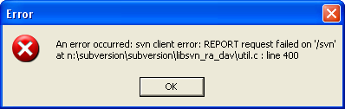

These error messages cover errors thrown from SVN. An error message caused by weaknesses in Ankh is captured through the Ankh error handling. We continuously collect information of unhandled Ankh exceptions through the exception mails.

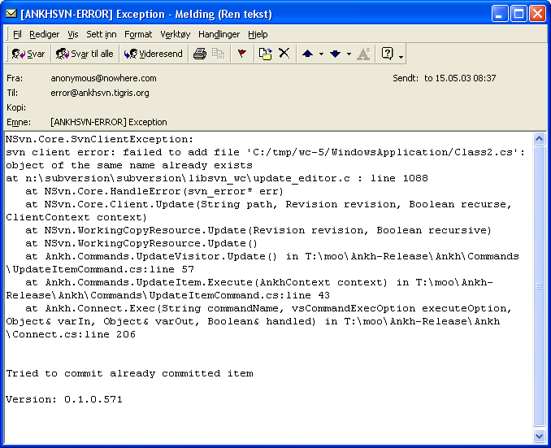

Conclusion
Ankh was unit-tested with NUnit and built outside VS.NET with NAnt continuously during the development phase to secure quality and sanity. Ankh was tested functionally by using Ankh while developing Ankh. Ankh was tested by the intended audience at http://ankhsvn.tigris.org. Feedback from these tests gave useful information of what to be improved and ideas for future development. The already mentioned, early paper prototype testing of the GUI confirmed that our navigation model was logic and intuitive and gave us useful ideas of how to improve the GUI. In the end Ankh was tested functionally with a number of tests described in this report to give an indication of the robustness of Ankh. Error messages are divided in 2 categories Ankh errors and SVN errors that reflect two different tools under development.

Appendix

Dictionary
Alpha testing The term alpha test means the first phase of testing in a software development process. The first phase includes unit testing, component testing, and system testing.
API Application Program Interface
Beta release Software under testing of the intended audience.
Beta testing Beta test is the second phase of software testing in which the intended audience tries the product out.
COM Component Object Model (COM), a software architecture that allows the components made by different software vendors to be combined into a variety of applications. COM defines a standard for component interoperability It is not dependent on any particular programming language, is available on multiple platforms, and is extensible.
COM add-in Is a dynamic-link library (DLL) that contains not only your custom code, but also special registry entries. These registry entries are used by Microsoft Office applications to determine the COM addin's behaviour at run time.
Commit Send changes from your working copy to the repository. Publish your changes to your colleagues.
Conflicted file If two users modify the same file at the same line a coflict will occur if the file is under revision control. The conflict occurs because the repository simply doesn’t know whether both or only one of the lines should be added. In some coding cases these new lines could mean the same and it would be logic to choose one of the lines
CVS Concurrent Version System. A free open source revision control system, the successor of Subversion.
GUI Graphical User Interface
IDE Integrated Development Environment
IIS Internet Information Server
IL Intermediate Language
Item file, folder, project, solution
Item menu Menu when right clicking on an item in VS solution Explorer.
NAnt A free .NET build tool.
NUnit Tool for unit testing.
.NET Framework
Repository A repository is much like an ordinary file server, except that it remembers every change ever made to your files. Yellow boxes indicates folders, green box indicate files in the figure below.
Repository Explorer
An Ankh explorer used to browse revision.
Colour
Revision control system
In a typical software development environment, many developers will be engaged in work on one code base. Revision control makes it easier for several people to share the same collection of program source code. A revision control system is a centralised system for sharing information where the core is a repository.
Solution Explorer VS explorer used to browse files in a solution.
SVN Short version of Subversion, which is a free open source revision control system.
SWIG Simplified Wrapper and Interface Generator
UI User Interface
UML Unified Modelling Language
Unversioned file File not under revision control
Versioned file File under revision control
VS .NET Visual Studio .NET. A programming platform that includes editors for programming in C#, C++, Managed C++ and Visual Basic
WC Working Copy. Collection of files and folders under revision control.
Working Copy Collection of files and folders under revision control.

Ankh environment image collection
This appendix shows images of menus, dialog boxes, file tree views, output panes etc. used by Ankh. This part is included to make it possible for the reader to read this report independently from the process and product documentation. The aim of this appendix was to quickly update the reader about the environment the tests are performed in based on minimum knowledge about VS.NET and Ankh on before hand.

AnkhSVN output pane
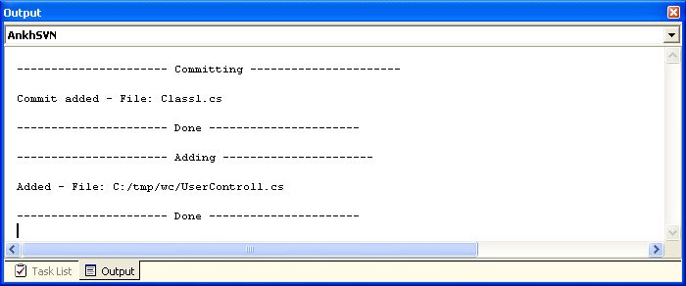

Commit dialog
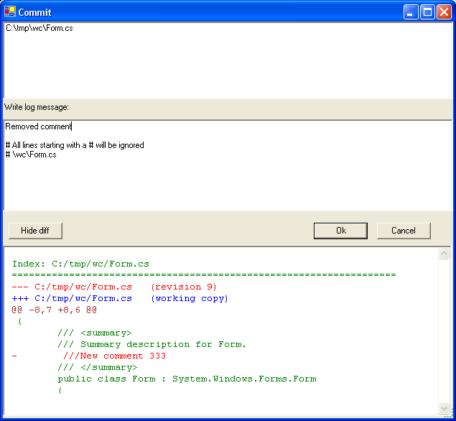

Date picker
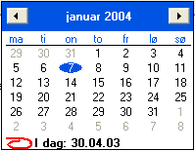

Diff in code view
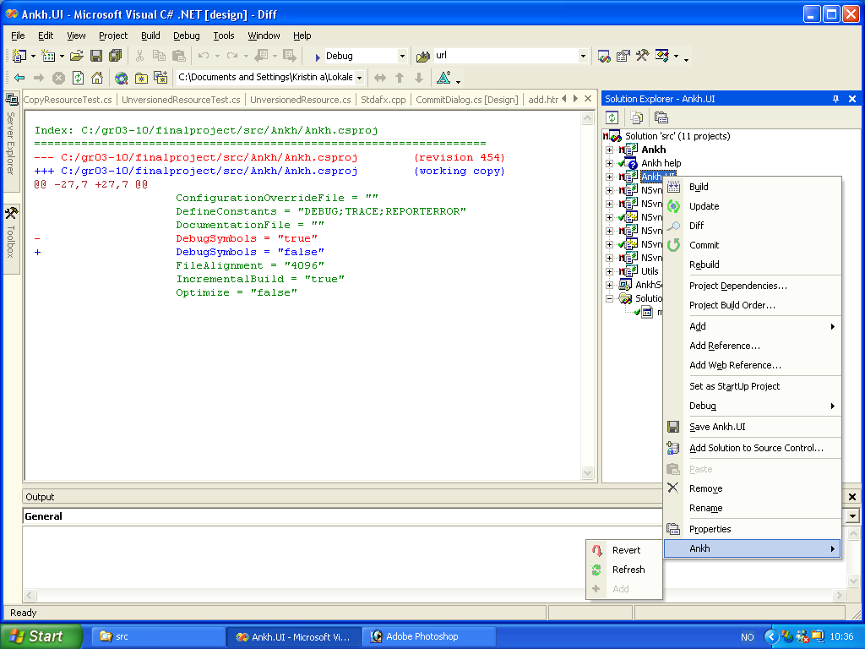

Item menu
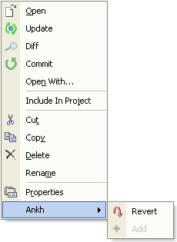

Login dialog

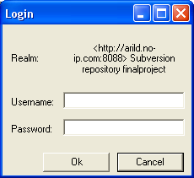

Repository Explorer
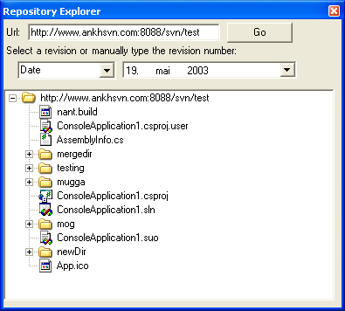

Revert dialog

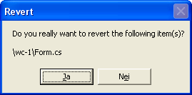

Solution Explorer
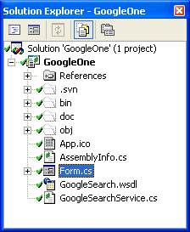

Ankh warning



 

