Ankh Test Report

Preface
This report contains the testing of Ankh. Ankh is an addin of the revision control system Subversion for VS.NET. The development of Ankh, was conducted as a final year project at HiO in cooperation with CollabNet.
This report is written for the computer personnel responsible for maintenance, updating, support and modifications to the system. The purpose of this document is to give a description of how t he system is tested.
It is an advantage to have knowledge about revision control systems and VS.NET to get a better understanding of this document. A dictionary containing terminology used is enclosed in the appendix. An Ankh image environment collection is also enclosed in the appendix. This part is included to make it possible for the reader to read this report independently from the process and product documentation. The aim of this appendix was to quickly update the reader about the environment the tests are performed in based on minimum knowledge about VS.NET and Ankh on before hand.

Table of contents

Ankh Test Report 1
Preface 2
Table of contents 3
Aim of the testing 4
1 Testing 4
1.1 Continuos NUnit testing through development 4
1.2 Independent NAnt build 5
1.3 Paper prototype testing 6
1.4 Functional testing 7
1.4.1 Testing of status icons in Solution Explorer 8
1.4.2 Testing of add in Solution Explorer 9
1.4.3 Testing of update in Solution Explorer 12
1.4.4 Testing of commit in Solution Explorer 15
1.4.5 Testing of diff in Solution Explorer 17
1.4.6 Testing of delete/remove in Solution Explorer 20
1.4.7 Testing of revert in Solution Explorer 21
1.4.8 Testing of cleanup in Solution Explorer 23
1.4.9 Testing of Commit dialog 26
1.4.10 Testing of Login dialog 27
1.4.11 Testing of feedback in AnkhSVN output pane 28
1.4.12 Testing of Ankh integration in Solution Explore 29
1.4.13 Testing of the Repository Explorer 29
1.4.14 Error handling 30
2 Conclusion 31
3 Appendix 32
3.1 Dictionary 32
3.2 Ankh environment image collection 33
3.2.1 AnkhSVN output pane 33
3.2.2 Commit dialog 34
3.2.3 Date picker 35
3.2.4 Diff in code view 35
3.2.5 Item menu 36
3.2.6 Login dialog 36
3.2.7 Repository Explorer 37
3.2.8 Revert dialog 37
3.2.9 Solution Explorer 38

Aim of the testing
The aim of the testing was to identify and capture possible weaknesses in Ankh and thereby make Ankh as robust as possible. Ankh was tested bottom-up and top down. We started to write unit-tests of small parts of the program. In a later stage we combined bit by bit parts of the program, and tested the whole program in the end.

Testing
Ankh was unit-tested with NUnit and built outside VS.NET with NAnt continuously during the development phase to secure quality and sanity. Ankh was tested functionally by using Ankh while developing Ankh. Ankh was tested by the intended audience at http://ankhsvn.tigris.org. An early paper prototype testing of the GUI was also performed to check whether our navigation model was logic and intuitive. In the end Ankh was tested functionally with a number of tests described in this report.

Continuos NUnit testing through development
NUnit is a free open source unit-testing framework for all .Net languages. Initially ported from JUnit which is an unit-testing tool for Java. Version 2.0 was used in the testing of Ankh. NUnit is coded in C# . Code example of a unit-test performed is listed below. The test verify the implementation of the Add method in the lower wrapper layer of Ankh. The Add method is supposed to add an unversioned file to revision control.

namespace NSvn.Core.Tests
{
/// <summary>
/// Tests NSvn::Core::Client::Add
/// </summary>
[TestFixture]
public class AddTest : TestBase
{
[SetUp]
public override void SetUp()
{
this.ExtractWorkingCopy();

this.notifications = new ArrayList();
}

/// <summary>
/// Attempts to add a file, checking that the file actually was
/// added
/// </summary>
[Test]
public void TestBasic()
{
string testFile = this.CreateTextFile( "testfile.txt" );

ClientContext ctx = new ClientContext( new NotifyCallback() );
Client.Add( testFile, false, ctx );

Assertion.Assert( "No notification callbacks received",
this.Notifications.Length > 0 );

Assertion.AssertEquals( "svn st does not report the file as added",
'A', this.GetSvnStatus( testFile ) );

}

}
XXX Could some of you make this more clear ?

In the Setup() method a working copy is extracted. A working copy is a collection of files and directories under revision control. To be able to add an unversioned file to revision control a working copy is required. An arraylist is initialised. Hopefully this list will contain feedback after Client.Add(..) has added the unversioned file to revision control.

In the TestBasic() method an unversioned file “testfile.txt” is created. The input parameter “false” in Client.Add(...) indicates that Add is performed on only one file, not recursively. Client.Add(..) is ran with required input parameters and should add an unversioned file to the extracted working copy. Assertion.Assert(....) checks whether there has been any feedback from Subversion (SVN) after the add was performed. If this.Notifications.Length is less than 1 the test will fail and “No notification callbacks received” will be displayed in the NUnit editor. Assertion.AssertEquals(...) checks if the status on the file has changed to “A”. If the status is not “A” the test will fail and “svn st does not report the file as added” will be displayed in the NUnit editor.

Independent NAnt build
Independent NAnt build of Ankh was performed continuously during the project period to ensure sanity and quality of the addin/wrapper. Every time a commit was performed the project was built by NAnt and all unit-tests were ran. A build mail concluding whether the build failed or succeeded was sent to all group members frequently during development. Example of a build mail is shown below.
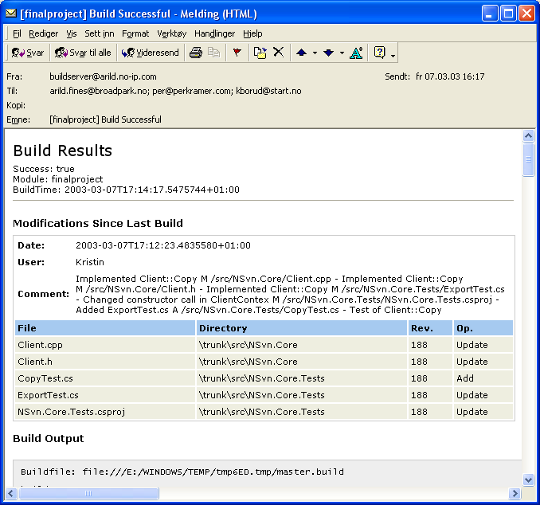

Paper prototype testing
Testing of GUI was performed to ensure optimal functionality of the GUI. A paper prototype test was performed to check whether our navigation model was logic and intuitive. Whether our choice of button-names, names in menus and names on text fields etc. were logic. The test was performed on 3 test persons with programming experience. One of the persons was familiar with revision control systems and VS.NET. Before the tests were performed the test persons were given a short introduction to revision control and VS.NET. 3 scenarios were selected covering integration of commit, log and edit properties. The overall conclusion from these tests were that our navigation model was intuitive and logic. Useful feedback from the tests made us modify button names and text fields in dialog boxes, and reorganise the placing of buttons, text fields, comboboxes etc.. A need of Help Integration was also identified.

Functional testing
During the Alpha testing phase the source code was published at http://ankhsvn.tigris.org. The term alpha test means the first phase of testing in a software development process. The first phase includes unit testing, component testing, and system testing. To gather as much information as possible from this phase exception mails were sent to all group members. These mails contained valuable information about exceptions thrown from Ankh. When an exception was thrown the user was asked whether he wanted to send the exception and add a comment by mail. The Ankh error report page is shown below.

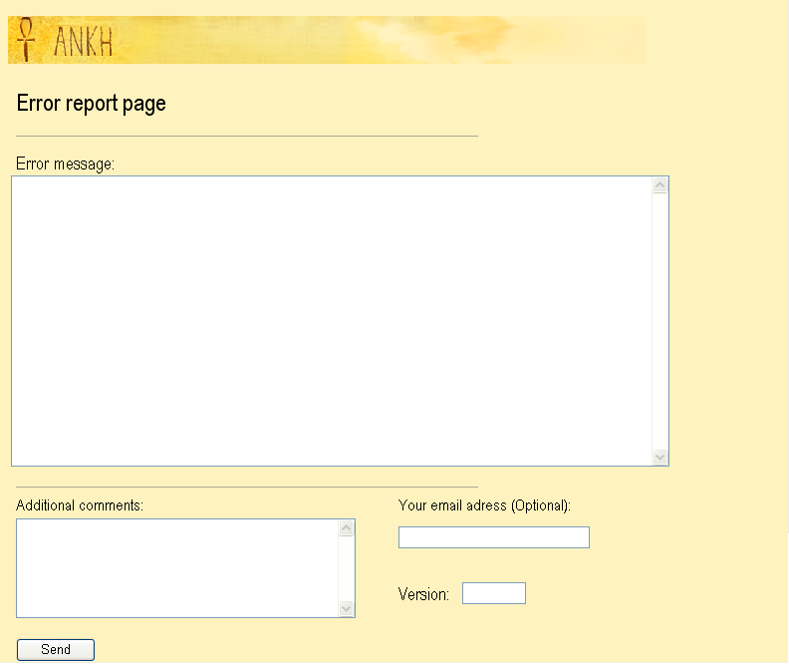

Details from the exception mails gave useful information of issues to be solved (see issue tracker at http://ankhsvn.tigris.org). The issue tracker lists preliminary weaknesses and possible future improvements of Ankh. The issue list shows type of feature, priority, status, result and summary of the issues. This list helped us to remember things we planned to implement in later versions and gave us the status on issues to be solved in near future. The Revert dialog was implemented by users request from this testing phase. The revert dialog is enclosed in the Ankh environment image collection .

After having implemented the most basic functions add, update, commit and status it was possible to use Ankh. Ankh was therefore tested functionally by using Ankh while developing Ankh. The picture below shows the Ankh project with a new instance of VS.NET above. The new instance was started from the Ankh project. This made it possible to continuously work with the last update of Ankh and testing it at the same time with real data. Ankh was thereby tested by using an iterative methodology in a natural environment with real data.

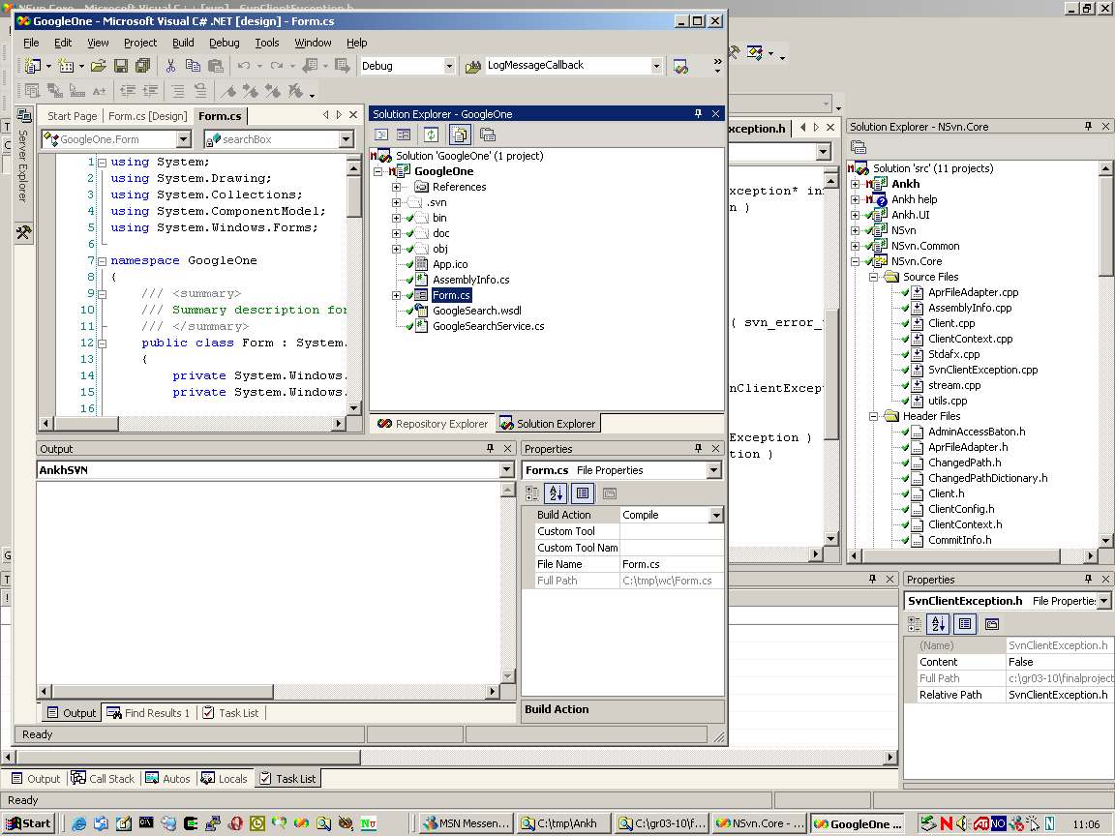

Ankh was tested on the intended audience in Ankh Alpha version 1.0. Ankh was made available for installation from http://ankhsvn.tigris.org. XXX
Ankh Alpha version 2.0 was tested functionally with a number of tests described in the following sub chapters.

Testing of status icons in Solution Explorer
Solution Explorer display files, directories, projects and solutions (item) with updated Ankh status icons. Tests performed to verify Ankh status icons displayed in Solution Explorer are listed in the table below. An image of Solution Explorer is enclosed in the appendix.

Test | Result /Comment | Date
status icon is shown in Solution Explorer in front of an unversioned file | Ok
status icon is shown in Solution Explorer in front of an unversioned directory | Ok
status icon is shown in Solution Explorer in front of an unversioned project | Ok
status icon is shown in Solution Explorer in front of an unversioned solution
status icon is shown in Solution Explorer in front of a versioned file | Ok
status icon is shown in Solution Explorer in front of a versioned directory | Ok
status icon is shown in Solution Explorer in front of a versioned project | Ok
status icon is shown in Solution Explorer in front of a versioned solution | Ok
status icon is shown in Solution Explorer in front of a modified, saved, versioned file | Ok the status is shown if the modified file is saved
status icon is shown in Solution Explorer in front of a modified, saved, versioned directory | Ok the status is shown if the modified directory is saved
status icon is shown in Solution Explorer in front of a modified, saved, versioned project | Ok the status is shown if the modified project is saved
status icon is shown in Solution Explorer in front of a modified, saved, versioned solution | Ok the status is shown if the modified solution is saved
status icon is shown in Solution Explorer in front of an added, versioned file
status icon is shown in Solution Explorer in front of an added, versioned directory
status icon is shown in Solution Explorer in front of an added, versioned project
status icon is shown in Solution Explorer in front of an added, versioned solution
status icon is shown in Solution Explorer in front of a deleted, versioned file
status icon is shown in Solution Explorer in front of a deleted, versioned directory
status icon is shown in Solution Explorer in front of a deleted, versioned project
status icon is shown in Solution Explorer in front of a conflicted, versioned file
status icon is shown in Solution Explorer in front of a conflicted, versioned directory
status icon is shown in Solution Explorer in front of a conflicted, versioned project
status icon is shown in Solution Explorer in front of a locked, versioned file
status icon is shown in Solution Explorer in front of a locked, versioned directory
status icon is shown in Solution Explorer in front of a locked, versioned project

Testing of add in Solution Explorer
Tests performed to verify the Add item menu option in Solution Explorer are listed in the table below. The add option adds an unversioned file to revision control. An image of the item menu is enclosed in the appendix.

Test | Result /Comment | Date
Add option is enabled in menu if unversioned file (status icon ) is selected in Solution Explorer and right clicked
Add option is enabled in menu if unversioned directory (status icon ) is selected in Solution Explorer and right clicked
Add option is enabled in menu if unversioned project (status icon ) is selected in Solution Explorer and right clicked
Add option is disabled in menu if unversioned solution (status icon ) is selected in Solution Explorer and right clicked
Add option is disabled in menu if versioned file (status icon ) is selected in Solution Explorer and right clicked
Add option is disabled in menu if versioned directory (status icon ) is selected in Solution Explorer and right clicked
Add option is disabled in menu if versioned project ( status icon ) is selected in Solution Explorer and right clicked
Add option is disabled in menu if versioned solution (status icon ) is selected in Solution Explorer and right clicked
Add option is disabled in menu if modified, versioned file (status icon ) is selected in Solution Explorer and right clicked
Add option is disabled in menu if modified, versioned directory (status icon ) is selected in Solution Explorer and right clicked
Add option is disabled in menu if modified, versioned project (status icon ) is selected in Solution Explorer and right clicked
Add option is disabled in menu if modified, versioned solution (status icon ) is selected in Solution Explorer and right clicked
Add option is disabled in menu if added, versioned file (status icon ) is selected in Solution Explorer and right clicked
Add option is disabled in menu if added, versioned directory (status icon ) is selected in Solution Explorer and right clicked
Add option is disabled in menu if added, versioned project (status icon ) is selected in Solution Explorer and right clicked
Add option is disabled in menu if added, versioned solution (status icon ) is selected in Solution Explorer and right clicked
Add option is disabled in menu if deleted, versioned file (status icon ) is selected in Solution Explorer and right clicked
Add option is disabled in menu if deleted, versioned directory (status icon ) is selected in Solution Explorer and right clicked
Add option is disabled in menu if deleted, versioned project (status icon ) is selected in Solution Explorer and right clicked
Add option is disabled in menu if conflicted, versioned file (status icon ) is selected in Solution Explorer and right clicked
Add option is disabled in menu if conflicted, versioned directory (status icon ) is selected in Solution Explorer and right clicked
Add option is disabled in menu if conflicted, versioned project (status icon ) is selected in Solution Explorer and right clicked
Add option is disabled in menu if locked, versioned file (status icon ) is selected in Solution Explorer and right clicked
Add option is disabled in menu if locked, versioned directory (status icon ) is selected in Solution Explorer and right clicked
Add option is disabled in menu if locked, versioned project (status icon ) is selected in Solution Explorer and right clicked
It is possible to add a C# file (*.cs) to revision control
It is possible to add a C++ file (*.cpp) to revision control
It is possible to add a VB file (*.vb) to revision control
Status icon is changed to in front of file in Solution Explorer after unversioned file is added
Status icon is changed to in front of directory in Solution Explorer after unversioned directory is added
Status icon is changed to in front of project in Solution Explorer after unversioned project is added
Add works recursively on several items (file, directory, project)

Testing of update in Solution Explorer
Tests performed to verify the Update item menu option in Solution Explorer are listed in the table below. The update option update a versioned file to include last committed changes.

Test | Result /Comment | Date
Update option is disabled in menu if unversioned file (status icon ) is selected in Solution Explorer and right clicked
Update option is disabled in menu if unversioned directory (status icon ) is selected in Solution Explorer and right clicked
Update option is disabled in menu if unversioned project (status icon ) is selected in Solution Explorer and right clicked
Update option is disabled in menu if unversioned solution (status icon ) is selected in Solution Explorer and right clicked
Update option is enabled in menu if versioned file (status icon ) is selected in Solution Explorer and right clicked
Update option is enabled in menu if versioned directory (status icon ) is selected in Solution Explorer and right clicked
Update option is enabled in menu if versioned project ( status icon ) is selected in Solution Explorer and right clicked
Update option is enabled in menu if versioned solution (status icon ) is selected in Solution Explorer and right clicked
Update option is enabled in menu if modified, versioned file (status icon ) is selected in Solution Explorer and right clicked
Update option is enabled in menu if modified, versioned directory (status icon ) is selected in Solution Explorer and right clicked
Update option is enabled in menu if modified, versioned project (status icon ) is selected in Solution Explorer and right clicked
Update option is enabled in menu if modified, versioned solution (status icon ) is selected in Solution Explorer and right clicked
Update option is enabled in menu if added, versioned file (status icon ) is selected in Solution Explorer and right clicked
Update option is enabled in menu if added, versioned directory (status icon ) is selected in Solution Explorer and right clicked
Update option is enabled in menu if added, versioned project (status icon ) is selected in Solution Explorer and right clicked
Update option is enabled in menu if added, versioned solution (status icon ) is selected in Solution Explorer and right clicked
Update option is enabled in menu if deleted, versioned file (status icon ) is selected in Solution Explorer and right clicked
Update option is enabled in menu if deleted, versioned directory (status icon ) is selected in Solution Explorer and right clicked
Update option is enabled in menu if deleted, versioned project (status icon ) is selected in Solution Explorer and right clicked
Update option is enabled in menu if conflicted, versioned file (status icon ) is selected in Solution Explorer and right clicked
Update option is enabled in menu if conflicted, versioned directory (status icon ) is selected in Solution Explorer and right clicked
Update option is enabled in menu if conflicted, versioned project (status icon ) is selected in Solution Explorer and right clicked
Update option is disabled in menu if locked, versioned file (status icon ) is selected in Solution Explorer and right clicked
Update option is disabled in menu if locked, versioned directory (status icon ) is selected in Solution Explorer and right clicked
Update option is disabled in menu if locked, versioned project (status icon ) is selected in Solution Explorer and right clicked
Update option is disabled in menu if locked, versioned solution (status icon ) is selected in Solution Explorer and right clicked
Status icon is changed in front of file in Solution Explorer after versioned file is updated to modified, corresponding file
Status icon is changed in front of directory in Solution Explorer after versioned directory is updated to modified, corresponding directory
Status icon is changed in front of project in Solution Explorer after versioned project is updated to modified, corresponding project
Status icon is changed in front of solution in Solution Explorer after versioned solution is updated to modified, corresponding solution
Ankh error handling if no communication to Internet Explorer for update to external repository
Update works recursively on several items (file, directory, project, solution)

Testing of commit in Solution Explorer
Tests performed to verify the Commit item menu option in Solution Explorer are listed in the table below. The commit option publish last changes by sending the changes to the repository. An image of the commit dialog is enclosed in the appendix.

Test | Result /Comment | Date
Commit option is disabled in menu if unversioned file (status icon ) is selected in Solution Explorer and right clicked
Commit option is disabled in menu if unversioned directory (status icon ) is selected in Solution Explorer and right clicked
Commit option is disabled in menu if unversioned project (status icon ) is selected in Solution Explorer and right clicked
Commit option is disabled in menu if unversioned solution (status icon ) is selected in Solution Explorer and right clicked
Commit option is disabled in menu if versioned file (status icon ) is selected in Solution Explorer and right clicked
Commit option is disabled in menu if versioned directory (status icon ) is selected in Solution Explorer and right clicked
Commit option is disabled in menu if versioned project ( status icon ) is selected in Solution Explorer and right clicked
Commit option is disabled in menu if versioned solution (status icon ) is selected in Solution Explorer and right clicked
Commit option is enabled in menu if modified, versioned file (status icon ) is selected in Solution Explorer and right clicked
Commit option is enabled in menu if modified, versioned directory (status icon ) is selected in Solution Explorer and right clicked
Commit option is enabled in menu if modified, versioned project (status icon ) is selected in Solution Explorer and right clicked
Commit option is enabled in menu if modified, versioned solution (status icon ) is selected in Solution Explorer and right clicked
Commit option is enabled in menu if added, versioned file (status icon ) is selected in Solution Explorer and right clicked
Commit option is enabled in menu if added, versioned directory (status icon ) is selected in Solution Explorer and right clicked
Commit option is enabled in menu if added, versioned project (status icon ) is selected in Solution Explorer and right clicked
Commit option is enabled in menu if added, versioned solution (status icon ) is selected in Solution Explorer and right clicked
Commit option is enabled in menu if deleted, versioned file (status icon ) is selected in Solution Explorer and right clicked
Commit option is enabled in menu if deleted, versioned directory (status icon ) is selected in Solution Explorer and right clicked
Commit option is enabled in menu if deleted, versioned project (status icon ) is selected in Solution Explorer and right clicked
Commit option is enabled in menu if conflicted, versioned file (status icon ) is selected in Solution Explorer and right clicked | XXX Ok ?
Commit option is enabled in menu if conflicted, versioned directory (status icon ) is selected in Solution Explorer and right clicked | XXX Ok ?
Commit option is enabled in menu if conflicted, versioned project (status icon ) is selected in Solution Explorer and right clicked | XXX Ok ?
Commit option is disabled in menu if locked, versioned file (status icon ) is selected in Solution Explorer and right clicked
Commit option is disabled in menu if locked, versioned directory (status icon ) is selected in Solution Explorer and right clicked
Commit option is disabled in menu if locked, versioned project (status icon ) is selected in Solution Explorer and right clicked
Commit dialog box pops up if Commit is selected from item menu
Status icon is changed to in front of file in Solution Explorer after modified, versioned file is committed
Status icon is changed to in front of directory in Solution Explorer after modified, versioned directory is committed
Status icon is changed to in front of project in Solution Explorer after added, versioned project is committed
Status icon is changed to in front of solution in Solution Explorer after added, versioned solution is committed
Ankh error handling if no communication to Internet Explorer for commit to external repository
Commit works recursively on several items (file, directory, project, solution)

Testing of diff in Solution Explorer
Tests performed to verify the Diff item menu option in Solution Explorer are listed in the table below. The diff option makes it possible to see removed, added and unchanged text if file is not binary. An image of the diff displayed in code view is enclosed in the appendix.

Test | Result /Comment | Date
Diff option is disabled in menu if unversioned file (status icon ) is selected in Solution Explorer and right clicked
Diff option is disabled in menu if unversioned directory (status icon ) is selected in Solution Explorer and right clicked
Diff option is disabled in menu if unversioned project (status icon ) is selected in Solution Explorer and right clicked
Diff option is disabled in menu if unversioned solution (status icon ) is selected in Solution Explorer and right clicked
Diff option is disabled in menu if versioned file (status icon ) is selected in Solution Explorer and right clicked
Diff option is disabled in menu if versioned directory (status icon ) is selected in Solution Explorer and right clicked
Diff option is disabled in menu if versioned project ( status icon ) is selected in Solution Explorer and right clicked
Diff option is disabled in menu if versioned solution (status icon ) is selected in Solution Explorer and right clicked
Diff option is enabled in menu if modified, versioned file (status icon ) is selected in Solution Explorer and right clicked
Diff option is enabled in menu if modified, versioned directory (status icon ) is selected in Solution Explorer and right clicked
Diff option is enabled in menu if modified, versioned project (status icon ) is selected in Solution Explorer and right clicked
Diff option is enabled in menu if modified, versioned solution (status icon ) is selected in Solution Explorer and right clicked
Diff option is enabled in menu if added, versioned file (status icon ) is selected in Solution Explorer and right clicked
Diff option is enabled in menu if added, versioned directory (status icon ) is selected in Solution Explorer and right clicked
Diff option is enabled in menu if added, versioned project (status icon ) is selected in Solution Explorer and right clicked
Diff option is enabled in menu if added, versioned solution (status icon ) is selected in Solution Explorer and right clicked
Diff option is disabled in menu if deleted, versioned file (status icon ) is selected in Solution Explorer and right clicked
Diff option is disabled in menu if deleted, versioned directory (status icon ) is selected in Solution Explorer and right clicked
Diff option is disabled in menu if deleted, versioned project (status icon ) is selected in Solution Explorer and right clicked
Diff option is enabled in menu if conflicted, versioned file (status icon ) is selected in Solution Explorer and right clicked
Diff option is enabled in menu if conflicted, versioned directory (status icon ) is selected in Solution Explorer and right clicked
Diff option is enabled in menu if conflicted, versioned project (status icon ) is selected in Solution Explorer and right clicked
Diff option is disabled in menu if locked, versioned file (status icon ) is selected in Solution Explorer and right clicked
Diff option is disabled in menu if locked, versioned directory (status icon ) is selected in Solution Explorer and right clicked
Diff option is disabled in menu if locked, versioned project (status icon ) is selected in Solution Explorer and right clicked
Diff is visible in temporary file in code view if Diff is performed on a file
Diff is visible in temporary file in code view if Diff is performed on a directory
Diff is visible in temporary file in code view if Diff is performed on a project
Diff is visible in temporary file in code view if Diff is performed on a solution
The diff visible in temporary file in code view shows unchanged text in green collor
The diff visible in temporary file in code view shows removed text in red collor
The diff visible in temporary file in code view shows new, added text in blue collor
Diff works recursively on several items (file, directory, project, solution)

Testing of delete/remove in Solution Explorer
Tests performed to verify the Exclude From Project and Delete item menu option in Solution Explorer are listed in the table below. The Delete option delete permanently versioned items from working copy. Exclude From Project option remove versioned items from working copy.

Test | Result /Comment | Date
Versioned file in Solution Explorer is not visible after Delete option is selected from item menu for versioned file
Versioned directory in Solution Explorer is not visible after Delete option is selected from item menu for versioned directory
Versioned project in Solution Explorer is not visible after Remove option is selected from item menu for versioned project
Delete option on item menu works recursively on several items (file, directory, project, solution)
Status icon on versioned file in Solution Explorer is changed to after Excluded From Project option is selected from item menu for versioned file
Status icon on versioned directory in Solution Explorer is changed to after Excluded From Project option is selected from item menu for versioned directory
Remove option on item menu works recursively on several items (file, directory, project, solution)

Testing of revert in Solution Explorer
Tests performed to verify the Revert item menu option in Solution Explorer are listed in the table below. The revert option restore pristine working copy. An image of the revert dialog is enclosed in the appendix.

Test | Result /Comment | Date
Revert option is disabled in menu if unversioned file (status icon ) is selected in Solution Explorer and right clicked
Revert option is disabled in menu if unversioned directory (status icon ) is selected in Solution Explorer and right clicked
Revert option is disabled in menu if unversioned project (status icon ) is selected in Solution Explorer and right clicked
Revert option is disabled in menu if unversioned solution (status icon ) is selected in Solution Explorer and right clicked
Revert option is disabled in menu if versioned file (status icon ) is selected in Solution Explorer and right clicked
Revert option is disabled in menu if versioned directory (status icon ) is selected in Solution Explorer and right clicked
Revert option is disabled in menu if versioned project ( status icon ) is selected in Solution Explorer and right clicked
Revert option is disabled in menu if versioned solution (status icon ) is selected in Solution Explorer and right clicked
Revert option is enabled in menu if modified, versioned file (status icon ) is selected in Solution Explorer and right clicked
Revert option is enabled in menu if modified, versioned directory (status icon ) is selected in Solution Explorer and right clicked
Revert option is enabled in menu if modified, versioned project (status icon ) is selected in Solution Explorer and right clicked
Revert option is enabled in menu if modified, versioned solution (status icon ) is selected in Solution Explorer and right clicked
Revert option is enabled in menu if added, versioned file (status icon ) is selected in Solution Explorer and right clicked
Revert option is enabled in menu if added, versioned directory (status icon ) is selected in Solution Explorer and right clicked
Revert option is enabled in menu if added, versioned project (status icon ) is selected in Solution Explorer and right clicked
Revert option is enabled in menu if added, versioned solution (status icon ) is selected in Solution Explorer and right clicked
Revert option is enabled in menu if deleted, versioned file (status icon ) is selected in Solution Explorer and right clicked
Revert option is enabled in menu if deleted, versioned directory (status icon ) is selected in Solution Explorer and right clicked
Revert option is enabled in menu if deleted, versioned project (status icon ) is selected in Solution Explorer and right clicked
Revert option is enabled in menu if conflicted, versioned file (status icon ) is selected in Solution Explorer and right clicked
Revert option is enabled in menu if conflicted, versioned directory (status icon ) is selected in Solution Explorer and right clicked
Revert option is enabled in menu if conflicted, versioned project (status icon ) is selected in Solution Explorer and right clicked
Revert option is disabled in menu if locked, versioned file (status icon ) is selected in Solution Explorer and right clicked
Revert option is disabled in menu if locked, versioned directory (status icon ) is selected in Solution Explorer and right clicked
Revert option is disabled in menu if locked, versioned project (status icon ) is selected in Solution Explorer and right clicked
Revert dialog box pops up if revert is selected from file menu
Revert dialog box pops up if revert is selected from directory menu
Revert dialog box pops up if revert is selected from project menu
Revert dialog box pops up if revert is selected from solution menu
If Ok button in Revert dialog box is clicked the item is reverted
If Cancel button in Revert dialog box is clicked the item is not reverted
Status icon is changed to in front of file in Solution Explorer after modified, versioned file is reverted
Status icon is changed to in front of directory in Solution Explorer after modified, versioned directory is reverted
Status icon is changed to in front of project in Solution Explorer after modified, versioned project is reverted
Status icon is changed to in front of solution in Solution Explorer after modified, versioned solution is reverted
Revert option in item menu works recursively on several items (file, directory, project, solution)

Testing of cleanup in Solution Explorer
Tests performed to verify the Cleanup item menu option in Solution Explorer are listed in the table below. The cleanup option recursively clean up the working copy, removing locks, resuming unfinished operations, etc. .

Test | Result /Comment | Date
Cleanup option is disabled in menu if unversioned file (status icon ) is selected in Solution Explorer and right clicked
Cleanup option is disabled in menu if unversioned directory (status icon ) is selected in Solution Explorer and right clicked
Cleanup option is disabled in menu if unversioned project (status icon ) is selected in Solution Explorer and right clicked
Cleanup option is disabled in menu if unversioned solution (status icon ) is selected in Solution Explorer and right clicked
Cleanup option is disabled in menu if versioned file (status icon ) is selected in Solution Explorer and right clicked
Cleanup option is disabled in menu if versioned directory (status icon ) is selected in Solution Explorer and right clicked
Cleanup option is disabled in menu if versioned project ( status icon ) is selected in Solution Explorer and right clicked
Cleanup option is disabled in menu if versioned solution (status icon ) is selected in Solution Explorer and right clicked
Cleanup option is disabled in menu if modified, versioned file (status icon ) is selected in Solution Explorer and right clicked
Cleanup option is disabled in menu if modified, versioned directory (status icon ) is selected in Solution Explorer and right clicked
Cleanup option is disabled in menu if modified, versioned project (status icon ) is selected in Solution Explorer and right clicked
Cleanup option is disabled in menu if modified, versioned solution (status icon ) is selected in Solution Explorer and right clicked
Cleanup option is disabled in menu if added, versioned file (status icon ) is selected in Solution Explorer and right clicked
Cleanup option is disabled in menu if added, versioned directory (status icon ) is selected in Solution Explorer and right clicked
Cleanup option is disabled in menu if added, versioned project (status icon ) is selected in Solution Explorer and right clicked
Cleanup option is disabled in menu if added, versioned solution (status icon ) is selected in Solution Explorer and right clicked
Cleanup option is disabled in menu if deleted, versioned file (status icon ) is selected in Solution Explorer and right clicked
Cleanup option is disabled in menu if deleted, versioned directory (status icon ) is selected in Solution Explorer and right clicked
Cleanup option is disabled in menu if deleted, versioned project (status icon ) is selected in Solution Explorer and right clicked
Cleanup option is disabled in menu if conflicted, versioned file (status icon ) is selected in Solution Explorer and right clicked
Cleanup option is disabled in menu if conflicted, versioned directory (status icon ) is selected in Solution Explorer and right clicked
Cleanup option is disabled in menu if conflicted, versioned project (status icon ) is selected in Solution Explorer and right clicked
Cleanup option is enabled in menu if locked, versioned file (status icon ) is selected in Solution Explorer and right clicked
Cleanup option is enabled in menu if locked, versioned directory (status icon ) is selected in Solution Explorer and right clicked
Cleanup option is enabled in menu if locked, versioned project (status icon ) is selected in Solution Explorer and right clicked
Cleanup option is enabled in menu if locked, versioned solution (status icon ) is selected in Solution Explorer and right clicked
Status icon is changed in front of file in Solution Explorer after locked, versioned file is cleaned up
Status icon is changed in front of directory in Solution Explorer after locked, versioned directory is cleaned up
Status icon is changed in front of project in Solution Explorer after locked, versioned project is cleaned up
Status icon is changed in front of solution in Solution Explorer after locked, versioned solution is cleaned up
Cleanup works recursively on several items (file, directory, project, solution)

Testing of Commit dialog
Tests performed to verify the commit dialog are listed in the table below. The commit dialog shows paths for files to be committed and add a log message to the new revision if Ok button is clicked. It is also possible to see the difference between added, removed and unchanged text by clicking at the Diff button. An image of the commit dialog is enclosed in the appendix.

Test | Result /Comment | Date
Correct path of file to be committed is visible in upper part of commit dialog if file is selected to be committed
Correct path of directory to be committed is visible in upper part of commit dialog if directory is selected to be committed
Correct path of project to be committed is visible in upper part of commit dialog if project is selected to be committed
Correct path of solution to be committed is visible in upper part of commit dialog if solution is selected to be committed
Correct path of items to be committed is visible in upper part of commit dialog if file, directory, project and solution is selected to be committed. (Recursive check)
It is not possible to edit upper text area (read only) in commit dialog
Default log message starts with the text # All lines starting with a # will be ignored
Check that all lines after the text # All lines starting with a # will be ignored actually is ignored in the log message after commit
Correct path is displayed on file in lower text area if file is selected to be committed
Correct path is displayed on directory in lower text area if directory is selected to be committed
Correct path is displayed on project in lower text area if project is selected to be committed
Correct path is displayed on solution in lower text area if solution is selected to be committed
Correct path is displayed on items in lower text area if file, directory, project, solution is selected to be committed. (Recursive check)
Correct status is displayed on items in lower text area if file, directory, project, solution is selected to be committed
If Show diff button is clicked the difference between added, removed an unchanged text is displayed
If Show diff button is clicked the name of the button is changed to Hide diff
If Hide diff button is clicked the diff-area is removed
If Hide diff button is clicked the name of the button is changed to Show diff
If Ok button is clicked status icons are changed in Solution Explorer and feedback is shown in AnkhSVN output
If Cancel button is clicked status icons are not changed in Solution Explorer and feedback (indicating that nothing has been performed) is shown in AnkhSVN output

Testing of Login dialog
Tests performed to verify the Login dialog are listed below. The Login dialog authenticates the user by username and password. If Save button is clicked in the dialog the dialog will remember the password next time the login dialog pops up. An image of the Login dialog is shown in the appendix.

Test | Result /Comment | Date
Svn error handling if username don’t correspond to password and Ok button is clicked.
Svn error handling if password is not correct and Ok button is clicked.
Save password if Save button is clicked for correct password and username
The saved password is marked with ******* next time the dialog pops up if password is saved

Testing of feedback in AnkhSVN output pane
Tests performed to verify the AnkhSVN output pane are listed in the table below. The AnkhSVN output shows feedback from add, update, commit, revert and cleanup options. An image of AnkhSVN output pane is enclosed in the appendix.

Test | Result /Comment | Date
If AnkhSVN output is not visible in VS.NET. View → Other Windows → Output display AnkhSVN output
Feedback from svn is shown in output pane if add is performed on a file
Feedback from svn is shown in output pane if add is performed on a directory
Feedback from svn is shown in output pane if add is performed on a project
Feedback from svn is shown in output pane if add is performed on a solution
Feedback from svn is shown in output pane if update is performed on a file
Feedback from svn is shown in output pane if update is performed on a directory
Feedback from svn is shown in output pane if update is performed on a project
Feedback from svn is shown in output pane if update is performed on a solution
Feedback from svn is shown in output pane if commit is performed on a file
Feedback from svn is shown in output pane if commit is performed on a directory
Feedback from svn is shown in output pane if commit is performed on a project
Feedback from svn is shown in output pane if commit is performed on a solution
Feedback from svn is shown in output pane if revert is performed on a file
Feedback from svn is shown in output pane if revert is performed on a directory
Feedback from svn is shown in output pane if revert is performed on a project
Feedback from svn is shown in output pane if revert is performed on a solution
Feedback from svn is shown in output pane if cleanup is performed on a file
Feedback from svn is shown in output pane if cleanup is performed on a directory
Feedback from svn is shown in output pane if cleanup is performed on a project
Feedback from svn is shown in output pane if cleanup is performed on a solution

Testing of Ankh integration in Solution Explore
Tests performed to verify the Ankh integration into Solution Explorer are listed in the table below.

Test | Result /Comment | Date
All working copy items (complete file tree) are listed in Solution Explorer “show all files” view with status icons
Close Solution Explorer if it is open. Open View → Solution Explorer. All working copy items with status icons are displayed in Solution Explorer
Ankh working copy display in Solution Explorer is not negatively affected by VS.NETs “Refresh” option

Testing of the Repository Explorer
Tests performed to verify the Repository Explorer are listed in the table below. The Repository Explorer shows files and directories with icons in a file tree view. An image of Repository Explorer and Date picker are enclosed in the appendix.

Test | Result /Comment | Date
Repository Explorer is visible as default if new instance of VS.NET is opened
VS.NET icons indicating the difference between file, directory, project and solution are shown in front of each item if valid url and revision is selected and Go button is clicked
All repository items are displayed with icons in Repos Explorer. Close Repository Explorer if it is open. Open View → Repos Explorer
Go button and date combo is disabled by default
Go button is enabled if revision number is printed or revision is selected in revision combo and url is defined
Go button is disabled if revision is not defined in revision combo but url is defined
Go button is disabled if revision is defined in revision combo but url is not defined
Warning dialog pops up if url is not valid and Go button is clicked
Warning dialog pops up if revision number is not valid and Go button is clicked
Date combo is enabled if Date is selected revision
Date combo is disabled if Head is selected revision
Date combo is disabled if revision number is selected
Date picker is displayed if Date combo is clicked and selected revision is Date
File tree view is displayed if valid url and valid revision is selected and Go button is clicked
File tree view is displayed if valid url and valid revision number is printed and Go button is clicked

Error handling
Error handling is separated into two categories to handle SVN errors and Ankh errors. As Subversion is under development there are still some weaknesses that are captured through the SVN error handling. These error messages cover errors thrown from SVN. Error messages caused by weaknesses in Ankh is captured through the Ankh error handling.

Conclusion
Ankh was unit-tested with NUnit and built outside VS.NET with NAnt continuously during the development phase to secure quality and sanity. Ankh was tested functionally by using Ankh while developing Ankh. Ankh was tested by the intended audience at http://ankhsvn.tigris.org. Feedback from these tests gave useful information of what to be improved and ideas for future development. An early paper prototype testing of the GUI confirmed that our navigation model was logic and intuitive and gave us useful ideas of how to improve the GUI. In the end Ankh was tested functionally with a number of tests described in this report to give an indication of the robustness of Ankh. Error messages are divided in 2 categories Ankh errors and SVN errors that reflect two different tools under development.

Appendix

Dictionary
alpha testing - The term alpha test means the first phase of testing in a software development process. The first phase includes unit testing, component testing, and system testing.
API - Application Program Interface
beta release - Software under testing of the intended audience.
beta testing - Beta test is the second phase of software testing in which the intended audience tries the product out.
COM - Component Object Model (COM), a software architecture that allows the components made by different software vendors to be combined into a variety of applications. COM defines a standard for component interoperability It is not dependent on any particular programming language, is available on multiple platforms, and is extensible.
COM add-in - Is a dynamic-link library (DLL) that contains not only your custom code, but also special registry entries. These registry entries are used by Microsoft Office applications to determine the COM addin's behaviour at run time.
commit - Send changes from your working copy to the repository. Publish your
changes to your colleagues.
conflicted file – If two users modify the same file at the same line a coflict will occur if the file is under revision control. The conflict occurs because the repository simply don’t know whether both or only one of the lines should be added. In some coding cases these new lines could mean the same and it would be logic to choose one of the lines
CVS – Concurrent Version System. A free open source revision control system, the successor of Subversion.
GUI - Graphical User Interface
IDE - Integrated Development Environment
IIS - Internet Information Server
IL - Intermediate Language
Item – file, directory, project, solution
Item menu –
NAnt - A free .NET build tool.
NUnit - Tool for unit testing.
.NET Framework –
pristine working copy -
repository – A repository is much like an ordinary file server, except that it remembers every change ever made to your files. Yellow boxes indicates directories, green box indicate files in the figure below.
Repository Explorer –
revision control system –
Solution Explorer –
SVN – Short version of Subversion, which is a free open source revision control system.
SWIG - Simplified Wrapper and Interface Generator
UI - User Interface
UML - Unified Modelling Language
unversioned file – File not under revision control
versioned file – File under revision control
VS .NET - Visual Studio .NET. A programming platform that includes editors for programming in C#, C++, Managed C++ and Visual Basic
wc - Working Copy. Collection of files and directories under revision control.
Working Copy - Collection of files and directories under revision control.

Ankh environment image collection
This appendix shows images of menus, dialog boxes, file tree views, output panes etc. used by Ankh. This part is included to make it possible for the reader to read this report independently from the process and product documentation. The aim of this appendix was to quickly update the reader about the environment the tests are performed in based on minimum knowledge about VS.NET and Ankh on before hand.

AnkhSVN output pane
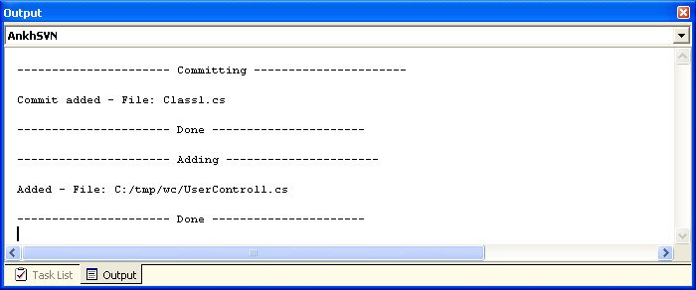

Commit dialog
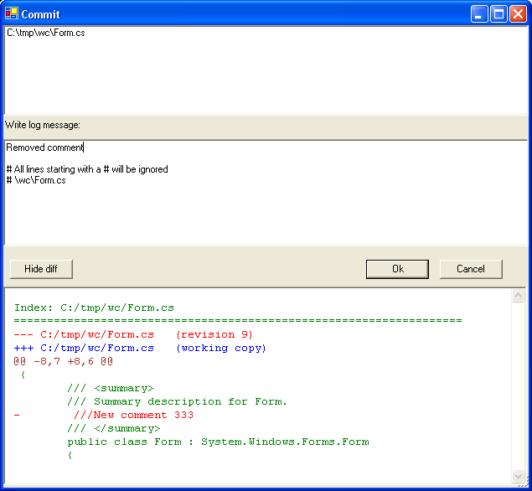

Date picker
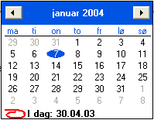

Diff in code view
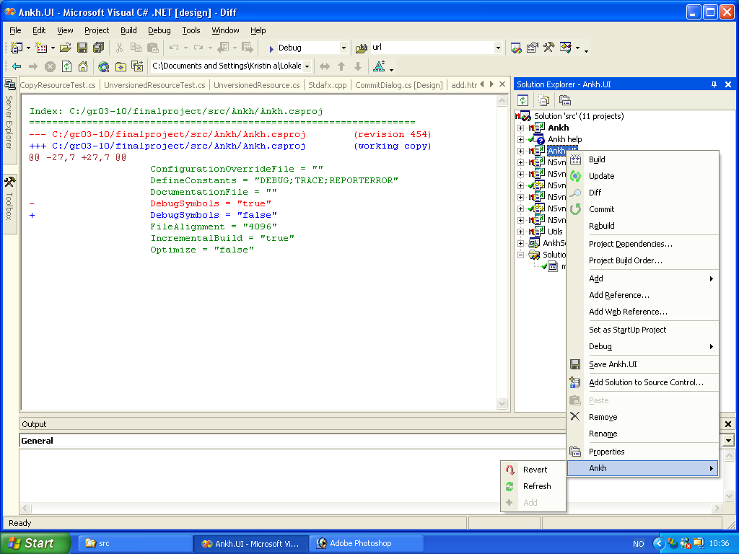

Item menu
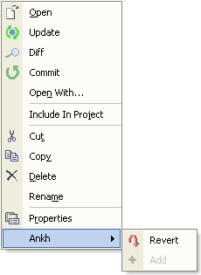

Login dialog

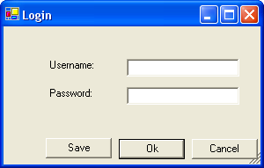

Repository Explorer
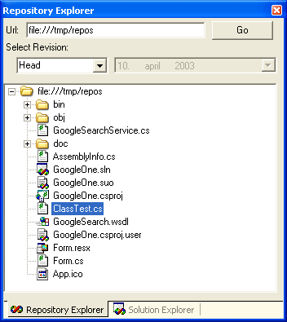

Revert dialog

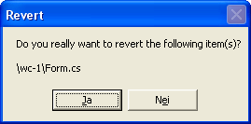

Solution Explorer


 

