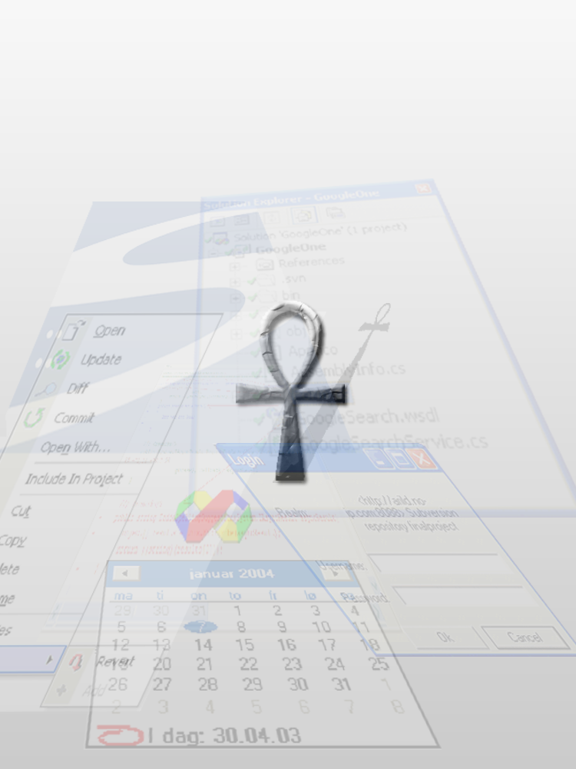
Preface
This is a project report on Ankh, a Visual Studio .NET addin for the Subversion revision control system, carried out in the spring of 2003.
The development of Ankh was conducted as a final year project at HiO in cooperation with CollabNet. The system contains an addin/GUI layer written in the programming language C#, and a .NET wrapper layer divided in a low level part interfacing with SVN's client API coded in Managed C++ and an object-oriented part coded in C#.
This report is intended for computer personnel responsible for; marketing, maintenance, updating, support and modifications to the system. The purpose of this document is to give a description of:
- System construction.
- Installation.
- Configuration.
The code is documented in detail in an html representation of the source code available on the enclosed CD.
The test report describes in detail the diverse system tests.
Alternative approaches as well as challenges in the development process and reasons for the selected GUI are described in the process report.
A prior knowledge to revision control systems, preferably Subversion and VS.NET is an advantage in order to acquire a full understanding of this report. A dictionary enclosed in the appendix covers basic terminology.
Table of contents
1 Introduction 5
1.1 Background 5
1.1.1 CollabNet 5
1.1.2 Subversion 5
1.2 Aim 7
1.3 Why use Ankh? 7
1.4 Navigation model and menus 7
1.5 What can Ankh do for you? 9
1.6 How does Ankh work? 15
1.7 Ankh Help 16
2 The Ankh project overview 19
2.1 Development tools 19
2.1.1 VS.NET 19
2.1.2 VS.NET Addin architecture 19
2.1.3 NUnit 19
2.1.4 NAnt 19
2.1.5 C# 20
2.1.6 Managed C++ 20
2.1.7 EA 20
2.2 System architecture 20
2.3 Conceptual model 21
2.4 Use case schemes 22
2.5 Coding structure 23
2.5.1 Naming guidelines 23
2.5.1.1 General 23
2.5.1.2 Classes 23
2.5.1.3 Interfaces 23
2.5.1.4 Methods 23
2.5.1.5 Properties 23
2.5.1.6 Attributes 23
2.5.1.7 Method parameters 24
2.5.1.8 Fields 24
2.5.2 Formatting 24
2.5.3 Comments 25
2.5.4 Namespaces 26
2.5.4.1 Ankh 26
2.5.4.2 Ankh.Commands 26
2.5.4.3 Ankh.EventSinks 26
2.5.4.4 Ankh.Help 26
2.5.4.5 Ankh.Setup 26
2.5.4.6 Ankh.Solution 26
2.5.4.7 Ankh.UI 26
2.5.4.8 NSvn 27
2.5.4.9 NSvn.Common 27
2.5.4.10 NSvn.Core 27
2.5.4.11 NSvn.Core.Tests 27
2.5.4.12 NSvn.Core.Tests.MCpp 27
2.5.4.13 Solution Items 27
2.6 Short system description 28
2.6.1 NSvn wrapper layer 28
2.6.2 GUI /addin layer 28
2.7 Testing 28
2.7.1 Weaknesses in Ankh 29
2.8 Future developments 29
3 Installation and configuration 30
4 How to build Ankh from source code 30
5 Conclusion 32
6 References 33
7 Appendix 34
7.1 Dictionary 34
7.2 Use case diagrams 36
7.3 Use case schemes 41
7.4 Class diagrams 64
7.4.1 Class diagram of Ankh 64
7.4.2 Class diagram of Ankh.UI 65
7.4.3 Class diagram of Ankh.Commands 66
7.4.4 Class diagram of NSvn 67
7.4.5 Class diagram of NSvn.Common 67
7.4.6 Class diagram of NSvn.Core 68
7.4.7 Class diagram of NSvn.Core.Client 69
7.4.8 Class diagram of NSvn.Core.Tests 69
7.4.9 Class diagram of NSvn.Core.Tests.MCpp 69
7.5 GUI not implemented in Ankh 70
7.5.1 PropertyEditorDialog 70
7.5.2 ViewLogDialog 72

Introduction
The introduction describes the background of the project, why Ankh should be used, how the program works and the navigation model.

Background
The background describes the aim of the project, the revision control system Subversion and the external employer CollabNet that funds the development of Subversion itself.

CollabNet
CollabNet is a California-based company that in the year 2000 provided the initial founding to begin development work on Subversion and which currently has several paid developers working on the Subversion project. CollabNet offers a wide range of products and services to improve software quality and accelerate time-to-market during product development. Their main product is SourceCast, which is a Web-based software development platform. Subversion is aimed to be the successor to an existing revision control system called CVS (Concurrent Versions System) and CollabNet intends to make it a part of the SourceCast platform.

Subversion
Subversion is a free open source revision control system. In a typical software development environment, many developers will be engaged in work on one code base. Revision control makes it easier for several people to share the same collection of files and folders in a code base. A revision control system is a centralised system for sharing information where the core is a repository.

A repository is much like an ordinary file server, except that it remembers every change ever made to your files. Yellow boxes indicates folders, green boxes indicate files in the figure below. The numbers on the blue arrow indicate version numbers.
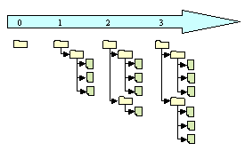
Each individual programmer checks out a working copy from the repository. A working copy is a collection of files and folders under revision control. Each file tree in the figure above are examples of a working copy that could be checked out from the repository. During the development work cycle these working copies are updated and synchronised with the repository.

When a commit is performed your changes are sent from your working copy to the repository. A commit publishes or makes your changes available for your colleagues. When a commit is performed it is possible to write a log message that usually contain a short description of changes performed.

Using revision control makes it possible to get an amazing overview of the work performed at any time from anywhere. If one project member has a problem that is difficult to solve another project members could easily get information of what is performed and support the other project member to solve the problem.
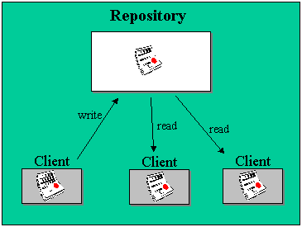

Subversion has a number of options. An attempt to analysed these options from the users point of view is done in a mental model in the process report. The Ankh integration of the SVN options are analysed from the developers point of view in a conceptual model in this report. Additional information could be obtained from http://subversion.tigris.org.
Subversion (SVN) did not have a GUI and had to be used from a command prompt when we started to work with Ankh.

Aim
The aim of the Ankh project was to provide an integration for Subversion into the integrated development environment Visual Studio .NET. By making an addin for Visual Studio .NET, the revision control system is available from inside Visual Studio, which for many developers is a clear improvement compared to the today’s command prompt. This will also make Subversion available for a huge userbase, which might not even consider it otherwise.
The .NET wrapper layer is available as a standalone component so that it easily can be used in other applications in the future.

Why use Ankh?
Ankh is a free open source tool that integrates the revision control system Subversion into VS.NET. Today there are several revision control systems available as an addin to VS.NET on the marked, but none of them are free.
Subversion is the successor of a widely used revision control system named CVS. Subversion was initially founded to improve CVS. The initial goal of Subversion was to preserve the same functionality as CVS and fixing the most obvious flaws

Navigation model and menus
The integration of Ankh in VS.NET is done as smooth as possible to avoid distracting the programmer. Ankh is hooked up to menus, output panes etc. that already exists in VS.NET. Colours, dialog boxes, file tree view, menus and output windows in Ankh therefore have almost the same design as used in VS.NET.

The following window types are used:
- multisquared windows (Windows where a special event in one window effects the output in another window.)
- multiwindow (Each window could be moved independently.)

The menu choices are as functional and obvious as possible. For example the command "svn ci" is named "commit" in the Ankh menu context. There might be some programmers that already are familiar with SVN. The wording used in Ankh therefore doesn’t deviate considerably from the SVN standard. We have deliberately avoided introducing new terms.

We have developed a set of icons that makes it easier to distinguish Ankh’s menu choices from the ones native to VS.NET itself.

Ankh provides tooltips on every menu option and on all text fields, combo boxes and buttons.

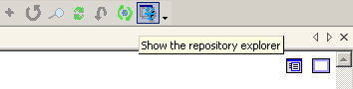

Our navigation model is described in the figure below. If the programmer right clicks on a file, directory, project or solution in Solution Explorer a menu will pop up. If input parameter for the option selected is required, a dialog box will be displayed. The result of the action initiated from the menu or dialog box will be displayed in the AnkhSVN pane in the Output view of VS.NET. There is also a new pane containing a file tree view of the repository.

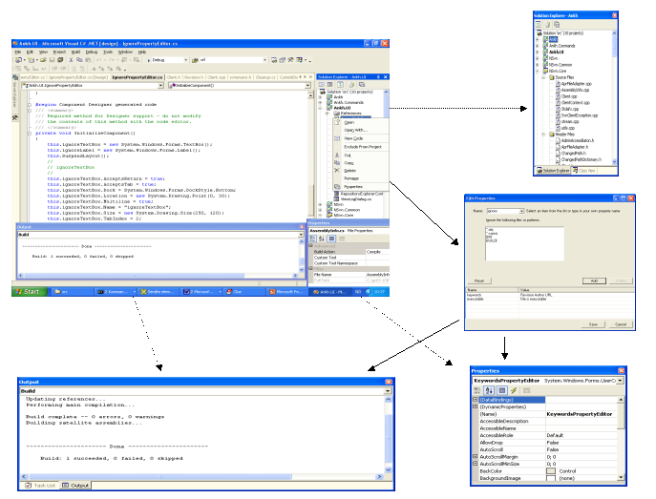

What can Ankh do for you?
When we started to integrate Ankh into VS.NET we made priority to those options that were most frequently used on a day-to-day basis. We aimed to get a product that could be used as soon as possible. Priority were made to the integration of the Subversion commands add, update, delete/remove, commit, diff, status, list and revert. Ankh therefore contains the following functionality:
- View status icons in working copy in Solution Explorer (Status icons in Solution Explorer)
- Add files, folders, individual projects and solution (item) to the working copy (Add)
- Update working copy item to include changes from last revision (Update)
- Examine changes of item in working copy (Diff)
- Revert changes in item in working copy (Revert)
- Delete/remove item from working copy (Delete)
- Commit changes to the repository (Commit)
- Show file tree view of repository in Repository Explorer (Repository Explorer)
- Authenticate the user if the repository used is restricted
Ankh support mainly Visual Basic (VB) , Visual C# (VC#) and Visual C++ (VC++) projects. Support for VC++ projects is weaker than VC# and VB projects.
Status icons in Solution Explorer
Shows status of working copy files, folders, projects and solutions (item) in Solution Explorer.

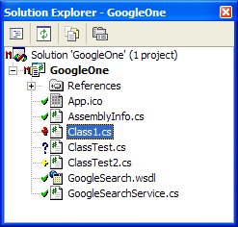

The meaning of the different status icons are listed below:
Unversioned item: Item not under revision control.
Versioned item: Item under revision control.
Modified versioned item.
Added and now versioned item.
Conflicted versioned item: If two users modify the same file at the same line a conflict will occur if the file is under revision control. The conflict occurs because the repository simply doesn’t know whether both or only one of the lines should be added
Locked versioned item: If a Subversion operation is interrupted for some reason, the working copy might be left in a locked state. This icon indicates that certain files are locked.

If an item is conflicted - the conflict has to be resolved. If an item is locked a cleanup is required. Ankh gives the following warning in case of a lock:

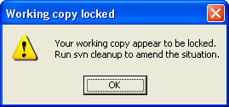

Ankh updates status icons in Solution Explorer automatically after the status has changed on item(s). There is also an option called Refresh available on the Ankh submenu, which allows the user to refresh a solution, project or folder manually.

Ankh has not yet implemented features handling resolve.

Add
Adds items to your working copy and schedules them for addition to the repository. These items will be added to the repository in your next commit. If you add something and change your mind before committing, you can unschedule the addition using Revert. Add works on both files and folders. The Add option is available from the item menu, which is displayed if an item is selected in Solution Explorer and right clicked.

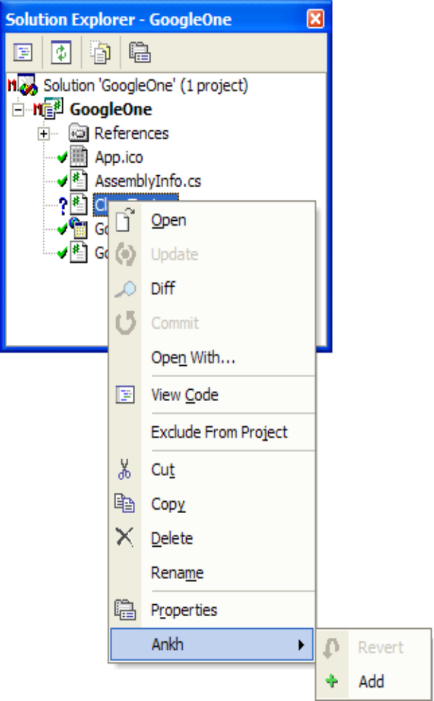

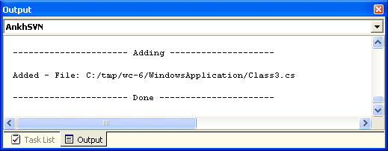

Update
Update brings changes from the repository into your working copy. It brings your working copy up-to-date with the head revision (last revision in repository). Update can be performed on several items and works recursively on folders, individual projects and the solution. The Update option is available from the context menu for any item selected in the Solution Explorer.
.
Diff
Display differences between two versions of the same item(s). The client compares base revision (last updated or committed revision) and working copy. Diffs are displayed in code view in a temporary file.

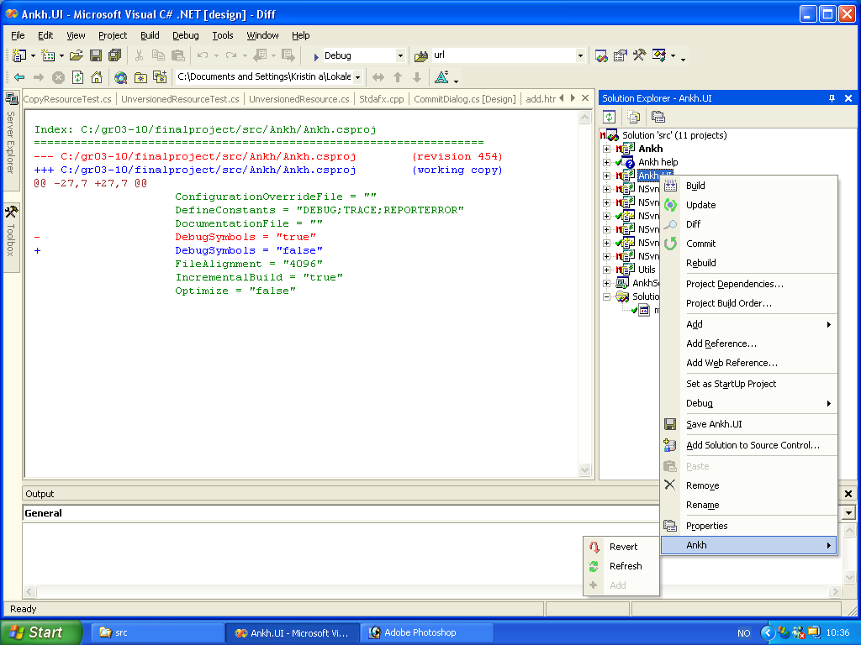

Red colour indicates text removed, green text indicate unchanged text and blue indicate new text added. Diff could be performed on several items and works recursively on folders, individual projects and the solution. The Diff option is available from the context menu of any item in the Solution Explorer

Revert
Reverts all local changes performed since the last update or commit. Revert can be performed on several items and works recursively on folders, individual projects and the solution. The Revert option is available from context menu of any item in the Solution Explorer.

Delete/Remove
When a user deletes a file or folder from within VS.NET, the svn delete operation is also invoked on the item. This prevents the working copy from getting out of sync with VS. NET’s Solution Explorer

Commit
Send changes from your working copy to the repository. A commit operation can publish changes to any number of items. In your working copy, you can change files, contents, create, delete and then commit the complete set of changes as a unit. It is possible to examine changes of item (Diff) in working copy from within the commit dialog. Commit works recursively on folders, individual projects and the solution. The Commit option is available from the context menu of any item in the Solution Explorer. Upon invoking the commit operation, a dialog appears in which the user enters a log message.

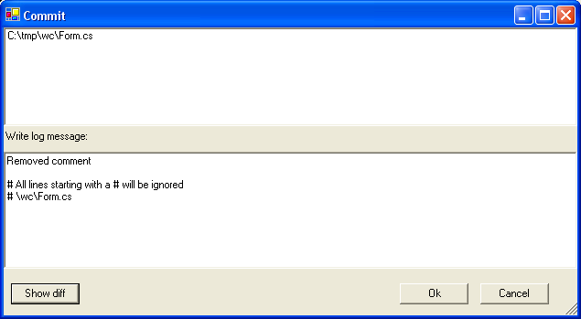

The upper text area displays the items that are to be committed. All lines starting with a # will be ignored in the log message sent to the repository. If the Show diff-button is clicked it is possible to examine the changes of the selected item(s) in working copy.

If the repository requires authentication for the commit the Login dialog will be displayed.

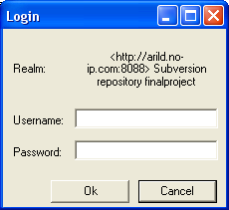

Repository Explorer
The Repository Explorer displays a file tree view of repository with file-type icons corresponding to those used by VS .NET for a valid URL and revision.

The Repository Explorer is available from View → Repos Explorer from main menu in VS.NET.

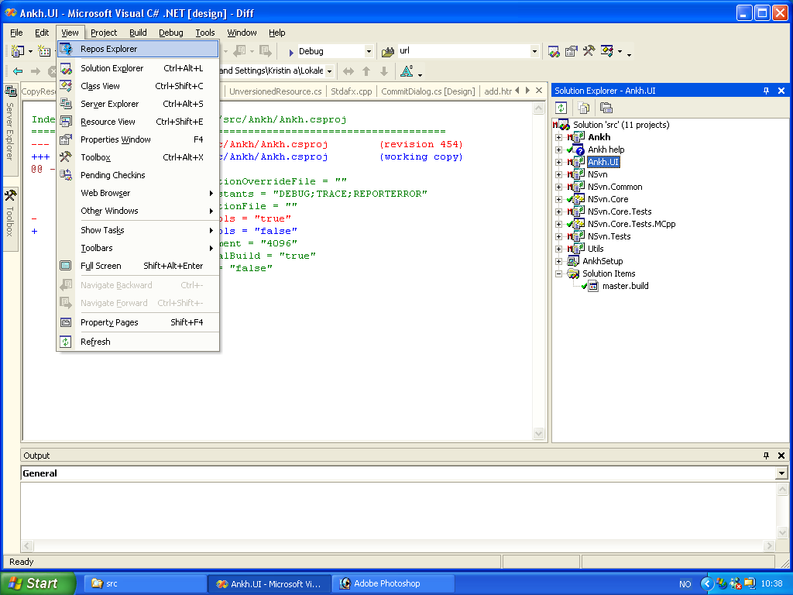

The Repository Explorer can display any revision in the repository, given as head, as specific date or a revision number. The head revision is the latest revision present in the repository. If Date is selected in the dropdown the date-picker is enabled and a calendar is available. Below is the Repository Explorer with date revision selected. The calendar is available.

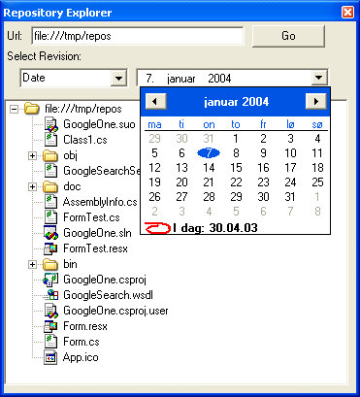

How does Ankh work?
This section is covered in Ankh Help integration.

Ankh Help
The Ankh Help was meant to be a user guide integrated in VS.NET available from the main menu. The Ankh Help integration cover information of basic operations and how to use Ankh. Some keywords are included in the Index view. The Index view works as a simple search where the search words are listed in the Index view.
In the Contents view below it is possible to see the content of Ankh Help. If a book icon is clicked twice the folder symbolised by a book icon will open and it is possible to see the content of the “book”. In the example below. The Introduction is clicked twice and the content is displayed.
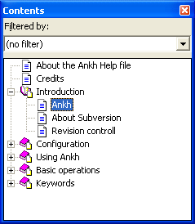
If “Ankh” is selected in the list of Contents the content of “Ankh” is visible in the ? view shown below.
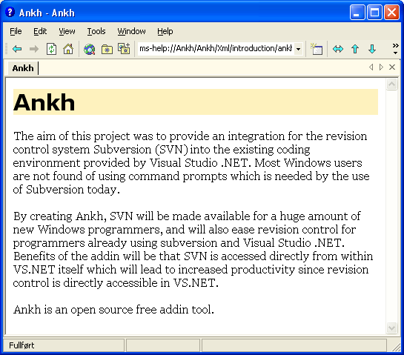
The Index view works as a simple search where the search words are listed in the Index view. We did not have time to enter all possible searching words into a base. The Index view gives you the possible searching words available. The articles connected to each search is listed in the Research view. In the below figure the keyword “about” is selected in the Index view.
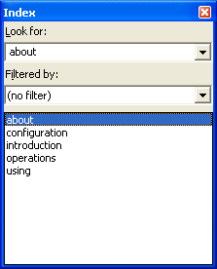
Results of the selected keyword “about” is visible in the Index Results view:
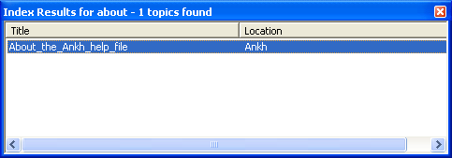
If the “About this help file” is selected - the content of “About this help file” is visible in the ? view.
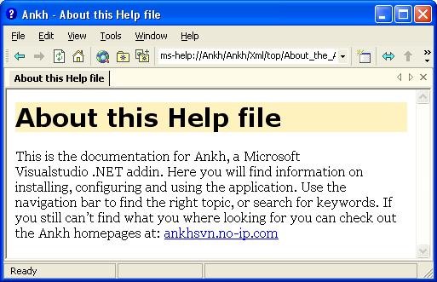
Collection level files to hierarchically integrate the Ankh Help Collection into VS .NET’s Help Collection were made. A method to customise the Help Registration merge module was used for deployment. Deployment and plugin of Ankh Help Integration into VS.NET Help Integration were not completed due to error messages using Orca-validation connected to the File_ParentHxT parameter in the HelpPlugin table in MSHelp2_RegTables__RTL_---_---.msm we could not solve. The parameter recommended by VS .NET Help Integration that gave the error message was FL_vscc_hxt_ENU____.3643236F_FC70_11D3_A536_0090278A1BB8.

The Ankh project overview
This chapter gives an overview of the Ankh project. Topics covered include system architecture, conceptual models, use case schemes, testing and future developments.

Development tools
This subsection describes the development tools used during the development of Ankh.

VS.NET
Visual Studio .NET is a coding environment for several coding languages. Visual Basic .NET (VB), Visual C++ .NET (VC++), and Visual C# .NET (VC#) all use the same integrated development environment (IDE), which allows them to share tools and facilities in the creation of mixed-language solutions. In addition, these languages leverage the functionality of the .NET Framework, which provides access to key technologies that simplify the development of ASP.NET Web applications and XML Web services.

VS.NET Addin architecture
Visual Studio NET provides an open development model that allows developers to extend the functionality of the IDE through special components called addins. Since VS.NET itself is implemented in COM, addins also need to be implemented using COM. Fortunately, .NET allows you to expose .NET assemblies as COM components very easily and that is what we did during the development of Ankh. VS.NET also allows you to develop addins using C++ and the Active Template Library(ATL), but this is a lot harder, while it doesn’t give any significant benefits over writing it in C#.

NUnit
NUnit is a free open source unit-testing framework for all .Net languages. It was initially ported from JUnit, which is a unit-testing tool for Java. We used Nunit 2.0 during the development of Ankh to make unit-tests for the classes in the NSvn wrapper layer.

NAnt
NAnt is a free .NET build tool. Instead of writing shell commands, the configuration files are XML-based, calling out a target tree where various tasks get executed. An object that implements a particular Task interface runs each task. Nant is used to generate regular builds of Ankh that don’t rely on having VS.NET installed on the build computer.

C#
Microsoft C# (pronounced C sharp) is a new programming language designed for building a wide range of enterprise applications that run on the .NET Framework. C# code is compiled as managed code, which means it benefits from the services of the common language runtime. These services include language interoperability, garbage collection, enhanced security, and improved versioning support. C# code was used for the main parts of Ankh except from the lower level part of the wrapper.

Managed C++
Managed Extensions for C++ are enhancements made to the C++ language. Managed Extensions simplify the task of migrating existing C++ applications to the new .NET Framework. Managed C++ code is used to translate Subversion client API coded in C to the low level part of the wrapper.

EA
Enterprise Architect is a project oriented UML modelling tool for the Windows platform. This tool was used to generate the use case diagrams and class diagrams.

System architecture
The system is divided into two main layers, a GUI/addin layer and a .NET wrapper layer. The addin/GUI layer contains the code for the addin itself and it’s graphical user interface in the C# language. This layer is called Ankh. The wrapper is divided into a lower level part for the SVN's client API coded in Managed C++ and a more object-oriented high level part coded in C#. The .NET wrapper is called NSvn.
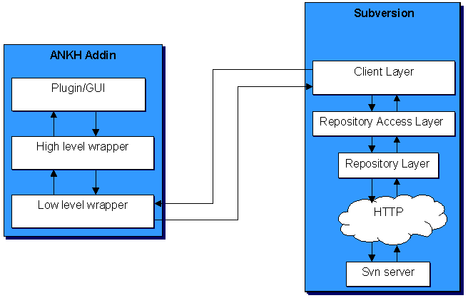

Conceptual model
The system was analysed from the developer’s point of view and a conceptual model is summed up in appendix 6.2 as a complete collection of use case diagrams. One example of the use case diagrams is shown below to better illustrate the text. Two actors were identified, the potential user of the system and the repository. The bubbles represent the most important objects identified and the lines indicate the relations. Some of the objects are reflected as menu options in Ankh. The action objects Import or Checkout must be performed before any of the other action objects could be performed (i.e. the item must be under revision control).

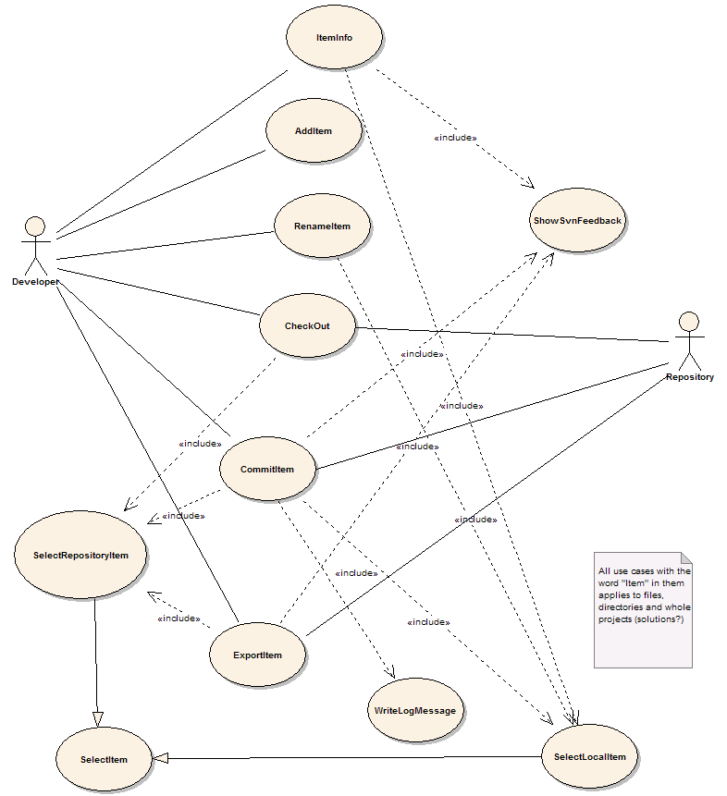

Use case schemes
Each object identified in the conceptual model was analysed as a use case. One example of the Add use case is listed below. Actors, preconditions, scenario and post conditions were identified and analysed. Collections of all the use cases are enclosed in appendix 6.3.

Use case | Add item
Actors | 1 Developer
Preconditions
1 The item is not currently in the workspace
2 The item is in a directory that is currently in the workspace
Scenario
1 The user invokes the VS.NET command File.AddNewItem or File.AddExistingItem
2 The item is added to the working copy
3 <Include 'ShowSvnFeedback'>
Postconditions
1 The item is in the workspace

The use cases implemented in Ankh are :
- Add Item
- Commit Item
- Diff Local Item
- Remove Item
- Revert Item
- Select Item
- Select Local Item
- Select Repository Item
- Show Local Changes
- Show SVN feedback
- Update Item
- View Item Status
- Write Log Message

Coding structure
This subchapter describe guidelines used in the coding structure.

Naming guidelines
Ankh follows the Microsoft .NET class library naming guidelines. A summary of these guidelines are listed below:

General
Hungarian notation, eg lpszFooBar are not used
Underscores are not used

Classes
Class names use Pascal case, like:
public class FooBar{...}

Interfaces
Interface names use Pascal Case
The name of an interface starts with the letter I

Methods
Methods are named using Pascal Case

Properties
Properties are named using Pascal Case
It is permitted(and even encouraged) to name a property the same as the underlying type:
public Color Color
{
get{ return this.color; }
}

Attributes
Attributes are named with Attribute suffix added, as in FooBarAttribute.
Attributes suffix are not used when applying an attribute(in C# this suffix is optional):
//yes
[FooBar]
public void Foo()
{...}

//no
[FooBarAttribute]
public void Foo()
{...}

Method parameters
Parameters are named in camel case

Fields
Private fields are named using camel case

Formatting
Tab characters are not used for indentation.
Each nested block is indented 4 spaces relative to the enclosing block
The 'normal' indentation style are used:
//yes
public void FooBar()
{
//...
}

//no
public void FooBar(){
//...
}

//no
public void FooBar()
{
//...
}

//no
public void FooBar()
{
//...
}

All use of member fields are prefixed with this.:
public class Foo
{
//...

public void Bar()
{
this.baz = 42; //yes
baz = 13; //no
}

private int baz;
}
Members of a class are ordered according to their protection level, in the following order from the top:
- public member methods
- public properties
- public fields(should be avoided as a general rule)
- protected member methods
- protected properties
- protected fields(should be avoided)
- private member methods
- private properties
- private fields

Comments
Comments in the Ankh code generally add information that is not obvious from reading the code alone. We have tried to choose variable and method names as self explanatory as possible to eliminate lots of comments. Method names are verbs and variable names are substantives. In general, end-of-line comments are avoided unless absolutely necessary. The only exception was while making method/function call that took a large number of arguments. In that case it was accepted to put each argument on a separate line and add a comment describing the parameter at the end of the line.
All classes and methods that are part of a public API have an extensive documentation comment. These comments are used to generate documentation about parameters, return value, potential exceptions that are thrown by the method and a verbose summary.
For entities that are not a part of a public API (protected/private methods, classes for internal use etc...) the comments are less stringent or formal. The main objective of the comments have been to provide enough information so that others can discern what a method does and what its parameters are for.

Namespaces
The code contains more than 100 files. To be able to locate each individual file the code is divided into different namespaces. Each unique namespace contain a logical collection of files closely connected to its functions. Class diagrams of the different namespaces are enclosed in appendix 6.4. The following sections describe the purpose of each namespace.

Ankh
Ankh is the name of our addin. The Egyptian name Ankh was selected because it can be visualised as a simple icon that readily can be used for marketing purposes. It was important to select an icon that could not be confused with another well-known software/tool. As other projects on the Tigris website tended to use Egyptian words we decided to follow this trend.

Ankh.Commands
The Commands namespace has a filename collection representing all implemented functions from SVN. The majority of the filenames were derived from the Use Case Bubble diagrams enclosed and relations between these files are shown in class diagrams also enclosed. This namespace hooks up “svn commands” to the item menu.

Ankh.EventSinks
Contains the code that deals with the events that are fired by the VS.NET automation model.

Ankh.Help
Contain collection of all files included in the Ankh Help Integration part of the project.

Ankh.Setup
Contains Licence Agreement and other files used to make the Ankh install file complete.

Ankh.Solution
Contains code pertaining to the integration with the VS.NET Solution Explorer.

Ankh.UI
The purpose of the UI namespace is to gather all files connected to the graphical user interface. The files are mainly represented by dialog-boxes and user controls. This namespace include a complete GUI of Ankh dialogs. Due to strict time schedule some of the user controls and dialog boxes are not integrated in Ankh and therefore are enclosed in the appendix.

NSvn
NSvn is the name of our VS.NET wrapper. The choice of the name selected was based on the short name of Subversion, SVN, combined with the letter N symbolising .NET. The NSvn namespace includes all files related to the .NET wrapper. The wrapper contains a complete translation of the Subversion Client API coded in C and therefore contains all Subversion’s client functionality. The namespace NSvn has two children named Common and Core.

NSvn.Common
NSvn.Common contains common functionality that code in both the NSvn.Core and NSvn namespaces rely on.

NSvn.Core
NSvn.Core contains the lower level part of the wrapper, written in Managed C++.

NSvn.Core.Tests
NSvn.Core.Tests contains unit tests for NSvn.Core, written in C#

NSvn.Core.Tests.MCpp
NSvn.Core.Tests also contains unit tests for NSvn.Core, but written in Managed C++. The need for two sets of tests for this assembly is due to the fact that some aspects of the functionality of NSvn.Core cannot be tested from a managed language.

Solution Items
Contains a build script that builds all projects in Ankh.

Short system description
This subchapter gives a roughly description of the system. The code is documented in detail in a html representation of the source code (Python generator) available at the enclosed CD and in the class diagrams enclosed.

NSvn wrapper layer
The wrapper contain a complete translation of the Subversion Client API coded in C. The wrapper is divided in 2 levels. A lower level part coded in Managed C++ and a more object-oriented higher level part coded in C#. NSvn contain the functionality of all “svn” commands described in the SVN Client API. Unit-tests to verify the translation were performed for all “svn” commands. An example of a unit-test is described in the test report. The NSvn wrapper was built outside VS.NET by the NAnt tool. The .NET wrapper layer is available as a standalone component so that it easily can be used in other applications in the future.

GUI /addin layer
The GUI/addin layer represents a complete example of how to hook up to menus, make explorer panes, output panes, how to make dialog boxes and user controls coded in C# in VS.NET.

Testing
Ankh was unit-tested with NUnit and built outside VS.NET with NAnt continuously during the development phase. Ankh was tested functionally by using Ankh while developing Ankh. Feedback from these tests gave useful information of what to be improved and ideas for future development. An early paper prototype testing of the GUI confirmed that our navigation model was logic and intuitive and gave us useful ideas of how to improve the GUI. In the end Ankh was tested functionally with a number of tests described in the test report to give an indication of the robustness of Ankh. Error messages are divided in 2 categories Ankh errors and SVN errors that reflect two different tools under development. Details about the testing is given in the test report.

Weaknesses in Ankh
Using Ankh while developing Ankh gave us an amazing overview of the weaknesses in Ankh. Below is a list of the most important weaknesses in Ankh.

- The Ankh menu entries sometimes don’t get registered on the first run. Restarting VS.NET will usually fix it.
- Support for VC++ projects is weaker than support for VB and VC# projects. If new file is added to the project through the IDE, you may need to run the Ankh Refresh option in the item menu in Solution Explorer on the project to detect the new file.
- If you delete a file, the status on the project node will not change. To be able to commit a delete, you need to change something else, then run commit on the project or solution.
- Adding a (web) form will not automatically add the corresponding .resx (or code behind) file. To add these files, click the Show All Files button in the solution explorer, and then add them the usual way.
- There is no support for checkout and import – you will need to create your repository and import your source to it using the command line tools. For details on how to use these, see http://svnbook.red-bean.com
- There is no support for svn rename through the IDE – Ankh might get very confused if you do so. The preferred way is to exclude the file in question from the project, run svn rename on it from the command line, and then re-add it to the project. The same goes for move operations.
- There is no support for editing SVN properties – this still needs to be done from the command line.
- The messages you get when updating a single file are misleading – they seem to indicate that you updated the whole directory. This is only a flaw in the message code – update itself works as expected.

Future developments

Fix Ankh weaknesses defined as issues in issue tracker at http://ankhsvn.tigris.org.

Due to limited time schedule and unforeseen challenges the following Use Cases are not implemented: Cleanup, Copy Item, Diff Repository Item, Edit Properties, Export Item, Import Solution, Item Info, Make Directory, Make patch, Merge Item, Move Item, Rename Item, Resolve File Conflict, Switch Item, View Log, View Repository File.

Deployment and plugin of Ankh Help Integration into VS.NET Help Integration were not completed due to limited time schedule and unforeseen challenges.

In middle March 2003 Microsoft announced a potential serious bug in VS.NET that affected C++ developers. The bug can occur while creating Managed C++ Class Libraries that contain a mixture of native code and intermediate language (IL).
As we are using mixed DLLs this bug can potentially affect our addin. As we had limited time available and did not experience a big impact of this bug we have not implemented the workaround. Guidelines for how to avoid problems caused by this bug are described in the article “The mixed DLL Loading Problem”.
An alternative approach to make the wrapper layer and avoid the uncertainty of the bug discovered during our project period was to use a tool called SWIG (Simplified Wrapper and Interface Generator). SWIG is a tool that generates wrappers for C and C++-based APIs automatically. The C# module had recently been added to SWIG and was still in a state of development during our project period and was therefore not used.

Installation and configuration
Ankh will install and run on any OS that is supported by VS.NET. This currently includes Windows 2000, Windows XP and Windows Server 2003. Visual Studio .NET 2002 was used to develop Ankh. The current release of the Ankh source code builds against Subversion 0.22.2.
Ankh does not currently run very well on VS.NET 2003. This is due to the fact that VS.NET 2003 was released late in our development cycle and we didn’t have access to a copy during development. We expect the next release of Ankh to fully support both VS.NET 2002 and VS.NET 2003
Ankh Setup.exe and the source code can be downloaded from http://ankhsvn.tigris.org or the enclosed CD.
The installer include a test repository that is optionally extracted to the computers local hard drive during installation. The persons who download Ankh are encouraged to use this repository to test Ankh.

How to build Ankh from source code
In order to build Ankh, you will also need to build Subversion itself. Start the process by building your own copy of the Subversion commandline client.

Note: The current source tree only builds against the 0.22.2 release of SVN.

Start by getting the 0.22 source tarball from http:\\subversion.tigris.org. You will also need the VS.NET version of the Berkeley DB binaries ( 4.0.14 version). Make sure you don't get the VC6.0 versions, since they will cause spurious access violations at runtime.

Extract the subversion tarball (using Winzip or similar). Then, extract the Berkeley zip into a directory called db4-win32 at the root of the tree (alongside the doc and build directories).

APR
Subversion relies on the Apache Portable Runtime(APR) library. Most of APR is included in the tarball, but to get Subversion to build on Win32 you will also need the apr-iconv module. You can check this out from the Apache CVS repository using a CVS client:

cvs -d :pserver:anoncvs@cvs.apache.org:/home/cvspublic login
(password: 'anoncvs')
cvs -d :pserver:anoncvs@cvs.apache.org:/home/cvspublic co apr-iconv

You may run into a problem with the supplied .dsp files in the tarball. If the person packaging it was using a UNIX machine, the line endings will probably be wrong and VS.NET will refuse to convert them. You can use an utility like unix2dos to fix this, or you can check out those modules from CVS using the approach described above(just substitute apr and apr-util for apr-iconv). All the modules need to be in the top-level directory of the Subversion source tree.

Building Neon

Open a VS.NET command shell (Start->Programs->Microsoft Visual Studio.NET → Tools → VS-NET Command Prompt), go into the neon directory at the root of the Subversion tree, and type the following:

cmd /c ..\build\win32\build_neon.bat debug
cmd /c ..\build\win32\build_neon.bat release

Building Subversion

Building Subversion requires you to have Python installed.

- Run gen-make.py -t dsp from the root of the Subversion tree.
- Open the solution by clicking on subversion_msvc.dsw at the root. VS.NET will prompt you to convert the workspace to the new VS.NET format. Answer yes to this.
- Disable the neon project in the VS.NET solution, as well as the tests_* projects and mod_dav_svn. If you chose to use the 4.1.25 version of the Berkeley binaries, you will need to change the svn, svnadmin, svnlook, svnserve and svnversion projects to link against libdb41(d).lib instead of libdb40(d).lib. The linker settings can be accessed through project properties, Linker → Input → Additional Dependencies. The whole solution should build now.
- Build both debug and release versions. Put the generated binaries somewhere in your PATH.
- Create a new system environment variable, SVNSRC, to point to the Subversion source tree. This is necessary to get the Ankh build to locate the Subversion libraries and headers.
Building Ankh it self
- Unzip the Ankh.zip file from the enclosed CD.
- Open and build src.sln. Run the ReCreateCommands.reg file in the Ankh directory.
- To get VS.NET to recognise the custom menu icons, you need to edit SatelliteDll.reg in the same directory. Set the path for SatelliteDllPath to the correct one for your system, then run the .reg file.
- Go into the Project Properties of the Ankh project. Choose Configuration Properties->Debug. Set Debug Mode to Program, and set Start Application to the path to devenv.exe on your system.
Starting the Ankh project should now create a new instance of VS.NET with Ankh loaded.

Conclusion
Improvements due to the development of Ankh:
- By creating a GUI, SVN is made available for a huge amount of new Windows programmers. Today the audience of the SVN are mainly Unix users. We hope to convert this trend.
- SVN functionality is accessed directly from within VS.NET itself.
- Increased productivity since revision control is directly accessible in VS.NET.
- We can offer the Windows users a FREE open source revision control tool integrated in VS.NET
- Ankh is a part of the open source community tigris.org.
- VS .NET integration coded in C# is poorly documented. The Ankh project represent a complete example of how to hook up to menus, make explorer panes, output panes and how to make dialog boxes and user controls coded in C#. Since Ankh is open source code we hope to transfer our knowledge to others.
Ankh covers the most frequently used functionality in a day-to-day basis of Subversion.
The .NET wrapper layer is available as a standalone component so that it easily can be used in other applications in the future. The wrapper covers a complete translation of the Subversions Client API coded in C to Managed C++ and C# code. NSvn cover all Subversion’s client functionality.
In respect to the potential new user group we have made an advanced Ankh Help.

References
- “NUnit” http://nunit.org/
- “VS.NET help” integrated in VS.NET
- “NAnt” http://nant.sourceforge.net/
- ”Ant” http://ant.apache.org/manual/
- "Creating Office Managed COM Add-Ins with Visual Studio .NET” by Paul Cornell, Microsoft Corporation, June 6, 2002
- ”EA” at http://www.sparxsystems.com.au/
- “The Mixed DLL Loading Problem Using Visual C++ .NET”, March 16, 2003 http://www.codeguru.com/dll/kmg15.html
- “15 SWIG and C#” http://www.swig.org/Doc1.3/CSharp.html
- “Subversion: The Definitive Guide”, Draft: Revision 5113, 26 February, 2003, by Ben Collins-Sussman, Brian W. Fitzpatrick, C. Michael Pilato, http://subversion.tigris.org
- “Inside Microsoft Visual Studio .NET” by Brian Johnson, Craigh Skibo, Marc Young
- Draco.NET http://draconet.sourceforge.net/
- Doxygen http://www.stack.nl/~dimitri/doxygen/

Appendix

Dictionary
Alpha testing The term alpha test means the first phase of testing in a software development process. The first phase includes unit testing, component testing, and system testing.
API Application Program Interface
Base revision Last committed or updated revision
Beta release Software under testing of the intended audience.
Beta testing Beta test is the second phase of software testing in which the intended audience tries the product out.
COM Component Object Model (COM), a software architecture that allows the components made by different software vendors to be combined into a variety of applications. COM defines a standard for component interoperability It is not dependent on any particular programming language, is available on multiple platforms, and is extensible.
COM add-in Is a dynamic-link library (DLL) that contains not only your custom code, but also special registry entries. These registry entries are used by Microsoft Office applications to determine the COM addin's behaviour at run time.
Commit Send changes from your working copy to the repository. Publish your changes to your colleagues.
Conflicted file If two users modify the same file at the same line a coflict will occur if the file is under revision control. The conflict occurs because the repository simply don’t know whether both or only one of the lines should be added. In some coding cases these new lines could mean the same and it would be logic to choose one of the lines
CVS Concurrent Version System. A free open source revision control system, the successor of Subversion.
DLL Dynamic Link Library
Doxygen Doxygen is a documentation system for C++, C, Java, IDL
(Corba, Microsoft, and KDE-DCOP flavors) and to some extent PHP and C#.The documentation is extracted directly from the sources, which makes it much easier to keep the documentation consistent with the source code. It can generate an on-line documentation browser (in HTML) and/or an off-line reference manual from a set of documented source files.
Draco Draco.NET monitors your source code repository,
automatically rebuilds your project when changes are
detected and then emails
you the build result along with a list of changes since the last build. Draco.NET version 1.4 supports the NAnt build tool. Now also supports Subversion as we contributed code to their repository.
Folder directory
GUI Graphical User Interface
Head revision Last revision in repository
Item File, folder, project or solution
IDE Integrated Development Environment
IIS Internet Information Server
IL Intermediate Language
Item file, directory, project or solution.
NAnt A free .NET build tool.
NUnit Tool for unit testing.
pristine working copy
Is the last updated working copy or working copy from last
local commit.
Repository A repository is much like an ordinary file server, except that it remembers every change ever made to your files.
Repository Explorer
A Ankh explorer used to browse revision.
Revision control system
In a typical software development environment, many developers will be engaged in work on one code base. Revision control makes it easier for several people to share the same collection of program source code. A revision control system is a centralised system for sharing information where the core is a repository.
Solution Explorer VS explorer used to browse files in a solution.
SVN Short name for Subversion, which is a free open source revision control system.
SWIG Simplified Wrapper and Interface Generator
UI User Interface
UML Unified Modelling Language
Unversioned file File not under revision control
VB Visual Basic .NET
VC++ Visual C++ .NET
VC# Visual C# .NET
Versioned file File under revision control
VS .NET Visual Studio .NET. A programming platform that includes editors for programming in C#, C++, Managed C++ and Visual Basic
WC Short for Working Copy.
Working Copy Collection of files and folders under revision control.

Use case diagrams

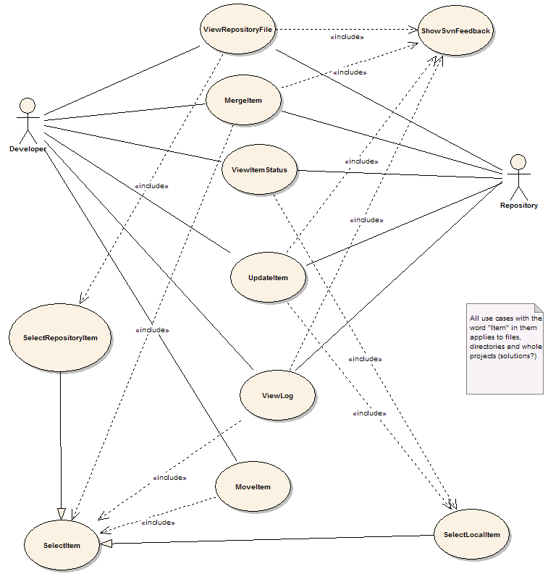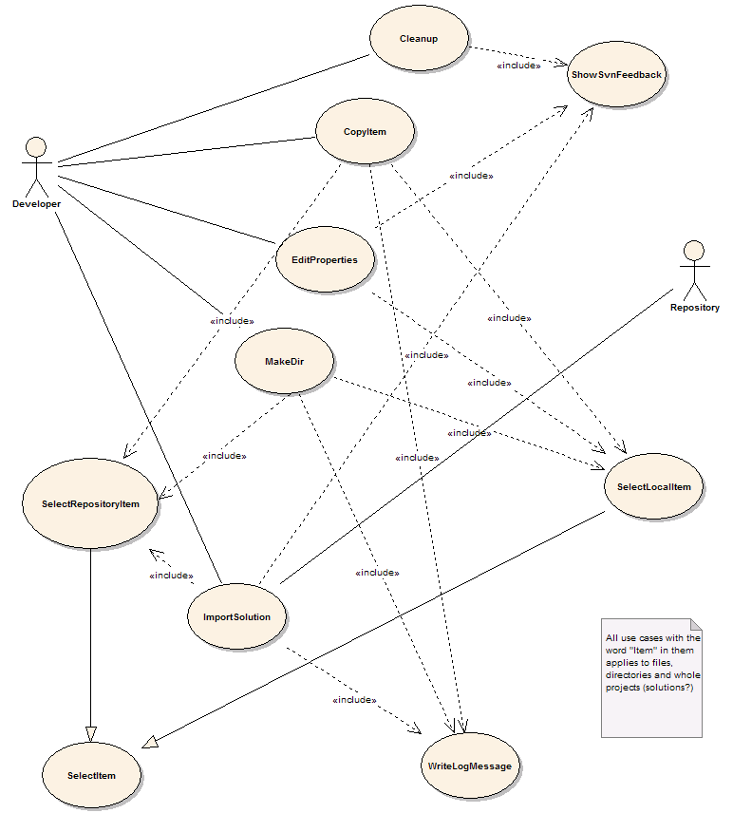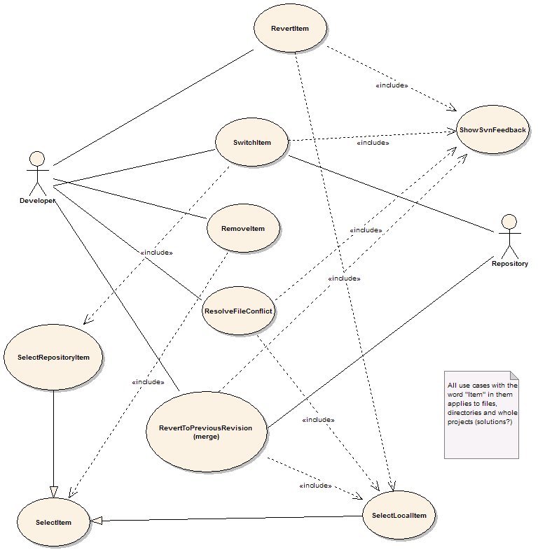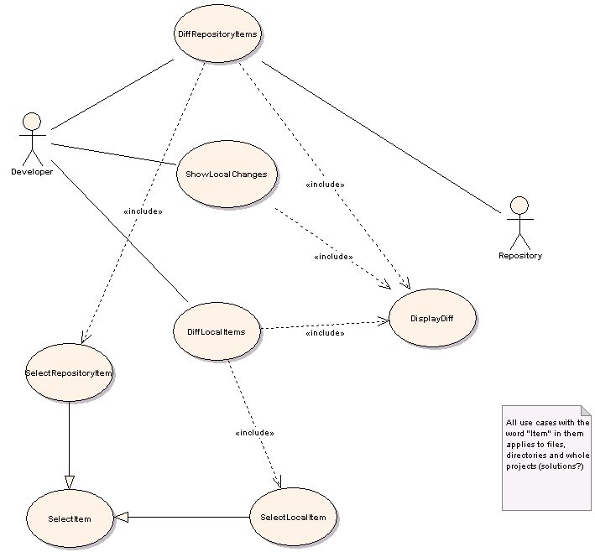

Use case schemes
The following schemes describe the use cases in the Ankh project. Each individual use case is derived from the objects in the conceptual model listed in the previous section.

Use case | Add item
Actors | 1 Developer
Preconditions
1 The item is not currently in the workspace
2 The item is in a directory that is currently in the workspace
Scenario
1 The user invokes the VS.NET command File.AddNewItem or File.AddExistingItem
2 The item is added to the working copy
3 <Include 'ShowSvnFeedback'>
Postconditions
1 The item is in the workspace

Use case | Cleanup
Actors | 1 Developer
Preconditions
1 The working copy is locked
2 An SVN operation has failed due to the locked wc
Scenario
1 Developer is asked whether a cleanup is desired
2 Cleanup is run on the working copy area
3 <Include 'ShowSvnFeedback'>
Postconditions
1 The working copy is in an unlocked state
2 OR: Cleanup failed

Use case | Commit item
Actors | 1 Developer  2 Repository
Preconditions
1 The item has local changes
2 The item is in the working copy
Scenario
1 <Include 'SelectLocalItem'>
2 The user selects Commit item from a menu
3 <Include 'WriteLogMessage'>
4 Commit the item to the repository
5 <Include 'ShowSvnFeedback'>
Postconditions
1 The item is committed
2 OR: The commit is rejected because of other committed changes

Use case | Copy Item
Actors | 1 Developer  2 Repository
Preconditions
1 Item doesn't exist at destination path
2 Item is under revision control
Scenario
1 <Include 'SelectItem'>
2 Developer selects "Copy" from menu
3 <Include 'SelectItem'>
4 <Include 'WriteLogMessage'>
5 Developer invokes "Paste"
6 svn copies item
Postconditions
1 Item is copied to new destination

Use case | Diff Local Item
Actors | 1 Developer  2 Repository
Preconditions
1 The item is under revision control
Scenario
1 <Include 'SelectLocalItem'>
2 Developer selects "Diff" from menu
3 Developer selects revisions
4 svn performs a diff
5 <Include 'DisplayDiff'>
Postconditions
1 The diff is displayed

Use case | Diff Repository Item
Actors | 1 Developer  2 Repository
Preconditions
1 The item exists in the repository
Scenario
1 <Include 'SelectRepositoryItem'>
2 Developer selects "Diff" from menu
3 Developer selects revisions
4 If developer wants to compare two different paths select another repository
5 svn performs a diff
6 <Include 'DisplayDiff'>
Postconditions
1 The diff is displayed

Use case | Edit Properties
Actors | 1 Developer
Preconditions
1 The item is under revision control
Scenario
1 <Include 'SelectItem'>
2 User selects "edit properties" on an item
3 Dialogbox pops up and the developer can edit the property list
4 Developer close the dialog box
5 The properties are applied onto the item
6 <Include 'ShowSvnFeedback'>
Postconditions
1 Properties are set on the item

Use case | Export Item
Actors | 1 Developer  2 Repository
Preconditions
1 The item exists in the repository
Scenario
1 <Include 'SelectRepositoryItem'>
2 Developer selects "Export"
3 Developer selects local folder to export to
4 SVN exports the item
5 <Include 'ShowSvnFeedback'>
Postconditions
1 The item is exported to a local directory

Use case | Import Solution
Actors | 1 Developer  2 Repository
Preconditions
1 The solution is not currently an SVN working copy
Scenario
1 Developer selects a VS.NET solution
2 Developer selects "Import solution"
3 <Include 'SelectRepositoryItem'>
4 <Include 'WriteLogMessage'>
5 SVN imports all source files contained in the solution
6 Close solution
7 Inform developer that backup copies will be made, and where
8 Make backup copies of solution directories
9 Delete solution directories
10 Check out solution from repository to original location
11 Reopen solution
Postconditions
1 Solution is under version control

Use case | Item info
Actors | 1 Developer
Preconditions
1 The item is under revision control
Scenario
1 <Include 'SelectLocalItem'>
2 Retrieve info from svn
3 Display info in VS:NET property pane
Postconditions

Use case | Make directory
Actors | 1 Developer
Preconditions
1 The parent path exists
2 The parent path is under version control
Scenario
1 <Include 'SelectItem'>
2 Developer selects "Make directory"
3 Developer enters new directory name
4 <Include 'WriteLogMessage'>
5 SVN creates new directory
6 <Include 'ShowSvnFeedback'>
Postconditions
1 New directory is created

Use case | Make patch
Actors | 1 Developer
Preconditions
1 Project is under revision control
Scenario
1 <Include 'SelectLocalItem'>
2 Developer invokes the MakePatch command
3 Run SVN diff on the item
4 Present developer with the diff
5 Allow user to copy diff to clipboard
6 OR: create new mail message with diff as attachment
Postconditions
1 A patch is created

Use case | Merge Item
Actors | 1 Developer  2 Repository
Preconditions
1 Paths exist and are in version control
Scenario
1 <Include 'SelectItem'>
2 Developer selects "Merge"
3 <Include 'SelectItem'>
4 Developer confirms operation
5 SVN performs the merge
6 <Include 'ShowSvnFeedback'>
Postconditions
1 The working copy contains the merged differences

Use case | Move Ite m
Actors | 1 Developer  2 Repository
Preconditions
1 Item doesn't exist at destination path
2 Item is under revision control
Scenario
1 <Include 'SelectItem'>
2 Developer choose "Cut" from menu
3 <Include 'SelectItem'>
4 Developer selects "Paste" from menu
5 <Include 'WriteLogMessage'>
6 svn moves item
Postconditions
1 Item is moved to new destination

Use case | Remove Item
Actors | 1 Developer  2 Repository
Preconditions
1 The item is under revision control
Scenario
1 <Include 'SelectItem'>
2 Developer choose "Remove" from menu
3 Developer is asked to confirme the delete
4 svn removes the item
Postconditions
1 The item is removed

Use case | Rename Item
Actors | 1 Developer
Preconditions
1 The item is under version control
Scenario
1 <Include 'SelectLocalItem'>
2 Developer invokes the VS.NET Rename command on the item
3 SVN renames the item
Postconditions
1 The item has a new name

Use case | Resolve File Conflict
Actors | 1 Developer
Preconditions
1 The files must be under revision control
2 A conflict must have occured
Scenario
1 <Include 'SelectLocalItem'>
2 Developer selects which of the revisions he wants to retain
3 svn delets the remaining files
4 Status is updated
Postconditions
1 Conflict is resolved

Use case | Revert Item
Actors | 1 Developer
Preconditions
1 The item has local changes
2 The item is under revision control
Scenario
1 <Include 'SelectLocalItem'>
2 Developer selects "Revert" from menu
3 Ask developer to confirm the revert
4 svn reverts item to "pristine" state
Postconditions
1 The item is reverted

Use case | Select Item
Actors | 1 Developer  2 Repository
Preconditions
1 The item exists
2 The item is under version control
Scenario
1 Developer selects item from a tree view
2 OPTIONAL: Developer selects revision
Postconditions
1 The item is selected

Use case | Select Local Item
Actors | 1 Developer
Preconditions
1 Item under revision control
Scenario
1 The developer clicks on an item in Solution Explorer
Postconditions
1 The item is selected

Use case | Select Repository Item
Actors | 1 Developer  2 Repository
Preconditions
1 Item under revision control
Scenario
1 The developer specifies an URL to the repository
2 Developer provides login credentials if required
3 SVN connects to repository and requests a list of files
4 The repository files are displayed in a tree-view
5 Developer selects an item from the tree-view
Postconditions
1 The item is selected

Use case | Show Local Changes
Actors | 1 Developer
Preconditions
1 The item is under revision control
Scenario
1 <Include 'SelectLocalItem'>
2 Developer choose "Show Local Changes" from menu
3 svn performs a diff
4 <Include 'DisplayDiff'>
Postconditions
1 The diff is displayed

Use case | Show SVN feedback
Actors | 1 Developer
Preconditions
1 The user has initiated an operation that needs to provide feedback
Scenario
1 A new Output window is created in VS.NET
2 The window receives focus
3 Output messages are written to the window
Postconditions
1 The developer is enlightened

Use case | Switch Item
Actors | 1 Developer  2 Repository
Preconditions
1 Working copy item exists
2 Repository path exists
Scenario
1 <Include 'SelectLocalItem'>
2 Developer selects "Switch"
3 <Include 'SelectRepositoryItem'>
4 Developer confirms the operation
5 SVN switches to the specified path
Postconditions
1 The working copy is updated to the specified path

Use case | Update Item
Actors | 1 Developer  2 Repository
Preconditions
1 The item is under revision control
Scenario
1 <Include 'SelectLocalItem'>
2 Developer selects "Update" from the menu
3 Optional: selects revision to be updated to
4 svn updates
5 <Include 'ShowSvnFeedback'>
Postconditions
1 The item is updated

Use case | View Item Status
Actors | 1 Developer
Preconditions
1 The item is under revision control
Scenario
1 An icon is displayed in the Solution Explorer next to the item signifying its status
Postconditions
1 Developer is enlightened

Use case | View Log
Actors | 1 Developer  2 Repository
Preconditions
1 The item must be under revision control
Scenario
1 <Include 'SelectItem'>
2 Developer selects "Log" from menu
3 Optional: Developer choose revision range
4 svn fetches log from repository
5 Display log
Postconditions
1 Log messages are displayed

Use case | View Repository File
Actors | 1 Repository  2 Developer
Preconditions
1 The file exists in the repository
Scenario
1 <Include 'SelectRepositoryItem'>
2 Developer selects "View"
3 SVN retrieves file contents from repository
4 If file is text: Show in VS.NET editor window
5 else: Invoke associated application
Postconditions
1 The selected file is displayed

Use case | Write Log Message
Actors | 1 Developer
Preconditions
1 An operation requiring log message has been invoked
Scenario
1 Developer selects whether he wants to see diff
2 Developer writes log message
3 Developer clicks "ok"
Postconditions

Class diagrams

Class diagram of Ankh
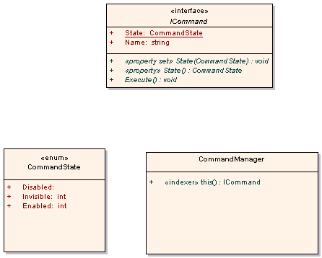

Class diagram of Ankh.UI
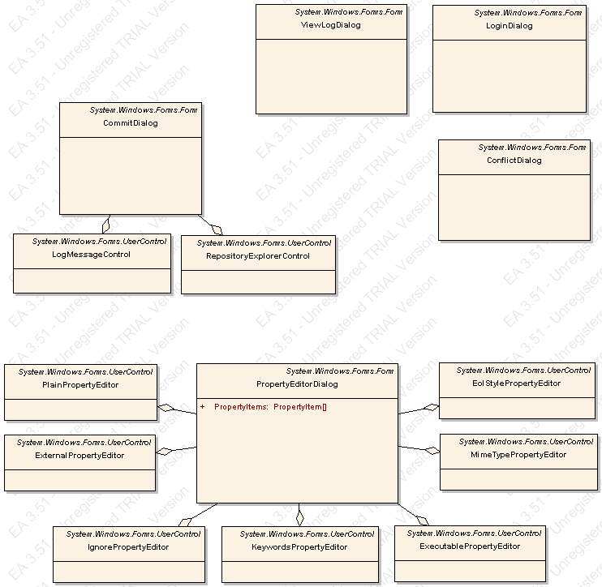

Class diagram of Ankh.Commands
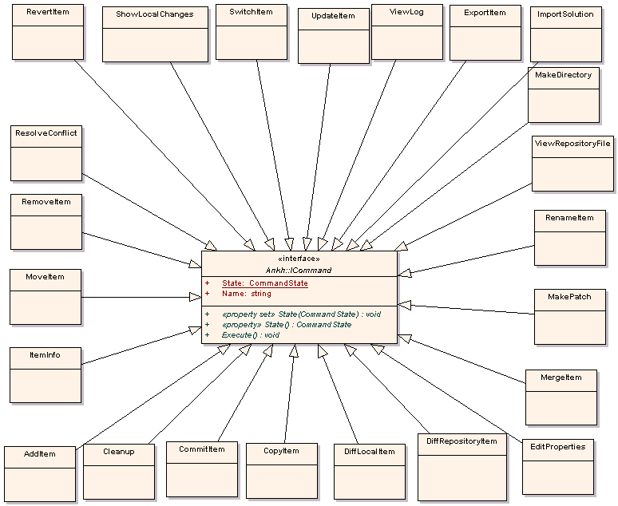

Class diagram of NSvn
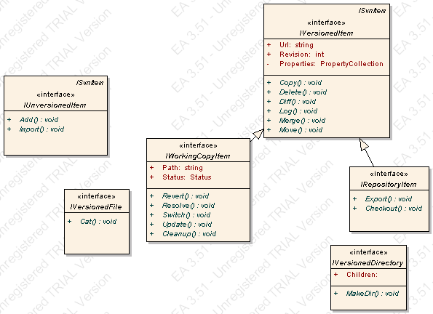

Class diagram of NSvn.Common
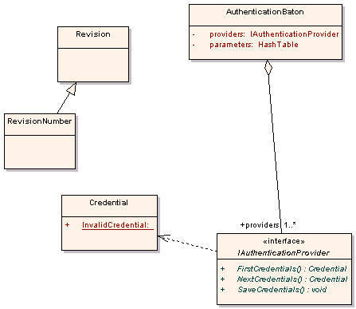

Class diagram of NSvn.Core
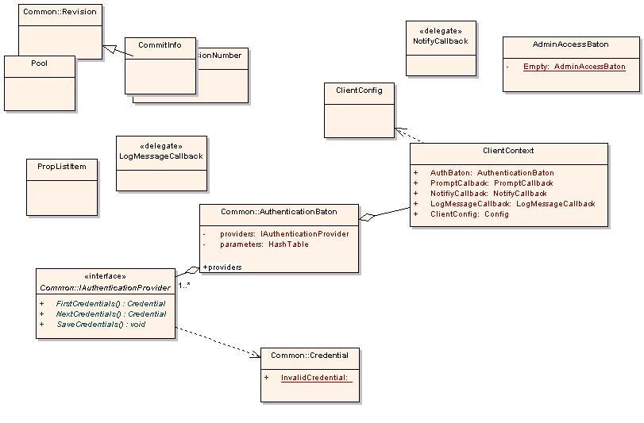

Class diagram of NSvn.Core.Client
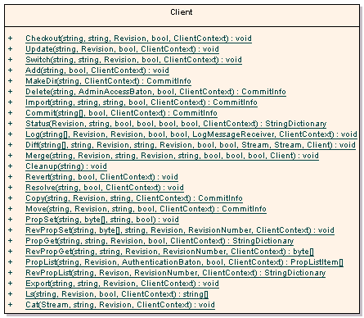

Class diagram of NSvn.Core.Tests

Class diagram of NSvn.Core.Tests.MCpp
 

GUI not implemented in Ankh
Due to limited time available the following dialogboxes were not implemented in Ankh.

PropertyEditorDialog
The following description was meant for Help.doc.

Setting properties
Here you will learn how to:
- set a predefined property
- create own property
- edit and/or delete properties
Select a file from the 'Solution Explorer', right click it and select 'edit properties'. You are now ready to set, edit or delete properties. If the file you selected already had a property, the list will populate itself. If you are uncertain what a property is, and how it works; look under the 'keywords' section under Properties

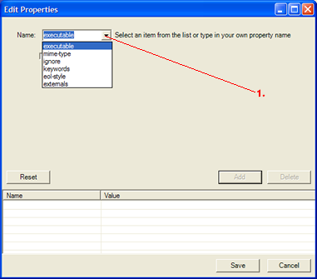
Set a predefined property
- 1. Select a item from the dropdown menu. Or you can define your own property by typing it directly in the "name" field. See next picture.

Creating your own properties
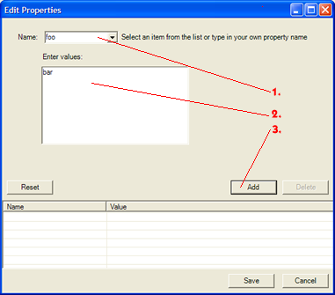
- 1. Type in the name of the property
- 2. Type in the value(s) of the property. Use a new line (ENTER) to differentiate between values.
- 3. Press 'Add' to store the property and the value(s). The property will be shown in the list at the bottom

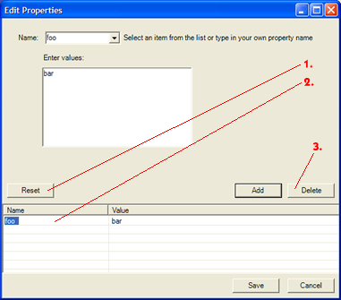
Changing and/or deleting properties
- 1. Resets all of the properties.
- 2. Select the property you want to work with from this list by double clicking it. The appropriate property screen will automatically be loaded, with values. Make your changes. And store them with 'Add'.
- 3. Deletes the property selected from the list (2.)
When you are finished defining all the properties, select 'Save'. All the properties are now stored and ready to use.

ViewLogDialog


 
 
 
 
 
 
 
 
 
 
 
 

