Front Page (specified by HIO) Process Documentation

Title page

Abstract
The development of the Subversion addin for Visual Studio .NET, named Ankh, was conducted as a final year project at HiO in cooperation with CollabNet.
Before Ankh was developed Subversion (SVN) had to be used from the command prompt. This is a very common approach for UNIX developers, but developers on Windows are more accustomed to graphical clients. The dominant developer tool on Windows is currently Microsoft Visual Studio.NET, and integration into this environment would make Subversion a viable alternative to a large number of Windows developers.
First step was to make a .NET wrapper for the Subversion's client API, and thereby use the wrapper to create a Visual Studio .NET addin for SVN. The system was coded in the C# and Managed C++ programming languages.
Improvements due to the development of Ankh:
- Most of the Windows users are not fond of using command prompts. By creating a GUI, SVN is made available for a huge amount of new Windows programmers. Today the audience of SVN are mainly Unix users. We hope to reach a new audience and convert the trend of UNIX user dominance.
- SVN is accessed directly from within VS.NET itself.
- Increased productivity since revision control is directly accessible in VS.NET.
- We can offer the Windows users a FREE open source revision control tool integrated in VS.NET.

Preface
This document describe how the process evolved and reasons for the selected approaches. The audience for this report is CollabNet and HIO. A dictionary containing the terminology used in this report is enclosed in the appendix.
The project group wanted to do a project in the Microsoft's .NET environment. One of the group members had used Subversion for several school and private projects for the last year and had the idea of the project. By developing Ankh we had a vision to provide the useful Subversion tool to a wider audience for no cost in an open source community.

After having defined the project we contacted CollabNet through the Subversion developer mailing list, and they immediately showed interest in being the employer for our project and provided our external supervisor, Karl Fogel.

The report is optimised for a paper-version.

Thanks to
Eva Hadler Vidhovde, HIO supervisor, for useful comments and guidelines for how a final project should be performed and an always optimistic attitude.
Karl Fogel, external supervisor from CollabNet, for giving us the liberty to fully influence the development process and final product of Ankh.
Ann Mari Torvatn for always paying interest to our project and for dedicating so much of her valuable time giving guidance to our documentation and visual presentation.

Table of contents
Front Page (specified by HIO) Process Documentation 1
Title page 1
Abstract 2
Preface 3
Table of contents 4
1 Introduction 6
1.1 The birth of the project 6
1.2 Revision Control 6
1.3 CollabNet 7
1.4 Subversion 7
1.5 Aim 8
1.6 Why use Ankh ? 8
1.7 What can Ankh do for you ? 8
1.8 Project specifications 9
2 Development process 9
2.1 Pilot project 9
2.2 Learning phase and tools used 9
2.3 Design phase 10
2.3.1 System design 11
2.3.2 Analysis of the users of our program: 11
2.3.3 Mental model 12
2.3.4 Navigation model and menus 13
2.4 Implementation and coding phase 15
2.4.1 NSvn wrapper layer 15
2.4.2 View Status icons in working copy (status) 15
2.4.3 Add, update, revert items in working copy 17
2.4.4 Commit your changes to the repository (commit) 20
2.4.5 Examine changes of item in working copy 21
2.4.6 Get file tree view of repository (list) 23
2.4.7 Project challenges 24
2.4.8 Possible alternative approach 24
2.5 Testing 24
2.5.1 Unit testing with NUnit 25
2.5.2 Functional testing 25
2.5.3 Testing of GUI 25
2.6 Deviations from project specifications 26
3 Phases of evolution in the group process 26
3.1.1 Commit mail 27
3.1.2 Build mail 28
3.1.3 Diary and internet sites 29
3.1.4 Issue-tracker 29
3.1.5 Relations to the employer CollabNet 30
3.1.6 Planning and methodology 30
4 Conclusion 30
5 References 31
6 Appendix 31
6.1 Dictionary 31
6.2 Development tools 32
6.2.1 VS.NET 33
6.2.2 VS.NET addin architecture 33
6.2.3 Code Comment Web Report 33
6.2.4 NUnit 33
6.2.5 NAnt 33
6.2.6 C# 33
6.2.7 Managed C++ 34
6.2.8 EA 34
6.3 Coding structure 34
6.3.1 Naming guidelines 34
6.3.1.1 General 34
6.3.1.2 Classes 34
6.3.1.3 Interfaces 34
6.3.1.4 Methods 34
6.3.1.5 Properties 34
6.3.1.6 Attributes 35
6.3.1.7 Method parameters 35
6.3.1.8 Fields 35
6.3.2 Formatting 35
6.3.3 Comments 36
6.3.4 Namespaces 36

Introduction
This chapter describe the background of the project, why Ankh should be used and what Ankh can do for you.

The birth of the project
One of the group members had used Subversion for several school and private projects for the last year and had the idea of the project. By developing Ankh we had a vision to provide the useful Subversion tool to a wider audience for no cost in an open source community.
Ankh is an Egyptic symbol representing both Physical and Eternal life. This could sound optimistic in the computer world. Based on the feedback we have experienced through the project period we know this product will be used and that maintenance are required. The Ankh project will be sustained. Ankh is a new born addin/wrapper project that will grow stronger and be a robust product in an open source community the project group appraise to be a part of.

Revision Control
In a typical software development environment, many developers will be engaged in work on one code base. Revision control makes it easier for several people to share the same collection of program source code. A revision control system is a centralised system for sharing information where the core is a repository.

A repository is much like an ordinary file server, except that it remembers every change ever made to your files. Yellow boxes indicates directories, green boxes indicate files in the figure below. The numbers on the blue arrow indicate version numbers.
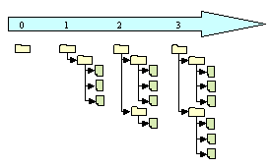
Each individual programmer checks out a working copy. A working copy is a collection of files and directories under revision control. During the development work cycle these working copies are updated and synchronised with the repository.

When a commit is performed your changes are sent from your working copy to the repository. A commit publish or makes your changes available for your colleagues. When a commit is performed it is possible to write a log message.

Using revision control makes it possible to get an amazing overview of the work performed at any time from anywhere. If one project member have a problem that is difficult to solve another project members could easily get information of what is performed and support the other project member to solve the problem.

CollabNet
CollabNet is a California-based company which provided the initial founding in 2000 to begin development work on Subversion and currently has several paid developers working on the Subversion project. CollabNet offers a wide range of products and services to improve software quality and accelerate time-to-market during product development. Their main product is SourceCast, which is a Web-based software development platform. Subversion is aimed to be the successor of an existing revision control system called CVS (Concurrent Version System) and CollabNet intends to make it a part of the SourceCast platform.

Subversion
Subversion is a free open source revision control system which makes it easier for several people to work within the same set of files. The files are placed into a central repository. Subversion has a number of options. An attempt to analysed these options from the users point of view is done in the mental model in this report. These options are analysed from the developers point of view in a conceptual model in the product report. Additional information could be obtained from http:\\tigris.org.
When we started to work with Ankh Subversion (SVN) had to be used from the command prompt. The prompt below shows feedback from SVN from a status command (svn st).
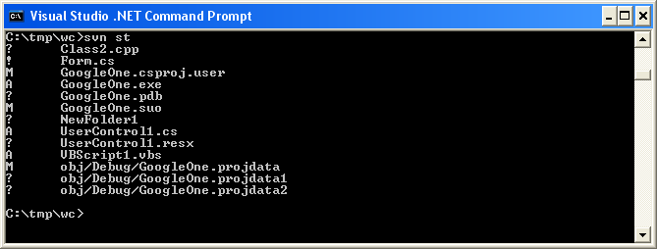

Aim
The aim of this project was to provide an integration for Subversion into the existing coding environment Visual Studio .NET. By making an addin for Visual Studio .NET the revision control system is made available for a huge amount of new users. The .NET wrapper layer is also available as a standalone component so that it easily can be used in other applications in the future.

Why use Ankh ?
Ankh is a free open source tool that integrates the revision control system Subversion into VS.NET. Today there are several revision control systems available as an addin to VS.NET on the marked, but non of them are free.
Subversion is the successor of a widely used revision control system named CVS (Concurrent Versions System). Subversion was initially founded to improve CVS. The initial goal of Subversion was to preserve the same functionality as CVS and fixing the most obvious flaws. Ankh is recommended because it is a useful, free tool which offers an improvement of the widely used CVS.

What can Ankh do for you ?
When we started to integrate Ankh into VS.NET we made priority to those options that were most frequently used on a day to day basis. We aimed to get a product that could be used as soon as possible even though it was not a complete product. Priority were therefore made to the integration of the Subversion commands add, update, delete/remove, commit, diff, status, list and revert. Ankh contain the following functionallity:
- View status icons in working copy (status)
- Add files, directories, project and solutions (item) to the working copy (add)
- Update working copy item to include changes from last revision (update)
- Examine changes of item in working copy (diff)
- Revert changes in item in working copy (revert)
- Delete/remove item from working copy (delete)
- Commit changes to the repository (commit)
- Get file tree view of repository (list)
A more detailed description of these commands and the integration into VS.NET are listed in the subchapter Implementation and coding phase.

Project specifications
To ensure the sanity and quality of the system at any given moment, and to catch regression bugs continuous unit tests using the NUnit testing framework were conducted.
We have provided NAnt build scripts that enable NSvn to be built without requiring the user to have Visual Studio.NET installed. The .NET wrapper layer is therefore available as a standalone unit for use in other applications.
The .NET wrapper layer covers the SVN client's API based on last version of SVN.
Common programming guidelines were composed to get an overall consistent look of the code.
Subversion was used for revision control both for the source code and documentation. All documentation was written in English, and a dictionary explaining relevant words used in the documentation.

Development process
This chapter covers the development process in the Ankh project. We passed through phases of learning, design, implementation/coding, and testing.

Pilot project

In this phase we wrote progress report, project proposal, contacted CollabNet, coded the diary, made the work plan and work schedule. The work schedule is enclosed in the appendix.

Learning phase and tools used
A description of the tools used is given in appendix 5.2 and the dictionary.

During our project we continuously used Subversion for revision control. Revision control systems are not a part of any lectures at HIO so we had to learn how to use Subversion and understand parts of the Subversion code (Client API coded in C) to be able to make the Ankh NSvn wrapper layer. To get a better understanding of the Client API in Subversion we frequently used the doxygen part of the Subversion documentation which is a web based “code comment report”. Subversion was under development and to be able to follow the development process we subscribed to the Subversion mailing list.

To get familiar with the VS.NET environment we explored features and ran macros and samples available through the help utility. During the development phase we frequently used the help utility integrated in VS.NET.

The code was mainly written in C# except from a thin Managed C++ code layer in the NSvn wrapper. To get familiar with the C# coding language we started to look at tutorials in C# and ran samples advised by the VS.NET help utility.

To gather information about VS.NET addins we searched at internet, tested some available free addins, read articles about the VS.NET addin architecture and used the help utility in VS.NET.

To get an overview of NUnit and NAnt we looked at tutorials.

Enterprise Architect were used to develop use case diagrams and schemes as one of the group members were familiar to this tool and easily could transfer his knowledge to the rest of the group.

The diary was programmed in python as one of the group members were familiar with the programming language and we were not sure whether a Tomcat server would be available for two alternative diaries made last year in Distributed Information Systems. Most of the diary at our internet site was coded during Christmas holiday last year, but the site was maintained and adjusted through the project period.

All of the tools and programming languages used were new for two of the group members and we believe that this project could not have been accomplished if not the third group members had knowledge of the majority of these tools.

Design phase
In this phase we agreed on system design, analysed the potential users of our program, tried to figure out what Ankh could be able to do for the user in a mental model and discussed the navigation model and menus to be used.
A conceptual model of Ankh from the developers point of view was made where we analysed each menu-option in Subversion and how it could be implemented in VS.NET. These use case diagrams and schemes are enclosed in the product documentation.
Common programming guidelines were composed before we started the coding to get an overall consistent look of the code. These guidelines are enclosed in appendix 5.3.

System design
The system was divided into 3 layers:
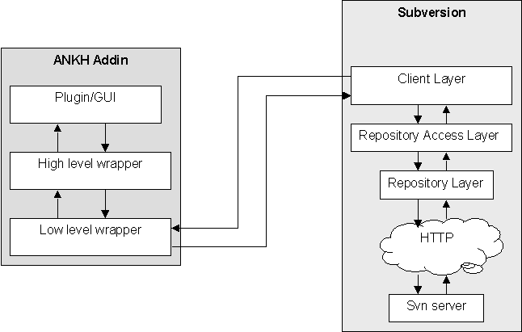
A lower level .NET wrapper layer (NSvn) for the SVN's client API coded in Managed C++.
A more object-oriented higher part of the .NET wrapper coded in C#.
A GUI/addin layer coded in C#.

Analysis of the users of our program:
The users of Ankh probably:
- have programming experience
- use or have knowledge about VS.NET
- have knowledge about revision control systems
- are fastidious to design and user-friendliness
- are usually men
- are often within the age of 20-45
- are probably member of a project group
- choose to use our addin because a revision control system is a very useful tool in development of a data product
- might have knowledge of the revision control system Subversion or CVS (the successor to Subversion)
Ankh is made for a programming environment. We concluded that ordinary people without programming experience would not represent Ankh users. A high level of functionality from fastidious users would therefore be required for the GUI.

Mental model
A mental model from the users point of view was made to describe the functionality of the wrapper and what Ankh could do for the user if we were able to implement all commands from Subversion. Two actors were identified. The programmer that wants to use revision control and the repository that could be compared to a server (with some additional features). Relations between the objects and the actors are shown with lines. The action objects Import or CheckOut must be performed before any of the other action objects could be performed (i.e. the solution in VS.NET has to be under revision control).

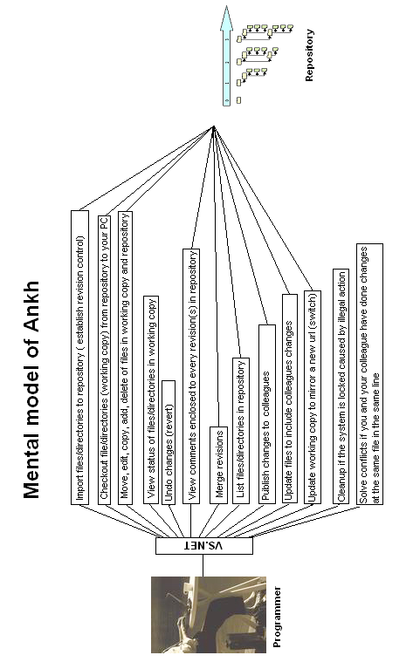

Navigation model and menus
Our goal was to implement Subversion into VS.NET as smoothly as possible. The VS.NET GUI was rather complex with lots of windows, menus and icons. Subversion was supposed to be a supplementary tool to VS.NET. Making fancy design in fresh colours would probably act distracting on the programmer who is supposed to concentrate on the coding. We therefore decided to use as much as possible of the already existing GUI. Add a new pane to the Ouput, implement icons into Solution Explorer and add new menu options to the already existing menus connected to a file, directory, project and solution.

The following window types were used:
- Multi squared windows (Windows where a special event in one window effects the output in another window.)
- Multi window (Each window could be moved independently.)
- Multi documents (One main window manage many dialog boxes. )
To be able to distinguish between SVN and VS.NET's own menu choices, dialog boxes, Solution Explorer, Output pane etc. without deviating too much from VS.NET's GUI design an icon was used. As the Subversion group tend to use Egyptic words we decided to follow their trend. The name Ankh was selected because it is Egyptic and could be visualised as a simple icon that easily could be used in the marketing of Ankh. It was important to select an icon that could not be confused with another well known software/tool and had a neutral meaning.
The menu choices are as functional and obvious as possible. For example the command "svn ci" are named "commit" in the menu context. There might be some programmers that already are familiar with SVN. The wording used in Ankh therefore don’t deviate considerably from the SVN standard. We have deliberately avoided new notions. “Publish” could have been a more understandable notion for “commit”, but as we decided to also take into account users already familiar with SVN we have avoided new notions.

Our navigation model is described in the figure below. If the programmer right click on a file, directory or project a menu will pop up. If input parameters for the option selected is required, a dialog box will be displayed. The result of the action initiated in the dialog box will be displayed in a Svn pane in the Output window. If the option selected is Edit properties new properties will be added to the Properties window. There are also a new pane containing a file tree view of the repository.

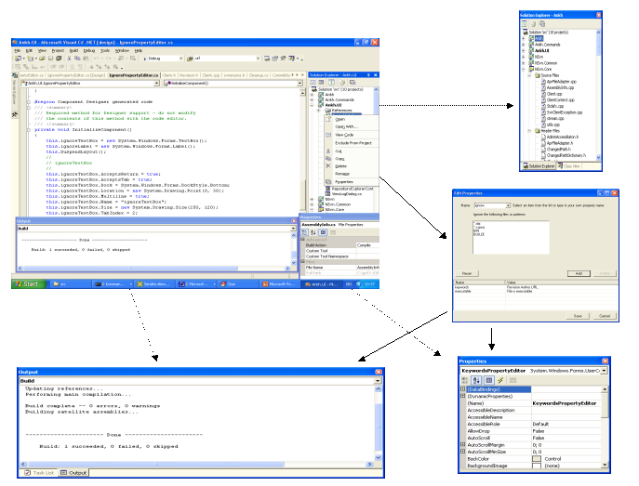

Implementation and coding phase
Before we started the coding we had agreed on common programming guidelines to get an overall consistent look of the code. The code-lines are enclosed in the appendix.
XXX NB This chapter is not complete yet. Should be ignored at the moment

NSvn wrapper layer
XXX

View Status icons in working copy (status)
This subsection describe the integration of the SVN command status into VS.NET’s Solution Explorer to give an indication of the GUI improvements and challenges of the integration.

The picture below shows the Subversion command svn status with feedback from svn in a command prompt.

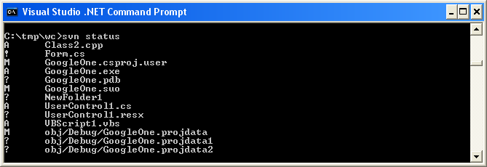

The svn status command prints the status of working copy files and directories. A working copy is a collection of files and directories under revision control. The letter or symbol in front of each file indicate the status of each file or directory.

The Subversion command svn status was integrated into VS.NET in Solution Explorer. Solution Explorer display files, directories, projects and solutions (item) with updated Ankh status icons in front of each item. The status icons visible in the Solution Explorer makes it easier to visually see which files that have changed status.
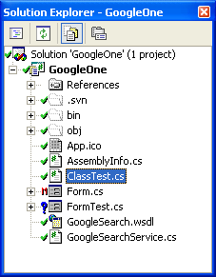
By using icons we hope to help the user to reduce his cognitive strain on a log time basis. If the programmer wants to publish his changes to his colleges. XXX
The meaning of the different status icons are listed below:
: unversioned item
: versioned item
: modified, versioned item
: added, versioned item
: deleted, versioned item
: conflicted, versioned item
: locked, versioned file
Ankh update status icons automatically after the status has changed. When we first integrated the status icons into VS.NET we refreshed the status icons on all items in the whole file tree view if the status on one item was changed. This was very time consuming and we therefore modified Ankh to only refreshed the status on the particular item where the status had been changed. A refresh option of the status icons is available in the item menu for solution, projects and directories.
XXX

Add, update, revert items in working copy
This subsection describe the integration of the SVN command add, update, revert into VS.NET’s Solution Explorers item menu to give an indication of the GUI improvements and challenges of the integration.

XXX

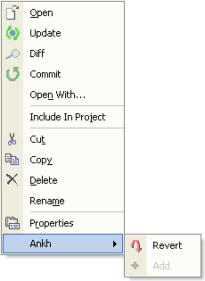
In VS.NET it is natural to update not only a file or directory but a whole project or solution.
The revert dialog below was integrated on users request after the source code release at http://ankhsvn.tigris.org. Details from this release are given in the test report.

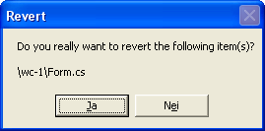

AnkhSVN output pane
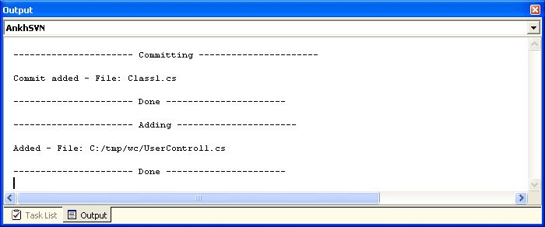

Commit your changes to the repository (commit)
This subsection describe the integration of the SVN command commit into VS.NET’s Solution Explorer to give an indication of the GUI improvements and challenges of the integration.

Image of the Commit dialog is shown below.

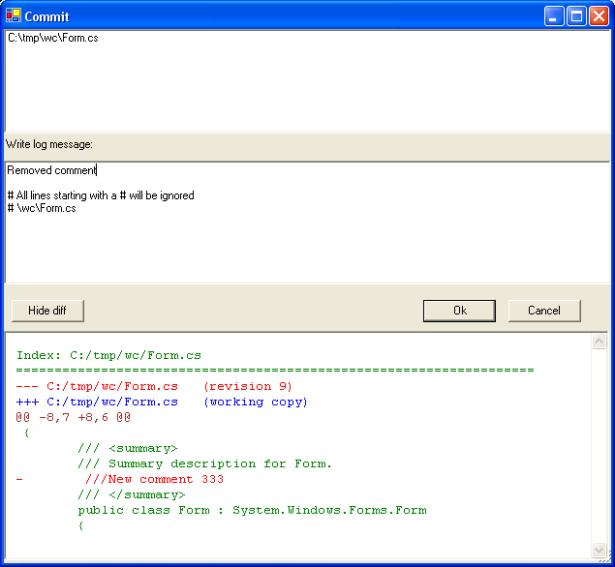

XXX

Examine changes of item in working copy

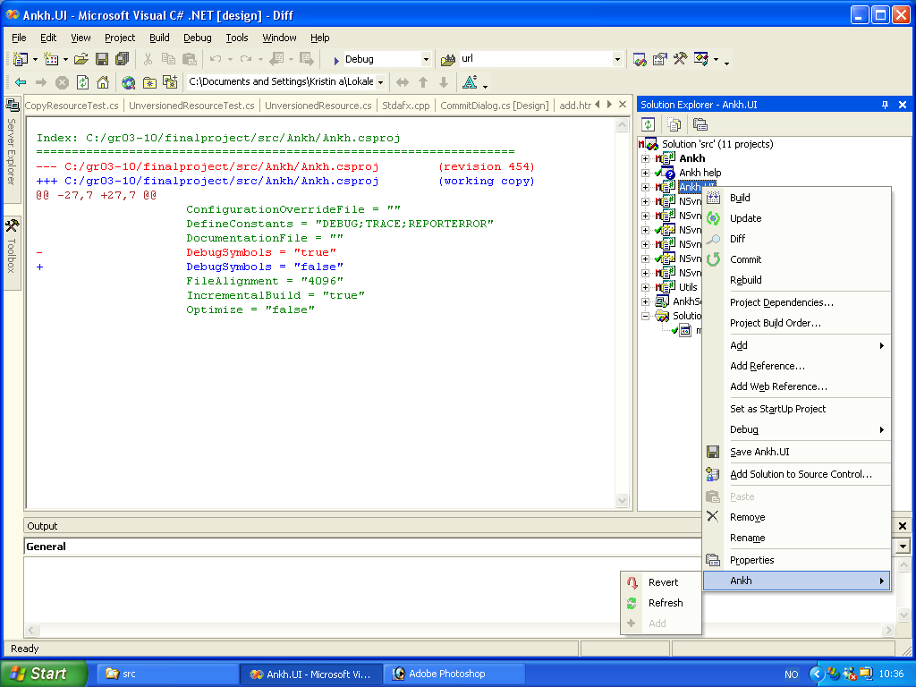

XXX

Login dialog

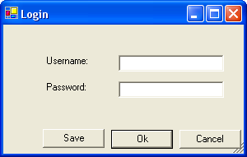

Get file tree view of repository (list)
This subsection describe the integration of the SVN command list into VS.NET’s Repository Explorer to give an indication of the GUI improvements and challenges of the integration.XXX

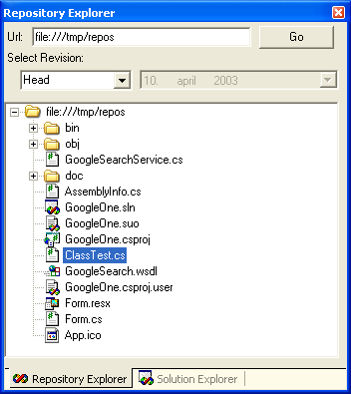

Date picker
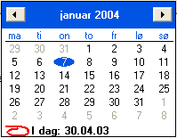

Project challenges
New versions of Subversion were released about every third week as Subversion was under development. We therefore had to adjust our addin during the development phase to new versions a number of times. Within every update we had to check out the source code of Subversion, build the project and distribute the .dll files to the Apache server and adjust new changes in Subversion to our addin. This was a time consuming process.

During the project progress Subversion unexpected changed their Client API to include a more flexible authentication. This introduced a new client context structure, that included client specific call backs and batons which served as a cache for configuration options and other various data. This made a delay in the project.

In middle March Microsoft announced a potential serious bug in VS.NET that only affects C++ developers. The bug could occur while creating Managed C++ Class Libraries that usually contain a mixture of native code and intermediate language (IL).
The build product of a “Managed C++ application” is an assembly of IL with an .exe extension. As we are using mixed DLLs this bug could affect our addin. A possible suggestion of a “workaround” solution for this bug was to set the build output in the Managed C++ Class Library project to have an IL-only file. As we had limited time available and did not experience a big impact of this bug we have not implemented the “workaround”.

How was technical problems solved ? What was the solution ? Was it difficult to find a solution ? How good was the solution ?

Possible alternative approach
We primarily intended to write most of the system in the C# programming language, but discovered that writing the .NET wrapper layer in Managed C++(C++ extensions for the .NET environment) was a better choice since Managed C++ offered a better integration with C-based APIs such as that of Subversion. Another alternative was to use a tool called SWIG (Simplified Wrapper and Interface Generator) - a tool that generates wrappers for C and C++-based APIs automatically. The C# module had recently been added to SWIG and was still in a state of development. We research these alternatives and seaked advice from people with knowledge in the area on the Subversions mailing list. We generally received support from the mailing list to our choice.

Testing
Ankh was unit-tested with NUnit and built outside VS.NET with NAnt continuously during the development phase to secure quality and sanity. Ankh was tested functionally by using Ankh while developing Ankh. Ankh was tested by the intended audience at http://ankhsvn.tigris.org. An early paper prototype testing of the GUI was also performed to check whether our navigation model was logic and intuitive. In the end Ankh was tested functionally with a number of tests described in the test report.

Unit testing with NUnit
Unit-testing of Ankh was performed continuously during the project period to ensure sanity and quality of the addin/wrapper. Every time a commit was performed the project was built by NAnt and all unit-tests were ran.

Functional testing
During the Alpha testing phase the source code was published at http://ankhsvn.tigris.org. The term alpha test means the first phase of testing in a software development process. The first phase includes unit testing, component testing, and system testing. To gather as much information as possible from this phase exception mails were sent to all group members. These mails contained valuable information about exceptions thrown from Ankh. When an exception was thrown the user was asked whether he wanted to send the exception and add a comment by mail. Details from the exception mails gave useful information of issues to be solved (see issue tracker at http://ankhsvn.tigris.org). The issue tracker lists preliminary weaknesses and possible future improvements of Ankh. The Revert dialog was implemented by users request from this testing phase.

After having implemented the most basic functions add, update, commit and status it was possible to use Ankh. Ankh was therefore tested functionally by using Ankh while developing Ankh. A new instance of VS.NET was started from the Ankh project. This made it possible to continuously work with the last update of Ankh and testing it at the same time with real data. Ankh was thereby tested by using an iterative methodology in a natural environment with real data.

Ankh was tested on the intended audience in Ankh Alpha version 1.0. Ankh was made available for installation from http://ankhsvn.tigris.org. XXX
Ankh Alpha version 2.0 was tested functionally with a number of tests described in the following sub chapters.

Testing of GUI
Testing of GUI was performed to ensure optimal functionality of the GUI. A paper prototype test was performed to check whether our navigation model was logic and intuitive. Whether our choice of button-names, names in menus and names on text fields etc. were logic. The test was performed on 3 test persons with programming experience. One of the persons was familiar with revision control systems and VS.NET. Before the tests were performed the test persons were given a short introduction to revision control and VS.NET. 3 scenarios were selected covering integration of commit, log and edit properties. The overall conclusion from these tests were that our navigation model was intuitive and logic. Useful feedback from the tests made us modify button names and text fields in dialog boxes, and reorganise the placing of buttons, text fields, comboboxes etc.. A need of Help Integration was also identified.

Deviations from project specifications
Process and product documentation was written in Word in stead of xml due to strict time-schedule and unforeseen challenges. We started to write the documentation in xml. Xml/xsl-documentation is suited for small documents, but among other things have no option for spell check. To get table of content, page numbering that should take into account different images sizes, headers/footers etc. complicated xsl-code would have been required. As the HIO did not require both an optimised paper and web-version of the documentation we made priority to the quality of the content in stead.

Phases of evolution in the group process
This section describe how we worked through the different phases of the project.

In the beginning of the project the group members worked together shorter or longer periods almost every day until all group members were masters of all new software and tools to be used during the project period. In this period we worked mainly together the all 3 of us at the school computer and remote on one “home PC”.

We started to work separately when all group members had successfully installed required software and tools on their home computers. We continued to meet at least 2 days every week at school also after we started to work independently at our home computers. In periods when we worked separately we communicated via MSN, mail and mobile.

We aimed that all group members should participate on as many as possible of the different parts of the coding. If all should participate on all the coding the project would probably had 3 versions which was not the intention and would not have been delivered within the time frame scheduled, but we aimed that all group members should be given the possibility to contribute and understand the coding in all the different parts of the project. All group members have coded in Managed C++, all have made NUnit tests, all have coded C# in the GUI layer and the wrapper layer. All have been involved in the part of the integration into VS.NET. All have used EA to generate use case diagrams and class diagrams. All group members have also contributed to the documentation. All documentation will be proof-read by the other group members.

During the project period we have discussed what to do and individually proposed what to work with. We have not had any group leader that has dedicated work, but taken the initiative for different tasks ourselves.

We did early decide that Arild was the contact person towards CollabNet, Per was the contact person towards the computer department at HIO, and Kristin had the responsibility to present weekly progress to Eva with contribution from the rest of the group if needed in weekly meetings.

To be able to at any time get the last update of the project we reviewed information from commit mails, build mails, the diary and had code reviews in addition to SVN revision control. Commit mails, build mails and the diary are described in the sections below.

Commit mail
Every time a project member did a commit, made his changes available for the rest of the group, a mail was sent to all group members. The mail contained a log message written to the specific revision and a “svn diff” that contained information about which files and directories that had been modified, added or deleted and which sentences that had been added or removed in each file (not binary files).
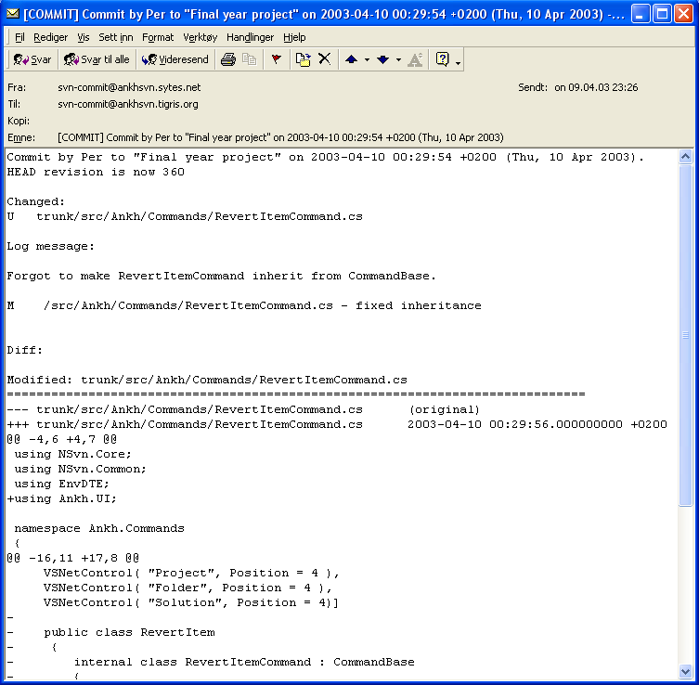
Using revision control and receiving commit mails made it possible to get an amazing overview of the work performed at any time. If one group member had a problem that was difficult to solve another group member could easily get information of what was performed and support the other group member to solve the problem.

Build mail
Every time a project member published her changes to the rest of the group, an independent NAnt build outside VS.NET was performed. In this build all unit-tests were ran to ensure the sanity and quality of the system at any given moment. A mail was sent to each group member with information about whether the build was a success or not.
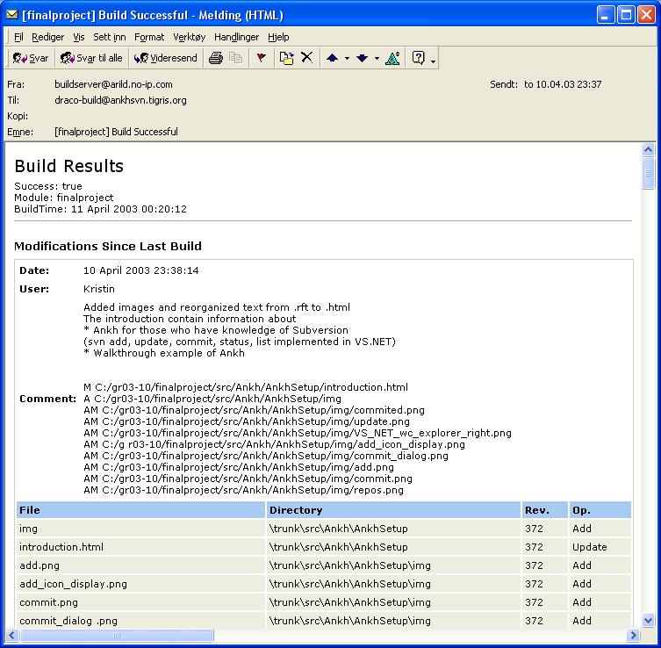

Diary and internet sites
The Internet site was adjusted to give focus on Ankh as a product not as a final year project at HIO. In the last part of the project period Ankh became a part of the Open Source Community at tigris.org. In the tigris.org Open Source Community an issue tracker was available for ankhsvn. We started to use this tool close to the Alpha release.

Issue-tracker
The issue tracker lists preliminary weaknesses and possible future improvements of Ankh. The issue list shows type of feature, priority, status, result and summary of the issues. This list helped us to remember things we planned to implement in later versions and gave us the status on issues to be solved in near future.

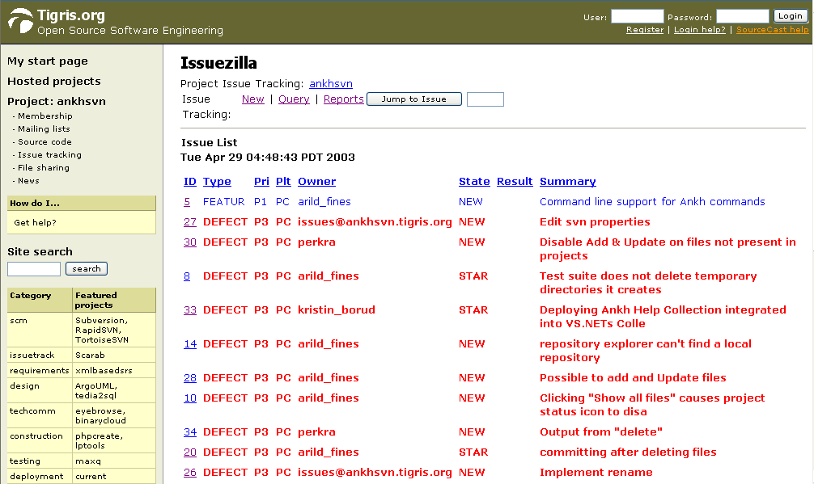

Relations to the employer CollabNet
XXX How the relations to CollabNet evolved through the process

Planning and methodology
In the beginning of the project period we used the waterfall method. Results from one phase were used in next phase of the development. It was not possible to start VS.NET integration before the wrapper was completed. During the VS.NET integration phase we used an iterative methodology. During development we used Ankh while developing Ankh. Ankh was thereby tested in a natural environment with real data.
XXX Waterfall method or prototyping ? Traditional systemising or X-ray sequence ? Feedback from CollabNet and potential users ?

Conclusion
Improvements due to the development of Ankh:
- By creating a GUI, SVN is made available for a huge amount of new Windows programmers. Today the audience of the SVN are mainly Unix users. We hope to convert this trend.
- SVN is accessed directly from within VS.NET itself.
- Increased productivity since revision control is directly accessible in VS.NET.
- We can offer the Windows users a FREE open source revision control tool integrated in VS.NET
XXX What we did, what we learnt, evaluation of work performed. What can the product do for you ? What does the employer mean about the product ? Will it be available download from Subversion internet site ? Could the wrapper be used in another context ? What could have been done different ?

References
- NUnit http://nunit.org/
- VS.NET help
- NAnt
- Ant http://ant.apache.org/manual/
- "Creating Office Managed COM Add-Ins with Visual Studio .NET” by Paul Cornell, Microsoft Corporation, June 6, 2002
- EA at http://www.sparxsystems.com.au/
- The Mixed DLL Loading Problem. Using Visual C++ .NET... – March
16, 2003 The Mixed DLL Loading Problem. http://www.codeguru.com/dll/kmg15.html
- “15 SWIG and C#” http://www.swig.org/Doc1.3/CSharp.html
- "Revision Control system" - www.csc.calpoly.edu/~dbutler/tutorials/winter96/rcs/

Appendix

Dictionary
alpha testing - The term alpha test means the first phase of testing in a software development process. The first phase includes unit testing, component testing, and system testing.
API - Application Program Interface
beta release - Software under testing of the intended audience.
beta testing - Beta test is the second phase of software testing in which the intended audience tries the product out.
COM - Component Object Model (COM), a software architecture that allows the components made by different software vendors to be combined into a variety of applications. COM defines a standard for component interoperability It is not dependent on any particular programming language, is available on multiple platforms, and is extensible.
COM add-in - Is a dynamic-link library (DLL) that contains not only your custom code, but also special registry entries. These registry entries are used by Microsoft Office applications to determine the COM addin's behaviour at run time.
commit - Send changes from your working copy to the repository. Publish your
changes to your colleagues.
conflicted file – If two users modify the same file at the same line a coflict will occur if the file is under revision control. The conflict occurs because the repository simply don’t know whether both or only one of the lines should be added. In some coding cases these new lines could mean the same and it would be logic to choose one of the lines
CVS – Concurrent Version System. A free open source revision control system, the successor of Subversion.
GUI - Graphical User Interface
IDE - Integrated Development Environment
IIS - Internet Information Server
IL - Intermediate Language
Item – file, directory, project, solution
Item menu –
NAnt - A free .NET build tool.
NUnit - Tool for unit testing.
.NET Framework –
pristine working copy -
repository – A repository is much like an ordinary file server, except that it remembers every change ever made to your files.
Repository Explorer –
revision control system – In a typical software development environment, many developers will be engaged in work on one code base. Revision control makes it easier for several people to share the same collection of program source code. A revision control system is a centralised system for sharing information where the core is a repository.
Solution Explorer –
SVN – Short version of Subversion, which is a free open source revision control system.
SWIG - Simplified Wrapper and Interface Generator
UI - User Interface
UML - Unified Modelling Language
unversioned file – File not under revision control
versioned file – File under revision control
VS .NET - Visual Studio .NET. A programming platform that includes editors for programming in C#, C++, Managed C++ and Visual Basic
wc - Working Copy. Collection of files and directories under revision control.
Working Copy - Collection of files and directories under revision control.

Development tools

VS.NET
Visual Studio .NET is a set of development tools for building ASP Web applications, XML Web services, desktop applications, and mobile applications. Visual Basic .NET, Visual C++ .NET, and Visual C# .NET all use the same integrated development environment (IDE), which allows them to share tools and facilitates in the creation of mixed-language solutions. In addition, these languages leverage the functionality of the .NET Framework, which provides access to key technologies that simplify the development of ASP Web applications and XML Web services.

VS.NET addin architecture
In VS.NET it is possible to make addins. This makes it possible for us programmers to add whatever preferred tool into VS.NET. We have made a COM addin.
A COM addin is a dynamic-link library (DLL) that contains not only your custom code, but also special registry entries. These registry entries are used by Microsoft Office applications to determine the COM addin's behaviour at run time.

Code Comment Web Report
VS.NET provide a tool that generate a web report displaying information about the definitions in your code in a series of .html pages. This feature allow you to browse the code structure within files in your current project or solution, such as classes, objects, members and interfaces. The comments are written in the C# source code by use of xml-tags combined with a special comment syntax.

NUnit
Nunit is a free open source unit-testing framework for all .Net languages. Initially ported from JUnit which is a unit-testing tool for Java. Version 2.0, the second major release of Nunit, was used in the testing of Ankh. NUnit brings xUnit to all .NET languages. The Nunit tests are visualised by a testing tree view where the various tests get executed gradually.

NAnt
NAnt is a free .NET build tool. Instead of writing shell commands, the configuration files are XML-based, calling out a target tree where various tasks get executed. Each task is run by an object that implements a particular Task interface.

C#
Microsoft C# (pronounced C sharp) is a new programming language designed for building a wide range of enterprise applications that run on the .NET Framework. C# code is compiled as managed code, which means it benefits from the services of the common language runtime. These services include language interoperability, garbage collection, enhanced security, and improved versioning support.

Managed C++
Managed Extensions for C++ are enhancements made to the C++ language. Managed Extensions simplify the task of migrating existing C++ applications to the new .NET Framework. Attributes, like C++ keywords, are used in source files and interpreted by the compiler. Attributes are designed to provide a quick and efficient method to simplify COM programming with Visual C++.

EA
Enterprise Architect is a project oriented UML modelling tool for the Windows platform. This tool was used to generate the use case diagrams and class diagrams.

Coding structure

Naming guidelines
Ankh follow the Microsoft .NET class library naming guidelines. A summary of these guidelines are listed below:

General
- Hungarian notation, eg lpszFooBar are not used
- Underscores are not used

Classes
- Class names use Pascal case, like:
public class FooBar{...}

Interfaces
- Interface names use Pascal Case
- The name of an interface starts with the letter I

Methods
- Methods are named using Pascal Case

Properties
- Properties are named using Pascal Case
- It was permitted to name a property the same as the underlying type:
- public Color Color
- {
- get{ return this.color; }
- }

Attributes
- Attributes are named with Attribute suffix added, as in FooBarAttribute.
- Attributes suffix are not used when applying an attribute(in C# this suffix is optional):
- //yes
- [FooBar]
- public void Foo()
- {...}

- //no
- [FooBarAttribute]
- public void Foo()
- {...}

Method parameters
- Parameters are named in camelCase

Fields
- Private fields are named using camel case

Formatting
- Tab characters are not used for indentation.
- Each nested block are indented 4 spaces relative to the enclosing block
- The 'normal' indentation style are used:
- //yes
- public void FooBar()
- {
- //...
- }

- //no
- public void FooBar(){
- //...
- }

- //no
- public void FooBar()
- {
- //...
- }

- //no
- public void FooBar()
- {
- //...
- }

- All use of member fields are prefixed with.:
- public class Foo
- {
- //...

- public void Bar()
- {
- this.baz = 42; //yes
- baz = 13; //no
- }

- private int baz;
- }
- Members of a class are ordered according to their protection level, in the following order from the top:
  - public member methods
  - public properties
  - public fields(should be avoided as a general rule)
  - protected member methods
  - protected properties
  - protected fields(should be avoided)
  - private member methods
  - private properties
  - private fields

Comments
Comments generally add information that is not obvious from reading the code alone. We have tried to choose variable and method names as self-explainable as possible to eliminate superfluous comments. Method names are verbs and variable names are substantives. In general, end-of-line comments are avoided unless absolutely necessary. The only exception was while making a method/function call that took a large number of arguments. In that case it was accepted to put each argument on a separate line and add a comment describing the parameter at the end of the line.
All classes and methods that are part of a public API have an extensive documentation comment. These comments are used to generate documentation about parameters, return value ,potential exceptions that are thrown by the method and a verbose summary
For entities that are not a part of a public API(protected/private methods, classes for internal use etc...) the comments are less stringent or formal. The main objective of the comments have been to provide enough information so that others can discern what a method does and what it's parameters are for.

Namespaces
The code contains more than 100 files. To better be able to locate each individual file the code is divided into different namespaces. Each unique namespace contain a logical collection of files closely connected to its functions.

http://msdn.microsoft.com/library/default.asp?url=/library/en-us/cpgenref/html/cpconnamingguidelines.asp

