Front Page (specified by HIO) Process

Abstract
The development of the Subversion addin for Visual Studio .NET, named Ankh, was conducted as a final year project at HiO in cooperation with CollabNet.
Before Ankh was developed Subversion (SVN) had to be used from the command prompt. This is a very common approach for UNIX developers, but developers on Windows are more accustomed to graphical clients. The dominant developer tool on Windows is currently Microsoft Visual Studio.NET, and integration into this environment would make Subversion a viable alternative to a large number of Windows developers.
First step was to make a .NET wrapper for the Subversion's client API, and thereby use the wrapper to create a Visual Studio .NET addin for SVN. The system was coded in the C# and Managed C++ programming languages.
Improvements due to the development of Ankh:
- Most of the Windows users are not fond of using command prompts. By creating a GUI, SVN is made available for a huge amount of new Windows programmers. Today the audience of SVN are mainly Unix users. We hope to reach a new audience and convert the trend of UNIX user dominance.
- SVN is available directly from within the VS.NET environment.
- We can offer the Windows users a FREE, open source revision control tool integrated in VS.NET.

Preface
This document describes how the process evolved and reasons for the selected approaches. The audience for this report is CollabNet and HIO. A dictionary containing the terminology used in this report is enclosed in the appendix.
The project group wanted to do a project in the Microsoft's .NET environment. One of the group members had used Subversion for several school and private projects during the last year and had the original idea for the project. By developing Ankh we hoped to deliver the useful Subversion tool to a wider audience for no cost in an open source community.

After having defined the project we contacted CollabNet through the Subversion developer mailing list, and they immediately showed interest in being the employer for our project and provided our external supervisor, Karl Fogel.

The report is optimised for a paper-version.

Thanks to
Eva Hadler Vihovde, HIO supervisor, for useful comments and guidelines for how a final project should be performed and an always optimistic attitude.
Karl Fogel, external supervisor from CollabNet, for giving us the liberty to fully influence the development process and final product of Ankh.
Ann Mari Torvatn for always paying interest to our project and for dedicating so much of her valuable time giving guidance to our documentation and visual presentation.
Thanks to all of you who have contributed to the testing of Ankh.

Table of contents
Preface 2
Table of contents 3
1 Introduction 5
1.1 The birth of the project 5
1.2 Revision Control 5
1.3 CollabNet 6
1.4 Subversion 7
1.5 Aim 7
1.6 Why use Ankh? 7
1.7 What can Ankh do for you? 8
1.8 Project specifications 8
2 Planning and methodology 9
2.1.1 Commit mail 10
2.1.2 Build mail 11
2.1.3 Diary and Internet sites 12
Issue-tracker 13
2.1.4 Relations to the employer CollabNet 13
3 Development process 14
3.1 Pilot project 14
3.2 Learning phase and tools used 14
3.3 Design phase 15
3.3.1 System design 15
3.3.2 Analysis of the users of our program: 16
3.3.3 Mental model 16
3.3.4 Navigation model and menus 18
3.4 Implementation and coding phase 19
3.4.1 General project challenges 19
3.4.2 NSvn wrapper layer 20
3.4.3 Integration of status icons in Solution Explorer 21
3.4.4 Ankh integration of menu options into VS .NET 24
3.4.5 Integration of Diff in VS.NET 26
3.4.6 Integration of Commit in VS.NET 27
3.4.7 Integration of file tree view of repository in VS.NET 29
3.4.8 Examples on reuse of user controls in GUI layer 30
3.4.9 Ankh Help integration 31
3.5 Testing phase 34
1.1.1 Unit testing and independent NAnt build 34
1.1.2 Functional testing and error handling 34
1.1.3 Testing of GUI 35
3.6 Deviations from project specifications 35
4 Conclusion 35
5 Evaluation of work performed 36
6 References 38
7 Appendix 39
7.1 Dictionary 39
7.2 Development tools 40
7.2.1 VS.NET 40
7.2.2 VS.NET addin architecture 40
7.2.3 Code Comment Web Report 41
7.2.4 NUnit 41
7.2.5 NAnt 41
7.2.6 C# 41
7.2.7 Managed C++ 41
7.2.8 EA 41
7.3 Avoiding duplication of code lines in GUI 41

Introduction
This chapter describe the background of the project, why Ankh should be used, what Ankh can do for you and project specifications.

The birth of the project
One of the group members had used Subversion for several school and private projects for the last year and had the original idea for the project. By developing Ankh we hoped to deliver the useful Subversion tool to a wider audience for no cost in an open source community.
Ankh is an Egyptian symbol representing both physical and eternal life. Based on the feedback we have experienced through the project period we know Ankh will be used.

Revision Control
In a typical software development environment, many developers will be engaged in work on one code base. Revision control makes it easier for several people to share the same collection of files and directories in a code base. A revision control system is a centralised system for sharing information where the core is a repository.

A repository is much like an ordinary file server, except that it remembers every change ever made to your files. Yellow boxes indicates directories, green boxes indicate files in the figure below. The numbers on the blue arrow indicate version numbers.
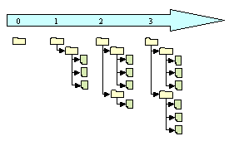
Each individual programmer checks out a working copy. A working copy is a collection of files and directories under revision control. Each file tree in the figure above is an example of a working copy that could be checked out from the repository. During the development work cycle these working copies are updated and synchronised with the repository.

When a commit is performed your changes are sent from your working copy to the repository. A commit makes your changes available for your colleagues. When a commit is performed it is customary to write a log message describing the changes performed.

Using revision control makes it possible to get an amazing overview of the work performed at any time from anywhere. If one project member has a problem that is difficult to solve another project members can easily get information of what is performed and support the other project member to solve the problem.
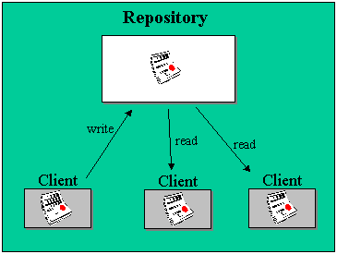

CollabNet
CollabNet is a California-based company that in the year 2000 provided the initial founding to begin development work on Subversion. CollabNet currently has several paid developers working on the Subversion project. They offer a wide range of products and services to improve software quality and accelerate time-to-market during product development. Their main product is SourceCast, which is a Web-based software development platform. Subversion is aimed to be the successor of an existing revision control system called CVS (Concurrent Version System) and CollabNet intends to make it a part of the SourceCast platform.

Subversion
Subversion is a free open source revision control system, which makes it easier for several people to work within the same set of files. The files are placed into a central repository. Subversion has a number of options. An attempt to analyse the Ankh integration of these SVN options from the users point of view is done in the mental model in this report. The Ankh integration of these SVN options are analysed from the developers point of view in a conceptual model in the product report. Additional information of Subversion can be obtained from http://subversion.tigris.org.
When we started to work with Ankh Subversion (SVN) had to be used from the command prompt. The prompt below shows the status command “svn st” followed by feedback from SVN.
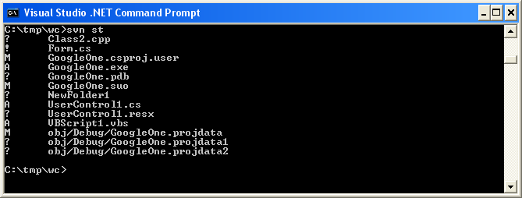

Aim
The aim of this project was to provide an integration for Subversion into the existing coding environment Visual Studio .NET. By making an addin for Visual Studio .NET Subversion is made available to a huge new user base. It also eases the way developers work with revision control, since subversion commands is accessible directly from Visual Studio. The .NET wrapper layer is also available as a standalone component so that it easily can be used in other applications in the future.

Why use Ankh?
Ankh is a free open source tool that integrates the revision control system Subversion into VS.NET. Currently there are several revision control systems available that plug into VS.NET on the market, but none of them are free.
Subversion is the successor to a widely used revision control system named CVS (Concurrent Versions System). Subversion was initially founded to improve CVS. The initial goal of the Subversion project is to preserve the same functionality as CVS and fix the most obvious flaws. Ankh is recommended because it is a useful, free tool, which offers an improvement over the widely used CVS.

What can Ankh do for you?
When we started to integrate Ankh into VS.NET we decided to prioritise those options that were most frequently used on a day-to-day basis. We aimed to get a product that could be used as soon as possible. Priority were therefore made to the integration of the Subversion commands add, update, delete/remove, commit, diff, status, list and revert. Ankh currently contains the following functionality:

- View status icons in working copy in Solution Explorer (Status icons in Solution Explorer)
- Add files, directories, project and solutions (item) to the working copy (Add)
- Update working copy item to include changes from last revision (Update)
- Examine changes of item in working copy (Diff)
- Revert changes in item in working copy (Revert)
- Delete/remove item from working copy (Delete)
- Commit changes to the repository (Commit)
- Show file tree view of repository in Repos Explorer (Repository Explorer)
- Authenticate the user if the repository used is restricted

Ankh mainly supports Visual Basic (VB), Visual C# (VC#) and Visual C++ (VC++) projects. Support for VC++ projects is currently somewhat weaker than for VC# and VB projects.

Project specifications
To ensure the sanity and quality of the system at any given moment, and in order to catch regression bugs, we conducted continuous unit tests using the NUnit testing framework.
We have provided NAnt build scripts that enable NSvn to be built without requiring the user to have Visual Studio.NET installed. The .NET wrapper layer is then available as a standalone unit for use in other applications.
The .NET wrapper layer covers the SVN client's API based on last version of SVN.
Common programming guidelines were composed to get an overall consistent look of the code.
Subversion was used for revision control both for the source code and documentation. All documentation was written in English.

The group had one available PC at HIO. We installed the following to this computer:
- Windows 2000 5.00.2195 Service Pack 3
- Visual Studio .NET 7.0
- Subversion.
As CollabNet is situated in USA all our communication was conducted via mail. CollabNet did not provide any software or computer equipment.

Planning and methodology
This section describes how we worked through the different phases of the project in general.

In the beginning of the project the group members worked together shorter or longer periods almost every day until the whole group mastered all the new software and tools that were to be used for the project. In this period we worked mainly together the three of us at the school computer and over remote sessions to computers located at our respective homes.

We started to work individually when all group members had successfully installed required software and tools on their home computers. We continued to meet at school also after we started to work independently at our home computers. In periods when we worked separately we communicated via MSN Messenger, mail and cell phone.

We intended to give all group members the possibility to participate on as many as possible of the different aspects of the project. All group members have coded in Managed C++, we have all made NUnit tests, and we have all coded C# in the GUI layer and the wrapper layer. All group members proofread all documentation.

During the project period we have discussed what to do and individually proposed what to work with. We have not had any group leader that has dedicated work, but taken the initiative for different tasks ourselves.

We did early decide that Arild was the contact person towards CollabNet, Per was the contact person towards the computer department at HIO, and Kristin had the responsibility to present weekly progress to Eva Vihovde with contribution from the rest of the group if needed in weekly meetings.

In the beginning of the project period we used the waterfall method. Results from one phase were used in next phase of the development. Results from the pilot project were used in the design phase. Results from the design phase were used in the coding phase. It was not possible to start VS.NET integration before the wrapper was completed.

Ankh was developed by using a prototype methodology. We first made a simple prototype of Ankh with reduced functionality and gradually included additional menu options and advanced functionality.

The development was conducted mostly using an iterative ideology, and we placed a lot of emphasis on testing early and often. We also used Ankh itself to develop Ankh, something that gave us a deeper insight in the strengths and weaknesses of the product, and made it easier to resolve bugs.

We used a prototype methodology in the testing of the Ankh GUI in the design phase. Details about the paper prototype testing is described in the subchapter Testing.

We aimed at avoiding duplication of code lines. If more than three code lines were used more than once, usually the common functionality was factored out into a new method. We attempted as far as possible to reuse already existing methods.

The technical challenges the group has been exposed to have mainly been solved internally within the group or using mailing lists, news groups and books. We have aimed to avoid Ankh workload in technical issues on our supervisors.

We made the project specification and work schedule ourselves. During the project period we experienced that it was difficult to make realistic plans and follow the time schedule, but in the end we find that we did not deviate considerably from the origin project specification taken into account the challenges we have gone through.

The tools used are described in detail in the appendix and subchapter XXX Learning phase and tools used.

Ankh became a part of the well established open source community at http://ankhsvn.tigris.org in Easter time. We communicated with the users of Ankh through the ankhsvn mailing list. The interest shown have been encouraging.

We spent some effort in developing an optimal process environment. As we planned to work separately in periods we needed a system where we could follow the project progress at anytime from anywhere. We therefore used revision control. To be able to at any time get the last update of the project we reviewed information from commit mails, build mails, the diary and had code reviews in addition to SVN revision control. Commit mails, build mails and the diary are described in the sections below.

Commit mail
Every time a project member performed a subversion commit, a mail was sent to all group members. The mail contained a log message written to the specific revision and an “svn diff” that contained information about which files and directories that had been modified, added or deleted and which sentences that had been added or removed in each file (not binary files).
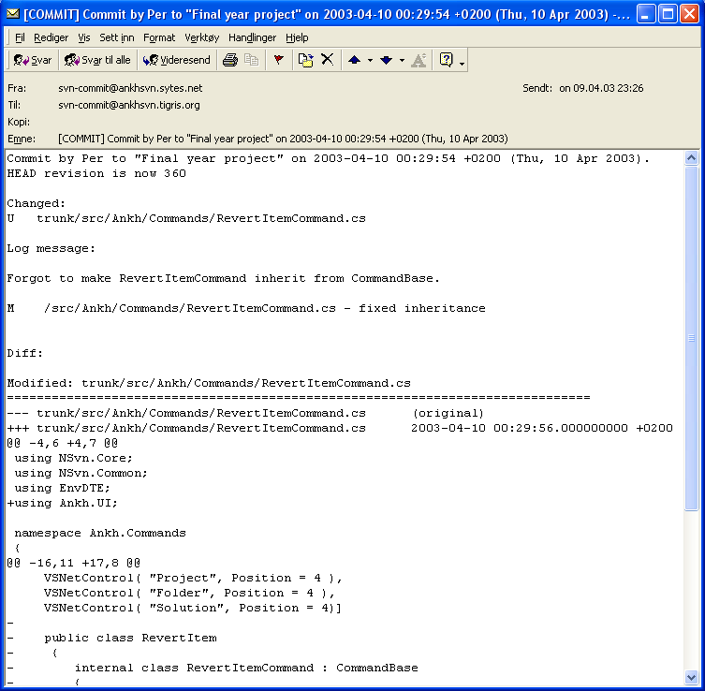
Using revision control and receiving commit mails made it possible to get an overview of which work was performed at any time. If one group member had a problem that was difficult to solve another group member could easily get information about the problem and support the other member.

Build mail
Every time a project member published changes to the rest of the group, an independent NAnt build outside VS.NET was performed. In this build all unit-tests were ran to ensure the sanity and quality of the system at any given moment. A mail was sent to each group member with information about whether the build and tests was run successfully. A Draco server for independent NAnt build and frequent unit –testing was installed and configured. Draco supported some revision control systems (CVS, VSS, PVCS) but not Subversion. We therefore contributed code to the Draco project to support Subversion.
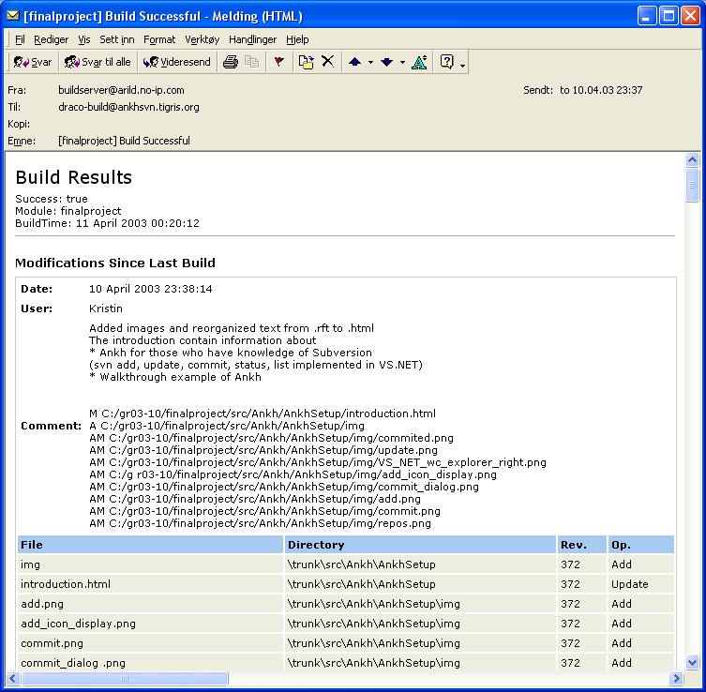

Diary and Internet sites
The Internet site was adjusted to give focus on Ankh as a product, and not merely as a final year project at HIO. The diary had both a public and a private part. Both supervisors had write access to the diary. The diary provided information of the Ankh project; a news part where important milestones were published and a part were we wrote information on a day-to-day basis.

In the last part of the project period Ankh became a part of the well established open source community at http:\\ankhsvn.tigris.org. From this sight Ankh were offered a number of utilities. One of the utilities were the possibility to subscribe to mailing lists. We did get a number of observers showing interest in the Ankh project. We communicated with the users of Ankh through the ankhsvn mailing list. The interest shown have been encouraging. In the tigris.org Open Source Community an issue tracker also was available for ankhsvn. We started to use this tool close to the Alpha release.

Issue-tracker
The issue tracker lists preliminary weaknesses and possible future improvements of Ankh. The issue list shows type of feature, priority, status, result and summary of the issues. This list helped us to remember things we planned to implement in later versions and gave us the status on issues to be solved in near future.

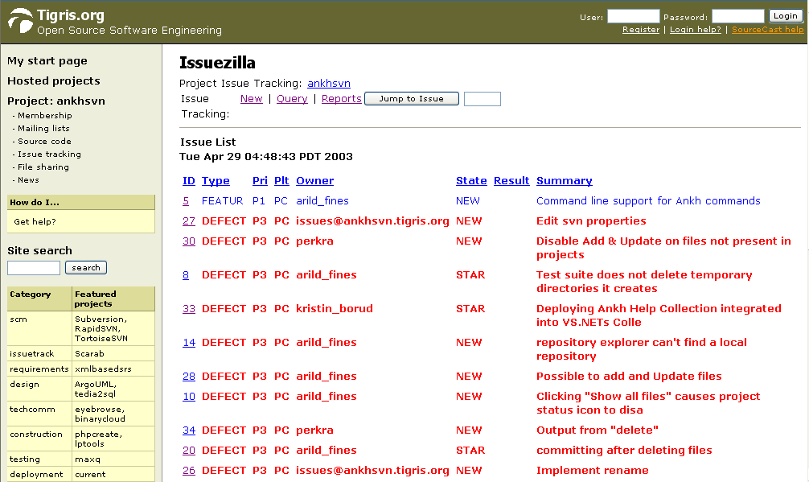

Relations to the employer CollabNet
CollabNet did not provide any software or computer equipment. We communicated with CollabNet via mail. We did not arrange any meetings, as CollabNet is located in the USA. Through the development phase we aimed to inform CollabNet about our progress. We sent mail when we had reached important milestones and frequently used our diary. CollabNet helped us in the process to be a part of the well-established open source community at http://ankhsvn.tigris.org.

Development process
This chapter covers the development process in the Ankh project. We passed through phases of learning, design, implementation/coding, and testing. This chapter describe general challenges in the development, which tools used for what purpose, what we did within each phase, alternative approaches, and arguments for the selected GUI.

Pilot project

In this phase we wrote progress report, project proposal, contacted CollabNet, installed software on the school PC, coded the diary, made the work plan and work schedule.

Learning phase and tools used

During our project we continuously used Subversion for revision control. Revision control systems are not a part of any lectures at HIO so we had to learn how to use Subversion and understand parts of the Subversion code (whose API is coded in C) to be able to create the Ankh NSvn wrapper layer. To get a better understanding of the Client API in Subversion we frequently referred to the SVN API documentation that was provided through a tool called doxygen The doxygen tool made it possible to get a kind of code comment web report of the SVN API documentation.

To become familiar with the VS.NET environment we explored features and ran macros and samples available through the help utility. During the development phase we frequently used the integrated help utility in VS.NET.

The code was mainly written in C# except for a thin Managed C++ code layer in the NSvn wrapper. To get familiar with the C# programming language we started to look at tutorials in C# and ran samples advised by the VS.NET help utility.

To gather information about VS.NET addins we searched the Internet, tested some available free addins, read articles about the VS.NET addin architecture and used the help utility in VS.NET.

To get an overview of NUnit and NAnt we looked at tutorials.

The CASE tool Enterprise Architect were used to develop use case and class diagrams as one of the group members were familiar with this tool and could easily transfer his knowledge to the rest of the group.

The diary was programmed in python as one of the group members were familiar with the programming language and we were not sure whether a Tomcat server would be available for two alternative diaries made last year in the Distributed Information Systems course. Most of the diary at our Internet site was coded during Christmas holiday last year, but the site was maintained and adjusted through the whole project period.

A more detailed description of tools used is described in the product report and in the appendix in this report.

Design phase
In this phase we agreed on system design, analysed the potential users of our program, tried to figure out what Ankh could be able to do for the user in a mental model and discussed the navigation model and menus to be used.
A conceptual model of Ankh from the developer’s point of view was made where we analysed each menu-option in Subversion and how it could be implemented in VS.NET. These use case diagrams and schemes are enclosed in the product documentation.
Common programming guidelines were composed before we started the coding to get an overall consistent look of the code. These guidelines are described in the product documentation.

System design
The system is divided into two main layers, a GUI/addin layer and a .NET wrapper layer. The addin/GUI layer contains the addin itself and code for graphical user interface written in the C# language. This layer is called Ankh. The wrapper is divided into a lower level part for the SVN's client API coded in Managed C++ and a more object-oriented high level part coded in C#. The .NET wrapper is called NSvn.
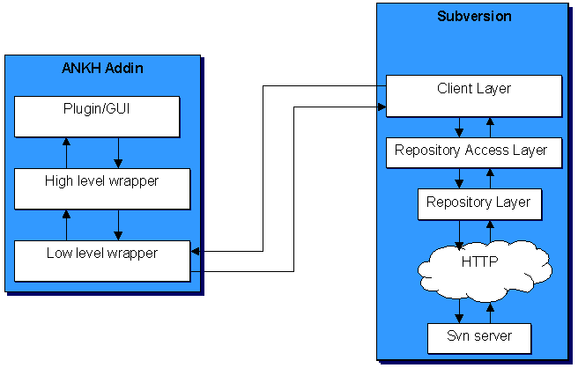

Analysis of the users of our program:
The users of Ankh:
- Have programming experience.
- Use or have knowledge about VS.NET.
- Have knowledge about revision control systems.
- Are fastidious to design and user-friendliness.
- Are usually male.
- Are often within the age of 20-45.
- Are probably member of a project group
- Choose to use our addin because a revision control system is a useful tool in development of a potential software product
- Might have prior knowledge of Subversion or CVS (the successor to Subversion)

Ankh is made for a programming environment. We concluded that ordinary people without programming experience would not represent Ankh users. A high level of functionality from experienced users would therefore be required for the GUI.

Mental model
A mental model from the users point of view was made to describe the functionality of the wrapper and what Ankh could do for them, if we were able to implement all commands from Subversion. Two actors were identified; the programmer that wants to use revision control and the repository that could be compared to a server (with some additional features). Relations between the objects and the actors are shown with lines. The action objects Import or Checkout must be performed before any of the other action objects can be performed (i.e. the solution in VS.NET has to be under revision control). An item means a file, folder, project or solution.

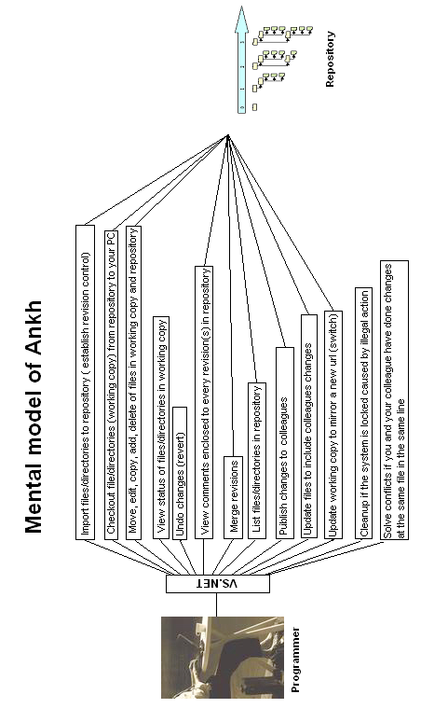

Navigation model and menus
Our goal was to implement Subversion into VS.NET as smoothly as possible. The VS.NET GUI was rather complex with lots of windows, menus and icons. Ankh was supposed to be a supplementary tool to VS.NET. Making fancy design in fresh colours would probably act distracting on the programmer who is supposed to concentrate on the coding. We therefore decided to use as much as possible of the already existing GUI. We added a new pane to the ouput view, implemented icons into Solution Explorer, added new Explorer pane and added new menu options to the already existing menus connected to a file, directory, project or solution.
The name Ankh, which is the name of our addin, was selected because it is Egyptian and can be visualised as a simple icon that easily can be used in the marketing of Ankh. It was important to select an icon that could not be confused with another well-known software/tool and had a neutral meaning. As projects on the tigris website tend to use Egyptian words we decided to follow their trend.
The menu choices are as functional and obvious as possible. For example the command "svn ci" are named "commit" in the menu context. There might be some programmers that already are familiar with SVN. The wording used in Ankh therefore doesn’t deviate considerably from the SVN standard. We have deliberately avoided new notions. “Publish” could have been a more understandable notion for “commit”, but as we decided to also take into account users already familiar with SVN we have avoided new notions.

Our navigation model is described in the figure below. If the programmer right click on a file, folder, project or solution (item) a menu will pop up. If input parameters for the option selected are required, a dialog box will be displayed. The result of the action initiated in the dialog box or from the item menu will be displayed in a AnkhSVN pane in the Output view. If the option selected were Edit properties we planned that new properties would be added to the Properties Window. There is also a new pane containing a file tree view of the repository.

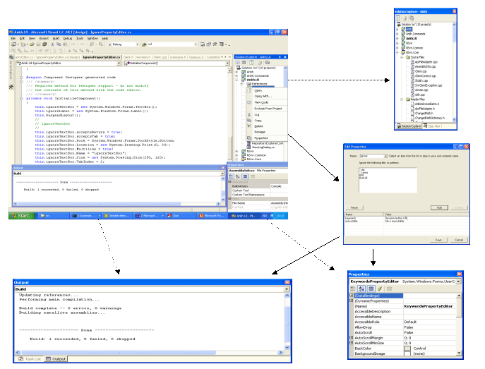

Implementation and coding phase
Before we started the coding we had agreed on common programming guidelines to get an overall consistent look of the code. The programming guidelines are described in detail in the product documentation.
During the coding phase we continuously tried to assured that we worked within the frames of the project specification. Use case diagrams and schemes were used as basis for the coding.

General project challenges
New versions of Subversion were released about every third week as Subversion was under development. We therefore had to adjust our addin during the development phase to new versions a number of times. Within every update we had to check out the source code of Subversion, build the project and distribute the .dll files to the Apache server and adjust new changes in Subversion to our addin.
This was a time consuming process. We started with SVN version 0.16 and ended with version 0.22.2.

During the project progress Subversion unexpected changed their Client API to include a more flexible authentication. This introduced a new client context structure that included client specific callbacks and batons, which served as a cache for configuration options and other various data. This made a delay in the project.

In middle March Microsoft announced a potential serious bug in VS.NET that only affects C++ developers. The bug could occur while creating Managed C++ Class Libraries that usually contain a mixture of native code and intermediate language (IL).
The build product of a “Managed C++ application” is an assembly of IL with an .exe extension. As we are using mixed DLLs this bug could affect our addin. A possible suggestion of a “workaround” solution for this bug was to set the build output in the Managed C++ Class Library project to have an IL-only file. As we had limited time available and did not experience a big impact of this bug we have not implemented the “workaround”.
The most difficult part of the C# coding in the Ankh project was the integration into VS.NET because this area was poorly documented and few relevant examples were available. The examples available were mainly macros coded in Visual Basic. To gather information in this phase we used news channels, mailing lists, books and searched the Internet. As the Ankh project is open source we hope to transfer our knowledge of the VS .NET integration coded in C# to others. The Ankh project represent a complete example of how to hook up to menus, make explorer panes, output panes and how to make dialog boxes and user controls coded in C#.
The project specification was important in the choice of the selected GUI. Based on the feedback from the paper prototype testing we realised that an Ankh Help was required. The Ankh help was not specified in the project specification.

NSvn wrapper layer
NSvn is the name of our VS.NET wrapper. The choice of the name selected was based on the short name of Subversion, SVN, combined with the letter N symbolising .NET. The wrapper contains a complete translation of the Subversion Client API coded in C. The wrapper is divided in two levels. A lower level part coded in Managed C++ and a more object-oriented higher-level part coded in C#. NSvn contain the functionality of all “svn” commands described in the SVN Client API. Unit-tests to verify the translation were performed for all “svn” commands. The NSvn wrapper was built outside VS.NET by the NAnt tool. The .NET wrapper layer is available as a standalone component so that it easily can be used in other applications in the future.

We primarily intended to write most of the system in the C# programming language, but discovered that writing the .NET wrapper layer in Managed C++(C++ extensions for the .NET environment) was a better choice since Managed C++ offered a better integration with C-based APIs such as that of Subversion. Another alternative was to use a tool called SWIG (Simplified Wrapper and Interface Generator) - a tool that generates wrappers for C and C++-based APIs automatically. The C# module had recently been added to SWIG and was still in a state of development. We research these alternatives and seeked advice from people with knowledge in the area on the Subversions mailing list. We generally received support from the mailing list to our choice

It was not possible to start the VS.NET integration before the wrapper was completed.

Integration of status icons in Solution Explorer
This subsection describes the integration of the SVN command status into VS.NET’s Solution Explorer to give an indication of the GUI improvements and challenges of the integration.

The picture below shows an example of how SVN works today in a command prompt.

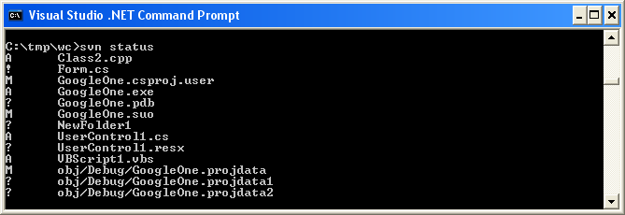

The “svn status” command prints the status of files and directories in a working copy. A working copy is a collection of files and directories under revision control. The symbols in front of each file indicate the status of each file or directory.

The Subversion command “svn status” was integrated into VS.NET in Solution Explorer. Solution Explorer display files, directories, projects and solutions (item) with updated Ankh status icons in front of each item. The status icon visible in the Solution Explorer makes it easier to see which files that have changed status while working.
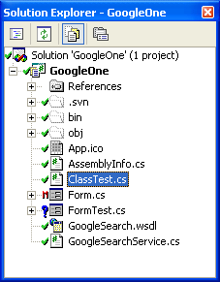
By using icons we hope to help the user to reduce his cognitive strain in a longer term .
The meaning of the different status icons are listed below:

Unversioned item: Item not under revision control.
Versioned item: Item under revision control.
Modified, versioned item.
Added, versioned item.
Deleted, versioned item. XXX(This icon is not visible in Ankh Alpha 1.0.) To be removed ?
Conflicted, versioned item: If two users modify the same file at the same line a conflict will occur if the file is under revision control. The conflict occurs because the repository simply don’t know whether both or only one of the lines should be added. In some coding cases these new lines could mean the same and it would be logic to choose one of them.
locked, versioned item : A locked item is an item that is not accessible. During for example a commit an item is not accessible for additional changes – it is locked. XXX (This icon is not visible in Ankh Alpha 1.0.)
To be removed ?

The red colour of the icons are used to indikate danger or attract attention. If an item is modified it could mean that some text is scheduled to be removed in a potential commit. Deleted items are scheduled for delete in a potential commit. Data that are modified or deleted therefore represent a danger because data could be “removed” from working copy. If an item is conflicted or locked a warning message will be displayed. It is important to solve a potential conflict and cleanup locked items. Red colour is therefore used to attract attention to locked and conflicted items.

The green colour on the versioned item icon () signalise that everything is ok. If a commit succeed the icon will be displayed in front of the committed item. The yellow colour on the added, versioned item icon () signalise that the item is ready (scheduled) for commit. Blue colour on the unversioned item icon () signalise a new category of items which is not versioned.
Ankh update status icons automatically after the status has changed. When we first integrated the status icons into VS.NET we refreshed the status icons on all items in the whole file tree view if the status on one item was changed. This was very time consuming and we therefore modified Ankh to refresh the status on the particular item(s) if the status had been changed. A recursive refresh option of the status icons is available in the item menu for the solution, individual projects and folders.

Ankh integration of menu options into VS .NET
This subsection describes the Ankh integration of the SVN command add, update, remove/delete and revert into VS.NET to give an indication of the GUI improvements and challenges of the integration. Below is the item menu for the file.

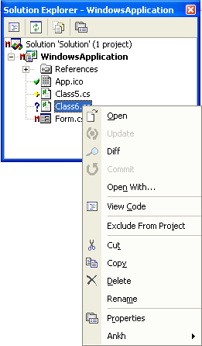

In VS.NET item menus are implemented not only for files and directories, but also for projects and solutions. Hooking up to these menus required integration of update, add, remove, delete, revert not only for files and directories but whole projects and solutions. VS.NET is a coding environment for several coding languages. Solution and Projects in Visual Basic, Visual C#, Visual C++, Setup and Deployment Projects and Other projects are different. It was required to identify and analyse which files and directories these different projects and solutions included to be able to perform Ankh menu options recursively (on all files and directories within a project or solution) also on different projects and solutions. Support for C++ projects are weaker than support for VB and C# projects. Below is the Add New Project dialog with a list of some of the different project types in VS.NET.

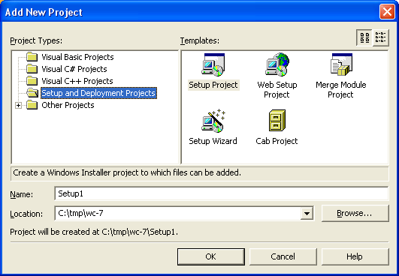

When VS.NET Delete an item, Exclude an item From a Project or Remove an item from a solution in a working copy – Ankh must catch the event and exclude or delete the item automatically from the working copy. The event fired by VS.NET was different for C++ items compared to items in the other coding languages this made the coding more complicated than assumed on beforehand.

Ankh icons are meant to help the user to remember the menu options and thereby reduce the users cognitive load. It is easier to remember a picture than to remember a technical term. The Ankh Add option could be confused with the VS.NET Add option. To avoid this the Ankh Add option has an icon in front of the menu option and is placed in the Ankh submenu.

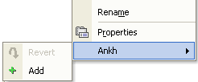

A magnifying glass was used in front of the Diff option to help the user remember that the Diff option display details about what is removed and added text since last local commit or update.

Revert could be associated with “undo” as it revert changes performed in the working copy and brings the working copy back to pristine state. An icon that looks like the undo icon is therefore used in the item menu in front of the revert option.

If the revert option is selected in the item menu for a specific item - the Revert dialog is displayed. The Revert dialog below was integrated on users request after the source code release at http://ankhsvn.tigris.org. Details from this release are given in the test report.

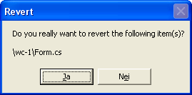

We used an output pane in VS.NET to display feedback from item menu options.
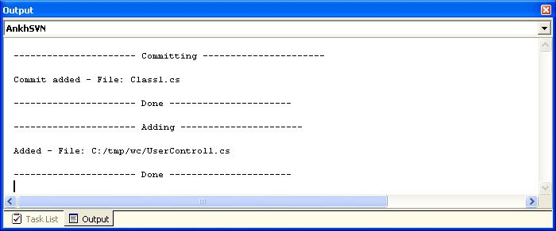

Integration of Diff in VS.NET
This subsection describes the Ankh integration of the SVN command diff into VS.NET to give an indication of the GUI improvements and challenges of the integration. The Diff option is available from the item menu in Solution Explorer or from within the Commit dialog. Below is the Diff option displayed in code view in temporary file.

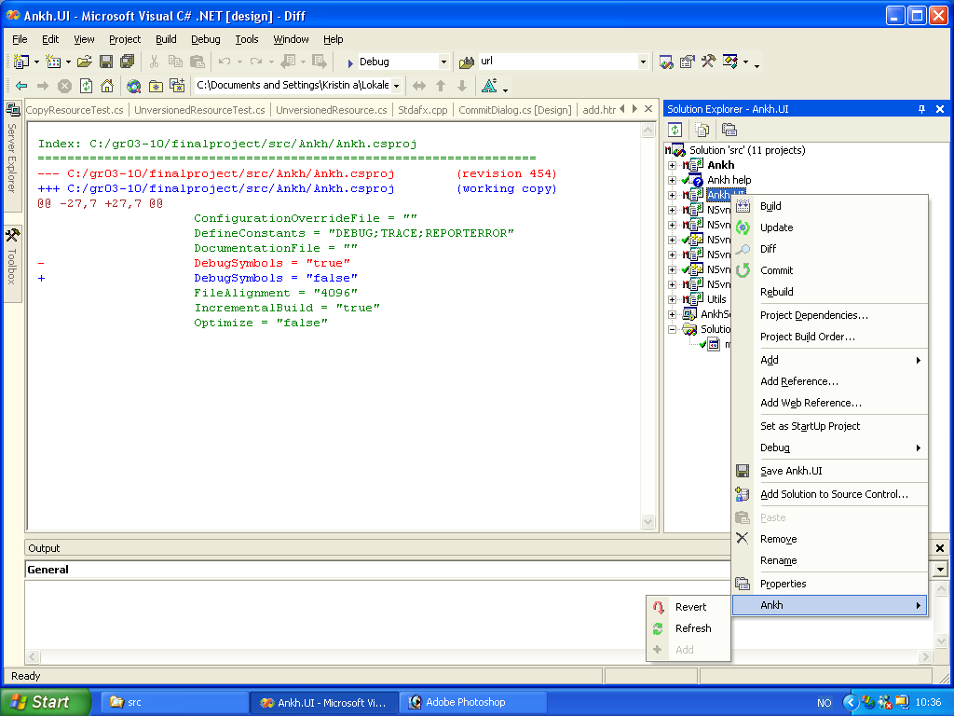

The Diff option makes it possible to examine changes performed in the working copy.
Red colour indicate text removed (danger), green text indicate unchanged text and blue indicate new text added.

Integration of Commit in VS.NET

This subsection describe the integration of the SVN command commit into VS.NET to give an indication of the GUI improvements and challenges of the integration.

Image of the Commit dialog is shown below.

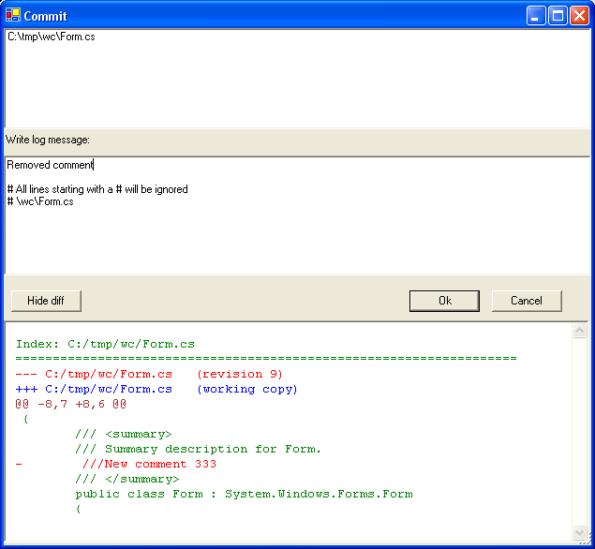

During the testing period while we used Ankh while developing Ankh we discovered that it was useful to visually see the changes we had performed while writing a log message. We often did several changes before a commit and it was difficult to remember all of them. The Get diff button in Commit dialog display changes performed since last local commit or update. The diff is therefore available both from the item menu in Solution Explorer and inside the commit dialog.

If the repository require authentication for the commit a Login dialog was displayed.

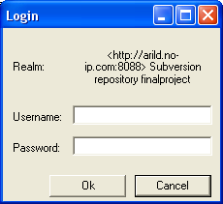

Integration of file tree view of repository in VS.NET
This subsection describe the integration of the SVN command list into VS.NET’s Repository Explorer to give an indication of the GUI improvements and challenges of the integration.

The picture below shows an example of how the SVN command list works today in a command prompt.

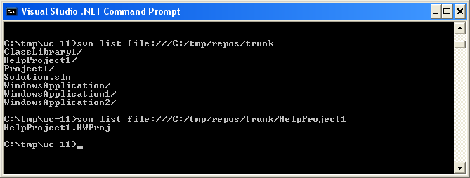

The “svn list” command prints a list of the content within the directory in the repository defined based on the url. If the repository contain a large number of files and directories it is required to do the list command a number of times to get a complete overview of the repository by using the prompt. We integrated the SVN list command as a file tree view into Repository Explorer in VS.NET.

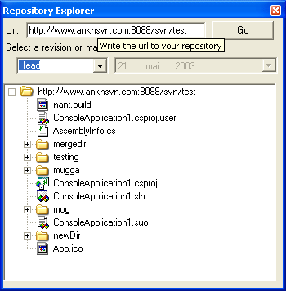

Tooltips are implemented in dialog boxes and is intended to work as a simple help.
A date picker was introduced in Repository Explorer if date revision was selected to reduce the possibility of wrong user input.

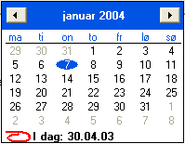

Examples on reuse of user controls in GUI layer
We aimed to not duplicate codelines. An example of creative reuse of code lines are shown from the GUI layer. In the Ankh.UI namespace we divided dialogs into smaller pieces by using User Controls. The RevisionPicker user control shown below was used both in Repository Explorer and in the View Log dialog. We did unfortunately not manage to integrate all dialogs made in the Ankh.UI namespace, but this namespace represent a complete collection of the dialogs required for the Ankh integration.

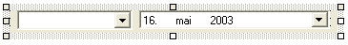

The RevisionPicker above is used both in Repository Explorer and View Log dialog below.

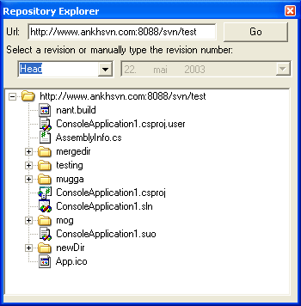

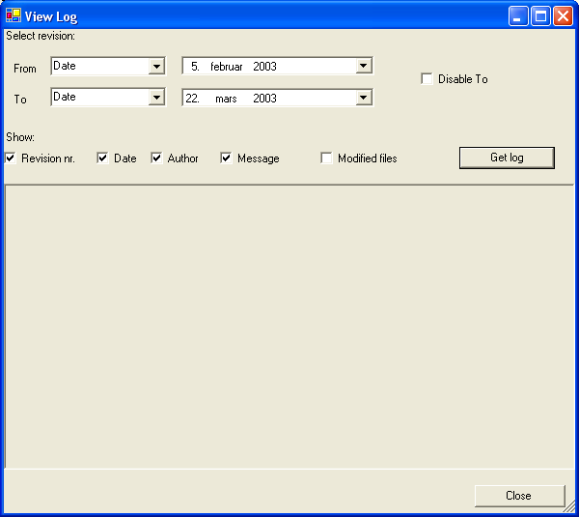

Another example of not duplicating codelines in the GUI layer was user controls used in the Edit Properties dialog shown in the subchapter Avoiding duplication of code lines in GUI in the appendix.

Ankh Help integration
In respect of the potential new user group we made priority to start the development of an advanced Ankh Help integration into VS.NET. The Ankh Help was meant to be a user guide integrated in VS.NET available from the main menu. The Ankh Help integration cover information of basic operations and how to use Ankh. Some keywords are included in the Index view. The Index view works as a simple search where the search words are listed in the Index view.
In the Contents view below it is possible to see the content of Ankh Help. If a book icon is clicked twice the folder symbolised by a book icon will open and it is possible to see the content of the “book”. In the example below. The Introduction is clicked twice and the content is displayed.

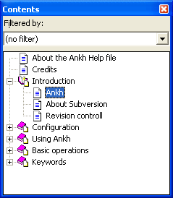
If “Ankh” is selected in the list of Contents the content of “Ankh” is visible in the ? view shown below.
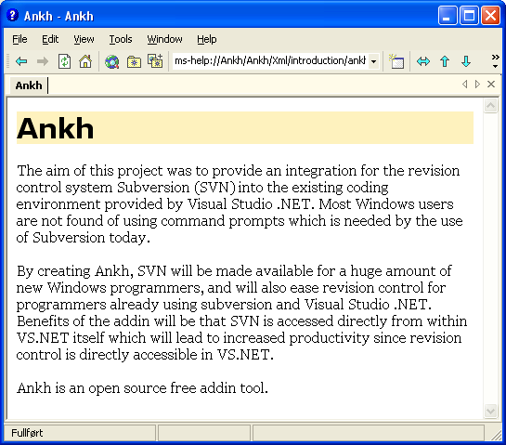
The Index view works as a simple search where the search words are listed in the Index view. We did not have time to enter all possible searching words into a base. The Index view gives you the possible searching words available. The articles connected to each search is listed in the Research view. In the below figure the keyword “about” is selected in the Index view.
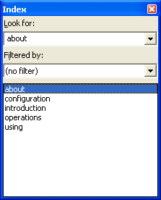
Results of the selected keyword “about” is visible in the Index Results view:
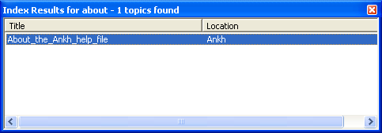
If the “About this help file” is selected - the content of “About this help file” is visible in the ? view.
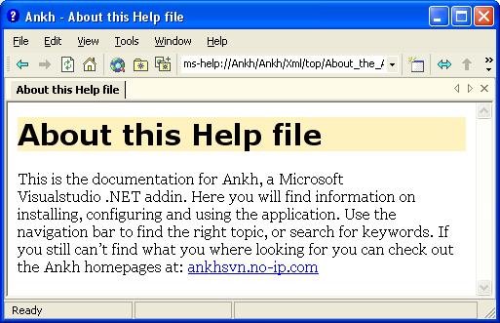
A method proposed by VS.NET to customise the Help Registration merge module was used for deployment. This method was poorly documented and few examples were available. We asked for advise at mailing lists and news channels, but did not solve the deployment part of this work. An alternative approach to deploy the project was to use H2Reg, but as this tool cost money, which is not preferable for an open source, we decided not to use it. We downloaded the trial version and had a look at the tool. A more detailed description of the problem is written in the product documentation.

Testing phase
Ankh was unit-tested with NUnit and built outside VS.NET with NAnt continuously during the development phase. Ankh was tested functionally by using Ankh while developing Ankh. The intended audience at http://ankhsvn.tigris.org tested Ankh. Feedback from these tests gave useful information of what to be improved and ideas for future development. An early paper prototype testing of the GUI confirmed that our navigation model was logic and intuitive and gave us useful ideas of how to improve the GUI. In the end Ankh was tested functionally with a number of tests described in the test report to give an indication of the robustness of Ankh. Error messages are divided in 2 categories Ankh errors and SVN errors that reflect two different tools under development.

Unit testing and independent NAnt build
Unit testing of Ankh was performed continuously during the project period to ensure sanity and quality of the addin/wrapper. Every time a commit of Ankh was performed NAnt built the project and all unit-tests were ran.

Functional testing and error handling
During the Alpha testing phase the source code was published in the well-established open source community at http://ankhsvn.tigris.org. The term alpha test means the first phase of testing in a software development process. The first phase includes unit testing, component testing, and system testing. To gather as much information as possible from this phase exception mails were sent to all group members. These mails contained valuable information about exceptions thrown from Ankh. When an exception was thrown from Ankh it was captured and the user was asked whether he wanted to send the exception and add a comment by mail. Details from the exception mails gave useful information of issues to be solved (see issue tracker at http://ankhsvn.tigris.org). The issue tracker lists preliminary weaknesses and possible future improvements of Ankh. The Revert dialog was implemented by users request from this testing phase.

After having implemented the most basic functions add, update, commit and status it was possible to use Ankh. Ankh was therefore tested functionally by using Ankh while developing Ankh. A new instance of VS.NET was started from the Ankh project. This made it possible to continuously work with the last update of Ankh and testing it at the same time with real data. Ankh was thereby tested in a natural environment with real data by using an iterative methodology.

Ankh was tested by the intended audience in Ankh Alpha version 1.0. Ankh was made available for installation from http://ankhsvn.tigris.org. Ankh Alpha version 1.0 requires the SVN Client version 0.22.2. The installer optionally included a test repository that was extracted to the computers local hard drive during installation. The persons who downloaded Ankh were encouraged to use this repository to test Ankh. Ankh Alpha version 1.0 was tested functionally with a number of tests described in the test report.

Error handling is divided in 2 categories Ankh errors and SVN errors that reflect two different tools under development.

Testing of GUI
Testing of GUI was performed to ensure optimal functionality of the GUI. A paper prototype test was performed to check whether our navigation model was logic and intuitive. We also tested whether our choice of button-names, names in menus and names on text fields etc. were logic. The test was performed on 3 test persons with programming experience. One of the persons was familiar with revision control systems and VS.NET. Before the tests were performed the test persons were given a short introduction to revision control and VS.NET. 3 scenarios were selected covering VS.NET integration of the “svn commands” commit, log and properties. The overall conclusion from these tests were that our navigation model was intuitive and logic. Useful feedback from the tests made us modify button names and text fields in dialog boxes, and reorganise the placing of buttons, text fields, combo boxes etc.. A need of Help Integration was also identified.

Deviations from project specifications
The project specification was not changed during the development process.

Process, test and product documentation was written in Word instead of XML due to strict time-schedule and unforeseen challenges. We started to write the documentation in XML. XML/XSL-documentation is suited for small documents, but among other things have no option for spell check. To get table of content, page numbering that should take into account different images sizes, headers/footers etc. complicated XSL-code would have been required. As the HIO did not require both an optimised paper and web-version of the documentation we made priority to the quality of the content in stead. We considered this deviation from the project specification of minor importance.
In respect to the new user group we have made an advanced Ankh Help that was not a part of the origin project specification.

Conclusion

Improvements due to the development of Ankh:
- By creating a GUI, SVN is made available for a huge amount of new Windows programmers. Today the audience of the SVN are mainly Unix users. We hope to convert this trend.
- SVN is accessed directly from within VS.NET itself.
- Increased productivity since revision control is directly accessible in VS.NET.
- We can offer the Windows users a FREE open source revision control tool integrated in VS.NET
- VS .NET integration coded in C# is poorly documented. The Ankh project represent a complete example of how to hook up to menus, make explorer panes, output panes and how to make dialog boxes and user controls coded in C#. Since Ankh is open source code we hope to transfer our knowledge to others.
Ankh covers the most frequently used functionality in a day-to-day basis of Subversion.
The .NET wrapper layer is available as a standalone component so that it easily can be used in other applications in the future. The wrapper covers a complete translation of the Subversions Client API coded in C to Managed C++ and C# code.
In respect to the new user group we have made an advanced Ankh Help that was not a part of the origin project specification.

Evaluation of work performed
The Ankh project was developed using advanced C# code. We have explored a new area of VS .NET that was poorly documented, and hope that our knowledge about VS.NET integration could be transferred to others through the open source community at http:\\ankhsvn.tigris.org.

The number of challenges in the Ankh project has been high. Through the project period we have worked with tools under development that still suffer from some children diseases. A possible serious bug was discovered in VS.NET and Subversion was still under development. Ankh were adjusted and built against the SVN source code for a number of SVN versions.

Due to strict project specifications there were not much space left for creativity. Even though examples of creativity is shown by:

- Using Ankh while developing Ankh.
- Reuse of user controls to avoid duplication of codelines in the Ankh GUI. In the Ankh.UI namespace usercontrols are reused within other usercontrols.
- Ankh icons in item menu were implemented to hopefully reduce the users cognitive strain in a long-term base.
In respect to the new user group we have made an advanced Ankh Help that was not a part of the origin project specification.
Ankh is available for anybody, anywhere through the open source community at tigris.org. Feedback from observers on the project has been encouraging. The Ankh project will sustain in the open source community at http://ankhsvn.tigris.org.

To optimise the working conditions and process revision control were used. Commit mails, build mails, error mails and the issue tracker made it easier to support and encourage eachother through the process period.

During the process period we have learnt how to use Enterprise Architect, Subversion and Visual Studio .NET. We have coded in C# and Managed C++, learnt how to write unit-tests in NUnit, written XML documentation, learnt how to make an addin to VS .NET and we have got a better understanding of the SVN Client API. We have learnt how an Open Source Community works and have been a part of the Open Source Community at tigris.org through the Ankh project.

Ankh was unit-tested with NUnit and built outside VS.NET with NAnt continuously during the development phase. Ankh was tested functionally by using Ankh while developing Ankh. The intended audience at http://ankhsvn.tigris.org tested ankh. An early paper prototype testing of the GUI was also performed to check whether our navigation model was logic and intuitive. In the end Ankh was tested functionally with a number of tests described in the test report.

The technical challenges the group has been exposed to have mainly been solved internally within the group or using mailing lists and news groups. We have aimed to avoid Ankh workload in technical issues on our supervisors.

Thanks to Arild who had the splendid idea of the project, represented an amazing knowledge base in the Ankh project, had an enormous working capacity and was the code guru in the group.

Thanks to Per who had an amazing ability to acquire new knowledge, showed an impressive creativity in technical discussions and has a marvellous ability to feel comfortable in whatever working conditions.

Thanks to Kristin for her always optimistic mind, her focus on the users and interest in the marketing part of Ankh.

References
- “NUnit” http://nunit.org/
- “VS.NET help” integrated in VS.NET
- “NAnt”
- ”Ant” http://ant.apache.org/manual/
- "Creating Office Managed COM Add-Ins with Visual Studio .NET” by Paul Cornell, Microsoft Corporation, June 6, 2002
- ”EA” at http://www.sparxsystems.com.au/
- “The Mixed DLL Loading Problem Using Visual C++ .NET”, March 16, 2003 http://www.codeguru.com/dll/kmg15.html
- “15 SWIG and C#” http://www.swig.org/Doc1.3/CSharp.html
- “Subversion: The Definitive Guide”, Draft: Revision 5113, 26 February, 2003, by Ben Collins-Sussman, Brian W. Fitzpatrick, C. Michael Pilato, http://subversion.tigris.org
- “Inside Microsoft Visual Studio .NET” by Brian Johnson, Craigh Skibo, Marc Young

Appendix

Dictionary
alpha testing - The term alpha test means the first phase of testing in a software development process. The first phase includes unit testing, component testing, and system testing.
API - Application Program Interface
beta release - Software under testing of the intended audience.
beta testing - Beta test is the second phase of software testing in which the intended audience tries the product out.
COM - Component Object Model (COM), a software architecture that allows the components made by different software vendors to be combined into a variety of applications. COM defines a standard for component interoperability It is not dependent on any particular programming language, is available on multiple platforms, and is extensible.
COM add-in - Is a dynamic-link library (DLL) that contains not only your custom code, but also special registry entries. These registry entries are used by Microsoft Office applications to determine the COM addin's behaviour at run time.
commit - Send changes from your working copy to the repository. Publish your
changes to your colleagues.
container – directory, project, solution
conflicted file – If two users modify the same file at the same line a coflict will occur if the file is under revision control. The conflict occurs because the repository simply don’t know whether both or only one of the lines should be added. In some coding cases these new lines could mean the same and it would be logic to choose one of the lines
CVS – Concurrent Version System. A free open source revision control system, the successor of Subversion.
GUI - Graphical User Interface
IDE - Integrated Development Environment
IIS - Internet Information Server
IL - Intermediate Language
Item – file, directory, project, solution
Item menu –
NAnt - A free .NET build tool.
NUnit - Tool for unit testing.
.NET Framework –
pristine working copy - is the last updated working copy or working copy from last local commit.
recursively – Means to do something on all subitems. If I want to add all files and directories of a specific project in VS.NET to the working copy – I will have to add all files and all directories connected to the specific project to. Files and directories are defined as subitems.
repository – A repository is much like an ordinary file server, except that it remembers every change ever made to your files.
Repository Explorer – File tree view of the repository content.
revision control system – In a typical software development environment, many developers will be engaged in work on one code base. Revision control makes it easier for several people to share the same collection of program source code. A revision control system is a centralised system for sharing information where the core is a repository.
Solution Explorer –
SVN – Short version of Subversion, which is a free open source revision control system.
SWIG - Simplified Wrapper and Interface Generator
UI - User Interface
UML - Unified Modelling Language
unversioned file – File not under revision control
VB –Visual Basic .NET
VC++ - Visual C++ .NET
VC# - Visual C# .NET
versioned file – File under revision control
VS .NET - Visual Studio .NET. A programming platform that includes editors for programming in C#, C++, Managed C++ and Visual Basic
wc - Working Copy. Collection of files and directories under revision control.
Working Copy - Collection of files and directories under revision control.

Development tools

VS.NET
Visual Studio .NET is a set of development tools for building ASP Web applications, XML Web services, desktop applications, and mobile applications. Visual Basic .NET, Visual C++ .NET, and Visual C# .NET all use the same integrated development environment (IDE), which allows them to share tools and facilitates in the creation of mixed-language solutions. In addition, these languages leverage the functionality of the .NET Framework, which provides access to key technologies that simplify the development of ASP Web applications and XML Web services.

VS.NET addin architecture
In VS.NET it is possible to make addins. This makes it possible for us programmers to add whatever preferred tool into VS.NET. We have made a COM addin.
A COM addin is a dynamic-link library (DLL) that contains not only your custom code, but also special registry entries. These registry entries are used by Microsoft Office applications to determine the COM addin's behaviour at run time.

Code Comment Web Report
VS.NET provide a tool that generates a web report displaying information about the definitions in your code in a series of .html pages. This feature allow you to browse the code structure within files in your current project or solution, such as classes, objects, members and interfaces. The comments are written in the C# source code by use of XML-tags combined with special comment syntax.

NUnit
Nunit is a free open source unit-testing framework for all .Net languages. Initially ported from JUnit, which is a unit-testing tool for Java. Version 2.0, the second major release of Nunit, was used in the testing of Ankh. NUnit brings xUnit to all .NET languages. The Nunit tests are visualised by a testing tree view where the various tests get executed gradually.

NAnt
NAnt is a free .NET build tool. Instead of writing shell commands, the configuration files are XML-based, calling out a target tree where various tasks get executed. An object that implements a particular Task interface runs each task.

C#
Microsoft C# (pronounced C sharp) is a new programming language designed for building a wide range of enterprise applications that run on the .NET Framework. C# code is compiled as managed code, which means it benefits from the services of the common language runtime. These services include language interoperability, garbage collection, enhanced security, and improved versioning support.

Managed C++
Managed Extensions for C++ are enhancements made to the C++ language. Managed Extensions simplify the task of migrating existing C++ applications to the new .NET Framework.

EA
Enterprise Architect is a project oriented UML modelling tool for the Windows platform. This tool was used to generate the use case diagrams and class diagrams.

Avoiding duplication of code lines in GUI
An example of avoiding duplication of Code lines in the GUI layer was user controls used in the Edit Properties dialog.
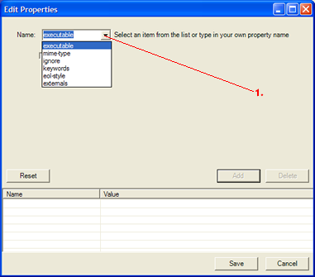

Dependant on different menu options (marked as 1 in the above figure) in the Name combo – different user controls were used. The area where the different user controls in the Edit Properties dialog is displayed are marked with dotted lines in the figure below.

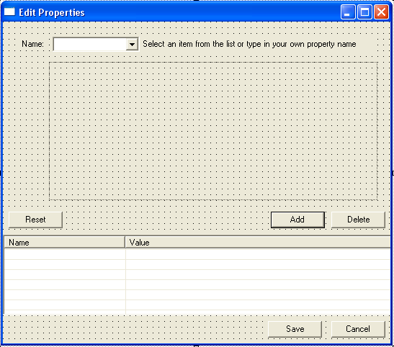

If keywords were selected in the Name combo in the Edit Properties dialog the following user control was displayed in the dotted area of the dialog.

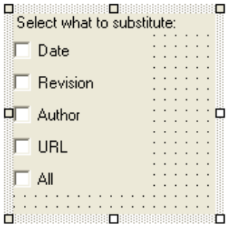

The intention in this view was that the selected keywords f.eks Date could be substituted with a real date 21.05.2003.

If eol-style is selected in the Name combo in Edit Properties dialog the following user control will be displayed in the dotted area.

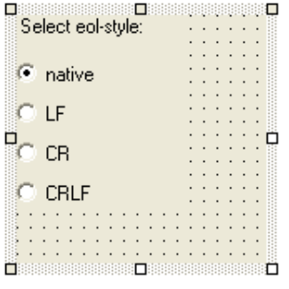
The intention in this view was that it should be possible to select different end of line style property for a selected item.

If executable was selected in the Name combo in Edit Properties dialog the following user control was used within the dotted area in Edit Property dialog.

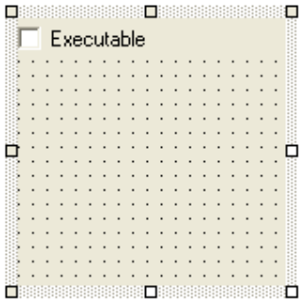
The intention in this view was that it should be possible to select whether the property was executable for a selected item.

If ignore was selected in the Name combo in Edit Properties dialog the following user control was displayed in the dotted area.

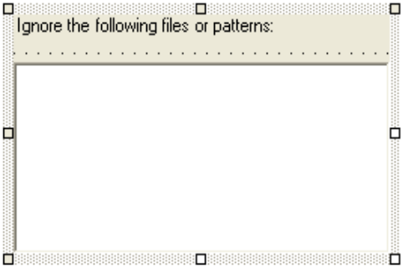

The intention in this view was that it should be possible to ignore different file types for example *.obj files for a selected item.

If the user select externals in the Name combo in Edit Properties dialog the following user control was displayed in the dotted area.

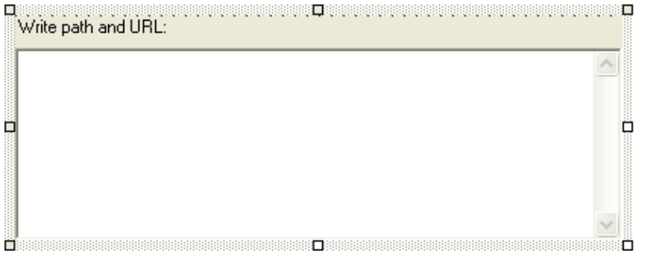
The intention in this view was that it should be possible to set a property that made it possible to for example make different subdirectories to come from different locations in a repository for a selected item.

If the user write a self defined propertyname in the Name combo in Edit Properties dialog the following user control was displayed in the dotted area.

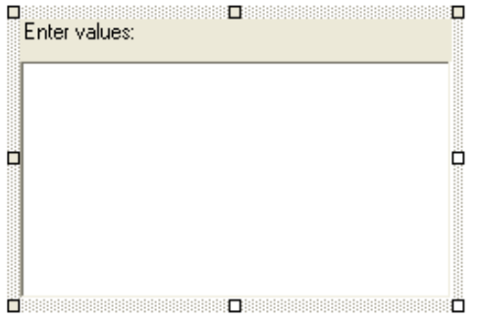

The intention in this view was that it should be possible to define a personal property.
An example on how the dialog could look if a self defined property was defined is shown below.

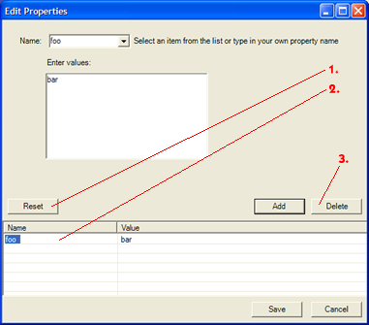

We have hereby shown an example which confirm that it is possible to not duplicate code also in dialogs in the GUI. In stead of making six different dialogs it it possible to make one dialog containing six user controls.

 

