A Different Kind of Coding Platform
Step-by-Step Lesson Flow — Mission-Based Learning (Example: Bubble Sort)
Most platforms — LeetCode, HackerRank, Visualgo — jump straight into code. Beginners don't understand why they're writing it. This platform makes users feel like they're on a mission, where coding is just one part of the journey. Each step below pairs the idea with a matching screen from the mockups.

1. Mission Briefing
Every lesson starts with a story instead of a bare topic title. Rather than "Bubble Sort," the user sees: a cargo robot has received six containers, and the launch won't begin until they're sorted. The robot talks, a small animation plays, and the screen shows XP reward, estimated time, difficulty, and the specific learning outcomes.
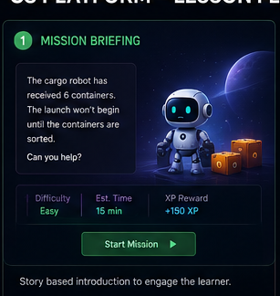

2. Understand (No Code)
Zero code here — only explanation, told through an everyday analogy (organizing books: compare two, swap if needed, move ahead, repeat until the largest lands at the end). Illustrations, small GIFs, and the robot narrating make the idea land before any syntax appears.
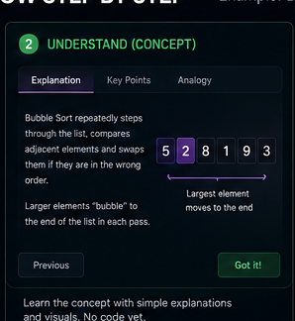

3. Interactive Thinking
Instead of teaching, the platform asks. The user sees two values and picks Yes/No on whether to swap, gets immediate feedback, and moves to the next pair. By the time they've answered a handful of these, they've already learned bubble sort without realizing it.
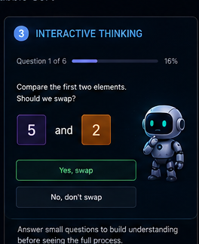

4. Visualization
The animation begins, and it's interactive rather than passive: play, pause, next step, previous step, and speed controls. Clicking any element reveals its current value, what it's being compared with, and its index. The robot walks along the array as it scans and swaps.
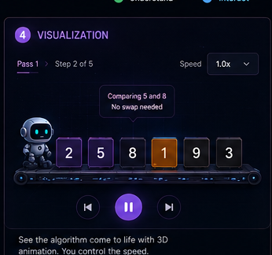

5. Prediction Mode
This is where real learning happens. The animation pauses and the robot asks what happens next — swap, don't swap, end of pass, or largest found. Correct answers earn XP; wrong answers get an explanation from the robot.
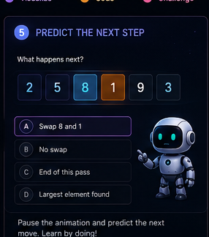

6. Dry Run Table
An automatically generated table (pass, i, j, array state, swap?) with the current row highlighted, giving students the step-by-step trace that they usually struggle to build for themselves.
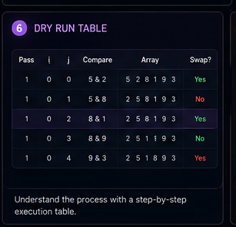

7. Code Explained
The real code finally appears, and every line is clickable — clicking a line opens a panel explaining why it's there. Even variables are interactive: hovering over a loop variable shows what it currently represents (e.g., current pass, comparing index).
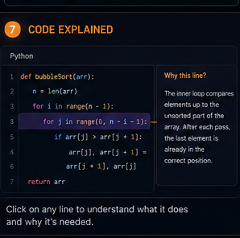

8. Fill Missing Code
Before writing code from scratch, the user fills in blanks within a skeleton, with autocomplete disabled and the robot checking each answer.
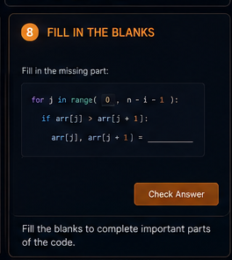

9. Build Together
The user is given roughly half the implementation and completes the rest, with hints available and the robot commenting encouragingly as pieces come together.
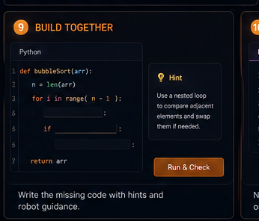

10. Build Yourself
A fully blank editor with a language selector (Java, Python, C++, Go, JavaScript, Rust, C#). An AI gives hints — never the solution.
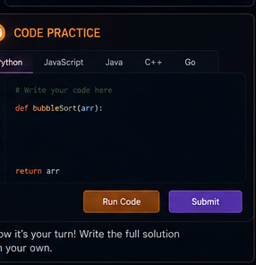

11. Test Cases
Rather than a flat pass/fail, results show input, expected output, actual output, and exactly where they diverge — making debugging far easier.
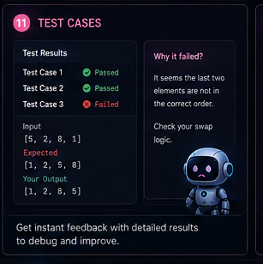

12. Boss Challenge
The user modifies the base algorithm — sort descending, sort objects or strings, find the largest K, add early exit, use a custom comparator — proving they actually understand it, not just memorized it.
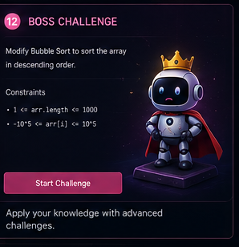

13. Real World
A section most platforms skip: where is this algorithm actually used (and where isn't it, and why)? For bubble sort, it's rarely used in production because it's slow — but it's worth learning because it teaches loops, comparison, swapping, and optimization.
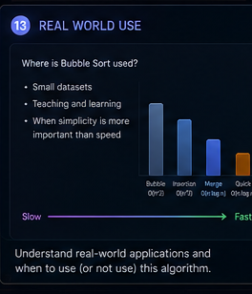

14. Rewards
Beyond XP: coins, robot parts, background themes, nameplates, badges, titles, emojis, and celebration effects — e.g., "Bubble Apprentice, +150 XP, +80 Coins, Robot Helmet Unlocked."
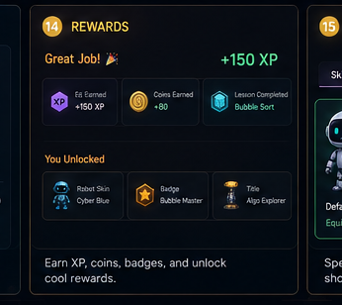

15. Robot Companion
The robot is a persistent study buddy that levels up alongside the student (Tiny Robot → Explorer Robot → Galaxy Robot → AI Commander). Coins or XP unlock skins, hats, pets, trail effects, speech styles, and post-lesson animations.
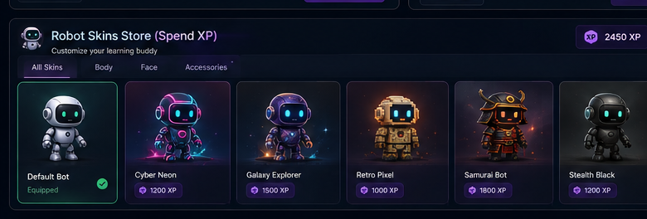
Robot Skins Store — spend earned XP to customize your learning buddy.

Bonus — "What If?" Mode
A feature worth highlighting, not yet in the mockups: after visualization, let students freely modify the algorithm — remove a loop, flip a comparison operator, start from the end, skip the swap — and watch the visualization update instantly while the robot explains the consequence. This shifts students from copying code to experimenting with algorithms, which builds real intuition faster than almost anything else.

Executed well — clean UI, smooth animation, a friendly robot, and a structured progression — this becomes a learning experience that feels like a game rather than a course, and a much stronger direction than another LeetCode clone.

