Documentation

# Qgis-Plugin: NextPrint

## Version: 2.7

## Developer: SOURCEPOLE (under Instant Print)

## Jesper Jøker Eg, GISkonsulenten up to version 2.6 (under Easy Template Print)

## Gerd Dreier geoplaning Gmbh since 2.7 (under Next Print)

# Scope

This plugin for Qgis gives the user an easy way to input text data into a print-composer, handles numerous composers and rotating maps.

The plugin is based on existing plugin “Instant Print” by SOURCEPOLE from Zurich and GISkonsulenten with added functionality to rotate plot and an easy input method for label-variables.

We have added functionality to change paper format and oriantationand some extras.

# How to use

Initial functions:

* Reads active composer from project file into list ”Composer:” sorted alphabetically.
* Sets scale to current map-scale in composer map item.
* Creates list of possible export formats
* Sets rotation to ”0”.
* Reads labels with expressions and adds them to up to 5 input fields. If no expression or less than 5 is found, input fields are left empty. Labelitems in dialog follows the order of labels in composer.

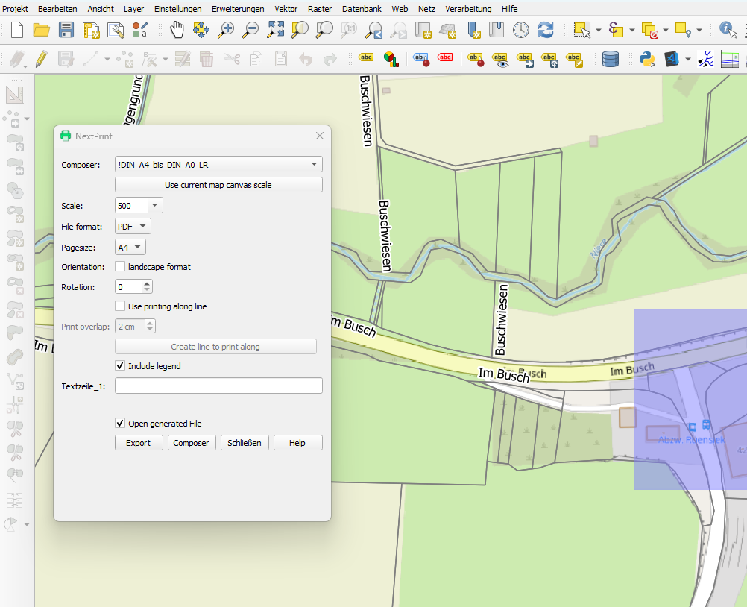

User functions in dialog:

* Select another composer from list.
* Use Map scale
* Change scale out of List or type it.
* Select file format.
* Select papersize.
* Select landscape format or portrait format.
* Change rotation. This affects all items related/locked to map rotation in composer.
* Use Printing along a line
* Input overlap size from multiprint
* Visible or unvisible the legend
* Input user defined texts
* After generation, open the PDF
* Export to file, Open the selected Layout in the Composer, Close the Window or Help to open this file

User functions in map:

* Move map extend by drag and drop

# Bindings in Composers

No template variables can have the same name as a Label-variable.

Label-variable must be in the format: [% @Region %] (pay attention to the spaces)

The plugin searches all labels items in composer. If label-item includes the characters “[% @]” this label is used to setup an input-field in dialog.

The input data is stored in project variables to further use with other composer.

# Extras

The Help-folder in the plugin directory contains composer templates and project file set up for proper use of the plugin.

# Papersize and orientation

If you want to change the paper size and want the layout to automatically adapt to the paper size, you must dynamically define the elements such as map, text or legend.

There is an example in the Layout plugin folder

See also “Creating the dynamic map canvas” on the QGIS Documentation Site

<https://docs.qgis.org/3.34/en/docs/training_manual/map_composer/dynamic_layout.html>