**Confirmations Manager Database**

**INDEX**

**Server Requirements .**………………………………………………………………………………………………………………. **2**

**Server Configuration** …………………………………………………………………………………………………………………. 2

**Database Creation** ...…………………………………………………………………………………………………………………..**5**

**Database Restoration .**………………………………………………………………………………………………………………. **7**

1. **File Stream Configuration**

The configuration manager system uses SQL Server 2012 Database with FileStream Access Level, this document explain the values and configurations required to set up the Server environment to use the Confirmation Manager Database.

1. **Database Requirements**
2. Active Directory Users
3. SQL Server 2012 CU2 or Higher
4. Windows Server 2008 or Higher
5. **Server Configuration**

As is knew it the SQL Server File Stream Access require users with Windows Authentication level also these users requires have rights in the File Stream folders created to the Database.

1. Install SQL Server version 2012 or higher
2. During the installation process enable the double authentication mode (Windows Authentication and SQL Server User Login)
3. Go to the Start 🡪 Microsoft SQL Server 2012 or higher 🡪 Configuration Tools 🡪 check all services are working and have set Mode On
4. Go to the Start 🡪 Microsoft SQL Server 2012 or higher 🡪 SQL Server Management Studio
5. Logon in the Server Instance with an user that have a sysadmin rights to Setup the server.
6. Go to the server instance name 🡪 Right Click over the Server name 🡪 Properties (image 1)
7. In the Properties windows go to Advanced 🡪 find File Stream Options (image 2)
8. Set up the File Stream Access Level to Full Access Enabled (Image 3)

Or run the next script in the SQL Server Management Studio.

USE master

GO

EXEC sys.sp_configure N'filestream access level', N'2'

GO

RECONFIGURE WITH OVERRIDE

GO

1. Validate the FileStream Share Name was created 🡪 Right Click Server Instance Name 🡪 Properties 🡪 Go to Advanced 🡪 FileStream options check the FILESTREAM Share Name

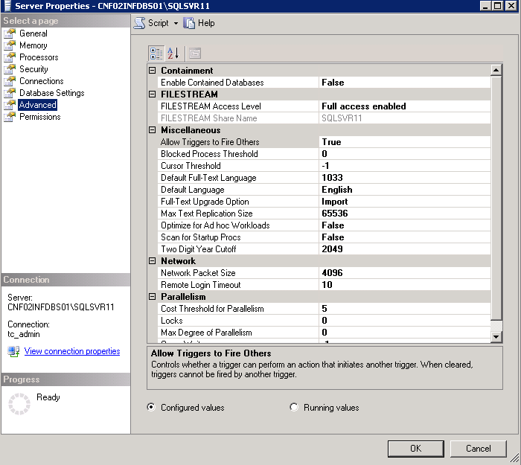

For check the File Stream Status via Query you can use it.

Values:

0 – Disable

1 – Enabled with T-SQL Access

2 – Enabled with Full Access and Windows Access

USE master

GO

SELECT * FROM sys.configurations

WHERE name = 'filestream access level'

Or

USE master

GO

EXEC sp_configure 'filestream access level'

1. The last step is check if the share resources have the correct rights to the Authenticate Users, this right is necessary because File Stream uses a Windows Authentication if the share resource not allow the access to the user, this could not save, delete or modify information on the FileStream folders via SQL Server.

This set can be check in the Server Computer via Start 🡪 Administrative Tools 🡪 Computer Management 🡪 System Tools 🡪 shares Folders 🡪 Shares here is necessary find the Share name of the resource created by SQL Server in the step # 9 🡪 Right Click 🡪 Properties.

By default SQL created this resource with Everyone and Permission Deny.

Remove the group Everyone then Add Authenticate Users and Allow the Full Control.

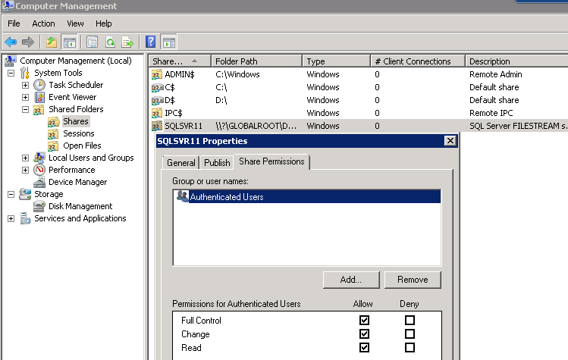

1. **Database Creation**
2. Create a new Database using Query or SQL Server Management Studio
3. In the Creation process is required add a new File Group for the database that need use FileStream.

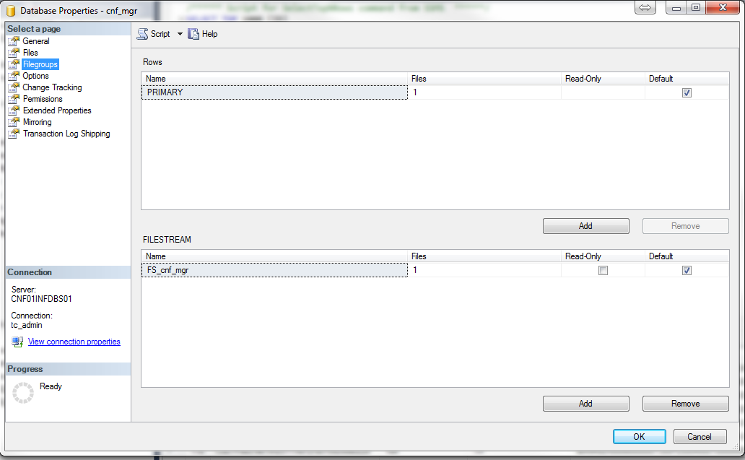

**4.1 Via Query**

USE master

GO

ALTER DATABASE cnf_mgr SET RESTRICTED_USER WITH ROLLBACK IMMEDIATE

GO

PRINT 'DATABASE ALTERED RESTRICTED MODE'

GO

ALTER DATABASE cnf_mgr SET FILESTREAM(NON_TRANSACTED_ACCESS = FULL) WITH NO_WAIT

GO

PRINT 'DATABASE ALTERED FILESTREAM ENABLED'

GO

ALTER DATABASE cnf_mgr SET MULTI_USER WITH ROLLBACK IMMEDIATE

GO

PRINT 'DATABASE ALTERED MULTI MODE'

GO

ALTER DATABASE [cnf_mgr] ADD FILEGROUP [FS_cnf_mgr] CONTAINS FILESTREAM

GO

PRINT 'DATABASE ALTERED ADDING FILESTREAM GROUP'

GO

ALTER DATABASE [cnf_mgr] ADD FILE (NAME = N'cnf_mgr_fsdata', FILENAME = N'Path')

TO FILEGROUP [FS_cnf_mgr]

GO

PRINT 'DATABASE ALTERED ADDING FILESTREAM FILE TO FILEGROUP'

GO

1. The last step is Add the file path to store the FileStream information

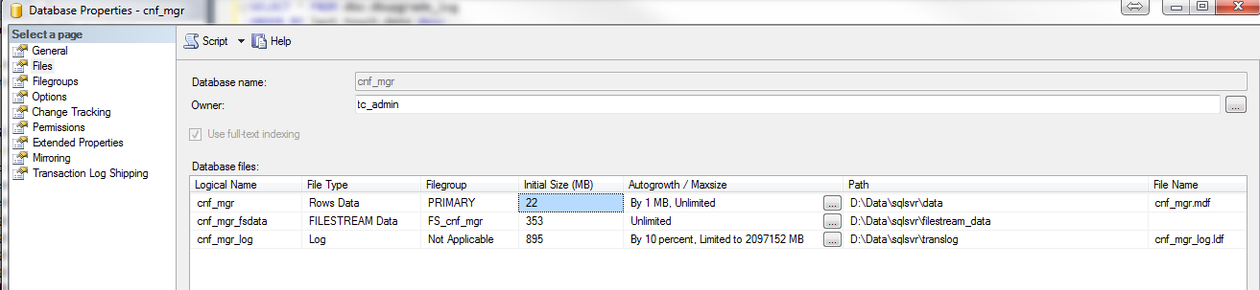

1. **Restoration**

**5.1 Restore using SSMS**

To restore the **cnf_mgr** DB that previously was used on other server only is required validate the FileStream configuration is Enabled in the server and the Share resource is working fine.

When it is validate the restoration process is normal as others Databases.

When the restore process is performed is necessary specified a path with enough space to store the FileStream information.

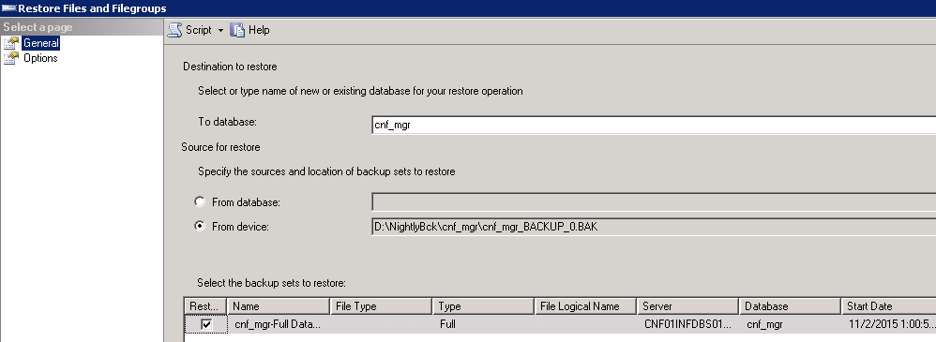

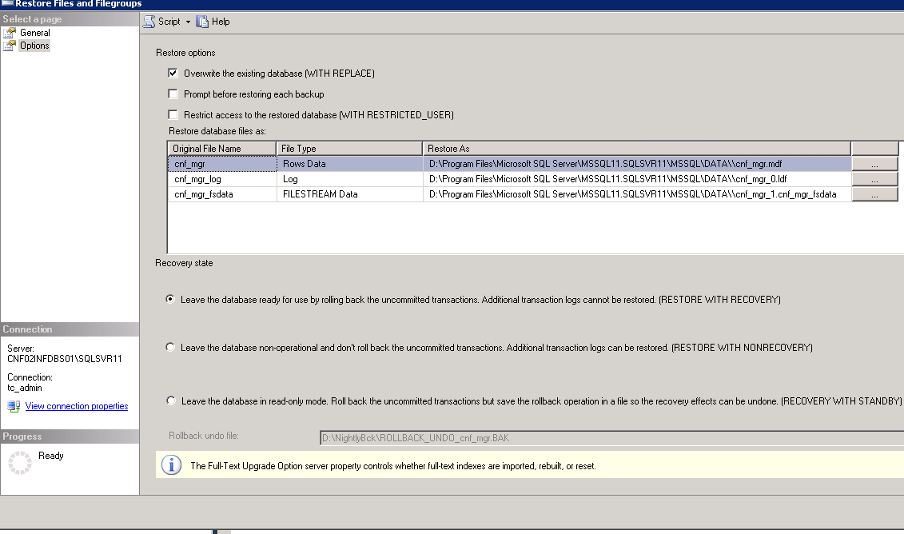

**5.2 Restoring via Script**

This process involves check if the steps explained in the Server Configuration are completed before to perform the script actions.

USE master

GO

RESTORE DATABASE [cnf_mgr]

FROM DISK = N'Backup Path File'

WITH FILE = 1,

MOVE N'cnf_mgr' TO N'MDF File Path',

MOVE N'cnf_mgr_log' TO N'TRANSLOG PATH',

MOVE N'cnf_mgr_fsdata' TO N'FILESTREAM PATH',

NOUNLOAD, REPLACE, STATS = 10

GO