To add users to the Confirmations Manager DB you need do the next steps:

Requires: Windows Authentication

**Via SQL Server Management Studio**

1. Create a Windows Login ID in your Windows domain
2. In SSMS Go to Security 🡪Logins Create a New Login User,

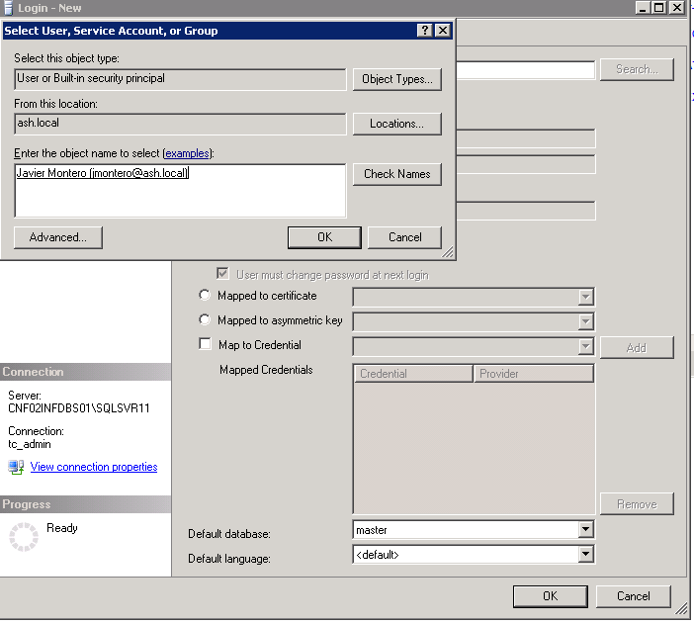

1. When a user created for first time in necessary map the DB then is necessary set the Default Schema for the user.

The default schema for the objects in the Confirmations Manager Projects is: **ConfirmMgr**

**Go to LoginID 🡪 Right Click 🡪 Properties 🡪 User Mapping 🡪 Set Default Schema ConfirmMgr**

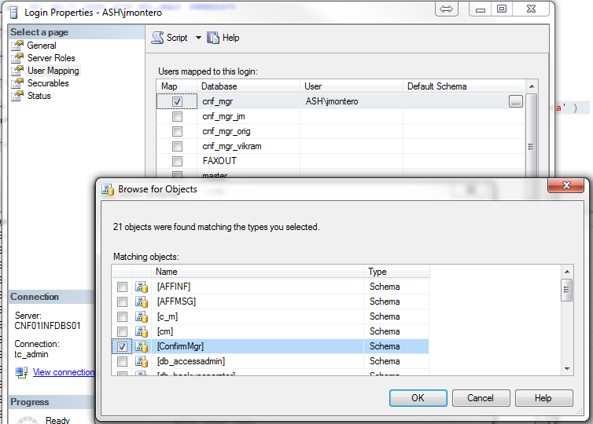

1. If is necessary map the user roles to have access to the tables using FileStream Access, for it in the DB exists 2 DB roles named:
   1. Service_broker_cnfmgr
   2. Stanford_developers

**Go to LoginID 🡪 Right Click 🡪 Properties 🡪 User Mapping 🡪 Check roles requires**

Both roles have specific grants to use FileStream access on the tables however the Service_broker_cnfmgr have grants to use the Service Broker Service in the DB.

If the user created not requires this Service Broker rights leave unchecked this option and only check Stanford_developers.

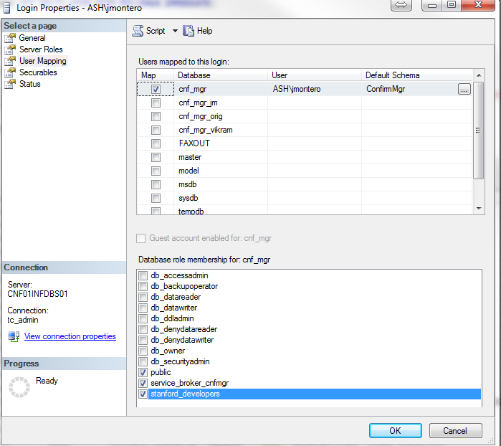

1. When the user is created and their roles are set up the user is ready to get access with the DB and File Stream Access.
2. Also is necessary validate the Windows domain built Windows Authenticate is present in the File Stream folder how is explained in the document **Confirmations Manager Database Configuration.**

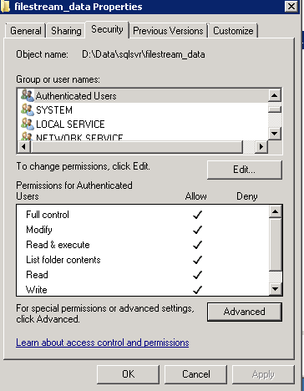

**Via SQL Script Query**

The user creation is possible to do using a SQL Query, as you can see the query include the user creation and set up their roles. Always is necessary check if the Windows Folder rights were configured previously that was explained in the step 6 above

In the GitHub repository exists a script to recreate the users in the Mercuria Environment, the script is named:

**ConfMgrDB_MercuriaReLinkUser.sql**

Also if the DB exists before and only was restored from previous backup I have included a script **Fix_Orphanet_Users.sql** to fix the Orphaned Database Users.

USE MASTER

GO

BEGIN

CREATE LOGIN [ash\kbarkman] FROM WINDOWS WITH DEFAULT_DATABASE = cnf_mgr

END

GO

USE cnf_mgr

go

CREATE USER [ash\kbarkman] FOR LOGIN [ash\kbarkman]

GO

ALTER USER [ash\kbarkman] WITH DEFAULT_SCHEMA=[ConfirmMgr]

GO

ALTER ROLE [service_broker_cnfmgr] ADD MEMBER [ash\kbarkman]

GO

ALTER ROLE stanford_developers ADD MEMBER [ash\kbarkman]

GO

PRINT'KBARKMAN USER CREATED SUCCESSFULLY!!!!!'

GO

