Delhi.dental

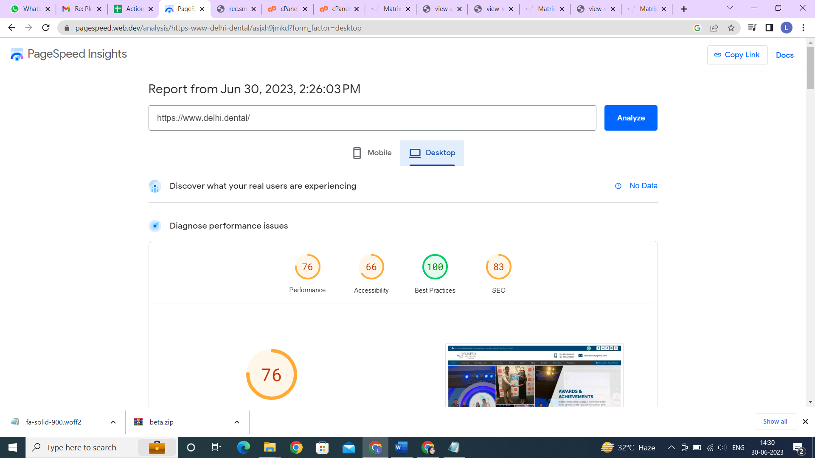

**Medrev**

**RESPL**  
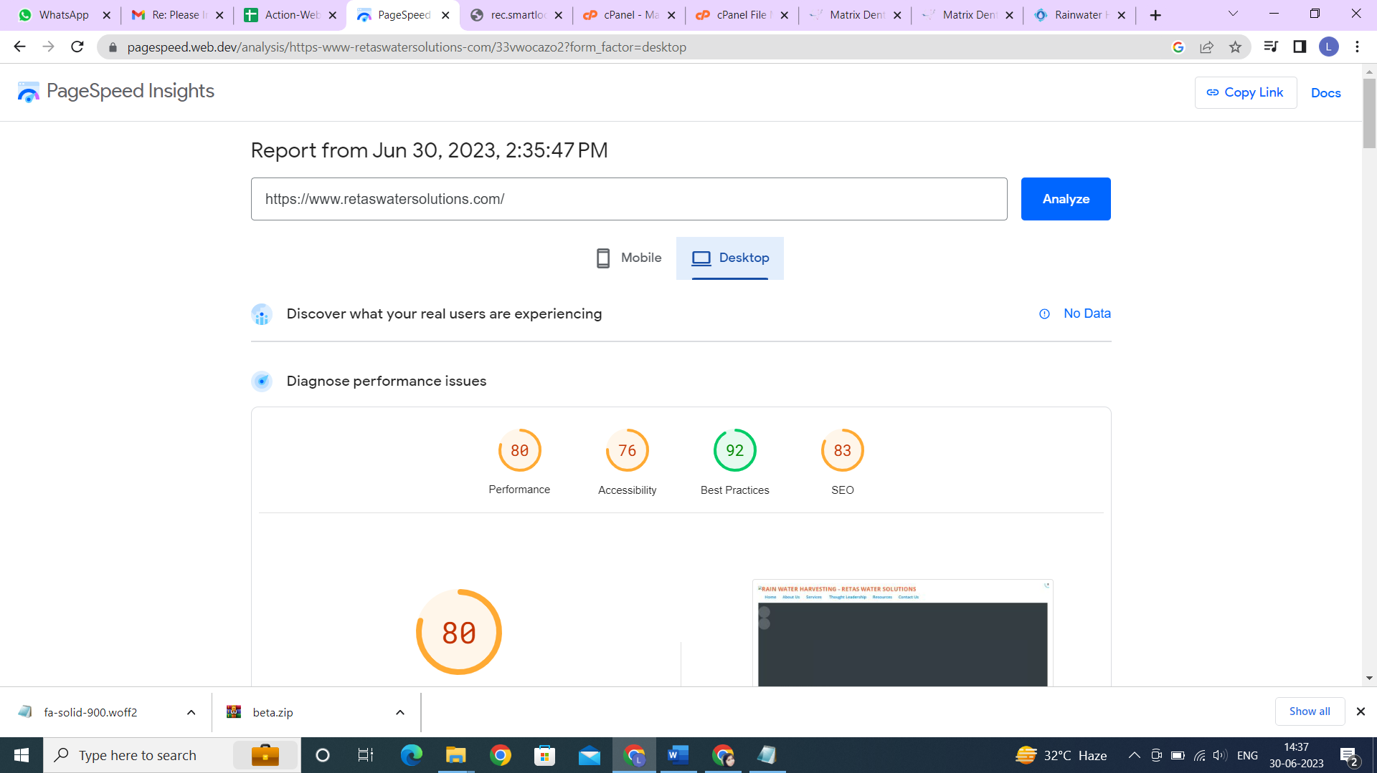

**CSIESPL**

