

Technical Specification Document

NIUA Project



Prepared By: PwC

Contents

Introduction 2

PHP Framework (CI Architecture) 2

Server Configuration 3

Architecture 3

Database Diagram 4

File Structure 10

# Introduction

This document is a technical document for NIUA Project(Assessment module) to understand the backend. It provides guidance which is intended to assist the technical Manager, Developer or Technical Person, in producing a project‑specific technical document. It is also useful background reading for anyone involved in developing or monitoring the Assessment module Portal.

# PHP Framework (CI Architecture)

We are Using CodeIgniter (Php Framework) as a programming language for socialsportz.com

CodeIgniter is an MVC Framework. MVC Stands for Model, View, and Controller. Below are the modules in MVC framework:

**Model (**Model used for database communication)

* Model work as back-end.
* Model deals with back-end operations.
* Fetch data from database and send to the controller

**Views (**HTML view that is visible to the User(frontend))

* View work as front-end.
* View deals with fronted operations.
* Display data and capture user action
* Send user action to the controller

**Controllers (**Where we implement Business logics)  
Controller works as intermediator between model and view.

# Server Configuration

1. PHP (version 8.2)
2. PostgreSQL (version 16.1)
3. OS – AWS
4. Apache (version 2.4.57)
5. CodeIgniter (version 4)

# Architecture

# Database Diagram

1. Super Admin

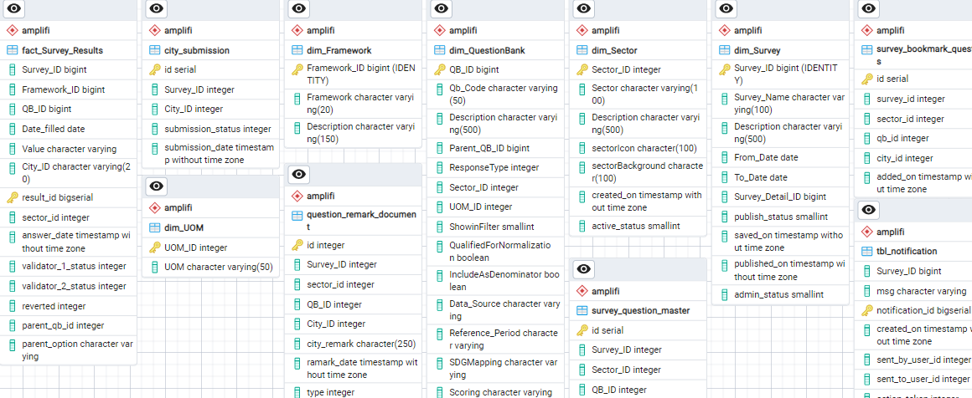

1. Admin

1. City Official

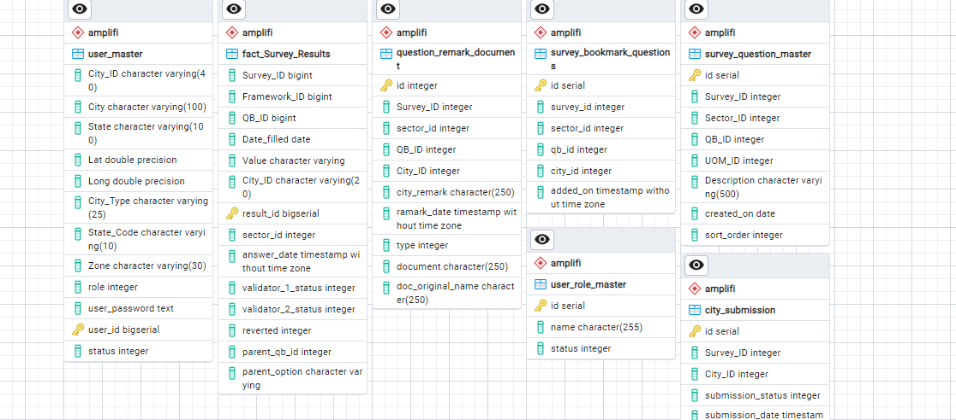

1. Validator 1 / Validator 2

# File Structure

Here we are listing the path of file and directory

1. **Registration / Login / Logout**
   1. **Directory*:***
   2. **Path:**
2. **User Module**
   1. **User Dashboard** 
      1. **Directory***:* Public_html->application->controllers-> dashboard.php
      2. **Path:** [<ROOT-DIRECTORY>/dashboard](https://vibestest.com/wip_projects/development/socialsportz/dashboard)
   2. **Admin Login**
      1. **Directory***:* Public_html->application->controllers->admin->user.php
      2. **Path:** [<ROOT-DIRECTORY>/admin](https://vibestest.com/wip_projects/development/socialsportz/admin)
   3. **Dashboard**
      1. **Directory***:* Public_html->application->controllers->admin->user.php
      2. **Path:**[<ROOT-DIRECTORY>/admin/user/dashboard](https://vibestest.com/wip_projects/development/socialsportz/admin/user/dashboard)
   4. **Admin User**
      1. **Directory***:* Public_html->application->controllers->admin->user.php
      2. **Path:**[<ROOT-DIRECTORY>/admin/user/admin_list](https://vibestest.com/wip_projects/development/socialsportz/admin/user/admin_list)
   5. **User**
      1. **Directory***:* Public_html->application->controllers->admin->user.php
      2. **Path:**[<ROOT-DIRECTORY>/admin/user/userlist](https://vibestest.com/wip_projects/development/socialsportz/admin/user/userlist)

**Note:** There are some intermediate file which work as a supporting file, these are not listed. Those can be finding from given files.

1. **API’s –** API’s for integration with mobile
   1. **Facility** 
      1. Directory*:* Public_html->application->controllers-> api->facility.php
         1. **Fn(facility_profile) –** This Api is used for profiling of facility.
         2. **Fn(delete_facility) –** This is used for deleting facility at the time of facility profiling
         3. **Fn(sports_step_3) –** This is used for add / edit sports of facility
         4. **Fn(facility_step_4) –** This is used for add / Edit amenities.
         5. **Fn(facility_academy_listing) –** This is used for listing of all facility and academy
         6. **Fn(master_amenities_list) –** This gives all master amenities added by admin
         7. **Fn(master_sport_list) –** This gives all master sports added by admin
         8. **Fn(reward_achievement_list) -** This gives all master reward achivement added by admin
         9. **Fn(fac_sport_listing) –** This gives facility sports listing added by facility owner
         10. **Fn(profile_summary_update) –** This is used for updating profile of facility owner
         11. **Fn(profile_academy_update) -** This is used for updating facility academy
         12. **Fn(achievements_details_update) –** This is used for updating achievement detal added by facility owner
         13. **Fn(profile_amenity_edit) –** This is used for updating amenities of user
         14. **Fn(fac_timing_edit) –** This is used for editing the timing of facility / Academy
         15. **Fn(add_edit_achievements) –** This is used for editing achievement of facility.
         16. **Fn(facility_reward_achievement)-** This is the listing of facility reverds
         17. **Fn(master_batch_package_list) –** This gives the master list of packages added by admin (ie – monthly, Quarterly)
         18. **Fn(master_batch_slot_type_list) –** This gives the master list of slot type added by admin (ie – premium)
         19. **Fn(add_edit_slot) –** This is used for add / edit slot of facility
         20. **Fn(add_edit_batch) -** This is used for add / edit batch of facility
         21. **Fn(batch_slot_listing) –** This gives the listing of batch and slot of facility
         22. **Fn(add_edit_facility_gallery)-** This is used for add / edit gallery of facility / academy
         23. **Fn(gallery_listing) –** This gives the listing of facility / academy gallery
         24. **Fn(add_edit_event) –** This is used for add / edit event of facility
         25. **Fn(event_listing) –** This gives the listing of events of a facility
         26. **Fn(booking_listing) –** This gives the listing of booking of a facility/ academy
         27. **Fn(review_listing) –** This gives the listing of review of a facility/ academy
         28. **Fn(enquiries_listing) –** This gives the listing of enquiry of user to facility/ academy
         29. **Fn(notification_listing) –** This is used for showing notification listing to facility owner that comes from the user end
         30. **Fn(email_notification_listing) –** This is used for showing notification listing to facility owner that comes from the admin end
         31. **Fn(available_slots)-** This gives the available slot for offline booking
         32. **Fn(user_details) –** This gives the user detail of user at the time of offline booking by using user’s mobile no
         33. **Fn(offline_booking_checkout) –** This is used for offline checkout (offline booking of slot or batch)
         34. **Fn(availability_count_of_month) –** This returns the count of slot / batch and bookings for showing data on calendar
         35. **Fn(slot_batch_detail) –** This gives the detail of slot batch
         36. **Fn(userbookingdetail) –** This gives detail of user’s that booked the slot / batch
         37. **Fn(email_verification) –** This is used for verification of facility email
   2. **User**
      1. Directory*:* Public_html->application->controllers-> api->user.php
         1. **Fn(user_login)** - This is used for user(player) login
         2. **Fn(user_registration)** - This is used for user signup(player) login
         3. **Fn(mobile_verification) –** This is used for the verification of user mobile.
         4. **Fn(change_password) –** This is used for the change of password by the user
         5. **Fn(forgot_password) –** This is used for the reset password if user forgot their password
         6. **Fn(existing_user) –** This is used for those users who is trying to signup with existing mobile no and email id
         7. **Fn(dashboard_Detail) –** This gives the data of dashboard for user