

Technical Specification Document

NIUA Project



Prepared By: PwC

Contents

Introduction 2

PHP Framework (CI Architecture) 2

Server Configuration 3

Architecture 3

Database Diagram 4

File Structure 10

# Introduction

This document is a technical document for NIUA Project(Assessment module) to understand the backend. It provides guidance which is intended to assist the technical Manager, Developer or Technical Person, in producing a project‑specific technical document. It is also useful background reading for anyone involved in developing or monitoring the Assessment module Portal.

# PHP Framework (CI Architecture)

We are Using CodeIgniter (Php Framework) as a programming language for socialsportz.com

CodeIgniter is an MVC Framework. MVC Stands for Model, View, and Controller. Below are the modules in MVC framework:

**Model (**Model used for database communication)

* Model work as back-end.
* Model deals with back-end operations.
* Fetch data from database and send to the controller.

**Views (**HTML view that is visible to the User(frontend))

* View work as front-end.
* View deals with fronted operations.
* Display data and capture user action.
* Send user action to the controller.

**Controllers (**Where we implement Business logics)  
Controller works as intermediator between model and view.

# Server Configuration

1. PHP (version 8.1)
2. Database PostgreSQL (version 16.1)
3. OS – AWS
4. Apache (version 2.4.57)
5. CodeIgniter (version 4)

# Architecture

# Database Diagram

1. Super Admin

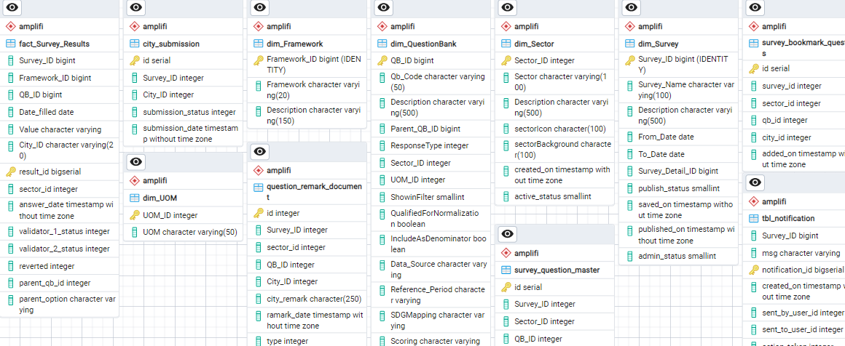

1. Admin

1. City Official

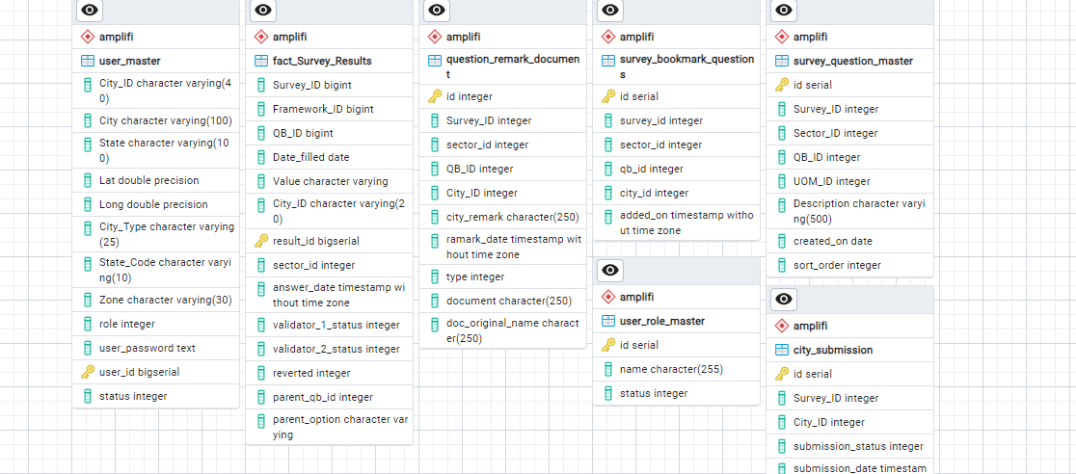

1. Validator 1 / Validator 2

# File Structure

Here we are listing the path of file and Url:

1. **Login / Logout**
   1. **Directory Path:**var/www/html/niua_amplifi/app/Views/backend/login.php
   2. **Login URL(Link):** [**http://35.154.100.13/niua_amplifi**](http://35.154.100.13/niua_amplifi)
   3. **Logout URL(Link):** [**http://35.154.100.13/niua_amplifi/admin/logout**](http://35.154.100.13/niua_amplifi/admin/logout)
2. **User Module**
   1. **City Official** 
      1. **Directory Path:**var/www/html/niua_amplifi/app/Views/backend/city_official/
   2. **Admin & Super Admin**
      1. **Directory Path***:*

var/www/html/niua_amplifi/app/Views/backend/admin

* 1. **Validator-1**
     1. **Directory Path***:* var/www/html/niua_amplifi/app/Views/backend/validator1

**4. Validator-2**

**i. Directory Path***:*

var/www/html/niua_amplifi/app/Views/backend/validator2

**Note:** There are some intermediate files which work as a supporting file, these are not listed. Those can be finding from given files.

**Directory Path***:* var/www/html/niua_amplifi/app/Views/backend/ajax

**Upload File Path***:* var/www/html/niua_amplifi/public/assets/uploads/

(All the uploaded files can be found in above path)

**Assets Directory Path***:* var/www/html/niua_amplifi/public/assets/niua/

(All the CSS, JS files can be found in above path)