**Name:** Dellova, John Paul Siano

**Section:** BSIT-NS-T-3A-T

**Subject:** ITEP310-T: IT Professional Elective 1

**Schedule, Room:** W 02:00PM-05:45PM, IT 103

**Faculty:** Prof. Maria Cristina D. Baloloy

**ASSIGNMENT 1**   
Create and customize your own simple product advertising website using HTML and CSS with Bootstrap. (You may modify your own product or use some sources on the internet, but make sure to cite them in the reference section)

**SCREENSHOTS OF THE WEBSITE:**

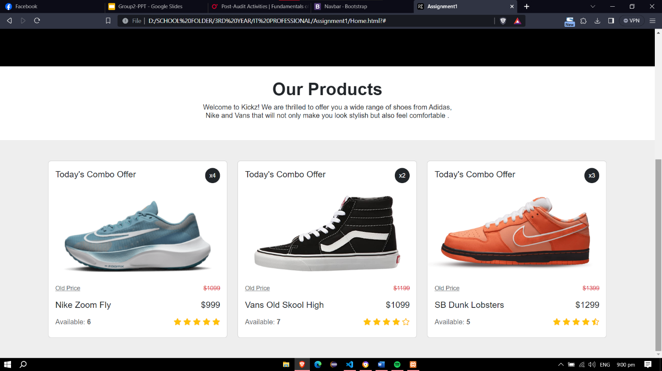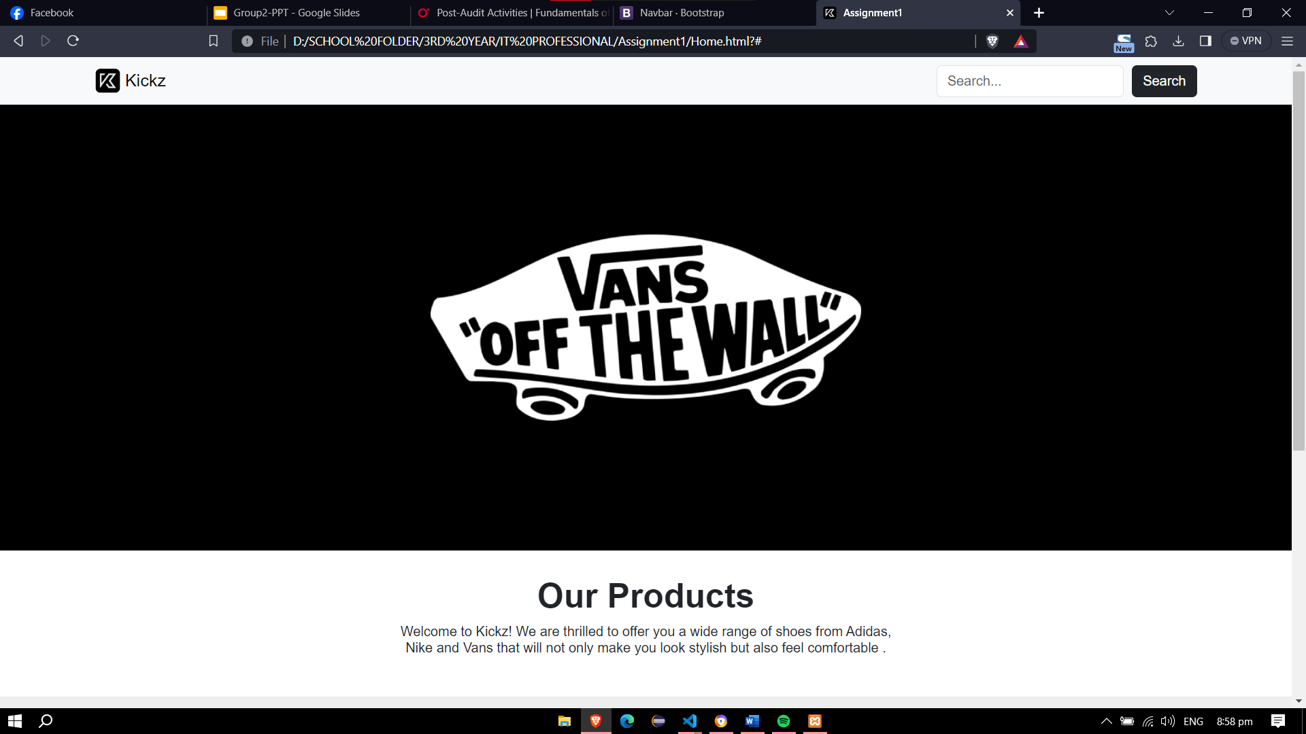

**SOURCE CODE:**

**HTML FILE:**

**CSS FILE:**

**REFERENCES**

*contributors, M. O., Jacob Thornton, and Bootstrap. (n.d.). Navbar. Getbootstrap.com.* https://getbootstrap.com/docs/4.0/components/navbar/

*Bootstrap Product Cards: free examples, templates & tutorial. (n.d.). MDB - Material Design for Bootstrap.* https://mdbootstrap.com/docs/standard/extended/product-cards/

‌