

**The Egyptian E-Learning University (EELU) Faculty of Information Technology**

**Graduation Project**

**202**4**-202**5

**Pneumonia Disease**

**Supervisors**

Dr/Hanaa Bayoumi

Eng/Abdelrhman Gamal



**The Egyptian E-Learning University (EELU) Faculty of Information Technology**

**Graduation Project**

**202**4**-202**5

**Pneumonia Disease**

**Submitted By**

* Amr Mahmoud Mohamed
* Shahd Bahaa-eldin Mahmoud
* Ebrahim Mohamed Ebrahim
* Roaa Osama Ibrahim
* Ahmed Mostafa Zkaria
* Sara Montaser Abdelghany
* Abdelrhman Khaled Magdy

Table of Contents

**Introduction** 5

**Motivation** 6

**Problem Definition** 7

**Related Work** 8

**Main Objective** 9

**Tools** 10

**Dataset** 11

Conclusion 14

Limitation of Dataet 17

**Methodology** 20

(Phase-1) 20

Augmentation 22

Augmentation (cont) 23

Modeling 24

(Phase-2) 30

Models Architectures 31

Model Overview & Workflow Steps 33

Models Evaluations 36

**Demo** 37

**Conclusion** 41

**Future Work** 42

**References** 43

# **Introduction**

Pneumonia is a leading cause of morbidity and mortality worldwide, especially among children and the elderly.

Early diagnosis is critical for effective treatment, yet access to diagnostic tools such as chest X-rays and the expertise of radiologists is often limited in low-resource areas.

With the advancement of mobile technologies and artificial intelligence, there is an opportunity to bridge this gap by creating tools that allow for faster, more accessible diagnosis.

This project aims to develop a mobile application that leverages machine learning to automatically detect pneumonia from chest X-ray images.

The application is intended to be used by healthcare workers in remote areas or by general users seeking an initial assessment before consulting medical professionals.

By providing a quick, reliable, and portable diagnostic solution, this project seeks to reduce delays in treatment and improve outcomes for pneumonia patients.

# **Motivation**

The application helps people who are far from hospitals and doctors long distances in rescuing infected patients and providing some assistance for the disease and dealing with it to avoid contracting severe pneumonia until they reach a specialist doctor and take the necessary measures.

A pneumonia application can provide information about the disease, its symptoms, and its treatment for patients. It can also help patients track their symptoms and manage their condition.

A pneumonia application can help patients identify the symptoms of pneumonia early on. This can lead to earlier treatment and a better outcome.

Helping patients detect pneumonia and reducing the death rate resulting from pneumonia.

The app can provide health tips, instructions about serious symptoms, and treatment guidelines, which helps raise health awareness.

# **Problem Definition**

Pneumonia remains one of the most significant public health challenges globally, with millions of cases reported annually.

Accurate and timely diagnosis is critical for preventing complications and ensuring proper treatment. However, in many parts of the world, access to radiologists and the necessary equipment is scarce, leading to delayed or missed diagnoses.

**This project addresses the following issues:**

* Limited access to radiology expertise in low-resource settings, leading to delayed diagnosis of pneumonia.
* Inefficient manual analysis of chest X-rays, which can lead to misdiagnosis.
* High costs and infrastructure needs associated with traditional diagnostic tools, making them inaccessible to many people.
* Overburdened healthcare systems that could benefit from automated diagnostic support.

# **Related Work**

|  |  |  |  |  |  |  |
| --- | --- | --- | --- | --- | --- | --- |
| **Name** | **Algorithms** | **Accuracy** | **Number of images** | **Years** | **Size** | **Limitation** |
| Detecting pneumonia on chest X-ray using radiological features and differential learning | CNN  (ResNet-18) | 88.6% | 9783 | 2021 | 7.86 GB | * Data Source Limitation. * Potential for Overfitting. |
| Pneumonia Detection on Chest X-ray Images Using Ensemble of Deep Convolutional Neural Networks | CNN  (DenseNet169 , MobileNetV2 , Vision Transformer) | 93.91% | 5863 | 2022 | 1.24 GB | * Complexity and Computational Load. * Resource Intensive. |
| A Convolutional Neural Network ensemble model for Pneumonia Detection using chest X-ray images | CNN  (DenseNet169 , MobileNetV2 , Vision Transformer) | 84.12% | 5863 | 2023 | 1.24 GB | * Potential Overfitting. * Interpretability Challenges. |
| Development of a pneumonia detection system using convolutional neural networks | CNN  (VGG16 , ResNet50 , MobileNetV3 ) | 97% | 5863 | 2024 | 1.24 GB | * Model Interpretability. * Computational Requirements |

# **Main Objective**

Early and Accurate Detection – Quickly identify pneumonia cases using AI-based image analysis, improving diagnostic accuracy compared to traditional methods.

Assist Healthcare Professionals – Support doctors, especially in areas with limited radiologists, by providing a second opinion for diagnosis.

Reduce Diagnosis Time – Automate pneumonia detection to speed up patient diagnosis and treatment.

Improve Patient Outcomes – Enable early intervention, reducing complications and improving survival rates.

Remote and Low-Cost Screening – Offer a mobile-based solution for diagnosing pneumonia in underserved areas, making healthcare more accessible.

Integration with Healthcare Systems – Provide a seamless way to store, analyze, and share results with medical professionals.

# **Tools**

* **Front-end**
* **Flutter**: is used for building **cross-platform applications** that run on multiple platforms.
* **AI Integration**
* **Python:** is widely used in **machine learning (ML)** due to its simplicity, versatility, and extensive ecosystem of libraries and frameworks.
* **Dataset**
* **Kaggle:** is an **online platform and community** for data scientists and machine learning enthusiasts. It is particularly well-known for providing access to datasets and hosting competitions.

# **Dataset**

The Chest X-Ray Pneumonia dataset contains X-ray images categorized into two classes: Normal and Pneumonia. The dataset includes:

* **Normal**: X-ray images showing healthy lungs.
* **Pneumonia**: X-ray images of lungs with signs of pneumonia.

|  |  |
| --- | --- |
| **Dataset Breakdown** | |
| Normal | 1,342 images |
| Pneumonia | 3,786 images |
| Training set | 5,216 images |
| Testing set | 624 images |
| Total images | 5,863 images |

These images are labeled as either normal or showing pneumonia and have varying image resolutions. There are no specific levels or subclasses of pneumonia in this dataset; it is simply divided between healthy and pneumonia-affected lungs.

**Why not other datasets?**

* Large Dataset of Labeled Optical Coherence Tomography (OCT) and Chest X-Ray Images - Mendeley Data.
* **Image Quality**

Despite efforts to filter out noisy or low-quality images, there are reports of some images being of poor quality, such as misaligned, blurry, or pixelated images. This can negatively affect model performance since training with noisy data can result in less accurate predictions.

* **Large Dataset Size**

The Mendeley dataset is relatively large and includes multiple diseases. While this is generally good for training, it might require significant computational resources (e.g., GPU or cloud computing) to train models effectively, especially for deep learning tasks.

* RSNA Pneumonia Detection Challenge | Kaggle
* **Complex Preprocessing**

The dataset is in DICOM format, which requires conversion to more common formats like PNG or JPG for most deep learning frameworks. Moreover, handling the annotations and preprocessing steps requires careful attention to detail.

* **Imbalanced Data**

The dataset contains a large number of images without pneumonia labels, which means it may need additional handling for balancing the data or careful selection of cases to avoid biased predictions

## Conclusion

* **Detecting pneumonia on chest X-ray using radiological features and differential learning**
* In this work, we present a novel framework by combining radiomic features and contrastive learning to detect pneumonia from chest X-ray. Experimental results showed that our proposed models could achieve superior performance to baselines. We also observed that our model could benefit from the attention mechanism to highlight the ROI of chest X-rays.
* **Development of a pneumonia detection system using convolutional neural networks**
* In this paper we proposed a CNN model to provide an efficient and accurate solution for the pneumonia detection problem based on X-ray images. The main novelty consisted in the placement of a dropout layer among the convolutional layers of the network. Instead of deploying pretrained networks via transfer learning, we created a CNN model from scratch. Experiments have shown that the proposed model performs better than its counter candidates in terms of accuracy and efficiency, achieving recall and precision well above 97% with predictions produced in only 122 ms.
* **Pneumonia detection in chest X-ray images using an ensemble of deep learning models**
* The article presents a novel automated CAD system for early pneumonia detection using deep transfer learning. The system employs an ensemble framework that combines the decision scores from three CNN models (GoogLeNet, ResNet-18, and DenseNet-121) to classify chest X-ray images into "Pneumonia" and "Normal."
* The weights assigned to the classifiers are calculated using a novel fusion strategy based on four evaluation metrics. The proposed framework achieved high accuracy rates on two publicly available pneumonia chest X-ray datasets, outperforming state-of-the-art methods.
* However, it has limitations in terms of computation cost and potential for improvement through image pre-processing techniques.
* **Efficient pneumonia detection using Vision Transformers on chest X-rays**
* The article conducts a thorough analysis of a Vision Transformer (ViT) framework for pneumonia detection in chest X-rays. ViTs' ability to analyze complex image relationships is showcased, demonstrating superior performance over traditional CNNs and other advanced techniques. ViTs excel in capturing global context, spatial relations, and handling variable image resolutions, leading to accurate pneumonia detection. The study aims to assess this method's effectiveness by comparing it to state-of-the-art models on a diverse CXR dataset. The results reveal ViT's superiority with an accuracy of 97.61%, sensitivity of 95%, and specificity of 98%. In conclusion, the ViT-based approach holds promise for early pneumonia detection in CXRs, offering substantial development potential in this field. However, limitations include data scarcity and the need for real-world validation. Future directions encompass enhancing interpretability, addressing model robustness, and conducting clinical trials for practical deployment.

## Limitation of Dataet

* **Large Dataset of Labeled Optical Coherence Tomography (OCT) and Chest X-Ray Images**
* **Dataset Dependency**: The study relies on the RSNA Pneumonia Detection Challenge dataset, which may not be representative of all clinical scenarios. Variability in data quality and patient demographics
* **Interpretability**: Although the model aims to enhance interpretability through radiomic features, the overall decision-making process of deep learning models remains complex and potentially opaque.
* **Limited Evaluation Metrics**: The study primarily focuses on accuracy, F1 score, and AUC. Other metrics like precision, recall, and real-world clinical impacts are not thoroughly discussed.
* **Future Work**: The study acknowledges the need for further research, such as exploring other deep learning architectures and weakly supervised learning, indicating that the current work may not be comprehensive.
* **Chest X-Ray Images (Pneumonia)**
* **Dataset Size and Quality**: The model's performance is heavily dependent on the quality and size of the dataset used. Limited access to large, diverse datasets might hinder the model's ability to generalize to new, unseen data. The use of small datasets may lead to overfitting, reducing the reliability of the predictions on real-world data.
* **Image Quality**: Pneumonia detection using chest X-rays may be affected by the quality of the images. Variations in resolution, clarity, or noise in X-ray images could lead to inaccurate predictions or misclassifications by the model.
* **RSNA Pneumonia Detection Challenge**
* In some instances the ensemble framework failed to produce correct predictions. In the future, we may investigate techniques such as contrast enhancement of the images or other pre-processing steps to improve the image quality. We may also consider using segmentation of the lung image before classification to enable the CNN models to achieve improved feature extraction. Furthermore, because three CNN models are required to train the proposed ensemble, the computation cost is higher than that of the CNN baselines developed in studies in the literature.
* **Labeled Optical Coherence Tomography (OCT) and Chest X-Ray Images for Classification**
* **Data Dependency**: The performance of the ViT model heavily relies on the quality and quantity of the training data. If the dataset is not diverse or is limited in size, the model may not generalize well to unseen data.
* **Interpretability**: Although Vision Transformers have been shown to perform well, their interprettability can be challenging. Understanding the decision-making process of the model may require additional techniques, which could complicate clinical applications.
* **Computational Resources**: ViT models can be computationally intensive, requiring significant processing power and memory, which may not be readily available in all clinical settings.
* **Training Time**: Training Vision Transformer models can be time-consuming, especially on large datasets. This may limit their feasibility for rapid deployment in real-world scenarios.

# **Methodology**

## (Phase-1)

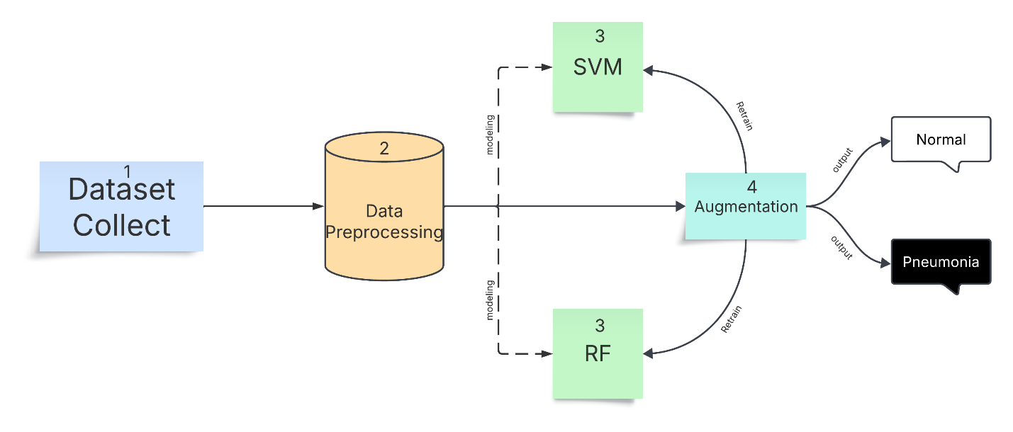

Figure 1

The figure represents a **pipeline for pneumonia detection** using machine learning models. Here’s a step-by-step breakdown of the flow:

1. **Dataset Collection (Step 1)**

* The process starts with collecting a dataset, likely chest X-ray images, for training and testing the models.

1. **Data Preprocessing (Step 2)**

* The collected dataset undergoes preprocessing, which may include resizing images, normalizing pixel values, removing noise, and enhancing image quality.

1. **Modeling (Step 3: SVM & RF)**

* Two different machine learning models are used for classification.

1. **Data Augmentation (Step 4)**

* To improve model performance, data augmentation techniques (e.g., rotation, flipping, contrast adjustments) are applied to artificially expand the dataset.
* The augmented data is then fed into the models to improve their generalization.

1. **Output Classification**

* The models predict whether an input image represents a **Normal** case or a **Pneumonia** case.
* Based on the decision boundary, the final output is displayed as either **"Normal"** (white box) or **"Pneumonia"** (black box).

### Augmentation

**Augmentation** is generally beneficial when working with the Chest X ray Pneumonia dataset, especially to improve generalization and handle data limitations effectively. However, the improvements may vary depending on the augmentation strategies and model architecture used.

While the dataset has over 5,800 images, augmentation can improve model generalization by compensating for variations in imaging conditions, such as misalignments, imperfect zoom, and lighting variations. Several studies have shown that augmentation can enhance model robustness and reduce bias in training.

**Common Augmentation Techniques**

1. **Rotation**: Rotates images by a random degree.
2. **Horizontal/Vertical Flip**: Flips the image along the horizontal/vertical axis.
3. **Zoom**: Randomly zooms in or out of the image.
4. Shift: Translates the image in the x or y direction.
5. **Brightness/Contrast Adjustments**: Adjusts the brightness and contrast randomly.
6. **Shear**: Applies a shear transformation to simulate different perspectives.
7. **Crop/Resize**: Crops a random part of the image and resizes it.

### Augmentation (cont)

In the beginning, our data set was not balanced in the normal part, so we made an augmentation to make it balanced.

1. We used **imgaug** library to do the augmentation.
2. Then I preprocessed the data and made it rotate, add noise, and change the lighting a little.
3. After that, I made a new folder and put its path in it and put it in it, and then I added the two together.

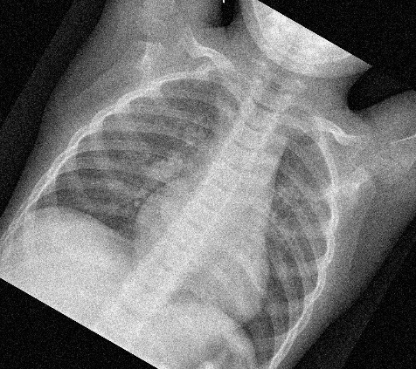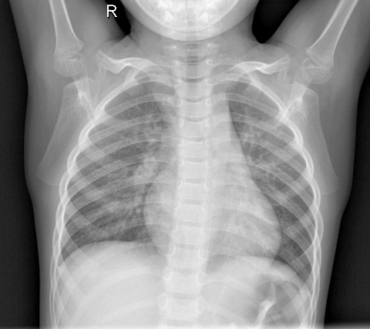

After

Before

### Modeling

#### Models we used

* Support Vector Machine (SVM)
* Random Forest (RF)

1. **Support Vector Machine (SVM)** is a supervised machine learning algorithm used for both classification and regression tasks. Its primary goal is to find the optimal hyperplane that separates data points into distinct categories in a high-dimensional space.
2. **Random Forest (RF)** is an ensemble learning method used for classification, regression, and other tasks. It operates by constructing multiple decision trees during training and combining their outputs to improve accuracy and robustness.

#### Modeling (cont)

**In SVM model, after we tried the dataset on the model, these were the results:**

**Accuracy**: This means the model correctly classified 95.90% of the images, whether they were normal or had pneumonia.

**Precision:** This value indicates that 96% of the images classified by the model as having pneumonia were actually pneumonia. In other words, the model is good at avoiding misclassifying normal images as having pneumonia.

**Recall:** This value means the model could correctly identify 96% of all images with pneumonia. In other words, the model is good at detecting all pneumonia cases in the data.

**F1-measure:** The F1-measure is the harmonic mean of precision and recall, providing a comprehensive indicator of the model's performance. In this case, the high F1-measure indicates that the model achieves a balanced performance in terms of precision and recall.

**Confusion matrix:** provides a more detailed breakdown of the classification errors made by the model. The diagonal cells in the matrix show the number of correctly classified images (i.e., normal images classified as normal and pneumonia images classified as pneumonia). The other cells show the number of misclassified images (i.e., normal images classified as pneumonia and pneumonia images classified as normal).

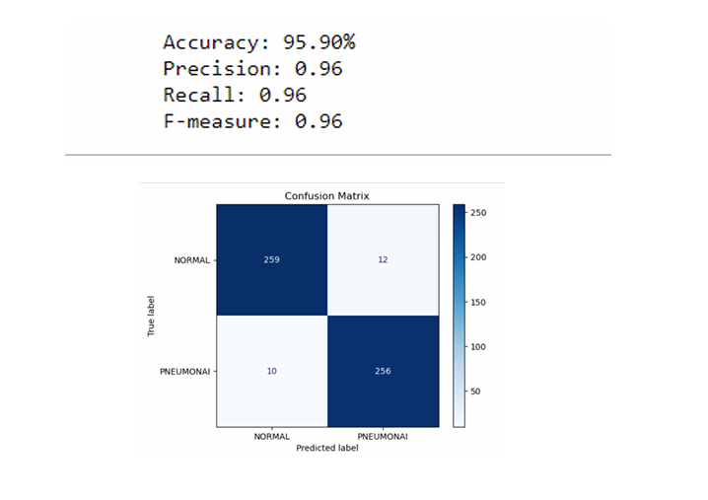

**This time we did an augmentation of our dataset using the same model and the result was:**

**Accuracy**: 96.84%: This means that the model was able to correctly classify 96.84% of the images, meaning that it was able to determine whether the image represented a healthy lung or one with pneumonia with high accuracy.

**Precision**: This value indicates that 97% of the images that the model classified as having pneumonia actually had pneumonia. In other words, the model is good at avoiding incorrectly classifying healthy images as having pneumonia.

**Recall**: This value means that the model was able to correctly identify 97% of all images with pneumonia. In other words, the model is good at detecting all cases of pneumonia in the data.

**F1-measure**: The F1-measure is the arithmetic mean of precision and recall, and gives an overall indicator of the model's performance. In this case, a high F1-measure indicates that the model achieves a balanced performance in precision and recall.

**Confusion matrix**: provides more detail about the classification errors made by the model. The values ​​on the main diagonal of the matrix indicate the number of images that were correctly classified, while the other values ​​indicate the number of images that were incorrectly classified.

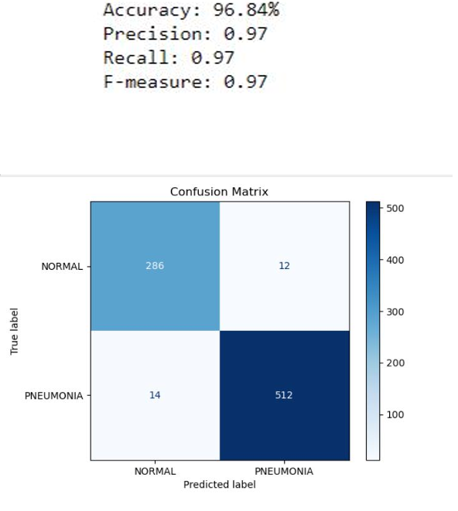

After the results of the previous model, we used another model, which is **Random Forest (RF),** and its results were good compared to the Decision Tree.

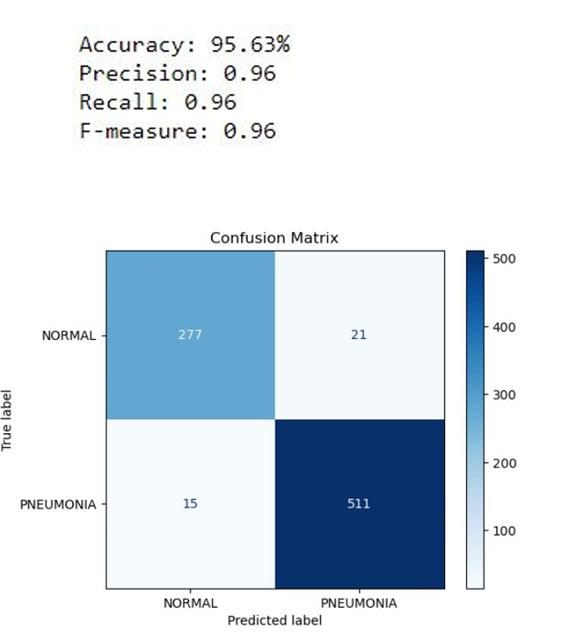

## (Phase-2)

At this stage, we will continue working on the same dataset that we augmented, but at this stage, we will use the **deep learning** model.

**What Is Deep Learning?**

* **DL** is a subset of machine learning, which itself is a branch of artificial intelligence (AI). It focuses on using artificial neural networks—inspired by the human brain—to model and solve complex problems.

**Convolutional Neural Network (CNN)**

* It’s a type of deep learning model mainly used for working with images, but it can also handle other types of data like audio or video.

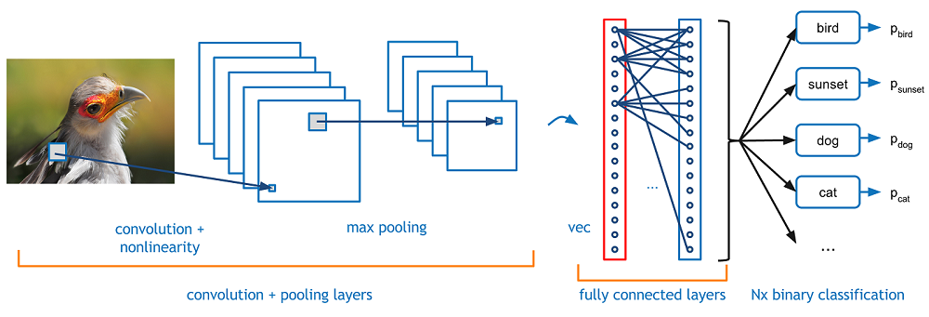

### Models Architectures

**VGG16**

* Is a deep convolutional neural network consisting of 16 weight layers, developed by the Visual Geometry Group at Oxford. It uses a simple and uniform architecture based on stacked 3x3 convolution filters, followed by max-pooling layers and fully connected layers.
* It is widely known for its performance in image classification tasks and was one of the top performers in the ImageNet 2014 competition.

**DensNet121**

* Is a convolutional neural network with 121 layers that features dense connections between layers—each layer receives inputs from all preceding layers.
* This design enhances feature reuse, reduces the number of parameters, and improves efficiency.
* Introduced in 2017, DenseNet-121 is known for its compactness, accuracy, and strong performance on visual recognition tasks.

**MobileNetV2**

* Is a lightweight and efficient convolutional neural network architecture designed by Google for use on mobile and embedded devices.
* It builds on the original MobileNet by introducing two key features: inverted residuals and linear bottlenecks, which allow for faster computation and fewer parameters without sacrificing much accuracy.
* MobileNetV2 is widely used for real-time image classification, object detection, and other vision tasks on low-power devices.

|  |  |
| --- | --- |
| **Name** | **Accuracy** |
| **VGG16** | **93.92%** |
| **DensNet121** | **94.15%** |
| **MobileNetV2** | **97.18%** |

### **Model Overview & Workflow Steps**

**Import Required Libraries**

* We import TensorFlow and Keras components to build and train our convolutional neural network. These include layers, callbacks, data generators, and a pre-trained model (MobileNetV2).

**Data Preparation**

* Images are resized to (224, 224) to match the input size expected by MobileNetV2.
* Data augmentation is applied (rotation, zoom, shear, horizontal flip) to artificially increase the training set and help prevent overfitting.
* Images are normalized by rescaling pixel values to the range [0, 1].

**Loading Training and Validation Data**

* ImageDataGenerator.flow_from_directory() is used to load images from labeled directories.
* Binary classification is enabled via class_mode='binary'.

**Using MobileNetV2 as Base Model**

* We use MobileNetV2 pre-trained on ImageNet with include_top=False, so we can add our own classifier on top.
* All layers in the base model are initially frozen (trainable=False) to retain the learned features.

**Model Architecture (Transfer Learning + Custom Layers)**

* We stack the following layers on top of the frozen MobileNetV2:
* GlobalAveragePooling2D: Reduces feature maps into a single vector per image.
* Dense(256, activation='relu'): Fully connected layer to learn custom features.
* Dropout(0.5): Helps prevent overfitting by randomly disabling 50% of neurons during training.
* BatchNormalization(): Stabilizes and accelerates training.
* Dense(1, activation='sigmoid'): Final output layer for binary classification (Normal vs Pneumonia).

**Model Compilation**

* Optimizer: Adam is used for efficient gradient descent.
* Loss function: Binary Crossentropy is used since it’s a binary classification problem.
* Metric: Accuracy is tracked during training and validation.

**Callbacks Setup**

* arlyStopping: Stops training if validation loss doesn’t improve for 5 consecutive epochs.
* ReduceLROnPlateau: Reduces learning rate by a factor of 0.2 if validation loss plateaus for 3 epochs.

**Model Training**

* The model is trained for up to 30 epochs using the fit() function.
* Training and validation steps are calculated based on batch size and sample count.
* Callbacks are applied to optimize the learning process.

**Model Evaluation**

* After training, the model is evaluated on the training set.
* The final training accuracy is printed as a performance reference.

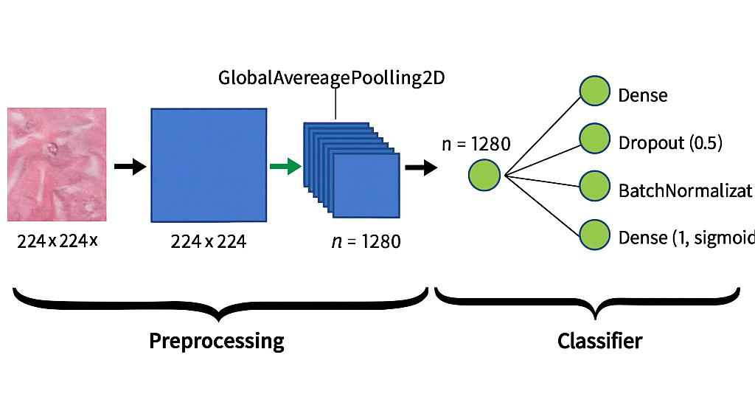

### Models Evaluations

* SVM
* VGG16 (CNN)
* DensNet121 (CNN)
* **MobileNetv2 (CNN)**

97.18%

93.92%

# **Demo**

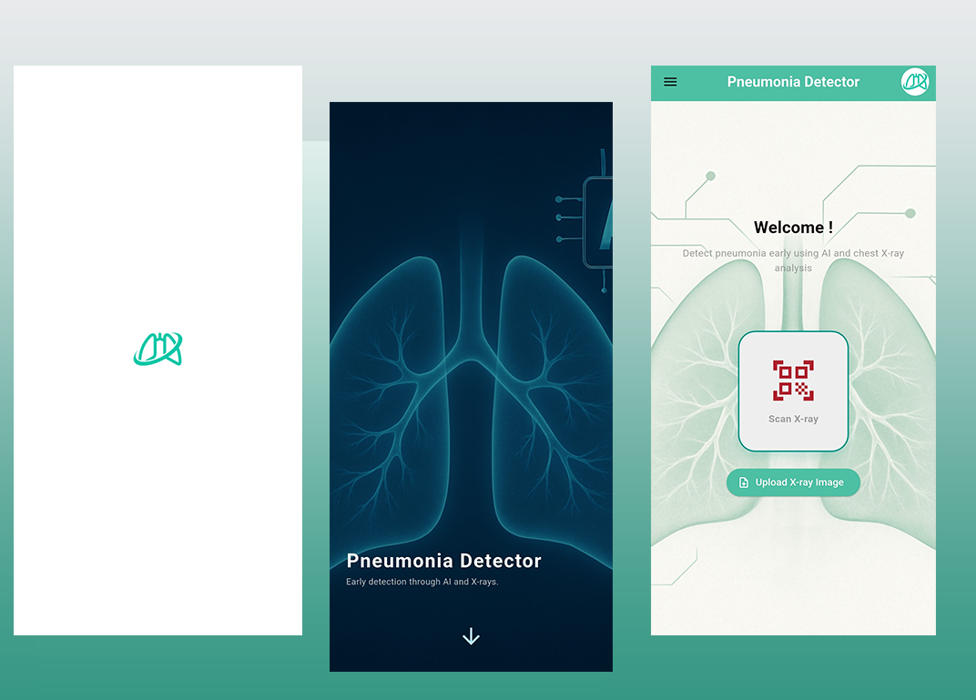

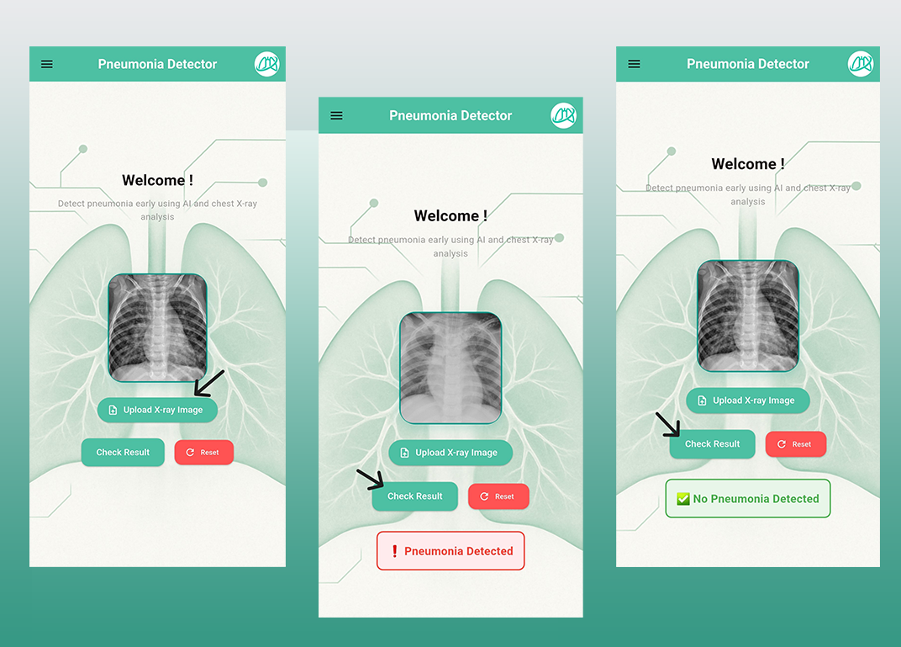

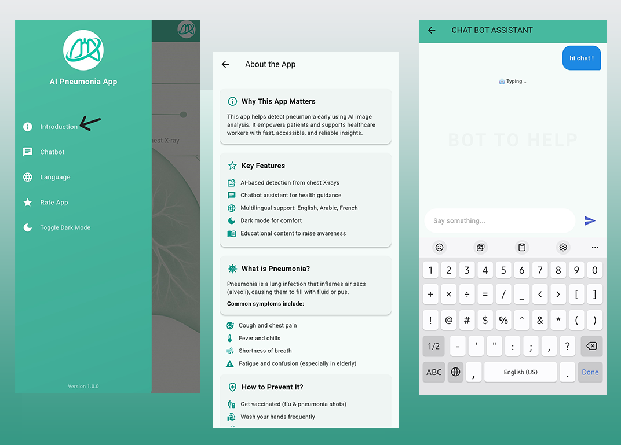

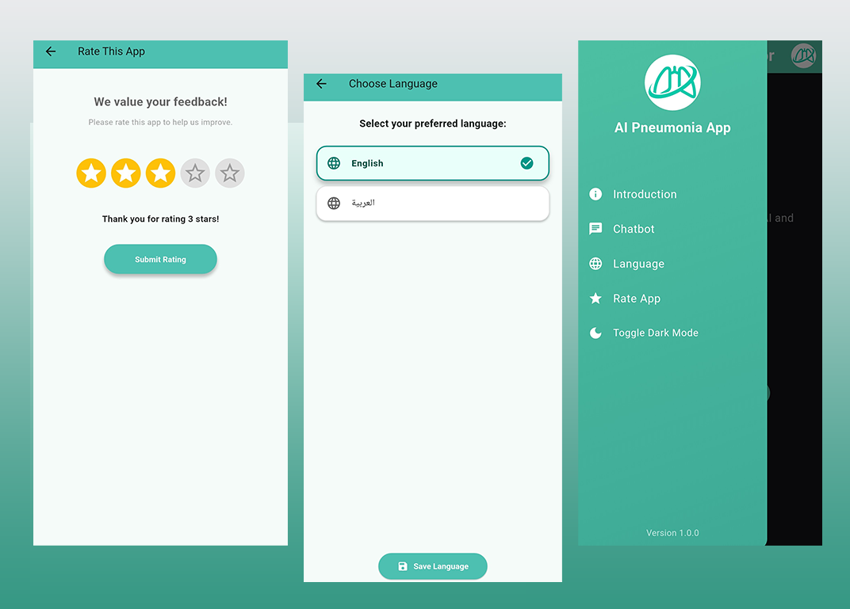

# **Conclusion**

We developed a mobile-based pneumonia detection system using machine learning and deep learning techniques applied to chest X-ray images. The solution is designed to assist healthcare providers and general users in remote or underserved areas by providing a quick and reliable initial assessment of pneumonia.

We began by applying traditional machine learning models such as Support Vector Machine (SVM) and Random Forest (RF), which achieved impressive results with accuracies over 96%. To further enhance performance, we leveraged deep learning architectures including VGG16, DenseNet121, and MobileNetV2. Among these, MobileNetV2 delivered the highest accuracy of 97.18%, making it a suitable choice for deployment on mobile platforms due to its balance of efficiency and accuracy.

Data augmentation techniques were used extensively to address the imbalance in the dataset and improve model generalization. Furthermore, transfer learning and regularization methods were applied to reduce overfitting and ensure robust model performance.

The project demonstrates the potential of AI-powered tools in improving diagnostic accuracy, reducing reliance on specialists in low-resource settings, and accelerating medical interventions. Our system provides an important step towards accessible, affordable, and effective healthcare delivery for pneumonia patients.

# **Future Work**

The application will not only predict the disease, but it will also diagnose the degree of the disease and suggest an appropriate initial treatment according to the case, and it will also suggest a suitable doctor for you according to your location.

We will improve the application design and add features such as status tracking through each user, as soon as he registers on the application, he will have his own data stored and there will be a challenge and follow-up of his status.

As for the model, there will be an improvement and we will also increase the dataset to give us higher accuracy in the results of disease prediction and reduce the error rate.

# **References**

* Dataset used

[Chest X-Ray Images (Pneumonia)](https://www.kaggle.com/datasets/paultimothymooney/chest-xray-pneumonia)

* Related work

[Pneumonia detection on chest x-ray using radiomic features and contrastive learning - pmc](https://pmc.ncbi.nlm.nih.gov/articles/PMC9096898/" \l "FN4)

[Large Dataset of Labeled Optical Coherence Tomography (OCT) and Chest X-Ray Images - Mendeley Data](https://data.mendeley.com/datasets/rscbjbr9sj/3)

[Detection of pneumonia using convolutional neural networks and deep learning - ScienceDirect](https://www.sciencedirect.com/science/article/pii/S0208521622000742" \l "s0050)

[https://www.sciencedirect.com/science/article/pii/S2772442523000436#d1e184](https://www.sciencedirect.com/science/article/pii/S2772442523000436" \l "d1e184)

<https://www.mdpi.com/2076-3417/12/13/6448>

<https://www.researchgate.net/publication/388418960_DEVELOPMENT_OF_A_PNEUMONIA_DETECTION_SYSTEM_USING_CONVOLUTIONAL_NEURAL_NETWORKS>