
SAMPLE
UNIVERSITI KUALA LUMPUR
ASSESSMENT BRIEF

COURSE DETAILS
CAMPUS | MALAYSIAN INSTITUTE OF INFORMATION TECHNOLOGY
COURSE NAME | INTERNET PROGRAMMING
COURSE CODE | ISB 42503
COURSE LEADER | DR NORHAIDAH A HARIS
LECTURER | NUR ATIQA BINTI BASARUDDIN
YEAR/SEMESTER | YEAR 2 / SEM 2

ASSESSMENT DETAILS
TITLE/NAME | PROJECT
DATE/DEADLINE | Week 13
COURSE OUTCOME(S)
INSTRUCTIONS | - This is a GROUP project (Create a group of 2 or 3 members).  - Students MUST do ALL SECTIONS of the project and submit it on or before the defined deadlines (see Submission Deadline).  - For plagiarism, the project’s marks will be deducted. 0 Marks will be given for late submission.  SUBMISSION: 4TH JUNE 11.59PM
DELIVERABLES | - CODES  - PRESENTATION  - REPORT (PDF format only)

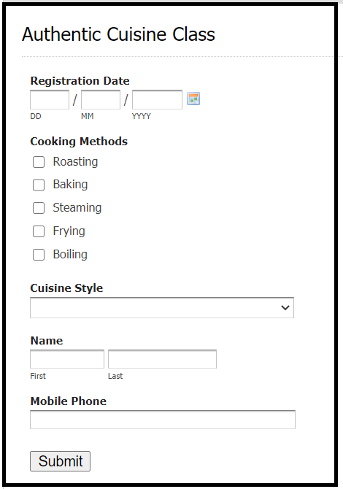

Figure 1: Cooking Class Form

INSTRUCTIONS:

- Develop a Cooking class Web-based System. Assume that you are the company that wishes to allow the public to book their cooking class using the online method. Your web page shall apply a suitable CSS design template (optional for the BONUS mark).
- You need to create one static HTML page (index) that explains the service.
- The following users should be developed as follows:

Administrator

- CREATE a default account for the administrator.
- Allow the administrator to view the customer booking details as follows: (view function)

custbook_id | Name | Mobile | Registration Date | Cook Method | Cuisine Style

- Allow the administrator to delete the booking (delete function)
- Use the “required” form attribute or JavaScript function check() or PHP function empty(), to make sure that all fields need to be entered before submitting. If one of the text fields is blank, display a dialogue message “Please enter all fields” and stop submission.

User
- Allow non-registered users to view a static HTML page explaining the service.
- Allow user to register as a customer and make a booking (insert function)
  - The form must have at least:-
    - Username
    - Password
    - Other relevant information (Refer to Figure 1)
    - Use the “required” form attribute or JavaScript function check() or PHP function empty(), to make sure that all fields need to be entered before submitting. If one of the text fields is blank, display a dialogue message “Please enter all fields” and stop submission.
- Allow the customer to view the booking details. (view function)
- Allow the customer to edit their booking (edit function)
- Allow the customer to cancel their booking (delete function)
- The “Cuisine Style” field allows the user to choose cuisine styles such as Haute Cuisine, Vegetarian Cuisine, Nouvelle Cuisine and Fusion Cuisine.

Database (MySQL)
- Create a database named cuisinefood
- Create a custbooking table as shown in Table 1 and a customer table as shown in Table 2.
- Create a table admin as shown in Table 4.
Table 1: custbooking
Field | Type | Null | Key | Extra
custbook_id | int(6) | NO | PRIMARY | AUTO_INCREMENT
register date | Date | NO
cook_method | Varchar(20) | NO
cuisine_style | Varchar(20) | NO
customer_id | int(6) | NO

Table 2: customer
Field | Type | Null | Key | Extra
customer_id | int(6) | NO | PRIMARY | AUTO_INCREMENT
f_name | varchar(20) | NO
l_name | varchar(20) | NO
mobile | varchar(20) | NO
username | varchar(20) | NO
password | varchar(20) | NO

Table 3: admin
Field | Type | Null | Key | Extra
admin_id | int(6) | NO | PRIMARY | AUTO_INCREMENT
username | varchar(20) | NO
password | varchar(20) | NO

//----------------------------------------------------------------------------------------------------------------------------//

SECTION A: SUBMISSION:

- All submissions are to be submitted through your VLE.
  - There are TWO (2) things that you need to submit.
- You are required to submit a report on your project.
  - The report should consist of all print screens of your INPUT and OUTPUT from your system. Make sure all images captured are readable and not too small.
- You are required to upload all the codes into the specified folder in VLE
  - All files (.php, .html, .css and database .sql)

SECTION B: PROJECT REPORT
The project report should consist of the following components:
- Cover page
- Plagiarism statement with student signature (Refer to Appendix 1)
- Clear listing of individual tasks (Refer to Appendix 1)
- Project section
  - Students should write a step-by-step guide on how to use the website.
  - Students must provide screenshots of their app to support the steps described in (i).
- Reference section
Students must provide all references they’ve used to complete this project (Minimum 5 references).

SECTION C: PROJECT PRESENTATION
- Presentation must be carried out by ALL members of the group, highlighting the main points of their project (Codes and Database).
- You are required to run your apps and demonstrate how your apps work.
- Presentation duration 10-15 minutes.

GOOD LUCK

The key to success is to focus on goals, not obstacles.

Great things never come from comfort ZONES.

Appendix 1:



MALAYSIAN INSTITUTE OF INFORMATION TECHNOLOGY

ISB42503 INTERNET PROGRAMMING
SEPTEMBER 2022
Plagiarism Statement

Read, complete, and sign this statement to be submitted with the written report.

We confirm that the submitted works are all our own work and are in our own words.

Name  (Block Capital &  Alphabetical Order) | Matric No. | Group | Signature*
1.
2.
3.

Date:

ISB42503 INTERNET PROGRAMMING

Individual Tasks Allocation

Indicate (√) in member name column if he/she have involved in that task.
Tasks and description |  | (Type Student Name 1) | (Type Student Name 2) | (Type Student Name 3)

