Correlation coefficient algorithm
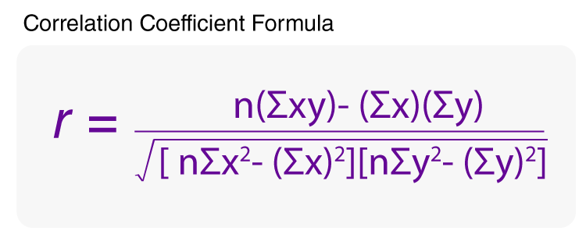

- Calculate Numerator

xy
x
y

